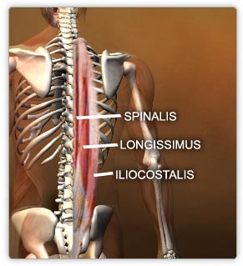  Intermediate Layer | ERECTOR SPINAE  (Sacrospinalis) | Insertion | Action  Trunk extensor
 | Iliocostalis (lateral) | Ribs and cervical transverse process | Billaterally: extension of vertebral column and head  Uniterally: Laterally bend vertebral column
 | Longissimus (intermediate) | 1.Between tubercles and angles of rib  2.Tranverse processes in thoracic and cervical region  3.Mastoid process of temporal bone
 | Spinalis (medial) | 1. Spinous processes in the upper thoracic region and skull
Common origin: | Broad tendon arises from:  - posterior part of iliac crest  - Posterior surface of sacrum, sacral and inferior lumbar spinous processes  - Suproiliac ligament  - Supraspinous ligament

Deep Layer  Transversospinal | Origin | Insertion | Action
Semispinalis | Arises from transverse processes of C4 – T12 | Occipital bone and spinous processes in thoracic and cervical regions  Spanning 4-6 segments | Extend head and thoracic and cervical regions of vertebral column and rotate them.
Multifidus | Arises from:  - Posterior aspects of sacrum and ilium  - Transverse processes of thoracic and lumbar vertebrae  - Articular processes of the C4- C7 | Spinous processes of thoracic and lumbar vertebrae  Spanning 2-4 segments | Stabilizes vertebrae during local movement of vertebral column
Rotatores | Transverse processes of vertebrae | Attaches the root of spinous processes of the next one or two vertebrae superiorly  Spanning 1-2 segment | Stabilizes vertebrae and assists with local extension and rotary movements of vertebral column
They originate from transverse processes of vertebrae to spinous processes of more superior vertebrae.

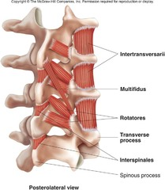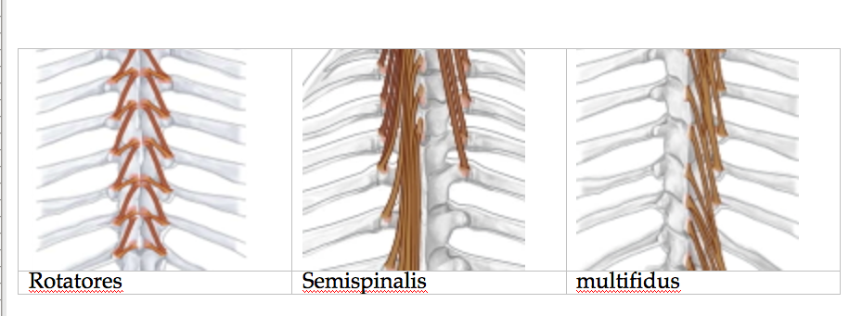

Minor deep Layer
Interspinal muscles | Intertransverse muscles | Levatores costarum
Connect sipous processes. | Connect transverse process | Elevate ribs
Extension and rotation | Lateral bending  Stabilizes vertebral column when acting bilatelly | Assisting inspiration and lateral bending of vertebral column
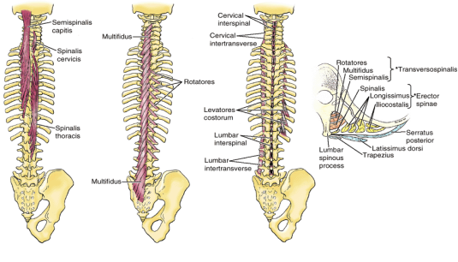

Muscles in Thoracic Wall Intercostal muscles
External Intercostal muscles | Internal Intercostal muscles | Innermost Intercostal muscles
Occupy the intercostal spaces | Run deep to and at right angles to the external intercostal | Separated from the internal intercostal by the nerves and vessels
Runs inferiorly from rib above to the rib below | Run inferoposteriorly from the inferior border of the ribs to the superior borders of the ribs inferior to them
Continues inferiorly with external oblique muscles in the anterolateral abdominal wall | continuous with the internal oblique muscles in the anterolateral abdominal wall
Action:  Muscles of inspiration  Elevates ribs | Action:  Muscles of expiration  Depresses ribs
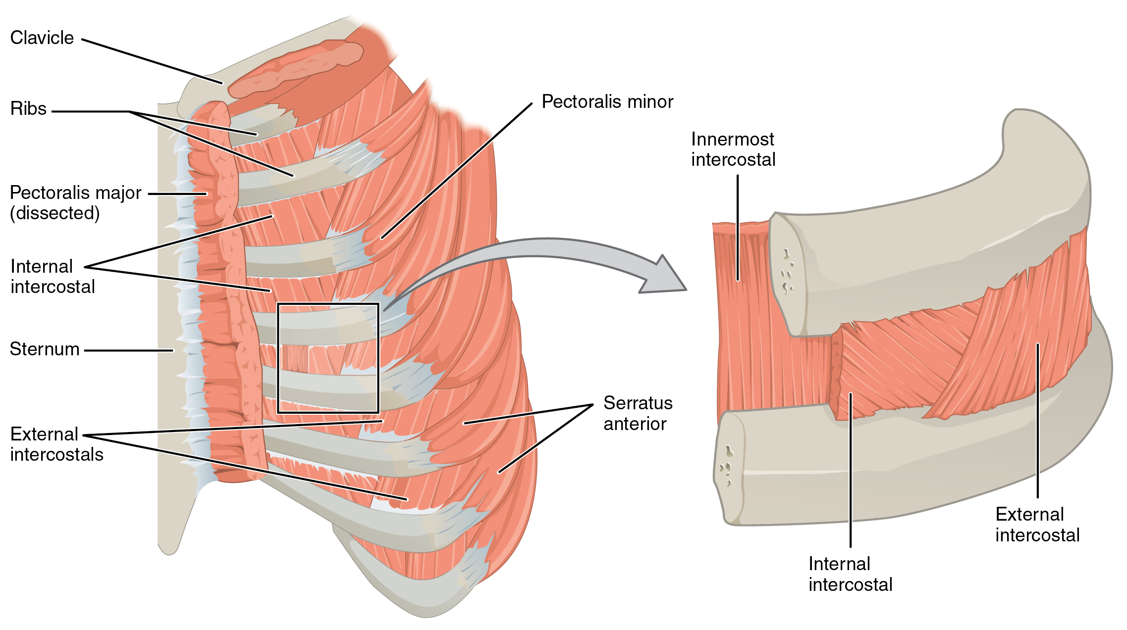

 | Anteriolateral wall
Muscle | External Oblique | Internal  Oblique | Transverse Abdominal | Rectus Abdominal | pyramidalis
origin | External surfaces of 5thh – 12 th ribs | Thoracolumbar fascia  Anterior two thirds of iliac crest  Lateral half of inquinal ligament | Innemorsmost of 3 abdominal muscles  Origin at internal surface of 7th to12th costal cartilags  Thoracolumbar fascia, iliac crest, and lateral third of inquinal ligament | Pubic symphysis and pubic crest
insertion | Linea alba, pubic tubercle and anterior half of iliac crest | Fibbers fan out anteromedially and insert to inferior borders of 10th-12th ribs, linea alba, and superior ramus of pubis | Linea alba with aponeurosis of internal oblique, superior ramus of pubis | Xiphoid process and 5th-7th costal cartilages
Main action | Compress and support abdominal viscera, flex and rotates trunk | Compress and support abdominal viscera  Flex and rotate trunk | Compress and support abdominal viscera | Most of the rectus abdominis is enclosed in the rectus sheath tendinous intesections anchor the rectus abbdominis transversely
 | - Flat muscles  - End anteriosly in aponeurosis  - Aponeuroses interlace at the linea alba  Linea alba runs from xiphoid process and is central attachement for all abdominal muscle |  |  | - vertical muscles  - withing rectus sheath (strong incomplete fibre compartment of two vertical muscles.  - Rectus is anchored to rectus sheath at tendinous intersections

Abdominal wall  Posterior wall:  Quadratus lumborum | Sternocleidomastoid  (SCM) | Thoracic diaphragm
Origin  Medial half of inferior border of 12th and tops of lumbar transverse processes | Superior attachment:  Mastoid process of temporal bone and lateral half of superior nuchal line of occipital bone | A dome-shaped musculotendious partition
Insertion  Iliolibar ligament and iliac crest | Inferior attachment  -sternal head: anterior surface of manubrium of sternum  -clavicular head: superior surface of medial third of clavicle | Separates the thoracis and abdominal cavities
Main action  Extends and laterally flexes vertebral column  Fixes 12th rib during respiration | Main action  Acting unilaterally  Laterally flexes  Rotates head and neck so the ear approaches the should of the same side  Acting bilaterally, flexes the neck | chief muscle of inspiration

