Chandler:

• Economies of scale: Cost per unit drops as the volume of output increases (geographical expansion)
• Economies of scope: Use same raw and semi finished materials and intermediate production processes to make a variety of different products (move into related markets)
• Functional divisions
• First movers: companies that quickly dominated their industries by making large investments and gaining competitive advantage. (high market share)
- created national and international marketing distribution organizations
- recruited teams of managers
• Management hierarchy:
- lower and middle managers: coordinate products though production and distribution
- top managers: coordinate and monitor current operations and to plan and
Allocate resources for future activities
• Research & development: to improve products and processes. Innovation and strategy is more important than price.
• Diversification, related & unrelated:
- Unrelated diversification: when managers acquire businesses in which they
have few if any organizational capabilities to give them a competitive edge
(ignore logic of managerial enterprise)
This leads to:
• Separation of top vs middle managers:
- Top managers have little knowledge of or experience with the technological processes and markets of the new acquisitions
- Overload in decision making at the corporate office
• Stock market pressures: loose profits and market share if:
- Entrepreneurial enterprises fail to become managerial enterprises
- Managerial enterprises fail to maintain their competitive capabilities
• Short‐term thinking: making a quick buck and trying to gain competitive edge through unrelated diversification
Chandler’s major claims

• Logic of Managerial Enterprise: Successful firms capitalize on economies of scale & scope, create management structures and invest in research & development
• Once a firm loses the opportunity to be a first mover, it is difficult to regain
competitive advantage
Chandler’s secondary claims

• Growth through unrelated diversification is a poor business strategy
• Business ownership patterns have diminished the likelihood of many firms’ long‐term success

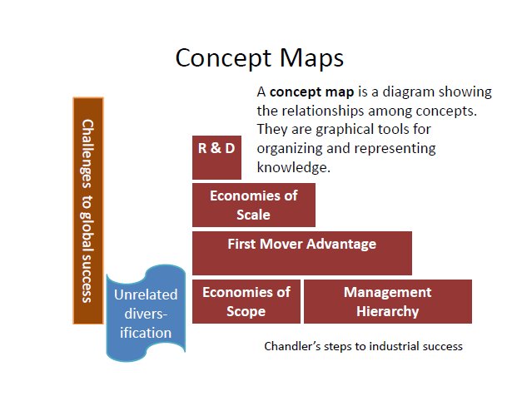
Larry Greiner
“Evolution & Revolution”

A theory of organizational life cycles, with a focus on growth

Greiner’s claims
• Organizational growth is characterized as a series of developmental phases
• Management practices that work well in one phase bring on a crisis in the next

Concept list
• Evolution & Revolution: Phases begin with a period of evolution (steady growth and stability) and ends with a revolutionary period (turmoil and change)
- If the revolutionary period is resolved, the company can move to next stage of evolution
• How organizations develop:
- Age of the organization: The same organizational practices are not maintained throughout a long life span. Management problems and principles are routed in time.
- Size of the organization: Problems and solutions tend to change with increased employees and sales revenue.
- Stages of evolution: As organizations grow, different evolutionary period emerge.
- Stages of revolution: Practices become outdated; companies that do not change will fold of cease to grow. Solution for one crisis becomes a major problem in the next.
- Growth rate of the industry: Speed of stages are related to the speed of the growth of the industry.
• Evolutionary and Revolutionary phases:
1. Creativity: Birth stage of organization. Frequent, informal communication, long work hours and modest salaries as well as promise of ownership benefits, decisions and motivations are highly sensitive to market feedback.
- “Crisis of Leadership”: Informal communication becomes infeasible, additional functions must be implemented. Need a strong business manager.
2. Direction: Functional organizational structure. Different departments, formal communication, more employees, increased efficiency, need of systems (accounting, inventory...)
- “Crisis of Autonomy”: Impersonal environment. Lower level employees have more knowledge about markets and machinery than management; want to take initiatives on their own. Need a decentralized hierarchy of management.
3. Delegation: Decentralized organizational structure. More responsibility given to lower management, bonuses are used to motivate employees, diversification of products.
- “Crisis of Control”: Lower level management begins to run their own show without coordinating with the rest of the organization. Management must focus on control.
4. Coordination: Strategic business units are formed. Top level management takes responsibility for the initiation and administration of the new system.
- “Red Tape Crisis”: Procedures take precedence over problem solving. Company has become too large and too complex to me managed though formal programs and rigid systems. Conflict between like and staff; line managers resent direction from those who are not familiar with local conditions. Management must promote interpersonal collaboration.
5. Collaboration: Strong interpersonal collaboration. Social control and self-discipline replace formal control, rewards are geared for team performance.
- “? Crisis”: Psychological saturation of employees who grow exhausted from the intensity of teamwork and innovation. May perhaps be solved though new structures and programs that allow employees to periodically rest, reflect and revitalize themselves.
• Management style:
- Managers need to know where they stand in the phases of development.
- Must know when it’s time to change and be able to activate it.
- Cannot skip phases, must go with the flow.
- Must be able to persuade ideas to other managers.

Porter: What is strategy?

• Operational effectiveness: You perform activities better than your competitors
• Strategy: You perform different activities from your competitors, or the same activities in different ways. Concentrates on combining activities as well as making trade-offs.
• Operational effectiveness is necessary, but not sufficient. Competition based on it is mutually destructive.
• Strategy – Importance of valuable uniqueness
– Variety‐based positioning = Be unique by having distinctive products or services. Based on choice of product or service rather than consumer segment.
– Needs‐based positioning = Be unique by targeting a special group of customers. Servicing most or all needs of a particular group.
– Access‐based positioning = Be unique by reaching your customers in special ways. Segmenting customers who are accessible in different ways.
• When choose a particular position, you choose NOT to use other approaches
– These trade‐offs are essential and make imitation (straddling) difficult
• Fit = Production, marketing, personnel, etc. should all be consistent
– When all activities work together as a system, imitation is difficult
– Strategy specific; no fit, not distinctive strategy
•Often, efforts to grow blur uniqueness, create compromises, reduce fit and ultimately undermine competitive advantage.

Sustained competitive advantage:
• Achievable when you have operational effectiveness AND competitors cannot copy your approach
• Many CEOs don’t have a strategy!
– Afraid of making trade‐offs
– Seduced by the concreteness of operational effectiveness
– Tempted to grow by broadening vs. deepening position & maintaining strategic continuity (A company must continually improve its OE and actively try to shift the productivity frontier; at the same time, there needs to be ongoing efforts to extend its uniqueness while strengthening the fit among its activities.)
– “Benchmarking best‐practices” & “outsourcing” lead to easy imitation… Competitive convergence (many companies doing the same things in the same ways)
– Strong leaders & strong choices are essential
– A company may have to change its strategic position due to a major structural change in the industry.
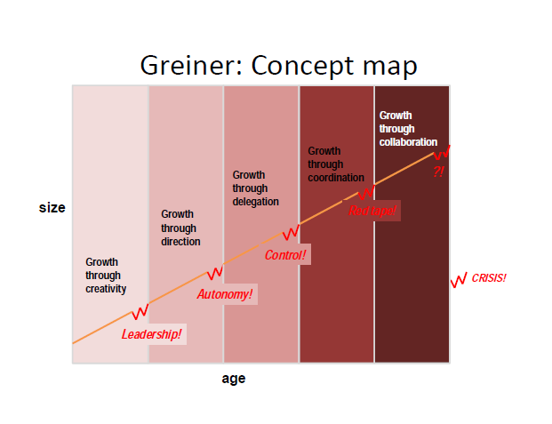
Greiner’s secondary claims

• Organizations should not try to skip phases
• Top managers whose style is no longer appropriate should remove themselves
• Growth is not inevitable
Collins & Porras: Vision

• Core ideology: Enduring character; Glue that holds the organization together. Captures what you stand for and why you exist.
– Core values: Beliefs about what is important. Timeless guiding principles, rarely if ever change.
– Core purpose: Ideals that underlie the work of the company. Reason for being, rarely if every changes. Provides inspiration and direction for doing the work.
– Must be authentic.
– Must be meaningful and inspirational only to the people inside.
– One established, everything else that is not part of the core ideology may be changed.
– Should not change in response to market changes.
- Getting people to share the core ideology.
• Envisioned future: BHAGs
– Audacious, vivid goals stimulate progress
– 10 to 30 year audacious goal plus vivid descriptions of what it would be like to achieve the goal.
– Spur passion & team spirit
– Difficult but not impossible to achieve
– Companies need to build a strong organization with people capable of achieving the goals (cf Chandler)
- Avoid the “We have arrived” syndrome

Herzberg’s concepts: How do you motivate employees?
1. Negative KITA: fear of what will happen if something is not done
2. Positive KITA: rewards, incentives
3. Hygiene factors
4. Motivators
5. Dissatisfiers
6. Satisfiers
7. Horizontal job loading: reducing personal contribution of employees rather than giving them opportunities for growth in their accustomed jobs in order to enrich certain job.
8 Vertical job loading
9. Job enlargement (no change in challenge)
10. Job enrichment: a systematic attempt to motivate employees by manipulating the motivational factors.
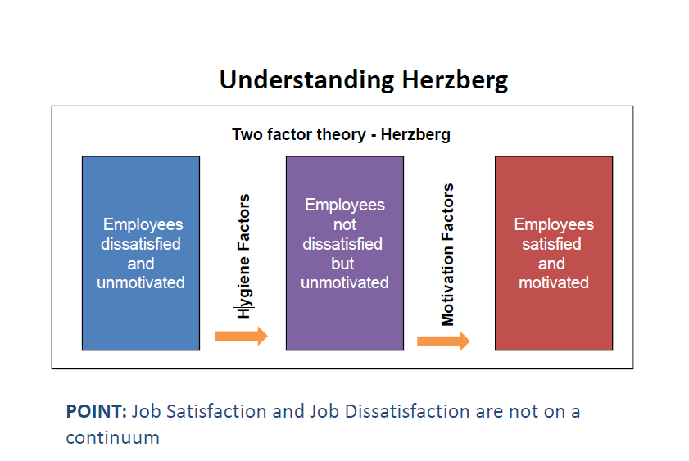

Vertical job loading (providing motivator factors)

What might you do to ‘improve’ a job?
• Remove some controls while retaining accountability
• Increase accountability of individuals for own work
• Give person a complete natural unit of work
• Grant additional authority; job freedom
• Make periodic reports directly available to workers themselves rather than supervisors
• Introduce new, more difficult tasks
• Assign workers to specialized tasks, enabling them to become experts

Steps for JOB ENRICHMENT (instilling motivators)

How might you go about improving a job?
• Select jobs, approaching them with the conviction that they can be changed
• Brainstorm possible changes
• Remove hygiene & horizontal loading issues
• Avoid direct participation by the employees whose jobs are to be enriched
• Be prepared for an initial drop in performance
• Expect first‐line supervisors to experience some anxiety

Not all jobs can or need to be enriched.
Ultimate reward in motivation is personal growth

Kaplan & Norton’s balanced scorecard

• The “bottom line” is not enough
• Four perspectives for a balanced scorecard

– Customer perspective
• What matters most to customers? (Specific measures that reflect the factors that really matter to customers) To achieve our vision, how should we appear to customers?

– Internal business perspective
• How can we produce to meet customer expectations? (Internal operations that enable them to satisfy customer needs) To satisfy our shareholders and customers, what business processes must we excel at?

– Innovation & learning perspective
• How can we make continual improvements? (improve existing products, launch new ones, create more value for customers.....)To achieve our vision, how will we sustain our ability to change and improve?

– Financial perspective
• How can we ensure profitability for shareholders? How do we look to them? To succeed financially, how should we appear to our shareholders?
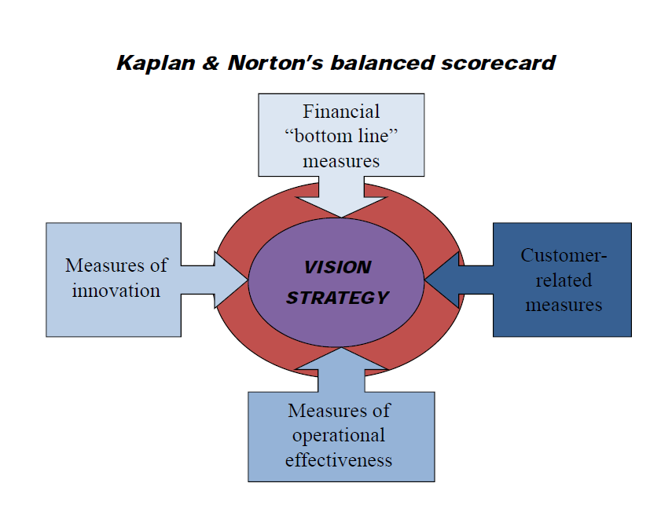
Example:
ECI 's Balanced Scorecard
Perspectives | Questions | Goals | Measurements
Customer | How do customers see us? | New products. | Percent of sales from new products.
Customer | How do customers see us? | Responsive supply. | On-time delivery as defined by the customer.
Customer | How do customers see us? | Preferred supplier. | Share of key account's purchases.
Customer | How do customers see us? | Customer partnership. | Number of cooperative engineering efforts.
Internal business | What must we excel at? | Technology capability. | Manufacturing geometry versus the competition.
Internal business | What must we excel at? | Manufacturing excellence. | Cycle time, Unit cost and Yield.
Internal business | What must we excel at? | Design productivity. | Silicon efficiency and Engineering efficiency.
Internal business | What must we excel at? | New product introduction. | Actual introduction schedule versus planned introduction.
Innovation & learning | Can we continue to improve & create value? | Technology leadership. | Time to develop the next generation.
Innovation & learning | Can we continue to improve & create value? | Manufacturing learning. | Process time to maturity.
Innovation & learning | Can we continue to improve & create value? | Product focus. | Percent of products that equal 80% of sales.
Innovation & learning | Can we continue to improve & create value? | Time to market. | New product introduction versus the competition.
Financial | How do we look to shareholders? | Survive. | Cash flow.
Financial | How do we look to shareholders? | Succeed. | Quarterly sales growth and operating income by division.
Financial | How do we look to shareholders? | Prosper. | Increased market share and Return on Equity.

Types of Power: French & Raven

The most common description of power is French and Raven (1960). This divides power into five different forms.

Coercive power
This is the power to force someone to do something against their will. It is often physical although other threats may be used. It is the power of dictators, despots and bullies. Coercion can result in physical harm, although its principal goal is compliance. Demonstrations of harm are often used to illustrate what will happen if compliance is not gained.
Coercion is also the ultimate power of all governments. Although it is often seen as negative, it is also used to keep the peace. Parents coerce young children who know no better. A person holds back their friend who is about to step out in front of a car.
Other forms of power can also be used in coercive ways, such as when a reward or expertise is withheld or referent power is used to threaten social exclusion.

Reward power
One of the main reasons we work is for the money we need to conduct our lives. There are many more forms of reward -- in fact anything we find desirable can be a reward, from a million dollar yacht to a pat on the back.
Reward power is thus the ability to give other people what they want, and hence ask them to do things for you in exchange.
Rewards can also be used to punish, such as when they are withheld. The promise is essentially the same: do this and you will get that.

Legitimate power
Legitimate power is that which is invested in a role. Kings, policemen and managers all have legitimate power. The legitimacy may come from a higher power, often one with coercive power. Legitimate power can often thus be the acceptable face of raw power.
A common trap that people in such roles can fall into is to forget that people are obeying the position, not them. When they either fall from power or move onto other things, it can be a puzzling surprise that people who used to fawn at your feet no long do so.

Referent power
This is the power from another person liking you or wanting to be like you. It is the power of charisma and fame and is wielded by all celebrities (by definition) as well as more local social leaders. In wanting to be like these people, we stand near them, hoping some of the charisma will rub off onto us.
Those with referent power can also use it for coercion. One of the things we fear most is social exclusion, and all it takes is a word from a social leader for us to be shunned by others in the group.

Expert power
When I have knowledge and skill that someone else requires, then I have Expert power. This is a very common form of power and is the basis for a very large proportion of human collaboration, including most companies where the principle of specialization allows large and complex enterprises to be undertaken.
Expert power is that which is used by Trades Unions when they encourage their members to strike for better pay or working conditions. It is also the power of the specialist R&D Engineer when they threaten to leave unless they get an exorbitant pay rise or a seat by the window.

Mintzberg – The manager’s job:

Myth & Reality
• MYTHS:
– Managers plan, organize, coordinate & control
• REALITIES:
– Interpersonal roles
• Figurehead, Leader, Liaison
– Informational roles
• Monitor, Disseminator, Spokesperson
– Decisional roles
• Entrepreneur, Disturbance‐handler,
Resource‐allocator, Negotiator

