Neural Tissue and Membrane Potentials

Overview
- Communication by neurons is based on changes in the plasma membrane’s permeability to ions.
- Two types of membrane potentials are of major functional significance: graded potentials and action potentials. (allows for communication)
- A typical neuron has a dendritic region and an axonal region. The dendritic region is specialized to receive information whereas the axonal region is specialized to deliver information.
- The human brain contains ~100 billion neurons – about the same number of stars in our galaxy. ~100 trillion synapses! (most complex network/system in the universe)

Major Divisions of the Nervous System
- The two major divisions in the nervous system are the central nervous system (CNS) and the peripheral nervous system (PNS).
  - CNSBrain and Spinal Cord
  - PNSEverything else
- Within the PNS, major divisions are the somatic nervous system (voluntary) and the autonomic nervous system (involuntary), which has two branches:
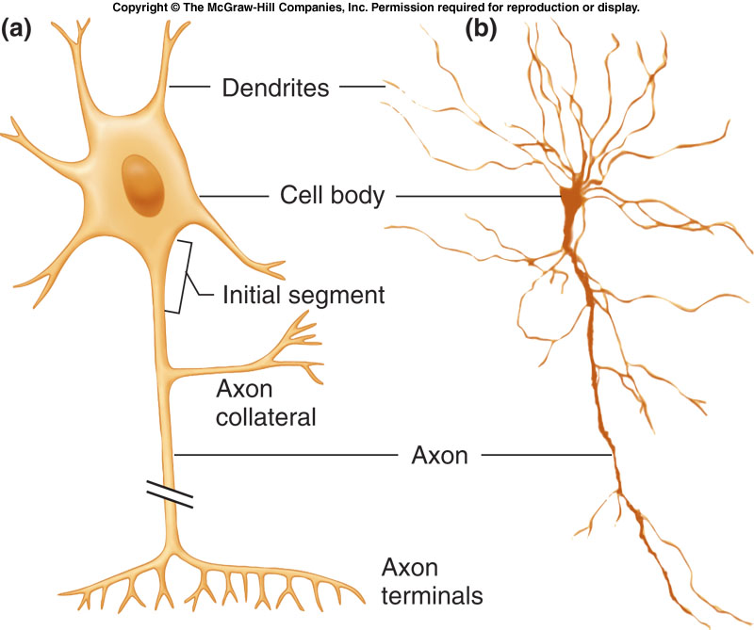
- the parasympathetic
- the sympathetic

The neuron (nerve cell)
- The neuron is the basic unit of the nervous system.
- Dendrites: receive information, typically neurotransmitters, then undergo graded potentials.
- Axons: undergo action potentials to deliver information, typically neurotransmitters, from the axon terminals.
  - be upto 2 m long
  - have collaterals (branches)
- The initial segment (or axon hillock) is the trigger zone where action potentials are generated.

Glial Cells
- Glia make up ~90% of the cells in the CNS (~50% by volume)
- Glial cells surround the soma, axon, and dendrites of neurons providing physical and metabolic support.
- Astrocytes:
  - help regulate the composition of the ECF in the CNS (Cerebral Spinal Fluid “CSF”) by removing K⁺ and neurotransmitters from synapses
  - Astrocytic endfeet also help to form the blood-brain barrier (BBB) which separates the blood from the CSF. The BBB prevent toxins and other substances from entering the brain.
  - Provide metabolic support to neurons (glucose and remove ammonia)
  - Help to guide neuronal processes in the developing brain and provide trophic substances (growth factors).
  - Recent evidence suggests astrocytes also contribute to neuronal signaling – they have ion channels, receptors for certain neurotransmitters and can generate weak electrical responses

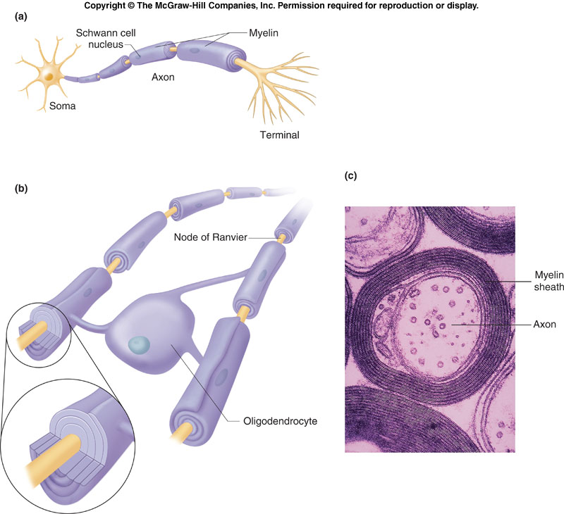
Glial cells and Myelination
- Oligodendrocytes form myelin on (ensheath) multiple central neuronal axons. The gray matter of the brain are cells bodies of neurons (mostly) whereas the white matter are myelinated axon tracts.
  - Basically cells that have dried out and is like a layer “sheath” of plasma membrane
- Schwann cells form myelin on peripheral neuronal axons.
- The myelin sheath speeds up conduction along the axon. Among all types of neurons, myelinated neurons conduct action potentials most rapidly.
- The myelin sheath is composed of highly compacted layers (20-200) of modified plasma membrane.
- The spaces between adjacent sections of myelin where the axon’s plasma membrane is exposed to the ECF [in this case of the CNS, the cerebrospinal fluid (CSF)] are the nodes of Ranvier.
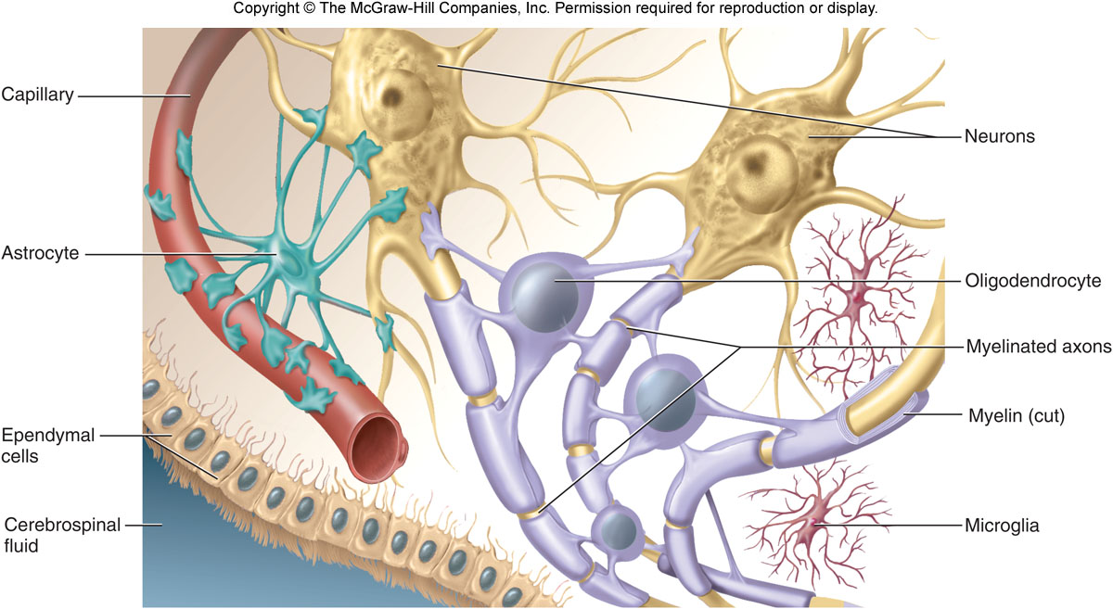
Glial cells…(cont’d)
- Microglia are specialized macrophage-like cells that reside in the CNS and will proliferate and become activated in response to injury.
- Ependymal cells line the fluid filled cavities of the brain and regulate production of the cerebrospinal fluid

Axonal Transport
- Transportation of nutrients and proteins are transported along the axon from the cell body to the terminal ends
- Kinesins (motor protein)transport secretory vesicles from the cell body to the axon terminal (they have legs that walk on track (microtubules)
- Dyneins motor proteins proteins that transport vesicles from the terminal to the cell body
- Anteriograde and retrograde transport
Functional Classes of Neurons

Functional Classes of Neurons
- Groups of afferent and efferent neurons form the nerves of the PNS. Note that a nerve fiber is a single axon, and a nerve is a bundle of axons.
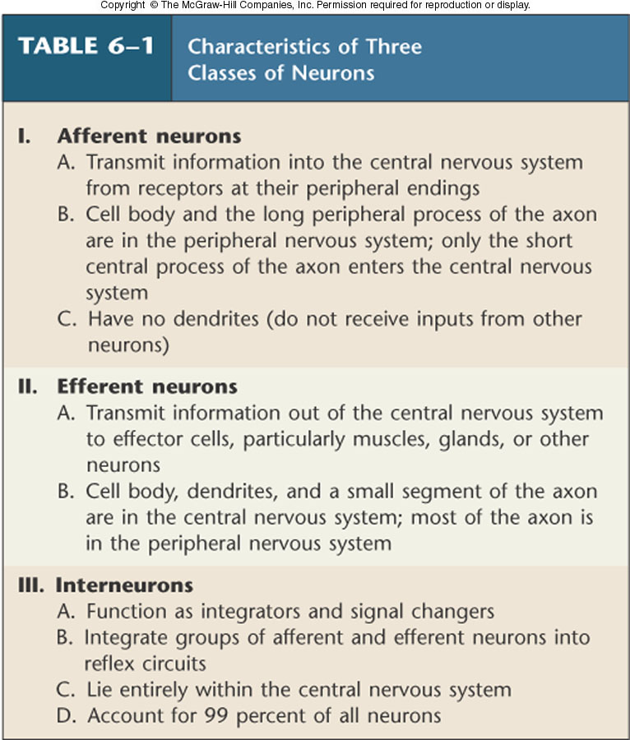
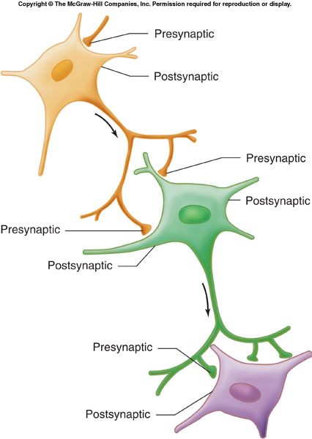
Synaptic Inputs
- Most synapses occur between an axon terminal of one neuron and a dendrite or cell body of another.
- (Others can be dendro-dendritic, dendro-somatic, or axo-axonic)
- A neuron that conducts a signal towards a synapse is called a presynaptic neuron and one that conducts signal away is called postsynaptic.
- A single neuron postsynaptic to one cell can be presynaptic to another cell.

Basic Principles of Electricity
- Opposite charges attract each other and will move toward each other if not separated by some barrier.
- Separate charges have the ability to do work – called electrical potential
- The difference in charge between two points is the potential difference (or just potential)
- Measured in volts (V). In biological systems the charge separation is small and is measured in mV.
- The movement of electrical charge is called a current. Current is proportional to the potential difference and inversely proportional to the resistance.
Ohm’s Law: I = V/R
- If you don’t have voltage you don’t have current, and no current means no voltage

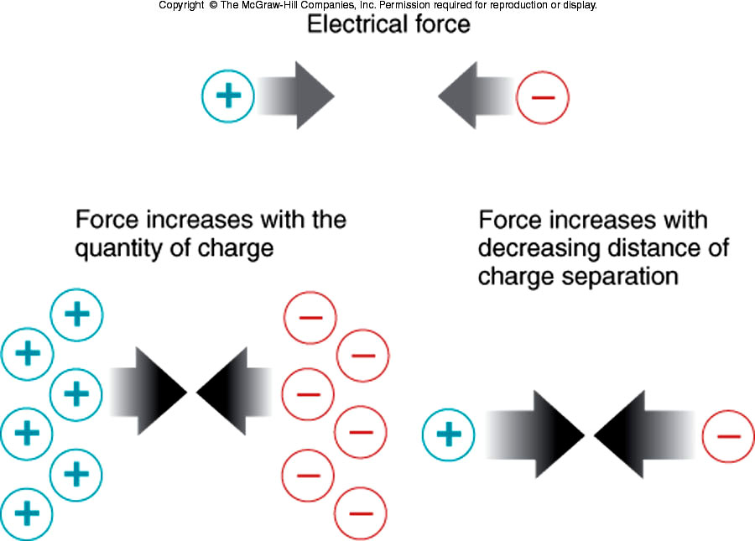
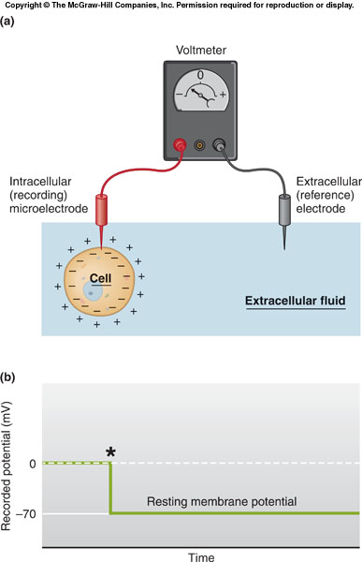
Membrane Potential
- All cells under resting conditions have a potential difference with the inside being more negative – the resting membrane potential.
- ECF assigned a voltage of zero
- If the potential across membrane is 70 mV and ICF has excess –ve charge, then the membrane potential is -70 mV.

Charge Separation Across the Plasma Membrane
- There is a tiny excess of –ve ions inside the cell and a tiny excess of +ve ions outside. Excess charges collect at plasma membrane. The bulk of the ECF and ICF remains neutral.
- The actual number of charges that are separated is infinitesimally small compared to total number of charges in the cell.
- Only a very thin shell of charge difference is needed to establish a membrane potential.

Distribution of Ions in a Nerve Cell
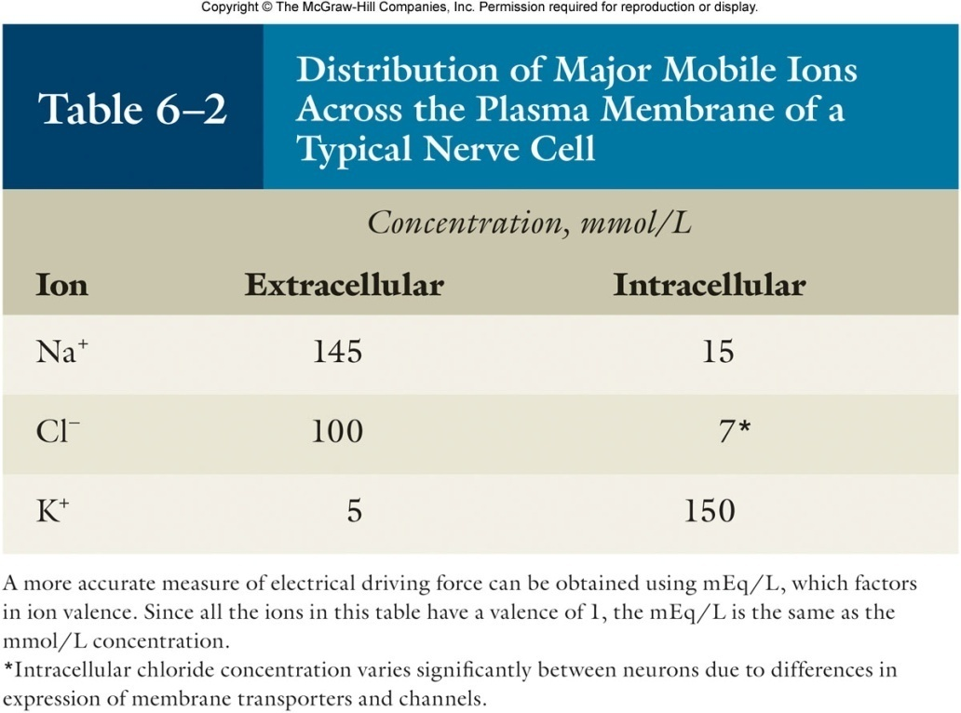
- There are many other ions, including Mg²⁺, Ca²⁺, H⁺, HCO₃⁻, HPO₄²⁻, SO₄²⁻, amino acids, and protein in both fluid compartments so that the bulk of the ICF and ECF are electrically neutral.
- Na+, K+ and Cl- are present in the highest concentration and membrane permeability to each is independently determined.
- Na+ and K+ play the most important role in generating the resting membrane potential but Cl- is a factor in some neurons.
- Na+ Cl- out, K+ in
- The resting membrane potential established and maintained mainly by Na⁺/K⁺-ATPase activity.

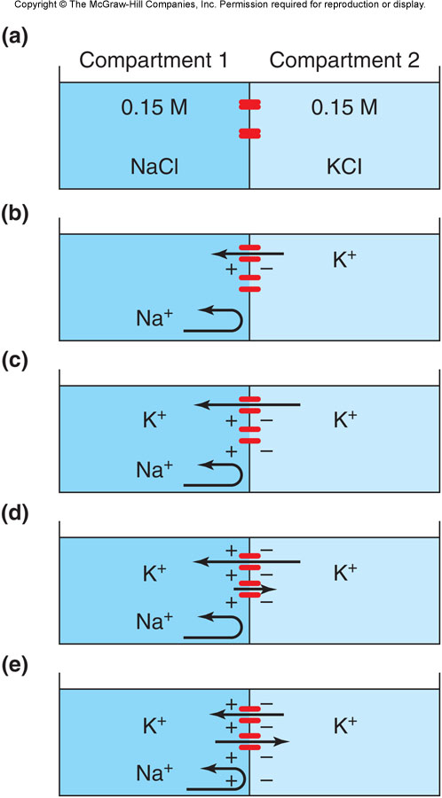
Membrane Potential
- The magnitude of the membrane potential depends mainly on two factors:
  - (1) [Ion] differences out vs in.
  - (2) Membrane permeability to the different ions (number channels open for each ion)
Consider a membrane that is permeable only to K⁺
- (a) no potential difference because +ve ions are equal and channels are closed.
- (b) If K⁺ channels open, K⁺ will diffuse from 2 1
- (c,d) Compartment 1 will have an excess of +ve charges and compartment 2, an excess of –ve charges.
- (e) The buildup of +ve charges in Compartment 1 (and –ve charges in Compartment 2) produces an electrical potential that exactly offsets the [K⁺] gradient.
The membrane potential at which the flux due to concentration difference becomes equal in magnitude but opposite in direction is called the equilibrium potential for that type of ion.

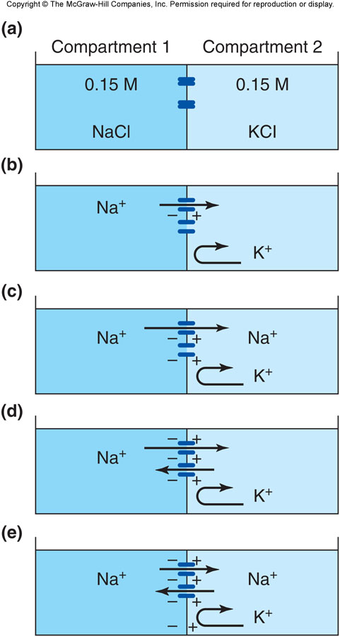

Membrane Potential…(cont’d)
Consider a membrane that is permeable only to Na⁺:
- (a) no potential difference because +ve ions are equal and channels are closed.
- (b) if Na⁺ channels are opened, Na⁺ will diffuse from 1 2
- (c,d) Compartment 2 will have an excess of positive charges and compartment 1, an excess of negative charges.
- (e) At the Na⁺ equilibrium potential: buildup of positive charge in Compartment 2 produces an electrical potential that exactly offsets the Na⁺ chemical concentration gradient.

The Nernst Equation: Equilibrium Potential
- The Nernst equation describes the equilibrium potential for any ion species – that is, the electrical potential necessary to balance a given ionic concentration gradient across a membrane so that the net flux on that ion is zero.
- Equation is used to find out what happens to membrane potential when concentration of an ion changes (ex. Na⁺)
- E_{ion} = 61/Z log (Co/Ci)

Where,
E_{ion} = equilibrium potential in mV
C_{i} = intracellular ion concentration
C_{o} = extracellular ion concentration
Z = valence of the ion
61 is a constant that takes into account the universal gas constant, the temperature, and the Faraday electrical constant.

- E_{Na} = 61/1 log (145/15) = +60 mV
- E_{K} = 61/1 log (5/15) = -90 mV
- What does this mean?
- At typical concentrations (see Table 6.2), Na⁺ flux through open channels will drive the membrane potential towards +60 mV while K⁺ flux will bring it towards -90 mV.
- In an actual nerve at rest, there are many more open K+ channels than Na+ channels; chloride permeability generally falls in between.
- P_{K} = 1, P_{Na} = 0.04, P_{Cl} = 0.45.

The Goldman-Hodgkin-Katz Equation
- How do we calculate the membrane potential if more than one type of channel is open?
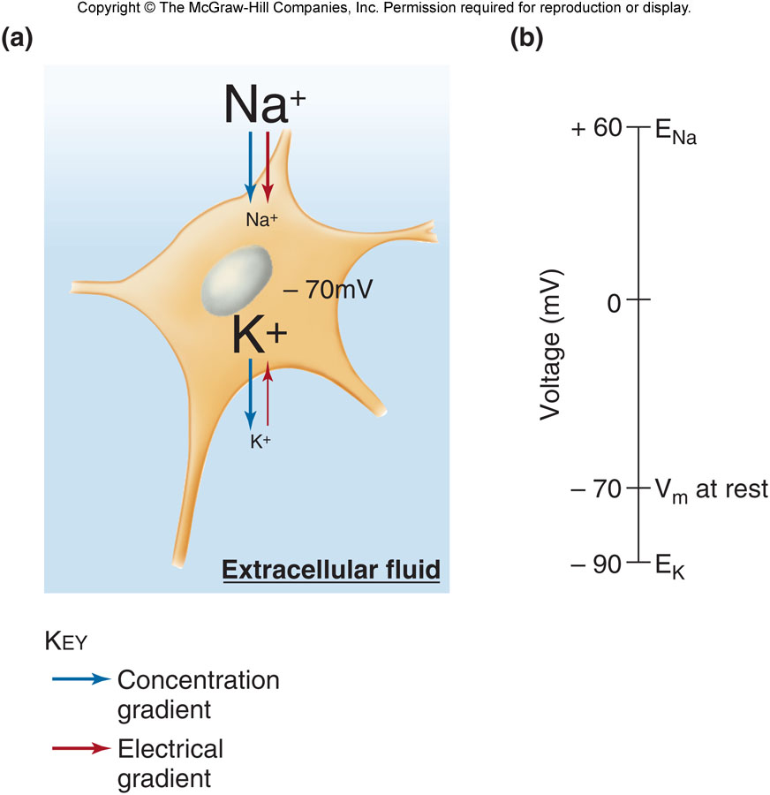
- We need to consider the permeability (P) for each ion species (how many channels are open) and the concentration difference.
- The GHK equations takes into account the individual ion permeabilities
- V_{m} = 61 log P_{K}[K_{o}] + P_{Na}[Na_{o}] + P_{Cl}[Cl_{i}]
P_{K}[K_{i}] + P_{Na}[Na_{i}] + P_{Cl}[Cl_{o}]
- Notice the terms for chloride is switched [Cl_{in}]/[Cl_{out}]

Forces Influencing Na⁺ and K⁺ at Resting Membrane Potential
- At a resting membrane potential of -70 mV both the concentration gradient and electrical potential favor inward movement of Na⁺, while the K⁺ concentration gradient opposes the electrical potential.
- The greater permeability and movement of K⁺ maintains the resting membrane potential at a value near E_{k}.

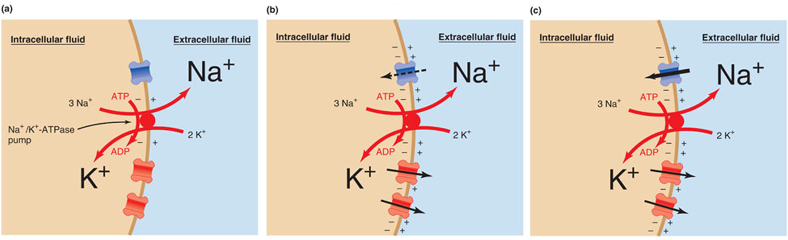
Summary: Establishing the Resting Membrane Potential

- The Na+/K+ ATPase establishes concentration gradient and generates a small negative potential; pump uses up to 40% of the ATP produced by the cell.
- Greater net movement of K⁺ than Na⁺ makes the membrane potential more –ve on the inside.
- At a steady state negative resting membrane potential, ion fluxes through the channels and activity of the pump balance each other.

