Homeostasis, Body Fluids, and Transport Mechanisms
Let’s begin with a clinical problem

George sets off on a long training run on a hot and humid Sunday morning. Two hours later you discover him lying at the roadside in a state of confusion and delirium. His skin is hot and dry. He is hyperventilating and his heart rate is increased.

- What is George’s problem? Stroke
- What should you do? How do you help him? Should you give him water? Gatorade? A large double, double?
- Or, do you use your iPhone to search the web to figure out what to do, to call 911 and then play solitaire until help arrives?
- Or, do you push him to the side of the road so that others don’t run him over like you just did because you were texting while driving.
- Do you have enough knowledge to understand the problem and know what to do? What is the underlying physiological problem?

This is a problem of “clashing demands”…
- Most common physiological variables found in normal, healthy organisms are maintained within a predictable range (e.g. blood pressure, body temperature, and blood oxygen, glucose and sodium). This gave rise to the concept that of a constant internal milieu is required for good health.
- The term “homeostasis” was coined by Walter Cannon, an early twentieth century physiologist, to describe the ability of the body to maintain relatively stable internal conditions even though the external environment changes continuously.
- Homeostasis is not “static” as the name implies.
- Homeostasis refers to the dynamic mechanisms that detect and respond to deviations in physiological variables from their “set point” values by initiating effector responses that restore the variables to the optimal physiological range.
- How are these limits maintained? What can go wrong?
- Clashing demands refers to the attempt to keep one property relatively constant only by moving others away from their usual set point.

Homeostasis: A defining feature of Physiology
- Homeostasis does not imply that a given physiological function or variable is rigidly constant, but rather that it fluctuates within a predictable and often narrow range. When disturbed up or down from the normal range, it is restored to normal.
- There’s a constant internal environment that needs to be maintained even if external environment may be dynamic and changing
- Thus, homeostasis is a state of dynamic constancy. A variable like blood glucose may vary in the short term, but is fairly constant when averaged over the long term.

Homeostasis…
- It is important to realize that a person may be homeostatic for one variable but not for another. For example, blood Na⁺ may be normal but may have abnormally high carbon dioxide levels resulting from a lung disease.
- Numerous physiological variables must be maintained homeostatically. Dramatic changes in just one variable can have life-threatening consequences.
- When homeostasis is lost for one variable, it may trigger a series of changes in other variables.
- Certain diseases or illnesses can be characterized as a loss of homeostasis in one or more systems in the body (homeostatic imbalance).

Homeostatic Regulation of Body Core Temperature

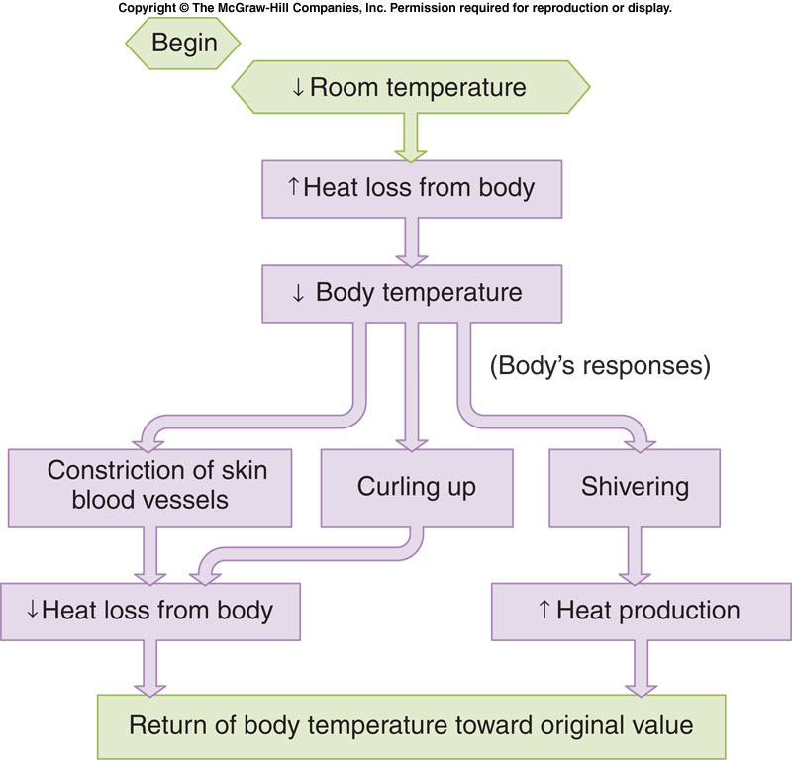

General Characteristics of Homeostatic Control Systems
- A steady state is defined as a system in which a particular variable is not changing, but energy must be added continuously to maintain a constant condition.
- It differs from equilibrium, in which a particular variable is not changing but no input of energy is required.
- The set point is the numerical value of the variable measured at steady state.
- Stability of an internal environmental variable is achieved by the balancing of inputs and outputs.
- In a negative feedback control system, a change in the variable being regulated brings about responses that tend to push the variable in the direction opposite to the original change. Negative feedback minimizes changes from the set point of the system, leading to stability.
- Regulation of Body core temperature
- Positive feedback , which accelerates a process, is less common because it pushes values away from the set point.
- Release of oxytocin during labor (oxytocin released causes uterus contraction, which in turn stimulates the release of more oxytocin)

Myth or Fact?
- Problem: Your friend tells you that St. Bernard rescue dogs carry casks of brandy because the alcohol enables a hypothermic person to survive longer.
- You know it’s likely untrue, but how do you convince your friend? How do you approach a such a problem?

A strategy for analyzing homeostatic responses
- Identify the internal environmental variable.
In this case: Body temperature
- Establish the “set point” value for that variable
36.8 +/- 0.7 °C
- Identify the inputs and outputs affecting the variable
External temperature, physical activity, time of day, alcohol
- Examine the balance between the inputs and outputs
Losing heat to the enivroment too quickly
- Determine how the body monitors/senses the variable.
Temperature sensitive nerve endings
- Identify effectors that resotre the variable to its set point
Shivering, the main way a body generates heat
- In hypothermia, the body temperature drops below that required doe normal metabolism and bodily functions. In humans, this is usually due to excessive exposure to cold air or water but it can be deliberately induced as a medical treatment. Symptoms usually appear when the body’s core temperature drops by 1-2 °C below the normal.
- The myth was tested by having 2 specimens swallow internal thermometers which allowed them to see a reading of their core body temperature.
  - When exposed to cold without alcohol their extremities froze but their core body temperature increased
  - When exposed to cold with alcohol in their system circulation to extremities was increases however the core body temperature began to drop
  - Moral: if exposed to cold for short duration alcohol will prevent frost bites; if exposed to cold for long alcohol will greatly decrease core temperature bringing one to a state of hypothermia

Components of Homeostatic Control Systems
- Usually multiple systems (organs) control a single variable. Homeostasis requires communication between these different organ systems. Signals are relayed mainly by the nervous system and by the endocrine system (hormones).
- Homeostatic control mechanisms are examples of reflexes.
- A reflex is an involuntary (built-in) response to a particular stimulus. Ex. muscles
- Many reflexes occur without our awareness. Many responses appear automatic but are the result of learning (acquired reflexes).
- Acquired reflex one that is learned ex. Defensive driving
- A pathway describing a reflex is known as a reflex arc.
- What components do you need to control a variable process?

Components of a Reflex Arc Regulating Body Temperature
- The components of a reflex arc include receptor, afferent pathway, integrating center, efferent pathway, and effector. The pathways may be neural or hormonal.
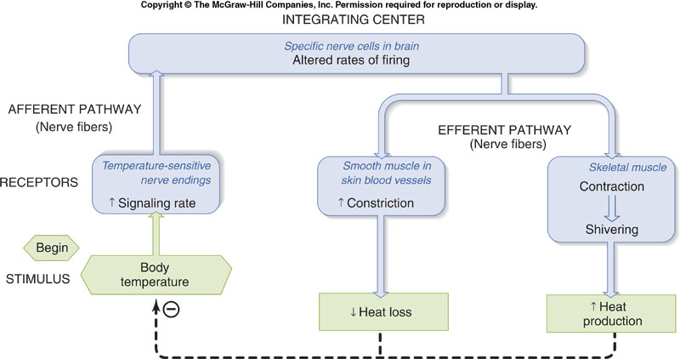
Homeostatic Control Systems Review
Important generalizations
- Stability of an internal environment variable is achieved by balancing inputs and outputs. The BALANCE between inputs and outputs is important not their absolute magnitudes
- Negative feedback system moving variable back toward the initial value (set point)
- A regulated variable has a range of normal values depending on the external environmental conditions rather than an absolute value homeostatic control systems can’t maintain complete constancy of any given feature of the internal environment.
- Set point of some variables regulated by homeostatic control systems can be reset physiologically raised or lowered.
- Homeostatic control systems have a hierarchy of importance constancy of certain variables is altered to maintain others at relatively constant levels – this means it isn’t always possible for the control system to maintain constancy in every variable

What about poor George?
- His skin is hot and dry – what does this mean? Normally, you perspire to help maintain body temperature homeostasis. But the water lost in perspiration leads to imbalance of total body water.
- He is not sweating. Why not? Where does sweat come from? We need to know more about fluid compartments in the body.
- What does sweat consist of? Is it water only? Water and salts? Should we give George gatorade? Or maybe he needs an IV?

Body Fluid Compartments
- Water is present within and around all cells and within all blood vessels.
- Collectively, the fluid present in the blood (plasma) and between cells (interstitial fluid) is called extracellular fluid (ECF).
- The ECF consists of 20-25% plasma and 75-80% ISF.
- In the capillaries, there is exchange of oxygen, nutrients, wastes, and other metabolic products between the plasma and the IF, so the concentration of most dissolved substances are the same in both compartments (except protein). Therefore, the ECF is essentially homogeneous in composition.
- More protein in blood compared to ECF because its hard for them to come out
- The composition of the intracellular fluid (ICF) is much different as we will see.

Body Fluid Compartments
- Water accounts for 55-60% of normal body weight and is the major component of body fluids.
- Fluids are enclosed in compartments, which are defined and maintained by barriers – the properties of the barriers determine which substances can move between compartments. These movements account for the differences in composition of the fluids in the compartments.

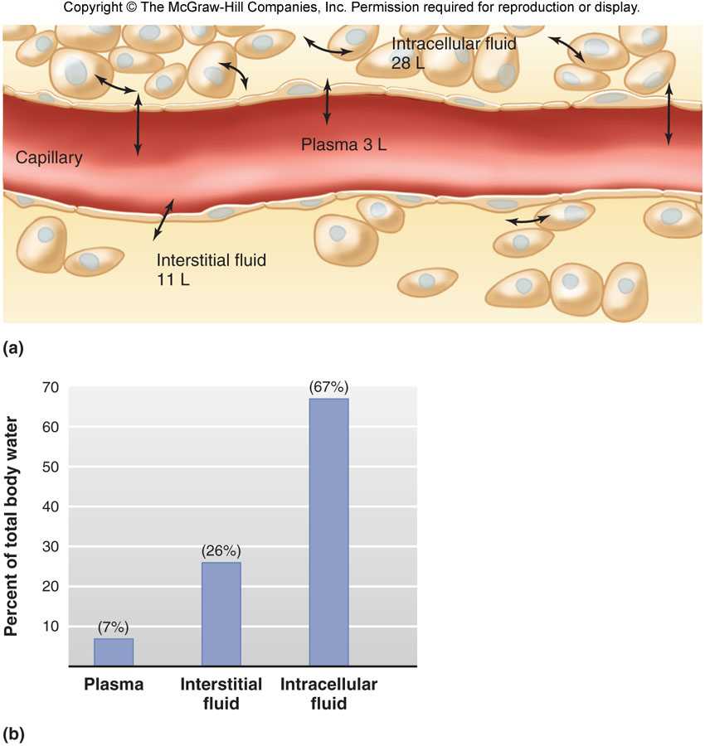

Movement of Molecules Across Cell Membranes
- The contents of a cell are separated from the surrounding ECF by a lipid bilayer – the plasma membrane.
- Role of plasma membrane maintaining the crucial differences in the fluid composition of the cytosol and the extracellular fluid.
- The plasma membrane acts as a selective barrier, certain substances pass through easily, others are prevented from crossing.
- There are several mechanisms by which substances pass through membranes.

Diffusion
- Diffusion movement of molecules from one location to another solely as a result of their random thermal motion
- Molecules of solute in a solution diffuse [High] to [Low].
- Flux amount of material crossing a surface in a unit of time
- Net flux between two compartments at any instant is the difference between the two one-way fluxes.
- The net flux always proceeds from a higher concentration to a lower concentration (“downhill”)
- Diffusional equilibrium system where the fluxes are equal in magnitude, but opposite in direction (net flux = zero)

Magnitude and Direction of Diffusion (ideal situations)
- The net flux is proportional to:
- The concentration difference
- Temperature (kinetic energy)
- Molecular mass (inversely)
- Surface area between compartments
- Ex. In the class demo if we look at net flux we see it is determined by
- Concentration difference (more people on one side compared to other)
- Temperature (how fast paper can be picked up and thrown to opposite side)
- Molecular mass (how heavy was the particle that was travelling? (ex. Bowling balls are harder to throw than paper ones)
- The medium through which the molecules are moving (ex. Water changed to glycerol which is thicker than net flux would be smaller)
- Diffusion time α (distance over which molecule diffuses)²
- Diffusion is only useful over short distances
- At equilibrium net flux is 0 but particle are still moving
- One way fluxes can never be 0 unless there is no kinetic energy

Diffusion Through Membranes (Reality/in the physiology)
- Diffusion rates across membranes are 10³ – 10⁶ times slower than through a water layer of equal thickness.
- The magnitude of the net Flux (J) is directly proportional to concentration difference across the membrane (C_{o} – C_{i}), the membrane surface area (A), and permeability coefficient (P):
- (Net Flux) = J = PA (C_{o} – C_{i})
- The lipid bilayer acts as a barrier to the passage of polar or charged molecules but non-polar (lipid soluble) molecules diffuse rapidly across membranes (drug design, metabolic intermediates).
- Some integral membrane proteins form channels that allow ions to diffuse across the membrane.
- Ion channels show selectivity for a particular type(s) of ion (for example, Na⁺ and K⁺) – based on channel diameter, charged residues lining pore, water of hydration.

Role of Electrical Forces in Ion Movements
- The unequal distribution of ions induces a separation of electrical charges across the plasma membrane - called the membrane potential (electrical force).
- Note this charge separation occurs only across the plasma membrane and that the cell in totality is NEUTRAL
- The direction and magnitude of ion fluxes across membranes depend on both the concentration AND the membrane potential. These two driving forces are collectively known as the electrochemical gradient. These forces may oppose each other.
- The inside of the cell has a net negative charge. **inside surface!!!

Regulation of Diffusion Through Ion Channels
- Ion channels can exist in open or closed state. The process of opening and closing channels is known as channel gating.
- For a given electrochemical gradient, the number of ions that are conducted by the channel depends on:
1. How often the channel opens
2. How long it stays open.
- A lot of things happen to protein based on its conformation and this leads to change in the function of protein

- Three kinds of gated channels:
- Ligand-gated
- Voltage-gated
- Mechanically-gated generally pressure sensitive
- A given ion may pass through several types of channels.
- A given membrane may possess many different channel types and subtypes.

Carrier-mediated transport
- Integral membrane transport proteins move solutes via conformational changes.
- Three factors determine the magnitude of solute flux through a mediated transport system
- (1) The extent to which the binding sites are “saturated”.
    - Note this is the same thing as concentration
    - When something is saturated it means its present in high concentration
- (2) The number of transporters in the membrane.
- (3) The rate at which the conformational change occurs.
- There are many types of transporters specific for a substance or class of substances (amino acids, glucose).
- Typically transport fewer molecules per unit time than ion channels.
- Two types of mediated transport:
- Facilitated diffusion
- Active transport

- Looking at extracellular concentrations in the graph can see that transporters have set binding sites and therefore have a maximal flux, once that is reached it doesn’t matter what extracellular concentration is, the cell will not intake more.
- Diffusion shows a linear relationship so the more concentration you add in extracellular environment the greater the cell’s intake flux.
Facilitated Diffusion and Active Transport
- In facilitated diffusion the net flux proceeds across a membrane from higher to lower concentration.
- In simple diffusion, flux is limited only by the concentration gradient.
- In carrier-mediated transport, flux depends on the number of available carriers.
- The net movement of solute from a lower concentration to a higher concentration requires the continuous input of energy from ATP.
- There are two means of coupling ATP to active transport
- The direct use of ATP in primary active transport
- The use of an electrochemical gradient to drive secondary active transport

Primary Active Transport
- The hydrolysis of ATP provides the energy for primary active transport.
- Transporters are ATPases - enzymes that hydrolyze (break down using water) ATP.

Example: Na⁺/K⁺-ATPase pump
- The transporter (with bound ATP) binds 3 Na⁺ on inside of cell (low affinity for K⁺ ).
- ATPase activated. Auto-phosphorylation.
- Conformational change and release of Na⁺ to outside.
- Increased affinity for K⁺ allows two K⁺ to binds.
- Dephosphorylation and return to original conformation. Release of K⁺ to inside.

The Na⁺/K⁺-ATPase establishes electrochemical gradient
- The pumping activity of the Na⁺/K⁺-ATPase establishes and maintains the characteristic distribution of high K⁺_{i} and low Na⁺_{i}
- Na⁺/K⁺-ATPase activity results in net transfer of positive charge to the outside of the cell, making the inside more negative.
- Thus, the Na⁺/K⁺-ATPase establishes an electrochemical gradient that:
- Can be used to do work (transport of other solutes, for example).
- Is the basis for electrical impulses in neurons
- Between 10 and 40% of the ATP a cell produces under resting conditions is used by the Na⁺/K⁺-ATPase pump to maintain the sodium (and potassium) gradient.

Secondary Active Transport
- The energy stored in a electrochemical gradient can be used to drive the transport of other solutes.
- In secondary active transport, the movement of an ion down its electrochemical gradient is coupled to the transport of another molecule (ex. Glucose, amino acids).
- These transporters have binding sites for an ion (usually Na+) and the cotransported molecule.
- Thus, secondary active transport uses the stored energy of an electrochemical gradient to move both an ion and a second solute across a membrane. The creation of the electrochemical gradient, however, depends on primary active transporters.

Symporters and Antiporters
- In secondary active transport, the movement of Na+ is always downhill, from [high] to [low].
- Cotransport (symport): the ion and the second solute cross the membrane in the same direction.
- Countertransport (antiport): the ion and the second solute move in opposite directions.

Diverse examples of carrier-mediated transport

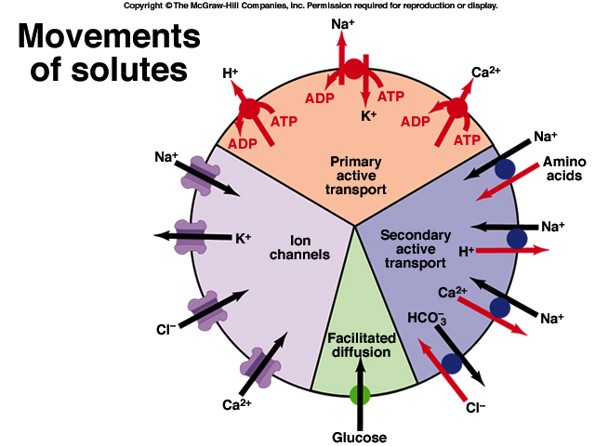

Summary of movement of substances across membrane
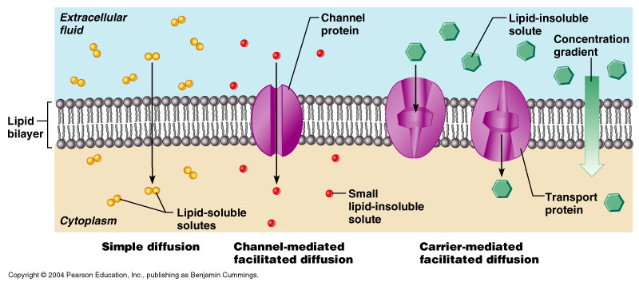

Summary of movement of substances across membrane
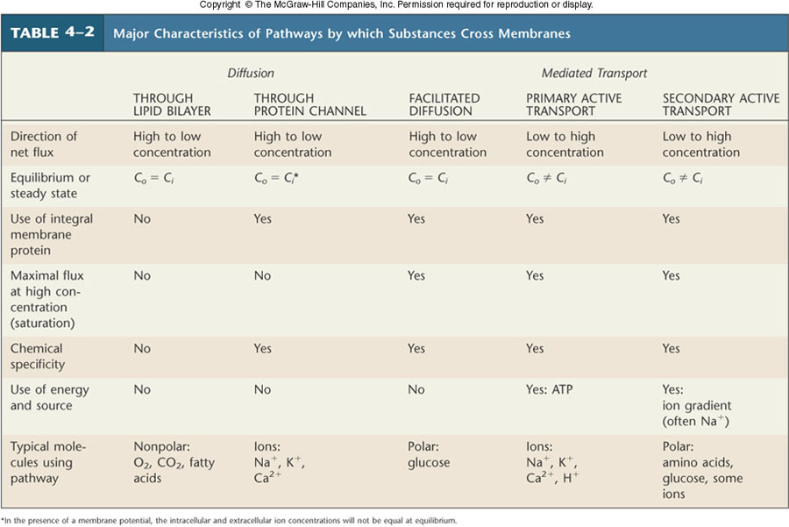

Osmosis
- Water is a polar molecule that rapidly diffuses across the plasma membrane of most cells.
- Facilitated by water channels called aquaporins. Aquaporins selectively conduct water molecules in and out of the cell, while preventing the passage of ions and other solutes.
- The water pores are completely impermeable to charged species, such as protons, a property critical for the conservation of the membrane's electrochemical potential.
- Net diffusion of water across a membrane is called osmosis.
- Water moves from [high] to [low].
- A liter of pure water (M.W. = 18 g/mol) weighs 1000g therefore concentration = 1000/18 = 55.5 mol/L or 55.5 M.
- The addition of solute lowers the water concentration. **This depends on the number of solute particles, not the chemical nature of the solute**

As you add solute molecules you displace water molecules
Osmolarity
- The total solute concentration of a solution is known as its osmolarity.
- Can also be defined as the number of water molecules it would displace if put in aqueous solution
- One osmol is equal to 1 mol of solute particles.
- 1 M solution of glucose = 1 Osm (1 osmol/L)
- 1 M solution of NaCl = 2 Osm
- 1 M solution of MgCl₂ = 3 Osm
- A 3 Osm solution may have 1 mol glucose and 1 mol NaCl.
- The higher the osmolarity, the lower the water concentration.
- Solutions with the same osmolarity have the same [water].

Osmotic Pressure
- When a solution containing solutes is separated from pure water by a semi-permeable membrane (permeable to water but not solutes), the pressure that must be applied to the solution (or compartment) to prevent the net flow of water into it is termed the osmotic pressure.
- (imagine you are squeezing a balloon trying to prevent someone from blowing it up further)
- The greater the osmolarity of a solution, the greater its osmotic pressure and the lower its water concentration.

Extracellular Osmolarity and Cell Volume
- Na⁺, Cl⁻, K⁺ and proteins behave as non-penetrating solutes.
- This is because they are being transported against their concentration gradient
- Osmolarity of ECF is ~ 300 mOsm
- Because water can diffuse across plasma membrane, osmolarity of ICF is also ~ 300 mOsm.
- Changes in extracellular osmolarity can cause cells to shrink or swell.
- The terms hypertonic, isotonic and hypotonic refer to solutions of non-penetrating solutes.
- The terms hyperosmotic, isoosmotic and hypoosmotic refers to solutions of without regard to whether the solute is penetrating (p) or non-penetrating (np).
- 1 L solution of 300 mOsm NaCl (np) and 100 mOsm urea (p) is hyperosmotic but isotonic. Why?

- When talking about tonicity were determining whether or not cell is going to change shape or sizeONLY LOOK AS OSMOLARITIES OF NON-PENETRATING SOLUTES

Endocytosis and Exocytosis
- Substances can also enter and leave cells without crossing the plasma membrane vie endocytosis and exocytosis, respectively.
- Most endocytic vesicles fuse with endosomes, which may transfer vesicle contents for enzymatic breakdown in lysosomes, or recycle contents to plasma membrane.
- Exocytosis provides a means of adding components to the plasma membrane and a route by which membrane impermeable molecules (ex. Proteins) can be released into the extracellular space.
- Certain pathogens can use the endocytic machinery to gain entry into, and infect cells.
- Alternative functions of endocytosis:
- Transcellular transport
- Endosomal processing
- Recycling the membrane
- Destroying engulfed materials T-cells in immune system

Types of Endocytosis

Epithelial Transport
- Epithelial cells line hollow organs or tubes and regulate the absorption or secretion of substances across these surfaces.
- Two ways for substances to cross the epithelial layer:
- By diffusion between adjacent cells – the paracellular pathway – limited by tight junctions. (Water and small molecules are the only ones that can do this)
- Diffusion into and out of epithelial cells – the transcellular pathway
- The luminal (apical) membrane or serosal (basolateral) membranes contains different channels and transporters which allows substances to undergo a net movement from a [low] on one side of the epithelium to a [higher] on the other side.

Transepithelial Transport of Solutes
- Transepithelial transport of most organic solutes involves their movement by secondary active transport driven by the downhill flow of sodium ions.
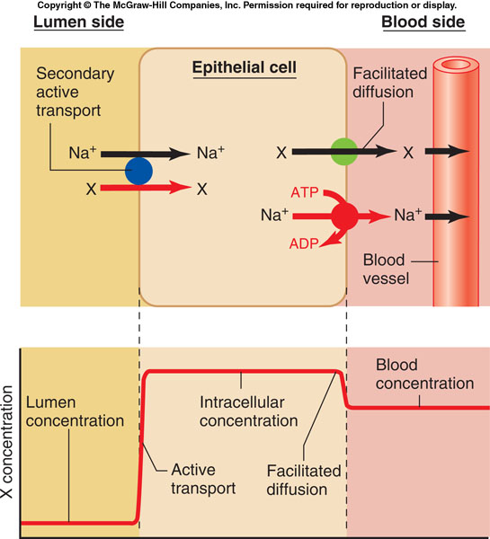

Water follows by osmosis…
- The active transport of sodium through an epithelium increases the osmolarity on one side of the cell and decreases it on the other, causing water to move by osmosis in the same direction as the transported sodium.


