BI110 – Unifying Life Processes
Department of Biology, Wilfrid Laurier University

Midterm Exam I
October 10, 2012

Instructor: Dr. M. Smith

Time: 50 minutes | Total marks: 48

READ ALL OF THE INSTRUCTIONS CAREFULLY:

- DO NOT OPEN THE EXAM PAPER UNTIL YOU ARE INSTRUCTED TO DO SO.

- Print your name and ID# at the top of each page of the exam paper. There are nine (9) pages, printed DOUBLE-SIDED.

- Use PENCIL ONLY to fill-in the ParSCORE (Scantron) sheets using dark marks that fill in the rectangles completely.

- You must fill in the Name field and indicate your 9-digit WLU I.D. number on the Scantron card. Note that there is a place for your ID# on both sides of the card. Be sure to fill in the appropriate rectangles below your ID#. Please leave a space between your last and first names when filling in the name field.

- There are four different versions of the exam, and you must indicate which one you have by filling in the Test Form field on the Scantron card. The Test Form is indicated on the first and last page of the exam; but do not open the exam until you are instructed to do so.

- Answer all 48 Multiple Choice questions by indicating the one best choice on the Scantron card. Only the Scantron card will be marked, but it is a good idea to also indicate your answer on the exam itself. Each question is worth one mark. There is no additional penalty for incorrect answers.

- You must hand in both the question sheets and your Scantron card.

- No additional materials are allowed.

This exam is TEST FORM A (please indicate this on your Scantron card)
Indicate the best choice for each question on the Scantron card provided (1 mark ea)

1. Light serves two important functions for life on Earth: it is the ultimate source of ________ that sustain(s) life and it provides organisms with information about the ________ world.
a. chemicals; surrounding
b. energy; physical
c. energy; chemical
d. chemicals; physical

2. Chlamydomonas cells contain a light sensor called a(n) ________ that allows it to sense both light direction and light intensity.
a. flagellum
b. chloroplast
c. eyespot
d. vacuole

3. In order for a photon to excite an electron in a pigment molecule, the photon must
a. have lower energy than the electron at the ground state.
b. have higher energy than the electron at the ground state.
c. match the energy difference between the ground state and one of the excited states.
d. have lower energy than the energy of the electron at the excited state.

4. Why do red and blue light drive photosynthesis more effectively than the green light?
a. because chlorophyll can absorb only red and blue light
b. because chlorophyll cannot absorb red and blue light
c. because chlorophyll can absorb only green light
d. because chlorophyll cannot absorb green light

5. Why does some photosynthesis still occur under green light?
a. because there are many different pigments involved in photosynthesis
b. because chlorophyll absorbs red and blue light
c. because chlorophyll is green in colour
d. because chlorophyll absorbs green light

6. The most common photoreceptor found in nature is
a. chlorophyll a.
b. phytochrome.
c. rhodopsin.
d. beta-carotene.

7. What is the purpose of photoreceptors in naked mole rats?
a. They allow the naked mole rats to see light.
b. They allow entrainment of the naked mole rats’ biological clock.
c. They do not have any purpose.
d. They allow the naked mole rats to see in the dark.

8. Bacteriorhodopsin in Halobacterium functions in photosynthesis.
- True
- False

9. Rhodopsin is
a. a protein bound to the pigment molecule retinal
b. a protein bound to the pigment molecule chlorophyll a
c. a photoreceptor
d. A & C
e. B & C

10. For which of the following is the plant photoreceptor phytochrome important?
a. for photomorphogenesis
b. for photorespiration
c. for growth
d. for photosynthesis

11. A probable intermediate step in the evolution of multicellularity from unicellular ancestors was the formation of
a. colonies
b. chloroplasts
c. mitochondria
d. endosymbiosis

12. Choose the correct order of words to fill in the blanks to describe the Central Dogma.

Information is stored in _______. The information in ________ is copied into ________. The information in ________ guides the production of __________.

- RNA. DNA, RNA. RNA, proteins.
- DNA. DNA, RNA. RNA, ribozymes.
- DNA. DNA, RNA. RNA, proteins.
- DNA. DNA, RNA. RNA, ATP.

13. Which statement is not true of the cytoskeleton?
a. Microtubules are microscopic hollow tubes.
b. Intermediate filaments are fibres that occur singly in interlinked networks.
c. Microfilaments are thick fibres.
d. Eukaryotic cell movements are generated by “motor” proteins that push or pull along microtubules or microfilaments.

14. The fact that not all eukaryotic cells contain both mitochondria and chloroplasts indicates that
a. endosymbiosis did not occur at all.
b. endosymbiosis occurred in stages.
c. endosymbiosis did not occur in stages.
d. endosymbiosis occurred only in the evolution of mitochondria.

15. Which statement is not true of mitochondria and chloroplasts?
a. The form or shape of both mitochondria and chloroplasts is similar to that of a prokaryotic cell.
b. They are components of the endomembrane system.
c. Both mitochondria and chloroplasts contain DNA.
d. The ribosomes of mitochondria and chloroplasts are of the type found in prokaryotes.

16. Endosymbiosis
a. Describes the origin of all eukaryotic organelles
b. Occurred after the evolution of aerobic respiration
c. Describes any close and prolonged physical relationship between individuals from two different species
d. All of the above
e. None of the above

17. Circadian rhythms are evident in sunflowers
- By the leaves tracking the sun during the day
- By the leaves turning toward the east before dawn
- By the leaves turning toward the east after the sun rises
- By the flowers tracking the sun during the day

18. Compared to the eyespot of Chlamydomonas, the human eye
a. is composed of photoreceptors
b. can detect changes in light intensity
c. can activate a signal transduction pathway when it absorbs light
d. is not damaged by ultraviolet light
e. is image-forming

19. Heterotrophs obtain carbon from
a. air.
b. soil.
c. any molecule.
d. organic molecules.

20. Photoautrophs generally obtain ___________.
a. energy from organic molecules and carbon from CO₂
b. energy from inorganic molecules and carbon from CO₂
c. energy from light and carbon from CO₂
d. energy from organic molecules and carbon from inorganic molecules

21. Proteins of the Golgi apparatus
- are synthesized by free cytoplasmic ribosomes
- are synthesized by ribosomes at the rough endoplasmic reticulum
- are synthesized by ribosomes at the plasma membrane
- are synthesized by ribosomes at the Golgi apparatus

22. Most of the proteins found in chloroplasts and mitochondria
a. are delivered through the vesicular trafficking pathway
b. are synthesized by mitochondrial or chloroplastic ribosomes
c. are synthesized on the rough ER
d. are synthesized on cytoplasmic ribosomes

23. Where did the first atmospheric oxygen come from?
a. anaerobic respiration
b. oxidizing of water
c. fermentation
d. aerobic respiration

24. A protein is destined to be secreted from a cell. In which of the following organelles would you expect to find the protein in last?
a. lysosome
b. golgi apparatus
c. secretory vesicle
d. rough endoplasmic reticulum
e. smooth endoplasmic reticulum

25. The following is a list of key events that most likely occurred during the evolution of early life on earth. What is the correct order, from OLDEST to MOST RECENT event?

1. appearance of first eukaryotes
2. appearance of protobionts
3. appearance of simple organic molecules
4. appearance of first prokaryotes
5. appearance of oxygen gas in the atmosphere
6. appearance of polymers
7. appearance of cyanobacteria

a. 2, 1, 5, 7, 6, 3, 4
b. 3, 5, 6, 2, 4, 7, 6
c. 6, 3, 2, 4, 7, 1, 5
d. 3, 6, 2, 4, 7, 5, 1
e. 3, 6, 2, 4, 5, 7, 1

26. Which of the following does NOT support the theory of endosymbiosis? Both mitochondria and chloroplasts
a. Are each about the same size and shape as many bacterial cells
b. Are surrounded by a membrane
c. Contain ribosomes
d. Possess electron transport chains
e. Contain their own DNA

27. Ribozymes may have played a critical role in the evolution of life because they
a. carry genetic information.
b. are composed of protein.
c. can have catalytic activity
d. A and C
e. all of the above

28. What is one approach that is being used to test the “RNA World” hypothesis in David Bartel’s lab at MIT?
a. Searching deep sea vents for primitive RNA-only organisms
b. Trying to create a ribozyme capable of catalyzing the addition of ribonucleotides to an existing RNA strand
c. Trying to create a ribozyme capable of replicating DNA
d. Trying to create synthetic cells

29. Which of the following statements about circadian rhythms is correct?
a. They have a period of approximately 12 hours
b. They stop if an organism is placed in complete darkness
c. They are found only in animals and plants
d. They enable organisms to anticipate changes to their light environment
e. Light sets the “biological clock”, but circadian rhythms aren’t a direct result of changes in the light environment

30. Rhodopsin and bacteriorhodopsin
a. Are two names for the same protein
b. Are H⁺ pumps
c. Are photoreceptors
d. Are activated when retinal absorbs a photon of light
e. All of the above

31. The development of DNA as the genetic material would have represented an evolutionary advantage because
a. Amino acids are more stable than ribonucleotides
b. DNA is more chemically stable than RNA
c. The sequence of DNA is more resistant to change than RNA
d. b and c
e. All of the above

32. Why do living organisms have potential for errors (mutations and/or variations) in their development?
a. so that they may change
b. so that they may contribute to evolution
c. so that they may live unchanged
d. so that they may live

33. What is the importance of the Miller-Urey experiment?
a. It showed that inorganic molecules could be produced abiotically.
b. It showed that organic molecules could be produced biotically.
c. It showed that inorganic molecules could be produced biotically.
d. It showed that organic molecules could be produced abiotically.
e. It showed that organic macromolecules could be produced abiotically.

34. Which of the following is NOT one of the characteristics of life?
a. Genetic information is passed on to the next generation through replication of existing cells
b. An organisms internal conditions are determined by the conditions of the external environment
c. Populations of organisms change over generations
d. Energy is obtained from the surrounding environment
e. Organisms can adjust their structure, function and behaviour in response to changes in the external environment.

35. As part of the evolution of eukaryotic cells, infolding of the plasma membrane led to the formation of
a. chromosomes
b. mitochondria
c. ribosomes
d. the nuclear envelope
e. mictotubules

36. Which statement best describes the first law of thermodynamics?
a. Matter can be created and destroyed.
b. Matter changes forms only.
c. Energy changes forms only.
d. Energy can be created and destroyed.

37. Which of the following is a closed system?
a. a single-celled organism
b. a human
c. a gas-powered automobile
d. the Earth

38. Which of the following can be said to occur during every energy transformation?
a. A change occurs in the free energy of the universe.
b. The entropy of the universe increases.
c. A change occurs in the total energy of the universe.
d. The entropy of the universe decreases.

39. Which property of RNA makes some RNA molecules able to act as catalysts?
a. that they are single-stranded molecules which can fold into very specific shapes
b. that they are single-stranded molecules which cannot fold into very specific shapes
c. that they are double-stranded molecules
d. that they are double-stranded molecules which can fold into very specific shapes

40. What is the name of the researcher who won the Nobel Prize for the discovery of ribozymes?
a. David Bartel
b. Thomas Cech
c. Lynn Margulis
d. Carl Woese

41. Which statement correctly describes living cells?
a. None of the cells is derived from pre-existing cells.
b. None of the cells contains a nucleus.
c. Some of the cells utilize organic fuel molecules as energy sources for their activities.
d. Some of the cells respond to outside stimulation.

42. What would you find in a cell making large quantities of proteins that were being secreted?
a. Abundant rough ER
b. Abundant smooth ER
c. Abundant mitochondrial ribosomes
d. Abundant cytoplasmic ribosomes

43. Of the seven characteristics of life, which are demonstrated by viruses? (taken from Peerwise)
a. They have order, they can replicate, and they evolve.
b. They have order, they respond to stimuli, and they can replicate.
c. They respond to stimuli, and have order.
d. They are considered to be living.
e. They do not display any characteristics of life.

44. Which of the following is true about early forms of life? (adapted from Peerwise)
a. The first cells were heterotrophic prokaryotes that used ingested food molecules to produce ATP via respiration in mitochondria.
b. The first cells were heterotrophic eukaryotes that used ingested food molecules to produce ATP via respiration in mitochondria.
c. The first cells were autotrophic prokaryotes that used anoxygenic photosynthesis, which is still used by some bacteria today.
d. The first type of autotrophy was likely anoxygenic photosynthesis in early prokaryotes that is still used by some bacteria today.

45. The Earth is thought to be approximately 4.6 billion years old. When is the earliest that it is believed that it could have first started to potentially support life?
a. 4.1 billion years ago
b. 3.6 billion years ago
c. 2.2 billion years ago
d. 1.6 billion years ago

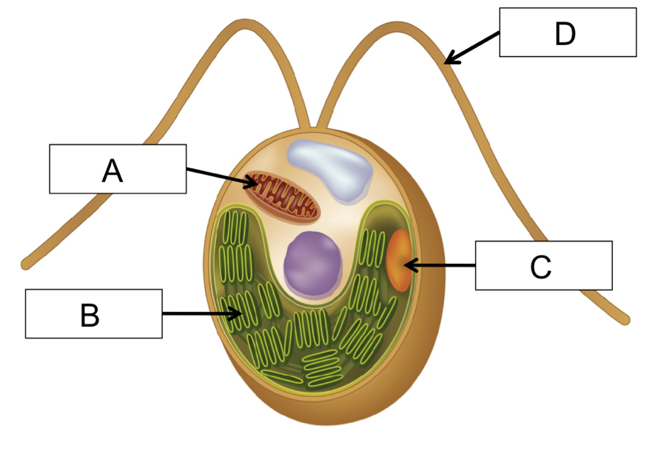

Use the figure shown above to answer the following 3 questions. Four structures are labeled, A through D.

46. The organism shown in the figure is _____.
a. a paramecium
b. a protobiont
c. a prokaryote
d. a Chlamydomonas

47. What structures shown in the figure above are used for the phototaxis response?
a. A
b. B
c. C
d. D
e. both C and D

48. In which structure would you find the photoreceptor rhodopsin?
a. A
b. B
c. C
d. D
e. Both B and C

Be sure that you indicated TEST FORM A on your Scantron/ParSCORE sheet!!!

