ECO1102 B

don't email he probably won't answer. ask him after class or ask a TA or office hours (TBD)
Evaluation
Midterms : 3 x 15% M/C only
Assignment: 10% released during reading week.
Final: 45% all topics, M/c only
sample exam questions with answers will be provided online along with several past-year examinations hopefully with answers (hopefully with correct ones)
- never trust answers or information

Chapter 1
LO
- Learn that economics is about allocation of scarce resources
- Examine some of the tradeoffs that people face
- Learn the meaning of opportunity costs
- See how to use marginal reasoning when making decisions
- Discuss how incentives affect people's behavior
- Consider why trade among people or nations can be good for everyone
- Discuss why markets are a good, but not perfect, way to allocate resources
- Learn what determines some trends in the overall economy
Ten Principles of Economics
Economy
- Greek word for "one who manages a household"
Households & economies
- who will work?
- What goods and how many of them should be produced?
- what resources should be used in production?
- at what price should the goods be sold
Economics - science of efficiency. we have to make choices.
- the study of how society manages it's scarce resources
- the management of society's resources is important because resources are scarce
Scarcity
- Society
  - has limited resources
  - cannot produce all the goods and services people wish to have
Ten Principles of Economics
How people make decisions (microeconomics)
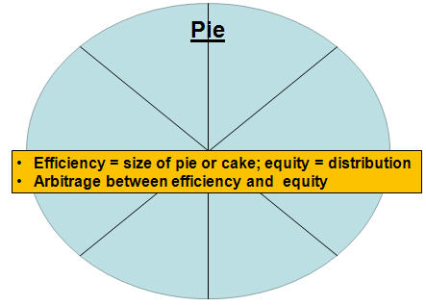
our focus is almost exclusively on efficiency
- People face tradeoffs
  - there is no such thing as a free lunch
  - to get something, we usually have to give up something else
    - guns v. butter
    - food v. clothing
    - leisure time v. work
    - efficiency v. equity
      - Efficiency: society gets the most that it can from its scarce resources you have a certain quantity of resources (which are used to produce goods and services)
      - Equity: the benefit of those resources are distributed fairly among the members of society
      - resources: labour, land, capital --> these are known as passive resources, they are not decision makers as such.
        - labour - passive
        - land - passive
        - capital - passive
          - physical capital (machinery
          - human capital (knowledge )
        - entrepreneurial spirit - what decides what will be produced &how - not passive

  - making decisions requires trading off one goal against another
  - some people are better at some things than other things. Given that we can't do everything we want we have to decide what is best for us- what will maximize our economic wellbeing.
- the cost of something is what you give up to get it
  - Decisions require comparing costs and benefits of alternatives
    - whether to go to college or to work
    - whether to study or go out on a date
    - whether to go to class or sleep in
  - opportunity cost of an item
    - what you give up to obtain that item, what you forego in order to obtain this item or do this thing. which one is the most satisfying alternative? the best alternative to what you did, what you gave up, for instance, is the cost of being here this morning, that cost is the opportunity cost.
    - we are talking about economic cost not accounting cost.
- rational people think at the margin
  - marginal changes
    - small, incremental adjustments to an existing plan of action
  - people make decisions by comparing costs and benefits at the margin
  - when you have to decide on the best option, you have to do a cost benefit analysis. what is the incremental benefit of doing this, and what is the cost of not doing that. you only change your life marginally/ incrementally etc.
- people respond to incentives
  - marginal changes in costs or benefits motivate people to respond
  - the decision to choose one alternative over another occurs when that alternative's marginal benefits exceed its marginal costs!
  - you have to look at both prices and cost to get to the best idea.
- trade can make everyone better off
  - people gain from their ability to trade with one another
  - competition results in gains from trading
  - trade allows people to specialize in what they do best
  - we cannot excel at everything. some people (individually, collectively) are better at some things than us. this is how you become better off by trading with somebody else, but all of these trades must be voluntary. you cannot have coerced trade here. when all trade is voluntary, in most cases it is a win-win situation. it does not mean that the gains are split 50-50, but everybody wins. If trade is not voluntary, then it is a loser-winner situation. in other words your wellbeing will decrease. we can all do this, because if you trade with people, people will specialize, and you will see that some people can do a far better job at doing certain things than others can. (adam smith). at the end of the day, specialization (focus on a narrow portion of a product) will increase efficiency. this will generage large wellbeing in the economy. trade is good as long as it is voluntary!
- markets are usually a good way to organize economic activity
you do not have enough resources to do / produce everything. markets (supply & demand / buyers & sellers) markets are there to optimize the allocation of ressources, to get the biggest bang for your buck. for instance if your car breaks down, or if you want to build a house, you can do it yourself, but it will cost you a lot of time to learn how to do it, and time is money. A specialist (builder, car repairman) can do it much more efficiently.
  - market economy
    - an economy that allocates resources through the decentralized decisions of many firms and households as they interact in markets for goods and services
    - markets are not truly efficient. either because of asymetric information or because of market structure etc.
    - the real focus is that you have specialists in a market economy, who will take less time (and therefore more efficient)
  - households
    - decide what to buy and who to work for
    - households supply labour and buy goods and services
    - decisionmaker
  - firms
    - decide who to hire and what to produce
    - decisionmaker
    - produce goods and services that households purchase. produced on the basis of labour provided by households
  - these markets are based on two decision makers (households & firms)
  - other decision makers in a modern economy:
    - gov't - buys and makes decisions
    - foreign sector - a lot of canadian goods are exported - buys goods and services and supplies us with capital.
  - Adam smith made the observation that households and firms interacting in markets act as if guided by an "invisible hand"
    - because households and firms look at prices when deciding what to buy and sell, they unknowingly take into account the social costs of their actions
    - as a result, prices guide decision makers to reach outcomes that tend to maximize the welfare of society as a whole
- governments can sometimes improve economic outcomes
  - market failure
    - occurs when the market fails to allocate resources efficiently
    - may be caused by
      - an externality, which is the impact of one person or firm's actions on the well-being of a bystander
      - market power, which is the ability of a single person or firm to unduly influence market prices
  - when the market fails (breaks down) governments can intervene to promote efficiency and equity
    - market inefficiency:
      - market structure: monopoly etc
      - corruption
      - natural disaster
      - taxes = disentives. as taxes rise, the tax burden increases, because leisure becomes less costly.
      - external affects / externalities: the environment/pollution - ie green tax
      - when you buy insurance, you have more information on your driving habits than the insurer, so this is known as asymetry

Trends and forces that affect how the economy as a whole works (macroeconomics)

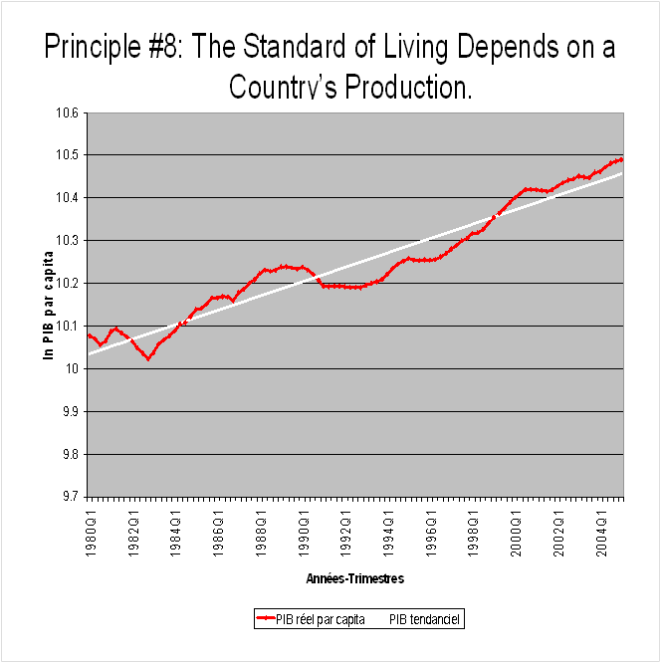

- the standard of living depends on a country's production - ch5
  - standard of living
    - may be measured by comparing
      - personal incomes
      - the total market value of a nation's production
  - almost all variation in living standards are explained by differences in countries' productivities
  - productivity is the amount of goods and services produced from each hour of a worker's time
  - GDP.
  - the more a country produces, the higher a standard of living.
  - the more money a country prints, the more inflation rises

- prices rise when the government prints too much money
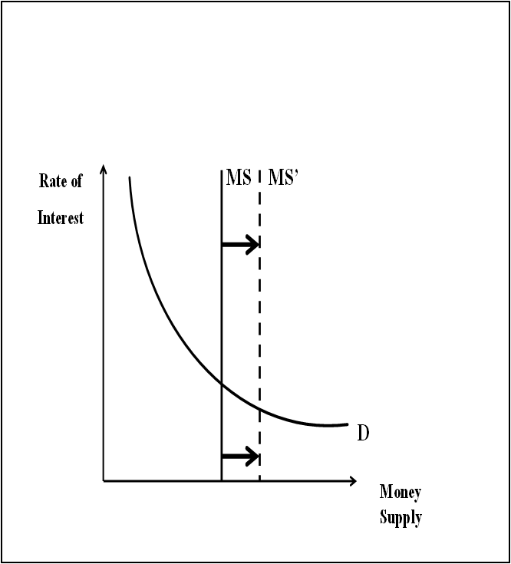
  - inflation is an increase in the overall level of prices in the economy
  - the rate of interest is just the price of money. when the supply of money increases, the price of money decreases, money is not worth as much!
  - one cause of inflation is the growth in the quantity of money
  - when the government creates large quantities of money, the value of the money falls

- society faces a short-run tradeoff between inflation and unemployment
  - the Phillips Curve illustrates the tradeoff between inflation and unemployment
    - Inflation ⇨
    - ⇑Unemployment
  - it's a short-run tradeoff
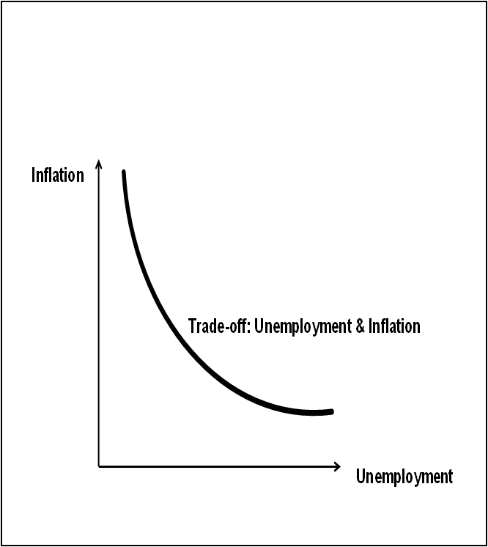
if the average price of goods & services decreases, we have deflation. (neverhappens)
unemployment is when people who are willing and able to work but cannot.
the important thing to remember is that there is a tradeoff btn inflation and unemployment. If the inflation rate increases, the rate of unemployment decreases.
ie before an election, unemployment is more visible. gov'ts may want to ddecreasse unemployment because it is more visible, and it will be at the cost of inflation (prices), which is more subtle.
Summary
- When individuals make decisions, they face tradeoffs among alternative goals
- the cost of any action is measured in terms of foregone opportunities
- rational people make decisions by comparing marginal costs and marginal benefits
- people change their behavior in response to the incentives they face
- trade can be mutually beneficial
- markets are usually a good way of coordinating trade among people
- governments can potentially improve market outcomes if there is some market failure or if the market outcome is inequitable
- productivity is the ultimate source of living standards
- money growth is the ultimate source of inflation
- society faces a short-run tradeoff between inflation & unemployment

Chapter 2 Thinking Like an Economist

Economists as Scientists
- Make positive statements
  - describe the world as it is (not as it ought to be)
  - statements can be confirmed or refuted
- Employ the scientific method to develop and to test theories above how the world works
Economists as Policy Advisors
- Make normative statements
  - prescribe how the world should (ought to) be
  - these statements cannot be confirmed or refuted
  - governments employ many economists for policy advice
    - finance canada, to help design tax policy
    - HRDC to help formulate labour-market policies
    - environment canada to help design environmental regulations
Positive & Normative Statements
Which statements are positive? Normative?
- prices rise when the gov't increases the quantity of money positive
- the gov't should print less money normative
- a tax cut is needed to stimulate the economy normative
- an increase in the price of gas will cause an increase in consumer demand for video rentals positive

Why economists Disagree
- Economists may
  - disagree about the validity of alternative positive theories about the world
  - have different values --> different normative views about what policy should try to accomplish
    - income distribution, minimum wages, income tax rates
- yet, there are many propositions about which most economists agree

Assumptions & Models
Assumptions
- simplify the complex world to make it easier to understand
- yield useful insights about the more complicated real world
  - example: when studying international trade, we might assume the world consists of two countried and two goods
- economist use models to study economic issues
  - a model is a simplified representation of a more complicated reality
    - ie: a road map, human anatomy, model airplane
the circular flow diagram: our first model
- a visual model of the economy
  - shows how dollars flow through markets among households and firms
- includes two types of economic decision-makers
  - households
  - firms
- includes two markets
  - goods and services
  - factors of production
    - used to produce goods & services
      - labour
      - land
      - capital
        - physical - buildings & machines
        - human - knowledge
      - entrepreneurial spirit
Model 1: The circular-flow diagram
    - Households:
      - own the factors of production that they sell/rent them to firms for income
      - buy and consume goods & services
    - Firms:
      - buy/hire factors of production to produce good & services
      - sell goods & services
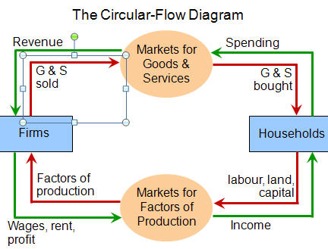
Model 2: the Production Possibilities Frontier (PPF)
    - Shows the combinations of two goods the economy can possibly produce given the available factors of production and the available production technology
    - example:
      - two goods: computers and wheat
      - one resource: labour (measured in hours)
      - economy has 50 000 labour hours per month available for production
        - producing one computer requires 100 hours of labour
        - producing one ton of wheat requires 10 hours of labour
 | Labour | hours | Production
 | Computers | wheat | Computers | Wheat
A | 50000 | 0 | 500 | 0
B | 40000 | 10000 | 400 | 1000
C | 25000 | 25000 | 250 | 2500
D | 10000 | 10000 | 100 | 4000
E | 0 | 50000 | 0 | 5000
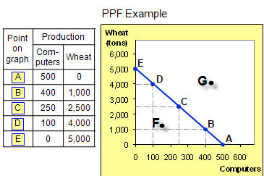
    - PPF: what we know thus far
      - points on the PPF (like A-E)
        - possible
        - efficient in production: all resources are fully utilized
      - points under PPF (like F)
        - possible
        - not efficient (some resources underutilizied) eg, workers unemployed, factories idel
      - points above PPF (like G)
        - not possible (not feasible)
      - Opportunity cost
        - what must be given up to obtain something
        - moving along a PPF involves shifting resources (e.g. labour) from production of one good to another
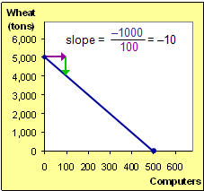
        - society faces a tradeoff: getting more of one good requires sacrificing some of the other
        - the slope of the PPF tells you the opportunity cost of one good in terms of the other.
          - the slope of a line equals the "rise over the run" - the amount the line rises when you move to the right by one unit. Here , the opportunity cost of a computer is 10 tons of wheat

        - in which country is the opportunity cost of cloth lower?
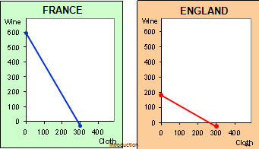
England, because the slope is not as steep
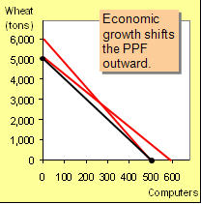
    - Economic Growth & the PPF
      - with additional resources or an improvement in technology, the economy can produce more computer, more wheat or any other combination of wheat and computers
    - the shape of the PPF
      - the PPF could be a straight line, or bow-shaped
      - depends on what happens to opportunity cost as the economy shifts resources from one industry to another
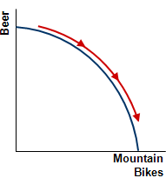
        - if the opportunity cost remains constant, the PPF is a straight line (in the previous example, cost of a computer was always 10 tons of wheat
        - if the opportunity cost of a good rises as the economy produces more of the good, which is more likely the case, then the PPF is bow-shaped
          - as the economy shifts resources from beer to mountain bikes
            - PPF becomes steeper
            - The opportunity cost of an extra mountain bike increases
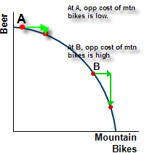
    - At point A, most workers are producing beer, even those who are better suited to building mountain bikes. So, we do not have to sacrifice much beer to get more bikes
    - At point B, most workers are producing bikes. The few left in the beer industry are the best brewers. Producing more bikes would require shifting some of the best brewers away from beer production, which would result in a big drop in beer output but little gain in the production of bikes
  - So, PPF is bow-shaped (ie concave) when different workers have different skills, which results in different opportunity costs of producing one good in terms of the other
  - The PPF would also be bow-shaped when there is some other resources, or mix of resources with varying opportunity costs. Eg, different types of land suited for different uses.
PPF: Summary
- The PPF shows all combinations of two goods that an economy can possibly produce, given its resources and technology
- The PPF illustrates the concepts of tradeoff and opportunity costs, efficiency and inefficiency, unemployment and economic growth
The concavity of the PPF illustrates increasing opportunity cost

Microeconomics & Macroeconomics
Microeconomics: the study of how households and firms make decisions and how they interact in markets
Macroeconomics: the study of economy-wide phenomena, including inflation, unemployment, and economic growth
These two branches of economics are closely intertwined, yet distinct: they address different questions

Your turn:
- What characteristics of a country’s production possibility frontier (PPF) reflects the opportunity cost of producing larger quantities of a good or services? The slope of the PPF reflects the opp cost
- If country A’s PPF is completely outside (to the right of) country B’s PF, can the two countries still benefit from trade? Explain.
- Specialization and trade allow countries to produce quantities of goods and service beyond their respecitive PPFs?
- Specialization and trade allow countries to consume quantities of goods & services beyond their respective PPFs?
- The final terms of trade between two countries must fall within the opportunity costs of the goods or services traded?

Sept 10, 2013

Chapter 5 Measuring a nation's income
Macroeconomic Policy Challenges - goals, may of which conflict
- Low unemployment (unemployment rate) - as low as possible but cannot be 0. if Unemployment goes up inflation will go down. impossible to satisfy all of them at one time
- Strong economic growth (GDP per capita) - want it to grow over the years at a reasonable rate, which requires sacrifices, cannot simply focus on GDP. rapid increase in GDP means prices will increase (impact on inflation). GDP is affected by local and international forces (if the boarders are open ie Canada & the US)
- stable economic cycle (mitigate GDP fluctuations)we want to minimize fluctuations in GDP b/c fluctuations in GDP make decision-making difficult
- stable prices of goods & services (inflation) we want inflation to be small because it has a subtle, nasty way of redistributing income.
- Reduce budgetary deficits é balance gov’t budgets (fiscal revenues and expenditures) - balanced
- balance trade & capital flows
  - exports X and imports M - we want balance between X and M. If you have a fluctuating exchange rate it will affect
Potential & Current GDP
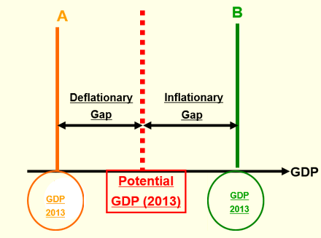
Canada's GDP is based on using all resourcing and using them efficiently. the Economy would like to be at position "Potential GDP"
We have a 7.1% unemployment rate now, which means a lot of ppl who would like to work cannot find work, and ppl who are working are not doing so in their most productive way. Instead of being dead on the GDP line the economy will stray. If the economy is to the left of the "potential gdp" (A) then resources are not being used, and you have a deflationary gap
If the economy has a GDP greater than it's potential (B), it is producing more than what it's ressources should allow for (short-term phenonemon) it is short-lived and it means that people are working more (ie overtime) and you have an inflationary gap;

the role of the bank of canada & the gov't is to bring the economy towards it's potential. There are policies intended to bring the economy back:
- monetary policy (bank of canada changing the supply of income)
- fiscal policy (gov't changing the level of expenditures or changing taxes - ie chaning gov't expenditures and revenues)
where is the economy now? Measur GDP

Measuring a Nation’s Income
Macroeconomics answers the following types of questions
      - why is average income high in some countries and low in others?
      - Why do prices rise rapidly during some time periods and are more stable during others?
      - Why do production and employment expand in some years and contract in others?

An economy's income & expenditure
- when judging whether the economy is doing well or poorly, it is naturalto look at the total income in the economy
  - total income is equal to wages and salaries in our circular-flow model (ie labour income
- the is the task of gross domestic product (GDP)

Income Approach or Expenditure approach either approach will give you the same answer a lot easier to sum the expenditures

GDP measures two things at once:
            - the total income of everyone in the economy
            - the total expenditure on the economy’s output of goods & services
for an economy as a whole, income must equal expenditure because:
- every transaction has a buyer and a seller
- every dollar spent by a buyer is a dollar of income rec’d by a seller

GDP
- a measure of the economy's income and expenditure
- the total market value (at current prices) of all final goods (as opposed to intermediate goods) and services produced within a country in a given period of time - the focus is on goods that are ready for consumption or investment, that is a final good.
- the equality of income and expenditure can be illustrated with the circular-flow diagram
Model: a simplification of the real world, we only use the variables that are of interst to us and assume the others are constant (drop them)

Major Sectors (decision-makers) of an economy
- Firms / businesses
  - hire and use resources (eg labour, land, human capital, physical, entrepreneurial spirit)
  - produce and sell goods and services
  - produce g&s by buying/renting resources to increase our economic well-being
- Households
  - own and supply resources to firms
  - buy and consume goods and services
- Gov'n
  - also buy G&S and use resources
- Foreigners
in this model we pretend there is no gov't or foreign sector, and we have only two markets: market for factors of production / resources (labour) firm is buyer and household is seller
other market is for goods & sellers, where firm is the seller and household is the purchaser

the green and red line enables us to measure GDP.
Green: income flow. Firms hire resources, have to pay them, so wages/rent/profit flows to markets for factors of production, and houselholds get income, they spend it and it flows back to the market for goods & services and eventually back to the firm and so on.

this is a model! all income is spent, there is no savings in this model, which is known as a leackage of income, but that would still come back to the stream in what is known as an investment.

(you can measure GDP by summing up all the wages, rent profit or you can measure all the spending)-?

GDP
the market value of all final goods & services produced within a country in in a given period of time.

final good: if they are not final goods, then they are intermediate goods and would be excluded.
anything illegal is excluded from GDP
it has to be a buyer and a seller in a market setup.
has to be market price = current price
there has to be a market for the thing. If you do some housecleaning, that would not be part of GDP - NO. but if you hired a molly maid then that would be included in GDP.
within the boarders of a country = geographic
given period of time - ie a quarter, a year etc.

GDP is the market value...
- valued at market prices
- final goods
remember that intermediate goods are excluded form GDP
- produced
  - includes g&S currently produced, not produced in the past
- within a country
  - measures the value of production within the geographic confines of a country
- in a given period of time
  - meausre the value of production that takes place within a specifi interval of time, usually a year or quarter
- includes all items sold legally in markets
- exclusions
  - items produced and consume at home that never enter the marketplace (eg garden vegetables)
  - goods sold illicitly
  - it your neighbor & you trade services (you are a plumger he is an electrician) - this is tax evasion, should be but isn't included in GDP

**be able to distinguish for GDP and GNP**

GDP & GNP (domestic vs national)
- Canadian GDP: the total market value of all final goods and services produced within Canada by Canadians and non-canadians in a given period of time
- Canadian GNP: the total market value of all final goods & services produced by Canadians throughout the world in a given period of time
your turn
in a simple circular-flow diagara, how are total income an dtotal expenditure interrelated
- they are seldom equal because of the dynamic changes that occur in an economy: iyou can calculate GDP on the income or expenditure side of the house
- they are equal only when all goods and services produced are sold
- they are always equal because every transaction has a buyer and a seller
- they are always equal because of accounting rules

Which of the following is not included in the GDP?
- unpaid cleaning and maintenance of houses
- services such as those provided by lawers and hairstylists
- final goods that are produced but not sold by the end of the year - stock or inventory is included in GDP in the year it is produced
- production of foreign citizens living in canada - included in GDP, but not included in GNP

which of the following non-market goods or serivces is included as an estimate in canadian GDP?
- value of unpaid housework
- value of vegetables that ppl grow in gardens -
- estimated rental value of owner-occupied homes - if you rent, it is included in GDP. because of the significance of this value, the statistical agency estimated the rent of owner-occupied homes.
- est value of illegal drugs

How are intermediate goods accounted for when calculating GDP?
- the value of all intermediate goods is included in GDP
- the value of intermediate goods is included in GDP only if they were produced in the previous year
- the value of intermidate goods is included in GDP only of the yare purchased by firms rather than housholds
- the value of intermidate goods is not included in GDP unless they are part of inventory iti s the value of the bread that is important, not the value of the products that make up the bread, but if you have excess flour at the end of the year, that is included inventory and included in GDP
George buys a house and lives in a newly ontrcuted home he paid 100,000 for in 2010. he sells in 2011 for 225 000. how is GDP impacted by the sale in 2011?
- the 2011 sale increases 2011 gdp by 225000 and does nothing to 2010 gdp
- the 2011 sale increases 20111 gdp by 225 and does ntthing to 2010
- 2011 sale does not increase 2011 gdp and does nothing to 2010 it was nothing to 2011 because it was built in 2010 so that is the only year it affects gdp in.
- the 2011 sale increases 2011 by 22f and 2010 is revised upward by 25
however, if he used a realtor, the commission paid to the realtor in 2011 would be included in GDP but the value of the house would still not be included in GDP because it was not build in that year.

Measures of Income: GDP and GNP
Canadian GDP
- Canadian GDP: the total market value of all final goods and services produced within Canada by Canadians and non-canadians in a given period of time
- Canadian GNP: the total market value of all final goods & services produced by Canadians throughout the world in a given period of time
- Canadian GDP 1987-2002

- 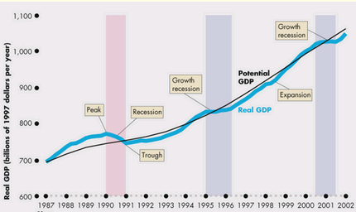
- y

Nirvana's GDP and GNP
- Nirvanaès GDP 2012 is 800B
- the income of Nirvanians working abroad in 2012 is 10B
- the income of foreign workers in Nirvana in 2012 = 25
GNP = 800B + 10B - 25B = 785B

a canadian company owns a fast food restaurant in romania. is the value of goods and services it produces included in canada or romania's GDP?
- in both Romania and canadian GDP
- d
- the right answer is C
would be included in romanian GDP but not GNP.
would be included in canadian GNP but not Canadian GDP

Corporate (business) profits Before Taxes
- Business Taxes: first clam in income is taxes to the gov't.
the rest of the money can be spent it two ways:
- Dividends to shareholders (retained earnings)
- undistributed profits
Calculating GDP: Income Method

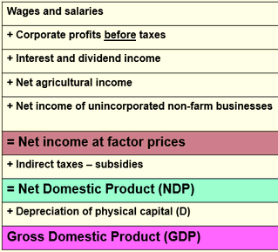
Wages & Salaries
+ Corp profits before taxes
+ interest and div income (bond and equity)
+net agricultural income (because of the importance of agriculture in canada)
+ net income of unincorporated non-farm businesses (those that are not incorporated)
= net income at factor prices (not GDP)
+ indirect taxes - subsidies (taxes less subsidies) ( indirect taxes are taxes on things other than income, HST for instance) (subsidies are transfer payments by gov't to corporations)
= Net Domestic Product (NDP)
+ Depreciation of physical Capital (D) the gov't calls it CCA - loss of value of physical assets
= Gross Domestic Product (GDP)

- for our purposes we are only concened with Corp income tax, undistribut corp profits and gov't transfer payments
- why do you subtract corporate income taxes? Because it is paid to the gov't not to individuals, this is part of GDP
- undistributed corporate profits (retained earnings) - what the company does not pay out to shareholders or the gov't but it is part of GDP so we must factor it out
- gov't transfer payments to persons
- Personal income taxes (leakage)
- Personal Disposable income: people either spend their money in Consumption (C) or they save it (S)

what does personal income include and exclude?
- it includes RE, corp income taxes and social insurance contributions, and excludes interest and transfer pmts rec'd by households from gov't
- it excludes REnorp income taxes, social incsurance contributions, and interest, and includes transfer mayment rec'd by households from gov't
- excludes RE, corp income taxes, and Social insurance contributions, and includes interst income and transfer payment rec'd by households from the gov't
- includes EE corp income taxes, social insurance contributions and interst, and excludes transfer pmts rec'd by households from the gov't

Retained earnings Is excluded
Interest income is Included
End of Sept 10th Class

September 13th Class

More income measures
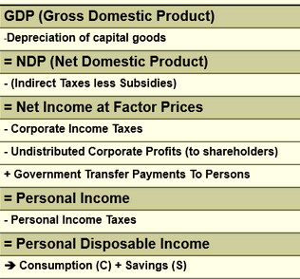
on the exam, he will probably ask us to calculate disposable income using some previous method/income measure

GDP - depreciation of capital goods = Net Domestic Product - (Indirect taxes less subsidies) = Net Income at Factor Prices - Corporate income taxes - Undistributed Corporate Profits (to shareholders) + Gov't transfer payments to persons = Personal income - Personal Income taxes = Personal Disposable Income --> Consumption(C) + Savings (S)

Depr = decrease in value of physical (not financial) assets), whether you use them or not

Factors = resources.
Indirect tax = tax on expenditure, not on income, like HST
Undistributed corp profits (Retained earnings)
Transfer payments are added because they are just a redeistribution of purchaseing power from the gov’t to persons
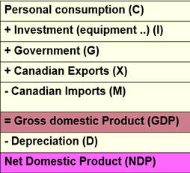
- Calculating GDP: Expenditure Method

Investments (I) = capital expenditures – must include depreciation – there are two types of I – Gross (befpre depr) and net (after depr) I_{g} = I_{N} +Dep
- Personal (residential construction)
- business (equipment of all kinds)
- gov’t (roads, hospitals, schools etc
Add Exports (X) and subtracts Imports (M) – if the borders are open
- if you import goods that means that people are

When we talk about investment in this call, we are not talking about financial investments. New housing is included in I. Residential construction is a physical investment. If you buy a new house that would be included in Investments. If you rented an apt, that would be included under Consumption..

NX = Net Exports (Imports minus Exports)

Q: A German citizen buys an automobile produced in Canada by a Japanese company, what happens as a result?
A: C: Canadian NX and GDP increase,
Japanese GNP increases,
German NX decreases and
German GDP and GNP are unaffected

Canadian GDP: 1987-2002 – This is REAL GDP (not nominal or actual GDP)
Potential GDP what a country should produce given it’s resources and given their productivity.
Peak: we are above potential because resources are being used more than expected (overtime)
Irregular cycles
Peak: For this period of time, our output exceeded our potential. What would this do to unemployment? – It would decrease? To price – would increase.
Trough: unemployment will rise and inflation will drop.
The important part is that our GDP over time has been increasing.

What could cause actual GDP to increase from one year to the next
      - price of goods & services increases
      - increase in the quantity of goods & services produced
- Tradeoff though
we are going to remove the price affect from the actual GDP

actual GPD is a function of the ….
real GDP focuses exclusively on a change of volume (remove the price affect)

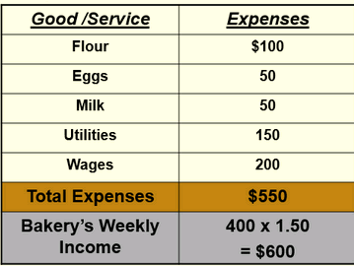
A Bakery’s Value Added
Bakery sells 400 loaves of bread weekly at 1.50$ each. What is the weekly income? What is its value added?

Here, a loaf of bread is a final good.
Output is a loaf of bread. What amount is included in GDP? 600$ for GDP we are only concerned with the price of the final unit, so 400x1.5$
The 550$ here is the value of the intermediate steps. And the difference is the profit, and the profit is included in GDP

Value Added
      - Wheat growers sell crop to miller for 100$
      - Miller sells flour to bakery for 200$
      - Loblaws sells bread to customers for $300
      - The economic value of the break sold by loblaws is?

Economic Growth
- Always irregular
- Every business cycle has
  - Two phases
    - Recession: a period during which real GDP decreases for at least 2 successive quarters
    - Expansion: a period during which real GDP increases
  - Two turning points
    - Peak
    - Trough
In order to compare two countries, you would compare real GDP and you would divide it by the size of the population.
WE can see that GDP is rising, but is it rising faster than the population?

Benefits and Costs of Economic Growth
Benefits of long-term economic growth
- Expanded consumption possibilities, including more health care for the poor and elderly, more research on cancer and AIDS, more space exploration, better roads, more and better housing, and a cleaner environment
- If GDP per capital is rising at a good clip, then all of us will have more: better healthcare etc. we all have better/ more of everything we want, cleaner environment, better houses etc.
Costs of economic growth
- Forgone consumption in the present, more rapid depletion of nonrenewable natural resources, and more frequent job changes
- If we want growth to be fast in the future, today we need to not consume as much. If all the Canadian resources are used in the production of beer & pretzels, then we are not adding to our stock of capital (machinery, capital etc) so next year we would only be able to produce, at best, the same amount, but probably the cost will be that we will only be able to produce less because we used all our resources this year.

Components of GDP
GDP (Y) is the sum of the following:
      - Consumption expenditures (C)
      - Investment expenditures (I)
      - Gov’t expenditures (G)
      - Net exports (NX) = Exports (X) – Imports (M) = (X-M)
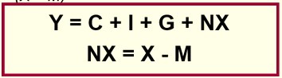

Consumption (C)
- Spending by households on goods & services, with the exception of purchases of new housing
- Current consumption expenditures on goods & Services. Includes durable and non-durable goods
- if I purchase a new car for pleasure (not business) it would be in C.
- A television set that I buy – C
- Anything you purchase for your own use (not for generating income) is in C
- (If a company buys a new delivery van, that would be included in I because it is a business and the van is for generating income)
Investment (I)
- Spending on capital equipment, inventories, and structures, including new housing
- Gross investment = net investment + depreciation
- Mostly Capital /physical assets. The life of the investment spreads over several years, more than just the year in which the asset was purchased.
- Gov’t construction of hospitals, roads, business investments of all kinds: machiner, equipment etc
- Change in the value of inventory is included
- Gov’t expenditures on capital
- Household expenditure on new housing
- Gross investment (includes depreciation)= (net investment + depr)
Government Purchases (G)
- Spending on goods & services by local, state, and federal gov’ts
  - Excludes transfer pmts b/c they are not made in exchange for currently produced goods or services
Net Exports (NX)
Exports (x) minus imports (M)
In economics there are two types of variables : stock and flow
- Stock variable: measured at a point in time (like a picture)
- Flow variable: measured over a period of time – most variables in macro
Savings (S)
- Income remaining after consumption expenditures (flow variable)
- What you don’t consume of your income over a period of time (flow)
Wealth
- Saving accumulated over time (stock variable)
- Market value of your assets at a point in time (stock)
- How much are you worth net of liabilities/debt
- Net worth
investment (I)
- Purchases of productive capital (buildings, plant, machinery and equipment) (flow variables)
- Also measured over time
- Very close cousin to savings
- This is what generates a capital stock
(Physical) Capital Stock
- Total physical capital at a point in time
- Like wealth: stock variable: measured at a point in time

Other Measures of Income
      - Net domestic product (NDP) = GDP minus depreciation
      - National income at factor cost = NDP minus indirect (sales) taxes plus subsidies
      - Personal income (PI) = inceom rec’d by households and non-corporate busineses
      - Disposable income = personal income less personal taxes
Also: GNP as opposed to GDP

Question: What is the GNP for this economy?
A:
GDP: 200
Income earned by citizens abroad: 15
income forigners earned here: 25
GNP = 200 + 15 – 25 = 90

Q: what is the NDP?
A:
GDP: 200
Depr: 7
NDP = 200-7 = 193
How do you go from GDP to NDP - subtract depreciation
GDP less depr = NDP

Q: what is national income? (income of all resources / all factors of production)
A: you have NDP – what do you have to subtract and add?
NDP – (indirect taxes + subsidy)
= 193-12+4
= 185

Q: personal income: = National income – corporate earnings -… check

Real & Nominal GDP
- If total spending rises from one year to the next, one of two things must be true
      - The economy is producing a larger output of goods & services
      - Goods & services are sold at higher prices
- Economists want to measure the quantity of goods & services produced
- Nominal (Actual) GDP values the production of goods & services at current (year) prices
- Real GDP values the production of goods & services at constant (reference or base-year) prices
- Remove the price effect
- Nominal GDP is simply the product of quantities x prices of that year
- Real gdp is the product of quantities produced in any year but you use base year prices instead of current year (prices of a reference year)

GDP Deflator
- If we want to remove the price effect we need a deflator.
- The deflator is simply the ratio of the two GDPs x 100
- A measure of the price level calculated as the ratio of nominal GDP to real GDP times 100
  - = 100 (nominal GDP ÷ real GDP)
- It tells us the rise in nominal GDP that is attributable to a rise in prices rather than a rise in the quantities produced
- $GDP Deflator=\frac{Nominal (Actual) GDP}{Real GDP} × 100$
GDP deflator is our way of measuring the impact of prices on GDP. What do you use in your daily life? Consumer price index.
End of class Sept 13

Converting Nominal GDP to real GDP
- Nominal GDP is converted to real GDP as follows
$$Real {GDP}_{20XX}=\frac{Nominal {GDP}_{20xx}}{{GDP Defaltor }_{20xx}} ×100$$
- All the 20xx must be the same. IE the GDP deflator for 2012, the nominal for 2012 and the real for 2012. You cannot mix years and you need to calculate the GDP deflator for the specific year
- Be able to calculate Real & Nominal GDP as well as the deflator for quizzes/exams
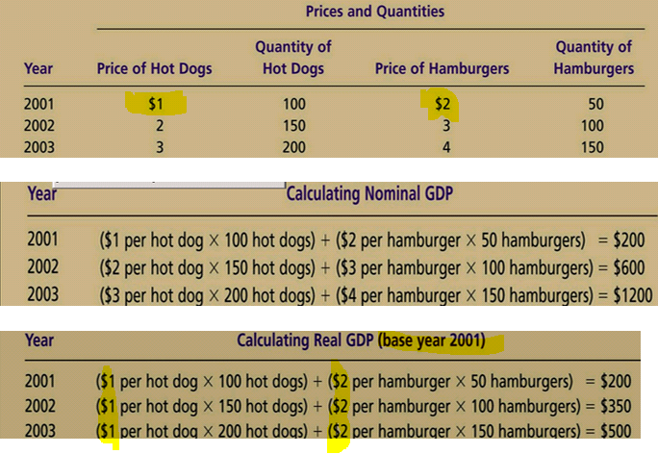
For Real GDP, quantities do not change. What does change is the price – they use the base year price.
In the base year, Real GDP = Nominal GDP
For the base year, GDP deflator is always 100(??)
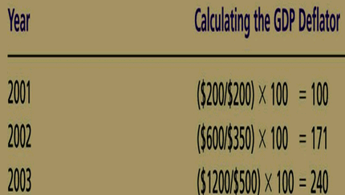
The rate of inflation does not change even if you change the base year.
What is the rate of inflation between 01 and 02 based on these numbers? ((171-100)/100)x100 = ((end yr – starting year)/ starting year GDP deflator) x 100 = inflation rate
Inflation rate: $\frac{End Yr GDP defaltor-starting year GDP deflator}{Starting year GDP deflator}×100$
Calculate the rate of inflation between 02-03 – (240-171)/171 x 100 =
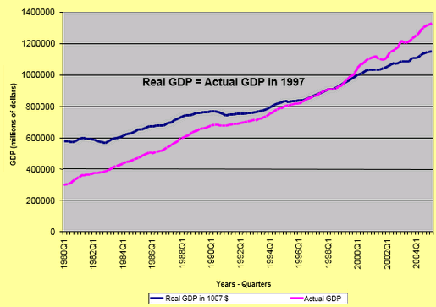

GDP and economic Well-Being
Our goal is to calculate well-being of a country based on GDP. Is it a good measure of economic well-being? Not perfect but the best we have.
- GDP is the best single measure of the economic well-being of a society
- GDP per person tells us the income and expenditure of the average person in the economy
- A higher GDP per person indicates a higher standard of living
- GDP is not a perfect measure of the happiness of quality of life
- Examples of contributions to well-being excluded from GDP
            - The value of leisure
            - The value of a clean environment
            - The value of almost all activities that occur outside markets
              - The value of time parents spend with their children
              - The value of volunteer work
            - When there is a natural disaster and people come to do rebuilding (like in Haiti) then GDP will rise b/c of a bad thing.
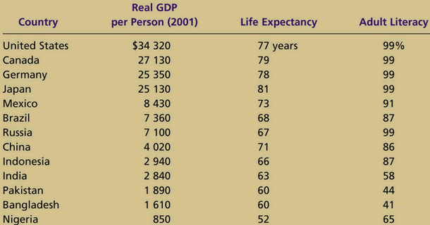
the higher the life expectancy and adult literacy, the higher the number, the higher the perceived well-being.

Chapter 5 Summary
Because every transaction has a buyer and a seller, the total expenditure in the economy must equal the total income in the economy
GDP measures
- An economy’s total expenditure on newly produced goods & services
- The total income earned from the production of these goods & services
GDP is
- The market value of all final goods & services produced within a country in a given period of time
- Divided among four components of expenditure: consumption, investment, gov’t purchases & net exports
Nominal GDP uses current prices to value the economy’s production
Real GDP uses constant base-year prices to value the economy’s production of goods & services
The GDP deflator – calculated from the ratio of nominal to real GDP – measures the level of prices in the economy
GDP is a good measure of economic well-being because ppl prefer higher to lower incomes
It is not a perfect measure of well-being because some things, such as leisure time and clean environment ,aren’t measured by GDP

(chapter 5 questions at end of chapter 5 slides)

Chapter 6 – Measuring the cost of living
Learning Objectives
            - Learn how the CPI is constructued
            - Consider why the CPI is an imperfect measure of the cost of living
            - Compare the CPI and the GDP deflator as measures of the overall price level
            - See how to use a price index to compare dollar figures from different times
            - Learn the distinction between real and nominal interest rates

To which expenditure component (C; I; G; X or M) do the following items belong
- Purchase of sports cars – Consumption
- Purchase of automobiles by firms – Investment because it is for a company
- Purchase of new machinery by CDN owned steel companies in Canada - Investment
- Purchase of new mach by CDN owned steel companies in the US – not part of GDP. Would be part of GNP
- Purch of new mach by US owned steel companies in Canada – GDP – Investment
- Increases in business inventories – if the company produces something that remains unsold at the end of the year, it is included in GDP because it was production during the year. It would be a part of Investment
- Purchases of second hand cars by a cab company – not included because it is second-hand
- Purchases of CND-produced beaver tails by Chinese firms – X – exports
Look at slides for Excel GDP Calculations – chapter 6 slides beginning and end
Slide 11: For GDP it is gross investment that you use. You would use Net investment to calculate Net domestic product.

Measuring the Cost of Living
- Inflation refers to a situation in which the economy’s overall price level is rising
- The inflation rate is the percentage change in the price level from the (or a ) previous product
- The CPI is a common measure of the price level
- Canadian Inflation has been
  - Similar to that in other industrial countries
  - Lower than that in developing countries
- Inflation – prices increasing
- Deflation – prices decreasing
- Stagflation: prices are increasing, and GDP is decreasing (as in early 80’s) – means the unemployment rate is increasing because GDP is decreasing, and Unemployment is decreasing because prices are increasing(check??)g – double whammy
Causes of Inflation
- Money supply: more money chasing the same quantity of goods: prices increase
  - Growth in the money supply (currency and bank deposits) exceeds the growth of goods & services
- Exchange rates: as the exchange rate decreases, we stop shopping in the states.
  - Value of one currency in terms of another currency; changes may affect the cost of purchasing goods & services from other countries
- Cost-push inflation: increases in production costs (wages) higher prices
  - Increase in prices because increase in wages
- Demand-pull inflation: demand for g&s grows faster than their production. Like a public auction – many ppl bidding on the same things

Why bother with inflation?
Subtle way of redistributing wealth
- Repercussions on the purchasing power of money
  - Purchasing power (or value) of money declines if prices increase and cash flows (including weekly wages) are not fully responsive (do not grow at the same rate as prices(
  - Future dollars are less valuable than today or present dollars
    - 100$ today will have a purchasing power of
      - 90.91 in 1 year if prices increase by 10 per cent during the year or
      - 62.10 in 5 years
- Investors are not satisfied with keeping pace with inflation
- A successful investment must result in a new gain in buying power over time (ie must exceed inflation(
  - Buyers of corporate bonds (for example) or investors in a business (such as a restaurant) must account for the impact of price changes in their decision-making
- Two rates of resturn are important in an investment decision:
  - Total or combined rate = real rate + rate of inflation
  - Real (inflation-free rate)
- Of course, an investor should not forget the impact of income taxes on the return on investment must determine his/her rate of return after adjusting for price changes AND after accounting for income taxes
- If you earn 5% on your money (50$ on 1000$) then you pay taxes on your interest, so say 5$ x 50%. Then you end up with only 2.50. Then if inflation is more than 2.5% you are losing money.

Is Inflation Problematic?
- Yes. Unpredictable changes in the inflation rate redistribute income (and wealth) in arbitrary ways between
  - Employers and workers
  - Lenders and borrowers
- A high inflation rate is problematic because it diverts resources from productive activities to the unproductive activity of forecasting inflation
  - An engineer allocates much of her time to forecasting inflation instead of producing the G&S to meet the needs of society
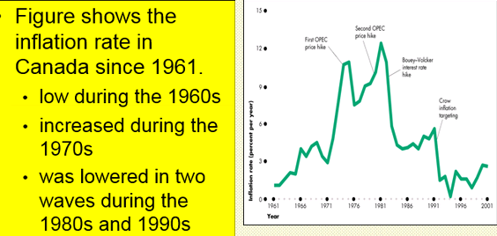
Calculating the CPI
Both CPI and GDP calculate inflation
- Find the prices
  - Of each of the g&s in the basket for each point in time
- Compute the basket’s cost
  - Use the data on prices to calculate the cost of the basket of g&S at different times
GDP and CPI are similar in that they both calculate inflation, only GDP uses a very big basket and CPI a much smaller one
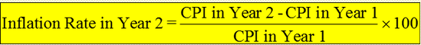
The GDP deflator would give a very similar number

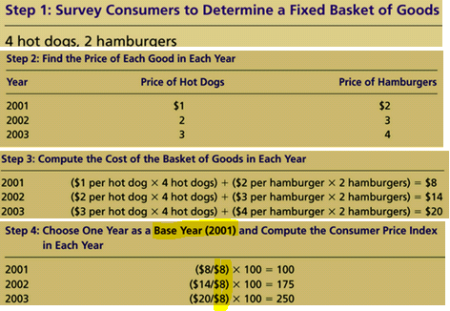
CPI is 100 for the base year just like for GDP.
For CPI the nominator does not change (here 8$) because the basket does not change from year to year as it does in GDP. .you can use the CPI to calculate the rate of inflation:
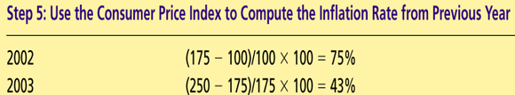

Your turn
 | Wheat production | Honey production | Price of a bushel of wheat | Price of a barrel of honey
2011 | 200 | 90 | 5 | 60
2012 | 210 | 80 | 7 | 65
Computer nominal GDP for each year. GDP in 2011 = 200(5)+90(60)=6400
GDP in 2012 =210(7)+____ = 6610

Compute real GDP each year using 2011 as the base year
Real GDP in 20ll = 6400 (same as nominal b/c this is the base year)
Real GDP in 2012 = 210(5)+80(60) = 5850

 | Nominal | Real
2011 | 6400 | 6400
2012 | 6610 | 5850
GDP deflator
GDO Deflator for 2011 = 100 (base year)
GDP deflator for For 2012 = 100 (6610/5850) = 113

What is the percentage increase in nominal from 2011 to 2012 due to inflation:
% increase in nominal = 100(6610/6400-1) = 3.28%

% incrr in real = 100 (5850/6400-1) =-8.6%

The CPI
- A measure of the overall cost of g&S bought by a typical consumer
- Stats can reports the CPI each month
- It is used to monitor changes in the cost of living over time
- The inflation rate fluctuates
A falling price level – a negative inflation rate – is called deflation.
- When the CPI rises, the typical family has to spend more dollars to maintain the ame standard of living
- Unpredictable changes in the inflation rate are a problem because they redistribute income in arbitrary ways between employers and workers and between borrowers and lenders
- A high inflaton rate is a problem because it diverts resources from productive activities to inflation forecasting
- Eradicating is costly because It bring a period of greater than average unemployment

Calculating the CPI
- Determine the basket (it is the same for CPI but it changes each year for GDP)
  - Determine what prices are most important to the typical consumer
  - If the typical consumer buys more hot dogs than hamburgers, then the price of hot dogs is more important and is given more weight in measuring the cost of living
  - Stats can sets these weights by surveying consumers to find out the basket of goods the typical consumer buys
- Choose a base year and compute the index
  - Designate one year as the base year, making it the benchmark against which other years are compared
  - Compute the index by dividing the price of the basket in one year by the price in the base year and multiplying by 100
- Compute the inflation rate
  - The percentage change in the price index from the preceding period

EXAM
- You will have to determine the GDP (nominal, actual, real)

Your Turn
For any given year, what is CPI? The price of the basket of goods and services in the given year divided by the price of the baseket in the base year, then multiplied by 100

An economy with only two goods – books and calculators
The fixed basket consists of 5 books and 10 calculators
year | Book price | Calculator price
05 | 24 | 8
06 | 30 | 12
07 | 32 (may be wrong elsewhere in slides) | 15

Using 2005 as the base year what is the CPI?
year | Nominal | Real gdp
05 | 200 | 200
06 | 270 | 200
07 | 310 | 200
 | GDP Deflator
05 | 200/200 |  | 100
06 | 270/200 |  | 135
07 | 310/200 |  | 155

September 20, 2013

Your Turn
The price index is 320 in one year and 360 in the next. What was the inflation rate?
= (360-329)/320 x 100 = 12.5 percent

Canada’S CPI
- The calculation is based on a basket of about 600 goods and services which are broken down into 8 major categories
- The basket is updated on a regular basis
- The current basket is based on a 2001 consumer expenditure survey
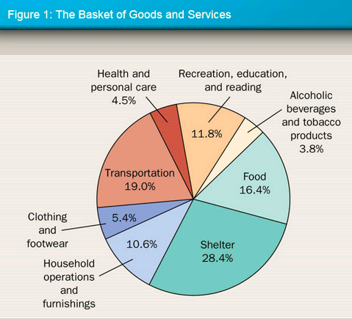
Example: calculating the CPI and the inflation rate
Base years is 2002
Basket of goods in 2002 costs 1200
The same basket in 2004 costs 1236
CPI = 1236 / 1200 x 100 = 103
Prices increased 3 percent between 2002 and 2004

Your house
Purchased price in 1990 = 150,000
Market value in 2005 (15 years late) = 225000
The annual inflation rate has been, on avg, 2%
Did your purchasing power increase between 1990 and 2005? – calculations like this on exam
- Real value of your house in 2005 in 1990 dollars
- = 225000 (1+inflation rate)⁻¹⁵
- = 225000(1.02 )⁻¹⁵
- = 167178
Answer: yes real value in 2005 > real value in 1990

We are talking about compound not simple interest
- F₂₀₀₅=P₁₉₉₀(1+f)^{N}
- Know this type of calculation
- Equivalent equation:
- P₁₉₉₀= F₂₀₀₅(1+f)-^{N} Check this
- F₂₀₀₅/P₁₉₉₀ = (1+f)^{N}
- (F₂₀₀₅/P₁₉₉₀ )^{1/n} = (1+f)
Your Turn
John’s hourly wage 10 years ago was $20 compared to $35 today
Ten years ago, the CPI stood at 145 compared to 240 today
Determine
- Whether john’s purchasing power increased during the last decade
  - John’s wage increase = 100(today’s wage – yesterday’s wage) = 100(35-20) = 75%
  - CPI increase : 100(240-145)/145 = 65.5%
  - Yes john’s purchasing power increased during the last decade

The annual rate of growth of john’s hourly wage during the last decade
  - From F=P(1+g)^{N}
  - 35=20(1+g)^{N}
  - (35/20)^{0.1}=1+g
  - G=5.76%

  - F = 35$ today
  - P = 20$ ten years ago
  - G= inflation
  - N = number of years

- The annual rate of growth of the CPI during the last decade
Annual CPI growth rate
- From F=P(1+g)^{N}
- 240 = 145(1+g)¹⁰
- (240/145)^{0.1} = 1+g
- Solve for g
- G=5.17%
Conclusion: since John’s hourly wage increased at a higher rate than the rate of CPI increase, his purchasing power rose during the last decade.
The equation for inflation is not provided on the final exam (but might be on the mid term)

Your turn exam question
Suppose the price of a litre of milk rises from 1 to 1.25 and the price of a t-shirt rises from 8 to 10. If the CPI rises from 150 to 175, what will people likely buy?
- You would buy the good for which the price has increased less – you substitute
- If they both rise by the same % which do you buy? Do you switch? No. it is only if there is a higher increase in one relative to the other.

Purchasing Power
When the quality of a good improves, what happens to the purchasing power of the dollar?
- It increases, so the CPI overstates the change in the cost of living if the quality change is not accounted for.

Be familiar with 4 biases in the way we measure CPI (slide 47 and on)
The CPI is an accurate measure of the selected good that make up the typical bundle, but it is not a perfect measure of the cost of living.
Problems with the index are widely acknowleged but difficult to solve:
      - Substitution bias
      - Introduction of new goods (typewriters replaced by computers)
      - Unmeasured quality changes
      - Outlet substitution

Substitution bias
- The basket does not change to reflect consumer reaction to changes in relative price
  - Consumers substitute toward goods that have become relatively less expensive
    - Chicken or beef when the price of beef increases relative to that of chicken (same protein count)
  - The index overstates the increase in cost of living by not considering consumer substitution
  - The introduction of new goods, and the unmeasured quality change cause the CPI to overstate the true cost of living. USA: between 1-2%. Canada: around 1%. The issue is important because many gov’t programs use the CPI to adjust for changes in the overall level of prices

Introduction of New Goods
- The basket does not reflect the change in purchasing power brought on by the introduction of new products
  - New products result in greater variety, which in turn makes each dollar more valuable
  - Computers for typewriters (computers are more expensive)
  - Consumers need fewer dollars to maintain any given standard of living
Generally speaking, the more options we have the better off we are
The fact that we have new good out there will tend to overestimate the CPI

Unmeasured Quality changes
- Ex: improvements in TVs and Cars over the years (with corresponding price increases)
- If the quality of a good rises from one year to the next, the dollar value of a dollar rises, even if the price of the good stays the same
- If the quality of a good falls from one year to the next, the value of a dollar falls, even if the price of the good stays the same
- Stats can tries to adjust the price for constant quality, but such differences are hard to measure
Outlet substitution
- In periods of rising price, ppl change their buying patterns (the items they buy( AND their points of purchase
- As prices rise, ppl face higher incentives to find least-cost outlets
- The weighting scheme is fixed so is ppl buy there stuff elsewhere it puts the numbesr off

GDP Deflator versus the CPI on
The GDP Deflator
- Reflects the current level of prices relative to the level of prices in the base year
- Is monitored by economists to guage how quickly prices are rising
- Is calculated as follows:
- $GDP Deflator=\frac{Nominal GDP}{Real GDP}×100$

The GDP Deflator vs the CPI
- Economists and policymakers monitor both the GDP deflator and the CPI to gauge how quickly prices are rising.
- There are two important differences between the indexes that can cause them to diverge.
- Which goods and services are included
  - The GDP deflator reflects prices of all goods & services produced domestically
  - The CPI reflects prices of all goods and services bought by consumers

How are prices weighted?
- The CPI compares the price of a fixed basket of goods to the price of the basket in the base year
- Stats can changes the basket of goods only occasionally
- The GDP deflator compares the price of currently produced goods and services to the price of the same goods & services in the base year

Dollar Figures from Different Times
- Do the following convert (inflate) the price of gse in 1957 to dollars in 2003:
- 1957 gas price in 2003 dollars = 1957 gas price x (CPI in 2003/CPI in 1957)
- $1957 gas price in 2003 dollars=1957 gas price ×{CPI in 2003}/{CPI in 1957}$
- Price indexes are used to correct for the effects of inflation when comparing dollar figures from different times
- Do the following

Indexation
- When some dollar amount is automatically corrected for inflation by law or contract, the amount is said to be indexed for inflation

Your turn
Which of the following is an important difference between the GDP deflator and the CPI?
Ans: the gdp deflator reflects the prices of all final goods & services prod’d domestically whereas the cpi reflects the prices of some goods & services bought by consumers

Real & Nominal Interest rates <- important for exam
- Nominal interest rate
  - The interest rate usually reported and not corrected for inflation (the interest rate that a bank pays
- Real interest rate
  - The nominal interest rate that is corrected for he effects of inflation (measures the increase in the lendor’s purchasing power
- If The rate of inflation is low (negligible), then:
  - $r=i-π$
  - Here, $π$ stands for inflation

Real & nominal interest rates (ignore slide 59)
- Nominal rate (i)
- Where f= inflation
- If f is small, I becomes
  - R+f and so on
  - Ignore slides from 59 until the summary

Be able to do problem s end (calculate GDP, GDP deflator & inflator, and fill out chart like in problem 2

Real & nominal interest rate
- You borrowed 1000 for one year
- The nominal interest rate is 15%
- During the year inflation will be 10%
- Real interest rate = nominal interest rate – inflation
  - 15%-10% = 5%

Summary
            - The CPI shows the cost of a basket of goods and services relative to the cost of the same basket in the base year
            - The index is used to measure the overall level of prices in the economy
            - The percentage change in the CPI measures the inflation rate
            - The CPI is an imperfect measure of the cost of living for the following three reasons:
                - Substitution bias
                - Introduction of new goods
                - Unmeasured changes in quality
            - The GDP deflator differs from the CPI because it includes goods & services produced rather than consumed
            - In addition, the CPI uses a fixed basket of goods, while the gDP deflator automatically changes the group of goods & services over time as the composition of GDP changes.
            - Dollar figures from different points in time do not represent a valid comparison of purchasing power
            - Various laws and private contracts use price indexes to correct for the effects of inflation
            - The real interest rate equals the nominal interest rate minus the rate of inflation

Chapter 7: Production and Growth
Learning objectives:
- See how economic growth differs around the corld
- Consider why productivity is the key determinant of a country’s standard of living
- Analyze the factors that determine a country’s producitivyt
- Examine how a country’s policies influence its productivity growth
- Factors underlying economic growth is different in the short and long term
  - Short-run is the period of time in which some factors of production are fixed.
    - In the short-run a n increase in GPD per capita can increase because of positive changes in the labour market; less unemployement etc – labour market variables – which should have a positive impact on GDP per capita in the short-run.
  - In the long-run everything is variable.

Production & Growth
- A country’s standard of living depends on its ability to produce g&S
- Within a country, there are large changes in the standard of living over time
- In Canada, over the past century, avg income as measured by real GDP per person has grown by about 2 percent per year
- Productivity refers to the amount of g&s produced for each hr of a worker’s time
- A nation’s standard of living is determined by the productivity of its workers
- Two ways to measure productivity: GDP per person or per hours work
- From here on we are only talking about real GDP because nominal GDP cannot measure changes in economic growth

Which of the following best explains productivity?
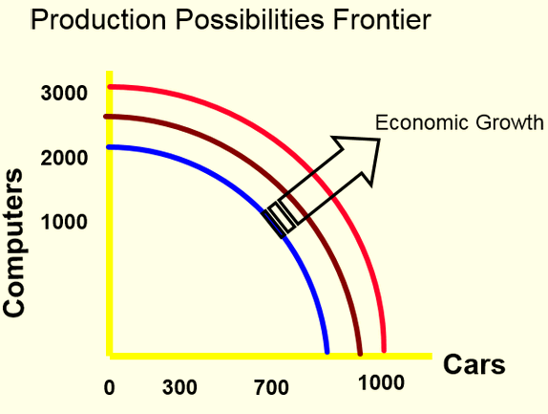
- Productivity is equal to nominal gdp per person
- Productivity is equal to real gdp per person (that is good)
- Productivity is the quantity of g or S that a worker can produce in one hr (best answer)
- Productivity is the growth rate of real gdp per person (that is not productivity)

Production Possibilities Frontier (PPF)
- Shows all combinations of two goods that an economy can possibly produce, given its resources and technology
- Illustrates the concepts of tradeoff and opportunity cost, efficiency and inefficiency, unemployment and economic growth
- The concavity of the PPF illustrates increasing opportunity cost
- During the period of analysis (the period we are concerned with) the quantity of resources does not change. To make life easier for us, we will only produce two goods.
- the blue line is the what a country is producing at one point in time- they are using all their resources at that time. Over time however, we want this curve to push out, we want to increase our production, aka we want economic growth
- negative slope because you must always give up something to produce something else. = tradeoff
- non-linear because of increasing opportunity costs of producing more cars
- capital goods = goods used in production (machinery)
- consumption goods (pepsi)
- If the country decides to produce a lot of consumption goods and not a lot of capital goods, but they are still producing a certain amount of capital goods, which allows in the second year for the curve to move out.
  - If instead they decided to produce not so much consumption goods and a lot of capital goods, then the country would have a lot of capital goods and therefore is allocating more of their resources to the production of machinery, so the curve might push out much further (more economic growth) because they are allocating more resources to production of capital goods.
  - If a country decides to produce more capital goods and fewer consumption goods, then the cost of economic growth is that we must not consume as much consumption goods (ie forego the consumption of pepsi)

Economic Growth around the World
- Living standards, as measured by GDP per person, vary significantly among nations.
- The poorest countries have avg levels of income that have not been seen in the developed world for many decades
- economic growth is not the same throughout the world
GDP per capita and life expectancy
- Life expectancy increases and GDP per capita increases
- People live longer in countries with higher GDP per capita
- Positive slope: positive relationship between life expectancy and GDP per capital
- Growth in GDP per capital is calculated using the growth formula: F=P(1+g)^{N} --
  - F = real GDP per person at the end of the period
  - P = real GDP per person at the beginning
  - G = solve for G
  - N= number of years
Compounding and Economic Growth
- Annual growth rates that seem small become large when compounded for many years
- Compounding refers to the accumulation of a growth rate over a period of time
Effects of compounding
- Sustained differences in growth rates over 20 or 30 years will generate spectacular results
- During the period 1960-1997, real GDP per capita in argentina and Venezuela grew by 1% and 0.1% respectivlely
- Growth rates were 4.7% and 6% in Japan and hong-kong
- 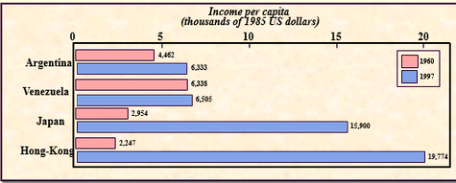
- 1000 will grow to
  - 1640 after 25 years and to 2692 after 50 years with a 2% annual growth rate
  - 2666 after 25 years and to 7107 after 50 years with a 4% annual growth rate
Growth rate calculation
- Utopia’s GDP per person was
  - 25,000(P) in 1970
  - 40,000 (F) in 1995 (25 yrs (g) later)
- What was the rate of growth of GDP per capita in Utopia between 1970 and 1995?
  - F=P(1+g)^{N}; 40,000 = 25,000(1+g)²⁵
  - 40,000/25,000 = (1+g)²⁵ = 1.6
  - 1.6^{(1/25)} = 1.60^{0.04} = 1.019
  - ~ Therefore, g=0.019 or 1.9%
  - We will get the starting point in terms of GDP per capita and will have to calculate G

Your turn
Last year real GDP in Oceania was 620b and the pop was 2.3 million. The year before, real GDP was 502 b and the pop was 2.0 million. What was the approximate growth rate of real gDP per person?
- 16%
- 13%
- 10%
- 7%
  - F = 620b/2.3million = future value
  - P= 502b/2.0million = present value
  - N= 1 year that has elapsed (make sure calculator is set on years not months – test)
  - Solve for g
Benefits of Economic Growth
- Satisfy the essential needs of a growing population (food, education and health)
- Increase life expectancy
- Increase the standard of living (GDP per capita) – more choice of goods and services
- Decrease world poverty and hunger – we hope it will decrease but if you look at some of the data that has not significantly taken place.

Costs of Growth
- Increase saving forgone consumption – if you want to increase GDP next year, you must forgo consumption this year, so you will end up saving. There is a close relationship between saving and investment. if you save your money it will be used by investors. If you save you have to not consume.
- Excessive use of natural resources (water, air, forests..) – non renewable resources get used up, might not be any left for future generations
- Excess production and pollution
- Consumption society at any cost
- World economic growth has not benefited all countries – to with serious worldwide poverty, hunger… problems

What can cause GDP per capita to increase in the long run?
- Let us dissect real GDP to understand the determinants of real GDP per capita:
- $\frac{GDP}{Population}=\left(\frac{GDP}{Hrs Worked}\right)\left(\frac{hrs worked}{employment}\right)\left(\frac{employment}{population}\right)$
- Only the first term on the right-hand side can have a sustained upward trend
- It measures production efficiency
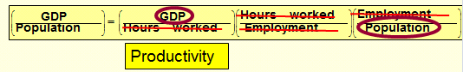
Determinants of economic growth
- Labour market and demographic variables can have an impact on GDP per capita
- Labour productivity – can also increase GDP per capita in the short run. Labour Productivity is essentially the only ingredient responsible for changes in GDP per capita in the long run.
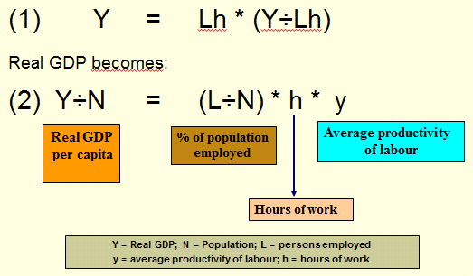
Standard of living and labour productivity
- = Lh x (Y/Lh)
Real GDP becomes:
- Y/N = (L/N) x h x y
Y/N = Real GDP per capital
L/N = % of that population employed (ch9)
H = hours of work
Y = average productivity of labour per hr worked = Y= real GDP
L = persons employed
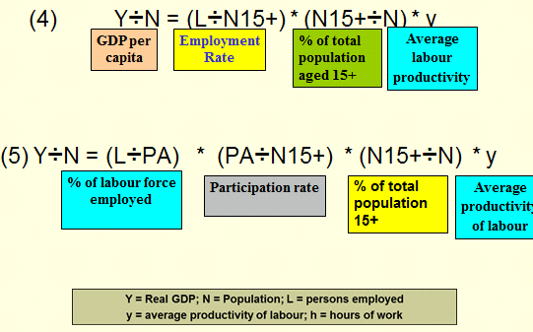

- Y/N = (L/N15+)x(N15+/N)xY
L/PA = labour force employed (%) how many ppl have a job
PA/N15+ = the participation rate- ppl who are at least 15
N15+/N = % of total population 15+
y = average productivity of labour
- Y/N=(L/PA) x (PA/N15+) x (N15+/N) x y

Importance of labour productivity
In the short run
- All terms on the right-hand side of equation (5) can increase or decrease ie change GDP per capital
- In the short-run Can there be significant changes in hrs worked? No
- In the short run, Can there be fluctuations in the number of ppl employed? There can be
In the short run, will pop change significantly? It can if there is significant immigration in one year for instance.
- In the short run, it is possible that the standard of living can be influenced by demographics to some degree. In the short run, GDP per population can be influenced by productivity, labour maket factors (employment/ unemp/ participation), population changes
- GDP per population as a metric for standard of living, looking at it from a short run(small number ofyear), which can be influenced by everything
- is labour force employed important in the short run? Yes – labour market variable
- can there be changes in the participation rate in the short run? Yes – labour market variable
- can there be changes in the % of total population 15+ in the short run? Yes – also a labour market variable.
- Average productivity of labour also can change in the short run (productivity is important in short and long run)
In the long run
- The contribution to GDP per capita of all terms on the right-hand side of equation (5) is marginal (except for labour productivity)
- The only factor that is can influence GDP per capita in the long run is labour productivity
- In the long run, labour maket variables are not important in the long run. Only Average productivity of labour is important, not: labour force employed, participation rate, % of total pop 15+
- Over the long run, countries try to increase productivity of labour

GDP Growth in the long term:
Y/N = y
GDP per capital = average labour productivity

Graphs:
Trends in employment: Short-run (blue line) fluctuates). Long-run: general tendency is to increase.

Productivity: Role and Determinants
Productivity
- The amount of g&s that a worker can produce from each hour of work
  - Gdp/hr worked
- Major determinant of living standards for all nations in the world

Why productivity is so important
- The understand the large differences in living standards across countries, we must focus on the production of g&s
- But seeing the link between living standards and productivity is only the first step
- Why are some economists so much better at producing g&s than others?

How productivity is determined
- Inputs used to produce g&s
  - Physical capital
  - Human capital
  - Natural resources
  - Technological knowledge
Directly determine productivity

Determinants of eco growth in the US 1928-1998
- Labour : 33% - important
- Physical capital: 19%
- Human capital: 13% - catching up
- Technology: 35% - important

Physical Capital
- Output produced in the past
- Stock of equipment and structures used to currently produce g&s
  - Tools used to build opr repair automobiles, furniture
  - Office building, schools etc
- Used in the production of other goods & services
- Over time, physical capital has a tendency to depreciate
Human Capital
- Knowledge and skills workers acquire through education, training and experience
  - Increases a nation’s ability to produce goods & services
Which of the following would NOT be considered physical capital:
- A new factory building
- A computer used to help mercury delivery service keep track of their orders
- On-the-job training (human capital)
- A desk used in an accountant’s office

Which of the following is human capital?
- Breakfast served in a companys cafeteria
- Undersanding how to use a companys accounting software
- Computers that show training videos for new corp employees
- Avg number of holiday days per year

Natural resources
- Inputs used in production processes that are provided by nature
  - Land, rivers and mineral deposits
  - Renewable resources include trees and forests
  - Nonrenewable resources include petro and coal
- Important but not necessary for an economy to be highly productive in produce g&S
- Countries with large natural resources do have a leg up in GDP, but it does not necessarily mean success. You could be wasteful. It is important to have significant bodies of natural resources but it is not a guarantee.

Technology Knowledge
- Probably the most significant one since 1980’s – it makes labour more productive, makes the world turn faster.
- Society’s understanding of the best ways to produce g&s
  - Common knowledge
  - Proprietary knowledge
- Keep distinction clear between technological knowledge and human capital
  - Human capital refers to the resources expended to transmit this understanding to the labour force.

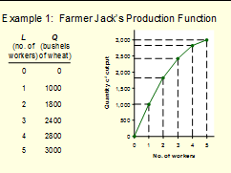
The Production Function (slide 38)
- Economists often use a production function to describe the relationship between the quantity of inputs used in production and the quantity of output from production.

Capital Accumulation and GDP
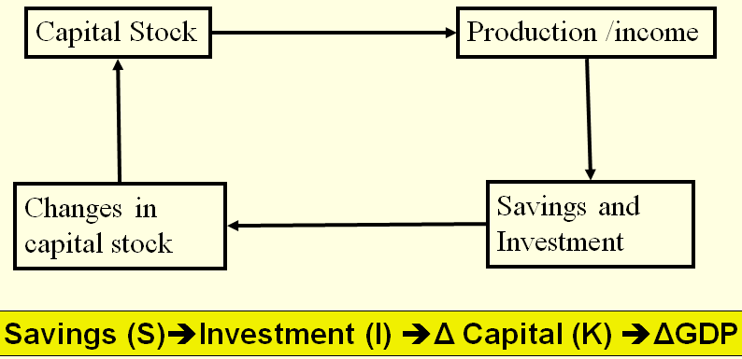

We save, and as a result of savings there is an investment.

We also know that the change in capital stock is not entirely equal to the change in capital stock, because of depreciation. The investment must compensate for depreciation. If it doesn’t your GDP the next year will be lower than the previous year. In most cases, the increase in investment is larger than the depreciation, and as a result capital stock grows.

Can society/economy rely solely on increases I capital stock in order to grow GDP? No.

The Production Function
Y=A F(L,K,H,N)
- Y = quantity of output
- A = available production technology
- L = quantity of labor;
- K= quantity of physical capital
- H= quantity of human capital
- N= quantity of natural resources
- F() is a function that shows how the inputs are combined
A production function has constant returns to scale if, for any positive number x,
xY = A F (xL, xK, xH, xN)
That is, a doubling of all inputs causes the amount of output to double as well
Production functions with constant returns to scale have an interesting implication.
- Setting x = 1/L for Y= A F(L,K,H,N)
- Y/L = A F(1,K/L, H/L, N/L)
- Where :
  - Y= GDP
  - A= Technology
  - Y/L = output per worker (productivity)
  - K/L = human cap per worker
  - N/L = natural resources per worker
- Y/L= A F(1, K/L, H/L, N/L) tells us that productivity (Y/L) depends on
  - Physical capital per worker (K/L)
  - Human cap per worker (H/L)
  - Natural resources per worker (N/L)
  - The state of technology, (A)
Graphs:
- Hrs worked per employed person – decrease over the years in all modern countries, however now it is increasing over time again in many countries
- Population with jobs – decrease in some countries (france) increase in other (UK, Canada)
- Labour productivity (Y/Lh) – strong increase in all countries
- Positive relation between investment & growth rate: As you invest more you grow more though it is a chicken and egg argument
- GDP and capital per worker: strong positive correlation: GDP per worker and Capital work move in the same direction

Economic Growth and Public Policy
Government policies that raise productivity and living standards:
Encourage or promote
- Saving and investment – get ppl to save for retirement and for investment purposes. TFSA,
- Investment from abroad
- Education and training
- Free trade
- Research and development – the more research, the more development, helps increase our GDP
- Establish secure property rights and maintain political stability people will no go out on a lim and innovate if property rights are not ridged.
Capital is a produced factor of production, and a society can change the amount of capital it has
Increase in capital increased potential production (potential GDP)
One way to raise future productivity is to invest more current resources in the production of capital

Diminishing returns and the Catch-up Effect (convergence)
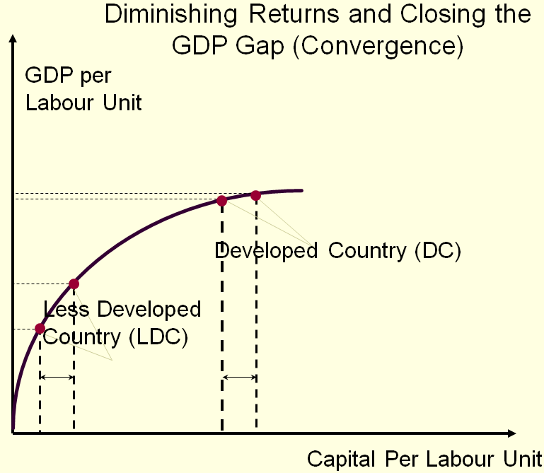
- Diminishing returns: as the stock of capital rises, the extra output produced from an additional unit of capital falls
  - Due to diminishing returns, an increase in saving rate leads to higher growth only for a while
  - In the long run, the higher saving rate leads to a higher level of productivity and income, but not to higher growth in these areas because of the diminishing impact of each additional unit of capital
- Catch-up Effect
  - Can poorer countries catch up to richer ones by saving / investing more? (strictly in terms of GDP per capital)
  - Refers to the property whereby countries that start off poor tend to grow more rapidly than countries that start off rich
  - Also known as “convergence”

Graph: Horizontal gap between pointed lines is the same in both situations – the investment is the same in each country. If the poorer country invests the same amount, their GDP increases more than when the developed country. Over time, if these countries were to invest the same amount each year, the LDC would eventually catch up to the DC because the DC’s increase stalls as it reaches the top of the curve. We are talking here strictly about physical capital. As you go up the curve you go up at a decreasing rate = diminishing returns to capital. Yes you move up the curve as you increase the amount, but the higher you go the lower the rate of increase. Each additional unit of capital per worker, while it has a positive impact, that impact diminishes over time? because of diminishing returns to capital.
Investment from Abroad
- Gov’t can increase capital accumulation and long-term economic growth by encouraging investment from foreign sources
- $I=S_{n}+S_{F}$
- $S_{N}$= National (Canadian) Savings
- $S_{F}$= Foreign Saving

Investment from abroad takes several forms:
- Foreign direct investment: capital investment owned and operated by a foreign entity - ie investment by Canadians where Canadians have certain amount of control of decision making power in terms of how things are done with their money. IE you are the sole owner of a tim hortons in Beijing. It doesn’t have to be 100% or 50% of the investment (depends on country) but what is important is that you maintain some control)
- Foreign portfolio investment: investments financed with foreign money but operated by domestic residents – ie equity, stocks, bonds, ETFs etc in another country but you have no say whatsovever how the funds are used. You are a passive investor
Your turn
Which of the following best explains the logic behind the cat-up effect?
- Workers in countries with low incomes will work more
- The capital stock in rich counties deteriorates at a higher rate because it already ahas a lot of capital
- New capital adds more to production in acountr that doesn’t have much capital than in a country that already has much capital
- Poor countries tend ot save a higher share of their income

Education
For a country’s long-run growth, education is at least as important as investment in physical capital
- In Canada, each yeah of schooling raises a person’s wage, on average, by about 10%
- Thus, one way the gov’t can enhance the standard of living is to provide schools and enourage the population to take advantage of them
- An educated person might generate new ideas about how best to produce g&s, which in turn, might enter society’s pool of knowledge and provide an external benefit to others
- One problem facing some poor countries is the brain drain - the emigration of many of the most highly educated workers to rich companies
- Canada benefits from the brain drain suffered by poor countries
- However, Canada also suffers from brain drain as highly educated workers are attracted to high-paying jobs in the US

Production function: Recall
Capital accumulation through net investment movement on the production function

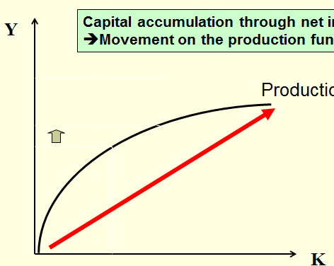 | 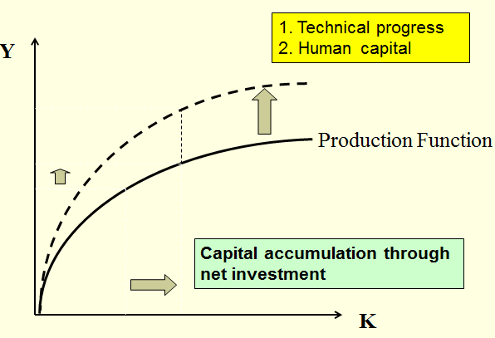
Each additional unit is not as productive as the other one (decreasing returns) | if you increase human and technical capital, those 2 guys are not subject to the law of diminishing returns – they escape that characteristic.  If you increase the amount of human or technology capital then the production function increases.  If a country wants to expand quickly, you don’t depend solely on physical capital, you call on human (knowledge) capital and technological progress.

Property rights & political Stability
Property Rights:
- The ability of ppl to exercise authority over the resources they own
An economy-wide respect for property rights is an important prerequisite for the price system to work
It is necessary for investors to feel that their investment is secure
People will not innovate unless there are ridged property rights because ppl will steal it from you. (ie patents)

Free trade
Free trade is important for Canada because it is a small country from a population pov. There are a few consumers, meaning if you produce more and more the production will go down, but if there are not enough consumers, you cannot benefit from the lower economies to scale. You produce things therefore for other countries as exports.
A country that eliminates trade restrictions will experience the same kind of economic growth that would occur after a major technological advance
Trade increases economic well-being
Some countries engage in…
- Inward oriented trade policies, avoiding interaction with other countries (closed economy)
- Outward-oriented trade policies, encouraging interaction with other countries (open economy)
Research & Development
The advance of technological knowledge has led to higher standards of living
- Most technological advance comes from private research by firms and individual investors
- Gov’t can encourage the development of new technologies through research grants, tax breaks, and the patent system
Graphs: no questions about graphs
- Economic freedom: lucrative liberty: the more economic freedom, the higher the annual average growth of GDP per person
- Rule of Law and Factor Accumulation: positive slope: the more laws the more factors of production ??
- Rule of Law and Productivity: positive slope: the more productivity, the more laws??
- Gov’t corruption and standard of living: negative slope: gov’t’s with less production have higher GDPs
- Economic Openness and GDP per capital: countries that are always open have higher average GDP per capita
- Democracy and GDP per capita: higher levels of democracy do not necessarily indicate higher levels of GDP per capita???

Case Study (slide 69)
- From 1963 to 1973 productivity grew at a rate of 2.3 percent per year
- From 1974 to 1982 productivity grew by only 0.3 percent per year before speeding up to 1.7 percent during 83-88
- Another productivity slowdown occurred during 89-96 (0.9 percent per year) before another spurt of 2.0 percent annual growth from 97-2000

Population Growth
Economists and other social scientists have long debated how population growth affects a society.
Population growth interacts with other factors of production
- Stretching natural resources
- Diluting the capital stock
- Promoting technological progress

Summary
- Economic prosperity, as measured by real GDP per person, varies substantially around the world
- The avg income of the world’s richest countries is more than ten times that in the world’s poorest countries
- The standard of living in an economy depends on the economy’s ability to produce goods and services
- Productivity depends on the amounts of physical capital, human capital, natural resources, and technological knowledge available to workers
- Gov’t policies can influence the economy’s growth rate in many different wys
- The accumulation of capital is subject to diminishing returns
- Because of diminishing returns, higher saving leads to a higher growth for a period of time, but growth will eventually slow down
- Also because of diminishing returns, the return to capital is especially high in poor countries

MIDTERM
There is nothing on 1,2,3,4
All questions are on chapter 5, 6, 7
Chapter 5:
- Definitions of income
- Mostly GDP
- Know def’n of all major income measures
  - GDP, NDP, net national income, personal income, personal disposable income, disposable personal income, what can personal disposable income be used for (C&S)
  - What is in GDP and what is excluded from GDP
  - Is it a perfect measure? No
  - NDP: definition of (he means gone from one to the other as well – ie given NDP, find GDP given other info
  - NDP, net national income (what is the difference) – subtract indirect taxes / subsidies (slide in ch 5)
  - Personal income – more difficult definition - subtract personal taxes to get personal disposable income
  - What do you do with personal disposable income : you consume or save.
- Know the dif between GDP and GNP
  - GDP based on geograpahy – everyone within the country
  - GNP – production of Canadians through the world
  - Know the dif and be able to capital actual(nomina) vs Real (constant-dollar) GDP per year
    - See 2x2 table where you have to calculate actual and real GDP
Chapter 6 – cost of living
- Calculate the inflation rate
  - You can use CPI or you can use GPD deflator. On the exam once you’ve done yoru real and actual GDP calculation or once you have done the value of a basket (same thing) you can calculate the inflation rate using either the GPD deflator or the CPI
  - Difference between types of baskets
    - CPI – goods and services that we more or less consumer during a period of time
    - GDP – pertains to everything that is produced by Canadians
  - At the end of the day they will give you both a very similar inflation rate.
  - Having calculated the inflation from the CPI or form the GDP deflator or the CPI
  - What is always the CPI or the GDP for the base year – it is always 100.
  - Is it possible for the CPI or the deflator to be less than 100 - yes, for years preceding the base year.
  - If you have the years 2005 and 2006 and 2005 is the base year and you calculate the GDP deflator, and then they turn around and ask you to do the same example using 2006 as the base year, would the deflator change? Yes because you changed the base year. If you use 2006 as the base year, now the CPI is 100 for 2006
  - Would the rate of inflation be the same if you change the base year? Yes – it is not a function of the base year. The deflator and CPI would change, but you would get the same inflation rate regardless of the base year.
  - CPI Biases (there are 4) – be familiar with all four (but only 2 will be on the exam) - substitution, new product, quality, factory outlet
    - What do they mean
    - If you have an example and ask you which type of bias it is
    - Biases tend to overstate the CPI by 1%
  - The fact that it overstates CPI, can have a bearing on what in society? What is the CPI used for in a modern society?
    - It can influence collective agreements, which are based on CPI (ie salary for the next 2 years is based on projection of the CPI
    - You need an accurate CPI so that it can be reflected in increases in wages.
    - If you are an older person getting a pension, those are indexed to the cost of living. If the CPI overstates inflation, you as a recipient are better off for it
Chapter 7 – productivity
- Know which factors (groups of factors) affect GDP per capita in the short run (just about everything)
  - In the long run some of these factors are stable and stay put in the long run, only factors of productivity, labour productivye = y is the only one that has an affect of productivity
  - What has an impact on y (labour productivity) there factors: physical capital (stock), human capital, and technology
- What can we say about physical capital? Subject to the law of diminishing marginal retursn to caital
- Influence on y – does this law apply (of diminishing returns?) no – doesn’t apply to human or technology
- What is a production function? Relationship between outputs and inputs (human, physical, technology, natural resources)
- Convergence/ catch up – it is all about physical capital and the impact of the increase of the stock on physical capital – it’s imact on gDP is more for the lesser developed countires. Over time if countries depend exclusively on physical capital, the LDC can catch up to the DC

Chapter 8 – Saving, Investment and the Financial System

Learning Objectives
- Learn about some of the important financial institutions in the Canadian economy
- Consider how the financial system is related to key macroeconomic variables
- Develop a model of the supply and demand for loanable funds in financial markets
- Use a model to analyze various gov’t policies
- Consider how gov’t budget deficits and surpluses affect the Canadian economy
The financial System
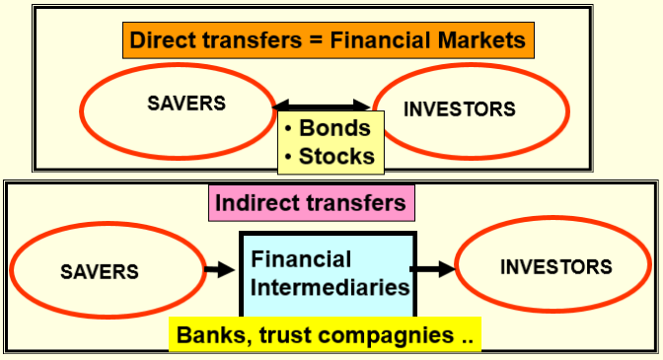

- Groups institutions (chartered banks…) in the economy that help to match/coordinate one person’s savings with another person’s investment
- Moves the economy’s scarce resources from savers to borrowers
Categories of financial institutions:
- Financial markets
  - Institutions through which savers can directly provide funds to borrowers
    - Bond market
    - Stock market
- Financial intermediaries
  - Financial institutions through which savers can indirectly provide funds to borrowers
    - Banks
    - Mutual funds
Financial Markets: the Bond Market
- Bond: A certificate of indebtedness that specifies obligations of the borrower to the holder of the bond
  - Characteristic of a Bond:
    - Term: the length of time until the bond matures
    - Credit risk: the probability that the borrower will fail to pay the principle
- Stock: a claim to partial ownership in a firm and is therefore, a claim in the profits that the firm makes
  - The sale of stock to raise money is called equity financing
    - Compared to bonds, stocks offer both higher risk and potentially higer returns
  - The most important stock exchanges in
    - Canada: the Toronto Stock Exchange (S&P/TSX)
    - US: the NYSE, the American Stock Exchange, the NASDAQ
Financial Markets: the Stock Market
- Most newspaper stock tables provide the following info:
  - Price (or a share)
  - Volume (number of shares bought and sold)
  - Dividend (profits paid to stockholders
  - Price-earnings ratio
Financial Markets: the Stock Index
- Available to monitor the overall level of stock prices
- Computed as an average of a group of stock prices
- The best-known and closely watched stock index in Canada is TSX 300
  - Based on price of 300 major firms
- The most famous stock index is the DJIA: based on prices of 30 major US companies
Financial Intermediaries: Banks
- Institutions through which savers can indirectly provide funds to borrowers
- Take deposits from those who save and use the deposits to make loans to those who borrow
- Pay depositors interest on their deposits and charge borrowers higher interest on their loans
- Help create a medium of exchange by allowing ppl to write checks against their deposits
  - A medium of exchange is an item that ppl can easily use to engage inn transactions
  - This facilitates the purchases of g&s
Financial Intermediaries: Mutual Fund
  - Institutions that sell shares to the public and uses the proceeds to buy a portfolio, of various types of stocks, bonds or both
  - Allow ppl with small amounts of money to easily diversify
Saving and investment in the national income accounts
- GDP is both total
  - Income in an economy, and
  - Expenditure in the economy’s goods & services:
    - Y=C + I + G + (X – M)
    - Y = C + I + G + NX
    - Y= real GDP
    - C = consumption expenditures
    - X = exports from Canada
    - M= imports to Canada
    - where NX = X-M
Typology of economies
- private: no gov’t
- closed: no X, M and international capital flows
- Mixed: private (business) and public (gov’t)
- Open; with X, M and international capital flows: X= exports; M=imports
Saving in a closed economy
- Closed borders no trade and no capital flows: Y= C + I + G
- Subtract C and G from both sides of the equation: I = Y – C – G
- The right side of the eqn is the total income (Y) in the economy after paying for consumption (C) and gov’t purchases (G): Y-C-G = national saving, or just Saving (S)
  - Y = GDP
  - C= consumption
  - I = investment
  - S= saving
  - G= gov’t
  - T= net taxes
- Substituting S for (Y – C – G), the eqn can be rewritten as: S=I
- National saving, or saving, is equal to: S=I
  - S= Y – C- -G
  - S = ( Y-T-C) + (T-G)
  - S= private saving + public saving
Meaning of saving and investement
- National saving (s) = Y-C-G
  - The total income in the economy that remains after paying for consumption and gov’t purchases
- Private saving: the amount of income that households have left after paying their taxes and paying for their consumption
  - Private saving = (Y-T-C)
- Public saving: the amount of next tax revenut (t) that the gov’t has left after paying for its spending
  - Public saving = T-G
    - T = tax revenues less transfer payments
- Budget surplus: if T>G the gov’t receives more money that it spends. The surplus of T-G represents public saving
- Budget deficit: if G>T the gov’t spends more money that it receives in tax revenue.
Saving in an open economy
- Private saving = Y-C-T
- Public saving= t>g
- Foreign savings = (Imports – exports) = M-X
- Total savings = private + public + foreign = (Y-C-T) + (T-g) + (m-x)
  - Total savings (s) = investment (I)
For the economy as a whole, saving must be equal to investment
- S= I
- Scenarios
- Leakages = Injections
  - S= I (private & closed)
  - S+G = I+G (mixed and closed)
  - S+T+M = I+G+X (mixed and open)
Your Turn
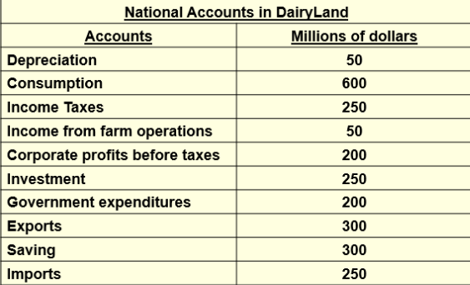

Private savings ?
Public saving?
Foreign saving?
Total saving?
Leakages?
Injections?

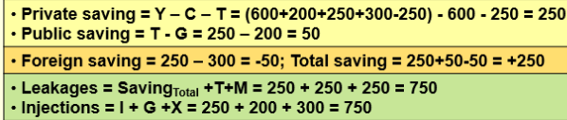

The Market for Loanable Funds
- Loanable funds refers to all income that ppl have chosen to save and lend out, rather than use for their own consumption
  - The supply of loanable funds comes from ppl who have extra income they want to save and lend out
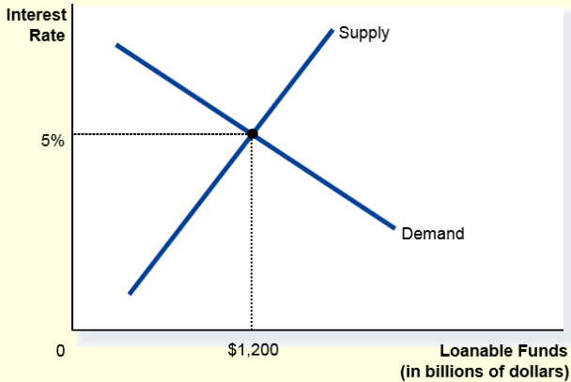
  - The demand for loanable funds comes from households and ifrms that wish to borrow to make investments
- Financial markets coordinate the economy’s saving and investment in the market for loanable funds
Supply and demand for loanable funds
- The interest rate
  - Price of the loan
  - Amount that borrowers pay for loans and the amount that lenders receive on their saving
- Financial markets work much like other markets in the economy
  - The equilibrium of the supply and demand for loanable funds determines the real interest rate
Analysis of Loanable funds market in a closed economy
- Analysis of gov’t policies that affect the economy’s saving and investment
  - Decide whether the policy shifts the supply curve or the demand curve
  - Determine the direction of the shift
  - Use the supply and demand diagram to see how the equilibrium changes
Gov’t policies that affect saving and investment (closed economy)
- Saving incentives
- Investment incentives
- Gov’t budget deficits and surpluses

Midterm exam October 1st
- The production function Y=A F (L,K,H,N) – what is a a production function? A relationship between two things: outputs and inputs. If we use certain quantities of labour, the net outcome will be
- A production function has constant returns to scale, if for any positive number x.
- xY = A F (xL , xK, xH, xN)
  - That is a doubling of all inputs causes the amount of output to double as well.
  - If Y (GDP) only increased by 1.5, then that is decreasing returns to scale
  - If Y (GDP) increases by 3 times, then that is increasing returns to scale.
- Y = quantity of output; A = available production technology this is outside of the function, indicating that fact that technology has an impact on all of the other resources
- L = quantity of labour; K=quantity of physical capital
- H = quantity of human capital
- N= quantity of natural resources
- F( ) is a function that shows how the inputs are combined

Your turn: suppose you bake cookes. One day, you double the time you spend; double the number of chocolate chips, flour, eggs and all other inputs; and bake twice as many cookes: what kind of production function is this?
- Decreasing returns / zero returns / constant returns/ increasing resturns

Your turn: suppose the country were to increase its saving rate. In the long run, which of the following would also increase? Its
- Level of income / growth rate of income / growth rate of productivity / growth rate in capital stock
- Savings is used and channeled through to investments.
- Because this is in the long run, the only thing that would change is the level of income. The rate of growth would drop to zero in the long run….
Your turn: suppose there are diminishing returns to capital. Suppose also that two countries are the same except that one has less capital and so less real GDP per person than the other. Suppose that the saving rate in both countries increases from 5 to 6 percent. Which of the following would we expect over the next ten years?
- Grow rate will not change in either country / country w less capital will grow faster / country with more capital will grow faster / both countries will grow at the same rate
- Physical capital suffers from diminishing returns to scale: if you add one additional unit of capital, it will not be as productive as the previous unit of capital
Your turn:

