Ch. 17 Blood
Blood exits the heart by arteries, which branch out to tiny capillaries. They diffuse across the capillary walls which leads oxygen and nutrients to leave the blood and enter the body tissues. Carbon dioxide and waste move from the tissues to the bloodstream. Oxygen diffident blood leaves the capillary beds and flow into the veins which return to the heart.
The major components of whole blood
Blood is a specialized type of connective tissues and contains:
- Living blood cells called formed elements
- The formed elements are suspended in nonliving matrix called blood plasma
If you place a blood sample into a centrifuge you will see that the heavier formed elements are packed down thanks to centrifugal force and the less dense plasma remain on top.
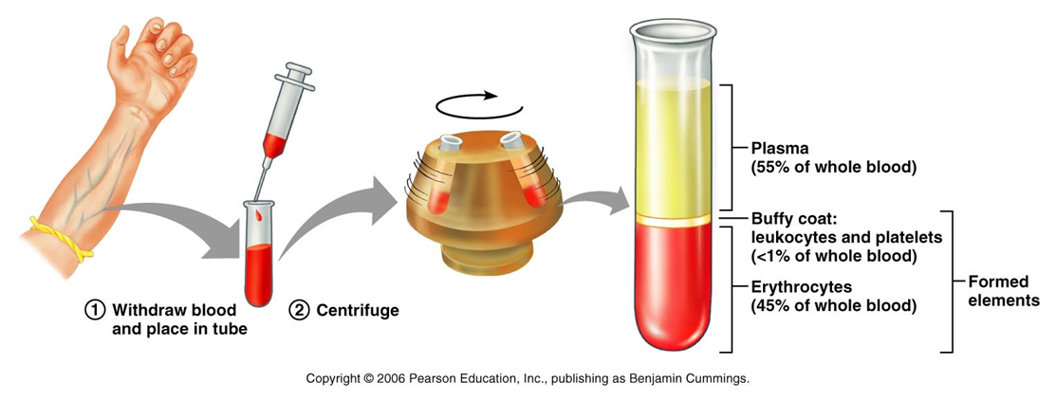
- Blood is slightly alkaline (pH=7.35-7.45)
- Temperature =38 ͦ(somewhat higher than body temp.)
Functions of blood
Transport ( distribution):
- O2 from lungs and nutrients from the digestive track
- Metabolites waste from cells to elimination sites. ( to lungs for the elimination of Co2, to the kidneys for disposal of nitrogenous wastes in urine.)
- Hormones from the endocrine organs to target organs
Regulation:
- By absorbing and distributing heat throughout the body and to the skin surface to encourage heat loss, blood helps regulate body temp.
- Many blood proteins and other bloodborne solutes act as buffers to prevent excessive or abrupt changes in blood pH.
- Salts and blood proteins act to prevent too much fluid loss from the bloodstream into the tissue spaces. This allows the fluid in the blood vessels to remain ample to support efficient blood circulation.
Protection:
- Preventing blood loss with the use of blood clots. (platelets and plasma proteins)
- Prevent infection, drifting along the blood are antibodies, complement proteins and white blood cells, all which help protect the body from viruses.
Blood plasma
Made mostly from water, 90%, blood plasma contains many other types of proteins ect in the blood.
Plasma proteins are most abundant plasma solutes, accounting for 8% of the volume of the plasma. With the exception of hormones and gamma goblins, most plasma proteins are produced in the liver. Plasma proteins are not used as fuel or metabolic nutrients.
Albumin accounts for 60% of plasma protein. Acting as a carrier to shuttle certain molecules through the circulation, important blood buffer, and is major blood protein contributing to the plasma osmotic pressure sodium also helps with osmotic pressure. Respiratory system and kidneys are called into action to restore plasma’s normal, slightly alkaline pH.
Formed elements
There are three types formed elements erythrocytes, leukocytes and platelets. Some unusual feature they have to offer are: two of the three aren’t true cells, erythrocytes have no nuclei or organelles and platelets are cell fragments, leukocytes are the only true cells. There are more erythrocytes than the others.
Erythrocytes
Structure and basic characteristics
Also known as red blood cells (RBCs) , they are small biconcave cells that lack nucleus and organelles. Contain protein spectrin that helps RBC to be flexible, change shape and squeeze through narrow capillaries. They have a huge surface area for gas exchange and high hemoglobin content. Anaerobic metabolism allows them to create ATP but even though they are carrying the oxygen they do not consume any of it.
Hemoglobin
Hemoglobin is what makes cells red and they bind easily and reversibly with oxygen. They are made up of four protein globin subunits, each bound to the iron binding red heme pigment. Each iron atom can combine reversibly with one molecule of oxygen (4 per Hb molecule; each RBC contains 250 million Hb molecules!!). Each globin molecule is made of 2α(alpha) and 2β(beta) polypeptide subunits. Hemoglobin carrying o2= oxyhemoglobin. Hemoglobin carrying CO2= carbarminohemoglobin.O2 combines with heme group, but CO2 combines with globin part.
RBC standard values
Things you need to know from the chart
Count of red blood cells
The hemoglobin number
Hematocrit
Number of reticulocytes

Red blood cell production= hematopoiesis= hemopoiesis
Red blood cells are continuously renewed by division of cells in red bone marrow ( reticular connective tissue bordering on large capillaries called blood sinusoids)
The production of RBCs requires:
Functional hematopoietic stem cells ( pleuripotent, at this stage can develop to any body cell type.)In the network of the sinusoids there are immature blood cells, macrophages, fat cells and reticular cells( which secrete fibers). The blood cells mature and migrate through the thin walls of the sinusoids and enter the bloodstream. Red marrow is found in the bones of axial skeleton and gridles, and in the proximal epiphyses of the humerus and femur.
Each blood cell goes through a process in which it turns into that cell.
Hemocytoblast or hematopoietic stem cell : stem cell the beginning of it, they are located in red marrow
Proerytgriblast: committed cell, this is when the hemocytoblast go into a certain pathway they become commited to that pathway and cannot turn back. This commitment signaled by the membrane surface receptors for specific growth factors and hormones that “push” the cell towards specialization.
Myeloid stem cell: descendant of a hemocytoblast
Early (basophilic) erythroblasts: they produce large numbers of ribosomes. During this phase the cell divides many times. When the hemnoglobin is synthesized and iron accumulates as the early erythroblast turns into late eryrthroblast and then normoblast. The color of the cell changes as the ribosomes are masked by the pink hemoglobin. When normoblast have accumulated almost all of the hemoglobin it ejects its’ organelles. The nuclear functions ends and the nucleus degrades and is pinched off which allows the cell to collapse inwards and eventually leads to the bioconcave shape. The name of the cell is reticulocyte ( young erythrocyte) still contains clumps of ribosomes. The entire process takes 15 days. The reticulocytes almost fills to bursting point with hemoglobin and enters the bloodstream. After 2 days of the degradation of the ribosomes it becomes a mature erythrocyte.
Reticulocytes account for 1-2% of all erythrocytes in the healthy body. Reticulocytes count allows us to estimate the rough index that the RBC are forming. Above or below this percent range means that there is an abnormal rates.
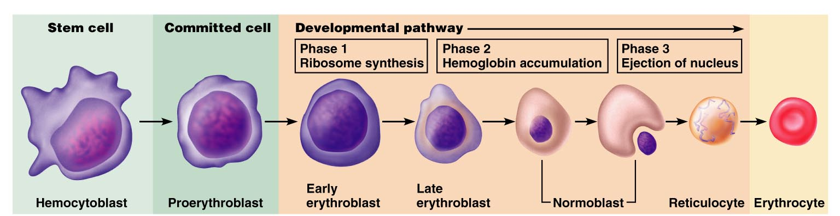
Erythropoetin (EPO) mechanism for regulating erythrocytes
Having too little erythrocytes can cause tissue hypoxia (oxygen deprivation) whereas having too many makes blood too viscous. To maintain a homeostatic range new cells are produced at a rate of 2 million per second in a healthy person.
Erythropotein is a glycoprotein hormone. Normally small amounts of this hormone circulates around the blood and sustain red blood cell production at a reasonable rate. Kidneys are very important for the production of the EPO and the liver also helps production as well. When certain kidney cells become hypoxic( not enough oxygen) oxygen enzymes are unable to carry out their normal functions of degrading an intercellular signaling molecule called hypoxia-inducible factor (HIF). As HIF accumulates it accelerates the synthesis and release of erythropoietin.
Drop in normal blood oxygen levels that trigger EPO formation can result from:
- Reduced number of red blood cells due to hemorrhage or excessive RBC destruction
- Insufficient hemoglobin per RBC( as in iron deficiency)
- Reduced availability of oxygen, as might occur at high altitudes or during pneumonia.
If there are too many erythrocytes or excessive oxygen in the bloodstream it can lower the production of erythrocytes. It is not the number of erythrocytes in the blood that control the rate of erythropoietin, actually control is based on their ability to transport enough oxygen to meet demands.
Athletes and EPO abuse: can increase hematocrit from 45% to 65%; but increased viscocity plus dehydration during race can -> clotting, stroke, heart failure.
When cell o2 falls, oxygen “sensor” in kidney and liver ( a heme protein) -> stimulates transcription of EPO. Kidney produces 85%- 90% of EPO. Other stimulators of EPO are catecholamines, androgens and alkalosis.
Raw materials in erythropoiesis are usual nutrients structural materials amino acid,lipids,carbohydrates.
Life cycle of RBC
Most hemoglobin degradation-in the macrophages of the spleen and iron is reused. Heme is reduced to bilirubin and eventually converted to urobilinogen metabolised by bacteria to stercobillin an excreted in feces. (look at diagram on p.641)
Bilirubin is a yellow pigment that is released to the blood and binds to albumin for transportation.
Iron uptake, incorporation into hemoglobin and storage
Iron is transported by transferrin and stored inside cells as protein-iron complex ferritin and hemosiderin.
The most common areas of iron storage in our bodies: liver, bone marrow, intestinal mucosa and spleen. If the body does not need iron, it is stored in the mucosal cells die and are slough.
Iron absorption in controlled by intestinal cell in response to changing body stores of iron.
65% of the bodies iron is stored in hemoglobin rest is stored in spleen ,liver and very little in bone marrow. Heme= iron and globin = amino acids.
Since iron on its own in toxic it is stored cells are protein-iron complexes such as ferritin and hemosiderin.
During transportation iron is loosely connected to transport protein called transferrin.
Heme iron is better absorbed than non-heme iron
Vitamin B12 and folate are necessary for synthesis of nucleic acids and nuclear maturation of the RBC
Vitamin B12 requires intrinsic factor for effective absorption. (Intrinsic factor is a glycoprotein that is necessary for absorption of B12)
Heme iron( in hemoglobin and myoglobin) found in :
- Organ meats ( liver, heart, kidney)
- Red meat ( beef, pork, veal and lamb)
- Fish ( clams, oysters, sardines)
- Poultry
None-heme iron (all iron found in vegetables, grains and supplements):
- Legumes ,dry fruits, enriched cereals and pasta
- Dark green leafy vegetables, eggs
Practical dietary strategies to meet iron needs
- Eat hem rich foods
- Enhance the absorption of non-hem iron ( include vitamin c at the same meal
- Be aware that some foods interfere with non-hem iron absorption (excess bran, strongly brewed tea, oregano
- Take iron supplements when advised too.
Erythrocyte disorders
Anemia is a condition in which the blood cannot carry a lot of oxygen , the oxygen levels are too low to support normal metabolism. Symptoms include paleness, cold, fatigued and short of breath.
- An insufficient number of red blood cells. Conditions that are concerned with a low red blood cell count (blood loss), excessive RBC destruction and bone marrow failure.
Hemorrhagic anemia: when there is a significant amount of blood loss. Ex stab by a knife.
Hemolytic anemia: erythrocytes rupture or lyse, prematurely.
Aplastic anemia: destruction or inhibition of the red marrow by certain drugs or chemicals, ionizing radiation or viruses. Destruction of marrow impairs formation of all formed elements; anemia is just one sign of it.
- Low hemoglobin content; when hemoglobin molecules are normal, but erythrocytes contain few than usual number, nutritional anemia is always suspected
Iron- deficiency anemia: usually a secondary result of hemorrhagic anemia, but also results from inadequate intake of iron- containing food and impaired iron absorption. If there is a chronic hemorrhage that is the cause you may need a red cell transfusion.
Microcytes: small pale blood cells that are a result from iron-deficiency anemia.
Athlete’s anemia: when athlete’s exercise vigorously their blood volume expands and can increase by as much as 35% over time. Since this increase in volume dilutes the blood components, when a test for iron content of the blood would show that this person has iron-deficiency anemia. It is reversed as blood components return to physiological levels within a week or two after normal levels of activity.
Pernicious anemia: when you have a deficiency in B12, this type of anemia is more of a problem for strict vegetarians and in the elderly. Treatment is injections into the muscle of B12 or an application of a B12 gel (Nascobal) to the nasal lining once a week.
Intrinsic factor: substance produced by the stomach mucosa (membrane of the stomach), that must be present for vitamin B12 to be absorbed by intestinal cells. Most cases seen the intrinsic factor is deficient.
Macrocytes: caused when erythrocytes grow but do not divide, creating large pale cells.

- Abnormal hemoglobin is a result of a genetic basis abnormality.
Β-Thalassemias: most common to people from the Mediterranean ancestry, such as Greeks and Italians. One of the globin chains is absent or faulty and the erythrocytes are thin, delicate and deficient in hemoglobin. Depending on how sever it is blood transfusions may be required.
Sickle-cell anemia: destruction caused by abnormal hemoglobin, hemoglobin s (HbS),occurs when there is a change in one of 146 amino acid in a beta chain from a globin molecule. The alteration caused the beta chain to bind under low oxygen condition, which result in forming stiff rods so that the hemoglobin S becomes shape and spiky. This causes the blood cell to become crescent shaped when they are reviled of their oxygen molecule or when oxygen levels in the blood are low such as exercising or other actives that increase metabolic rate.
These erythrocytes rupture easily and tend to clog up small blood vessels which leads’ to less oxygen and in result leaves the person grasping for air. They are also in extreme pain and are prone to infections, strokes and bone and chest pains.
Treatment is a blood transfusion for extreme cases, or they use an inhaled nitric oxide to dilate blood vessels.
Fetal hemoglobin (HbF) does not sickle therefor they are using this as a method to prevent RBC’s from sickling. Clotrimazole, reduces sickling by blocking ion channels in the RBC membrane, keeping ions and water inside the cell.
Polycythemia: abnormal amount of erythrocytes that increase blood viscosity, causing it to sludge or flow sluggishly.
Polycythemia vera : bone marrow cancer, characterized by dizziness and an exceptionally high RBC count. (8-11 million) the hematocrit may be as high as 80% and blood volume may double causing the circulation to be impaired.
Secondary polycythemias: less oxygen is available or EPO increases. Secondary poly that is present in people living in high altitudes is a normal physiological response to atmospheric pressure.
Blood doping: when athletes competing in aerobic events take some of their red blood cells out and then inject them with the blood a few days before the event. The erythrocytes are quickly replaced by erythropoietin mechanism is triggered shortly after blood removal.
Folate deficiency anemia
Folate, from the Latin “folium” meaning leaf.
Involved in metabolism of DNA, amino acids and their derivatives
Often works together with vitamins B12 and B6 and produces deficiency syndromes often identical to vitamin b12 deficiency.
Folate is need to form all new cells including RBC
Folate deficiency can result from:
- Insufficient intake and/or absorption(e.g., alcoholism, Crohn’s disease, anorexia, bulimia)
- Increased requirement, ) pregnancy, lactation)
- Insufficient utilization due to other factors such as vitamin B-12 deficiency
Megaloblastic anemia caused by folate or vitamin B12 deficiency
This occurs when blood cells are unable to divide, leaving large immature red blood cells. Either a folate or vitamin B12 deficiency may cause this. Measurements of blood form both vitamins are taken to help find out what caused the anemia.
Vitamin B12
Vitamin B-12 is need for the production of red blood cells ( helps in recycling of folate coenzymes), for the maintenance of the sheets surrounding and protecting never fibers.
Found mainly in animal products and fortified cereals and milk.
About 50% of vitamin B-12 is absorbed by healthy adults
Pernicious anemia( pernicious means “leading to death” and autoimmue disorder related to decrease production of the intrinsic factor, needed for transport and absorption of vitamin B 12
Decreased absorption of vitamin B12
Absorption can be interrupted by :
- Absence of: R protein, pancreatic proteases, or intrinsic factor produced in the stomach as well as defective binding of the intrinsic factor
- Absence of much or all the stomach and ileum
-bacterial overgrowth
-tapeworm infestation
-some ulcer medications (e.g., omeprazole)
-chronic malabsorption (Crohn’s disease, AIDS)

