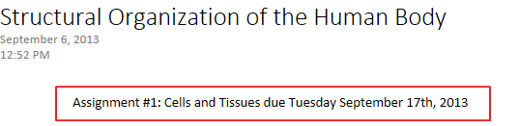
1.1 Describe the levels of structural organization of the body.
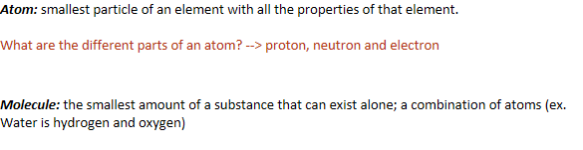
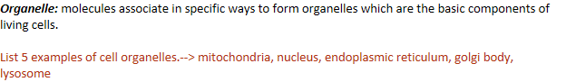
Cell: fundamental structure and functional unit of a living thing; cells vary widely in size and shape, reflecting unique functions in the body
Tissue: groups of similar cells with a common function
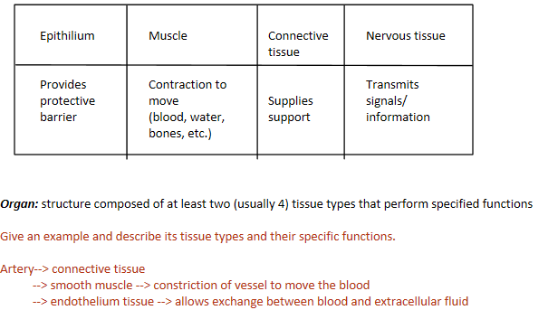
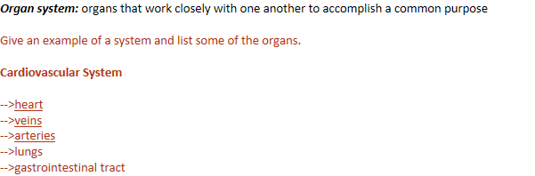
1.2 Cells: summarize the major organelles, their structure and their function.
Structure | Function
Plasma Membrane | Regulates the relationship between intercellular and extracellular fluids
Mitochondria | Energy production and synthesis
Ribosomes | Protein synthesis
Rough ER | Organized "factory" for proteins to be exported
Smooth ER | Complex molecule synthesis
Golgi apparatus | Shipping and receiving of synthesized particles in the cell
Lysosome | Breaks down used components of organelles and has an acidic environment
Peroxisomes | Break down toxic chemicals in the body
Microtubule | Largest component of the cytoskeleton… think of it as the femur of the cytoskeleton
Microfilaments and intermediate filaments | Components of the cytoskeleton, intermediate filaments being bigger than microfilaments
Centriole | Organizational centre for the cytoskeleton
Cilia | Movement of liquids, present on most epithelial linings (ex. trachea)
Flagellum | Allow for movement of the cell, the flagella is the long tail that provides movement for the sperm cell
Microvilli | Increase surface area to increase absorption
Nucleolus | Manufactures ribosomes
Nuclear envelope | Mediates exchange of information with the nucleus
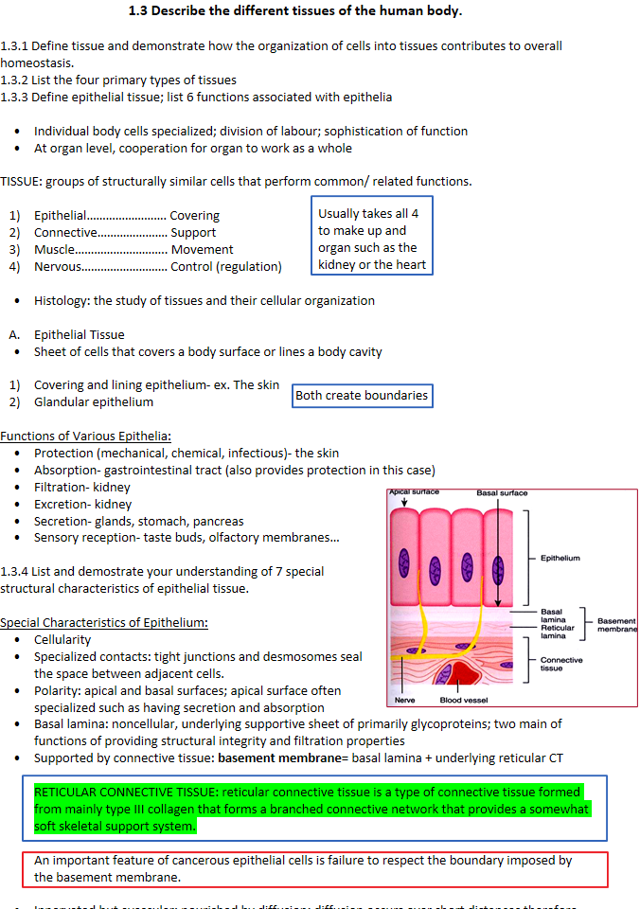
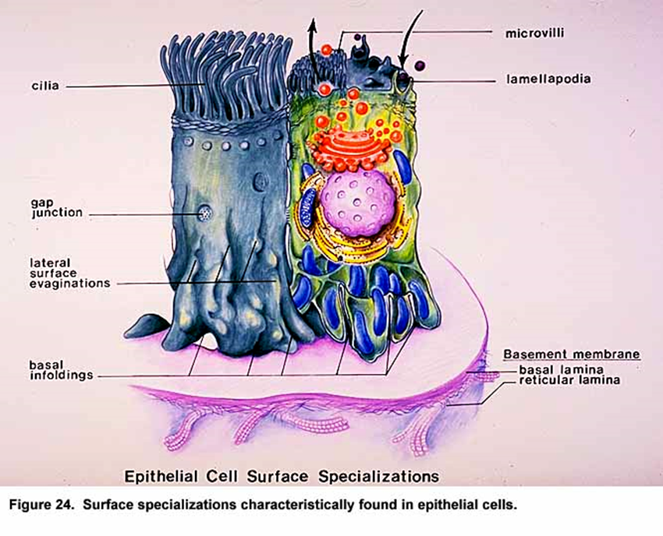
1.3.5 Indicate the 2 criteria used to classify epithelial cells.
 | 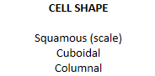 |  |  |  |  | 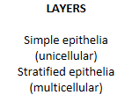
 |  | 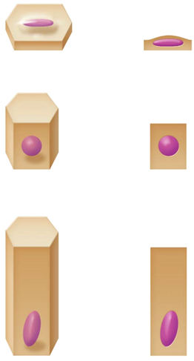
 |  |  |  |  | 

