Anatomy of the Skeletal System
Cartilage
- features btw dense CT and bone, tough but flexible
- avascular, devoid of nerve fibers
- collagen fibers (can have some elastic fibers)
- up to 80% water
Terms relating to cartilage
Perichondrium
- firbrous, CT membrane covering the external surface of cartilaginous structures
- in damages areas can form scar tissue because poorly vascularized cartilage repairs badly
- ossification of cartilage with aging
Chondroblasts
- high mitotic rate
- immature cartilage cells, actively form cartilage
Chondrocytes
- low mitotic rate
- mature cartilage cells, maintain cartilage
Lacinae
- localized clusters of chondrocytes
- in clusters because the perichondrium takes up a lot of room, so there is little room to expand
Types of cartilage
Hyaline cartilage
- most abundant
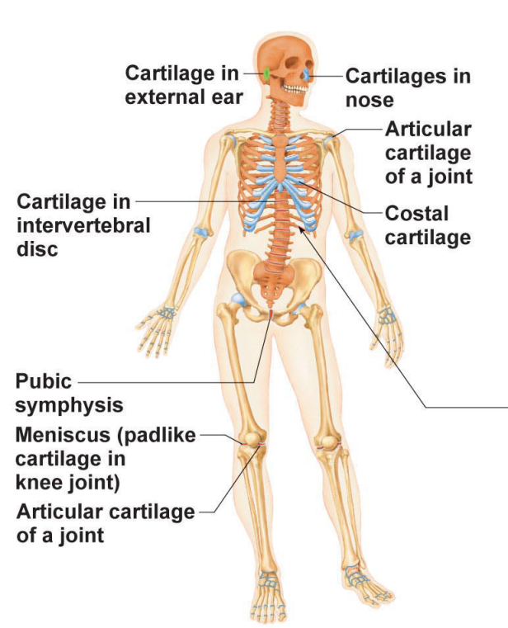
- firm support and pliability
- lots of collagen (only fiber type present)
- appears glassy blue-white
- volume is 1-10% chondrocytes
- found in the embryonic skeleton, ends of long bonds (epiphyseal plates in growing children), costal cartilages of ribs, cartilages of the nose, trachea and larynx
- supports and reinforces, resilient cushioning and resists compressive stress
Elastic cartilages
- like hyaline cartilage but more elastic fibers
- only found in two locations, the external ear and epiglottis
- maintains shape while giving lots of flexibility, stand up to repeated bending
Fibrocartilage
- rows of chondrocytes with alternating rows of thick collagen fibers
- structural intermediate btw hyaline cartilage and dense regular CT
- found in the intervertebral discs, pubic symphysis, discs of knee joints (where hyaline carrtilage meets a ligament or a tendon)
- tensile strength with ability to absorb compressive shock
Growth of Cartilage
- during bone growth during youth and during old age, cartilage can become calcified, hardened due to deposit of calcium salts
- this is not bone, cartilage and bone are distinct tissues
- two types of growth
1. Appositional growth
- growth from outside
- cartilage forming cells in the surrounding perichondrium secrete new matrix against the external face of the existing cartilage tissue
2. Interstitial growth
- growth from inside
- lacunae bound chondrocytes divide and secrete new matrix, expanding the cartilage within
Overview of bones
- living dynamic tissue which responds to its environment
- reacts to the amount of force applied by increasing both density and amount of roughening on bone when force is increased
- decrease density when force is reduced or eliminated eg paralysis- loss of muscle function and feeling
- bones store calcium, it is resorbed and transferred to bloodstream when needed
- changes mineral composition 7-10% every week
- can repair itself, reshape and remodel bones
Functions of bone
Support
- framework that supports the body and cradles its organs
- lower limbs act as pillars to support the trunk and the rib cage supports the thoracic wall
Protection
- fused bones of the skull protect the brain, vertebrae around the spinal cord and the rib cage protect the vital organs of the thorax
Movement
- skeletal muscles attached to bones by tendons, act as levers to move the body and its parts
Mineral storage and growth factor storage
- reservoir for minerals, mostly calcium and phosphate
- stored minerals are released into the bloodstream as needed and distributed to all parts of the body
- bone matrix stores important growth hormone
Blood cell formation
- hematopoiesis, occurs in the bone marrow
Classification of bones
- unique shape of each bone fulfils a particular need
1. Axial skeleton
- bones of the skull, vertebral column and rib cage
- protect, support and carry other body parts
- see picture of skeleton above
2. Appendicular skeleton
- bones of upper and lower limbs, girdles (shoulder and hip bones) that attach the limbs to the axial skeleton
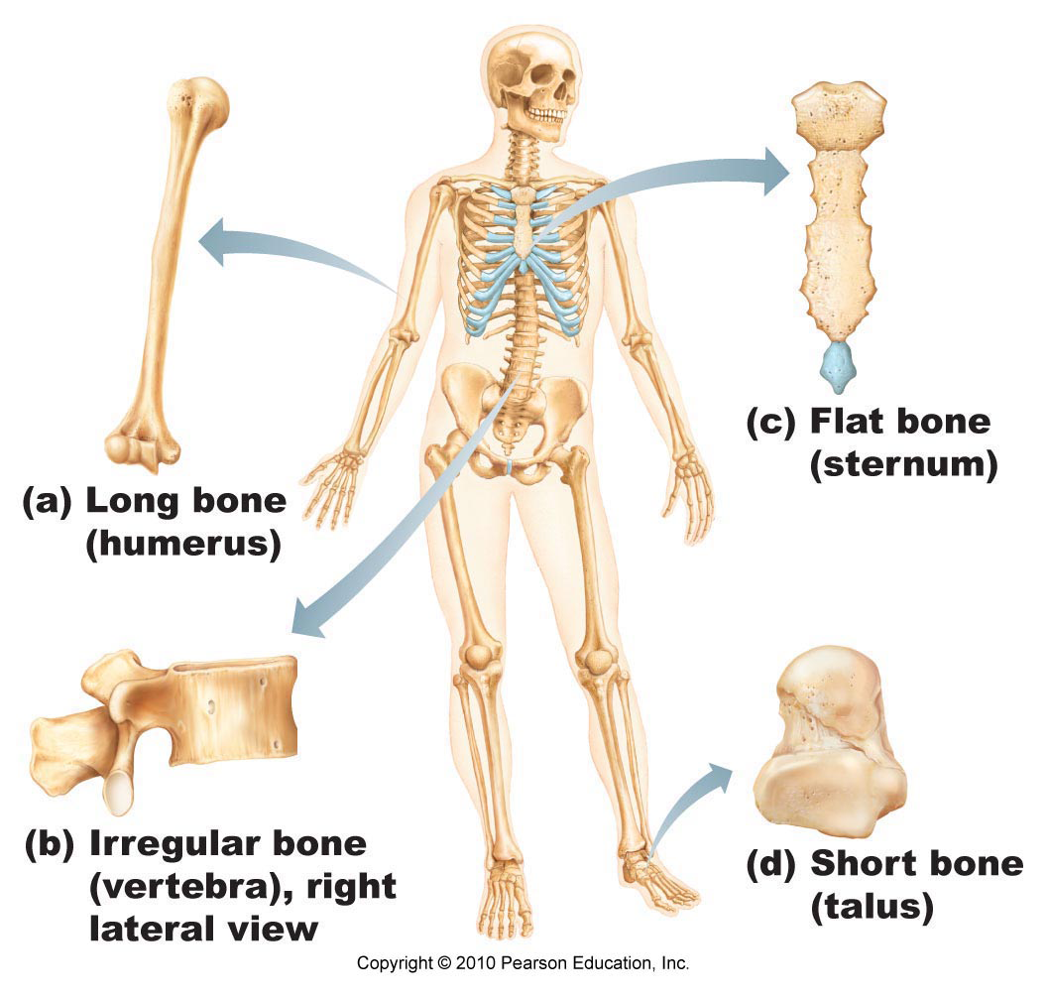
- for locomotion
a) Long bones
- much longer than wide
- shaft plus 2 ends
- mostly compact bone with hollow centre (marrow cavity)
- spongy bone near joint ends
- all limbs bones except patella (kneecap) and the wrist and ankle bones are long bones, even the 3 bones in each finger
d) Short bones
- roughly cubed shaped
- wrist, ankle and sesamoid bones (embedded with a tendon)
- primarily spongy bone with outer layer of compact bone
c) Flat bones
- thin, flattened and sometimes curved
- skull bones, ribs and breastbone (sternum)
b) Irregular bones
- vertebrae and hip bones
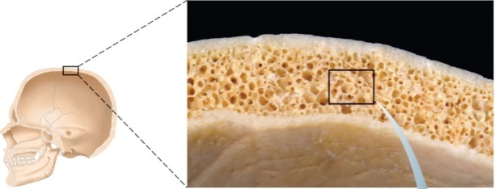
- primarily spongy bone plus thin covering layer of compact bone
Bone textures
- dense outer layer that looks smooth and solid is the compact bone
- internal to this is the spongy bone, a honeycomb of small needle like or flat pieces called trabeculae
- in living bones the open spaces btw trabeculae are filled with red or yellow (fatty) bone marrow
Structure of short, irregular and flat bones
- all 3 have similar structures
- compact bone outside, spongy bone inside
- compact covered with periosteum and spongy lined with endosteum
- not cylindrical so no shaft, marrow cavity or epiphyses but do contain bone marrow btw trabeculae
Structure of typical long bone
Diaphysis
- tubular shaft, long axis
- collar of compact bone surrounding marrow cavity(medullar cavity)
- in adults, medullary cavity contains fat (yellow marrow or yellow bone marrow cavity)

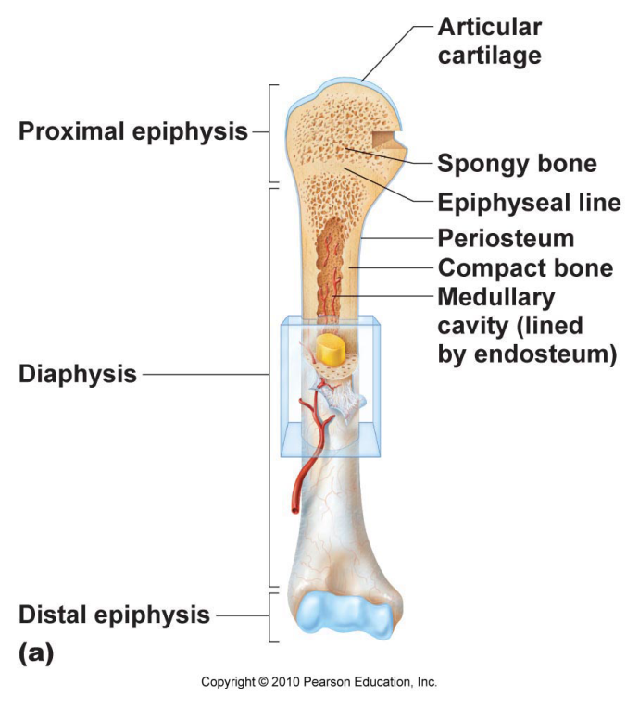
Epiphyses (single epiphysis)
- bone ends, usually broader than the diaphysis for articulation with other bonds
- compact bone form thin outer layer, interior filled with spongy bone
- thin layer of hyaline (articular cartilage), to cushion the opposing bone ends during movement and absorbing stress
Epiphyseal line
- btw diaphysis and each epiphysis
- remnant of the epiphyseal plate
- a disc of hyaline cartilage that grows during childhood to lengthen the bone
Membranes
1. Periosteum
- white
- double layered membrane that covers the outer surface
- contains osteoblasts and osteoclasts
- outer fibrous layer is dense irregular CT
- inner osteogenic layer is primitive stem cells, osteogenic cells
- rich with nerve fibers and blood vessels, which pass through the shaft to enter the bone marrow cavity
- perforating (Sharpey's) fibers extend from the fibrous layer into the bone matrix to secure the periosteum to the underlying bone
- anchoring points for tendons and ligaments
2. Endosteum
- covers the inner surface (lines bone marrow cavity)
- delicate later of CT that contains osteoblasts and osteoclasts
Bone Markings
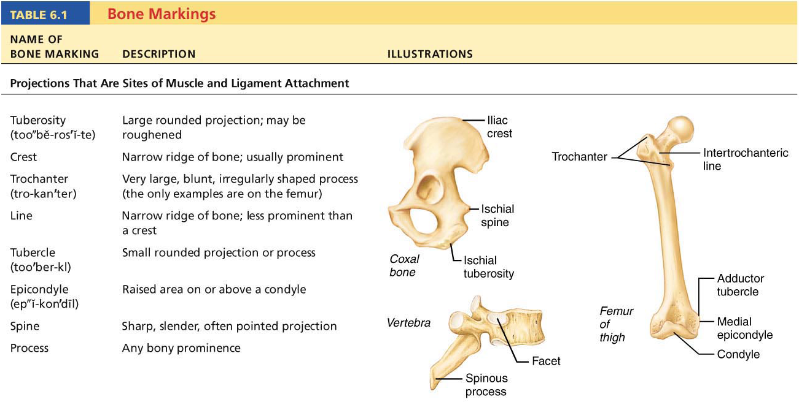
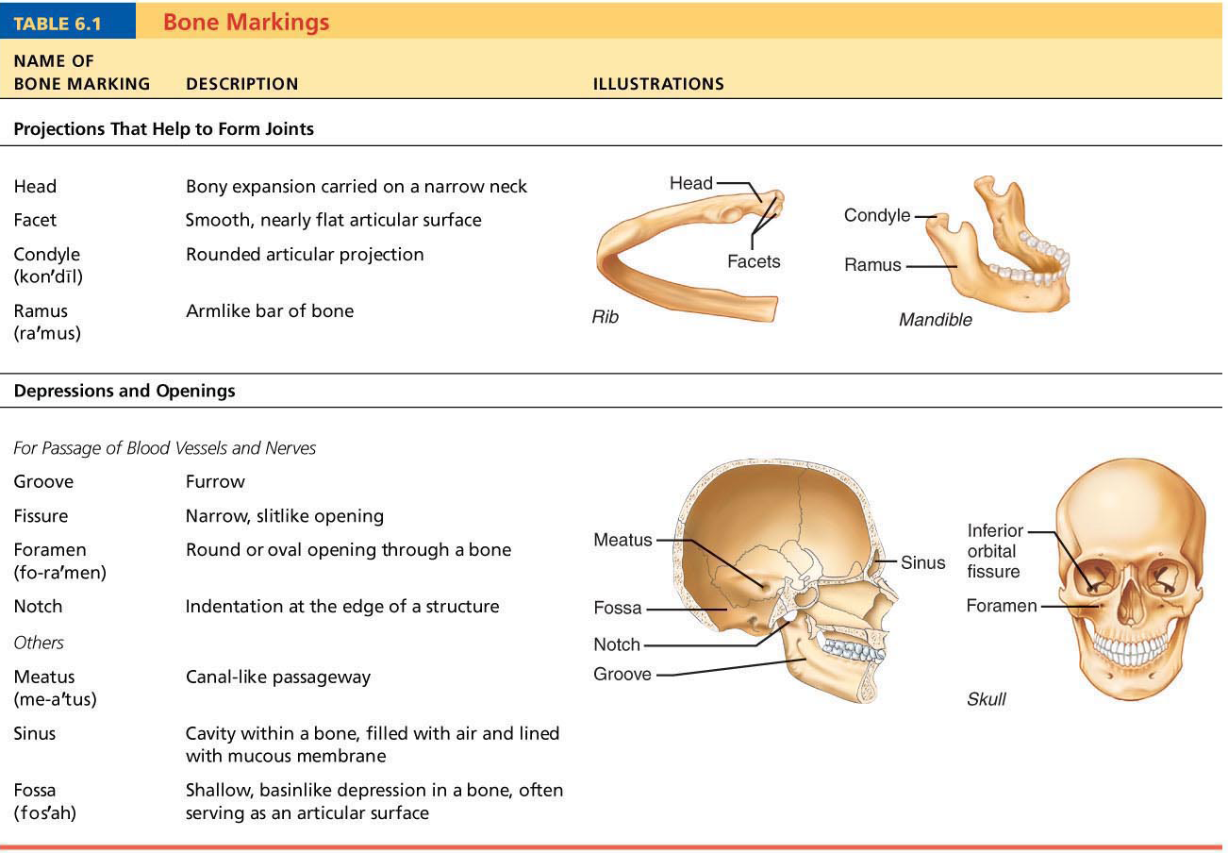
Osteogenic cells
- mitotically active stem cells found in the membranous periosteum and endosteum
- in growing bones, are flattened or squamous cells
- when stimulated, they differentiate into osteoblasts or bone lining cells, while other stay as osteogenic cells
Osteoblasts
- bone forming cells that secrete the bone matrix, actively mitotic
- bone matrix they secrete includes collagen (90% of bone protein) and calcium binding proteins that make up the initial unmineralized bone
- cube shaped when active, flattened when inactive
- when they become completely surrounded by the matrix being secreted, they become osteocytes
Osteocytes
- mature bone cells that occupy space (lacunae)
- monitor and maintain the bone matrix
- if they die, the surrounding matrix is resorbed
- stress or strain sensors and respond to mechanical stimuli (bone loading, bone deformation and weightlessness)
- communicate this to osteoblasts and osteoclasts so the bone matrix can be made or degraded
- spidery looking cells
Osteoclasts
- giant multinucleate cells
- located at sites of bone resorption
- when resorbing bone, they rest in shallow depressions called a resorption bay and exhibit distinctive ruffled border which directly contacts the bone
- the ruffled border increases the surface areas

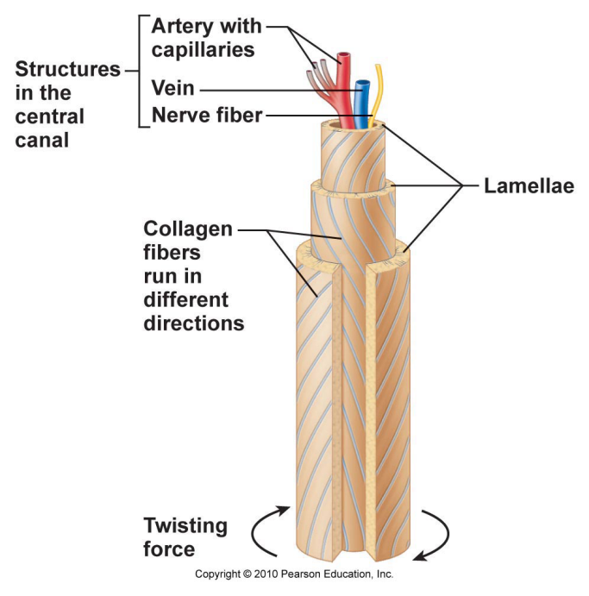
Compact bone
Osteon
- structural unit
- elongated cylinder oriented parallel to the long axis of the bone
- weight bearing pillars
- a single osteon is a group of hollow tubes of bone matrix
- each matrix tube is called lamellar bone
- collagen fibers run in different directions to allow for twisting forces
- core of the osteon is the Haversian (central) canal, containing blood vessels and nerve fibers
- Volkmann's (perforating) canal lie at right angles to the long axis of the bone and connect the blood and nerve supply of the periosteum to those in the central canals and the medullary cavity
- lacunae are present at the junctions of the lamellae
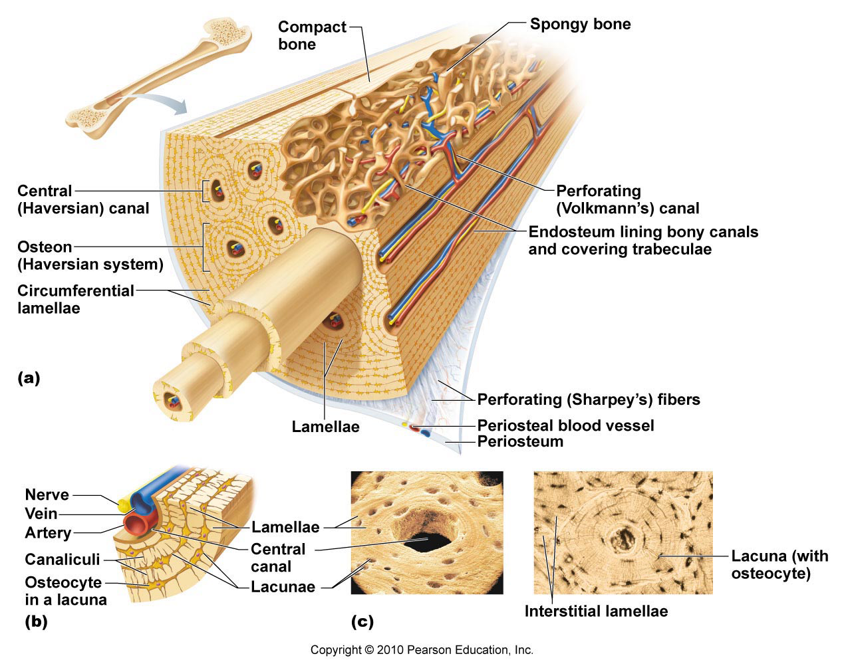
- hair like canals called canaliculi connect the lacunae to each other and to the central canal

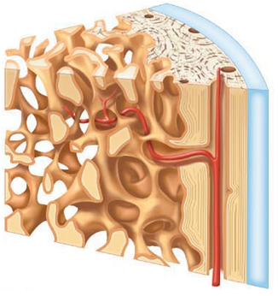
Spongy bone
- trabeculae arranged along lines of stress, helps bone resist stress as much as possible
- only a few thick cell layers thick, trabeculae contain irregularly arranged lamellae and osteocytes interconnected by canaliculi
- no osteons
- nutrients diffuse through canaliculi from the marrow spaces btw the trabeculae to reach osteocytes
Chemical composition of bone
- cells, osteogentic cells, osteoblasts, osteocytes, bone lining cells and osteoclasts
- 1/3 of bone composition is organic material
Osteoid
- ground substances (proteoglycans and glycoproteins) and collagen (90%)
- contributes to bones structure and to the flexibility and tensile strength that allows it to resist stretch and twisting
Inorganic
- remaining 2/3 of bone
- hydroxyapatites- mineral salts, calcium phosphates in and around collagen fibers
- they are responsible for hardness of bone that allows it to resist compression
Mechanisms of bone formation
Osteogenesis or Ossification
- in embryos leads to the formation of the boney skeleton
- bone growth occurs during childhood and adulthood, body increases in size
- remodelling and repair of bones in adults
Intramembranous ossification
- bone developed from fibrous CT membrane containing mesenchvmal cells
- cranial bones of the skull and the clavicles (flat bones)
- begins at about 8 weeks of embryonic development
Endochondral ossification
- bone development via the replacement of a hyaline cartilage model
- all bones below the skull, except the clavicle
- begins in second month of development
- more complex than intramembranous ossification because the hyaline cartilage must be broken down as ossification proceeds
Endochondral ossification in a long bone
- for long bones, formation begins in the center of the hyaline cartilage shaft at a region called the primary ossification center
- in short bones, only the primary ossification centre is formed
- most irregular bones are formed using several distinct ossification centres
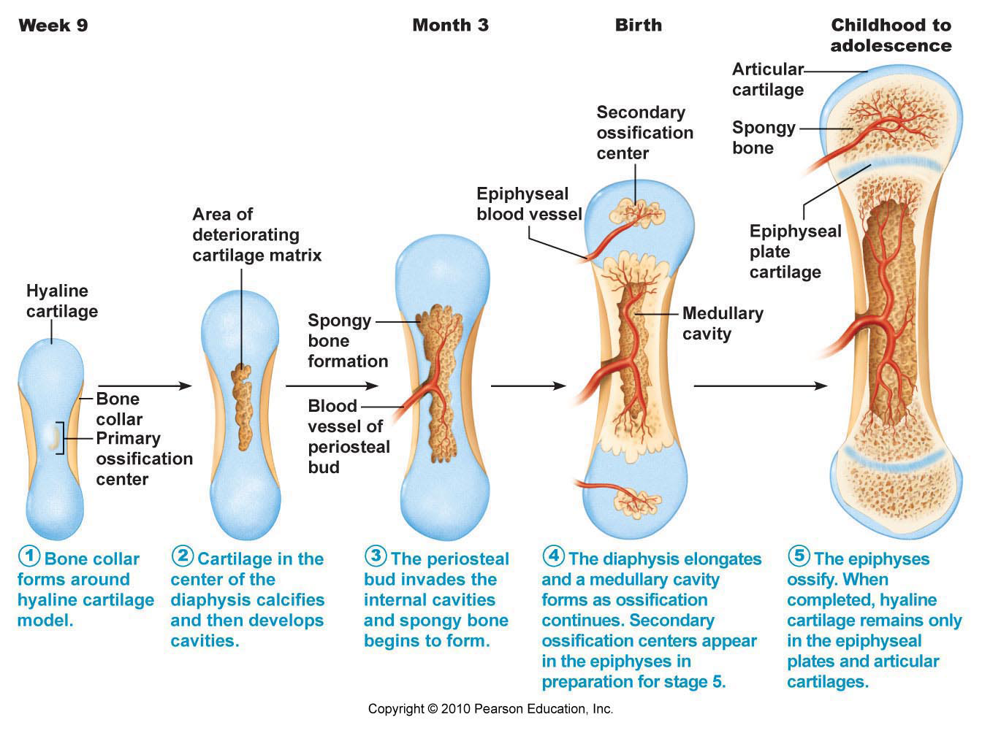
- when secondary ossification is complete, hyaline cartilage remains on the epiphyseal surfaces as the articular cartilage and at the junction of diaphsis and epiphyses where it froms the epiphyseal plates (where ling bones continue to grow)
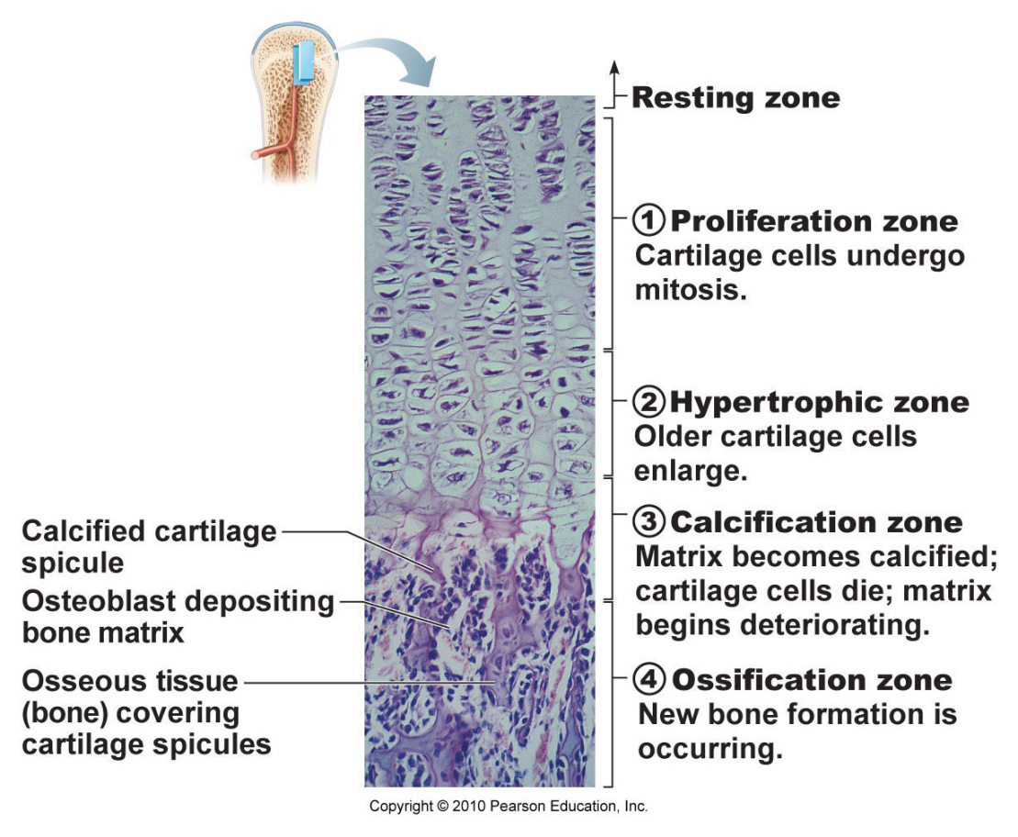
Bone growth
- during infancy and youth, bones lengthen entirely by interstitial growth of the epiphyseal plates and all the bones grow in thickness by appositional growth
- most bones stop growing during adolescence or in early adulthood
- some facial bones such as the nose and lower jaw continue to grow throughout life
Growth in length of long bones
- cells that make up the proliferation zone, divide quickly, pushing the epiphysis away from the diaphysis and lengthening the entire long bone
- older chondrocytes in the hypertrophic zone, their lacunae erode and enlarge, leaving large interconnecting spaces
- surround chondrocytes die and deteriorate and matrix calcifies to form the calcification zone
- calcified cartilage spicules are invaded by marrow elecements
- oestoclasts digest the spicule tips and the cavity lengthens
- during growth, the epiphyseal plate maintains a constant thickness because the rate of cartilage growth on its epiphysis facing side is balanced by its replacement with boney tissue in its diaphysis facing side
- longitude growth is accompanied by continuous remodeling of the epiphyseal ends
Epiphyseal plate
- stays about the same size throughout childhood and adolescence
- becomes thinner, cartilage cells multiply more and more slowly
- longitudinal growth ends when one of the epiphysis and diaphysis fuses, this is epiphyseal plate closure, age 18 in females and 21 in males
Growth in width
- appositional growth
- layers of bones are laid down on top of one another
- osteoblasts on periosteal side secrete bone matrix
- osteoclasts on the ednpsteal side remove bone matrix
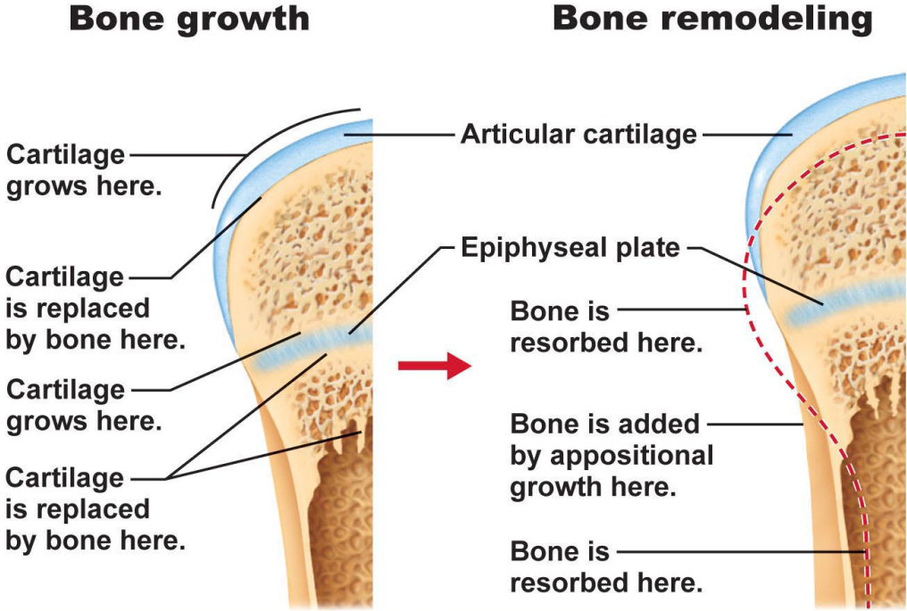
- slightly more building up than breaking down
Bone remodeling
- as the bone lengthens, the shape of the ends must be altered (modeling)
- ends wider then shaft
- as length increases, external surface of ends made slimmer while internal surfaces is thickened
- bone mass remain constant in healthy adults, rate of bone deposit and resorption are equal
Control of remodeling
1. Hormonal controls
- negative feedback hormonal loop that maintains calcium homeostasis in the blood
- calcium needs for transmission of nerve impulses, muscle contractions
- parathyroid hormone (PTH), produced by the parathyroid glands
- low levels of calcium in blood, PTH is released, this stimulates osteoclasts to resorb bone, releasing calcium into the blood
- as blood concentration of calcium rises, stimulation for PTH ends and blood calcium levels fall
2. Mechanical stress
- mechanical and gravitational forces acting on the skeleton
- bones anatomy is reflective of the stress its under
- thicker where there is more stress
Mechanism of fracture repair
- 4 stages of repair (8-12 weeks for simple fractures)
1. hematoma forms
- mass of clotted blood forms at the fracture site
- bone cells deprived of nutrients die and the tissue at the site becomes swollen, painful and inflamed
2. fibrocartilaginous callus forms
- formation of soft callus
- capillaries grow into the hematoma and phagocytic cells invade to clean up debris
- fibroblats and osteoblasts migrate to area to reconstruct the bone
- fibroblasts form collagen fibers (span break)
- some fibroblasts become cartilage cells and begin to lay down cartilage matrix
- osteoblasts forms spongy bone
3. bony callus forms
- new bone trabeculae appear and converts to a bony (hard) callus of spongy bone
4. bone remodeling occurs
- excess material is removed and compact bone is laid down to construct the shaft walls
Osteoporosis
- bone resorption outpaces bone formation
- bones become porous and fragile
- areas of skeleton especially vulnerable: spine, neck of femur
Risk factors
Age
- estrogen, testosterone promote bone health by restraining osteoclast activity and promoting deposition of new bone
Other contributing factors
- insufficient exercise
- diet poor in calcium and protein
- abnormal vitamine D receptors
- smoking (reduces estrogen levels)

