Chapter 14 Moral Development
Moral development is determined by your culture and you're moral development. We also have different periods of development with different moral reasoning.
Morality Issues
- Moral rules
  - What is fair and what is just?
- Social conventions
  - we have rules to keep society in place
  - Moral Reasoning: How you think about things
  - Moral Conduct: The way you act
Theories of Moral Development
- Pieagets Stage Theory
  - Stage 1 (2-4 yrs): Children have no true conception of morality
  - Stage 2 (5-7 yrs): Understand rules but are not flexible in rule use
    - Objective Responsibility: Children evaluate moral situations on the basis of amount of damage
    - Immanent Justice: There should be immediate justice
  - Stage 3 (8-11 yrs): They realize rules are conventions and they can be altered. They now consider intention
  - Stage 4 (12 up): Children develop rules as needed and extend moral reasoning beyond their personal level. Moral reasoning develops as the cognitive structures of the child develop
- Kohlberg's Model
  - Three levels of reasoning
    - Preconeventioanal: Only satisfying their own needs
    - Conventional: Social systems must be based on laws and regulations. The law says it's bad so I won't do it
    - Postconventional: The value, dignity and rights of each person must be maintained.
  - Invariant sequence is generally supported
  - Cultural critique - Speaks to the universality of Kohlbergs model.
    - If you grow up somewhere with strong religion
  - The Gender critique - Female are often encouraged to care for other people. Some females feel obligated to respond like that
  - Everyone will go through the three stages.
- Turiel's Model
  - Moral Domain: Is concerned with people's rights and welfare
    - Prohibitions against lying, cheating, stealing
  - Societal Domain: Involves rules that guide social relations
    - Being polite, wearing appropriate clothing
  - Children's understanding of moral and societal issues is influenced by context
Evolutionary and Biological Approaches
- Altruism: Behaviors that benefit another but that may cost the person
- Kin Selection: A person aids someone who shares their genes
- Reciprocal Altruism: Members of a group reciprocate in their altruism so that all members are more likely to survive and pass their genes
- Aggression: Defending and protecting the home. It is a inevitable part of human nature
  - Aggression may lead to dominance hierarchies. Even though bullying is wrong it still happens. People are getting something from aggressive acts.
Environmental and Learning Approaches
- Enviormental Learning
  - Reinforcement and observational processes are involved in moral development
  - As children develop, they internalize what they have learned to regulate their own behaviour
  - If a child grows up in a home where hitting is allowed they will think it's okay
- Socialcultural
  - Moral developemtn is a process of socialization
  - Through interactions with family and cultural institutions, children are assisted by other people in structuring and interpreting situations for themselves
Social and Family Influences on Moral Reasoning
- Peer interactions force children to wrestle with moral issues
- Interaction with a peer whose level of moral reasoning is higher (usually by one level) can improve moral reasoning in a child
- Social learning theory suggests that moral reasoning can be influenced by modeling and imitation
- Parents’ disciplinary practices
  - Power assertion
    - Involves the use of commands, threats, physical force
    - EX: You wont go out for a month
  - Love withdrawal
    - Involves the use of disapproval and withholding of affection
    - EX: I can't believe my child did this
  - Induction
    - Refers to reasoning with the child to explain why certain behaviors are prohibited
    - EX: Being nice. You could have done something else.
  - Induction leads to higher moral reasoning and Power Assertions leads tot he lowest
Prosocial behaviour
- They are socially desirable and include helping, sharing, and conflict resolution.
- The roots of prosocial behaviour are empathy and sympathy.
- Empathy can be observed in infants (cry when hearing another infant cry)
- Development of sympathy is related to children’s ability to understand others’ mental states
- Hoffman’s six stages
  - Stage 1: Global empathic distress
  - Stage 2: Egocentric empathic distress
  - Stage 3: Quasi-egocentric empathic distress
  - Stage 4: Veridical empathy
  - Stage 5: Empathic distress beyond the situation
  - Stage 6: Empathy for distressed groups
- The stages start off as a very self serve perspective and towards the end it turns into a empathy to other people.
Development of Prosocial Behaviour
- Helping
  - Toddlers comfort those in distress
  - Increases with age
- Sharing
  - Emerges by the end of the first year
  - Children are more likely to share with friends and those who have given them help in the past
- Conflict resolution
  - From coercion to negotiation
  - Resolve conflict both verbally and nonverbally
Determinants of Prosocial Behaviour
- Biology
  - Genes influence prosocial development through temperament
- Affect
  - Higher empathetic distress you will engage in higher levels of prosocial behaviours.
- Cognition
  - Prosocial reasoning, and children’s mental state understanding
- Socialization
  - Parents contribute to children’s prosocial development by
    - providing opportunities to practice prosocial behaviours
    - communicating prosocial values using inductive techniques
    - modelling and reinforcing prosocial behaviors.
Aggression
- Behaviour that is intended to harm persons or property and that is not socially justified.
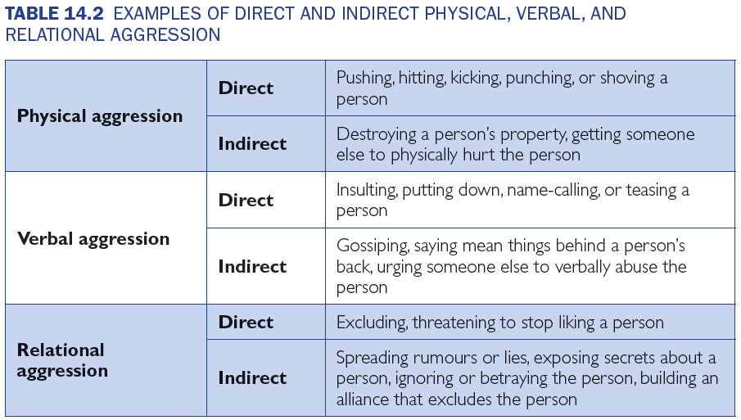
Relational Aggression: Males and females both do it but males do it differently. Males more likely to physical aggression and girls relational. Females do relational aggression because of verbal skills. Peaks in grade 6,7,8.
Determinants of Aggression
- Biological
  - Level of testosterone
  - Genetically mediated
  - Related to early difficult temperament
- Social influences
  - Family processes and peer interactions
  - TV and video game violence
  - Violent environments
- Cognitive and affective influences
  - Development of social cognition and empathy
Controlling Agression
- Different interventions for treating antisocial behaviour are employed
  - Catharsis
    - The belief that aggression can be reduced by viewing aggression or by engaging in high-energy activities. Sports.
  - Targeting parents’ child-rearing methods
  - Teaching children problem-solving strategies, empathy, and perspective taking and rethinking the attributions they make of others
  - Education


