Exam Review
Ch.9
Actual Product Attributes: Brand name, Quality, Features/Design, Packaging.
Associated Services: Financing, Product Warranty & Support

Specialty Products: customers show strong preference and spend considerable effort to search for best supplier. Example: luxury car
Shopping Products: consumers will spend a fair amount of time comparing products. Example: sneakers, fragrances.
Convenience Products: consumer is not willing to spend any effort to evaluate prior to purchase. Example: Bread
Unsought Products: consumers don’t usually think of buying these or do not about them.

Product Mix: complete set of all products offered by a firm
Product Lines: groups of associated items
Product Category: assortment of items that people seem as similar

Breadth: number of product lines, variety offered by a firm
Depth: number of products within a line

What makes a brand???
- Brand name, domain name, logos and symbols, characters, slogans, jingles, and distinctive packaging.
Value of Branding for the Customer and the Marketer:
- Brands facilitate purchasing
- Brands establish loyalty
- Brands protect from competition
- Brands reduce marketing costs
- Brands are assets
- Brands impact market value

- Brand equity-> Brand awareness, perceived value, brand associations, brand loyalty.
- Brand ownership strategies->
- Manufacturer or National brand: known and managed by the manufacturer, example Nike.
- Private Label or Store brand: developed and marketed by a retailer and available only from that retailer, example PC.
- Generic: product sold without a brand name
- Brand name strategies->
- Corporate or Family brand: use of a firm’s own corporate name to brand all product lines and products, example Gap, GE.
- Corporate and Product line brand: use of a combination of a family brand name and individual brand name, example Kellogg’s (Rice Krispies, Fruit Loops, Frosted Flakes)
- Individual: use of an individual brand name for each product: P&G’s detergent products (Tide, Gain, Cheer, Downy, Febreeze)

Choosing a brand name…
- Suggest benefits and qualities
- Easy to pronounce recognize & remember
- Capable of registration & legal protection
- Translated easily

Brand extension: use of the same brand name for new products being introduced to the same or new markets, example Life Savers soda.
- Benefits of brand extension
- Well established name
- Brand known for high quality
- Lower marketing costs
- Synergy among products
- Boost sales of the core brand
Brand dilution: when a brand extension adversely affects consumer perceptions about the attributes the core brand is believed to hold.
To prevent this, marketers should… Evaluate the fit, evaluate consumer perceptions, refrain from extending to too many products, and consider if extension is distanced fro the core brand.

Cobranding: marketing 2 or more brands together on the same packaging or promotion.

Brand licensing: contractual agreement between firms where 1 allows the other to use its brand name, logo, symbols, in exchange for a fee.

Packaging- more than tangible or physical benefits; consumers seek convenience.
Labeling- label provides info the customer needs to make their purchase.

Ch.10

Service: intangible offering that involves a deed, performance or effort that can’t be physically possessed.

All products are services- it’s a product, but it’s actually offering you a service through bettering your life once you get it.

Services are->
- Inseparable: produced and consumed at the same time, little opportunity to test a service before use
- Intangible: cannot be touched, seen, or heard
- Inconsistent: quality may very because humans are different, variable
- Inventory: it’s perishable and cannot be stored for future use

Gaps Model…
- Knowledge gap: difference between customer expectations and firm’s perceptions of those expectations. (Knowing what customers want)
- Standards gap: difference between firm’s perception of customer’s expectations and the service standard it sets. (Setting standards for quality; develop systems to ensure high-quality)
- Delivery gap: difference between firm’s service standard it sets and the actual service it provides. (Delivering service quality)
- Communication gap: difference between actual service provided and the service that the promotion offered. (Communicating the service’s promise)

Customer’s perception of how well a service meets or exceeds their expectations:
- Reliability: dependable and accurate service
- Responsiveness: willingness to help customers/ provide prompt service
- Assurance: knowledge and courtesy by employees
- Empathy: caring and individualized attention to customers
- Tangibles: appearance of facilities, equipment, personnel, and communication materials.

Zone of tolerance: difference between what the customer really wants and what they will accept before going elsewhere.
- This is based on: importance of each service quality dimension, low to high rating of each service dimension, and them compared to the competition.

REDUCE->
Delivery Gap… Empowering employees, use of technology, and provide them with support and incentives.
Communications Gap… manage customer expectations, promise what you can deliver, and communicate service expectations.

Service Recovery:
- Listen to the customer- they get emotional over a service failure. Usually just want someone to listen to them.
- Resolve problems quickly- longer it takes to resolve, more irritated they are.
- Provide a fair solution-
- Distributive Fairness: benefits customer received vs. the inconvenience or loess that resulted from a service failure.
- Procedural Fairness: customer’s perceived fairness of the process used to resolve complaints.

Ch.11

5 C’s of Pricing…
- Competition, Costs, Company objectives, Customers, and Channel members.

Company Objectives
- Profit Orientation- focusing on target profit pricing (particular profit goal as their main concern; price stimulates sales), maximizing profits (mathematical determination of price at which profits are largest), or target return pricing (designed to produce a specific return on investment, expressed as a % of sales).

- Sales Orientation- their focus is on increasing sales. Concerned with overall market share. Doesn’t imply low setting low prices.

- Competitor Orientation- firm measures itself against the competition. Common among smaller firms that lack knowledge or experience in setting prices. Usually, consumers use reference prices to indicate quality, so new brands set prices equal to competitors.

- Customer Orientation- matches the concept of the consumer’s value to setting the price to their expectations.

Customers
Understanding customer’s reactions to different prices…

In general, as prices increases, demand decreases. But sometimes it’s even opposite!

Price Elasticity of Demand= %change in quantity demanded / % change in price
- Elastic (price sensitive)
- Inelastic (price insensitive)
- Income effect- change in quantity demanded due to consumers’ income
- Substitution effect- consumers’ ability to substitute products for others
- Complementary products- products whose demand curves are positively related
- Cross-price elasticity- % change in demand for A occurs in response to % change in B

Costs
- Variable costs (vary with production volume) like labour & materials.
- Fixed costs (unaffected by production volume) like rent & utilities.

Break Even Point= Fixed costs / (Price – variable cost per unit)

Competition

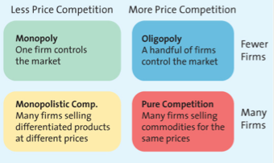

Price War- when 2 or more firms compete primarily by lowering their prices.

Channel Members
- Manufacturers, wholesalers and retailers can have different perspectives on pricing strategies
- Manufactures must protect against grey market transactions

Other factors that affect pricing are:
- The internet (increased priced sensitivity & growth of online auctions)
- Economic factors (greater disposable income, increasing status conscience, cross-shopping, increasing globalization, local economic conditions)

Pricing strategies…
Cost-based: finds the final price to charge by starting with the cost, without recognizing consumer input or competitors price.
Competitor-based: set prices to signal information of how product compares with their competitors.
Value-based: focuses on the value of the product offering perceived by the consumer.
Market Penetration Pricing: set initial price low for the introduction of the new product/service.
Price skimming: selling new product/service at a high price that innovator and early adopters are willing to pay to obtain it. After market is saturated and sales decrease, lower price skims the next most price-sensitive segment.

- Reference price- comparing current price with the actual selling price
- EDLP- continuity of their prices at a level lower than others
- Odd Prices: suggest good deal, low quantity, tradition
- Pricing Strategy is based on the 5 C’s and is long term. Pricing Tactics is based on the stuff below and is short term.

- Seasonal Discounts- spurs buyers into buying merchandise early
- Cash discounts- reduces invoice cost if buyer pays prior to end of discount period. 3/10, n/30 means buyer takes a 3% discount on total amount if bill is paid within 10 days of invoice date.
- Allowances- lowers the final cost in return for specific behaviour. Advertising allowance (to channel members) Listing allowance (to retailers)
- Quantity Discounts- Cumulative (discount based on amount purchased over specified time period and many transactions) Non Cumulative (based on amount purchased in a single order, one time thing)

Uniform delivered pricing- shipper charges 1 rate of shipping no matter what
Geographic pricing- shipping rate depends on where you’re located

- Price lining- Marketers establish a price floor/ceiling and sets prices in between. Allows easy competition.
- Price Bundling- sell more than 1 product for a lower price than what items would cost separately.
- Leader Pricing- gets people in the store with cheap milk hoping they’ll buy other stuff.

- Markdowns- reductions retailers take on initial selling price
- Size discounts- the more you buy, the cheaper the cost (big box of cereal)
- Seasonal Discounts- encourages customer to buy year round
- Coupons- retailer handles them
- Rebate- manufacturer handles them (usually mail-in)

Ch.12

Distribution channel- institutions that transfer the ownership of and move goods from production to consumption.
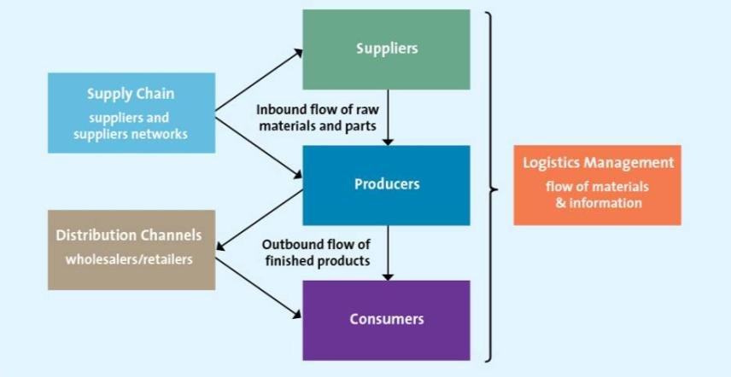
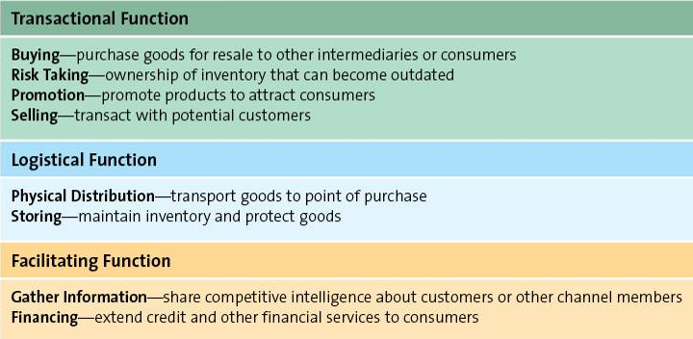
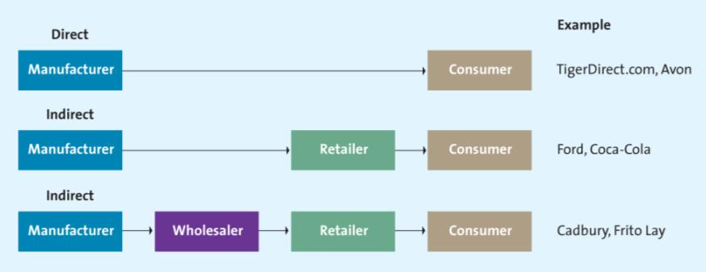

Distribution Intensity:
- Intensive- manufacturers get products to as many outlets as possible; more exposure= more sales
- Selective- manufacturers use a few selected companies in a territory
- Exclusive- manufacturers grant exclusive geographic territories to one or few retailers

Administered Vertical Marketing Systems: no common ownership, no contractual relationship, but the dominant channel member controls the channel relationship. Dominant channel member could dictate what’s to be produced, when it should be delivered.

Contractual Vertical Marketing Systems: independent firms at different levels of the supply chain join together through contracts to obtain economies of scale and coordination to reduce conflict. Franchising, for example. And contracts should include min. purchasing amount, price, and penalties.

Corporate Vertical Marketing Systems: when a parent company has complete control and can dictate the priorities and objectives of the supply chain. It may own the entire distribution channel.

Supply chain management streamlines distribution. Think about how many transactions 3 factories to 3 consumers. Or, 3 factories to 1 retailer to 3 consumers. 9 vs. 6. Increases value for customers and the factories.

Supply chain management affects marketing. Fulfilling delivery promises, meeting customer expectations, relying on efficient supply chain.

Data warehouse- think of a cube with all data on a transaction- year, season, day, time, sku, company, store, etc.

Electronic Data Interchange EDI- exchange of business documents between retailer & vendor over the computer. (Reduces cycle time, increases communication, easily used and analyzed data)

Strategic or Partnering Relationship- supply chain relationship where members are committed to having long-term goals mutually beneficial to each other.

Just-In-Time Systems:
Deliver less merchandise on a more frequent basis. Firm gets the merch. just in time to be used.

Lead time- amount of time to recognize an order needs to be placed and the arrival of that merchandise to be store ready.

Ch.13

Choosing Retail Partners

- Channel structure- level of difficulty a manufacturer has in getting retailers to buy its products pretty much.
- Customer expectations- retailers need to know what customers want to buy and manufacturers need to know where their customers expect to find their products and those of their competitors.

Types of Retailers

Food retailers…
Supermarket (groceries, meat, produce, and a limited non-food items)
Big-box Food retailer (supercentre, hypermarket, and warehouse clubs, carry both food and non-food items)
Convenience located in a lot of places, small selection of items high price

General Merchandise retailers…
Discount store (broad variety of merchandise, limited service, low prices)
Specialty store (small store, limited number of complementary merchandise categories)
Category specialists or killers (offers narrow variety but a deep assortment of merchandise)
Department stores (broad variety, deep assortment, some customer service)
Drugstores (specialty store that concentrates on health & personal grooming)
Off-price retailers (offers inconsistent assortment of merchandise at a cheap price)

Choosing a Retail Strategy:
Product: providing the right mix of merchandise and service for the consumers. This is the most important thing retailers can do.
Price: defines the value of both the merchandise and the service provided. Price DOES matter; always implies image.
Promotion: retailers use a variety of promotions both within their retail environment and though mass media. Manufacturers are also HEAVILY involved in promotion. They look for successful retailers.
Place: convenience is key to success. Location, location, location.

Multichannel retailers: retailers that sell merchandise in more than one retail channel (example store online kiosk, etc.)

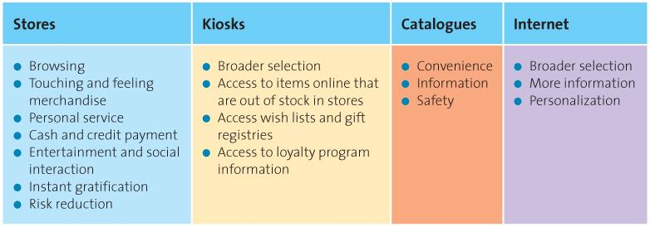

Ch.14

Sender (firm, Home depot) Transmitter (encodes message; advertising agency) Communications Channel (media) Receiver (consumer; decodes message) Feedback (between sender and receiver). All the while, there’s noise from the Environment (competing messages, lack of clarity, etc.)

- Receivers perceive, or decode, messages differently
- Senders adjust messages according to the medium and the receivers’ traits.

Integrated Marketing Communication Tools
- Advertising- Print, Television, Radio, Outdoor.
- Personal Selling- Sales calls, Telemarketing.
- Sales Promotion- Coupons, Deals, Premiums, Samples, Loyalty Programs, POP displays, rebates.
- Public Relations- Media relations, News releases, Press kits, Annual Reports.
- Direct Marketing- Direct mail, Catalogues, DRTV, Kiosks.
- Electronic Media- Internet blogs, text messages, social media.

Steps in Planning an IMC Campaign

1. Identify Target Audience- appeal, tone of message, tracking, mass or niche media, generate awareness of trial, inform and persuade and remind.
2. Set Objectives- nature of the market or product, stage in the product life cycle. Pull strategy (getting the product into store through consumers demanding it)
Push strategy (pushing the product they want to consumers via distribution channels)
3. Determine Budget-

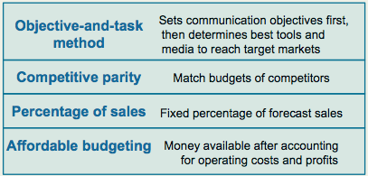

4. Convey the Message- rational and emotional appeal. Unique selling proposition: differentiating a product by communicating its unique attributes (usually a slogan or theme in the advertising campaign).
5. Evaluate and Select Media- Decide what you need through Media Planning, then find out what your Media Mix will be. Finally, go through Media Buy to purchase all your airtime or print pages. Mass media include newspapers, magazines, television, etc. Niche media include specialty magazines, Internet, cable TV, etc.

Advertising Schedule
- Continuous- runs steadily throughout the year, like laundry detergent
- Flighting- implemented in spurts with heavy, then no ads.
- Pulsing- base level of advertising, then increasing intensity in certain periods. Like school supplies in August.

6. Create Communication- high creativity, depends on what the medium executed is.
7. Assess Impact by Using Marketing Metrics-
- Pretesting- assessment BEFORE ad campaign is implemented.
- Tracking- monitor key indicators WHILE ad is running.
- Postesting- evaluation of impact AFTER ad campaign ends.
Measure the success through… Frequency, Reach, Gross Rating Points, Web Tracking. GRP=reachXfrequency

Ch.15

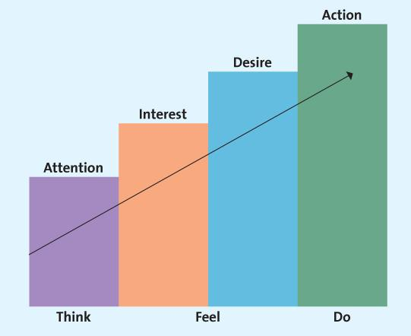

- Informative, Persuasive, and Reminder Advertising
- Aided recall vs. Top-of-the-mind awareness.
- Can be advertisements about a product/service or about institutions.
- Public Service Advertising (PSA)
- Under Canadian Radio-television and Telecommunications Commission rules broadcasters must devote a specific amount of free airtime to PSAs
- Puffery- legal exaggeration of praise, stopping just short of deception, lavished on a product.
- Stealth marketing
- Sales Promotions- coupons, deals, premiums, contest, sweepstakes, samples, loyalty programs, POP displays, product placement.
- Personal Selling through- the Internet, Telephone, Face to Face, Teleconference.
- Salespeople educate and provide advice
- Salespeople save time and simplify buying
- Personal Selling Process- Generate & Quantify Leads Pre-approach Sales Presentation/Overcoming Objections Closing the Sale Follow Up.

Ch.16

Globalization of Production (or offshoring)- making goods and services around the world to take advantage of costs.

PEST- Political/Legal, Economic Analysis, Socio-cultural Analysis, and Technology & Infrastructure.

P

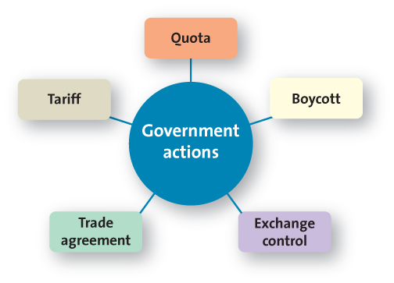
- Tariffs are taxes; artificially raise prices and lowers demands.
- Quotas are maximum limit and reduce availability of imported goods.
- These benefit domestic products reduce foreign competition.
- Exchange Control refers to the regulations of a country’s exchange rate.
- Countertrade is trade between 2 countries of goods, not money.
- WTO deals with the global rules regarding trade regulations

Trade deficit- country imports more goods than it exports
Trade surplus- exports more goods than imports

GDP- market value of goods and services produced by a country in a year
PPP- if exchange rates are equal, a product purchased in China will cost the same in Canada, in the same currency
Human Development Index- measure of 3 indicators in the quality of life: life expectancy, educational attainment, if incomes meet needs sufficiently.

- Firms can make adjustments to an existing product or change the price to meet the unique needs of a particular country market
Socio-cultural Factors
- Power distance- willingness to accept social inequality as natural
- Uncertainty avoidance- relying on certainty, orderliness to function
- Individualism- obligation and dependence to groups
- Masculinity- dominant values are male-orientated. Low means gender is equal, high rating means men are perceived higher.
- Time orientation- short-term vs. long-term orientation.

- Infrastructure and Tech Capabilities- transportation, communication, distribution channel, commerce.

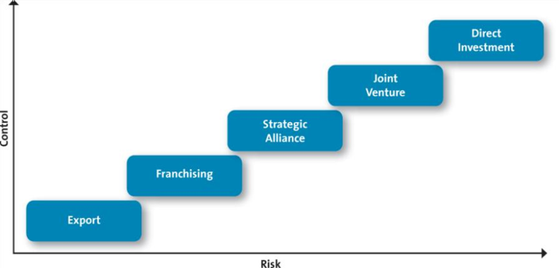
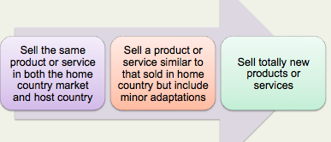
Global Product or Service Strategies^

Global Pricing Strategies: depend on tariffs, quotas, anti-dumping policies, economic conditions, and competitive factors.

Global Distribution Strategies:
- Some global channels are very long and complex.
- Consumer shop local small local stores.
- Suppliers must be creative in delivering to these outlets.

Global Communication Strategies:
- Literacy levels vary by country
- Firms choose whether to adapt to language differences
- Cultural and religious differences matter

Environmental Concerns:
- Waste Management
- 80/20 Rule: 80% of waste created by 20% of the population
- Many developing countries don’t manage waste well

Global Labour Issues:
- Fair wages
- Working conditions
- Child labour

Impact of host country culture:
- Cultural imperialism (belief that ones own culture is superior to that of other nations.

