ADM 3301 C
ASSIGNMENT # 2
Aggregate Planning
Prepared by: Irina Prikazchikova, 5641228
Max Charbonneau, 5596848
Prepared for: Professor Rim Jaber
TA: Victory Nkweti Khan
Problem #1

- Chase strategy aggregate production plan.

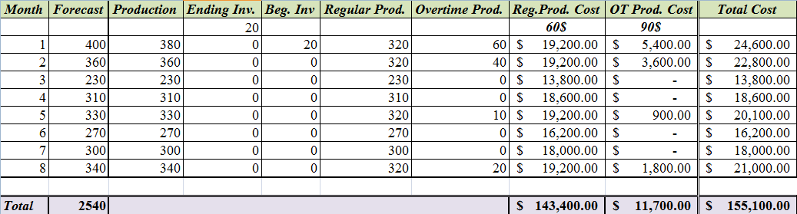

The total cost of the engines using the chase strategy production plan is $155,100.00.

- Level strategy production plan.
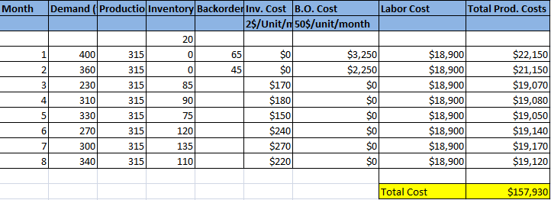

The total cost of the engines using the level strategy production plan is $157,930

- As a production manager, we would implement the first plan, using the chase strategy. It has a lower total cost of $155,100.00 than the level strategy which has a total cost of $157,930.

Problem #2

- By using the regular production, the total cost is $54,040.00.
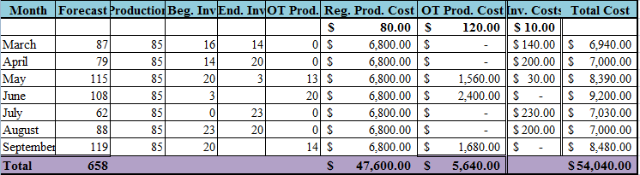

- Using the level strategy, where the regular production and subcontracting quantities are the same for the 7 months.

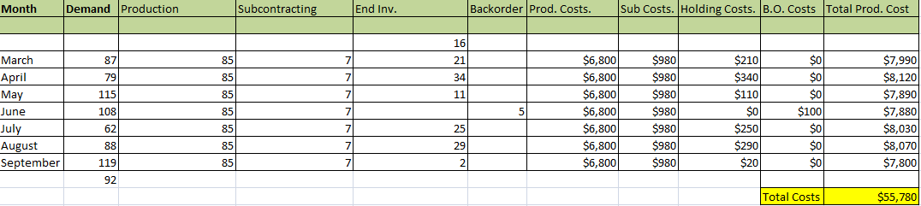

- Using the level strategy, and trying to minimize the cost.
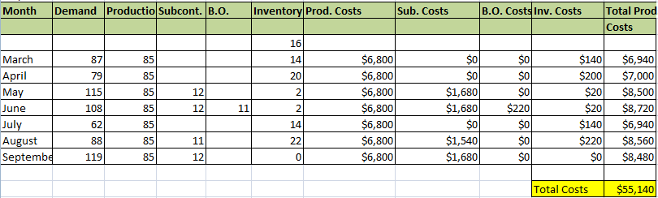

The total cost in this production plan is $55,140.00 which is the lowest cost that was found as to comparing to the previous production plans.

- Transportation method
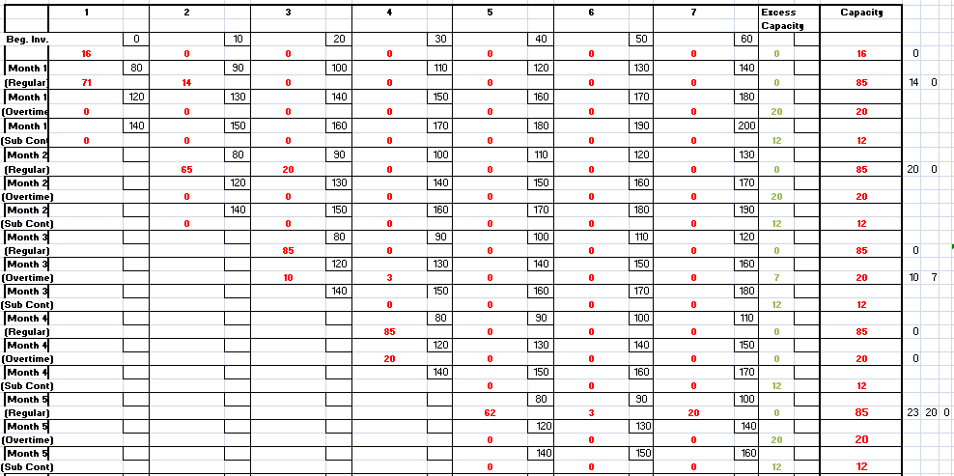
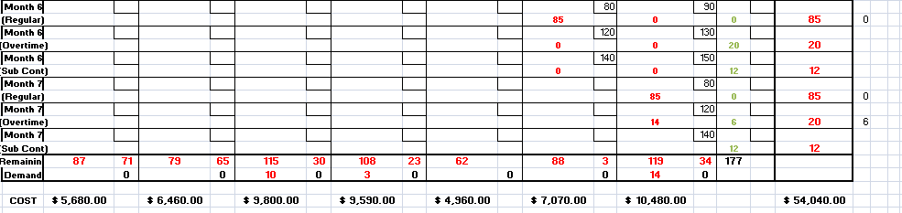

The total cost is $54,040.00 when using the transportation model.

E) Amongst all the proposed plans the aggregate plan using the transportation method (Q2.D) has the lowest cost of all with a total cost of $54,040 which give us the same cost that we found in (Q2.A) by using only reg. Production, OT and inventories

