Mars Exploration Program

Submitted by:
Student Number:
Date Submitted: June 7th, 2013.
1086F Origin and Geology of the Solar System
1.0 Introduction

With Mars being on of the closest planets to Earth, it has always been a focal point in the astronomy community. In the past few decades, science has revolutionized how we think and view our closet planetary neighbour. Although science has given us many of the tools that allow us to categorize many of the red planet’s attributes, there is still so much that we do not know about the planet. There are a few facts however that can be stated about the planet. It is the fourth planet from the sun and one if the closest from earth, depending on the time of year and it’s orbit (NASA, 2013). Mars is also approximately half the size of earth as seen in Figure 1. The red planet gets it red-orange colour from its heavily saturated iron-oxide surface (Taylor, 2010). Mars has two moons, Phobos, and Deimos, and an average temperature of 218 Kelvin, or – 55 degrees Celsius. With all that being said, there is still a great amount of detail that is unknown to the human species, and how, to this date, do we know the facts aforementioned above? The Mars Exploration Program, first initiated in 1993 (Taylor, 2010) has, is, and will give us the knowledge and data about the planet we desire. Since its creation, the Mars Exploration Program has governed four, long term, scientific goals. The four goals are to characterize the geology of Mars, characterize the climate of Mars, construct the preparation for human exploration, and to determine if life ever arose on Mars (Taylor, 2010). The Mars Exploration Program has attempted on a numerous amount of occasions to explain and provide an answer to the goals they have outlined. The aim of this report is to outline, and explain how the most successful missions of the Mars Exploration Program has given us the knowledge and data about the planet that we know today, as well to give a clear and concise explanation and answer to the four scientific goals first outlined by the Mars Exploration Program through the use of its rover and orbiter missions and the technology on board.
2.0 Past Missions
Many of the Mars Exploration missions in the past resulted in failure due to two key characteristics, failure to land or lose of communication, or a combination of the two. It was because either of these reasons that some missions lacked information recovered. It wasn’t until 1996 that a successful mission took place. Many rovers have never been seen or heard from since their departure from earth. However, some missions outlined below from 1996 to 2007 resulted not only in success but also contributed to astonishing observations and analysis of Mars.
2.1 Mars Global Surveyor
Launched November 7th, 1996, the Mars Global Surveyor was the first successful mission to Mars in nearly 20 years (NASA, 2013). The purpose of the mission was to “map” the planet. The surveyor flew and has flown since, at a low altitude obtaining data on the planets surface, atmosphere, and interior. The surveyor uses a highly advanced wide-angle camera, called the Mars-Orbital Camera to capture its images. The outcome of this mission confirmed that the planet has very distinct weather patterns and distinct weather behavior based on the time of year, i.e. Martian Autumn, etc.(NASA, 2013). Along with the understanding of weather patterns, which can be used to determine launch times, locations, and performance of other missions, the surveyor also determined Mars has gullies and debris flows, which can used to conclude that water, more specifically an aquifer (a body of permeable rock that can contain or transmit groundwater), once existed (NASA, 2013).
2.2 Mars Pathfinder
Launched December 4th, 1996, the Mars Pathfinder was only designed as experiment to test how NASA could land a rover on the surface of Mars (Garvin et al, 2001). To the surprise of many, the rover not only accomplished more then its original mission but also out lived its predicted life span and provided a great amount of data about the chemical analyses of the rocks and soil of mars, as well as more than 16,500 images of the planet (NASA, 2013). The Pathfinder used an, at the time, innovative system of air bags to cushion its decent after a parachute was deployed. The outcome of this mission not only confirmed a possible way of landing a rover on the planet but also, it started the debate on whether life on mars existed, even at a microbial level at some point in its history with the presence of water in the soil and rocks.
2.3 Phoenix
Launched August 2007 and arrived on May 25th, 2008, Phoenix was a scout program used by NASA to satisfy the pursuit of the existence of water on the planet. The Phoenix used a lander system to land on one of the polar regions of Mars. Phoenix dug into a predicted ice-rich layer to determine if ever life could had survived on the planet. The Phoenix had on board a mini lab where it could sample the soil and analyze the soil by heating it to release volatiles (NASA, 2013) that can be used to determine the chemical composition and other chemical and biological characteristics. The Phoenix, one of the most technologically advanced rovers in the past also provided range maps of the planet, used to calculate new dig sites, accompanied by atmospheric observations such the formation of dust clouds, clouds, etc.
3.0 Present missions
3.1 Mars Odyssey
Launched April 7th, 2001 and arrived on October 24th, 2001, the Mars Odyssey has provided images that measure temperature of the planet. It has also created maps that scientists have used to determine where minerals, buried iced and chemical elements are located on Mars. These images have aided in the determination of locations of future mission, as well as temperature analysis of the planet, creating a vast understanding of both geology and climate (Briggs and McKay, 2000). The main bit of data that the Mars Odyssey has produced is that the atmosphere of Mars contains low levels f radiation. This has created concern about potential health affects, if human were to ever travel to the planet. The Mars Odyssey has done all that its has accomplished via it’s UHF antenna, a device that utilizes ultra high frequency radio waves to travel long distance.
3.2 Spirit and Opportunity

As Spirit and Opportunity are both identical rovers but landed on different sides of Mars, each one has a different launch and arrival then the other. Spirit was launched June 10th, 2003, and arrived January 3rd, 2004. Opportunity was launched July 7th and arrived January 24th, 2004. Between the two rovers, they have traveled miles across the Mars collecting data on the planet. They have concluded that across both sides of the planet, the soil at one point in time was indeed wet. Each is equipped with high-resolution cameras and spectrometers to analyze soil sample from the planet. NASA has stated that “Special rock abrasion tools, never before sent to another planet, have enabled scientists to peer beneath the dusty and weathered surfaces of rocks to examine their interiors” (NASA, 2013). Opportunity’s major accomplishment is that it has concluded that lakes once existed that evaporated in sulfate-rich sand banks. Spirit’s major accomplishment is that it studied the geology of the planet, concluding that the planet was characterized by asteroid impacts and explosive volcano eruptions.
3.3 Mars Reconnaissance Orbiter

Launched August 2005 and arrived March 2006, the Mars Reconnaissance Orbiter is equipped with the most powerful camera ever sent to Mars. The strength of this camera is next to none in comparison to past orbiters with equipped and has provided the most detailed pictures of the geology and landscape of the planet (Graf et al, 2005). It is also equipped a sound making device that can detect minerals beneath the surface. The Orbiter is also the first step in connecting telecommunications between Mars and Earth.
4.0 Future missions

4.1 MAVEN

MAVEN (Mars Atmospheric and Volatile Evolution) projected launch window is December 2013. The key objective of this mission is to analyze the atmosphere in the most detailed way that has been seen. By doing this, a better understanding of climate and climate change will be obtained about the planet. Maven will be the first spacecraft to make direct measurements of the atmosphere and analyze how fast the atmosphere is being lost to space. This present analysis will allow predictions to be made about how and when atmospheric changes occurred in past. It will also allow for future predictions about the climate, and geology. MAVEN will continue to communications and will better improve how data is sent back and forth from Earth to Mars.
4.2 ExoMars Orbiter

This orbiter, planned to launch in 2018 along with the ExoMars Rover will be part of the ExoMars Trace Gas analysis of the planet. It will further improve the telecommunication radios used to communicate between the two planets, its orbiters and rovers currently on mars, and future spacecraft that will be sent to Mars. It will also increase the understanding of weather patterns, as it will be equipped with a similar form of Doppler radar, used here on Earth (NASA, 2013).
4.3 ExoMars Rover

The predicted launch for the ExoMars Rover is in the year of 2018. The ExoMars Rover is being designed to study soil samples and the chemical composition of those soil samples. It will be equipped with a lab quality spectrometer and will answer whether organic molecules do, or ever did exist on the planet (NASA, 2013)

5.0 Latest Information from Rovers

5.1 Presence of Streambeds

As seen in Figure 2, this is an image sent back from the rover Curiosity. Although not mentioned in this report, it is one of the many rovers sent to Mars and has taken countless pictures of the planet allowing scientist to analyze and confirm phenomenon that occurred on this planet. In this photo, it shows what is called a “Link”, which bears rounded pebbles that provide evidence about vigorous flow of water in a stream on ancient Mars (NASA, 2013). This further concludes that the presence of water once existed on Mars. Perhaps there still could be life on the planet, yet to be discovered.
6.0 Conclusion

It is evident that the Mars Exploration Program has accomplished, to some degree, the four scientific goals it had laid out. It has observed and quantified the geology of the distant planet through current day missions such as Spirit, the Reconnaissance Orbiter, and Odyssey. Through mostly all missions it has in some form, sometimes different from one another, detected the presence of water and therefore the possibility of life. It has used missions such Odyssey to establish reasonable concerns about human space travel to the planet. Lastly, it has established an understanding of the climate and whether patterns of the planet. This allows for easier and better-planned missions. The Mars Exploration Program has been a success. That success cannot be measured by simply interpreting data sent back from Mars, but rather through the growth and continuation of the program. Mission have been planned into the 2020’s, and thus, the Mars Exploration Program has and will continue to have success in its scientific frontier of understanding the planet Mars.

Figure 1. Earth Compared to Mars (NASA, 2013).

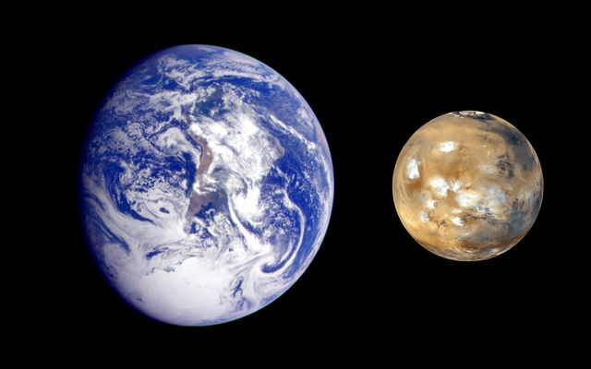

Size comparison between Earth and Mars

Figure2. Photo Taken by Mars Rover Curiosity (NASA, 2013)

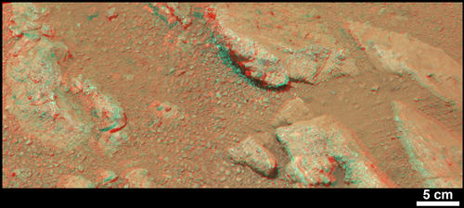

Image of a Link on Mars

7.0 References

7.1 Book/Journals

Briggs, G., and C. McKay. 2000. Mars exploration 2003 to 2013: An integrated perspective. Concepts and Approaches for Mars Exploration; 01 July 2000: 45-45

From imagination to reality: Mars exploration studies of the journal of the british interplanetary society. pt. 1 - precursors and early piloted exploration missions. pt. 2 - base building, colonization and terraformation. 1997. From imagination to reality: Mars exploration studies of the Journal of the British Interplanetary Society.Pt.1 - Precursors and early piloted exploration

James B. Garvin, Orlando Figueroa, and Firouz M. Naderi. Astrobiology. December 2001, 1(4): 439-446.

International Journal of Satellite Communications and Networking (March 2007), 25 (2), pg. 111-145

Strategies for mars: A guide to human exploration. 1996. Strategies for Mars: A guide to human exploration,

Mars global surveyor mission: overview and status Science , v.279 (5357) , p.1671 , 1998 Albee AL et al.
Opportunity in mars exploration. 2003. INTECH 50, (10): 37-37

Taylor, F. W. The scientific exploration of Mars. Cambridge, UK New York: Cambridge University Press, 2010. Print.

The Mars Reconnaissance Orbiter Mission Acta Astronautica , v.57 (2-8) , p.566 , 2005 , Graf JE et al.

7.2 Websites

"Mars Exploration Program." Mars Exploration Program .NASA.http://mars.jpl.nasa.gov.

