Spores and other internal structures
Spores
- restricted almost exclusively to some Gram positives
- Extremely rare in gram negatives
- very resistant to heat, irradiation, chemical disinfectants and desiccation (drying)
- many spore formers are pathogens
- viable for hundreds of years or much longer
- The shape of the spore, the location and distention (bulging) is diagnostiv
  - Ie can be terminal, oval, distending
- aid in survival when nutrients or moisture scarce
- complex structure: many layers
- 15% of the cell dry weight is dipicolinic acid complexed with calcium
- stabilizes the spore nucleic acids
- Revival and Identification of Bacterial Spores in 25-40 Million Year Old Dominican Amber
  - Extract stomach contents of bee trapped for 25 million years in amber
  - Bacteria was not any known species- different RNA sequence
  - were able to grow bacteria related to modern Bacillus sphaericus
    - not a contaminant
  - spore had remained viable trapped for millions of years
Inclusion bodies
- granules of organic or inorganic material that are stockpiled by the cell for future use
- some are enclosed by a single-layered membrane
  - membranes vary in composition
  - some made of proteins; others contain lipids
Organic inclusion bodies
- glycogen
  - polymer of glucose units
  - Remains as carbon stores in cell
- polyhydroxybutyrate
  - lipid-like compound (plastic like)
  - Commercial use as degradable plastic
  - surrounded by protein shell
  - most common bacterial carbon reserve material
- cyanophycin granules
  - Found only in cyanobacteria
  - large polypeptides containing about equal quantities of arginine and aspartic acid (only 2 amino acids)
  - Acts as nitrogen store for cell
- carboxysomes
  - contain the enzyme ribulose-1,5,-bisphosphate carboxylase (Rubisco), enzyme used for CO₂ fixating organisms
  - Enzyme helps cells fix co2 into sugar
Inorganic inclusion bodies
- polyphosphate granules
  - also called volutin granules and metachromatic granules
  - linear polymers of phosphates
  - Can be used to make ATP when they are nutrient starved
- sulfur granules- stored sulfur source
- magnetosomes
  - intracellular chains of magnetite (Fe₃O₄) (Tiny magnets)
  - 40-100nm, membrane enclosed
  - acts as magnet to orientate the cell in magnetic field
  - Magnetic fields guide them to swim down into the nutrient rich sediment and away from oxygen
  - Microaerophilic- killed by high oxygen levels but still need a little bit to grow
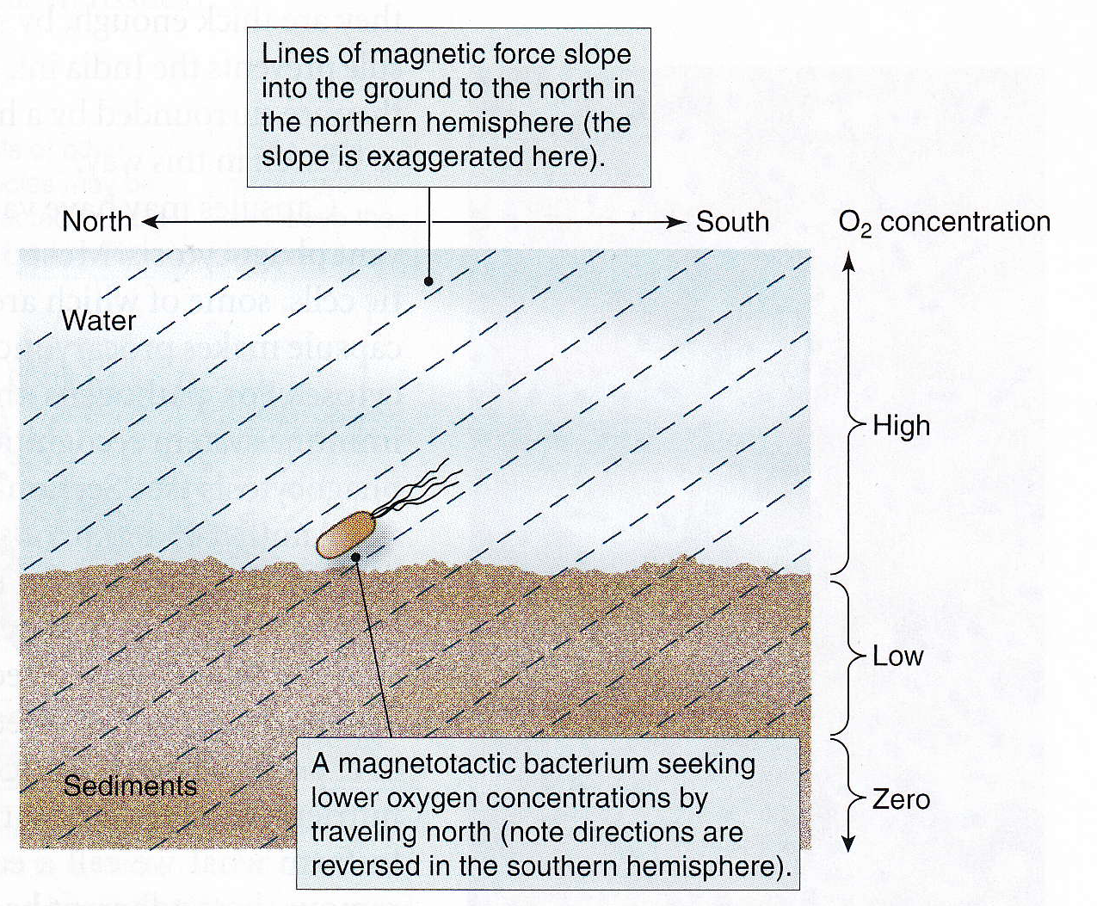

Gas vesicles (type of inclusion)
- many cyanobacteria and other aquatic forms
- floating device that allows cells to reach optimum depth for light, oxygen and nutrients
- Gas vesicles are aggregates of large numbers of small hollow cylinders
  - If they want to move up they make vesicles, if they want to move down the collapse some
- vesicle walls don’t contain lipid, just protein
- impermeable to water but permeable to atmospheric gases
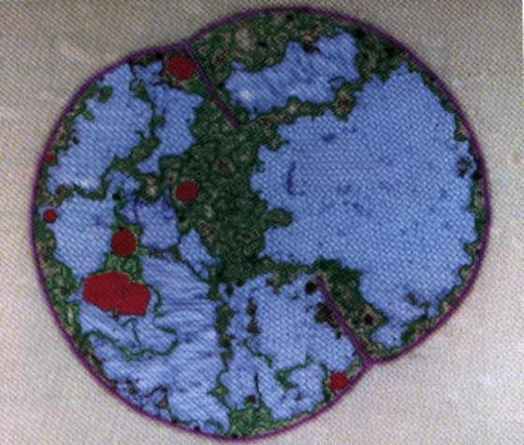
Internal membrane systems
- few specialized groups of bacteria have extensive internal membrane systems
  - e.g., photosynthesizing bacteria using light energy
- Allow cells to put light capturing structures on the membrane
- involved in chemiosmotic generation of ATP

