Transposons, Plasmids and Conjugation
DNA
- chromosome or genome
  - genes, genotype
- each gene encodes a single protein or can also code for RNA
  - structural (pili, flagella, cell wall)
  - transport/export
  - signal transduction
  - enzymes: catabolic and degradative
  - RNA e.g. tRNA, rRNA
- genome determines the nature and activities of the cell (phenotype i.e. observable properties)
- Phenotype is not constant because not all genes are being transcribed at the same time
  - Ex planktonic v/s biolfilm state
- Genome is not constant; additional sources of DNA (DNA is not constant)
  - plasmids
  - gene transfer from other bacteria
Plasmids
- extrachromosomal DNA molecules (physically separate from the chromosome)
- carry genes, usually not essential genes (if cell loses plasmid it can still grow)
- generally circular molecules (rarely linear)
- self replicating (copy themselves independently from the chromosome)
  - Own origin of replication independent of chromosome
- much smaller than chromosome (3-10 Kb v/s 2-4 Mb for bacterial chromosome)
- characteristic copy number- often correlates with actual size of plasmid
  - low copy 1-2 per cell (large plasmids usually)
  - high copy number (30->100, smaller plasmids)
Bacterial Plasmids
- small, double-stranded, usually circular DNA molecules
- are replicons
  - have their own origin of replication
  - can exist as single copies or as multiple copies
- curing
  - elimination of plasmid
  - can be spontaneous or induced by treatments that inhibit plasmid replication but not host cell reproduction
  - Cure=rid the cell of the plasmid (ex acridine orange)
- episomes =plasmids that can exist either with or without integrating into the hose chromosome
- conjugative plasmids (self transmissable)
  - have genes for sex pili
  - can transfer copies of themselves to other bacteria during conjugation via sex pili
- some non conjugative
  - can be mobilized by conjugative plasmids if in the same cell via sex pili
  - No genes to code for their own transfer
Importance of Plasmids
- Pathogenesis
  - Rapid spread of resistance to antibiotics
  - Can encode for toxins found on the plasmid
- Environmental
  - Biodegradation e.g Tol plasmids of Pseudomonas sp
  - Due to enzymes present on plasmids
- Biotechnology
  - vectors for cloning, overexpression etc e.g pUC plasmids
  - All cloning vectors based on plasmids
Types of plasmids
- 1.Fertility factor (F factor)
  - 94.5 kb- very large
  - Has genes genes for conjugation (ie sex pili)
  - Info required for transfer is found in tra operant: tra genes for transfer, involved in preparing the gene for transfer and formation of sex pili etc
  - F factors are episomes
- Resistance (R) factors
  - enzymes that destroy or modify antibiotics
  - can be resistance to many antibiotics on one R factor (as many as 8 have been found)
  - conjugative and promiscuous: easily spread
  - Can transfer even to different genre
  - Whole different genre can pick up anibiotic resistance
- Col plasmids
  - a type of bacteriocin –encodes protein that destroys other bacteria, usually closely related species
    - encode colicin (kills E. coli)
    - Made by certain strains of e. coli that kills other strains of e.colileaves more of the resource left for that strain
- some are conjugative
  - some carry resistance genes
- virulence plasmids
  - carry virulence genes- make a particular organism more pathogenic
    - e.g., genes that confer resistance to host defense mechanisms
    - e.g., genes that encode toxins (ex E.coli and travelers direaha) antrax by baccillus anthraxes
- metabolic plasmids
  - plasmids that carry genes for metabolic processes
    - e.g., genes encoding degradative enzymes for pesticides
    - e.g., genes for nitrogen fixation (Rhizobium and legumes) legumitus plants fix nitrogen and rely on rhizonium
Transposable Elements
- transposition=the movement of pieces of DNA around the genome or onto plasmids
- transposable elements (transposons)=segments of DNA that carry genes for transposition
- widespread in bacteria, eucaryotes and archaea
Types of transposable elements
- insertion sequences (IS elements)- contain only genes encoding enzymes required for transposition (ie. The enzyme transposase)
  - transposase genes are flanked with inverted repeats (short stretches 15-20 bases long) at either end
- composite transposons- carry genes in addition to those needed for transposition (still have transposase)
  - contains inverted repeats and antibiotic resistance- when it goes to a plasmid it can take the antibiotic resistance with it
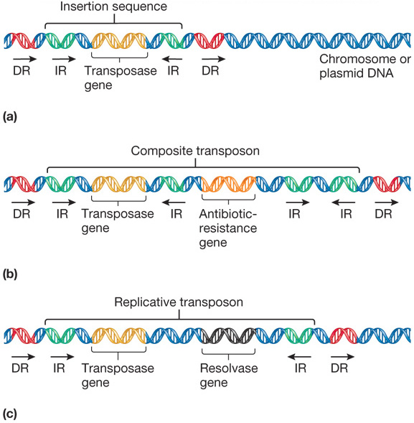
The transposition event
- usually the transposon is replicated, remaining in original site, while duplicate inserts at another site
- insertion generates direct repeats of flanking host DNA
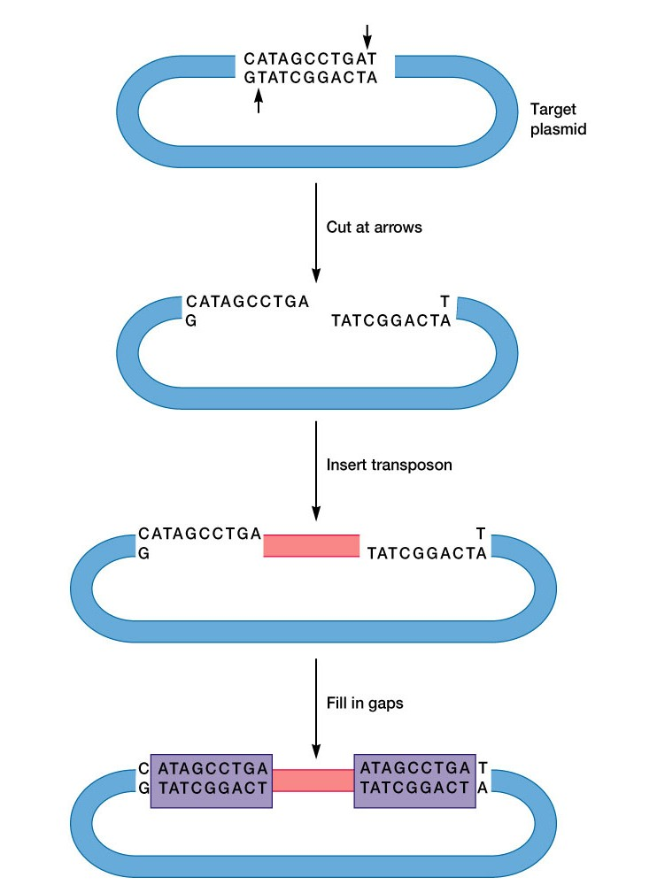
- Arrows in the top drawing indicate where the 2 strands of host DNA will be cut. Pink bar represents the transposon. Purple boxes represent repeats of host DNA at each end of the transposon.
- Enzyme recognizes target site and cuts staggared site, transposen inserts, and leaves direct repeat on either side (flanked) of transposon’s inverted repeates-

Effects of transposition
- mutation in coding region by insertion into a gene
- arrest of translation or transcription
- activation of genes- if transposon has promoter
- generation of new plasmids
  - e.g., resistance plasmids
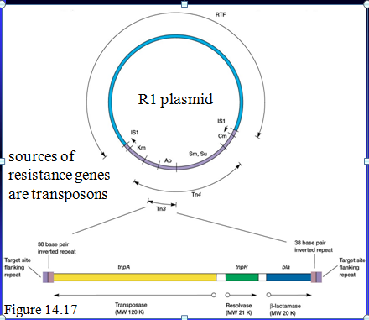
The R1 palsmid carries resistance genes for 5 antibiotics. Cm=chloramphenicol; Sm=streptomycin; Su=sulfonamide; Ap=ampicillin; Km=kanamycin. The resistance genes are contained in the Tn3 and Tn4 transposons. RTF codes for the proteins necessary for plasmid replication and transfer. At the bottom, the structure of TN3 is shown in more detail. The arrows below that drawing indicate the direction of transcription.
Within transposon 4 is transposon 3- plasmid originaly had T4, t3 came in- now it has 2 resistance genes
Conjugation
- transfer of genetic information from one bacterial cell to another by direct cell to cell contact
- U-tube experiment-auxotrophs vs prototroph
Bacterial Conjugation
- The transfer of genes between bacteria that depends on
  - Direct cell to cell contact mediated by the F pilus encoded by F plasmid
  - A type IV secretion system is involved in conjugation
Type IV secretion
- Sex pilus encoded by F plasmid makes initial contact between male and female cell, then retracts to pull cells together
  - Cell that has plasmid is male
- Male prepares for DNA transfer by assembling type IV secretion system consisting of sex pilus and other Transfer proteins; pilus is embedded in secretion structure
- DNA goes through the type IV secretion apparatus but may not go through the pilus itself
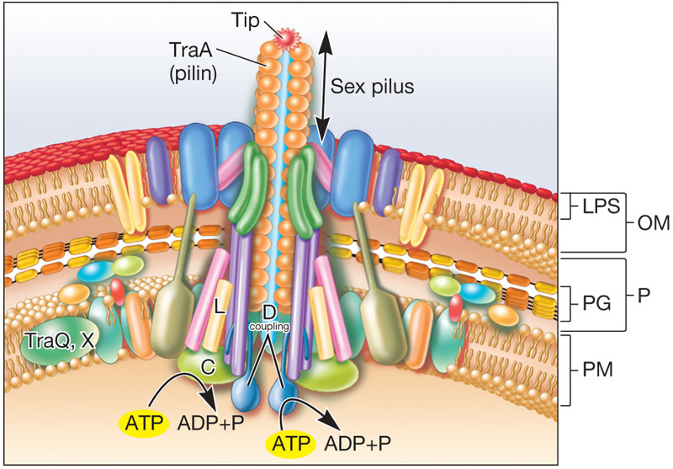
Lederberg and Tatum 1946
- Mixed multiple auxotrophic strains and after a few hours plated on minimal media
- One strain required biotin, phenylalanine and cysteine, the other thiamine, threonine and leucine
  - Auxotroph= organism that has a mutation that inables it to synthesize its own amino acidscan’t grow on minimal media unless you supply these
  - Protrohph- can make all of its vitamins and amino acids on its own and therefore can live on minimal media
- Neither one of the starting strains could grow on minimal media but after mixing the two together they got colonies on minimal media
- Therefore exchange of genetic material later shown by Davis in the U-tube experiment in 1950 to require cell to cell contact
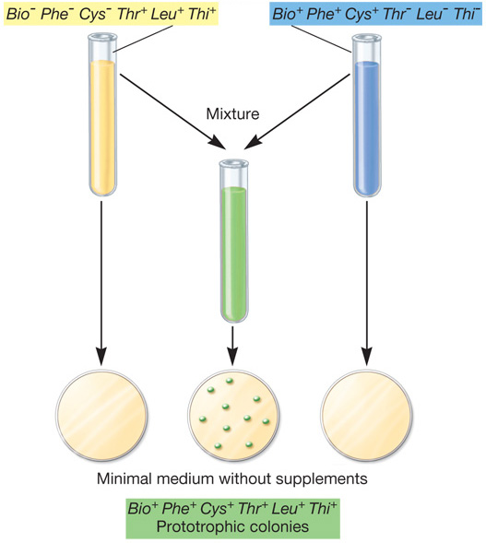
The U-Tube Experiment of Davis
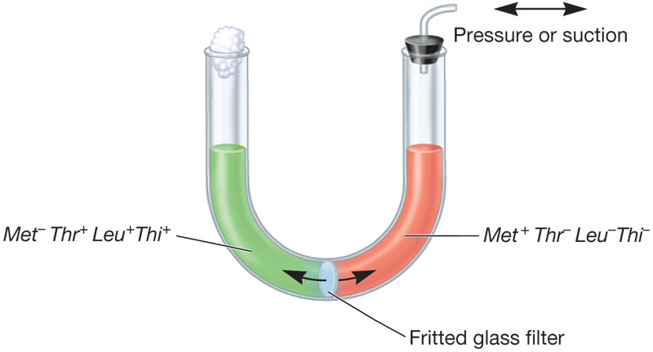
- Took muliple auxotrophic strains on either side of a glass filter
- Media could go back and fourth but bacteria could not with filter, no colonies grew on minimal media, Without filter coloinies grew on minimal media
- Sex pilus contact was prevented by glass filter
The F plasmid
- Bears genes responsible for cell attachment and plasmid transfer between E.coli
  - Info located in tra operonall tra genes are necessary for transfer
- 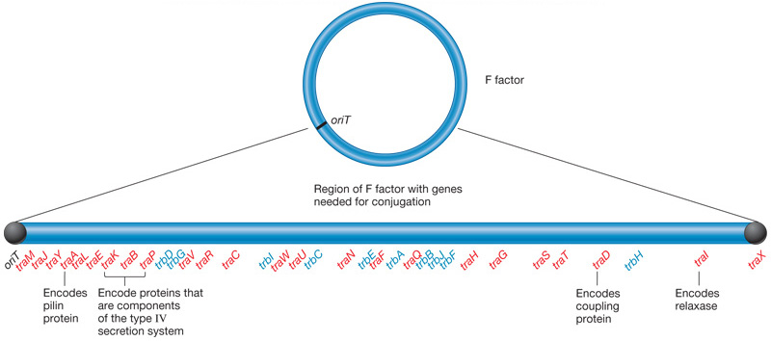

F⁺ X F⁻ mating
- transfer is polar (Hayes in 1952)- only goes from donor to recipient
  - donors (males, F⁺) and recipients (females, F⁻)
- F⁺ have sex pili: channel for DNA passage?
- replicative transfer, i.e. recipient becomes male (donor)-
  - one copy is replicated 1 is transferred
- chromosomal genes not transferred (rarely changes from auxtrophic)
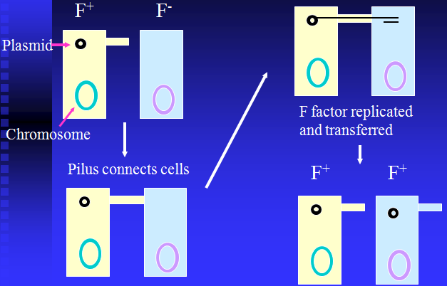
Hfr conjugation
- F factor integrates into chromosome
  - Strain now called Hfr strain
- still mates with F⁻ transfer of chromosomal genes
- recipient usually stays F⁻ because only part of F⁺ is transferred
- Origin is in the middle of the F factor so you have to transfer the whole chromosome to get the whole F factor which takes 90 minutes (too long) so recipient stays female (f-)

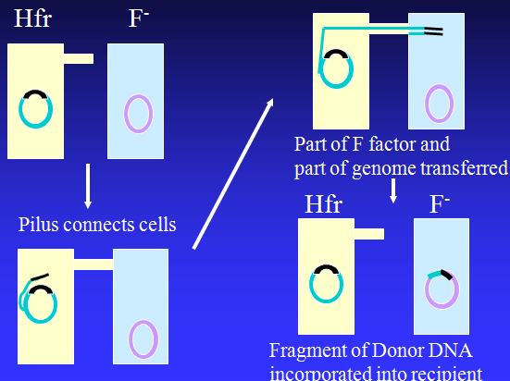

F’ mating
- integrated F factor can leave chromosome (it is an episome)
- sometimes imperfect excisionpicks of a piece of chromosome
- F factor then carries small amount of chromosome
  - This is called F’ (F prime)
- in F’ x F⁻ mating, chromosomal genes on F’ are transferred with high frequency


