Bacteria Cell Walls
Procaryotic cell wall
- Lies just outside plasma membrane
- shape maintaining
- protection against osmotic lysis and from toxic substances
- contributes to pathogenesis
- site of action of many antibiotics
- knowledge about assembly important in design of new antibacterial agents
Types of cell wall
- bacterial
  - Gram positive: electron dense thick layer (20-80nm) of peptidoglycan outside cytoplasmic plasma membrane, teichoic acids
    - More resistant to osmotic pressure due to thick PG layer
  - Gram negative: CM, thin peptidoglycan plus a think outer membrane
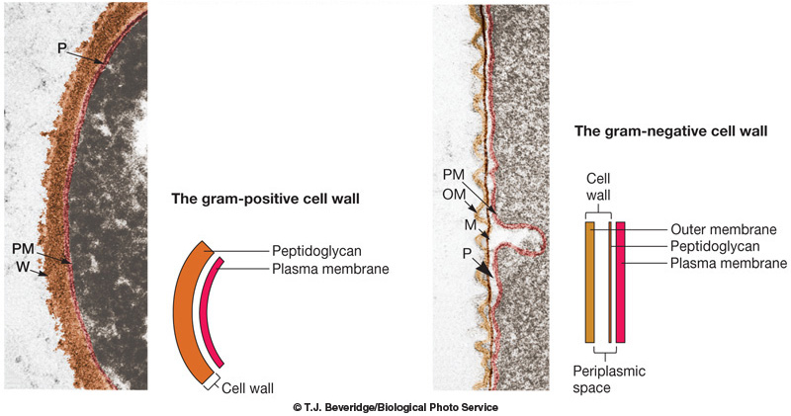
- Exception: mycoplasmas (bacteria) have no cell wall
- Archaea (halophiles, thermoacidophiles, methanogens)
  - diversity of walls
  - no peptidoglycan!
Mechanism of Gram staining
- difference in gram staining is due to difference in physical nature of cell walls
  - if cell wall is removed from gram positive it stains gram negative
  - bacteria with no cell wall (mycoplasms) stand gram negative
- bacteria are stained with crystal violet then treated with iodine to promote dye retention
- bacteria are then treated with alcohol in decolorization stepalcohol shrinks the pores of thick PG layer of gram positive cells, this causes PG to act as permeability barrier and prevent the loss of crystal violet dye so they stay purple
- PG in gram negative is not as highly cross linked and has larger pores, alcohol extracts lipids from the OM making it more porousalcohol therefore removes crystal violet dye from gram negative bacteria
  - Gram negative are easily stained pink by counterstain safranin
To look up:
- spheroplast vs protoplast
- when gram negative bacteria are exposed to lysozome or penicillin, the PG layer is lost but the outer membrane remainscell in this state is called spheroplast
- when gram negative are exposed to a lysozome or penicillin the cell wall is completely lostcell in this state is called a protoplast

Gram negative
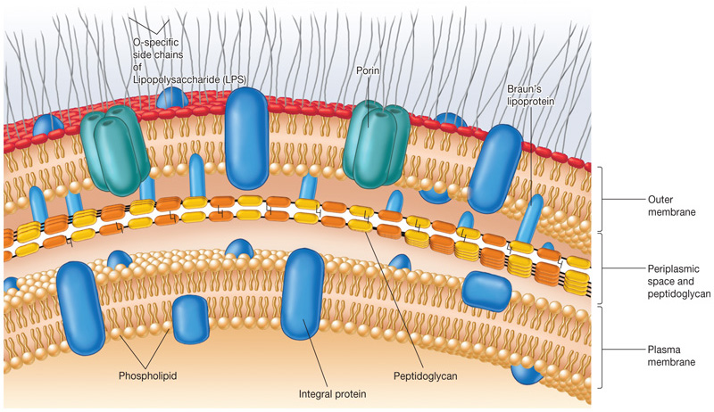
Outer membrane
- chemically distinct from the cytoplasmic membrane
- acts as barrier to keep periplasmic proteins from diffusing away
- OM is linked to PG by Braun’s lipoproteins
- relatively permeable to small hydrophilic molecules (ex sugar)
  - Porin proteins in outer membrane allow passage
- toxic properties- lipopolysaccharide
  - Major component
Brauns lipoprotein
- mw of 7200, 700,000 copies- most abundant protein in OM
- anchors OM and PG- covalently joined to underlying PG layer and embedded in the OM by hydrophobic end
  - N-terminus at OM (hydrophobic)cystine with fatty acids bound to OM
  - C-terminus bound at PGlysine bound covalently to DAP of peptidoglycan
Lipopolysaccharide (LPS)
- Large complex molecule containing both lipid and carbohydrate
- asymmetric location- found only in outer leaflet of outer membrane
- major component of OM- covers 40% of cell surface
  - 3-9% cell dry weight
- Endotoxin (LSP)- property of gram negative bacteria that can cause disease
  - Pyrogenic, diarrhea
  - Fibrinolysis- interferes with blood clotting
  - in large doses: tissue necrosis shock and even death
- composed of three parts: (1) lipid A, (2) core polysaccharide (3) O-antigenic side chain
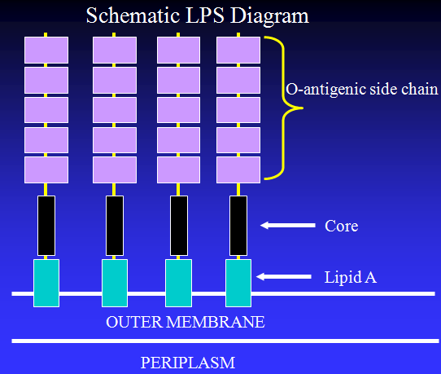
Lipid A: endotoxic part
- contains a phospohylated dimer of glucosamine each with three fatty acids attached
  - glucosamine is a disaccharide (derivative of sugar)
- fatty acids either linked directly to glucosamine or ester linked to 3-OH fatty acids that are directly linked to glucosamine
  - ie more fatty acids can be attached to each other
- hydrophobic fatty acid chains anchor the LPS into the bacterial membrane, and the rest of the LPS projects from the cell surface
- responsible for toxicity of gram negative cells: When bacterial cells are lysed by the immune system, fragments of membrane containing lipid A are released into the circulation, causing fever, diarrhea, and possible fatal endotoxic shock (also called septic shock)

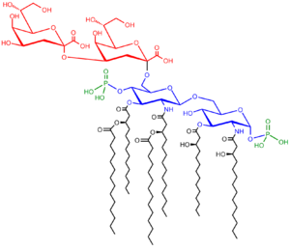
Core polysaccharide
- connected to Lipid A at position 6 of glucosamine
- 8-10 unusual sugars, often branched, heavily phosphorylated
  - Phosphate group has charged therefore we get an accumulation of charge in the inner region
- 2 unusual sugars attached: make up inner core
  - keto-deoxyoctulosonate (KDO) (8 carbons) attached to lipid A
  - Heptose- (7 carbons)- attached to last KDO residue
- The outer core is made of hexose residues that are attached to the last heptose residue in the inner core
O-antigenic side chain
- Repetitive glycan polymer- units of 3-5 sugars polymerized up to 50 times to give a structure larger than core
  - Antigenic- triggers immune response (antibodies)
- Each repeating unit contains 2-7 monosaccharide residues diversity results in the O-chain of most bacterial species being unique
  - hydrophilic sugars and amino sugars
- responsible for the serological specificity
  - If you get an infection you get antibodies to that specific polysaccharide

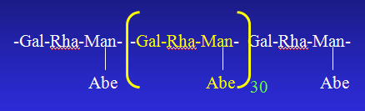
LPS biosynthesis
- Assembly occurs in the cytoplasm and is completed LPS is transferred to outer leaflet of OM
- Assemble is sequential- Lipid A assembled first
- core sugars added one at a time
- only when core is complete can O-chain be added
- O-chain added as a repeating unit or polymer of repeat units
  - Assembled separately- added as polymer or 1 repeat unit (normally the whole polymer is added all together)
  - No single sugars added
Periplasm
- area between OM and CM on either side of the PG
- observed as big space in EM
  - artifact: really a gel and not large at all
  - Distance between PG and OM is very small – held by Braun’s protein
    - Huge tugor pressure pushing up PG to OM
- unique set of proteins (ex chaperones) only found in this specific area
  - released by osmotic shock- cells go in, buffer with sucrose and kelator (binds divalent cations sitting on core to mask negative charge of core polysacharide) kelator removes cations leaving negative charge- without charge mask, water can enter and cell bursts- periplasmic proteins are released
  - transport proteins, degradative enzymes
Outer membrane proteins
- very limited number of major OMPs (Most proteins found in small numbers)
- noncovalently associated with PG- most are porins
- Porins are present as a trimer, tube shaped, which span the OM
  - acidic
  - exposed on cell surface
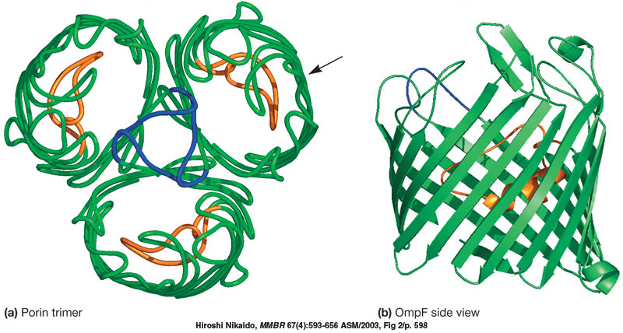
OMP function
- structural: OmpA
- permeability: Most function as porins that form holes in outer membrane
  - 1. OmpC AND OmpF: mainly cations
    - non-specific- hole is big enough a tri-tetrasaccharide
  - 2. PhoE: phosphate (inducible)
    - Specific- responsible for phosphate uptake
    - Made when cell is in phosphate starved
  - 3. LamB: maltose, lambda receptor
    - Originally called this for barteriophage lambda
  - 4. Tsx: nucleosides, T6 receptor
  - 5. TonA: ferrichrome, T1 receptor
- All are specific expect for ompC and F
Peptidoglycan
- 5-10% of Gram negative wall
  - may be only 1-2 layers thick in Gram negative
- much more crosslinking in Gram positives
- Main function: cell shape maintenance
  - Protects cell against osmotic pressure if you interfere with PG synthesis the cell will burst
- Meshlike polymer composed of many identical subunits, each contains 2 sugars:
  - N-acetyl glucosamine (NAG) and N-acetyl muramic acid (NAM)
    - Only found in PG
  - NAG is beta 1,4 linked to NAM- backbone is composed of alternating NAG AND NAM residues
- connected by short peptides of 4 alternating D-and L-amino acids
  - connected to carboxyl group of NAM
    - D-amino acids are only ever found in PG (not in proteins)
- Presense of D-amino acids protects against peptidases which only recognise L isomer of amino acid residues third position is a d-amino acid (diaminopimelic (DAP), or lysine)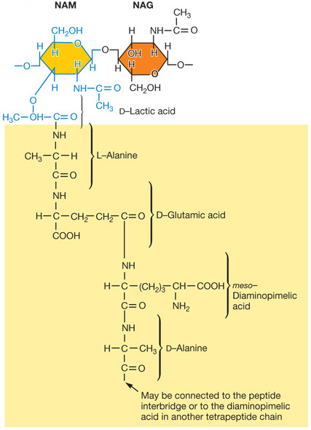
- chains of linked PG subunits joined by crosslinks (transpeptidation reaction)
  - directly: COOH of terminal alanine (position 4) to amino group of DAP/lysine in next peptide chain
  - indirectly through a pentaglycine bridge
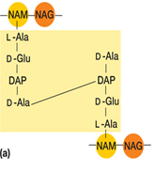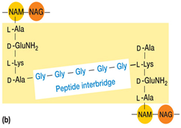
- Top: E. coli peptidoglycan; direct cross-linking, typical of many gram-negative bacteria
- Bottom: Staphylococcus aureus peptidoglycan- more common in gram positive
- Because there is not a lot of crosslinking in gram negative, there is a lot of free DAP, which is where the brauns proteins bind a lot of them 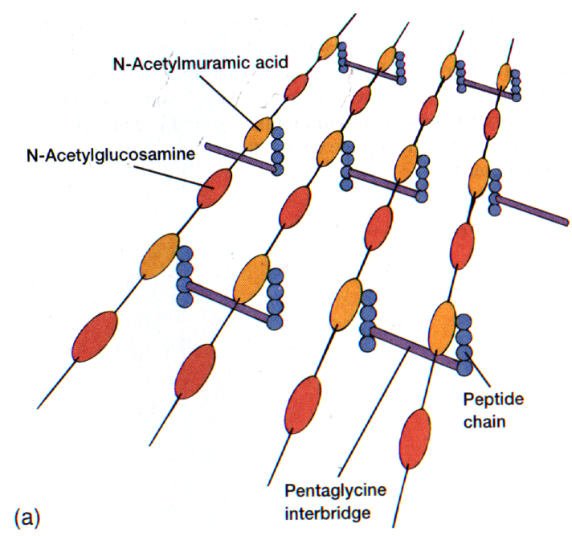
- Interconnected mesh of PG allows cell to resist tugor pressure and maintain its shape- this is what many antibiotics act on
Peptidoglycan as a target for antibiotics
- Penicillins block the transpeptidation reaction no crosslinkage
- leads to osmotically fragile cells
- penicillin can only act on growing cells- it can only prevent the formation of new linkage as cell grows (it cannot destroy ones already there)
Gram Positive Walls
- 50-60% peptidoglycan
- up to 50% teichoic acids
- no outer membrane: no lipid, no LPS, no OMPs
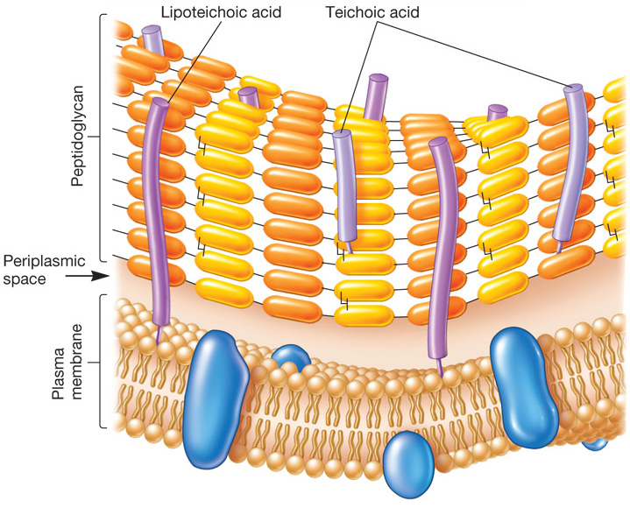
Teichoic acids
- polymers of glycerol or ribitol joined by phosphate groups
  - Polymerized up to 30 units long, exposed on surface
- amino acids (especially D-alanine) and/or sugars (gluscose) are attached to the glycerol and ribitol groups
- techoic acids are covalently bonded to PG layer
- wall teichoic acids linked to 6-OH of NAM of PG
- lipoteichoic acids linked to membrane glycolipids (only glycerol types)
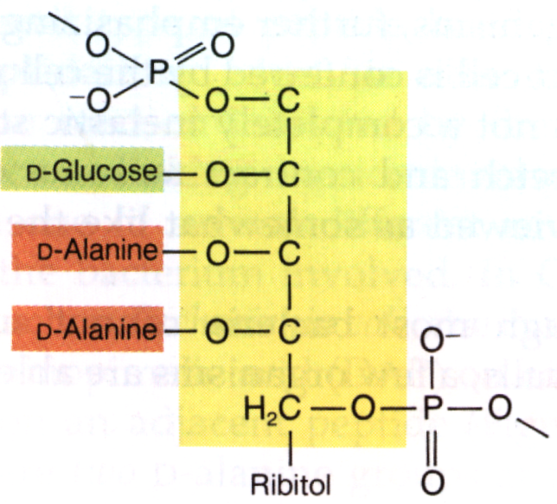
- 5 carbons, 1st and 5th attached to phosphate
- The other are attached to glucose and alanine
- Highly charged due to phosphate groups
Teichoic acid function
- negatively charged: regulate cation supply to cell surface
- potential role in cell shape
  - Unlikely because this is the role of pg which is especially thck in gram positive
- regulate autolysins
- enzyme which digest the PG in specific area to allow incorporation of new subunits (Must be regulated to maintain structure)

