Notes

Current Topics in Bioinformatics

Bio 465
Winter 2011

Index of content
Index of content I
1. Introduction - 1 -
2. Dynamic programming - 1 -
2.1. Biological relevance of sequence alignments - 3 -
2.2. Scoring functions - 4 -
2.3. PAM and BLOSUM amino acid scoring matices - 4 -
2.4. Derivation of scoring matrices - 4 -
2.5. Blosum matrices - 5 -
2.6. Database searching - 5 -
2.7. Blast - 6 -
2.8. Blast derivates - 7 -
3. Lecture – MSA - 7 -
3.1. Data sources and data considerations - 7 -
3.2. MSA – practical consideration - 8 -
3.3. Method overview - 8 -
3.3.1. Progressive alignment (Feng and Dolittle (FD)) - 8 -
3.3.2. Local/global weighting (T-Coffee) - 9 -
3.3.3. DiAling - 9 -
3.3.4. MUSCLE – iterative realignment by a provisional tree - 9 -
3.4. Steps of the progressive FD algorithm - 9 -
3.4.1. Aligning everything with everythign - 9 -
3.4.2. Calculating a tree - 9 -
3.5. Guide trees vs phylogenetic trees - 10 -
3.6. Fixing initial errors in the MSA - 10 -
4. Session – MUSCLE paper - 10 -
4.1. What is an MSA is used for? - 11 -
4.2. What is the difference between the Sum of pair alignment and the progressive alignment? - 11 -
4.3. What is a Kmer or K-tupel? - 11 -
4.4. What is the difference between the first and the second guided tree in the MUSCLE algorithm? - 11 -
4.5. What is a distance between two sequences? - 11 -
4.6. What are the three basic steps of the MUSCLE MSA? - 11 -
4.7. When a pair of sequences is aligned how is the pairwise identity calculated? - 12 -
4.8. Kmer counting – they don’t explain how they do this - 13 -
4.8.1. Log expectation function: - 13 -
4.9. Distance correction - 13 -
4.10. Concept of test set: - 13 -
4.11. How does the actual subtree cutting works? - 14 -
5. Phylogentic trees - 14 -
5.2. Models of evolution – phylogeny II - 17 -
5.3. Better distance – the poisson distance d_{p}. - 17 -
5.4. Jukes-Cantor model? - 17 -
5.5. Maximum likelyhood - 18 -
5.6. Bootstrap analysis – resampling data - 20 -
6. HAP MAP - 21 -
7. CNVs - 21 -
8. Protein evolution (Lecture 18.) - 21 -
9. - 22 -
10. Promotore recognition – Promotor inspector - 23 -
11. RNA – Seq: - 24 -
12. Closing remarks - 26 -

Introduction
Bioinformatics applications:
- sequence alignments
- sequence comparisons
- clustering and phylogenetic trees
- gene finding
- evolutionary histories
- functional annotation
- pattern analysis
Random examples:
- LC MS: Digest liquid chromatography
- Ensemble – comparative genomics – mapping blocks – where are chromosome areas found in other organisms? Mouse model organisms.
- Protein structure modeling
- Genotype analysis
- Gene regulation analysis
- Systems biology
- Homology recognition – global/local sequence Alignments (Needleman wunsch/smith waterman)
- Blast – heuristic homology search. Several variances – WU blast is good for over 65 % identity – Based on two models, Homology or not.
- Substitution matrices. PP or NN, PAM and BLOSUM, PAM HIGH QUALITY; SINGEL CHANGE, EXTRAPOLATION. BLOSUM for Database search – B62 best compromise
- Use of log odd values is more easy than using no log values + addition
- Homology modeling of proteins – Model the protein structure based on known structure of known proteins
- When sequence homology is found, you know they are related. Homology is a es and no question. Log odd is zero if a occurrence is the same as random matching.
- Training set – what is that: Test set of data.
- Gap penalties are heuristic as well.

Dynamic programming
We have a DNA or protein sequence and we want to calculate a score that reflects how similar they are. Thus how likely it is that they are derived from a common ancestor. Because there are sequences differ not only in substitutions but also in insertions and deletions, we want to find an optimal way to align the two sequences to maximize similarity.
We can’t score all possible alignments, because it would get way to time intense to calculate. The time is dependent on “to the power of N” :
$$\frac{2^{2N}}{√(2πN)}$$
For N=300 this is already ${10}^{179}$
Two sequences
X Y
Length respectively
M N
Residues respectively
$$X_{i}$$
$$y_{j}$$
Need a scoring matrix (4x4 for Nucleotides, 20x20 for amino acids) or a match and mismatch score
$$σ\left(x, y\right)$$
Penalty for introducing a gap
$$γ$$
The dynamic programming consists out of four parts:
- A recursive definition of the optimal score
- A dynamic programming matrice for remembering the optimal score of sub problems
- A bottom up approach of filling the matrix by solving the smallest sub problem first
- Traceback of the matrix to recover the structure of the optimal solution that gave the opt score
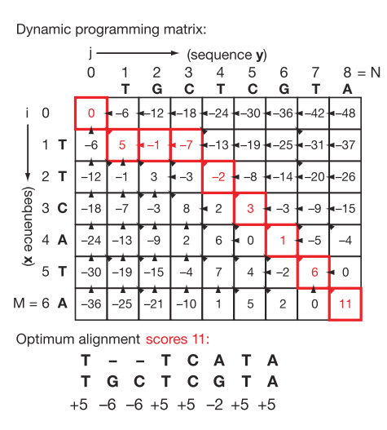
Figure 1: Match: +5; Mismatch: -2; Gap/Indel:-6, Arrowheads are tracebacks. This time the path is unique, sometimes more paths are possible.
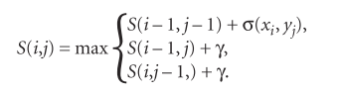
Figure 2: The general recursive solution of all partial problems. Recursive because the score is defined by the residues that came before. Just this score counts and note down where the score comes from! This is the tracking.
The sub-problems are tracked: This is the difference to simple recursion. The sub problems are stored in the dynamic programming matrix.
Dynamic programming gives you a mathematically optimal solution. Whether or not this is of biological relevance depends on the scoring matrix.
Simple scoring functions are used because they strike a reasonable compromise between biological reality and efficient computation.

Biological relevance of sequence alignments
The primary goal of alignments is to determine whether or not the sequences are homolog, in other words, do they have a common ancestor.
This is used to infer a similar function of the sequence
Infer a common origin
Determine evolutionary distance
Find target genes and proteins in a model organism
Used for homology modeling of proteins
Identification of important residues

Scoring functions
Could be either base on amino acid scoring matrices or nucleotide-nucleotide scoring matrices.

PAM and BLOSUM amino acid scoring matices
PAM is for Global alignment. PAM matrices are derived from the comparison of sequences from closely related proteins. Other matrices are extrapolated from PAM1. PAM 1 assumes 1% divergence of sequence.
What is divergence from sequence?
BLOSUM are based on local alignments. The BLOSUM 60 matrices are derived from amino acid seqeuences with 60 percent identity. BLOSUM matrices are not extrapolated, they are derived from observed seqeuences! Blosum 62 works quite well for close relationships.

Derivation of scoring matrices
The odds ratio is important! It is the ratio between the probability of two different models. One assumes a random probably another assumes a evolutionary distance.
The most scoring systems use the Log odd, because the probabilities are then just additive instead of multiplicative.
$$\frac{q_{a,b}}{p_{a}p_{b}}=odds ratio$$
q_{ab} is the evolutionary probability of an alignment between two residues, p_{a} and p_{b} are the probabilities of each residue to occur and the multiplication therefore the probability of random occurrence.
In other words
$$\frac{q_{a,b}}{p_{a}p_{b}}=\frac{probability that alignment is authentic}{probability that alignment is random}$$
It’s assumed that for each column the alignment is independent and therefore these ratios can be multiplied
$$odds ratio={Π_{u}(\frac{q_{a,b}}{p_{a}p_{b}})}_{u}$$
If the logarithm is formed then the equation becomes more simper.
$$S=\log{odss ratio}=Σ_{u}{(log⁡(\frac{q_{a,b}}{p_{a}p_{b}}))}_{u}$$
Equivalently, this is the log odds ratio of observed frequencies to random frequencies. $λ$ is a scaling factor. f are the background occurencies of the amino acids a and be respectively. P is the observed probability of a amino acid pair.
$$s\left(a,b\right)=\frac{1}{λ}\log\left(\frac{P_{ab}}{f_{a}f_{b}}\right)$$

Blosum matrices
From the BLOCKS database with many ungapped local multiple sequence alignments.
It is obvious, that amino acids with similarities interchange more frequent than highly diverse amino acids. This is reflected by the score in the Blosum matrix.
Too similar sequences in the training set – i.g. the alignments the blosum matrix is derived from will bias the results. Therefore the sequences have to be weighted.
How was this weighting performed? Sequences with more than 80% identity were clustered to one sequence.
So now how are the numbers generated in the BLOSUM matrix? Given a lot of amino acids that are aligned in a training set on can calculate their frequency of occurrence together, f_{ij} and the
$$q_{ij }=\frac{f_{ij }}{\sum_{i=1}^{20}{\sum_{j=1}^{20}{f_{ij}}}}$$
Is this equation correct? Does the double sum really reflect the background frequency of a couple of amino acid? It is the sum of exchanges of all amino acids with all other amino acids?
I don’t understand what the summation under the fraction bar means. It should be the random frequency that amino acids occur? What is summed up? All frequencies of exchange of one amino acid plus the frequencies of exchange of the next one and so on… what is that? You sum up every possible exchange frequency.
Scaling factor and log can be added later to the matrix. Is it required?
Where are the gap penalties derived from? They don’t have a solid theoretical derivation. They are chosen

Database searching
There is a alignment between the database entries and he initial query sequence. The results are reported and ranked. An E value is calculated to rank these alignments. The E value is the probability of generating the same score of the alignment by just aligning random sequences. How exactly would this random score be generated? How do I calculate how probably it is that a certain score will be achieve?
Heuristic methods are used to search the databases. So called words or k-tupels are used for searching the database.
Databases: EMBL/GeneBank, Swissprot, PDB

Blast
b. BLAST Program Search Strategy:
Step 1. Rapid exact-match searches identifies promising regions
Step 2. Smith-Waterman algorithm implemented on this restricted set of alignments
This heuristic search strategy is 10-100 times faster than the complete Smith-Waterman, although less accurate. Thus, BLAST sacrifices the guarentee of optimality in local alignments for a significant improvement in runtime.

http://searchlauncher.bcm.tmc.edu/help/BLASToutput.html
How is the E value calculated in BLAST?
The Expect value (E parameter) represents the number of times this match or a better one would be expected to occur purely by chance in a search of the entire database. Thus, the lower the Expect value, the greater the similarity between the input sequence and the match. Any database sequence whose sequence alignment satisfies the E parameters will be reported in that line of the histogram. Thus, for each E parameter value, there is a graphical representation of the number of database sequences that fit that E value.
The P-value for observing such a match. 'Sum', when present, indicates that Sum statistics were used to caluculate Expect and P values. The value following sum P in parentheses - Sum P(*) - is the N parameter indicating the number of HSPs used in the statistics.
What is the relationship between a P and an E value?
P = 1 - e^{-E}, (for E and P < 0.05, E ≈ P)
What are k m n ?
E = Kmn e^{-λS}
in bit scores, E = mn 2^{-S}
What is S in this case?

E values below 0.1 are considered significant.
Protein sequences are more useful for interfering function and structure from sequence sequence.
Low complexity regions (e.g. repetitive regions) can be similar without being related, blast mostly blocks these regions.
Significant similarity most often means homology, but homology does always goes with sequence similarity. (remember Homology: common ancestor)
Identity: % identical residues
Similarity: % similar residues
Homology is a yes or no question! Keep this in mind when blasting a sequence in the database! You want to know if your Sequence is already in the database or a homolog sequence is there which allows to draw conclusion in respect of the function of the proteins

Blast derivates
Blast n: DNA vs DNA
blastp Protein vs Protein
blast x: All 6 reading frames vs Protein
tblastn: Protein vs all six reading frames of a DNA sequence
tblastx: All six reading frames of DNA vs all six reading frames

Lecture – MSA
What are the applications for aligning multiple sequences? A multiple sequence alignment elucidate which sequences are conserved, which common structures, patterns motives are present and what. Conserved regions are often of structural or functional importance. MSAs are better in detecting homologs. The output of a blast search can be in the form of an MSA, which reveals additional data to your query.
Your single sequence can also be searched in an MSA database. Eg. in the conserved domain database (CDD).
One of the functional characteristics of a sequence could be a regulatory element, eg. TATA BOX for pol binding, also active centers and certain 3D Structure determining residues.

Data sources and data considerations
Where does the data comes from that I use in an MSA? Often we start with a single sequence of interest, wherever this sequence comes from. Further related sequences then can be found by blasting a database (RefSeq (filters redundancy), nr, pdb( limit to structure)). The identified homologs then can be used for further search of also homolog sequences. This search can include keyword searching. This is a somehow iterative step. All these sequences then can be evaluated if they are of interest for the MSA. A PSI-BLAST was mentioned as well, how does psi blast works? Position specific iteration blast? For this a Position specific scoring matrix is used (PSSM).
Position-Specific Iterative (PSI)-BLAST is a protein sequence profile search method that builds off the alignments generated by a run of the BLASTp program. The first iteration of a PSI-BLAST search is identical to a run of BLASTp program (1). It then generates a multiple alignment of the highest scoring pairs of the BLASTp run above a certain preset score or e-value threshold and calculates a profile or a position-specific score matrix (PSSM) from the multiple alignment. The PSSM captures the conservation pattern in alignment and stores it as a matrix of scores for each position in the alignment-highly conserved positions receive high scores and weakly conserved positions receive scores near zero. This profile is used in place of the original substitution matrix for a further search of the database to detect sequences that match the conservation pattern specified by the PSSM. The newly detected sequences from this second round of the search, which are above the specified score (e-value) threshold are again added to alignment the profile is refined for another round of searching. This process is iteratively continued until desired or until convergence, i.e., the state where no new sequences are detected above the defined threshold. The iterative profile generation process makes PSI-BLAST far more capable of detecting distant sequence similarities than a single query alone in BLASTp, because it combines the underlying conservation information from a range of related sequence into a single score matrix.
Also literature can be mined for information.

MSA – practical consideration
The goal is to include all related sequences – is there something known about our protein of interst that helps us to include sequences?
Mostly: more sequence the better.
3 Sequences give not much information
Highly identical sequences introduce redundancy and should be removed – above 80 percent identity- highly identical sequences can be represented as one sequence by aligning them.
On the other hand at least a little identity is required – 40 – 50 % - Sometimes low identity sequences are added if eg. a certain structure is known to be present.
Other consideration:
Do the sequences have the same length? Is there a known domain structure? May the MSA be divided into subgroups? For some reason redundant structures could be added again.

Method overview

Progressive alignment (Feng and Dolittle (FD))
Sequences are globally aligned (needleman wunsch) in a given order eg ClustalW (rapid algorithm)
There are continuously sequences added in the FD algorithm – there is no check!
Steps in the FD:
- Do a set of pairwise alignments with the Needleman Wunsch algorithm (global!)
  - Every sequence gets alined with every other sequence – scores are then used to build the tree in step 2.
  - To similar sequences can be removed or counted as one
  - Dissimilar sequences can be edited.
- Create a guide tree to specify the order of the further alignment
  - This is done by the taking the scores from step one and converting them into distance scores
  - The three indicates the distances between the scores
  - First ClustalW used UPGMA, newer one uses Neighbour joining.
- Progressively align the sequences
Computational power: $N^{2}$

Local/global weighting (T-Coffee)
Uses a bunch of alignments – information from other sequences are used to weight pairwise alignments. How is this done?
What is meant by “ local and global” sequences are weighted?´

DiAling
No specific gap penalty. How is this different to the others? Aligns short regions and then merges sequences. How does this work?

MUSCLE – iterative realignment by a provisional tree
Sequence subsets are removed and realigned. A tree based hierarchy is used.
What are these sequence subsets?

Steps of the progressive FD algorithm

Aligning everything with everythign

Calculating a tree
The simplest method just takes in account percent identity between sequences. This then is used to calculate the fractional mismatch.
$$D=1-\underset{\begin{aligned}fractional \\ identity\end{aligned}}{\underbrace{\frac{\%identity}{100}}}$$
This not takes in account multiple substitutions.
Kimura introduced a equation that accounts for multiple substitution. This is the so called kimura distance. This is used by MUSCLE and other algorithms. D is the fractional identity.
$$d_{Kimura }= -\ln\left(1 - D - 0.2⋅D^{2}\right)$$
Which is valid for D < 0.854 (% id > 14.6%)
This takes in account that multiple substitutions occur in a different way similarities.
Another method was introduced by Feng and Dolittle:
$$D = -ln S_{eff}$$
$$S_{eff}=100\%⋅\frac{S_{real ij}-S_{ran ij}}{S_{ident ij}-S_{ran ij}}$$
What does this mean? The Distance is D. S_{eff} is the.. ? What is S_{eff}?
i a j are sequences
S_{real} is the observed similarity between i and j
S_{ident} is the average score of the sequence compared to itself
S_{ran} is the score obtained from several hundred alinments of random shuffled sequence i and j.
if i = j – Distance will go to zero – S_{eff} goes to 1
if not similarity – Distance will get to infinity
What is meant by the average score of a sequence compared to itself? When I compare a sequence to its self its hundred percent identical? Therefore reaches S_{max}? Or in other words fractional identity goes to one. 100/100. Fractional mismatch would be zero.
What is meant by a baseline score? Comparison of randomized sequences should somehow give the minimum score? Identity is the maximum possible score.

Guide trees vs phylogenetic trees
The question is: Are the guide trees also effective phylogenetic trees that reflect evolutionary connections? Not really, they are based on the pairwise sequecene alignment and not optimized to be a phylogenetic tree. It is based on pairwise similarity not based on similaritiy in a MSA (comparasion to the other sequences). It’s more an intermediate step in the analysis of sequence data.

Fixing initial errors in the MSA
What happens if there is an error in one of the very first pairwise alignments? This error would be retained in the MSA if there is no algorithm dealing with this problem. Several solutions exist.
Eg.
Pairwise alignments could be weighted using other sequences. This approach compares a given position in a pairwise alignment to the other sequence and asks how often this postion is shared with other sequence. (T-COFFEE)
Or the iterative removement of re-alignment of sequences (MUSCLE). How are sequences removed from an alignment? How are they realigned?

Session – MUSCLE paper
Common in Bioinformatics – it compares the current method with other methods – benchmarking – faster or more accurate.
Structure of the paper:
First sentences – why MSA - Explains the best way – SP is still NP complete – there is no polynominal solution - time intense
Strong men argument – you set someone up – what they show is it not the best – but they do it in a nice way.

What is an MSA is used for?
Creating phylogenetic trees, predicting structures and finding critical residues in a protein sequence.

What is the difference between the Sum of pair alignment and the progressive alignment?
The SP is the aligning of all sequences with each other and finding the best sum of pair score. This is an NP complete problem. The calculation effort rise with the power of sequence numbers. O ( L^{N}) which is slow. The progressive method uses a former estimated guide tree to make pair wise alignment afterwards. The MUSCLE Algorithm uses a progressive Method to estimate the Guide Tree1.

What is a Kmer or K-tupel?
Kmers finding in a sequence is correlated to sequence identity and can be therefore used for estimating a first guide tree. Instead of aligning all sequences with all sequences a rapid guide tree is estimated by looking for Kmer words. In muscle they look for something called a compressed alphabet. They are looking for the arrangement of amino acids with certain properties.

What is the difference between the first and the second guided tree in the MUSCLE algorithm?

What is a distance between two sequences?
A distance can be estimated via different methods. Eg by looking at the fractional mismatch or the kamura distance. Also other ways exist (eg. Feng Dolittle Method).
In the Muscle algorithm the distance is first calculated and a guide tree derived by searching Kmers.
The actual Distance matrix is first derived by the kmer search and the second distance matrix is derived by an actual alignment.

What are the three basic steps of the MUSCLE MSA?
K-Mer counting to creating the first guide tree. Remember (progressive, guide tree vs sum of pair – best score by aligning everything by everything)
Creating a distance matrix based on the k-mer counting.
Using UPGMA to create a guide tree
Create the first alignment with the progressive algorithm
Set up a kimura distance matrix (accounting for multiple substitutions)
Build the second guide tree by UPGMA of the kamura distances
Create the second MSA by the progressive algorithm
Delete edges of the seond Tree to create subtrees.
Compute subtree profiles
Re align the profiles to get a new MSA
If the score is better repeat the subtree profile and realigning otherwise accept the new MSA as the optimal one.
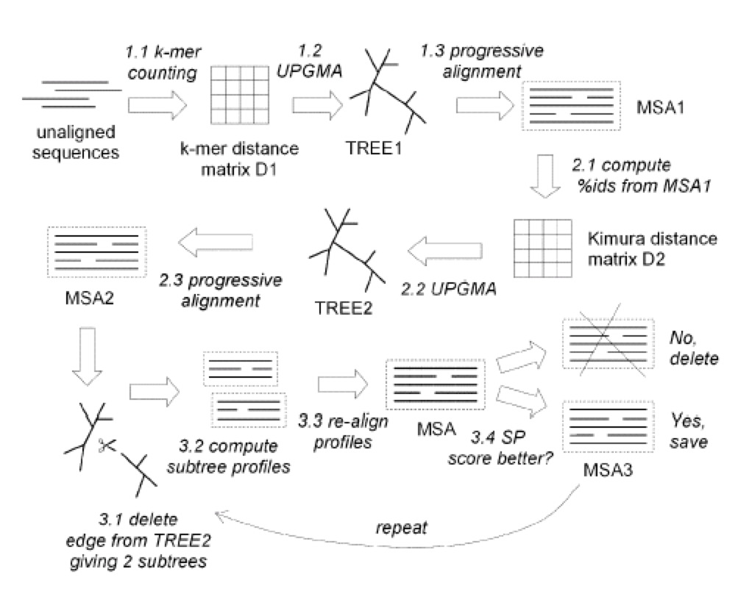
What is the log expectation ratio?
What does the first step, the second step and the third step of the algorithm do?
How is the better performance of the MUSCLE algorithm evaluated?
What is a profiling function?
What is a profile?
Why is refinement desired?
What is a compressed alphabet?
What is the difference between the UPGMA and the neighbor joining method to produce a distance matrix?
Profiles

When a pair of sequences is aligned how is the pairwise identity calculated?
Kamura distance is counting for multiple substitutions –
They used a fairly large word size from the dayhoff. Paper. Its not so relevant what they used – the other paper explains that it works.

Kmer counting – they don’t explain how they do this
- No pairwise alignment
- For each sequence make a word
- Count how many words are in common
- Translate the 20 aa in an compressed alphabet of 6 groups (characteristics )

Log expectation function:
The profiles get scored by a special scoring function:
It includes the frequencies of gaps in each column (what is the column), it includes the background occurrence of the amino acids, the probability of aligning these amino acids and the occurrence of the aa in the different columns.
Scoring function is a variation
$${LE}^{xy}=\left(1-{f^{x}}_{g}\right)\left(1-{f^{y}}_{g}\right)log⁡(∑_{i}∑_{j}\frac{f_{i}^{x}f_{i}^{y}p_{ij}}{p_{j}p_{i}})$$

Distance correction
Kimura distance takes in account multiple replacments:
$$D=-\ln\left(I-p-0.2p^{2}\right)$$
$$p=fractional difference$$
Fractional identity? D = $\frac{Identiy\%}{100}$

Concept of test set:
Ho using a test set that’s not produced by the algorithm?
Biased data can cause overfitting:

Independent test set to evaluate the algorithm is required
Personal alignment
Know structure, translate back to sequence – compare
Balibase – pretty good, designed for test purpose, expert dataset
SABmark – structure based
SMART – not so good, maybe suggested by the rewievers
PREFAB – self made, not best test set because lacks independence

Training set – Testing set
How you sy its good or bad?
Q- Quality= Correct aligned pairs / TC complete colums
Still just 90 percent
Why does clustal W takes longer (aligning everything with everything globally)
Kmer O(NL) Pairwise alignment O(N^2)
Global pairwise (L^2 N^2)

How does the actual subtree cutting works?
Edges are deleted in order of decreasing distance from root of tree. This allows effectively the realignment of each invidual sequence to the rest of the alignment. Sub trees of several sequences are then realigned as well. Accuracy is better or the same compared to other heuristic methods.

Phylogentic trees
MSA is a kind of circular approach – some kind of tree is used to set the order of the first alignment – then the MSA is used to make a phylogenetic tree.
Basic steps:
- Choose your sequences wisely
  - Sequences should be true orthologs found in established dbs.
  - Take when you want to build a species tree
    - Pariwise orthologs – gene is dublicated (less homolog)
    - Some parts of the genome are homolog but not mappable
    - Blue are the core orthologs
  - DNA is preferred, more information, sometimes translated into protein
- FUNDAMENTAL: Create a MSA and define substitution model
  - AVOID MISALIGNMENT! Just take homolog sequences!
  - Define gap penalty (you don’t want large unaligned regions, you cant mathematically deal with them, leave them out!) Sometimes whole species!
  - scoring
  - Restrict MSA to regions with data for all taxa. delete whole colums if enough other data is available
  - Weigthing of substitutions
- Tree building -
  - Distance based involve distant metric of aa ora distant score- (UPGMA or Neighbor joining)
  - character based include maximum parsimony or maximum likelyhood.
- Evaluate the three (Xenologs (horizontal gene gransfer?), or substitution paralogs (wron version of the gene)?
  - Consistency
  - Efficiency
  - Robustness – Once you have the MSA and Tree do Bootstrapping (resampling data) – Resampling whole columns in the MSA – will it give the same tree? Do this when you don’t know the distribution of your sample. doing reshuffeling will show it!
Tree topology – different visualization of the phyologenetic tree

You can set up either a protein tree or a species tree
Phyolgenetic trees should be additive - the sum of distances between terminal elements are preserved. Microarray data would a non additive example.
Distances should be additive: What you can see here is, that the distances are additive. Neighbor joining does a better job than UPGMA.

    - UPGMA this does not assume additivity

    - Neighbor joining:
In bioinformatics, neighbor-joining is a bottom-up clustering method used for the construction of phylogenetic trees. Usually used for trees based on DNA or protein sequence data, the algorithm requires knowledge of the distance between each pair of taxa (e.g., species or sequences) in the tree.
- Based on the current distance matrix calculate the matrix Q (defined below).
- Find the pair of taxa in Q with the lowest value. Create a node on the tree that joins these two taxa (i.e., join the closest neighbors, as the algorithm name implies).
- Calculate the distance of each of the taxa in the pair to this new node.
- Calculate the distance of all taxa outside of this pair to the new node.
- Start the algorithm again, considering the pair of joined neighbors as a single taxon and using the distances calculated in the previous step.
Nj = D_{ij}
$$u_{i}=\frac{∑D_{ij}}{\left(\left(n-2\right)\right)}$$
Calculating the QU matix from the distance matrix.
$$m_{ij}=(D_{ij}-u_{j}-u_{j})$$
m_{ij} is the defined value at a certain position in the distance matrix.
This is a better approximation of the evolutionary data!
Neighbor-joining is based on the minimum-evolution criterion for phylogenetic trees, i.e. the topology that gives the least total branch length is preferred at each step of the algorithm. However, neighbor-joining may not find the true tree topology with least total branch length because it is a greedy algorithm that constructs the tree in a step-wise fashion.
The neighbor joining is step wise. Closest neighbours are joined together and then the distance to the next closest neighbor calculated… somehow.

Models of evolution – phylogeny II
“All models are wrong, but some are useful” you miss some details
You want to explain how far organisms or sequences are in terms of evolution. Why is it not as simple that we can always assume the p-distance?
Everyhting would be easy if:
- constant rate of mutations would be seen in branches
- sequences would be divergent so just only multiple changes were not seen at individual sties
What is the p-distance? It’s used as a measure for evolutionary distance.
- $p=\frac{d}{L}$
- D is the number of observed changes and L is the sequence length
  - But: Does not account for multiple changes
  - Not account for different rates between sequences?
  - Short sequences: To high statistical variation

Better distance – the poisson distance d_{p}.
- How we deal with the leveling off?
Iit accounts for multiple substitutions at individual sites – is better for nucleotide sequences.

Jukes-Cantor model?
Nucleotide sequence evolution One parameter is the change rate of nucleotide
Simple model for nucleotide sequence
Complete random
Sites are equal
Substitutions are equal rated
More algebra
Use the JC model
Use the distance calculation
Rate of reversion is 2 alpha
Not go trhough the ways of calculation of the refineri
You have one model and can build on it
Build a two parameter model
Take in account transversion and transition
Keep going: 25% model of each nucleotide, you can take this in account as well.
GC is higher in thermophile – stronger interaction
Any given nucleotide (pi terms) Have 4 of them because
Another correction: Some parts are really conserved – how build that in?
Corbin distribution gamma distance?
Overall form is similar?
Gamma turns large? Constant mutation rate? Its like its not there.
Histon – high conserved –
Models of protein evolution?
GTR –
You will probably apply this – so keep going-

Maximum likelyhood
What are the features of maximum likelyhood without getting to deep in the math of the
Likelyhood testing: Which is the best tree?
Can you take a data set and chose the parameters. Evaluate the result.

Models of protein evolution:
You can do the same thing
Most common ones WAG and LG
Derived in a similar manner as PAM or BLOSOM matrices
JTT larger data set
WAG likelyhood and parameter estimation
LG
Maximum likelyhood is the peak of likelyhood distribution
Very well developed field of mathemathematics
Gamma shape parameter: usually estimated from the data Γ
Γ Number of invariant sites –
Character based methods of phylogeny
Parsimony
Long branches – no multiple changes took in account -
Maximum likelyhood – look at thousands tress – assume what the model is – gives a tree – evaluate the tree – the most likely tree is the most likely evolutionary tree
Maximum likelyhood
Model sequence evolution
Probability of obtaining data
P ( data|tree, model) -> What does that mean?
Iplict omodel? You have to specify the model?
What is included in the model of evolution
Neighbour joingin or
Wee need trees for input – will improve the trees, improve tree – can we build a more likely tree?
Local optimum!
Not possible to calculate all trees
ML is assuming independent sites
Example calculate likelyhood of the transition
Rate matrix shown
Fairly simple calculation for the likely hood
Incoorporating branch link –
Log likelyhood is easier dealt with
Trees are part of them model as well
More even probability distribution –
More time – more chance for multiple substitutions
Strength and weaknesses
Correct tree given the correct model
Weakness: Time intense
If the wrong model is chosen, to complex or too simple, you get the wrong result
Under the correct model, ML will accout for parallel changes and back mutations
Parsimony pulling things together
The correction version there is an offbranch between trees and flowers
Maximum LH is more likely
Why are these model kept?
Can have cases where different

Bootstrap analysis – resampling data
How we get a good model for this – Akaike information criterion AIC
Minimal number - best model
General time reversible likelihood parametes? There are several parameters you look at
Several programs are doing this for you phyML is one of the common ones –
ML is one of the most common one to come up with a phylogenetic tree
Bayesian inference of phylogeny
Monty Carlo – similar to resampling – simulating the data – introducing random steps into the date – change something move a branch and look at the new tree – there is probability to accept or discard the new tree
Bayesian Marcov chain monte carlo – Starts from a random tree – exploring the space around the
Bayesian stats – 482 – not into deep – other stuff that is equally important – he posts a poster –get a little bit familiar with it – ruff idea – not the core of the course –

The idea of maximum likelyhood – Bayesian is similarity – tells a little what the outlook it – competing –
Prior propability – example: bayesion analys – testet for rare genetic desease – probability to fail and win – outcome of the test – bayesion model includes the overall probability- what is the probability that the actual person we test is infected?
Molecular clock?
Main complements of Bayesian analysis
Prior probability
Likelyhood
Posterior probability
Little bit more information and a little bit faster – different way to estimate probabilities?
Will us not test on it.

HAP MAP

CNVs
What is the difference between the affymetrix array for SNP detection and the cooperative genome hybridization strategy in the tile path array?
Lets try 2 Methods to have something to compare something. 500 k means 500 k spots on it Quartet is a match or mismatch for an allel – figure out what the single polymorphism is. Not use snp but
2nd can we not put the whole genome on a chip? 93 % of the chromosome. Be nice connected: They got a chip designed for them
Why was the DNA from the lymphozytes differentiated from somatic artefacts? What are somatic artefacts?
Artificial – more genetic changes occur. Don’t necessarily represent the parental cells!
What are the different algorithms to identify either CNVs in affymetrix or cooperative genome hybridization experiments?
What does it meant to segment a continuous distribution of intensity radius into discrete ratios regions of CNV?
Why are noisier experiments characterized by higher rate of false positive than by false negative?
What was the sense of defining overlapping CNVRs

Protein evolution (Lecture 18.)
How do genes evolve?
What method for modeling expression divergence is present?
ASK SLIDE 11

Picture slide 13
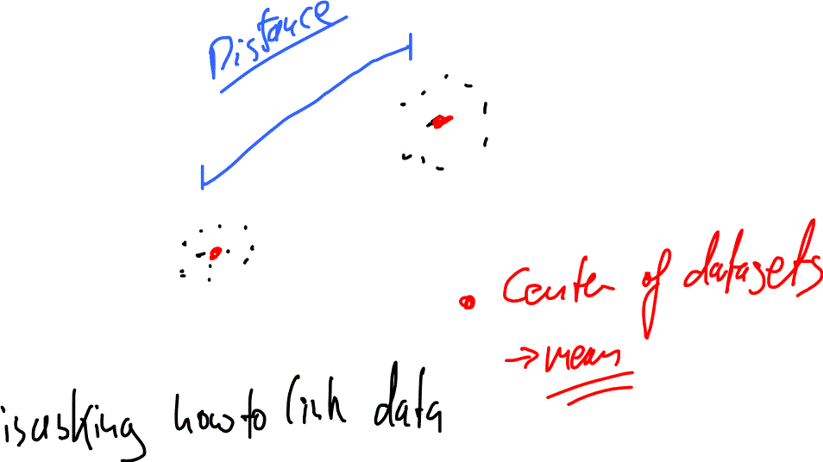
Figure 3: Arbitory distances - things are representated as data points - then you take the line

Transcription factor binding sites
Epression – different tissues – transcription factor binding – homologeous genes are conserved – the control mechanism are also conserved – experimental
Phylogenetic footprinting –going beyond sequences –usually multiple species – build a PSI MATRIX –To extend this – build a broader scale search –
Con site was used – in Explore transcription factor binding sites shared by two genomic sequences – looking for patterns of conservations amongst genomes –
Tiling array! Regions upstream and downstream .
tiling das Kacheln Tiling to cover the genome, each tile is 16 bp long, cover 10% of the region –
It’s a method that enrich small regions of DNA Promotr
Sonication rips apart the DNA to fragments – no consistant length –

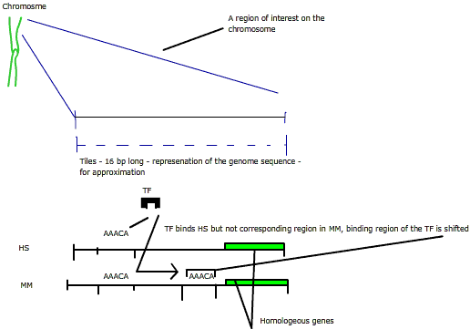

Promotore recognition – Promotor inspector from the seminar
Not as easy as you thing.
What are the things that are taken in account to identify a promoter region?
Define the genomic context. Look at large data sets to train an algorithm?
There are many unknown parameters.
Break the search word up in wild cards.
How many hits is enough? You have classifiers. Matching a classifier improves the probability that the region is a promoter.
They used a assignment threshold – the higher the threshold the lower the promoter recognition
Evaluation of the method? His method took not in account the sense/antisens
True positives/False positive.
Changed to bigger
No large number of false positives
First find the optimum parameters will the optimized parameters work on different –
Coverage is not really hight – polymerase

RNA – Seq:
What do they mean by that? That’s comparable with the data you get from a micro array. They are looking at the RNA complement of the genome.
- Entire genome sequencing: The techniques should be long enough. For Eukaryotes – you cant sequence a genome yet, because the regions are too short yet.
- Next generation of human genome sequencing – sequencing parts and map it back to the reference genome.
- SNIPs single nucleotide polymorphisms –
- Microarrys – each spot defined nucleotide sequence – still have to have the defined sequences. Assembly for novel genomes –
- Third one – dominant microarray technique – identify gene expression patterns.
There are a varyiety of RNAs
- rRNA – not interesting here
- tRNA
- mRNA 3%
- other things as well
  - microRNA
  - Pewee RNA – silencing – interact with microarray
  - Longe RNA transcripts – they are there – identify where are they in the genome?
Pleniminary sceening – Get rid of rRNA and tRNA – get the pure mRNA. Look for poly A tails – associated to coding sequence – use poly T primer for reverse transcriptase reaction. 5’ phosphate is specific to ribosomal rRNA.
Various sequencing techniques:
- 40 to 100 base pairs – illumine, 454 etc.
Typical RNA seq experiment
- start with mRNA
- Two choise
  - Fragment or convert to cDNA library
- Target fragments with tags.
- Short sequence reads –
- Huge steps from going to
  - Take in account error read – 32 bp up two mistakes.
  - How to map these reads to the genome but allow also for some errors?
  - No Needleman wunsch algorithm – to many millions reads –
  - Because of two errors – there is no exact match – clever ides to over come:
    - two errors in one strand: Divide the 32 read in 8bp fragments and align it – easy solution
    - Same sort of concept – divide in windows of eleven
    - Spaced seeds as well
  - Assembled
  - low expressed mRNA – maybe not in the library. If intron exon boundaries are crossed –
  - Two ways of doing it –Doing what?
    - Take sequence and split it in two halfs
    - lok up and downstram to figure out where the part ist
  - Dynamic range? Fairly limited – one side back ground other side saturation of the detector .
  - If you sequence directly you get rid of some of these problems.
  - Looked at table 1 in the
    - RNA seq – sequence RNA directly –
    - Put an est tag library . do sanger sequencing – there or not -
    - tiling microarray – split it in small fragments – em on a microarray – expensive. – depends on known bases –
  - Absolute expression data – arrays are not that good –
  - RNA-Seq does not need much RNA, that is good!
- W
Figure 2
- expression level in high throughput vs micro array
- Fluorescence intensity (log) vs log count
- Whatdoes it says – split it –
- Loosing the correlation –getting signal on microarray is not to related that
  - Reasonable on well on average – but not at high and low expressed genes.
- Can detect 9000 copies vs one copy
- This is the dynamic range aspect.
How many sequences do we need?
- 50 percent coverage of the ORFs – order of million
- 80
- 90 ten million
- How much you get from these experiments 40 million.
- Variation in gene expression under environmental conditions – you don’t getall expression – sporulation genes – forming spores.
Dependent on experimental conditions variation of results
- shear it – break it in the middle – drop off .
- Fragmentation methods – 3 prime to 5 prime – when you copy it, reads are gonna be biased towards towards the 3 prime ends. This influence experimental results.
Interesting things – its not too suprising – no clear rules –
- not all genes get their poly a tag – they found at the actin open reading frames – they found that there are two sites – they are not clean – its not clean – where it stops to add the poly A tail. This leads to two different sites.
- If you expressed the genome – where the starting site – similar to alternative splicing – defines where the gene stops – mechanisms where adds the tail is varying –
- Yeast genome – interesting opposite overlapping reads – that you could not pick up that easylie in a microarray –
The next generation sequencing things – micro array they are better for clinical data – looking for changes – this might complement the microarray thing
look at expression of everytign in an unbiased way – RNA sequ seems to be cool!
Keep this heart rate up!
Bioinformatics – you could not find some thigns with other tools –
Future directions – target more complex transcriptomes – look at rare RNA
Look at huge amount of data – look at millions of these – when it changes expression

Ref Seq will replace transcriptomics (some applications will remain domain of)

Closing remarks
Toolbox
Sequence alignments
Phyologenic and clustering – clustering ordering data – all kind the same
What are patterns within sequence or structure? How to relate to a biological question?
Analysis and synthesis – come up with practical and useful information.
Know what is new and effective and what is established.

Review:
Dynamic programming
Scoring matrices
MSA
Phyologenetic methods
Clustering
Stats analysis
Complex problems:
Genetic variation within the human genome
Haplotype mapping Hapmap
Copy number variation – blocks within genome that have large variations
Whole genome tiling arrays
Systems Biology and Network – bigger picture
Mass spec + Proteomics
NGS
TF and gene expression – analysis and computational work focus

Saturday Apr. 9. 9:00 – 11.30 RCH 205
Seminar presentation – there won’t be specific tests on the papers and
Some question will be recall of information – no trivial – conceptual – know what the algorithm does – but don’t draw it.
Others will involve synthesis or application –
Questions may include tools or techniques discussed in class applied to novel.
Given scenario – not definite answers – what are the genes ivolved in sulphur metabolism –
sequence based – expression based –how to deal with a random biological problem.
same organism – annotate the genome? What are the tools available.
Ask about – Medical issues – how would you find genes in Alzheimer – how you would you use hapmap?
How do NGS work – what data you get from NGS – there will be some choice – few questions of longer questions – pick up a couple –
Its not a time test – so should not be overly long – think about things a bit –
If there is no filtering of relevant information – what is the most relevant – how do you do a proteomics analysis – don’t answer 2 pages MS – answer to analys – fit answer and question .

