MOLECULAR BIO REVIEW III

EUKARYOTIC TRANSCRIPTION
Types of RNA Polymerase in Eukaryotic Systems
- RNA Polymerase I
- located in the nucleolus
- synthesizes precursor of most rRNAs
- RNA Polymerase II
- located in the nucleoplasm
- synthesized mRNA precursors, snRNAs
- RNA Polymerase III
- located in the nucleoplasm
- synthesizes precursors of 5S rRNA, tRNAs and small nuclear and cytosolic RNAs

Types of RNA in Eukaryotic Systems
- mRNA code for the synthesis of proteins
- rRNA contribute to the structure of the ribosome
- tRNA play an important role in translation for carrying amino acids
- snRNA involved in the RNA splicing process
- snoRNA play a role in rRNA maturation/covalent modification
- miRNA and siRNA help regulate gene expression
- ncRNA involved in telomere synthesis and x-chromosome inactivation

RNA Polymerase II: Structure/Function Relationship

- highlighted are the different domains of RNA polymerase II
- synthesis occurs inside the hollow core of the enzyme
- CLAMP mobile arm that holds DNA in place
- RUDDER separate strands of DNA
- LID where newly transcribed RNA molecule exits the enzyme
- the RNA polymerase has a long C-terminal domain (500 – 650 Angstroms)
- contains a conserved heptameric motif: [Pro-Thr-Ser-Pro-Ser-Tyr-Ser] Note that repeat is Tyr-Ser-Pro- Thr-Ser-Pro_ser.
- extension of CTD coincides with onset of transcriptional elongation
- for CTD to be extended, it must be phosphorylated

TRANSCRIPTIONAL MACHINERY
- an assembly of multiple protein subunits that cooperate with each other to synthesize the mRNA

1) General Transcription Factors
- help position RNA polymerase correctly at the promoter (needed at all promoters transcribed by RNA Pol II)
- aid in pulling apart the 2 strands of DNA
- release of RNA polymerase from promoter into elongation mode

1. TFIID
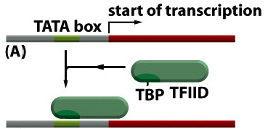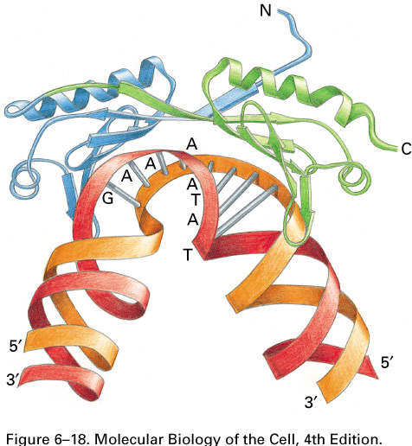
- TBP subunit: “TATA-binding protein”
- recognizes the TATA box
- contains beta sheet domains (in the shape of a saddle) that will form hydrogen bonds with the minor groove of DNA, causing bending of the double helix
- helps expose DNA so that other general transcription factors may bind
- thought that local distortion of double helix acts as physical landmark to find regions actively transcribed
- TAF subunit: help to recognize sequences other than TATA near TSS

2. TFIIB
- MAIN ROLE: ESTABLISHES ORIENTATION
- recognizes BRE element @ - 35 of TSS
- single polypeptide
- anchors RNA polymerase II holoenzyme to the promoter
- directional binding allows for proper orientation of the transcriptional machinery (this allows for only downstream)

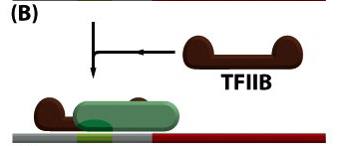
3. TFIIF
- stabilizes RNA polymerase interaction with TBP and TFIIB; helps attract TFIIE and TFIIH
- bound to the RNA polymerase

4. TFIIE
- attracts and regulates TFIIH

5. TFIIH
- unwinds DNA at the transcription start site, phosphorylates Ser5 of the RNA polymerase CTD; releases RNA polymerase from the promoter
- largest and most complex of the factors (8 – 9 subunits)
- Helicase activity transient opening of DNA double helix
- protein kinase activity phosphorylation of Ser5 in CTD of RNA polymerase II (causes conformational change)

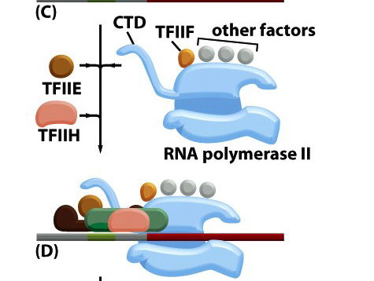
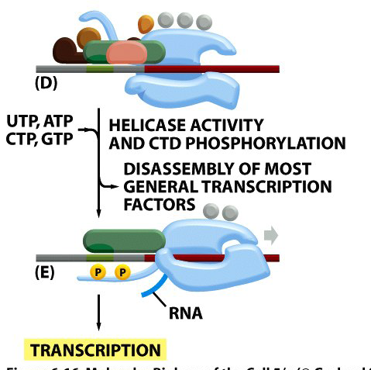

2) Mediator Complex
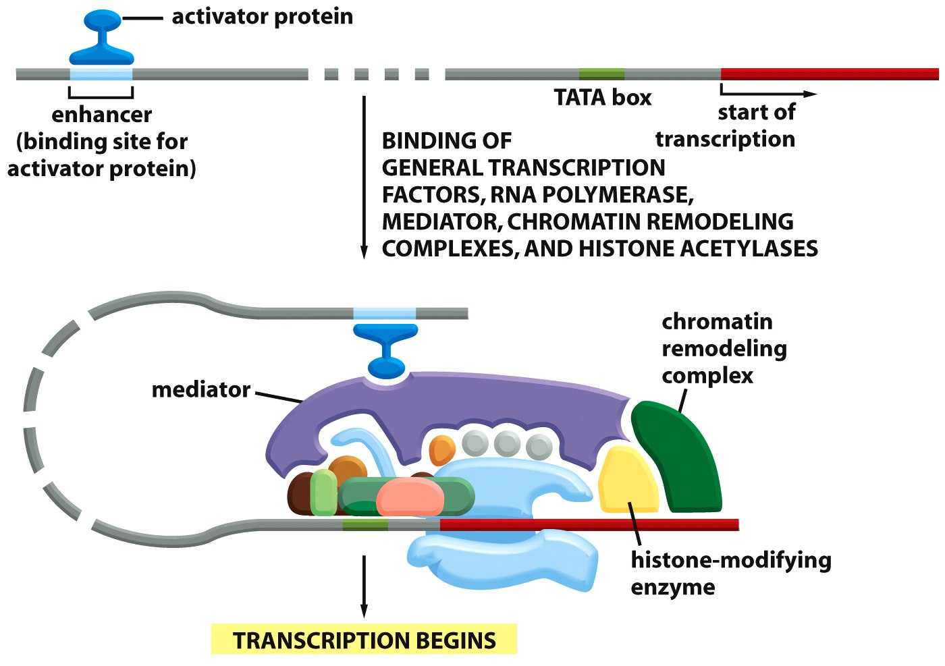
- large multi-protein complex
- transmits instructions to increase or decrease rate of transcription
- recruited by enhancer bound to an activator protein
- no binding affinity for DNA
- regulator of protein kinase module of TFIIH
- complex binds to general transcription factors, RNA polymerase, chromatin remodelling complexes, and histone acetylases

3) Chromatin Remodeling
- FACT proteins that facilitate chromatin transcription
- during elongation, there are still nucleosomes in the way
- FACT releases H2B-H2A dimers
- factors other than FACT release H3H4 dimer
- RNA polymerase moves along the free DNA, and as this happens the nucleosomes reassemble behind it via histone modifiers

1. ATP-dependent remodelling complexes
- use energy form ATP hydrolysis to transiently destabilize DNA/histone interactions
1. SWI/SNF modify path of DNA around the octamer, causing sliding
2. ISWI slide the octamers without apparent change in structure
3. SWR replaces H2A-H2B dimers with H2A.Z-H2B variant

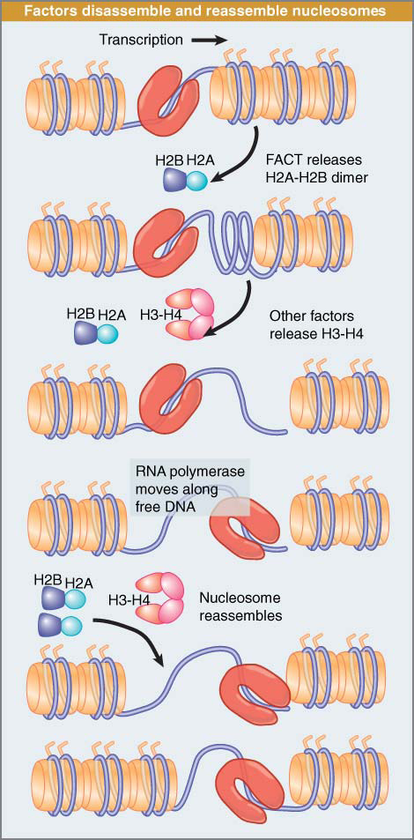

2. Histone Acetyltransferases (HATs)
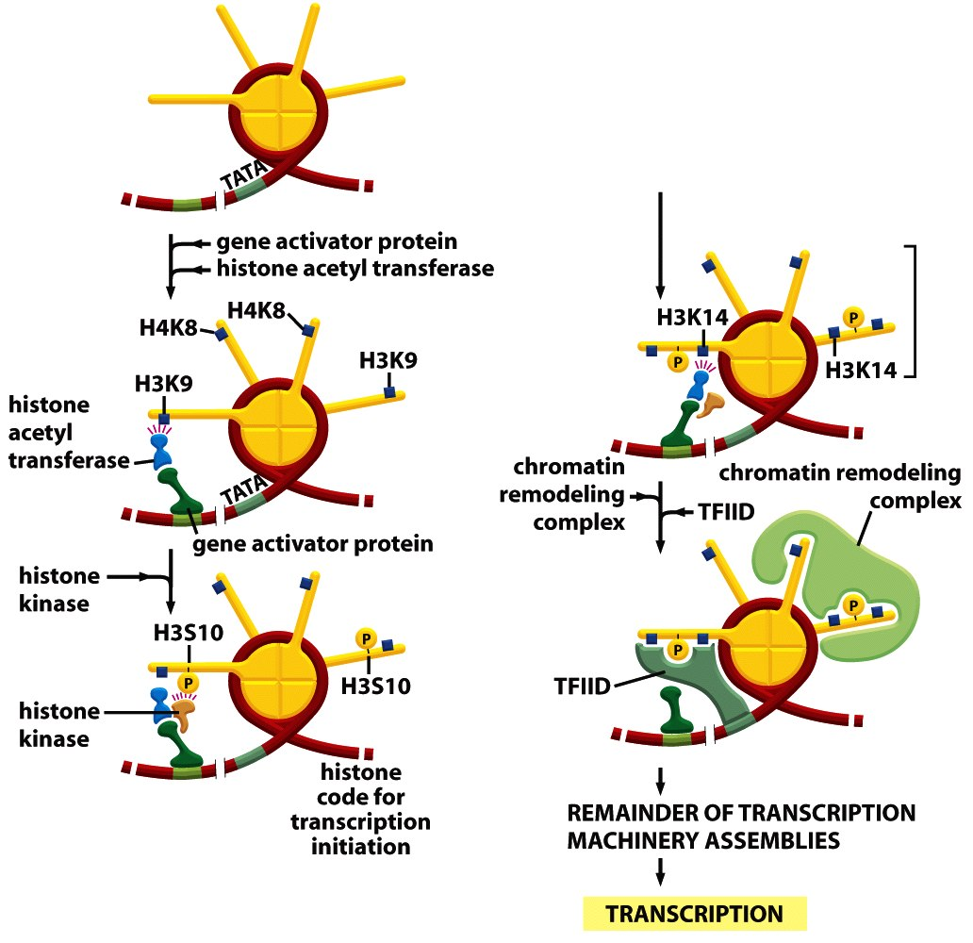
1) activator binds to DNA
2) attracts HATs and histone kinases (modification of the histone tail)
3) histone code is read by TFIID and SWI/SNF (via bromodomain)
- modifying the histone tails makes DNA more accessible
- HATs transfer an acetyl group onto the tails, which decreases affinity for DNA.
- mark of gene activation, determined by activators
-

PROCESSING, TRANSPORT AND CELLULAR DISTRIBUTION OF mRNAs
5’ CAP
- capping enzymes bind to CTD (phosphorylated at Ser5) of RNA polymerase II
- enzymes are poised to modify the 5’ end of the new mRNA as soon as it emerges from polymerase

Why is it advantageous?
- protects from RNAses
- helps with 5’ recognition by ribosome
- helps to distinguish transcripts from Pol II versus for example tRNA
- 5’ cap bound by group of proteins needed for processing, transport and translation

- Phosphatase removes gamma phosphate of the 5’ rNTP
- Guanyl transferase converts GTP to GMP by removing both beta and gamma phosphates
- GMP is transferred to rNDP through a reverse linkage (5’ to 5’ )
- phosphodiester bond makes the 5’ end resistant to RNAses (specifically cut 5’ to 3’ bond)
- Methyltransferase adds a methyl group on position 7 of guanine to protect it

TRANSCRIPT SPLICING AND EXON ASSEMBLY

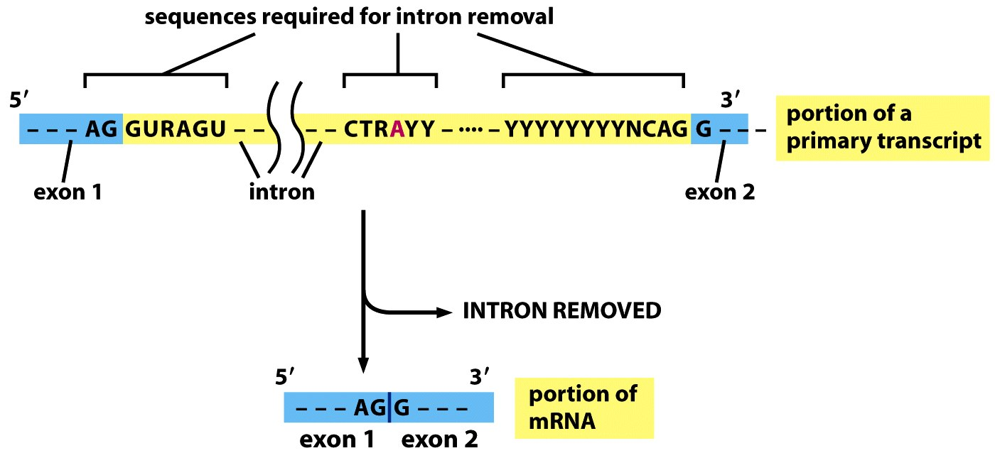
SPLICE DONOR BRANCH POINT SPLICE ACCEPTOR
SPLICEOSOME – conduct mRNA splicing
- most of the actual work done by RNA molecules (200 nts or less each) rather than the proteins
- snRNPs = small nuclear ribonucleoprotein = snRNAs + proteins = spliceosome

Splicing Mechanism
The Nucleophilic Reaction
1) Adenine in the intronic branch point sequence (CURAYY) conducts nucleophilic attack of phosphodiester bond between the 2 guanines of the splice donor site (AG/GURAGU)
2) Exposed phosphate at 5’ end of GURAGU intron sequence forms a divalent bond with the free 2’OH of the ribose of adenine at the branch point transesterification
3) This produces a lariat (lasso) free 3’ OH at end of exon (AG) which attacks 5’ phosphate on splice acceptor site (2nd transesterfication)

Spliceosome Interaction
1) branch point binding protein (BBP) and U2AF (accessory protein) recognizes branch point

2) U1 recognizes sequence of exon/intron junction

3) U2 replaces BBP and U2AF (exposes catalytic site, unpaired adenine)
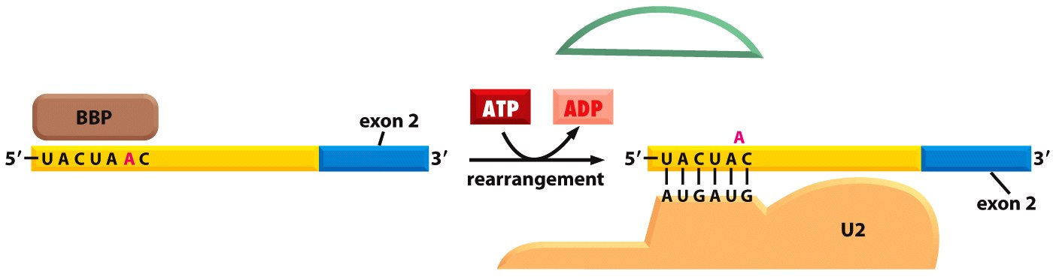
- the replacement of BBP with U2 check/recheck
- binding of U2 forces adenine to be unpaired (activated for attack)

4) U4/U6/U5 is recruited to complete the splicesome assembly

5) U4 and U6 interact together through complementary bonds (help form lariat structure)
6) ATP-dependent rearrangement of RNA pairings destabilizes U4 and U6
7) U4 is expelled and U1 replaces by U6 (creates closed loop, 1st transesterification)
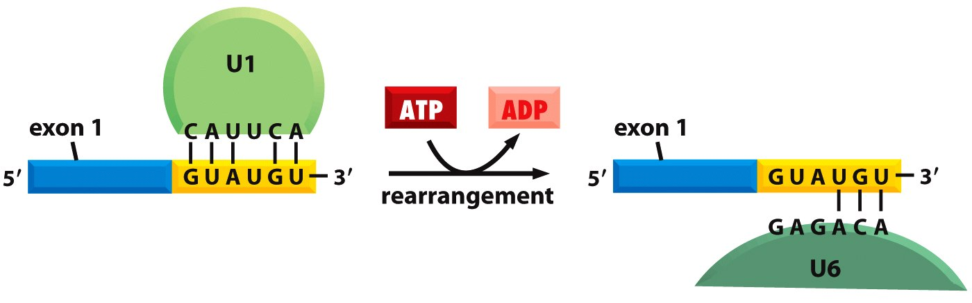
- check/recheck
8) More ATP-dependent rearrangements allow for U1/U5/U6 to make up active site for spliceosome
- note how U6 and U2 complement each other AND RNA
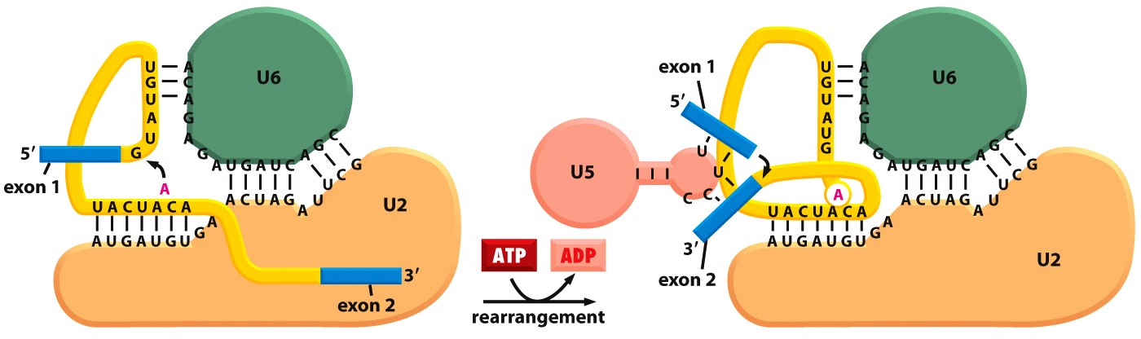
9) 3’ acceptor cleaved and 2nd transesterification reaction joins the two exons
- U5 undergoes rearrangement

Exon Definition Hypothesis
- intron sequences vary in size (up to 100 000 nts), therefore fidelity mechanisms are built in:

1) Coordination of transcription with splicing
- phosphorylated CTD of RNA pol II carries several components of the spliceosome
- snRNPs assembled at 5’ splice site are initially presented with only a single 3’ splice site
- pevents exon skipping

2) Exon Definition
- exon size is much more uniform than intron size (100 – 200 nt)
- splicing machinery seeks out homogenously sized exons
- SR proteins (rich in serines/arginines) assemble on the sequence and help mark off each 3’ and 5’ splice site (start at 5’ end of mRNA)
- SR proteins recruit U1 snRNA (downstream exon boundary) and U2AF (upstream exon boundary)
- hnRNPs (heterogenous ribonucleoproteins) condense large introns and make cryptic splice sites

Other Forms of Splicing
1) Minor form of spliceosome (U12-type spliceosome)
- recognizes a different set of RNA sequences at 5’ end and 3’ splice junctions and at branch point (0.1% of introns in humans)
- U1 and U2 respectively replaced by U11 and U12 (contain different complementary sequences)
- delayed form of splicing
- permits complete patterns of alternative splicing

2) Trans-splicing
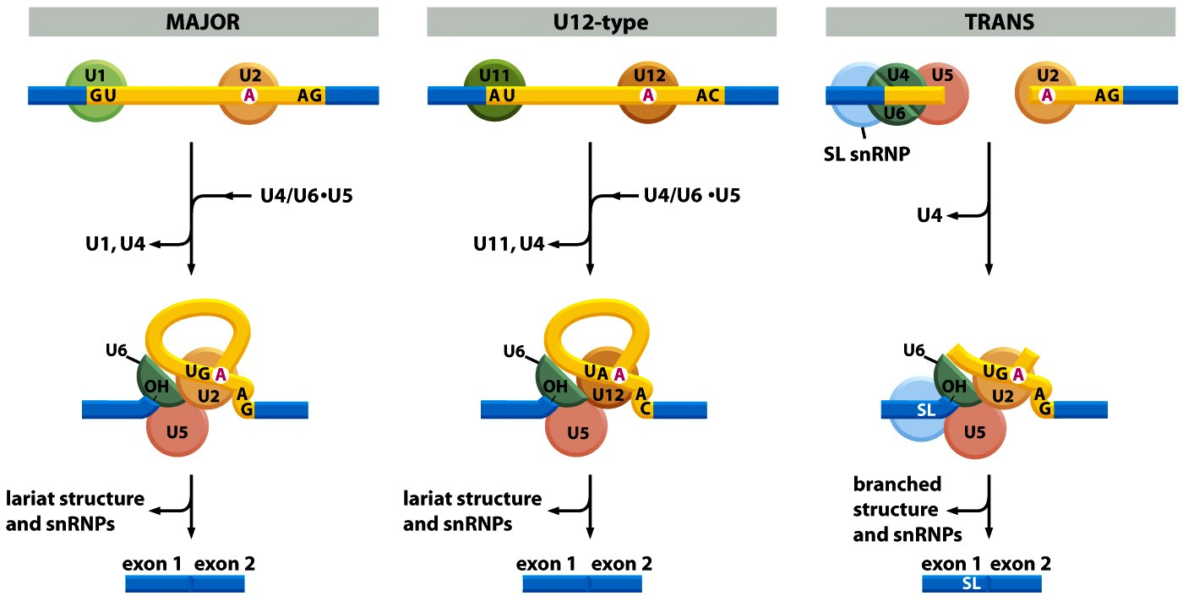
- 5’ exon is spliced onto the 5’ end of many different mRNAs
- same 5’ end and different 3’ exons
- SL RNP brings in the common exon

POLYADENYLATION AND TRANSCRIPT TERMINATION
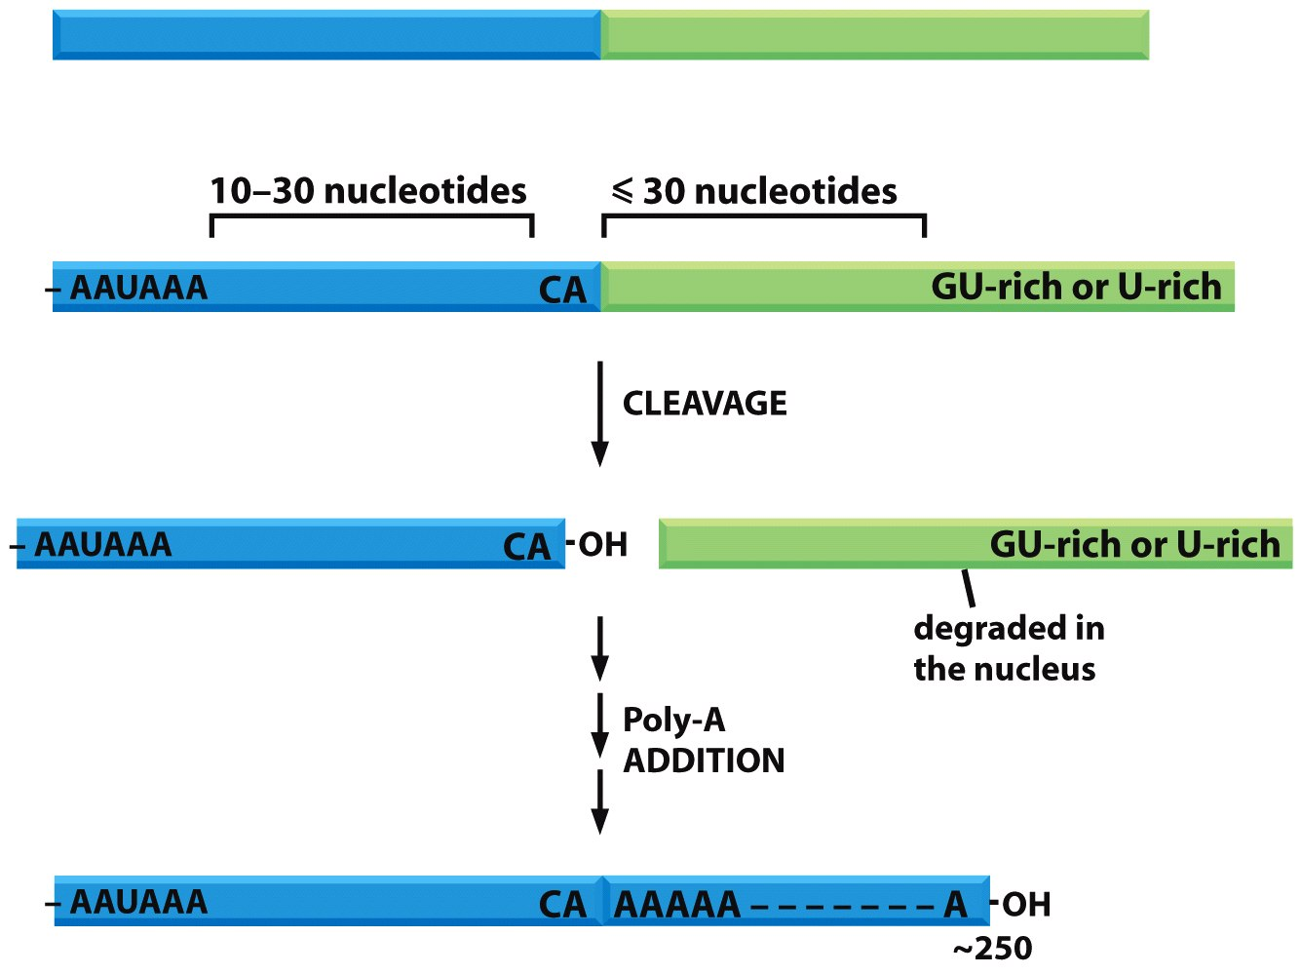
- signals that define the 3’ end of a mRNA are contained within the 3’ UTR of the pre-mRNA
- AAUAAA
- GU-rich element
- CA sequence
- consensus sequences are transcribed by RNA polymerase II and recognized by a series of RNA-binding and RNA-processing enzymes

- CPSF (cleavage and polyadenylation specificity factor) binds to AAUAAA
- CstF (cleavage stimulation factor) binds GU-rich motif

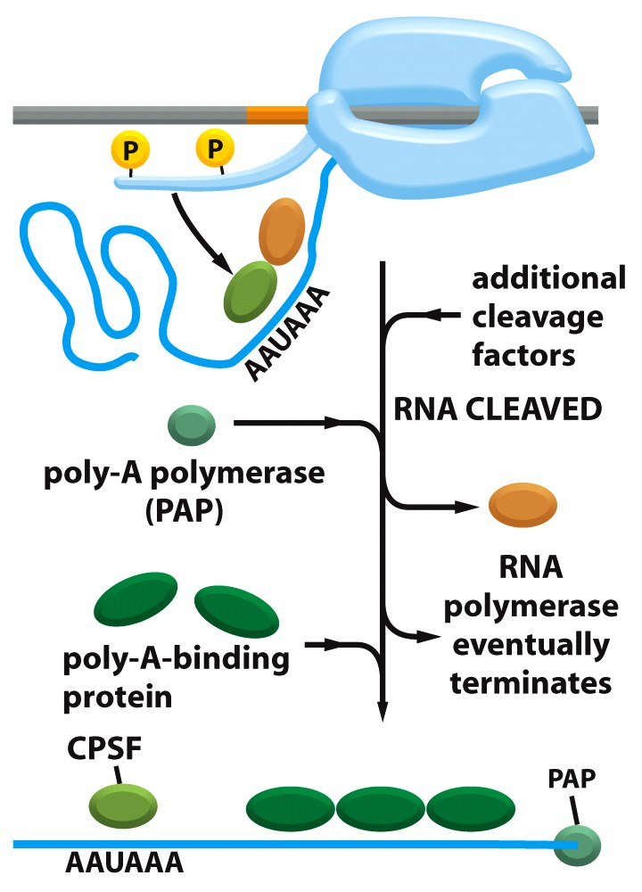
- both travel with the RNA polymerase CTD, but bind to motifs when encountered
- both recruit endoribonucleases
- cleave transcript following the CA nucleotides of the cleavage site, which produces 3’OH on ribose of A:
this serves as substrate for polyA polymerase (adds 200 A’s). PAP ATP dependent/matrix-independent
terminal transferase (therefore needs ATP but no need for template)
- after PAP, polyA binding proteins (PABP) assemble on tail determine length of tail
- even after cleavage, RNA polymerase II continues to transcribe (absence of 5’ cap will cause degradation by exonucelase at 5’ end)

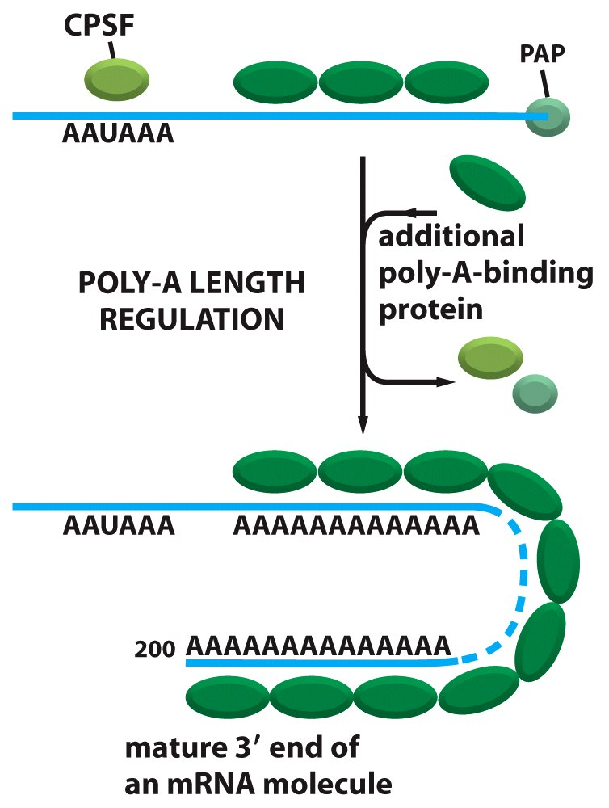

PACKING AND TRANSPORT OF MATURE mRNA
- mRNA’s transport into the cytoplasm proceeds if the mRNA is bound by
- CAP binding complex*
- PABP*
- SR proteins
- hnRNPs
- export factors
- exon junction complex (EJC)
* only these stay, any other proteins (ex. hnRNPs, export factors, etc.) are released and stay in the nucleus
- in cytoplasm, transcript is bound by factors necessary for translation initiation (eIF-4E and eIF-4G)
- eIF factors displace CBC and interact with PABPs to mask the extremities and protect against degradation

SUMMARY
- Prior to transcription, CTD is not phosphorylated (associated with mediator complex, etc.)
- Ser5 phosphorylation takes place during transcription initiation allows capping factors to be recruited and positioned close to 5’ end of native RNA
- Phosphorylation of Ser2 during elongation phase allows recruitement of spliceosome
- Cleavage and polyadenylation factors are recruited to phosphorylated CTD once transcription machinery has reached polyA signal

GENE EXPRESSION IN EUKARYOTES:
- Transcription control: IMPORTANT INITIATION FREQUENCY
- RNA processing control: QUALITY CONTROL, SPLICING
- RNA transport and localization control: DISTRIBUTION
- Translational control: LEVEL OF mRNA DECODING
- mRNA degradation control: mRNA HALF LIFE
- Protein activity control: FOLDING, LOCALIZATION, MODIFICATION, ½ LIFE
LEVEL 1: TRANSCRIPTION CONTROL

TRANSCRIPTION CONTROL IS THE STEP THAT CONTROLS ALL OTHER STEPS!
several important elements are involved

TRANSCRIPTIONAL CONTROL
- absolutely required for transcription by RNA Polymerase II
- encompasses 65 nts both upstream and downstream of the TSS
- made of : 1) TATA box TATA (A/T) A (A/T)
- -20 to -30 bp from TSS
2) BRE motif (B responsive element)
(G/C) (G/C) (G/A) CGCC
- -35 bp from TSS
3) Inr sequence (initiator sequence)
(C/T) (C/T) AN (T/A) (C/T) (C/T)
- often overlaps with +1 site
4) DPE sequence (A/G) G (A/T) CGTG
- +30 from TSS

BASAL PROMOTER
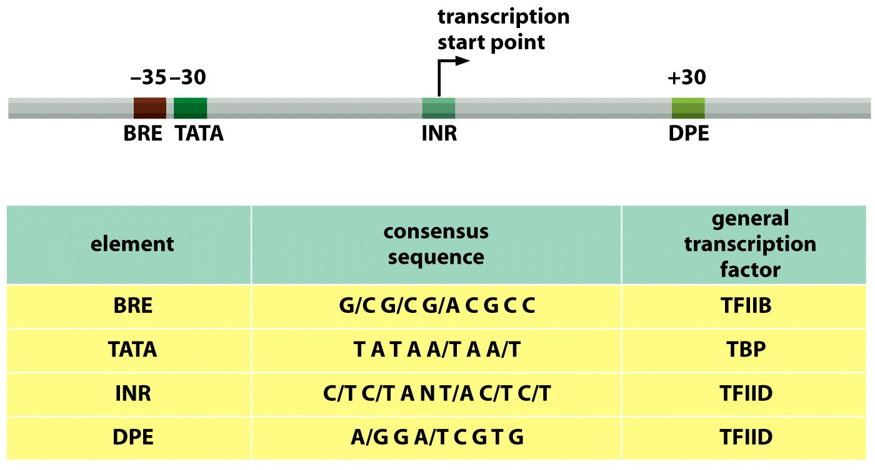

- if basal promoter was deleted, the gene would not be transcribed

REGULATORY ELEMENTS
- modulate promoter strength
- binding sites for gene regulatory proteins (GRP)
Proximal Regulatory Elements
- spans sequence from -1 from -350
- activity depends on position/orientation
- increase, decrease or inhibit transcription initiation frequency

Distal Regulatory Elements
- 5’, 3’ or introns
- activity is independent of position/orientation
- regulate chromatin domains
- can render whole part of chromatin accessible or inaccessible
- work over large distances (1 – 50 kb+)
** work over large distances (challenging when trying to identify elements
- increase, decrease or inhibit initiation frequency

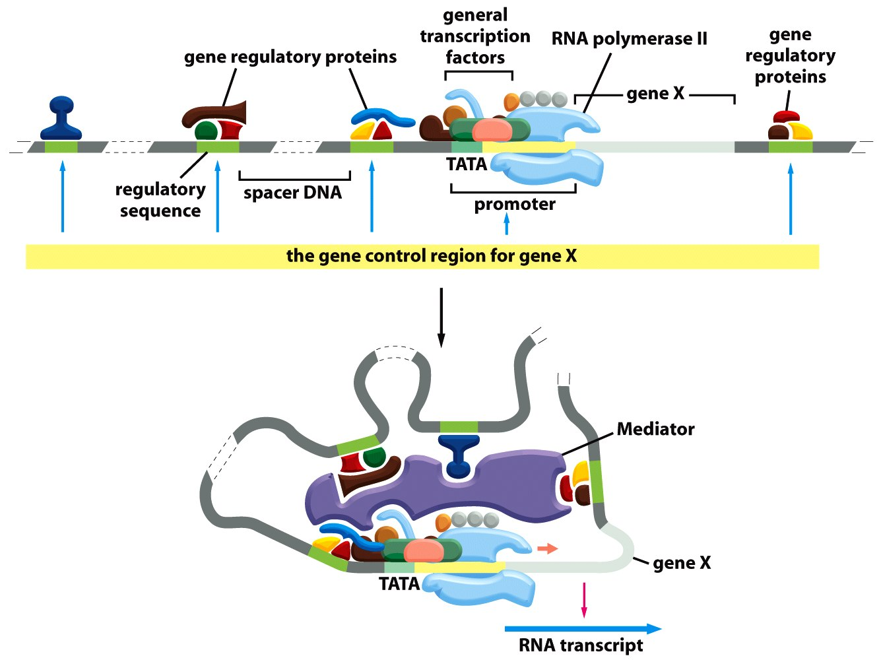

LOCUS CONTROL REGION (LCR)
- DNA elements that control expression of one/several genes located within a large chromatin domain by modifying access during development

- allow GRPs bound to the LCR to interact with GRPs bound to proximal regulatory elements (DNA looping)

- attract chromatin remodelers, histone-modifying enzymes and transcriptional machinery

*controls the expression of all genes, and is bound by different regulatory proteins. Is the equivalent of operon in eukaryotes

INSULATOR ELEMENTS

- DNA sequences that prevent eukaryotic GRPs from influencing distant genes
- They:
1) protect active genes by preventing heterochromatin formation
2) act as physical barriers that limit the action of distal regulatory elements
- GRPs bind to these insulator elements and cause interference protein on enhancer cannot bind to gene A

GENE REGULATORY ELEMENTS (RDBP)
- RDBPs recognize their target cis-acting regulatory elements on dsDNA
1) recognize their own specific sequences high degree of specificity (RDBP-RDBP)
- these sequences are in the distal and proximal regulatory regions (exception: some share consensus site to competitively regulate expression at promoter)
- GRPs recognize sequences via the distinctive pattern displayed on the edge of each base pair
- binds via hydrogen-bonds, ionic bonds and hydrophobic interactions
- > 20 contacts ensure that interaction is highly specific and very strong

THE FUNCTIONAL ANATOMY OF GRPs (RDBPs)
1) HELIX-TURN-HELIX MOTIF (HTH)
composed of two alpha helixes joined by a turn
- found in eukaryotes and prokaryotes

- CTD is the recognition site (DNA binding domain) alpha helix rich in lysines and arginines

- binds major groove

- found in CAP, cro and cI

- HOMEODOMAIN the more evolved and advanced version only found in eukaryotes
- important role in development
- stretch of 60 amino acids contained in the HTH motif
- instead of two alpha helices, there are three (helixes 2 and 3 represent the basic HTH). Helix 3 binds to major groove of DNA, the short extension out of Helix 1 can also bind but to the minor groove.

2) ZINC FINGER DNA-BINDING PROTEINS
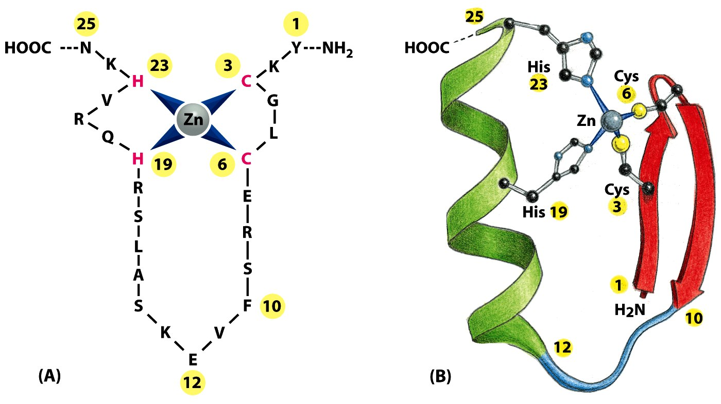
- zinc atoms are structural components scaffold for domain to form

- DNA-binding domain two beta sheets and 1 alpha helix

- main contacts take place of G-residues of the major groove of DNA via highly-conserved arginine in the alpha helix

3) DNA BINDING VIA BETA SHEETS
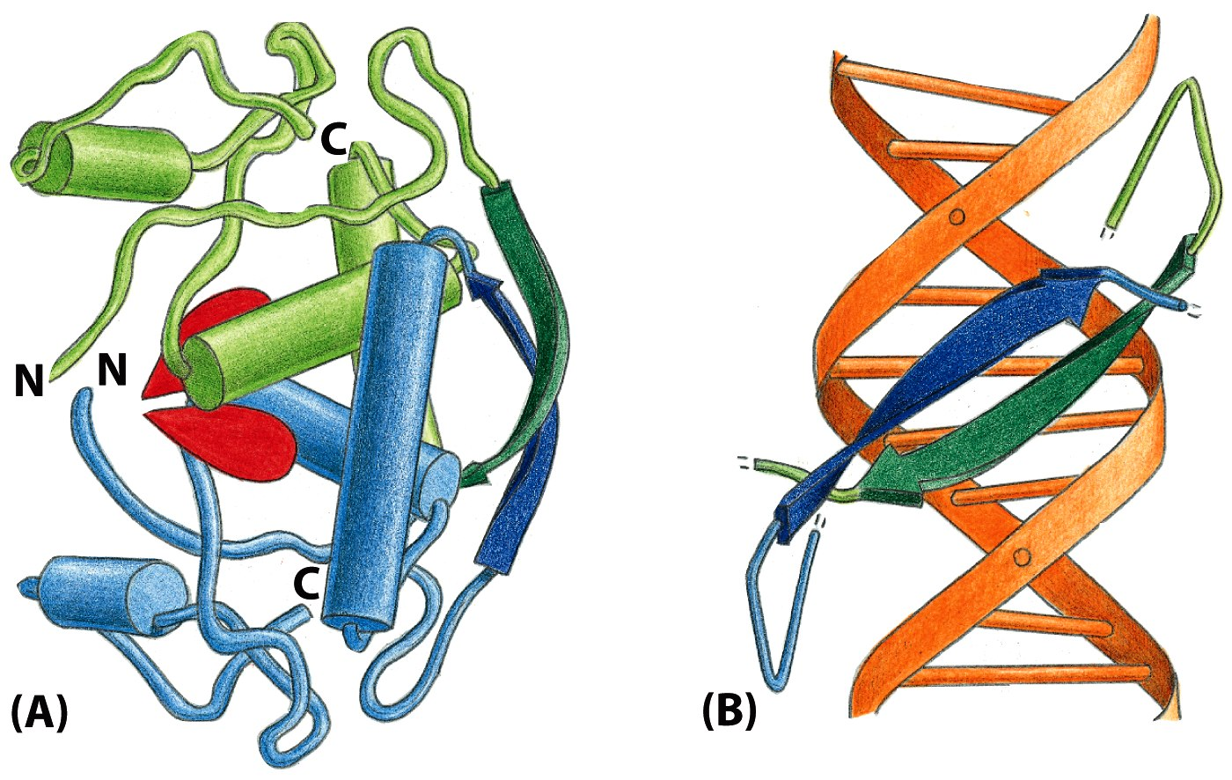
- beta sheets bind to DNA via basic residues (vs positively charged surfaces of alpha-helices)

- similar to the TBP (TA binding protein)

4) DNA BINDING USING LOOPS
- use protruding loops to “read” nucleotide sequence
- loops protrude from protein structure and make contact with DNA
- arginines and lysines are very important
- an example is p53: the most common mutation is Arg248 binding of DNA inhibited, which causes cell division in uncontrolled fashion

5) LEUCINE ZIPPER MOTIF
- short stretch of leucine residuesat every 7th position of an amphipathic alpha-helix (both hydrophobic and hydrophilic)
- two helices are held together by interactions between hydrophobic side chains (dimerization surface)
- like a clothes pine binding to DNA
- ALWAYS A DIMER (both helices kept together via hydrophobicity, which creates a coiled-coiled structure)

6) HELIX-LOOP-HELIX MOTIF
- two alpha helixes (one short, one longer) connect by a loop
- DNA-binding and formation of dimers (homo or hetero)
- dimerization requires alpha-helix to have amphipathic character
- NOT like HTH because that doesn’t dimerize (more like leucine zipper)
- the CTD dimerizes, the N terminal binds to DNA

The Importance of Dimerization
- simultaneous recognition of two regulatory motifs
- increases variety of regulatory sites in the genome
- combinatorial control
- truncated HLH proteins = mechanism to attenuate/inhibit action of a regulatory protein (by sequestration)

PROPERTIES OF REGULATORY PROTEINS
EACH GENE REGULATORY PROTEIN IS MADE UP OF TWO PARTS:
- DNA-BINDING DOMAIN
- ACTIVATOR DOMAIN

Regulation of GRPs
- PROTEIN SYNTHESIS: protein produced when needed
- LIGAND BINDING: ligand needed to activate already present protein
- COVALENT BINDING: phosphorylation, glycosylation, acetylation, etc. to activate protein
- ADDITION OF SECOND SUBUNIT: protein made up of subunits, only active when they come together
- UNMASKING: inhibitor masks the protein
- STIMULATION OF NUCLEAR ENTRY: protein must be present in nucleus to be active
- RELEASE FROM MEMBRANE: must be cleaved from membrane to be active

- One gene can influence many different genes
Ex. glucocorticoid receptor + the glucocorticoid hormone can activate multiple GRPs and genes

GRP’S INFLUENCE THE OVERALL TRANSCRIPTION RATE OF A GENE
1) Synergistic Control
- rate of transcription is determined by the number and activity of the GRP’s that occupy a regulatory element
- in other words SYNERGY = overall rate is more than the sum of the rate contribution of each part
Ex. 2 proteins separately have low transcription. Together there is high transcription

2) Co-activators and co-repressors
- GRP’s can come together in different ways to either activate transcription or repress transcription

3) Repressor GRPs
- these proteins can attenuate or inhibit transcription of a gene by REDUCING frequency of initiation.
- It can do this through:
- 1) Competitive DNA binding
- repressor competes with RNA polymerase for promoter
- usually the repressor and activator sequences overlap therefore only repressor or activator can be present at one time.
- 2) Masking the activation surface:
- interfering or blocking the activation site masks the activation surface, decreasing transcription
- 3) Direct interaction with the general transcription factors:
- the repressor bound to its site can loop and bend DNA molecule to inhibit assembly of activator- TF complex
- OR it can prevent RNA Pol from dissociating from TFs (need for Polymerase to move on)
- 4) Recruitment of Chromatin Remodelling Complexes:
- repressor can recruit these complexes to remodel architecture of nucleosome so genes become more tightly packed and inaccessible.
recruitment of histone deacetylases
recruitment of histone methyl transferase

- for overall transcription rate of a gene, multiple concensus sites recruiting different proteins work together
- certain proteins bend the DNA to allow for cooperative assembly of gene regulatory proteins

DNA METHYLATION AND THE CONTROL OF GENE EXPRESSION
- 1 – 3% of cytosines in vertebrate genomes are methylated
- These cytosines are located in the CpG island nucleotides located in or around the 5’ regulatory regions/promoters of genes
- They are methylated by DNA methyl transferases (DNMTs)
- de novo (newly methylated): DNMT 3A and DNMT 3B
- maintenance of methylation: DNMT 1
- this methylation often decreases transcriptional activity
- repressive state when CpG Islands are recognized by 5-methylcyotsine-binding proteins
- these proteins help to recruit chromatin remodelling complexes and histone deacetylases
- note that in genomic imprinting, the methylation patterns of DNA are wiped out for meiosis but are usually re-established
- methylation and imprinting are not always associated with inactivation of gene expression
- Ex. sequence that codes for insulator protein is methylated, which then allows another gene to be expressed (insulator inhibited the gene previously)
- mutations of 5-methyl cytosine account for a third of single-base mutations observed in inherited diseases
- 5-methylC + deamination + hydrolysis = thymine

SUMMARY
- Gene regulatory proteins influence transcription by
- influencing the assembly of the transcription machinery
- modify local chromatin structure

LEVEL 2 – mRNA PROCESSING

1) ALTERNATIVE SPLICING AND POLYADENYLATION
ALTERNATIVE SPLICING
- this method can produce several versions of a protein from the same mRNA
- 75% of genes in humans are alternatively spliced
- ex. Drosophila gene has potential to create 38 000 different splicing patterns
- therefore proteome MORE COMPLEX than transcriptome!

Four different scenarios
- 1) OPTIONAL EXON ex. exons 1 + 2 + 3 or exons 1 + 2
- 2) OPTIONAL INTRON ex. intron may be included or not in the mRNA
- 3) MUTUALLY EXCLUSIVE EXONS: ex. exons 1 + 2 or 1 + 3 (cannot have 2 or 3 in the same mRNA)
- 4) INTERNAL SPLICE SITE: intron has cryptic splice site that can be used for splicing. Ex: first mRNA lacks intron 2 completely, the 2nd mRNA has half of intron.
- 5) CONSTITUITIVE ALTERNATIVE SPLICING: sometimes the cell correctly sees the splice site, sometimes it doesn’t. Therefore both variations are found in the cell in roughly the same amount.

REGULATION OF ALTERNATIVE SPLICING
- regulation of mRNA splicing can generate different version of a protein in different cell types
- ex. alpha-tropomyosin gene codes for protein needed for muscle contraction. Different forms of splicing in smooth or striated muscles, or in brain or fibroblasts mRNAs because each tissue has different kind of muscle and different cellular needs.
- under negative or positive control:
- NEGATIVE CONTROL intron usually removed to generate mRNA
- use of REPRESSOR – repressor binds to junction between intron and exon so spliceosome cannot bind, therefore splicing does not occur
- Repressor binds pre-mRNA and blocks access of the transcriptional machinery (can often result in use of cryptic splice sites)
- POSITIVE CONTROL weak spliceosome that is usually skipped
- use of ACTIVATOR – helps spliceosome recognize a weak splic site that would otherwise be overlooked. Results in intron being spliced out.

ALTERNATIVE POLYADENYLATION
- the cell can use alternative cleavage sites for the polyadenylation tail to create different 3’ ends
- therefore different consensus sequences for polyadenylation
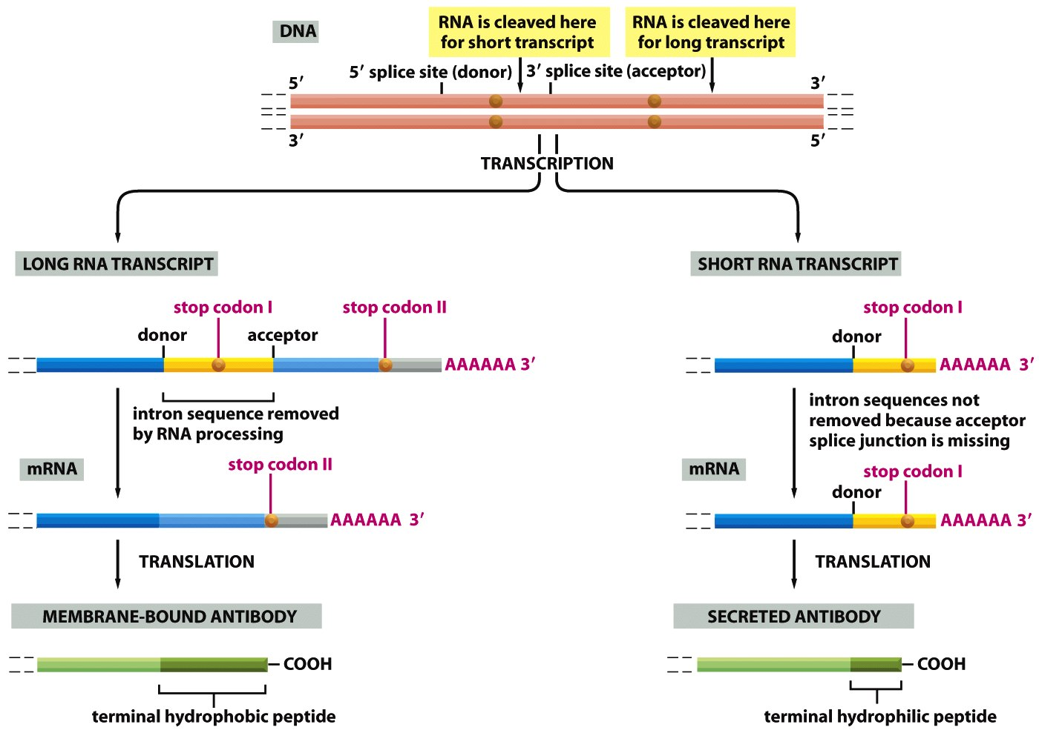
- Example: antibody production in the B lymphocytes
- early on, the antibody produced is anchored in the membrane (acts as a receptor for antigen).
- as the B cell matures, the antibody is secreted
- the antibody in the membrane has a hydrophobic C terminal peptide, the secreted one has a hydrophilic one. The rest is identical.
- The cleavage site for the non-membraneous antibody is a weak site located within an intron, therefore is not detected as is removed when intron is removed. During maturation, there is an increase of proteins for polyadenylation, and CstF (which recruits endonuclease) concentration increases. Because of this, the weak cleavage site gets recognized.

2) mRNA EDITING
EDITING BY GUIDE RNAs
- guide RNAs alter the nucleotide sequence of RNA transcripts once they are synthesized, changing the message they carry. This is not necessarily due to mutation, rather a mechanism of control to activate a certain mRNA
- Requirements:
- Target mRNA
- set of guide RNAs (with partial sequence similar to target, 40 – 80 nts transcribed independently)
- specialized ribonucleotide proteins (RNPs)
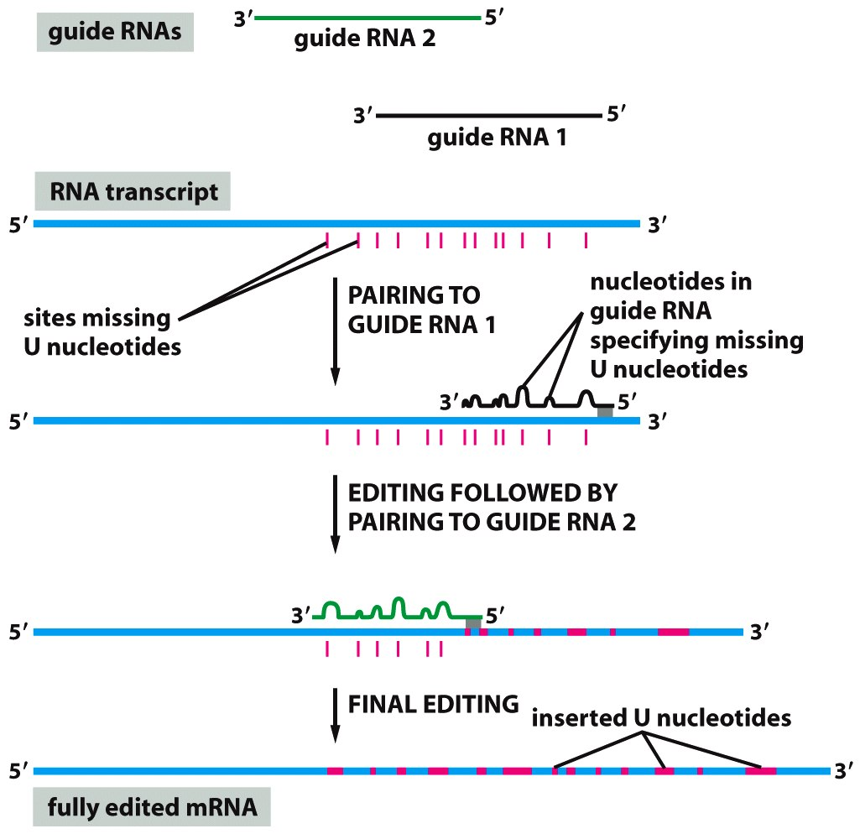
- dashes on the diagram represent missing uracil nucleotides in sequence. The short guide RNAs have region at their 5’ end that is complementary to transcript that is edited
1) Guide RNA pairs to mRNA
- loops contain the info necessary to eliminate or add extra U’s
2) editing followed by pairing to guide RNA 2
3) final editing

- TWO METHODS THAT THIS CAN OCCUR
- here, the top strand represents the target RNA, the bottom the guide RNA
- loops form because nucleotides in guide RNA do not have consensus sequence
- the first endonucleated base is the one 3’ of the first unpaired nucleotide.
- INSERTION:
- TUTase (Terminal uridylyl transferase) inserts Uracils (based on complementary rules of guide RNA)
- DELETION
- the guide RNA has only one U which pairs with mRNA’s A so the extra U’s are removed
- each case is followed by sealing nicks via DNA ligase
- process propagated in 3’ to 5’ direction along target RNA (several guides required)

ADAR EDITING
- RNA editing in not frequent in mammals; if edited, it is usually adenine replaced with inosine (deamination)
- ADAR = adenosine deamination acting on RNA
- ADAR enzyme binds on hairpin structure (exon and downstream intron complement) which is its docking site
- the resulting inosine pairs with C
- if we change a nucleotide in the exon, it will change amino acid sequence in the protein
- if in intron, it may either be silent or lead to alternative splicing

3) QUALITY CONTROL: DEGRADATION OF NONSENSE mRNA
- if mRNAs are defective they are not exported out of the nucleus nuclear RNA degradation
- degradation carried out by exosomes in the nucleus
- multisubunit
- RNA helicase, 3’ to 5’ and 5’ to 3’ exonuclease activities
- degrades when defective decapping, splicing, polyadenylation

NONSENSE MEDIATED mRNA DECAY (NMRO)
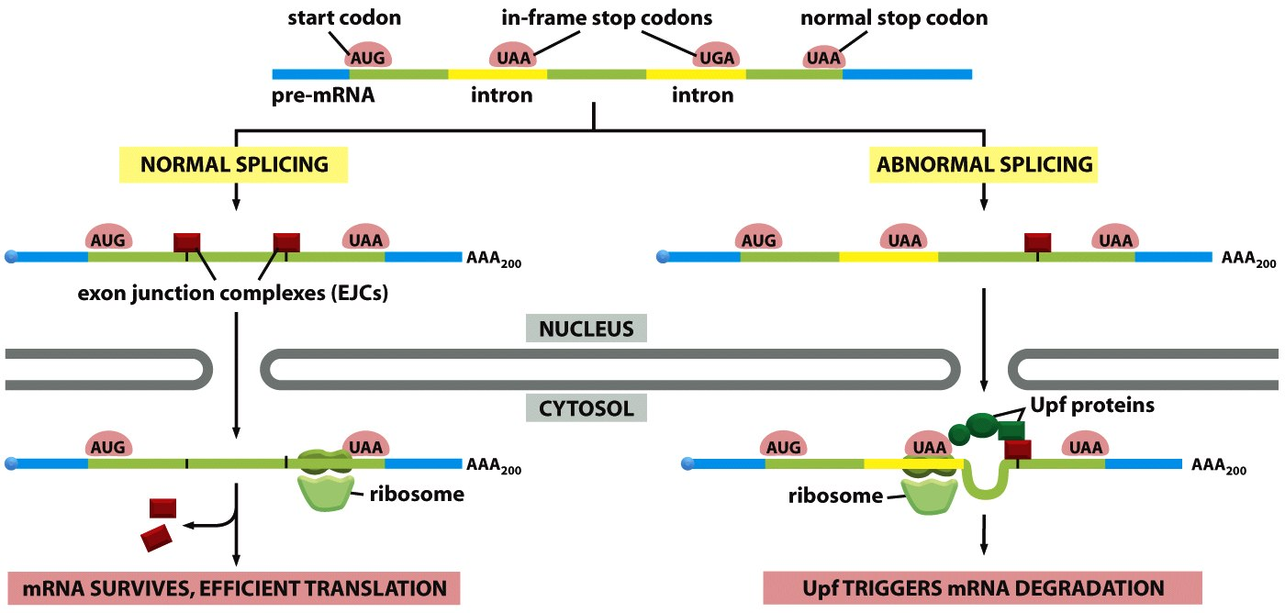
- cytoplasm mechanism to detect and degrade defective mRNAs
- happens in cytoplasm, but begins in nucleus
- usually to detect nonsense mutaitons
- exon junction complexes (EJCs) on mRNA after splicing, should be between start and stop codons
- once in mRNA, ribosomes will do test translation on the transcript
- as it passes exon/intron boundary, ribosome displaces the EJCs
- abnormal mRNA is exported out of nuceus with EJCs downstream of a stop codon. Ribosome detects this and recruits UpF proteins which cause degradation
- in terms of evolution: allows for new proteins that are functional
- important in inherited diseases if gene is truncated and toxic, mRNA degradation may be way to treat it.

LEVEL 3 – mRNA PROCESSING
mRNA Transport and Cellular Distribution
Nuclear Export

Subcellular Distribution of mRNAs
- position mRNAs close to the sites where the encoded protein is needed
- independent regulation of gene expression (i.e. polarized cells such as neurons)
- localized signals usually located in the 3’ UTR of the mRNA
- directed transport on cytoskeleton: proteins on cytoskeleton bind mRNA molecules and redistribute around cell (polarized in lumen of gut for example). mRNA placed into anchoring proteins (enhances translation)
- random diffusion and trapping
- generalized degradation + local protection:
High turnover of mRNA causes degradation of mRNA except those bound to anchoring protein.

- example found in experiment of Drosophila, where marked 3’ UTRs are found to be located in anchoring proteins or along one side of the cell.

LEVEL 4 – TRANSLATIONAL CONTROL
1) SELECTION OF START CODONS
- in prokaryotes, the Shine-Delgarno sequence is used to recognized the start sequence of the protein and positioning of the ribosome
- in eukaryotes, the Kozak sequence is used. A complex composed of a small ribosome along with initiation factors assembles onto this sequence.

Leaky Scanning
- nucleotides immediately surrounding AUG influence efficiency of translational initiation
- if the consensus (Kozak) sequence is poor, ribosome may pass over the first AUG and look for second or third one. Therefore started translation downstream creates shorter protein
- by using the 2nd or 3rd AUG, we can produce mRNA that has a signal sequence, one that doesn’t (increases regulation over gene expression)
- “leaky” scanning can be regulated in cell-specific manner: we can influence which AUG is translated

Upstream Open Reading Frames (uORFs)
- located in the 5’ UTR
- having an open reading frame upstream from the real gene “traps” the scanning ribosome initiation complex
- ribosome translates the uORF and dissociates from mRNA before it reaches protein-coding sequence
(nothing functional will come of it)

Internal Ribosome Entry Sites (IRES)
- IRES = several hundred nucleotides long: form hairpin structures
- mechanism used by viruses to make sure cells will transcribe their own mRNA
- proteases of virus cleave eIF4G (polyA binding proteins and 5’ cap bound to this) which means all cap-dependnet translation shuts down.
- because of this, only IRES dependent translation used
- in apoptosis, general translation DECREASES which means CAP dependent translation does not occur. Proteins still need to be made therefore IRES is carried out.

2) GLOBAL CONTROL OF PROTEIN SYNTHESIS
PHOSPHORYLATION OF INITIATION FACTORS
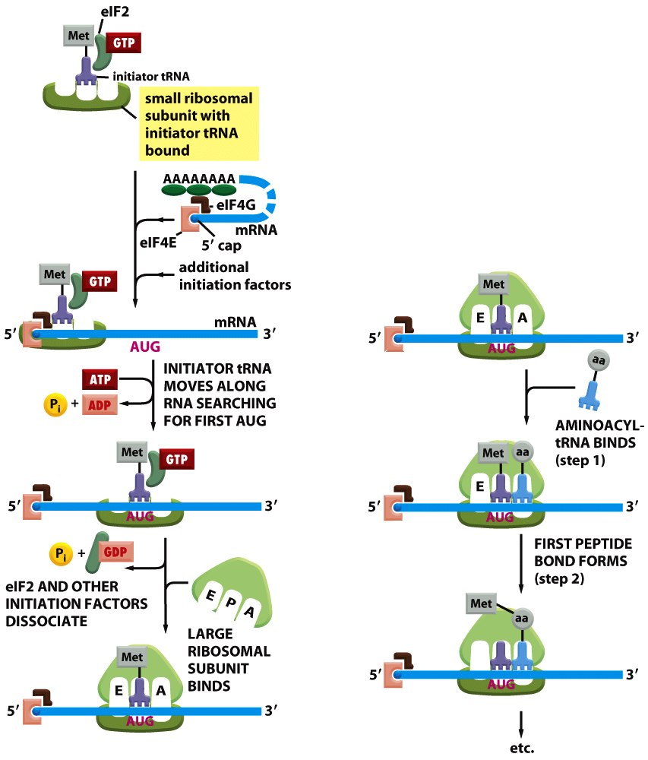
- eukayotes can decrease overall rate of protein synthesis during periods of stress (ex. temperature)
- phosphorylation of eIF2 by protein kinases that respond to changes in conditions

- eIF2 bound to GTP helps recruit the complex of small ribosome, helps to bring the intiator to 5’ cap.
- eIF2 hydrolyzes GTP causing shape change and thus dissociation of eIF2
- eIF2 is active when bound to GTP. When it’s bound to GDP it is inactive
- eIF2B = guanine exchange factor
- because GTP-eIF2 is hard to dissociate, eIF2B exchanges GDP for GTP
- eIF2B cannot be reused when it is phosphorylated
- part of the mechanism that allows for cells to enter G_{o} (non-proliferative, 20% decrease in total protein synthesis)

LEVEL 5: mRNA STABILITY
DEADENYLATION OF mRNAs
Deadenylation-Dependent Decay
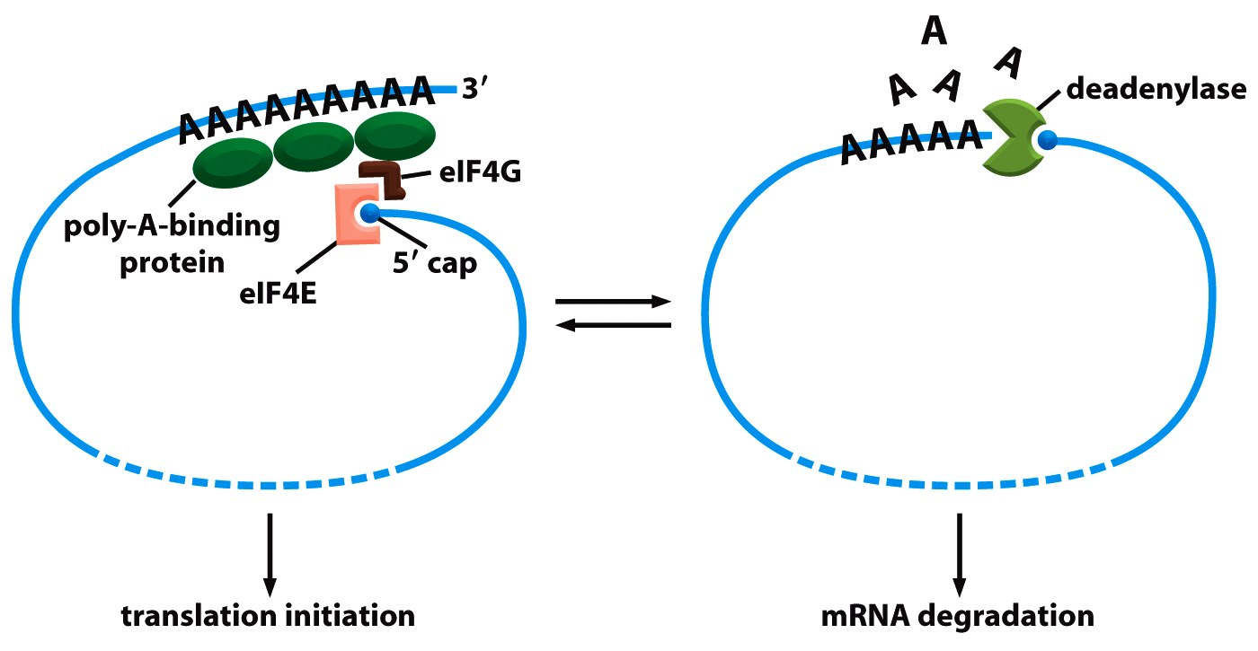
- we can regulate stability of mRNA through its half-life.
- in prokaryotes the half-life is 3 minutes, whereas in eukaryotes it’s up to 10 hours
- half-life is regulated by the polyA tail
- as soon as the polyA tail reaches the cytoplasm, the polyA tail starts to shorten critical length is 30 nt
- PABP can no longer bind to polyA tails shorter than 30 nts
- phosphodiester bonds are targeted by nucleases without polyA biding proteins

- there is an equilibrium between deadenylation and translation
- during intiation, deadenylase interacts with the 5’ cap but PABP protect polyA tail
- if polyA tail is too short, there are no PABP and deadenylase starts degrading mRNA

Endonucleotytic Cleavage
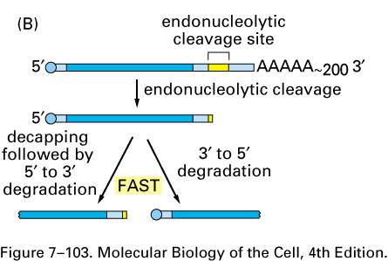
- sequence-dependent endonuclease recognition sites (located within 3’ UTR) degradation
- it is possible to block this site by binding a protein site to mask this

2) INTERFERING mRNAs
RNA INTERFERENCE: miRNAs
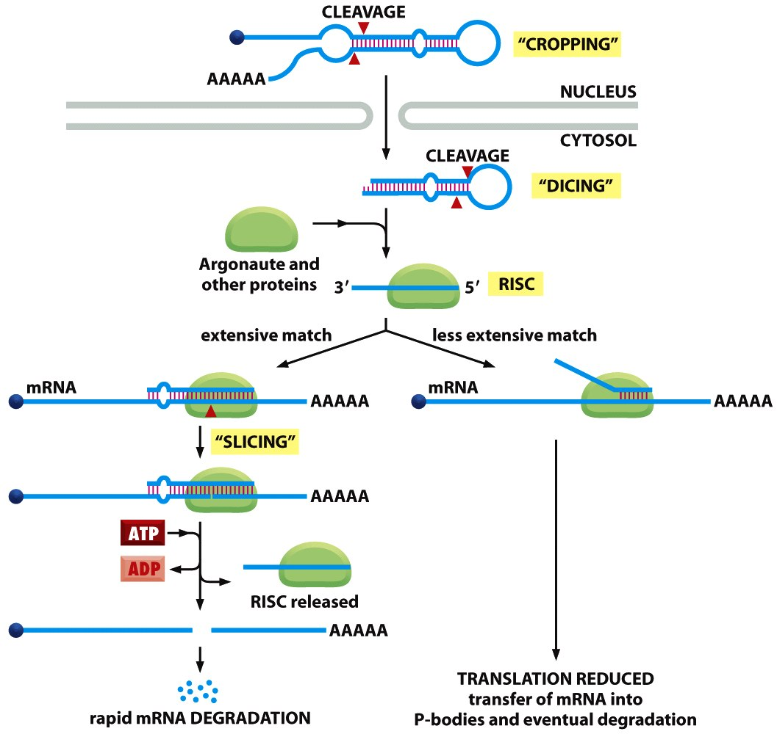
- 100 – 200 nts long and synthesized by RNA Polymerase II
- also processed with a 5’ cap and polyA tail
- sequence has lots of complementary base pairs within the sequence to allow for stemmed loop structure
- unlike mRNA, these go additional processing steps:
- CROPPING: eliminating cap and polyA tail to end with stemmed loop structure
- DICER: cleaves off loop portion after export into the nucleus. Left is a 22 nt dsRNA
- Argonaute and other proteins bind dsRNA to produce RISC (RNA-induced silencing complex) which are involved in repressing gene expression
- Argonaute cleaves RNA (endonuclease activity): it nicks strands to cleave complex, which causes nicked strand to be released. It also places miRNA in optimal position for hybridization with target RNA

- miRNA base pair with specific mRNAs regulate their stability and their translation
- MINIMUM of 7 nts in 3’ UTR of target mRNA
- SCENARIO 1:extensive match
- Argonaute will permit hybridization with mRNA, then will cleave the target mRNA
- with ATP, RISC is released left with cleaved mRNA to be degraded
- SCENARIO 2: less extensive match
- RISC complex will be recruited to create P bodies
- P bodies = large assemblies of mRNA and RNA-degrading enzymes
- ribosomes will not be able to access RNA eventual degradation

miRNAs AS REGULATION OF GENE EXPRESSION
- single miRNA can have several different targets (share common sequence in 3’ UTR)
- combinatorial control (sometimes more than one miRNA need to be bound)
- miRNA occupy very little space in the genome

RNA INTERFERENCE: siRNAs
- defense mechanism: degradation of foreign molecules (viruses) by fungi, plants and worms
- the cell can detect dsRNA as foreign
- The enzyme dicer (same as miRNA pathway) will cleave dsRNA into short dsRNA segments.
- Argonaute plus RISC proteins will bind to siRNA.
- These siRNA follow mechanism as seen previously for exact sequence (degradation of the rest of the viral genome)
- Note: these siRNA were derived from the dsRNA of the viral genome, therefore EXACT MATCH

- selective transcriptional silencing (plants, nematodes)
- RITS complex = RNA-induced transcriptional silencing complex
- silence transcription using RITS complex
- binds to the RNA as it is being synthesized
- It can also recruit histone modifiers:
- we introduce a more compact, closed, chromatin structure at the promoter of these genes. We will no longer be able to transcribe the target RNA

- NOTE: siRNA NOT found in humans! In humans, it is miRNA.
RNAi: A POWERFUL EXPERIMENTAL TOOL
- allows scientists to inactivate almost any gene via introduction of short dsRNA
- how can it be used to treat human diseases? some diseases caused by misexpression, therefore these could be used to target expression of these genes (only good for simple disease mechanisms)

