Unit 1 Forces and Motion (lots of equations less factual)
Chapter 1; Motion
1.1 Motion in Our Lives
- Uniform motion is movement at a constant speed in a straight line. Most motions are non-uniform
- A scalar quantity has magnitude but no direction. E.g. Distance, time, and speed
- The Systéme International (SI) base units, the metre (m), the kilogram (kg), and the second (s), can be used to derive other more complex units, such as metres per second (m/s)
- Average speed is the ratio of the total distance travelled to the total time, or v=d/t
- A ticker tape timer is just one of several devices used to measure time intervals in a school laboratory
1.2 Uniform Motion
- A vector quantity has both magnitude and direction. Examples are position, displacement and velocity
- Position d, is the distance and direction of an object from a reference point. Displacement, d is the change in position of an object from a reference point
- Average velocity is the ratio of the displacement to the time interval, or v=d/t
- The straight line on a position-time graph indicates uniform motion and the slope of the line represents the average velocity between any two times
- The area under a line on a velocity-time graph represents the displacement between any two times
1.3 Two-Dimensional Motion
- In two-dimensional motion, the resultant displacement is the vector sum of the individual displacements, ∆d_{R}=∆d₁+∆d₂
- The average velocity in two dimensional motion is the ratio of the resultant displacement to the time interval, v= ∆d/∆t
- All motion is relative to a frame of reference. We usually use Earth as our frame of reference. For example, the velocity of a train relative to Earth or the ground can be written V_{TG}
- When two motions are involved, the relative velocity equation is v_{AC=}v_{AB} +v_{BC} which is a vector addition
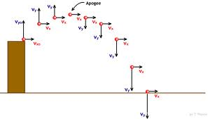
1.4 Uniform Acceleration
- Uniformly accelerated motion occurs when an object, travelling in a straight line, changes its speed uniformly with time. The acceleration can be one that is speeding up or slowing down
- The equation for average acceleration is a=v/t or a=vf-vi/∆t
- On a velocity-time graph of uniform acceleration, the slope of the line represents the average acceleration between any two times
- A position-time graph of uniform acceleration is a curve whose slope continually changes. Tangents to the curve at specific times indicate the instantaneous velocities at these times, which can be used to determine acceleration
- You should be able to determine the acceleration of an accelerating object using at least one experimental method
1.5 Acceleration near Earth’s Surface
- On average, the acceleration due to gravity on Earth’s surface is g=9.8 m/s² (down). This means that in the absence of air resistance an object falling freely toward Earth accelerates at 9.8 m/s² (down)
- Various experimental ways can be used to determine the local value of g
- The topic of accelerated motion is applied in various fields, including transportation and the sport of skydiving.
1.6 Solving Uniform Acceleration Problems
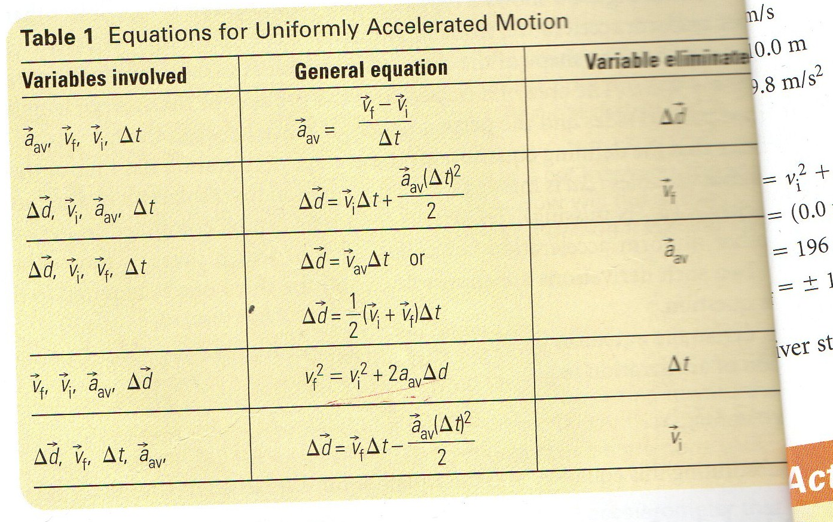
- Starting with the defining equation of average acceleration, a= vf-vi/∆t and a velocity-time graph of uniform acceleration, equations involving uniform acceleration can be derived. The resulting equations, shown in Table 1 can be applied to find solutions to a variety of motion problems
Table 1: Uniformaly Accelerated Motion Equations
Chapter 2; Forces and Newton’s Laws of Motion
2.1 Forces in Nature
- A force which is a push or a pull, is a vector quantity; its SI unit is the Newton (N)
- The fundamental forces responsible for all forces are gravitational, electromagnetic, strong nuclear, and weak nuclear
- Some common forces we experience are friction, tension, and the normal force
- Drawing free-body diagrams is an important skill that helps in solving problems involving forces
2.2 Newton’s First Law of Motion (inertia)
- Galileo’s real and virtual experiments led the way for Newton to formulate his three laws of motion
- The net force acting on an object, Fnet is the vector sum of all forces acting on the object
- Newton’s first law of motion is observed and applied in many situations, including the need for restraint systems in automobiles.
2.3 Force, Mass, and Acceleration
- To determine the relationship among three variables, a controlled investigation can be performed in which one independent variable is kept constant while the other independent variable is varied, and vice-versa
- A controlled investigation can be performed to determine how the acceleration of an object depends on the mass of the object and the net force acting on the object
2.4 Newton’s Second Law
- Newton’s second law of motion relates the acceleration of the object to the mass of the object and the net force acting on it
- A=f/m or f=ma
- Used in many problem solving situations
2.5 Newton’s Third Law
- Newton’s third law of motion, which always involves two objects, states that for every action force, there is a reaction force equal in magnitude, but opposite in direction
- Action-reaction pairs of forces are applied in many situations, such as a person walking, a car accelerating, and a rocket blasting off into space

Chapter 3; Gravitational Force and Friction
3.1 Gravitational force on earth’s surface
- Earth’s gravitational field is the space surrounding Earth in which the force of gravity has an effect
- On Earth’s surface, the average gravitational field strength is g=9.8 N/kg (down)
- Mass is the quantity of matter (measured in kilograms) and weight is the force of gravity (measured in Newton’s and determined using the equation F=mg)
- The magnitude of g decreases as the distance from earth’s centre increases, so this magnitude is smaller at higher altitudes, and it is greater at the poles than at the equator because Earth is slightly flattened at the poles
- An object orbiting another object maintains its orbit by constantly free falling toward the central body. For example, the international space station and its contents constantly free fall toward Earth.
3.2 Universal Gravitation
- Newton’s law of universal gravitation applies to all objects in the universe. It is an example of an inverse square relationship in which the force of gravitational attraction between any two objects in the universe is inversely proportional to the square of the distance between the objects.
- For particles or spherical objects, the equation for the law of universal gravitation is Fg=Gm1m2/d^2 where G is 6.67x10⁻¹¹ N•m²/kg²
- The concept of universal gravitation is applied in astronomy, space science, and satellite technology
3.3 The Effects of Friction
- Friction acts parallel to two surfaces in contact in a direction opposite to the motion or attempted motion if an object
- Static friction tends to prevent a stationary object from starting to move. Kinetic friction acts against an objects’ motion; it is usually less than static friction
- For an object to maintain uniform velocity the net force acting on it must be zero, so for an object moving at uniform velocity on a horizontal surface, the applied horizontal force must be equal in magnitude to the kinetic friction.
- Unwanted friction can be reduced by changing sliding to rolling, by using bearings, and by using lubrication
- The extent to which certain factors affect friction, such as the types of surfaces in contact or the mass of the object, can be determined using a controlled experiment.

3.4 Analyzing Motion with Friction
- The coefficient of friction, µ, is the ratio of the magnitude of the force of friction to the magnitude of the normal force between two surfaces in contact.
- The coefficient of static friction is µs= Fs/Fn and the coefficient of kinetic friction is µk=Fk/Fn. These coefficients can be determined using a controlled experiment in which a horizontal applied force is used to move an object with constant velocity across a horizontal surface.
- Problem-solving skills developed throughout this unit can be synthesized in order to solve problems that include friction and coefficients of friction.
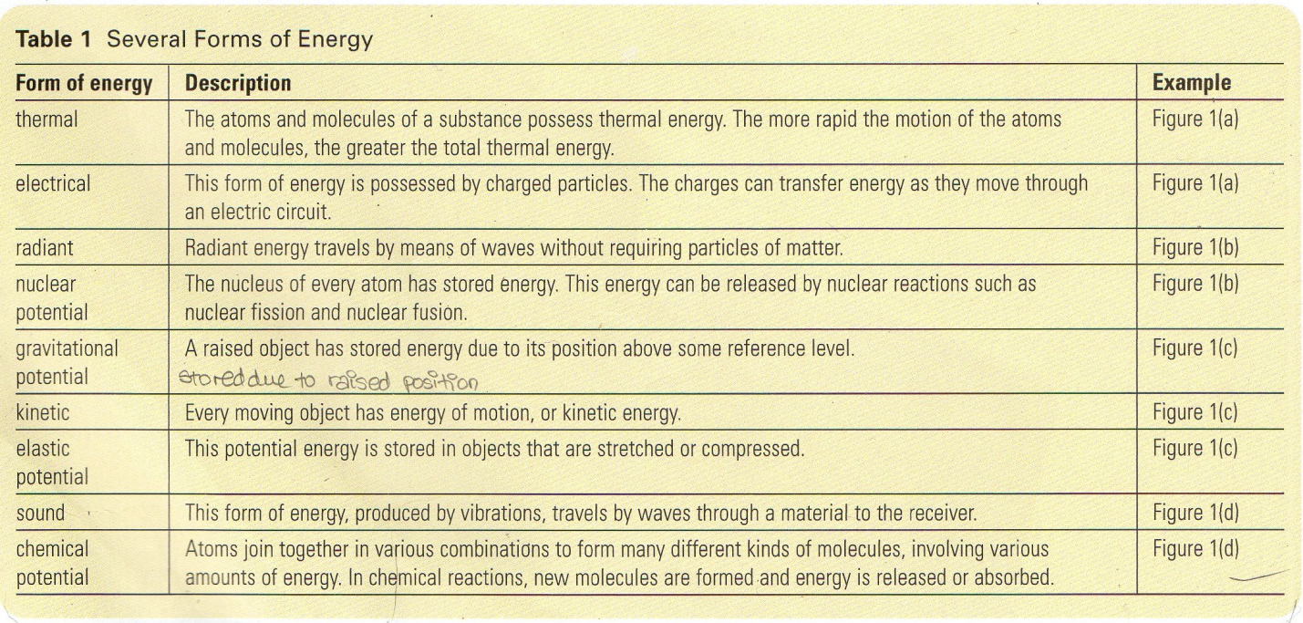
Unit 2 Energy, Work, and Power
Chapter 4; Energy, Work, Heat, and Power
4.1 Energy and Energy Transformations
- Energy is the capacity to do work
- Energy exists in many forms, such as thermal energy and kinetic energy
- In an energy transformation, energy changes from one form into another. The transformation can be described using an equation with arrows
4.2 Work
- Work is the energy transferred to an object by an applied force over a distance
- If the force and displacement are in the same direction, the work done by the force, W=F∆d, is a positive value. If the force and displacement are in opposite directions,the work done is a negative value.
- Work is a scalar quantity measured in joules (J)
4.3 Mechanical Energy
- Gravitational potential energy, which is energy possessed by an object due to its position above a reference level, is given by the equation E_{g}=mgh, where m is the mass of the object, g is the magnitude of the gravitational field, and h is the height above the reference level
- Kinetic energy, which is energy of motion, is found using the equation E_{k}=mv²/2
4.4 Conservation of Energy and Efficiency
- The law of conservation of energy states that when energy changes from one form to another, no energy is lost
- The law of conservation of energy is applied in many situations, including playing sports, operating hydroelectric generating stations, and problem solving in physics
- The efficiency of an energy transformation is found using the equation; efficiency=E_{out}/E_{in} x 100%. Almost all waste energy goes to heat or thermal energy
4.5 Thermal Energy and Heat
- It is important to distinguish between thermal energy, heat, and temperature
- Heat transfer can occur by means of conduction, convection, and radiation
- The quantity of heat, Q, transferred to an object of mass m and specific heat capacity c in raising its temperature by ∆t is found using the equation. Q=mc∆t
4.6 Power
- Power is the rate of doing work or consuming energy, found using the equation p=W/∆t, or P=∆E/∆t
- Power is a scalar quantity measured in Watts (W)
Chapter 5: Not much to talk about or learn, Remember types of energy in society and their impacts on the environment, and future of Earth. E.g. Coal, Oil, Natural Gas are fossil fuels which produce harmful emissions, that damage our environment.

Unit 3 Waves and Sound (very factual less equations)
Chapter 6; Vibrations and Waves
λ: Length of pulse
Formulas:
T = 1/f f=1/T
v = fλ v = λ/T
Unit of measurement: Hertz (Hz)
Rest position = Equilibrium position
Medium: What the wave is made of. (Exp. rope, hose, slinky, body of water etc.)
Types of waves:
Sound waves Telephone chord waves
Radio waves Microwaves
Water waves Stadium waves
Earth quake waves Visible light Waves
Wave: The motion of a disturbance that travels through a medium from one location to another.
3 Types:
Transverse vibration:
When an object vibrates perpendicular to its axis at the normal rest position.
Longitudinal Vibration:
When an object vibrates parallel to its axis at the rest position.
Torsional Vibration:
When an object twists around its axis at the rest position
Properties of Wave
Pulse: Wave that consists of a single disturbance.
Equilibrium: State of rest or uniform motion in which there is no resultant force (Rest position)
Crest: Maximum value of a wave
Trough: Minimum value of a wave
Amplitude: Distance between equilibrium and crest or trough
Wave Length: Distance between two consecutive similar points.
Wave frequency: Amount of times a pulse passes a fixed point over a given amount of time.
Wave period: Time it takes for one cycle to complete.
6.1 Characteristics of Vibrations and Waves
- Most waves originate from a vibrating source
- A wave is a transfer of energy over a distance in the form of a disturbance
- In a transverse vibration, the object vibrates perpendicular to its length, while in a longitudinal vibration it vibrates parallel to its length
- The frequency (f) is the number of cycles per second
- The period (T) is the time required for one cycle
- The frequency and the period are inversely related (f=1/t)
- Objects are vibrating in phase if they have the same period and pass through the rest position at the same time
- The period of a pendulum is directly proportional to the square root of its length
6.2 Wave Motion
- Periodic waves originate from periodic vibrations where the motions are continuous and are repeated in the same time intervals
- In a transverse wave, the particles of the medium move at right angles to the direction of the wave motion
- In a longitudinal wave, the particles in the medium vibrate parallel to the direction in which the wave is moving
- A transverse wave consists of alternate crests and troughs
- A longitudinal wave consists of alternate compressions and rarefactions
- One wavelength is the distance between points on successive crests or troughs in a transverse wave
- In a longitudinal wave, one wavelength is the distance between the midpoints of successive compressions or rarefactions
- The speed of a wave is unaffected by changes in the frequency or amplitude of the vibrating source
6.3 The Universal wave Equation
- One vibration of the source produces one complete wavelength
- The frequency and the period of a wave are the same as those of the source, and they are not affected by changes in the speed of the wave
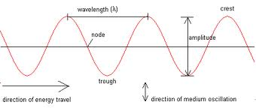
- The Universal wave equation, v=fλ, applies to all waves

6.4 Transmission and reflection
- Pulses reflected from a fixed end are inverted
- Pulses reflected from a free end are not inverted
- When a pulse enters a new medium, no inversion occurs
- When a wave enters a slower medium, its wavelength decreases; in a faster medium its wavelength increases.
- When waves strike the boundary between two different media, partial reflection occurs
- The phase of transmitted waves is unaffected in all partial reflections, but inversion of the reflected wave occurs when the wave passes from a fast medium to a slow medium
6.5 Properties of Waves
- A wave ray is a straight line drawn at right angles to the wave front, indicating the direction of the wave motion
- When waves are reflected from a solid obstacle, the angle of incidence is always equal to the angle of reflection
- When a wave enters a medium in which it moves slowly, its wave length decreases
- When a water wave enters a slower medium at an angle, its direction of transmission changes; the wave has undergone refraction
- When a wave passes by a barrier or through a small opening, it tends to diffract or change direction
6.6 Interference of Waves
- Waves can pass through each other in a medium without affecting each other; only the medium particles are momentarily affected
- The resultant displacement of a particle is the algebraic sum of the individual displacements contributed by each wave
- If the resultant displacement is greater than that caused by either wave alone, constructive interference is occurring; if it is smaller , destructive interference is occurring
6.7 Mechanical Resonance
- Resonance occurs when an object that is free to vibrate is acted on by a periodic force that has the same frequency as the object’s natural frequency
- Mechanical Resonance must be considered when designing any object that has some freedom of movement and has some physical contact with a source of vibration

6.8 Standing Waves
- For total destructive interference to occur, the waves interfering must have identical wavelengths and amplitudes
- Nodes are points in a medium that are continuously at rest; that is the resultant displacement of the particles at these points is always zero
- Points in a medium at which constructive interference occurs are called anti-nodes
- A stationary interference pattern of successive nodes and anti-nodes in a medium is called a standing wave pattern
- The distance between successive nodes or antinodes in a standing wave interference pattern is one-half the wavelength of the interfering waves
6.9 Two-Point Interference Pattern
- The interference pattern between two identical point sources, vibrating In phase, is a symmetrical pattern of alternating areas of destructive and areas of constructive interference radiating out from the point sources
Chapter 7; Properties of Sound Waves
7.1 What is Sound?
- All sound waves are caused by vibrations
- Sound stimulates the auditory nerve
- Humans can hear a range between 20 and 20 000 Hz
- Infrasonic sounds have a frequency below 20 Hz
- Ultrasonic sounds have a frequency above 20 000 Hz
7.2 Production and Transmission of Sound
- Sound originates from a vibrating source
- Sound requires a physical medium for its transmission
- Sound travels as a series of compressions and rarefactions
- Pitch is related to frequency; the higher the frequency, the higher the pitch
7.3 The Speed of Sound
- The speed of sound in air at 0˚C is 332m/s
- The speed of sound increases when the temperature increases
- The speed of sound can be measured using echoes
- The speed of sound changes if the medium changes

7.4 Sound Intensity
- Sound intensity is measured in watts/metre squared, and intensity level is measured in decibels
- For humans the threshold of hearing is 0dB and the threshold of pain is 130dB
- The intensity of sound decreases as the distance from the source increases
7.5 The Human ear and Hearing
- The human ear magnifies and transforms sound into electrical nerve pulses
- The range of hearing for most young people is 20-20,000Hz
- The range diminishes with age and/or exposure to loud sounds
- People in noisy locations should protect their hearing
- Hearing loss can be improved by electronic devices, such as hearing aids
7.6 The Reflection of Sound Waves
- Sound waves obey the laws of reflection
- Echolocation is used in sonar applications, including navigation and food collection by some animals
- Ultrasound has many medical applications, both for diagnosis and treatment
7.7 Diffraction and Refraction of Sound Waves
- Sound waves can be diffracted and refracted
- Diffraction is greater when the sound wavelengths are larger
7.8 The interference of Sound waves
- Sound waves interfere, producing areas of constructive and destructive interference
- The interference pattern between two identical sources of sound is similar to that produced by identical point sources in a ripple tank
7.9 Beat Frequency
- Interference between two nearly identical sources of sound results in periodic changes in intensity, called beats
- Beat frequency is the difference between the frequencies of two sound sources
7.10 Doppler Effect and Supersonic Travel
- Doppler shift is the perceived frequency shift when a source of sound moves relative to an observer
- Doppler shift is used to measure the speed of moving objects
- The Mach number is used to measure supersonic speeds
- Objects exceeding the speed of sound break the sound barrier, creating sonic booms
- Sonic booms create disturbances for animals and humans
Chapter 8; Music, Musical Instruments, and Acoustics
8.1 Sound Waves and Music
- Longitudinal sound waves can be displayed on a computer monitor or oscilloscope as transverse waves for easier analysis
- Music consists of notes with constant frequencies; noise is sound with constantly changing frequency
- Pitch, loudness, and quality are all subjective characteristics of sound since they depend on the perception of the listener
- If the frequency of a sound increase, pitch of the note increases
- Sounds are harmonious and have consonance if their frequencies are simple ratios
- A musical interval of an octave has a sound that is double the frequency of the original sound
- The two common musical scales are the scientific musical scale based on the 256Hz, and the musicians scale, based on 440Hz
8.2 Vibrating Strings
- The frequency of a vibrating string is determined by its length, tension, diameter, and density
- The frequency of a string is inversely proportional to its length (f$∝$1/l)
- The frequency of a string is directly proportional to the square root of its tension (f$∝$ $√F$)
- The frequency of a string is inversely proportional to it diameter (f$∝$1/d)
- The frequency of a string is inversely proportional to the square root of its density
(f$∝$1/$√D$)
8.3 Vibrations and Sound Quality
- A string may vibrate along its whole length in a single segment or in segments that are simple (whole-number) fractions of its length
- When an object vibrates in its fundamental mode of vibration, it produces its lowest possible frequency, called the fundamental frequency
- Frequencies of overtones modes are simple (whole-number) multiples of the fundamental frequency called harmonics
- The quality of a musical note depends on the number and relative intensity of overtones it produces along with the fundamental

8.4 Resonance in Air Columns
- Resonance occurs in closed air columns at lengths of 1/4λ, 3/4 λ, 5/4 λ and so on from the original sound wave
- The resonant lengths of open air columns are 1/2 λ, λ, 3/2 λ, 2 λ and so on of the original sound wave
Musical Instrument Notes;
Air columns can be:
Closed: Means one end is closed and one end is open.
Open: Where both ends are open.
Instruments with Strings:
Made with two main parts Vibrator (strings) Resonator (vibrates in resonance with sound source) Can be plucked, struck or boned. Some have frets and others do not.
Wind Instruments:
Are made up of columns with vibrating air Length of pipe can be fixed (pipe organ or can be altered (trombone) There are 4 ways the air is forced to vibrate: Air reed instruments: air through opening i.e. Recorder. Single membrane instruments: air vibrates a reed Double mechanical reed instruments: two vibrates against each other Lip Reed instruments (aka Brass): Players lips are the double reeds. Quality of sound is based on quality of construction and ability of player.
Percussion:
Instrument that is struck with a firm object. Three categories: Single indefinite Pitch: beat keepers and special effects. Multiple Definite Pitch: have bars and bells of varying sizes (thus their own harmonics and resonate frequencies which produce different sounds)
Variable Pitch: include a device which allows for rapid changes in pitch
Human Voice Makes Music:
There are various frequency ranges for types of singers.
Bass (82-294Hz) Baritone (110-392Hz) Tenor (142-523Hz) Alto (196-698Hz) Soprano (262-1042Hz) The Process for Producing Sounds:
Air from lungs forced across vocal cords. Vocal cords 2 bonds of skin vibrate creating a situation like a double reed. Amount of air influences loudness. Pitch is controlled by tension and size of the vibrating portion. Quality is controlled by the proportions that vibrate (pharynx, mouth, nasal cavity, tongue and lips) Males are generally larger instruments (which have lower resonant frequencies) thus have a lower range generally than female voice.
Electronic Musical Instruments:
Has 4 main Parts:
Oscillator (creates vibrations) Filter circuit (selects frequencies to be sent to mixing circuit) Mixing circuit (adds the frequencies together to produce the output sound.) Amplifier and speaker (output the sound loud enough to be heard. A synthesizer can make any shape of wave and as a result can produce sounds that match other traditional musical instruments.
Acoustics
Acoustics are the total effect of sound produced in an enclosed space and are influenced by everything in the space including composition and shape.
Reverberation Time: is the time required for the intensity of the sound to drop to 10^-6 (a millionth of the original value (or until inaudible).
Unit 3 Electricity
Physics Chapter 12 Summary
12.0 Electrostatics
- The fundamental laws of electric charges state that opposiye electric charges attract each other; similar electric charges repel each other; and charged objects attract some neutral objects
- The net charge in solids is due to an excess or deficit of electrons
- A conductor is a solid in which charge flows freely; an insulator is a solid that hinders the flow of charge
- Solids can be charged by friction, contact, induction, or grounding
12.1 Electric fields and Electric Charge
- Every charged object creates an electric field of force in the space around it; any other charged object in that field will experience a force of electrical attraction or repulsion
- Electric charge is measured in units called coulombs ( C )
- Milikan’s oil drop experiment proved the existence of a smallest unit of electric charge, which he called the elementary charge ( e )
- The total charge, Q, on an object, measured in coulombs, is given by the equation Q=Ne
12.2 Electric Current
- When electric charges move from one place to another, this constitutes an electric current
- The electric current, I, through a cross-section of cylindrical wire is represented by the equation I=Q/t
- Electric current or conventional current describes electric charges travelling through a conductor from the positive terminal to the negative terminal of the source of electric potential
- Electron flow is a term used to indicate that the electric current in metals is due to the motion of electrons
- Direct current (DC) results when charges flow in a particular direction; alternating current (AC) results when charges periodically reverse direction

12.4 Electric potential Difference
- Electric potential difference (V) is the amount of work required per unit charge to move a positive charge from one point to another in the presence of an electric field
- The electric potential difference (V) between two points, A and B, is represented by the equation V=W/Q
- Because of the units in which it is measured, electric potential difference is often called “Voltage”
- The electrical energy lost by a current, through a potential difference, V, for a time, ∆t, is represented by the equation ∆E=VI∆t
12.5 Electric Circuits
- Sources of electric potential energy are connected to electric loads by means of a circuit
- In a series circuit, the charges have only one path to follow, and as a result each charge goes through each load in turn
- In a parallel circuit, charges can move along several paths, and as a result pass through any one of several loads in the circuit
- Kirchhoff’s voltage law (KVL) states that around any complete path through an electric circuit, the sum of the increase in electric potential is equal to the sum of the decreases in electric potential
- Kirchhoff’s current law (KCL) states that at any junction point in an electric circuit, the total electric current into the junction is equal to the total electric current out.
Notes;
Voltages are the same across all components connected in parallel.
Currents add up for components connected in parallel.
Voltages add up for components connected in series.
Currents are the same through all components connected in series.

12.6 Electric resistance
- When charges pass through a material or device, they experience an opposition known as resistance
- Ohm’s law is represented by the equation V/I=R
- The unit of electric resistance is called the ohm Ώ
- If the number of resistors connected in series is n, the equivalent resistor is given by Rs=R₁+R₂ +…+Rn
- If the number of resistors connected in parallel is n, the equivalent resistor is given by 1/Rp=1/R1+1/R2+…+1/Rn

12.7 Power in Electric Circuits
- The rate at which a device uses energy is known as power, represented by the equation P=VI
- Electrical energy is measured in kilowatt hours (kW.h)
- The total cost of electricity can be calculated by multiplying the number of kilowatt hours of energy used by the rate (price per kilowatt hour)
Chapter 13; Electromagnetism
13.1 Magnetic force and Fields
- Opposite magnetic poles attract and similar magnetic poles repel
- The space around a magnet in which magnetic forces are exerted is known as the magnetic field of force
- The magnetic field around a bar magnet is three-dimensional in nature
13.2 Magnetic Materials
- Certain substances are ferromagnetic and can be induced to become magnetized by placing them in a magnetic field
- When a ferromagnetic substance becomes magnetized, all its dipoles temporarily align in the same direction to form a magnetic domain
13.3 Oersted’s Discovery
- The principle of electromagnetism states that whenever an electric current moves through a conductor, a magnetic field is created in the region around the conductor
- The magnetic field lines around a straight conductor are in concentric circles
- The right-hand rule for a straight conductor states that if a conductor is held in the right hand with the right thumb pointing in the direction of the electric current, the curled fingers will point in the direction of the magnetic field lines
13.4 Magnetic Field of a coil or Solenoid
- The magnetic field around a coil is the sum of the magnetic fields of each of its segments
- The right-hand rule for a coil states that if a coil is grasped in the right hand with the curled fingers representing the direction of electric current, the thumb points in the direction of the magnetic field inside the coil
- The magnetic field strength of a coil depends on the current in the coil, the number of loops in the coil, and the type of core material

13.5 The Motor Principle
- The motor principle states that a current-carrying conductor that cuts across external magnetic field lines experiences a force perpendicular to both the magnetic field and the direction of electric current. The magnitude of this force depends on the magnitude of both the external field and the current, as well as the angle between the conductor and the magnetic field it cuts across
- The right-hand rule for the motor principle states that if the fingers of the open right hand point in the direction of the external magnetic field, and the thumb represents the direction of electric current, the force on the conductor will be in the direction in which the right palm faces
Chapter 14; Electromagnetic Induction
14.1 Faraday’s Discovery
- The law of electromagnetic induction states that if the magnetic field inside a coil changes amount or direction, an electric current is induced in the coil
- Mutual induction occurs whenever a changing current in one coil induces a current in a nearby coil
- The magnitude of an induced current in a coil is affected by the number of turns on the induction coil, the rate of change of the inducing magnetic field, and the strength of the inducing magnetic field
14.2 Direction of induce Current
- Lenz’s law states that for a current induced in a coil by a changing magnetic field, the electric current is in such a direction that its own magnetic field opposes the change that produced it
14.3 Electric Generators: AC and DC
- An electric generator is a device that converts mechanical energy into electrical energy using the rotational motion from a continuous source of energy
- An AC generator provides current from an outside circuit connected by means of slip rings and brushes
- A DC generator provides current from an outside circuit connected by means of a commutator
14.4 The Transformer
- A transformer is a device that can change the electric potential difference in a secondary circuit by varying the current in the primary circuit
- The transformer equation states
14.5 Distribution of electrical Energy
- AC generators are used for large-scale electrical energy supply
- Transformers allow the tremendous amount of electrical power produced at electric generating stations to be transferred into safe and efficient power for use by consumers

