CHM4317 Organometallic Midterm

Bonding Theory Review for Organometallic

Sigma interaction = direct s orbital overlap
Pi interaction p orbitals side by side
In phase Bonding
Out of phase anti-bonding
Incommensurate orientation non-bonding
Bond Order #bonding – anti-bonding / 2
O2 is a triplet state
EN elements have more of that atoms character
Cyclic H3+ vs linear
Effective Atomic Number Rule: Donor Pair vs Radical Method
Π-Acceptor ligands: CO, CNR, CN⁻, alkenes, alkynes
Sigma donation to metal, pi-backbonding into anti bonding orbital of ligand
IR. More electron rich M more back-bonding lower C-O Vibration
Bridging COs lower v_{co} than terminal.
More metal pi-basicity lowers v(CO)
Isoelectronic isonitriles, CNR are better sigma-donors and poorer pi-acceptors, stabilize low oxidation states.
CN stabilize higher oxidations states
Metal carbides can act as ligands
Bond lengths are longer with trans donor ligand
M-C > M=C > MtripleC
Bonds get stronger going down the group
Sp2 C have higher BDE
EN alpha-substituents stabilize M-C bond

Fundamental Reactions

Ligand Substitution
No change in oxidation.
2nd row better than 1st and 3rd
Associative, Dissociative, Interchange
Hapticity change possible (frees up coordination)
Cis and Trans effect.
Oxidation by 1e helps activate for substitution

Associative:
-Common for 16e SP.
-SN2 like (α Nuc. + LG)
-Retention of Config.
-Intermediate = square pyramid via barry pseudo rotation

Trans Effect
-H⁻ > PR₃ > I⁻, Me⁻ , CO, CN⁻ > Br⁻ > Cl⁻ > NH₃

*Kinetic Trans Effect*
-Ethylene > CO, CN⁻ > H⁻, PR₃ > Me⁻ > I⁻ > Br > Cl > NH₃
Depends on EW ability and pi-back bonding ability

Substitution on 18e Aromatic complex
-Possible because of intial slow rearrangement that opens a coordination site without changing oxidation state.
-Larger Indenyl > Cp because of the retention of the benzene aromaticity

Dissociative Substitutions
-Most common for 18e (16e intermediate k2 ~ k-1)
-Enthalpy = large positive K depends on steric bulk of L

Cis Effect
Ligands cis to pi donor X are more labile than trans. Giving a preferential cis dissociative substitution. Reasoning: CO are good pi acceptors and X is a pi donor; this interaction is trans, making the trans interaction stronger.

Steric Effect
-Phosphorus ligand cone angles and kinetics
-Bulkier tert substituents increase the M-P bond length making it more labile, and a good LG.
-Phosphorus is EW, when substituted with EWGs it increases the strength of the CO bonds. IR band.

Oxidative Addition:

4 Pathways: 3-center, concerted, polar, sn2-like, radical
Oxidation state +2 usually; +1 sometimes
Common oxidizers: Me₃SiH, O₂, HgCl₂, HX, ArSO₂Cl, MeI, H₂

Concerted (H-H, C-H, C-C)
C-H Bond Activation
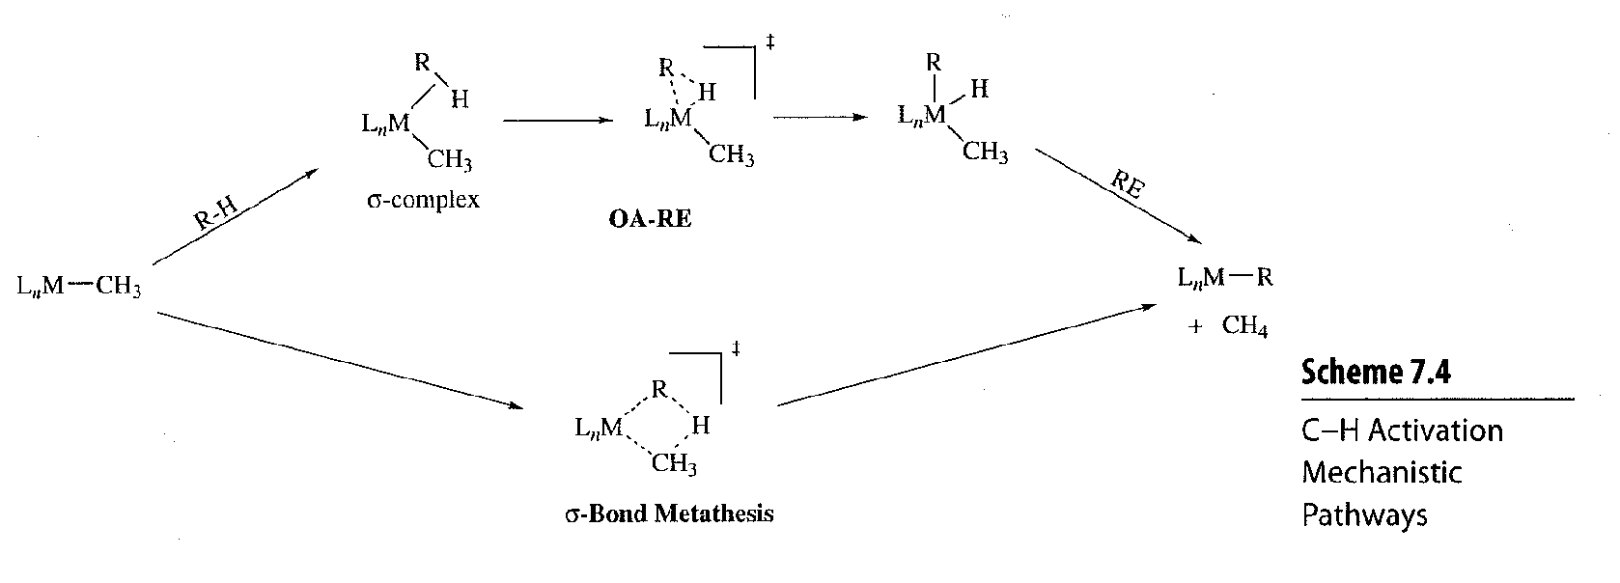
OA-RE 3-centered sigma bonded intermediate. VS Concerted 4 center for aryl vinyl species
Driving force = C-H vs C-C bonding
Early T_{M} have greater M-H (sorta M-C) bond strength then late transition metals

C-C Bond Activation

Polar(X-X)/SN2 mech. (R-X)
Halogen or pseudohalogen (NC-CN)
SP Associative trans effect
TBP Dissociative cis effect
Common for R-X with R = Me, ally, benzyl, acyl (good pi-back bonding)
-Large negative delta S
-Faster rates with electron-rich metal center (late transition), less bulky ligands, polar solvents, better leaving groups

Radical MEch.
Accompany or dominate SN2: common with paramagnetic metal complexes
Stability of radical α Reaction rate
Rate increased by radical initiators, UV light, and decreased by radical scavengers
Mixed stereochem
Non-chain mech. Means no effect of intiators or scavengers
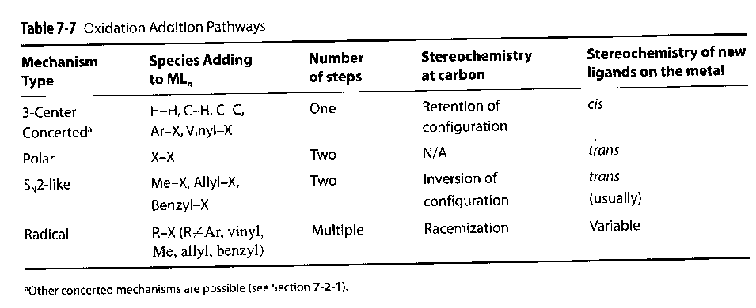

Reductive Elimination:

Products are difficult to stabilize.
SN2 mech. Is favored by bulky poorly donating ligands
Reverse of Associative oxidation, still 3-centered intermediate. With cis elimination, and retention of config.
Ligand contribution to rate: association of a new ligand then formation of R-R* preferred to direct loss or loss and concerted RE
Reductive elimination must be cis (Coupling of R-R*) Trans-cis isomerization can be aided by polar solvents. (trans-SP + Sol. SPy + Barry-pseudo-rot. cis-Spy – Sol. cis-SP
Rigid trans No RE
Stereochemistry always retained (for product)
Reductive elim. Of Ar-X like α-elim

Insertion Reactions

1,1-Insertion
Migration to M-CO, M-CNR, M=CR₂
Two steps: Could be the CO or the R that migrates. It’s the R. Rto make M-(CO)-R allowing for
Insertion into empty coordination site (CO). Inversion of M stereochemistry.

1,2-Insertion
Insertion into M-H, M-C
Delta H ~(-15)-(-30) kcal/mol, but negative Delta S makes Delta G ~ -
Β-Elim and insertion are accessible.
Early Metal d⁰ not prone to elim. Functionalize alkenyls with retention of stereochem.
For late metals its possible if there are no β-Hs.
For early metals you may get 1,1-deinsertion, forming alkylidene complex (M=C)

Insertion into M-C is thermodynamically favored than M-H kinectic barriers are higher.

Nuclephilic Addition
Three pathways:
- Addition to C=C terminal. (does nothing)
- Addition to Metal 1,2-insertion
- Substitution to metal: -Sub X, sub L, sub Alkene (transmetallation)
Nucleophilic Attack / abstraction
at M-CO, M=CRs
CO2 abstraction/hydrometallation/substitution (attack of CO by OH)
Attack at M=CR(OMe) positively charge Nu⁺-H MeOH + M=CRNu

Formation of metal formyl complex by blocking coordination sites and doing a Nu attack on CO by H⁻.

Addition of M-Coordinated π-Ligands RULES

Even Open > Odd Open > Even Closed > Odd Closed
Even Open Terminal
Odd Open Internal (unless M is EW)
Smaller > Larger

Odd open are preferentially attacked internal, which means the terminal positions can attack the metal, forming a metallocycle. Odd, Open –ene Nu-Internal attack Terminal ene-M attack metallacycle.

Electron Density at the metal.
Electron=poor Terminal
Electron-Rich Internal

Attack on alkenes stereochem is anti. Regiochem is poor.
For Ph substituted good regiochem
Arenes are activated by Coordination to metals.
Directing effects opposite to electrophilic substitution. Meta directing.

Addition to the aromatic ligands can decrease hapticity and change coordination

Nucleophilic Abstraction

Shilov. Oxidized [Pt⁴⁺-Me]⁺ + H₂O MeOH + Pt²⁺ + H⁺
Methyl abstraction by Nu, H2O
Nu abstraction can be used to remove carbonyl ligand (CO) freeing up a coordination site for another ligand.

Electrophilic Reactions

Three types of lewis acids:
1) Metal Electrophiles (higher oxidation state)
2)Organic Electrophiles CPh3⁺ RX
3)Non-metallic electrophiles X₂, NO_{x}⁺ , BX₃
Protonation of M-C gives retention of stereochem
Cleavage by Halogens
Once X is added. Multiple pathways are possible. RE C-X coupling cis-Ls
SN2 (steric R) pathway inversion of sterochem.
Aromatic substituent at C2 stabilizes C+ giving the cis-L product
Cleavage by Metal Ions
Primary C gives RE and stereochem retention
Tertiary gives a R+
Re-alkenyl ether + MeI carbene-Me + I- acyl + MeI

Bulky metal center can prevent addition and promote abstraction
Syn addition of Hydride from CP ring using extreme nucleophile.
Beta-elim with trityl Cation (hydride abstraction)
Electrophilic Abstraction from pi-bonded L increases hapticity

