Sample Questions, CAPS 390, Week 1

1. During tissue preparation, what is the main purpose of the fixation process?

A. Infiltrates the tissue with paraffin, making it possible to cut very thin slices from the tissue
B. Preserves the shape of tissue and subcellular structures by cross-linking proteins using chemical agents
C. Cuts very thin slices from the tissue, making it easier for viewing with a microscope
D. All of the above are correct
E. None of the above is correct

2. Which of the following can be stained by eosin?

A. Cartilage matrix
B. Collagen fibers
C. Nucleus
D. None of the above
E. All of the above

3. Which of the following is true regarding the epithelium?

A. Exchanges nutrients and wastes with connective tissue via blood capillaries
B. There is only a single type of epithelium
C. Has a high cell:ECM ratio
D. None of the above
E. All of the above

4. Name the following type of epithelial tissue:

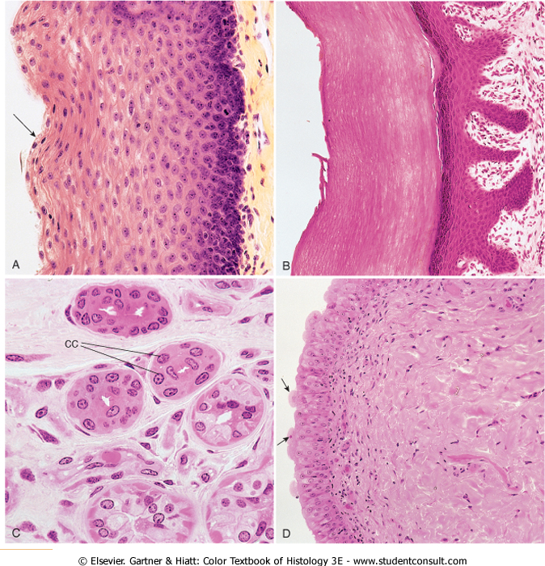

A. Simple squamous
B. Simple cuboidal
C. Simple columnar
D. Stratified squamous (non-keratinized)
E. Stratified squamous (Keratinized)

5. If you were miniaturized and were standing within the lumen of a body vessel of a human, looking at the epithelial tissue of the vessel, which surface of the epithelial tissue would you be looking at?

A. Basal surface
B. Apical surface
C. Lateral surface
D. Basement membrane
E. None of the above

6. If a type of exocrine gland secretes its products by pinching/budding off a portion of each secretory cell, and the secreted product is rich in enzymes, which of the following can be used to name this type of exocrine gland?

A. Holocrine
B. Apocrine
C. Mucous
D. Serous
E. Both A and C
F. Both B and D

7. Which of the following statements regarding dense irregular connective tissue is INCORRECT?

A. Contains a greater abundance of fibers and fewer cells than loose connective tissue
B. Contains collagen fibers that are arranged into parallel cylinders
C. It is found in the dermis
D. It is found in the capsule of some organs
E. All of the above

8. Which one of the following is mainly found in tendons and ligaments?

A. Loose regular CT
B. Dense irregular CT
C. Loose irregular CT
D. Dense regular CT
E. A & D

9. Which of the following statements is/are INCORRECT regarding fibroblast?

A. It is the most abundant cell type in the connective tissue
B. It synthesizes almost all of the extracellular matrix (ECM)
C. It has a spherical shape and contains almost no rough endoplasmic reticulum
D. When in active phase, its cytoplasm is rather basophilic
E. All of the above

10. During collagen synthesis, which of the following events occur OUTSIDE the cell?

A. Transcription and translation of nucleic acids to produce preprocollagen
B. Hydroxylation and glycosylation of preprocollagen
C. Cleavage of propeptides to form tropocollagen molecule
D. Formation of procollagen triple helix
E. All of the above

11. Reticular connective tissue contains which of the following types of collagen as its major fiber component?

A. Type I
B. Type II
C. Type III
D. Type IV
E. Type V

12. Which of the following statements regarding macrophages is CORRECT?

A. They are derived from B lymphotcytes
B. Their major role is to participate in allergic reactions
C. Their lack of large secretory vesicles indicates that they always continuously secrete antibodies
D. They are unable to produce cytokines and growth factors
E. They are able to remove cellular debris and protect the body against foreign invaders

13. Which of the following statements regarding white (unilocular) adipose tissue is CORRECT?

A. It is mainly found in subcutaneous layer and throughout the body
B. The cell membranes of its component cells (adipocytes) possess receptors for insulin, growth hormone, norepinephrine and glucocorticoids
C. It is richly vascularized
D. All of the above
E. None of the above

14. Which of the following statements regarding skeletal muscle is CORRECT?

A. Muscle fibers are individually surrounded by endomysium to form a muscle bundle
B. It is striated
C. Each muscle cell contains many nuclei
D. Each myofibril is surrounded by an interconnected network of sarcoplasmic reticulum
E. All of the above

15. Which of the following steps is NOT a molecular event described by the sliding filament theory?

A. Conformational change in troponin masks the actin-binding site on the myosin molecule.
B. As ATP is split into ADP and Pi, cocking of the myosin head occurs
C. Myosin cross bridges with the actin myofilament.
D. ADP is released and the thin filament is dragged toward the center of the sarcomere.
E. A new ATP molecule binds to the myosin head, the cross bridge detaches

16. Which of the following statements regarding myofilaments is INCORRECT?

A. Thick filament is made up of myosin molecules with heavy and light subunits
B. Thin filament is made up of filamentous actin, troponin and tropomyosin
C. Thick filament but not thin filament is attached directly to “Z” disks for anchorage
D. During muscle contraction, the widths of I and H bands reduce leading to shortening of the sarcomere
E. All of the above

17. Which of the following is NOT a characteristic of white (type IIB) muscle fibers?

A. Anaerobic
B. Capable of producing high force
C. Slow twitch
D. Contain few mitochondria
E. All of the above

18. Which of the following BEST represents differences between skeletal and smooth muscles?

A. Skeletal muscles have no striation, whereas smooth muscles do
B. Skeletal muscles do not have the “T” tubule system, whereas smooth muscles do
C. Myofilaments in skeletal muscles attach to dense bodies, whereas those in smooth muscles attach to the Z disks
D. Generally speaking, skeletal muscles are involuntary, whereas smooth muscles are voluntary
E. Generally speaking, skeletal muscle contractions are less sustainable and shows more fatigue than smooth muscle contractions Answers:

1. b
2. b
3. c
4. d
5. b
6. f
7. b
8. d
9. c
10. c
11. c
12. e
13. d
14. e
15. a
16. c
17. c
18. e

