Chapter 10 – Aversive Control: Avoidance and Punishment
Information | Example | Research
Avoidance  - individual has to make a specific response to prevent an aversive stimulus from occurring  - negative contingency between instrumental response and aversive stimulus  - if response occurs, stimulus is omitted  - increases the occurrence of behavior  - final result: less contact with aversive stimulus  - active avoidance (achieving increasing periods of safety by doing something)  - no pleasures are derived from these experiences  Origins of Avoidance Behaviour  - proved that avoidance conditioning is different from standard classical conditioning  The Discriminated Avoidance Procedure  - method similar to the one used by Brogden  - discriminated or signaled avoidance  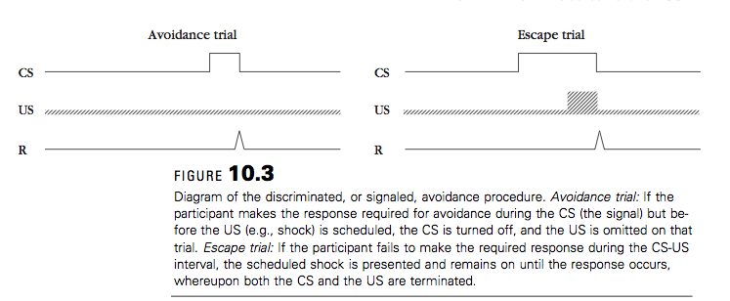  - involves discrete trials  - each trial is initiated by the warning signals or CS  - events that occur after depend on what participant does  - subject makes target response before the shock is delivered = CS is turned off and US is omitted (successful avoidance trial)  - subject fails to make required response during CS-US interval = shock appears and remains on until the response occurs (escape trial)  - during early stages of training, trials are usually escape trials but after training avoidance trials become predominate  - shuttle avoidance: two types  1. left to right then back the other way (two-way shuttle avoidance)  2. animal starts trial at the same time and always moves in the same direction (one-way avoidance)  - one way avoidance is easier to learn  Two-Process Theory of Avoidance  - proposed by Mowrer and elaborated by Miller  - dominant theory  - two mechanisms are involved in avoidance learning:  1. classical conditioning of the fear to the CS  2. instrumental reinforcement of the avoidance response through fear reduction  - classical and instrumental processes depend on each other  - classical conditioning has to occur first  - it explains avoidance behavior in terms of escape from conditioned fear rather than in terms of the prevention of shock  Experimental Analysis of Avoidance Behaviour  -Acquired-Drive Experiments:  - source of motivation for instrumental behavior caused by presentation of a stimulus that was previously conditioned with a primary or conditioned reinforcer  Independent-Measurement of Fear During Acquisition of Avoidance Behaviour  - based on the assumption that if fear motivates and reinforces avoidance responding, conditioning of fear and conditioning of instrumental avoidance behavior should go hand in hand  Extinction of Avoidance Behaviour Through Response-Blocking and CS-Alone Exposure:  - if the avoidance response is effective in terminating the CS and no shocks are presented, avoidance responding can persist for a long time  - flooding or response prevention : involves presenting the CS in the avoidance situation without the US but with the apparatus altered in such a way that the participant is prevented from making the avoidance response. Subject is exposed to the CS without being able to terminate it. There are two components:  1. getting exposed to the CS without the aversive stimulus  2. Blocking access to the avoidance response also facilitates extinction  Nondiscriminated (Free-Operant) Avoidance  - an avoidance conditioning procedure in which occurrences of the aversive stimulus are not signaled by an external stimulus  - in absence of avoidance response, the aversive stimulus is presented periodically, as set by the S-S interval  - each occurrence of the avoidance response creates (or resists) a period of safety determined by the S-R interval during which the aversive stimulus is not presented  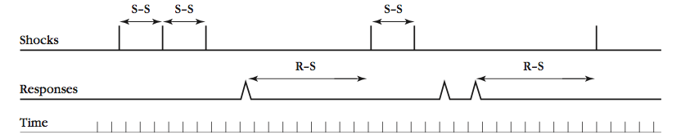  Demonstrations of Free-Operant Avoidance Learning  Free-Operant Avoidance and Two-Process Theory  - temporal cues have been conditioned to elicit fear  - making the S-S and R-S intervals unpredictable makes it more difficult to use the passage of time as a signal for shock  Alternative Theoretical Accounts of Avoidance Behaviour  - reinforcement of avoidance response is assumed to be provided by the reduction of fear  - negative reinforcement: reinforcement due to removal of an aversive stimulus  Positive Reinforcement Through Conditioned Inhibition of Fear or Conditioned Safety Signals:  - performance of an avoidance responses always results in distinctive feedback stimuli (spatial cues)  - response feedback stimuli may acquire conditioned inhibitory properties  - safety signals  - safety signals hypothesis – the safety signals that accompany avoidance responses may provide positive reinforcement for avoidance behavior  - spatial, tactile and proprioceptive stimuli accompany the avoidance response and become safety cues  - you can also have a distinctive stimulus as a safety cue (tone or light)  Reinforcement of Avoidance Through Reduction of Shock Frequency:  - shock-frequency reduction: alternative to two process theory. Hypothesis according to which reduction of frequency of shock serves to reinforce avoidance behavior  Avoidance and Species-Specific Defense Reactions (SSDRs)  - proposed by Bolles  - species typical responses animals preform in an aversive situation. Response may involve freezing, fleeing or fighting  Predatory Imminence an Defensive and Recuperative Behaviours  - different response occur depending on the level of danger faced by an animal  - progression of increasing levels of danger  - different responses are assumed to occur at different levels of predatory immence  - circa strike response | - Grab a handrail to avoid slipping or take an umbrella to avoid getting rained on  If you make the appropriate avoidance responses, you will not fall, et rained on or drive off the road.  - it is “flooded” with the CS  Small rodents that is potential a source of food for cats, coyotes, snakes and others. The rat is the safest when in its nest in a burrow but has to go out periodically for its on food. When it is out foraging, it is not in much danger as long as predators are around. When a snake is around, level of danger increases, but not much if it is far away. As the snake gets closer, level of danger rises.  Rat is forced to forage for food in location where it periodically encounters snake, it is likely to leave its burrow to get food less often and eat larger meals during each excursion  When the snake actually touches the rat, rat is likely to leap into the air. Freezing response leads to leaping and exploding into the air | - originated in studies of classical conditioning  Vladimir Bechterev (1913):  - interested in studying associative learning in humans  - placing finger on metal plate, warning stimulus was then presented (CS), then a shock (US)  - participants lifted their finger due to shock and eventually learned to lift their finger to the CS  - CR does not cancel or change the presentation of the US  Brogden, Lipman and Culler (1938)  - tested two groups of guinea pigs in rotating wheel apparatus  - CS = tone, US = shock  - shock caused them to rotate the wheel  - CS group = shock presented two seconds after beginning of the tone  - avoidance group = the shock followed the tone when animals did not make the conditioned response  - avoidance group learned to make the CR (100% of the time), CS group never achieved this level  - conducted in shuttle box  box consisted of two compartments  - at the start of the trial, CS is presented  - if subject crosses over to the other side before shock occurs, no shock is delivered and CS is turned off  - at the end of intertribal interval next trial is administered starting with animal in the second compartment  - shuttle avoidance  Browns and Jacobs (1949)  Esmoris-Arranz, Pardo-Vazquez and Vazquez-Garcia (2003)  - compared escape from fear learning after delayed and simultaneous conditioning in shuttle box  - initial phase: rats confined to one side (shock side) and received 10 trials  - fear-conditioning phase  - test trial: tested for escape from fear  - results: both delayed and simultaneous conditioning groups showed decreases latencies to escape from the fear and showing that learning to escape from fear occurred  Solomon (1953)  - dogs become less fearful as they become proficient in performing an avoidance response  Lovibond, Saunders, Weidermann & Mitchell (2008)  - college students received conditioning with three different stimuli  - stimuli = coloured blocks  - US -= shock on finger  - results: fear decreased across trials for avoidance stimulus  Solomon, Kamin and Qynne (1953)  Schiff, Smith and Prochaska (1972)  - rats trained to avoid shock in response to an auditory CS by going into the safe compartment  - results: blocked expose to the CS facilitated extinction of the avoidance response. This effect was determined mainly by the total duration of expose to the CS  Lovibond (2008)  - college students experiment  - fear and expectancy of shock declined with successful avoidance training but both returned during tests when the opportunity to make the avoidance response were blocked  Bolles (1969)  - found that rats can rapidly learn to run in a running wheel to avoid shock.  - their performance of a rearing response (standing on hind legs) did not improve much during course of avoidance training  - running was learned because it was closer to the rat’s SSDRs  Craske (1999)  - human fear and anxiety reactions of perceived danger  - lower level of perceived danger leads to worry  - next level leads to fear and vigilance (like freezing)  - highest level: panic  - men and women respond differently  - men= flight or fight response  - women = tend-and-befriend  - women when stressed also tend to protect and care for their offspring and seek out social support
Punishment  - positive contingency  - target response produces an aversive outcome  - suppresses instrumental responding  - final result: less contact with aversive stimulus  - passive avoidance (increased safety is not achieved by doing something)  - good technique for modifying behavior  Experimental Analysis of Punishment  - procedure: aversive stimulus is presented after a target instrumental response. If the procedure is effective, response becomes suppressed  - lab studies begin with a preliminary phase  - punishment procedure is superimposed on the schedule of positive reinforcement  - the behavior needs to occur in the first place  - Therapeutic settings: target a harmfl activity that Ps are doing  - In the lab: Animal has to be trained to do an instrumental response for reinforcement. A punishment procedure is then superimposed on the schedule of positive reinforcement. Measure degree of response suppression  Characteristics of the Aversive Stimulus an its Method of Introduction  - Primary aversive stimuli (inherently aversive stimui, aversive properties are unlearned)  - Secondary aversive stimuli (acquired aversive properties by being paired with primary aversive stimuli)  - time-out: removal of the opportunity to obtain a positive reinforcement. Also used to punish children  - Response cost: loss of reinforer and usually entails a penality of some sort contingent behavior  - overcorrection involves requiring a person not only to rectify what was done badly but to overcorrect or the mistake (restitution and positive practice)  - a convenient aversive stimulus in human studies of punishment is point loss  - response suppression produced by punishment depends in part of features of the aversive stimulus  - more intense and longer shocks are more effective in punishing responding  - low intensity punishment produces only moderate suppression of behavior  - responding often recovers with continued punishment with mild hock  - if a high intensity of shock , instrumental response will be severely suppressed  - if high intensity is reached after a slow escalation, much less suppression of behavior will occur  - exposure to low intensity of punishment builds resistance and makes the subject immune to the effects of more severe punishment  - initial exposure o punishment determines ho they will respond to punishment subsequently  - after exposure to intense shock, mild shock should be more effective in suppressing behavior than if the mild shock had been used from the beginning  - overall it is more effective if the aversive stimulus is more intense and lasts longer, punishment is introduced at an intense level and gradually decreases, types of punishers are varied over trials and adaptation to repeated use of same punisher  Response-contingent versus response-independent aversive stimulation  - response-independent aversive stimulation can result in some suppression of instrumental behavior  - more suppression of behavior occurs if the aversive stimulus is triggered by the instrumental response  Effects of Delay of Punishment  - interval between the target response and the aversive stimulus  - increasing the delay of punishment results in less suppression of behavior  - less suppression of behavior with increased delay between the response and the aversive stimulus (don’t want to punish good behavior and want punishment to be associated with bad behavior)  Effects of Schedules of Punishment  - punishment may also be delivered only intermittently  - if punished on a FR schedule, we find less suppression with higher FR values  Types and Schedules of Positive Reinforcement  - the target response is simultaneously maintained by a schedule of positive reinforcement  - when positively reinforced on either a FI or VI schedule, you find punishment decreases overall rate of responses but pattern is the same (still see FI scallops and VI steady rate)  - with FR schedule of positive reinforcement find punishment increases the length of postreinforement pause but doesn’t change the ratio run (Still respond at the same rate when responding but longer breaks after earn reinforcement)  Availability of Alternative Sources of Positive Reinforcement  - If the punished response is the only activity available to the subject for obtaining reinforcement, punishment will be much less effective than if an alternative source of reinforcement is provided along with punishment  Effects of a Discriminative Stimulus for punishment  - discriminative punishment: procedure in which responding is punished in the presence of a particular stimulus and not punished in the absence of that stimulus  - the person who administers the punishment also serves as a discriminative stimulus for punishment  Punishment as a Signal for the Availability of Positive Reinforcement:  - under certain circumstances people seem to seek out punishment  - punishment seeking can result if positive reinforcement is available only when the instrumental response is also punished  - if a positive reinforcement is only available when the instrumental response is also punished, then find punishment increases the response rather than decreases it  Theories of Punishment  The Conditioned Emotional Response Theory of Punishment  - proposed by Estes  - conditioned stimulus that has been paired with shock will suppress the performance of food-reinforced instrumental behavior  - The stimuli the subject experiences just before punishment will come to elicit emotional responses (CERs) that are incompatible with the punished response  - Can explain:  More intense and longer shock produces increased suppression  Response-contingent aversive stimuli produces more suppression  The Avoidance Theory of Punishment:  - Agrees that stimuli prior to the punished response become conditioned by the aversive stimuli, and so these CSs acquire conditioned aversive properties  - Also assumes subjects learn to escape aversive CSs by performing some other behaviour that is incompatible with the punished response  - Thus, punishment is the acquisition of incompatible avoidance responses  Punishment and the Negative Law of Effect:  - Thorndike  - positive reinforcement strengthens behavior, punishment weakens it  - Premack  - Punishment, a low-valued activity occurs contingent on the performance of a higher valued behavour  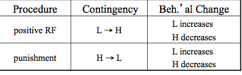  Punishment Outside the Laboratory  - parental use of punishment  - Effectiveness of punishment in lab doesn’t justify its use outside the lab because:  - Procedures easily misused  - Easy to implement punishment when angry or frustrated, which doesn’t constitute systematic training  - Serious ethical considerations  - Particularly with physically aversive stimuli  - Possible side effects  - Following punishment, children show increased aggression, anti-social, and delinquent behaviour, decreased mental health, and increased aggression in adulthood  - Punishment redefined:  - Layman’s definition:  - Focus on justice, pain, retribution  - Behaviour modification definition:  - Focus on decreasing bad behaviour and increasing good behaviour  - Punishment intended as a learning tool  - Should always try non-punishment procedures first  - Alter/remove antecedents for bad behaviour  - Positive reinforcement  - Extinction  - Punishment useful when:  - Bad behaviour is physically dangerous  - Difficult to give reinforcement for behaviour incompatible with bad behaviour  - Temporarily suppressing bad behaviour while good behaviour is being reinforced | If you get a touch a hot stove you will get burned  Child sticks a metal fork in an electric outlet, resultant shock is likely to discourage repetition of that behavior  Shock, loud noises, pain  No, frowns, parking ticket  Child is asked to sit in a time out chair  Paying a parking ticket  Child who has placed a object in his mouth may be asked to remove the object and wash out his mouth with an antiseptic solution  Spending two weeks in jail is not a disturbing experience for someone who has become accustomed to shorter periods of incarceration  High school student is punished for violating the school’s dress code is being simultaneously reinforced for breaking the rules by social approval from her peers  A highway patrol car is a discriminative stimulus for punishment for speeding. Drivers are more likely to stay at or below the speed limit where they see patrol cars that in unpatrolled stretches of highway  Exposing oneself to shock has much lower probability than pressing a lever for food | Vorndran and Lerman (2006)  - documented the effectiveness of punishment in two participants with developmental disabilities  O’Donell, Crosbie, Wiliams & Saunders (2000)  - college students pressed a response level to obtain points that could be exchanged for money at the end of the experiment  - results: responding was well maintained during the baseline phase, and it continued during punishment phase  Goodall (1984)  - compared lever-press responding in rats in the presence of two different stimuli  - one was used in punishment and the other is used as conditioned suppression  - results: delivering shocks contingent on an instrumental response is more effective in suppressing that response than delivering the aversive stimulus independent of behavior  Church (1969)  3 groups of rats lever pressing for food  - Control Group: no shock  - Non-Contingent Group: random shock  - Contingent Group: lever pressing led to food and shock  Found most suppression in Contingent Group, least in Control Group  Herman and Arzin (1964)  - early study of adult male smokers  - subjects seated facing two response levers  - pressing lever was reinforced with a cigarette  - when the behavior was occurring at a stable ate, responding on one of the levers was punished by a loud noise  - availability of alternative response for obtaining positive reinforcement greatly increased suppressive effects of punishment  Azrin et al. (1963):  - Pigeons reinforced for pecking on a VI schedule and punished according to various FR schedules  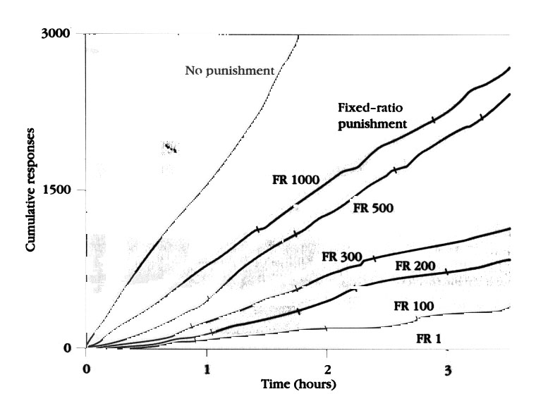  Herman & Azrin (1964):  Human males reinforced on a VI schedule for pressing lever and punished with a loud noise  Group 1:  no other response available to get reinforcement  Group 2:  other way to get reinforcement

