Chapter 9 – Extinction of Conditioned Behaviour
Information | Example | Research
Extinction  - involves omitting the US or reinforce.  - in classical conditioning, extinction involves repeated presentations of the CS by itself.  - in instrumental conditioning, extinction involves no longer presenting the reinforcer as a consequence of the instrumental response  ***both types of procedures conditioned responding declines***  - appears to be the opposite of acquisition  - it is not the same thing that occurs because of forgetting  - Exposure therapy is basically an extinction procedure in which participants are exposed to cues that elicit fear in the absence of the aversive US | Extinction is an active process produced by the unexpected absence of the US or the reinforcer WHEREAS Forgetting is a decline in responding that may occur simply because of the passage of time and does not require non-reinforced encounters with the CS or the instrumental response.  - Social phobia, fear of flying, claustrophobia and other pathological fears and phobias are treated with some form of exposure therapy .  - It is also helped with treating drug addiction with the aim of extinguishing cues associated with drug taking behavior | Extinction is being studied at the level of brain structures, neurotransmitter systems or fear conditioning paradigms.  - Exposure to the actual fearful stimulus is the best way to conduct exposure therapy but is not often practical.  - Having clients imagine being in the fearful situation can be helpful.  - More vivid and realistic exposure is now possible with the use of virtual reality techniques

Effects of Extinction Procedures
Information | Example | Research
Behavioural Effects of Extinction:  1. Target response decreases when the response no longer results in reinforcement  2. It increases response variability, at first.  Extinction procedures also produce strong emotional effects:  1. The emotional reaction induced by withdrawal of expected reinforcer is called frustration  - frustative non-reward energizes behavior  - frustration may be intense enough to induce aggression | - Did not succeed in opening the door to your apartment with your key. You wouldn’t give up at first, but would keep trying. However if it still didn’t work, you would eventually quit trying.  - If the key no longer opens the door, you will give up. However, before you give up, you are likely to jiggle the key in various ways in an effort to make it work.  - Vending machine breaks down and no longer delivers the candy bar, you are more likely to become annoyed.  - Partner takes you out every Saturday, you will be upset if your partner calls one Saturday and cancels. | Neuringer, Kornell & Olufs (2001)  - lab rats  - apparatus and procedure were set up to facilitate the measurement of response variability  - response levers and response key, rats had to make three responses in a row to obtain food pellet  (LLL, RLK, LLK)  - one group was reinforced for varying response sequences (Group Var). They got food only if their response sequence was different then the one from earlier trials.  - second group also require to make three responses but there was no requirement (Group Yoke)  - Results: reinforcement produced the expected difference between the two groups in terms of the variability of their response sequences. Group var showed more variability. Group yoke responded somewhat faster.  - Extinction produced a decline in responding  - increase in response variability that occurred during extinction did not come at the expense of the subjects repeating response sequences that they had performed during reinforcement  (response sequences that were highly likely to occur during reinforcement phase continued to occur during extinction)  Arzin, Hutchinson & Hake (1966)  - two animals are placed in the same skinner box  - one is reinforced for pecking a response key, the other is restrained in the corner  - key pecking animal ignores the other animal so long as it is being reinforced by food  - when reinforcement ceases, the previously rewarded animal is likely to attack its innocent partner (this also occurs if there is a stuffed animal instead of a real animal)

Extinction and Original Learning
Information | Example | Research
- Although extinction produces important behavioual and emotional effects, it does not reverse the effects of acquisition  - it does not erase what was originally learned  Spontaneous Recovery  - extinction typically produces a decline in conditioned behavior, but this effect dissipates with time. If a rest period is introduced after extinction training, response is observed to recover.  - produced by the introduction of a period of rest  - also prominent phenomenon following extinction of instrumental behavior  Renewal  - refers to a recovery of acquisition performance when the contextual cues that were present during extinction are changed  - change can be a return to the context of original acquisition or a shift to a neutral context  - in conditioned suppression procedures, greater levels of conditioned fear are represented by smaller values of the suppression ratio  - renewal is not due to excitatory properties conditioned to the renewal effect  - renewal effect occurs because the memory of extinction is specific to the cues that were present during the extinction phase  - shifts in concept do not disrupt the originally acquired continued suppression  - Why is it that original acquisition is less disrupted by a change in context when extinction performance is highly context specific?  - renewal effect has important implications for behavior therapy  - suggests that even a therapeutic procedure is effective in extinguishing a pathological fear or a phobia in a therapists office but it can easily return when the client encounters the fear CS in a different context  Reinstatement  - refers to the recovery of conditioned behavior produce by exposures to the unconditioned stimulus  - it is also a challenging phenomenon for behavior therapy  - context specificity of reinstatement raises the possibility that reinstatement is a result of context conditioning  - US presentations that occur during the reinstatement phase can result in conditioning of the contextual cues of the experimental situation  - that context conditioned could then summate with any extinction remaining to the CS at the end of extinction to produce the reinstatement of conditioned responding  - research has shown that context conditioning is important, but not because it permits summation of extinction. Rather, the role of context is to disambiguate the significance of a stimulus that has a mixed history of conditioning and fear  - context has relatively little effect on stimuli that do not have a history of extinction | - the word “cut” could refer to physical procedure of creating two pieces, or it could refer to dropped a player from a team. The meaning depends on the semantic context.  - Taste aversion to fish because you got sick after eating fish. Your aversion is then extinguished by nibbling on fish without getting sick on a number of occasions. You may even learn to enjoy eating fish. However, if you were to get sick again for some reason, your aversion to fish would return even if your illness has nothing to do with eating fish.  - client who suffers from anxiety and fear of intimacy acquired during the course of being raised by abusive parent. Extensive therapy may be successful in providing relief but the reinstatement suggests that the fear and anxiety may return full blown if the client experiences and abusive encounter later in life (if exposed to US again) | Rescorla  - original acquisition was conducted with two different unconditioned stimuli delivered into cups recessed in one wall of the experimental chamber.  - infrared detectors identified each time the rat poked its head into the food cups  - one US was conditioned by a noise and the other was a light.  - S1 had a rest period of 8 days after extinction sessions and S2 had no rest period  - responding for S1 rapidly recovered which was tested 8 days later  - critical factor is introducing a period of rest between the end of extinction training and assessments of responding.  - typical finding is that behavior has become more suppressed by extinction recovers with a period of rest  - increased responding after a rest than no rest  Bouton and King (1983)  - extinction of conditioned fear in laboratory rats  - rats first conditioned to press a response lever for food reinforcement (base line)  - acquisition of fear was then done by pairing a tone with a CS foot shock  - this was done in two chambers with two different contextual cues  - group A and B showed similar strong levels of repression  - both groups were brought back to original chamber.  - Results: conditioned fear was renewed when group b was removed from the extinction context and returned to the context of original training  0 loss of suppression evident during the extinction phase for group B did not reflect the unlearning o the conditioned fear response  Bouton (1993, 1994)  - suggested that contextual cues serve to disambiguate the significance of a conditioned stimulus  - function is similar to the function of semantic context in disambiguating the meaning of a word  - other techniques for reducing the renewal effect involve conditioned inhibition training, differential conditioning and presenting the CS explicitly unpaired with the US  LaBar and Phelps (2005)  - human fear conditioning  - Yale undergraduates  - CS = blue scare presented on computer screen for four seconds  - on acquisition trials, CS ended with one second loud pulsating noise (US)  - conditioned fear was measured in terms of increased skin conductance (mild sweating)  - four acquisition trials and eight extinction trials  - four reinstatement noise bursts were then presented either in the same room or a different room  - Results: skin conductance increased during the course of fear conditioning and decreased during extinction. US presentations in the same room resulted in recovery of response and US presentations in a different room did not produce this recovery.  - thus reinstatement effect was context specific  Bouton (1984)  - conditioned suppression preparation with rats  - refer to table below for procedure  - results: context conditioned facilitates the reinstatement effect  - results: found without extinction, CS showed similar suppression ratios with whatever context reinstatement occurred in  - with both conditioning and extinction, showed more suppression in the same context than different  - suggests that context conditioning facilitates the reinstatement effect
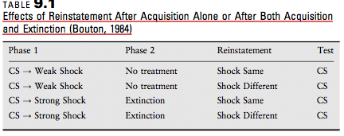

Information | Example | Research
Retention of Knowledge of the Reinforcer  - if a conditioned behavior reflects an S-O or R-O association, devaluation of the reinforcer should produce a decrement in responding. We can determine whether extinction eliminates S-O or R-O associations by seeing if reinforcer devaluation also suppresses conditioned responding  - another line of evidence that indicates that knowledge of the reinforcer is not lost during the course of extinction comes from tests of the specificity of reinstatement |  | Ostlund &Balleine (2007)  - rats trained in chabers that had two response levers  - pressing one produced a pellet, the other produced a sugar solution  - the levers then switched their responses  - results indicated that the extinction procedure did not erase knowledge of which reinforcer had been used with which response during original training
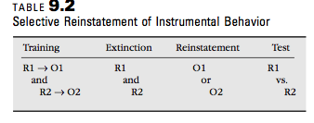
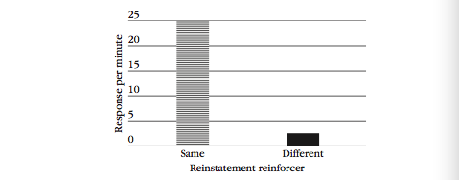

Enhancing Extinction
Information | Example | Research
Number and Spacing of Extinction Trials  - simplest way to increase the impact of extinction is to conduct more extinction trials  - the use of larger numbers of extinction trials produces a more profound decrease in conditioned responding  - conduct extinction trials spaced close together in time (massed)  Reducing Spontaneous Recovery  1. to reduce spontaneous recovery, repeated periods of rest and testing  - less and less recovery occurs with successive cycles of rest and testing  2. interval between initial training and extinction  - effects of extinction in fear conditioning are more permanent if extinction was conducted right after acquisition  3. introduce cues associated with extinction  Reducing Renewal  1. Can be attenuated by conducting extinction in several different contexts  - this helps to increase stimulus generalization of extinction performance  2. Present reminder cues of extinction in the renewal contexts  - reduce renewal effect by reactivating extinction performance in the renewal context  Compounding Extinction Stimuli  - presenting two stimuli at the same time that are both undergoing extinction  - this can actually deepen the extinction of those cues |  | - this outcome has been found in learning situations including eye blink conditioning, taste-aversion learning and context learning  Cain, Blouin and Barad (2003)  - found greater loss of fear with massed extinction trials then with spaced  - difference persisted when the subjects were tested the next day  Myers, Ressler and Davis (2006)  - reported that fear extinction conduced 24-72 hours after fear acquisition showed the usual spontaneous recovery, renewal and reinstatement effects  - however if extinction was conduced 10-60 minutes after fear acquisition, these recovery effects were not observed  - confirmed in studies of appetitive conditioning with rats  - encouraging results also find in a study of exposure therapy with people who are afraid of spiders  - participants who were instructed to mentally recall the treatment context showed less fear of spiders in a novel situation than participants who did not engage in the reminder exercise  - tactic can be applied more broadly to increase generalization of treatment outcomes by engaging clients to carry a card, repeat a short phrase or call a help line whenever they are concerned about relapsing to remind then of the therapeutic context  Rescorla (2006)  - instrumental conditioning experiment which rats were first conditioned to press a response lever during each different discriminate stimuli, light (L), nose and tone stimulus (X and Y)  - reinforced on a VI 30-second schedule with food  - following acquisition, they were then presented repeatedly by themselves with lever pressed no longer reinforced  - responding went close to 0  - compound conditioning was put in place
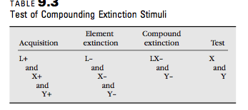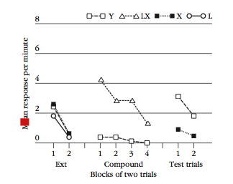
- compounding two extinction cues depends the extinction of individual stimuli suggests that extinction operates at least in part by an error-correction process like the Rescorla-Wagner model
- according to this model, associative values are adjusted if the outcome of a trial is contrary to what is expected
- original acquisition creates an expectation that the US will occur
- expectation is violated when the US is omitted in extinction and that error is corrected by reduced responding on subsequent extinction trials
- compounding two conditioned stimuli increases the resulting error when the trial ends without a reinforcer which induces a larger correction and greater reduction of responding

What is Learning in Extinction?
Information | Example | Research
- studies of spontaneous recovery, renewal, reinstatement and knowledge of the reinforcer after extinction all indicate that extinction does not involve unlearning and leaves response outcome (R-) and stimulus-outcome (S-O) associations pretty much intact  Inhibitory S-R Associations  - S-R mechanisms to explain extinction performance  - nonreinforcement produces an inhibitory S-R association  - the effects of extinction will be highly specific to the context in which the response was extinguished  - emotional effects stem from the frustration that is triggered when an expected reinforcer is not forthcoming  - nonreinforcement in the face of the expectation of reward is assumed to trigger an unconditioned aversive frustrative reaction  - aversive emotion serves to discourage responding during the course of extinction through the establishment of an inhibitory S-R association |  | - establishment is done by lab rats first receiving discrimination training in which a common response (poking the nose into a hole) was reinforced with food pellets whenever a light or noise stimulus (L or N) was present.  - training was conducted so that nonreinforcement in the presence of L or N would elicit frustration when extinction was introduced  - targets of extinction: lever press and a chain pull  - they were first reinforced with food pellets  - extinction conducted in third phase and consisted of presenting L and N (to create expectancy of reward)  - this phase established inhibitory S-R associations  - results: responding during the stimulus with which the response had been extinguished was significantly less than responding during the alternative stimulus

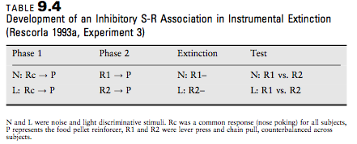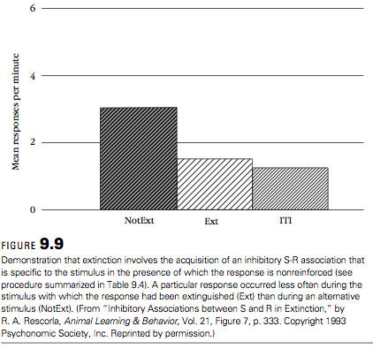

Paradoxical Reward Effects  - if decline in responding in extinction is due to frustrative effects of an unexpected absence of reinforcement, then one would expect more rapid extinction following training that establishes greater expectations of reward  1. Overtraining extinction effect  - represents fewer responses in extinction after more extensive reinforcement training  2. Magnitude reinforcement extinction effects  - refers to the fact that responding declines more rapidly in extinction following reinforcement with a larger reinforcer and is also readily accounted for in terms of the frustrative effects of nonreward  3. Partial reinforcement extinction effect  - used to describe greater persistence in instrumental responding in extinction after partial (or intermittent) reinforcement training that after continuous reinforcement training  - Persistence of responding created by intermittent reinforcement  - PREE can also occur in the same subjects if they experience continuous reinforcement in the presence of one set of cues in intermittent reinforcement in the presence of other stimuli  Mechanisms of the Partial-Reinforcement Extinction Effect  - introduction of extinction is easier to detect after continuous reinforcement than after partial reinforcement  - if you don’t get reinforced after each response during training, you may not immediately notice when reinforcers are omitted altogether in extinction  - absence of reinforcement is easier to detect after continuous reinforcement  - discrimination hypothesis – explanation of the PREE according to which extinction is slower after partial reinforcement than continuous reinforcement because the onset of extinction is more difficult to detect following partial reinforcement  Frustration theory is based on what subjects learn about the emotional effects of nonreward during partial reinforcement training  - learning something paradoxical namely to continue responding when you expect to be reinforced or frustrated  - rewarded trials lead individuals to expect reinforcement and nonrewarded trials lead them to expect the absence of reward  - with sufficient training, intermittent reinforcement results in learning to make the instrumental response when the subject expects nonreward  - continuous reinforcement does not produced persistence in extinction  Sequential Theory based on what subjects learn about memory of nonreward  - subjects can remember whether or not they were reinforced for performing the instrumental response in the recent past  - memory mechanisms make more of a contribution when training trials are scheduled closer together  - learning supported by such relief should lead to the inhibition of fear | - the more training that is provided with reinforcement, the stronger will be the expectancy of the reward and therefore the stronger will be the frustration that occurs when extinction is introduced  - Habitual gamblers.  - occasional winnings encourage them to continue during long strings of losses  - Parenting  - child throws temper tantrum because of candy  - intermittent reinforcement of the requests for candy will make the child very persistent and obnoxious in asking for candy during future shopping trips | Chen and Amsel (1980)  - rat pups permitted to run or crawl down an alley for a chance to suckle and obtain milk as the reinforcer  - some were reinforced each time (continuous), others were reinforced some of the time (partial)  - after training, all were tested under conditions of extinction  - this was repeated with rat pups of two different age groups (12 dy old and 10 day old)  - 12 day old pup ran faster  - 10 day old pups increased their running speeds with training  - when extinction was introduced, they all slowed down  - PREE was evident in 12 day old but not 10 day old  - result: developmental difference in the emergence of PREE is related to the rapid maturation of the hippocampus during this stage of life  Jenkins (1962):  - Phase 1: Group 1: PRF, Group 2: CRF  - Phase 2: both groups CRF  - Phase 3: extinction  -  Found Group 1 more resistant to extinction than Group 2  Sequence of R and N trials is critical: RNNRRNR  - Trial 4: memory of 2 N trials gets rewarded  - Trial 7: memory of 1 N trial gets rewarded

Resistance to Change and Behavioural Momentum
Information | Example | Research
- response persistence in extinction represents resistance to the change in reinforcement contingencies that occurs when the extinction procedure is introduced  Behavioural Momentum  - susceptibility of responding to a disruption by manipulations such as pre-session feeding, delivery of free food or a change in the schedule of reinforcement  - behavior that has a great deal of momentum will also be hard to “stop” or disrupt by various things  - directly related to the rate of reinforcement  - higher rate of reinforcement = behavior with greater momentum which is less susceptible to disruption  - two behaviours that occur at similar rates do not necessarily have similar degrees behavioural momentum | A fast moving bullet and a slow moving train analogy | Nevin and Grace (2000)  - behavior momentum should be increased by adding reinforcers to a component of a multiple schedule even if those reinforcers are not contingent on responding  - this was confirmed with a study of pigeons and a study wit children with developmental disabilities

