Chapter 7 – Instrumental Conditioning: Motivational Mechanisms
- The motivation of instrumental behaviour has been considered from two radically different perspectives.
  - 1. Thordike – Associative Structure of Instrumental Conditioning
    - relies heavily on the concept of associations and hence is compatible with the theoretical tradition of Pavlovian Conditioning
    - molecular perspective
    - examines instrumental learning in isolated behaviour preparations
  - 2. Behavioural Regulation
    - considers the motivation of instrumental behaviour from more of a molar perspective
    - considers long-term goals and how organisms manage to achieve these goals within the context of all their behavioural options
    - more functional perspective

The Associative Structure of Instrumental Conditioning
- there are three events to consider in an analysis of instrumental learning:
  - 1. Stimulus (S)
  - 2. Instrumental response (R)
  - 3. Response Outcome or reinforcer (O)
- three-term contingency
  - s actually triggers the R-O association
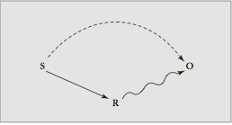

- The S-R Association and the Law Of Effect
  - Association between the contextual stimuli (S) and the instrumental response R: the S-R association
  - According to the Law of Effect instrumental conditioning involves the establishment of an S-R association between the instrumental response (R) and the contextual stimuli (S) that are present when the response is reinforced
    - Assumes that the only role of the reinforcer is to strengthen the S-R association
    - Reinforcer itself is not a party or participant in this association
  - Problems:
    - Very counterintuitive
    - Evidence for representations of O
  - Habits arise when people repeatedly use a particular contexts to pursue their goals. However once acquired, habits are performed without mediation of a goal
    - Constitute about 45% of human behaviour
    - Automatic reactions to the stimulus context in which a goal was previously attained
    - Auto-pilot things
    - RESEARCH: Holland
      - Habits learned in rats
        - Rats trained for 2, 5 or 20 sessions to lever press for food
        - Then food was devalued
        - Found extensive training weakened reinforcer devaluation effects
        - This is evidence for s-r associations
- Expectancy of Reward and the S-O Association
  - Pavlovian conditioning is the basic process of signal learning
    - Stimuli always present when response outcome occurs
  - 1. Presence of S comes to evoke the instrumental response directly through Thorndike’s S-R association
  - 2. The instrumental response also comes to be made in response to an S-O association that creates the expectancy of reward
- Two-Process Theory
  - Two distinct types of learning: Pavlovian and Instrumental Conditioning.
  - During the course of instrumental conditioning, the stimuli (S) in the presence of which the instrumental response is reinforced, become associated with the response outcome (O) through pavlovian conditioning and this results in an S-O association.
  - Rescolra and Solomon assumed that the S-O association activates an emotional state which motivates the instrumental behaviour
    - Emotional state assumed to be either positive or negative depending on whether the reinforcer is appetitive or aversive (food vs shock)
      - Appetitive reinforcers are assumed to lead to a common positive emotional state
      - Aversive stimuli are assumed to lead to a common negative emotion
        - Food reward = hope
        - Shock consequence = fear
  - Pavlovian-Instrumental Transfer Test
    - If a central state motivates behaviour, then changing the intensity of the state should cause a corresponding change in the vigour of the instrumental response
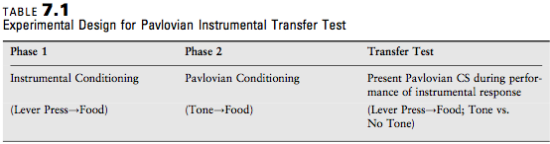

    - Involves three separate stages
    - 1. Subjects receives standard instrumental conditioning
    - 2. Receive pure Pavlovian conditioning
    - 3. Permitted to perform the instrumental response but the Pavlovian CS is presented periodically
      - if a Pavlovian S-O association motivates instrumental behaviour, then the create of lever pressing should increase when the tone CS is presented
    - determines how independently established Pavlovian CS transfers to influence or motivate instrumental responding
  - the presentation of a Pavlovian CS for food increases the rate of instrumental responding for food
    - positive emotion elicited by the CS+ for food summates with the appetitive motivation that is involved in lever pressing for food
  - According to the two-process theory, conditioned suppression occurs because the CS_+ for shock elicits an emotional state (fear) that is contrary to the positive emotion or expectancy (hope) that is established in instrumental conditioning with food
    - RESEARCH: Rescolra & LoLordo
      - Phase 1: dogs learned to escape shock in shuttle box
      - Phase 2: dogs learned CS+ = shock and CS-=no shock
      - Test: present two CSs during shock escape in shuttle box
    - RESEARCH: Rescorla & Soloman
      - Made a number of predictions about how Pavlovian CS+ and CS- influence instrumental response
      - First figure out what is motivating the instrumental behaviour, like lever pressing or key pecking (the response that is emitted, not elicited); is the behaviour occurring to get something good (appetitive; this would be the top row in the table), or to avoid something bad (aversive; this would be the bottom row in the table). Once you know what row you're dealing with, figure out the Pavlovian side of it. Is the US appetitive or aversive; if appetitive, this is the 2 left columns, if aversive, this is the 2 right columns. Then determine whether the CS predicts the presence of the US (this would be a CS+) or the absence of the US (this would be a CS-).
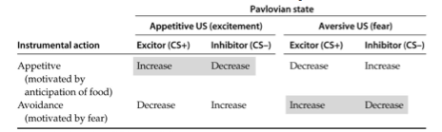

      - Test yourself: Increase or Decrease?
        - A pigeon pecking a key to earn grain is presented with a light that has been paired with shock
appetitive, CS+ paired with something aversive = decrease
        - A pigeon pecking a key to earn grain is presented with a buzzer that has been paired with the absence of food
decrease
        - A pigeon pecking a key to turn off a shock is presented with a clicking sound that has been paired with shock
increase
        - A pigeon pecking a key to turn off a shock is presented with a tone that has been paired with the absence of food
increase
  - Response Interactions in Pavlovian Instrumental Transfer
    - An elicited emotional state is not necessary to understand such an outcome
      - An elicited emotional state is also unnecessary if the classically conditioned stimulus elicited overt response
  - Conditioned Emotional States or Reward-Specific Expectancies
    - Animals also acquire specific reward expectancies instead of just categorical positive or negative emotions during instrumental and classical conditioning
    - Conditioned emotional states or reward-specific expectancies?
      - Sometimes there aren’t just feelings of hope or fear, but rather representing a specific outcome
    - RESEARCH: Colwill & Rescorla
      - Phase 1: L:Rp-O1; N:RP-O2
      - Phase 2: R1-O1; R2-O2
      - Test: L:R1 vs R2; N: R1 vs R2
        - L – light, Rp – sticking nose in hole O – certain outcome N-noise
        - Are they associating a specific stimulus with a specific outcome?
  - Evidence of R-O Associations
    - Intuition says the animal performs the response to receive the outcome
    - Test using the reinforcer devaluation effect
      - If a response is associated with a specific reinforcer, then decreasing the value of that reinforcer should decrease the response
    - RESEARCH: Colwill & Rescorla
      - Rats reinforced with food pellets (O1) for pushing rod left (R1) and reinforced with sucrose solution (O2) for pushing rod right (R2)
      - Devalued O1 or O2 by pairing it with illness
      - Found decreased R1 or R2
      - Shows each R was associated with its own O
        - Could not be S-O association
        - Could not be S-R association
  - Hierarchal S(R-O) Relations
    - R-O association is activated by the stimuli that are present when the response is reinforced
      - S does not activate R directly, but rather activates the R-O association
      - The subject comes to think of the R-O association when it encounters S and that motivates it to make the instrumental response
      - O is not predicated from S alone; O only occurs if R happens in the presence of S
    - Skinner suggested that many S, R and O in instrumental conditioning are connected through a conditional S(R-O) relation
    - RESEARCH: Colwill & Rescorla
      - Phase 1:
        - L:R1-O1; R2-O2
        - N:R1-O2; R2-O1
      - Phase 2:
        - O2-illness
      - Test:
        - L: R1vsR2
        - N:R1vsR2
          - In front of the light, they should prefer to do R1 over R2 (this does happen)
          - In front of the noise, they should be doing R2 over R1 (this does happen)
      - This shows that they are developing specific associations towards a specific stimulus with gives a certain response and a specific outcome

Behavioural Regulation
- Antecedents of Behavioural Regulation
  - Satisfying state of affairs
  - Consummatory-Response Theory
    - Species-typical unconditioned response
      - Critical features of reinforcement
    - Attributes reinforcement to these species typical behavours
    - Reinforcer responses were assumed to be special because they involved the consummation or completion of an instinctive behaviour sequence
      - Not views as a special kind of stimuli but as a special type of response
      - Its not what the stimulus is, it’s the special things you can do with it
    - Theory assumed that consummatory responses are f different from instrumental responses
  - The Premack Principle
    - Given two responses of different likelihood, H and L, the opportunity to perform the higher probability response after the lower probability response will result in reinforcement of response L (L H reinforces L). The opportunity to perform the lower probability response after the higher probability response will not result in reinforcement of response H (HL does not reinforce H)
    - Focuses on the difference in the likelihood of the instrumental and reinforcer responses
      - Differential probability principle
      - RESEARCH: Children playing pinball or eating candy
        - Measured preferred behaviour at baseline
        - Implemented rule where they had to play pinball in order to eat candy
        - Found pinball increased compared to baseline only for those children who preferred eating candy at baseline
          - Pinball playing decreased compared to the baseline for those children who preferred playing pinball at the baseline
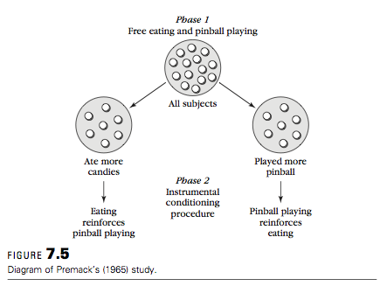

- RESEARCH: Rats drinking water or running in a wheel
  - If water deprived, drinking more probable than running
    - H=drinking L=running
  - If not water deprived, running more probable then drinking
  - Shows running and drinking could be interchangeably as the instrumental response and the reinforcing response
- Applications of the Premack Principle
  - Thinking about reinforcers as responses rather than as stimuli, greatly expanded the range of activities investigators started to use as reinforcers
  - Schizophrenic patients in clinical settings
    - Opportunities to sit resulted in more work performance than verbal instructions to participate in work
  - Children with autism
    - Opportunity to engage in prevalent stereotyped response resulted in better performance on academic related skills than food reinforcement
  - Problems:
    - Behaviour at baseline may differ then behaviour under a contingency
      - Sometimes depriving a subject of performing a low probability response can increase the in reinforcement value of that response
      - No clear way to handle preference tests
        - We want different things at different times
- Response-Deprivation Hypothesis
  - In most instrumental conditioning procedures, the probability of the reinforcement activity is kept at a high level of restricting access to the reinforcer
  - Restrictions on the opportunity to engage in the reinforcing response increase its effectiveness as a reinforcer
  - Restriction of the reinforcer activity was the critical factor for instrumental reinforcement
  - Low probability response can serve as a reinforcer, provided that participants are restricted from making this response
  - Response deprivation is more basic to reinforcement effects than differential response probability
  - Provided a new principle for predicting what will serve as an effective reinforcer
  - Provided a new procedure for creating reinforcers: restricting access to the reinforcer activity
  - Traditional views of reinforcement assume that a reinforcer is something that exists independent of an instrumental conditioning procedure
- Behavioural Regulation and the Behavioural Bliss Point
  - Theories assume that analogous mechanisms exist with respect to behaviour
  - Organisms have a preferred distribution of activities that they work to maintain in the face of disruption
  - Behavioural Bliss Point
    - Behavioural regulation theory assumes that if organisms are free to distribute their responses among the available alternatives, they will do so in a way that is most comfortable, or in some less optimal for them
  - Imposing an Instrumental Contingency
    - Behavioural-regulation theory stats that organisms will defend against challenges to the behavioural bliss point, just as physiological regulation involves defense against challenges to a physiological set point
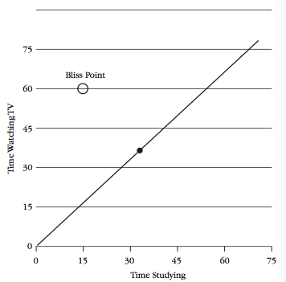
    - Free baseline behaviour bliss point usually cannot be reestablished after an instrumental contingency has been introduced

- Dilemma posed by an instrumental contingency
  - Does not permit getting back to the bliss point
- Minimum-deviation Model
  - Introduction of a response-reinforcer contingency causes organisms to redistribute their behaviour between the instrumental and contingent responses in a way that minimizes the total deviation of the two responses from the bliss point
    - Filled circle
    - Explanation of Reinforcement Effects
    - Viewing Reinforcement Contingencies in a Broader Behaviour Context
      - Focusing on just the instrumental response and its antecedent and consequent stimuli is not enough
      - Effect of a particular instrumental conditioning procedure may depend on what alternative sources of reinforcement are available to the organism, how those other reinforcers are related to the particular reinforcer involved in the instrumental contingency and the costs of obtaining those alternative reinforcers
      - Economic Concepts and Response Allocation
  - Fundamental question: How do the constraints of an instrumental conditioning procedure produce changes in behaviour?
  - “Similarities between economic restrictions in the marketplace and the schedule of constraints in instrumental conditioning
    - “income” = number of response an organism is able to make
    - “price” = number of responses required to earn each reinforcer
    - “commodity” reinforcer obtained
  - Consumer Demand
    - Relation between the price of a commodity and how much it is purchased
      - Demand curve
    - Degree to which price influences consumption is called elasticity of demand
    - Consumer demand has been used to analyze a variety of behaviour problems
      - Considers the number of responses performed (or time spent responding) to be analogous to money and the reinforcer obtained to be analogous to the commodity that is purchased
      - The price of a reinforcer then is the time or number of response required to obtain the reinforcer
      - The price of the reinforcer s determined by the schedule of reinforcement
      - The goal is to understand how instrumental responding (spending) is controlled by instrumental contingences (prices)
- Availability of Substitutes
  - Availability of alternative reinforcers that can serve as substitutes for reinforcer of interest
  - Increases the sensitivity of the original item to higher prices
- Price Range
  - An increase in price has less of an effect at low prices than at high prices
  - Notice that at low prices, there is little change in the number of reinforcers obtained as the price increases a bit. With a small increase in price at the low end of the price range, participants adjust by increasing the number of responses they performer to obtain the reinforcer. However, dramatic declines occur in the number of reinforcers obtained in the high range of prices
- Income Level
  - The higher your income, the less deterred you will be increase in price
  - This is also true for reinforcers obtained on schedules of reinforcement
  - In studies of instrumental conditioning the number of responses or amount of time available for responding corresponds to income
  - These are resources an organism can use to respond to a schedule constraint
  - The more responses or time animals have available, the less their behaviour is influenced by increases in the cost of the reinforcer
  - Also influences the choice of substitutes
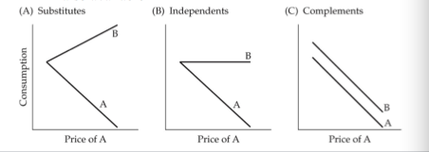

- Problems with Behavioural Regulation Approaches
  - Typically the bliss point is determined during a free-operant baseline period when there are no constrains on response choices. Choices observed during this baseline period are then used to predict performance after an instrumental conditioning procedure has been introduced
    - Responses performed in the absence of experimenter-imposed constrains are basically the same as the response that occur when an instrumental contingency is in effect
  - Do not say much about how organisms manage to defend a preferred combination of goods or activities
    - Molar theories that don’t address how much processes lead to the molar outcomes
- Contributions of Behavioural Regulation
  - 1. Looks for causes of reinforcement in how instrumental contingencies constrain free-flow behaviour
  - 2. Instrumental conditioning involves creating a new distribution of responses
  - 3. No fundamental distinction between instrumental and reinforcer responses
  - 4. Optimal distribution of activities is determined by the organism’s natural response tendencies
  - 5. Emphasizes that instrumental behaviour must be considered among all the response options available
Concluding Comments
- One way to think about the two approach’s is that they involve different levels of analysis
- The associationsist approach involves molecular level
- Focus is on individual stimulus response and their connections
- Behavioural regulation operates at a molar level
  - Contingency is introduced
  - Makes better contact with the complexities of an organism’s ecology

