Sensation II Ch 14 Notes

-temporary hand anesthetized = use more force; no feedback

Somatosensory System Components
- Cutaneous Senses- touch & pain. Somatosensory input
- Proprioception- limb position in space
- Kinesthesis- sense limb movement

*Skin heaviest & largest organ

2 Skin Layers
- Epidermis- outer layer; dead cells
- Dermis- inner layer; nerve endings & receptors called mechanoreceptors which respond to pressure stretching and vibration
    - These are similar to the hair cells in the auditory system and the photo receptors in the visual system
    - Mechanoreceptors just like the ones in the auditory system need to be mechanically moved to be stimulated and produce electrical signals

Superficial Mechanoreceptors
Merkel receptors | Meissner corpuscles
- Disk shapped  - Continuous firing from pressure  - Fine details  - Low f | - RA1  - Fire when stimuli applied & removed  - Controls handgrip

Deep Mechanoreceptors
Ruffini Cyclinders | Pacinian Corpuscle
- Continuous firing  - Skin stretching | - Elliptical shape  - Fires when stimuli applied & removed  - Rapid vibrations & fine textures by moving fingers  - High f

Skin to Cortex Pathways
Nerve fibers travel in bundles (peripheral nerves) to the spinal cord. Two major pathways in the spinal cord

Medial Lemniscal Pathway | Spinothalamic Pathway
- Large fibres  - Proprioception (the position of limbs in space) & touch perception | - Small fibers  - Temp & Pain

**Lemniscal & Spinothalamic synapse @ VLN (ventrolateral nucleus) in thalamus and then the synapse at the somatosensory cortex

Signals travel from the thalamus to the somatosensory receiving area (S1) and the secondary receiving area (S2) in the parietal lobe.
There is more cortical representation responsible for perceiving fine details

*S1 & S2 in Parietal

**Penfield mapped homunculus on surgery patients

Homunculus- “little man,” topographic map in S1

Experience Dependent Plasticity(EDP)- $↑$coritical representation with $↑$use
**representation not fixed; modifiable

Increased Monkey Representation Study (Jenkins & Merzenich)
- $↑$skin stimulation to monkey’s finger; $↑$finger’s cortical representation

-Braille readers: 100words/min

Tactile Acuity- smallest detectable skin detail

Tactile Acuity Measurements
- Two Point Threshold- smallest point separations between 2 points, perceived as 2 points. Most used in the beginning of tactile research
- Grating Acuity- smallest grooved surface which orientation judged.
- Raised pattern identification- use patterns that are complicated to determine the smallest the size that can be identified
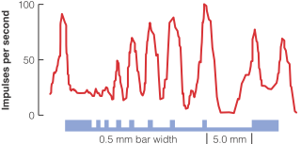
*Merkel detail sensitive
- Firing signals details (grooves)

**High Merkel density in fingertips
**Most sensitive areas= high Merkel density
low threshold on fingertips on both thresholds

**Receptor Density & Cortex important for sensitivity**

*Body part representation magnification similar to Foveal magnification in V1

RF(Receptive Field)- area when stimulated, influences neuron’s firing rate

*Better Acuity= smaller RF on the skin

*Pacinian Corpuscle sense rapid vibrations
- Perceives rapid pressure changes
- Corpuscle has a series of layers like an onion that has a fluid that transfers the vibration like the ear
- If you apply continuous vibration it wont fire and there wont be any response from the fibre

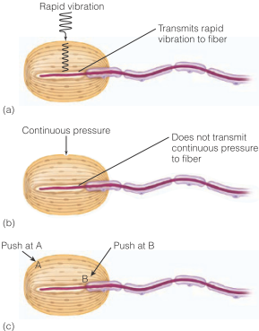

PC

PC Experiment(Lowenstein)
- PC responded when pressure first applied/removed but not when continuous
- When corpuscle removed; fiber responded to continuous pressure but not initial and at removal

Perceiving texture depends on:

Spatial Cues- texture info, determined by size, shape, element distribution such as bumps & grooves
Good for determining course texture

Temporal Cues- texture info determined by vibration rate occurring as finger moves across surface
- Only detected when fingers move across surface and not necessarily from the vibration
- Very fine texture cues

Duplex Texture Perception Theory (Katz)- texture perception determined by spatial & temporal cues

Selective Adaptation Study (Hollins et al)

- 10Hz vibration to adapt Meissner corpuscle, 250Hz vibration to adapt PC
- Couldn’t tell fine texture difference after adapting to 250Hz vibration;
- **PC adaption eliminated ability to sense fine textures by moving fingers over surface**
- graph in book

Active Touch | Passive Touch
- Actively explore object with fingers & hands  - Haptic Perception: the active exploration of 3d environment with the hand | - Stimuli applied to skin  - Things experienced on the skin  - Soft or prickly stimuli

Haptic Perception- exploring 3D object with hands

3 Systems Required for Haptic Perception
- Sensory
- Motor: moving fingers
- Cognitive: brain to think about information
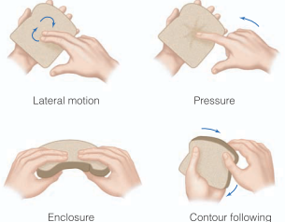
Exploratory Procedures (EP)- hand/finger movements used to identify 3D objects
- Lateral Motion & Contour Following: judge texture
- Enclosure & Contour Folowing: judge shape

4 EPs
- Lateral Motion
- Pressure
- Enclosure
- Contour Following

**Neurons more specialized as you go up the pathway

VLN (thal) has center surround RFs

*Some S1 neurons tuned to stimuli moving in specific direction, others to different orientations, others to specific objects
*Monkey arm stimulation picture from the book

Attention & Tactile Stimulation Study (Hsiao et al)
- Used raised letters and two conditions, visual attention vs not
- Larger response when paying attention to tactile stimulation
- **Response affected by attention, thinking
- Visual condition low neuron firing
- Top down can influence perception and physiological neural firing

-pain warns of potentially damaging situations. Multimodal phenomenon

Pain- unpleasant sensory & emotional experience associated with actual/potential tissue damage

3 Pain Types
- Nociceptive Pain- nociceptor activation (heat, chemical, severe pressure, cold)
- Warns for skin damage
- Inflammatory Pain- tissue damage & joint/tumor inflammation
- Release chemicals activating nociceptors
- Inflammatory Soup
- Neuropathic Pain- NS lesions/damage
- Ex. Carpal Tunnel Syndrome

Direct Pathway Model(DPM)- pain when nociceptor stimulated, send signals to brain
- Pain from skin stimulation

**Direct Pathway Model not completely true

Data Refuting DPM
- Pain Affected by Mental State
- Ex. US soldiers didn’t take pain meds so they could stay in hospital, away from battlefield
- Pain can occur without skin stimulation
- Phantom limb pain
- Pain affected by Attention
- $↑$pain when $↑$attention to it

Gate Control Model- pain perception controlled by L & S fiber activity.
- Additional pathways act to open/close gate, determining signal strength leaving Spinal Cord
- $↑$T cell activation= $↑$pain

Substantia Gelatinosa (SG)- SC nucleus receiving L&S input, inhibit T cells
- SG+ & SG-
Income comes from

S Fiber(Small Diameter) | L Fiber(Large Diameter) | Central Control
- nociceptor fibers/receptors; fire to damaging/painful stimuli  - $↑$SG+ = $↑$T cell activation  - Stimulate T cell = $↑$Pain | - Non-painful tactile stimulation info (ex. Rubbing skin)  - $↑$SG- = $↓$Pain  - Inhibit T cell activation; $↓$Pain | - Cognitive functions (expectations, attention, distraction)  - Inhibit T cell = $↓$Pain

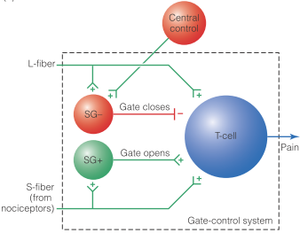

Pictures & Pain Study (deWied & Verbaten)
- 3 Conditions: Positive Images( sporst & attractive F), Neutral (household objects, nature, people), Negative(burn victims/accidents)
- Results: hand in ice water long with positive pictures

Hypnotic Pain Study (Derbyshire et al)
- HI Group: told painful heat coming from hand stimulator
- PI Group: heat pulses delivered through hand stimulator
- Control: told stimulator turned off, imagine heat coming from it
- Results: PI & HI reported pain; *pain hypnotically induced*
- Fmri there was activity in the same cortical areas
- Supports that you don’t need skin stimulation to experience pain
- Refer to book for the whole experiment

Cognition & Pain
- Expectations
- $↓$Pain when have high pain expectations
- patients told what to expect request fewer painkillers
- Placebo- pain relief, think taking pill that decreases it
- Attention Shifting
- $↓$pain when not paying attention
- Ex. Virtual reality games & burn victim pain
- Emotional Distraction
- Gazing @ positive pics $↓$pain
- Hypnosis
- Pain can be hypnotically induced

Pain Matrix- brain structures involved in pain perception
- Thal, hypothal, amygdala, S1, insula, ACC, prefrontal
- Widespread activation of pain
- All together known as the pain matrix

Multimodal Pain Nature- pain has sensory & emotional components
- Sensory Component- throbbing, prickly, hot, dull
- Affective (emotional)- torturing, annoying, frightful, sickening

Multimodal Pain Study (Hofbauer et al) very important
- Used hypnosis to $↑$/$↓$ subjective intensity (Sensory) & unpleasantness (Affective)
- Hypnosis of subjective intensity altered sensory & unpleasantness rating
- S1 activation
- Hypnosis of unpleasantness intensity altered unpleasantness rating only
- ACC activity

Naloxone- revives heroin OD; inhibits opioid receptors
- Also effects endorphins
- Reduces the effect of placebos

*social pain activates same areas activated during physical pain

Cyberball Exlcusion Study (Eisenberger et al)
- ACC activation when socially exclused

*Watching other experience pain activates ACC

Seeing Others Experience Pain Study (Singer et al)
- couples looked @ other partner receive shock
- Same areas lite up for person receiving pain as well as seeing their partner receive pain
- There is a correlation between empathy and degree of social pain experience

