Sensation II CH 16 Notes

*current psychologist: newborns have some perceptual abilities

Spontaneous Looking Preference (SLP) - infants prefer looking @ certain stimuli
- Prefer novel stimuli, contours

Visual Acuity In Newborns By
- PLT (Preferential Learning Technique)- presents 2 stimuli; observe which one baby looks @ more;
- If looks @ one longer; can tell difference
- Based on SLPs
- VEP (Visual Evoked Potential)- measures Occipital lobe activity; if stripes detected, $↑$activity
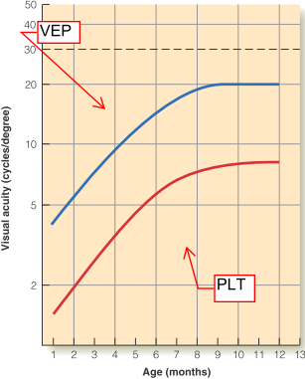
- Objective measure
**VEP = always higher measurements

Adult Acuity- smallest letter identified

Infant Acuity- smallest stripe width baby looks more at

*Visual Acuity determined by behavioural & electric recordings

Newborn Visual Acuity = ${20}/{400}$ - ${20}/{600}$

Adult Visual Acuity after 1yr

*Periphery (rods) adult like @ birth

Low Newborn Visual Acuity Reasons
- Visual cortex not fully developed
- Foveal cones too widely spaced
- Small outer segment – less visual pigments (less efficient absorbance)
- Fat inner segments – large space between segments (most light lost between spaces)
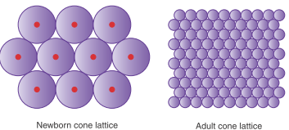
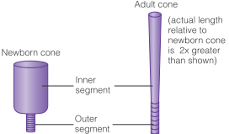
Contrast Sensitivity (CF) - smallest dark/light bar difference grating still detected
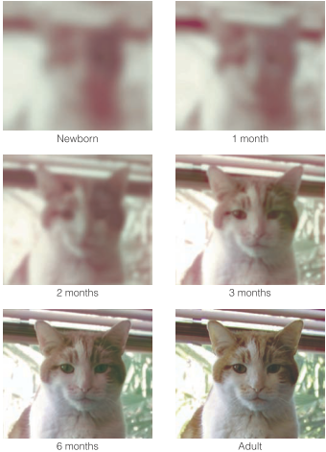

1 cycle =

Spatial Frequency (SF) - #cycles/visual degree
- Depends on observer distance
- Moving closer = $↓$SF

Contrast Sensitivity Function (CSF) – CF vs. SF plot

*Adults: most sensitive 3 cycle/degree
*1-3mnth: perceive low f, noting $>$2-3 cycles/degree
*infants see large, low f forms
*3-4months: tell diff facial expressions, diff between cat & dog
*@ 6months, acuity almost adult like

*Colour vision @ 3-4months

Habituation | Dishabituation
- present stimuli until familiar; looks @ it less  - ignores stimuli | - $↑$looking time due to new stimuli

Habituation Technique- determines if infant sees change; if so dishabitutes

Colour Habitation Study (Bornstein et al)
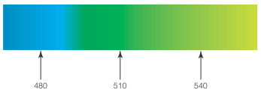
- Habituated to 510nm, presented with 480nm or 540nm light
- Dishabutation @ 480 only
- 4month old categorizes colour like adult trichromats
- **young children have colour vision

*Binocular disparity functional early, pictorial cues later

*Binocular disparity requires binocular fixation
- ***Disparity @ 3.5-6months

Binocularly Fixate- both eyes foveating to same spot
- @ 3 months

Infant Random Dot Stereogram Study (Fox et al.)
- Moving RDS, only tracked if disparity presented
- 3-6month olds tracked RDS
- ***Disparity @ 3.5-6months

Pictorial Depth Cues: overlap,l
*Pictorial Depth Cues @ 5-7months, experience dependent
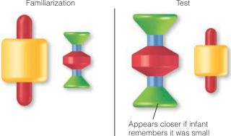
Toy Reaching Study (Granrud, Haake, Yonas)
- 5 & 7 month olds familiarized with two toys (small & large)
- Toy sizes switched
- Results:
- 7month reached for larger toy; thought it was closer
- 5 month old didn’t
- **familiar size depth perception @ 5-7months

Evidence Infants Recognize Mom’s Face
- (Bushnell et al) newborns looked 63% time @ mom
- Study: Respond more to mom’s videotaped face
- (Pascalis et al) infant didn’t look more @ mom when mom & stranger wore scarves covering hairline
- **Recognition by using high contrast hairline/face border
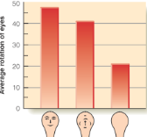
Special Face Perceiving Mechanism Support
- Moving Object & Face Study (Morton & Johnson)
- Newborns look more @ face like object
- Prosopagnosia Study (Farah et al.)
- Prosopagnosia newborn couldn’t tell faces, still recognized other objects
- 87% correct for other objects

-Study: infants stare more @ mom’s face if exposed to her more days post birth
- Experience looking @ face effects face perception
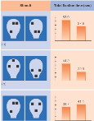
General Object & Face Perceiving Mechanism Support
- Top/Bottom Heavy Study (Turati et al.)
- Look @ top heavy stimuli even when non face like
- 2 top heavy stimuli; one face like & other not, still no preference

**Infants: more attention to top heavy display regardless of face resemblance
**movement helps infants perceive occlusion

Occluded Moving Rod Study (Kellmen & Spelke)
- Infant habituated to occluded rod moving behind block
- Shown two rods or 1 rod moving; dishabituation to 2 rods
- 4month saw one rod occluded
- No results when habituated to stationary occluded rod

-study: newborns don’t make occlusion inference 4month old make

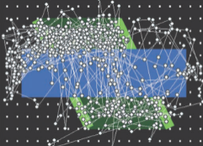
Perceiver/Non-perceiver Study (Johnson et al.)
- Perceiver= perceived rod continuous behind occluder
- Non Perceiver= didn’t perceive rod continuous
- Results
- Perceivers fixated on rods, horizontal eye movements
- Perceivers fixated @ stationary occluder

**Newborns: some audio capabilities @ birth, improve with age
*Newborns: crude sound localization

Infant Hearing Threshold Study (Olsho et al.)
- Presented sounds through headphones
- Observer judged if sound heard through: facial expressions, wide eye look, head turning, activity level changes
- Results: @6months, within 10-15dB of adult threshold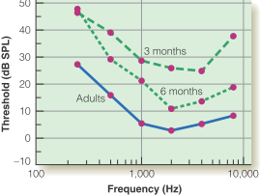

Infant Sound Recognition
- 2day infants modify sucking to hear mom’s voice, native language, story version heard in womb

Phoneme- smallest speech unit
- Changes word meaning when changed

Phonetic Boundary-boundary between 2 phoneme categories

Adult Categorical Perception: hear either or categories when VOT changed over large range
**1month same categorical perception as adults

Infant Categorical Perception Study (Eimas et al.)
- Dishabutation between 20 & 40 ms (ba to pa)
- No dishabutation between 60 & 80 ms (pa & pa)

*@ birth, distinguish phonemes from all languages
*@ 1 yr, tuned to language most exposed to
- Infants possess speech perception mechanism for all langs, becomes tuned with experience

Intermodal Perception- perceptual whole from coordinating info from different modalities

*1moth old able use intermodal perception

Pacifier Shape on Screen Study (Kaye & Bower)
- Pacifier in 1 day old’s mouth
- 2 shapes on screen, one of pacifier in mouth
- 11/12 babies kept image of pacifier’s shape on screen longer
- **newborns able to sense general shape & generalize it to visual mode

Talking Face & Sound Study (Kuhl & Meltzoff)
- Shown two talking faces, played audio from one
- Result: 74% time looked @ face where lip movement matched sound

-Intermodal Perception important, transfers mom’s voice familiarity to her face
- Result: preference for mom’s face

****Olfactory & Taste most developed sense @ birth

-Newborns discriminate between
- Sweet
- Sour
- Bitter
-No salty response

Paired Comparison- participant first familiarized to stimulus, given choice between that & new stimulus. Looking time indicates if stimulus difference sensed
- Combines habitation & PLT

Human & Monkey Paired Comparison Study (Pascalis et al.)
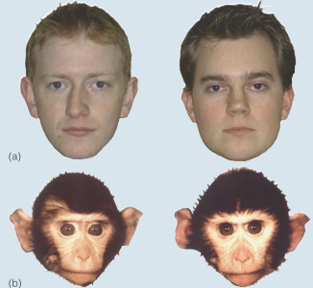
- Adults
- looked more @ novel stimuli when familiarized to human faces
- No diff in looking time when familiarized to monkey faces
- **Only discriminates human faces
- 6month old
- Discriminated both human & monkey faces
- 9month old
- Like adult; only discriminate between human faces

