Sensation IICh 15 Notes

*olfactory & taste called molecular detectors aka gatekeepers

Reasons for Olfactory & Taste Being Called Gatekeepers
- Identifies things needed for survival
- Reject bad things

Neurogenesis- constant receptor renewal
- Unique to olfactory & taste
- Taste 1-2 weeks
- 5-7 weeks olfactory system

Macrosomatic | Microsomatic
- Keen olfactory sense; necessary for survival  - Animals | - Less keen olfactory sense; not critical to survival  - Humans

Menstrual Synchrony- experiencing same menstrual cycle due to living together
- Due to pheromones

Menstrual Synchrony Dorm Study (McClintock)
- Studied F undergrads living together
- Found menstrual synchrony

Pheromones- chemical signals effecting other’s physiology/behaviour

Cotton Swab Menstrual Study (McClintock & Stern)
- W received cotton swabs with sweat, alcohol (control) over upper lip
- 2 pheromones present to create menstrual synchrony
- One shortened cycle in the beginning phas3 of their cycle
- One lengthened cycle if in the ovulating stage

Anosmia- smell loss due to injury/infection usually end up losing taste because of the connection of the two

Odour Detection Threshold- smallest [odour] detected
- Measured either with yes/no or forced choice, could result in bias. Only take the 50%. Absolute threshold.
- Force choice better, determining the strongest odor, better for eliminating bias, you have to take the 75% threshold. Discrimination threshold. JND

Odour & Animals
- rats 8-50x more sensitive
- Dogs 300-10,000x more sensitive
**all animals have same sensitivity; better olfactory from $↑$receptors

*Olfactory sensitivity $∝$ # receptors

Odour Difference Threshold- smallest difference [] between 2 odours that’s detectable
- Measured with olfactometer
- Threshold is actually 11%

Olfactometer- presents olfact stimuli with precision

Odour Quality- floral, pepperminty, rancid
- 3 fold increase above threshold before it can be described

Recognition Threshold-concentration where quality recognized

*difficulty identify specific odours

-Study: when asked to identify substance associated with odour; 50% correct rate
- 98% correct when provided with substance names
- **trouble identifying odours due to inability to retrieve odour’s name from memory

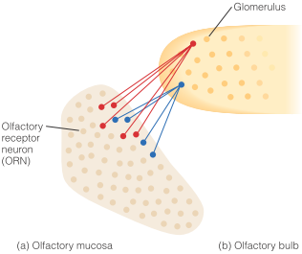
*Similar structures can smell different*

OM(Olfactory Mucosa)- contains ORNs; in nasal cavity
- Dime sized
- Contains receptors 350 different types that each have a protein that crosses the membrane 7 times
- Similar to photocells and hair cells

ORN(Olfactory Receptor Neurons)- sensory neurons containing olfactory receptors

ORNs and Rod&Cone Similarities & Differences
Similarities | Differences
- protein receptors; stimuli cross membrane 7x to create a signal  - Narrow range sensitivity  - ORNs contain 1 receptor type  - Rod/cone contains 1 photo pigment type | - 4 photo pigments 1 rod and 3 cones  - 350 olfactory receptors

Olfactory bulb****

Receptor Activity Measurement Methods
- Ca²⁺ Imaging- measures $↑$Ca²⁺ in ORN. $↑$Ca²⁺ = darker region
- Inverse relationship, more calcium, darker area more activation
- Measures ORN activity
- Pattern of activation determines recognition profiles
- Example of distributed processing
- Optical Imaging- measures reflected red light. More active cell = $↓$red light reflected
- Measures OB activity
- Remove part of skull
- 2DG- measures radioactive glucose uptake; $↑$uptake = $↑$activity
  - pattern of activation depends on chemical structure and perception

Recognition Profile- olfactory receptor activation pattern due to odorant

*Recognition profile similar to trichomacy code in colour vision; diff activation patterns in 3 cones from diff $λ$s

Olfactory Bulb (OB)- contains glomeruli
- Receives info from olfactory receptors

Glomeruli- receives input from similar ORNs
- Collects info about small odorant group
*all ORNs of 1 type send info to 1 or 2 glomeruli

C Chain Length Study (Uchida)
- Glomeruli opitcal imaging
- Functional group determines gerenal OB activation area; C length determines position within that area
- $↑$C chain = $↑$leftward activation
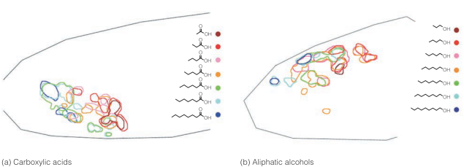

*Olfactory codes diff odorants based on ORN & OB response to specific molecule features (side groups, C chain length)

Piriform Cortex(PC) [aka Primary olfactory cortex]- under temporal lobe; receives info from glomeruli

Orbitofrontal Cortex(OFC) [aka Secondary Olfactory Cortex]- under frontal lobe; reeives OR signals
Signal goes both ways

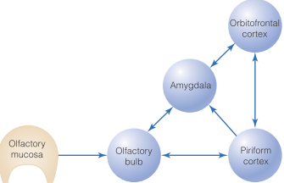

Higher Order Olfactory Processing Examples
- Single perception from many molecules
- Ex. Coffee smell from 100 diff molecules
- Ability to seperate odours
- Past experiences/learning’s effects
- Top down and bottom up processing

PC Isoamyl Study (Wilson)
- 2 Conditions: 1. mixture (isoamyl + pepperment) 2. Component (isoamyl)
- Looked @ how well neurons could tell diff between mixture & compenent after mixture exposure
- Result
- 10s sniff: similar response in both conditions
- 50s sniff: PC more rapid firing for component
- Given enough time; PC learn disciminate between diff odors

Cheddar Cheese vs Body Odour Study(Araujo et al.)
- More pleasant rating when odour labeled cheddar cheese than when labaled body odour
- Orbitofrontal cortex is associated with pleasantness, more pleasant equal more activity
- The difference is because of higher order processing
- Refer to graph in the book related to the experiment

Taste Functions
- Sweet nutritive/caloric value; automatic acceptance
- Bitter automatic rejecton response
- Salty indicates Na+ presence

5 Basic Taste Sensations (Qualities)\
- Sweet
- Salty
- Sour
- Bitter
- Umami

Basic Taste Quality Study (McBurney)
- Most tastes described with 4 basic taste qualities (sweet, sour, sality, bitter)
- Some substances have 1 taste (NaCl, hydrochloric acid, sucrose)
- Other sustances made from multiple taste qualities

Tongue- taste receptor sheet
- Roughness from papillae

-10,000 taste buds

Papillae- ridges & valleys containing taste buds

4 Papillae
- Filiform- cone shaped, all over tongue but mostly in centre
- No taste buds
- Fungiform- mushroom shaped, on tip & side
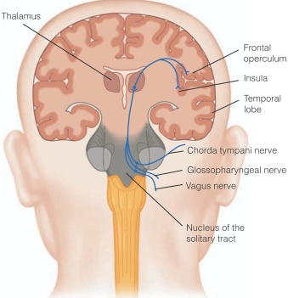
- Foliate- folds on side & back
- Circumvilliate- flat mound shaped; back of tongue

Taste Bud- contains taste cells; located within papillae

Taste Cell- do transduction; chemical contact receptor sites/channles on tips on the taste cells

*each taste bud has ~50-100 taste cells
*table 15.2

4 Taste Nerves
- Chorda Tympani- (front + side tongue)
- Glassopharyngeal- (back tongue)
- Vagus- mouth & throat
- Superficial Petronasal (soft palatte)

Solitary Tract Nucleus- recieves signals from mouth, tongue, larnyx, transmits signal through chorda tympani, glossopharyngeal, vagus and travel to FOC (Frontal Operculum Cortex) & Insula in Frontal lobe and Orbital frontal cortex

Taste Pathway
Taste cellsTaste budPapillaeChorda tympani, glossopharyngeal, vagusThalSolitary tractFOC & Insula (frontal)

Specificity Coding | Distributed Coding
- Neuron activity tuned to specific quality | - Quality signaled by activity pattern across many neurons  - Aka across fiber patterns  - Preferred to way to encode sensory information  - It is the most efficient

Distributed Coding Support (Erickson)
- KCl & NH₄Cl have similar across fiber patterns; shocked rat for drinking KCl
- Gave choice between NH₄Cl & NaCl
- Results:
- Avoided NH₄Cl
- Worked other way round; when shocked for dinking NH₄Cl, avoided KCl
- Review in text book

Specificity Coding Support
- PTC Rate Experiment (Mueller)
- Rats don’t avoid PTC normally
- Genetic cloning to add PTC receptors to mice; when added avoided PTC
- Not all data shows the same results
- Review in textbook
- Individual Neuron Taste Test Study (Sato et al)
- Looked @ response in 66 chorda tympani neurons; found certain neurons respond best to certain qualities
- Ex. Sucrose best, Quinine best
- Results graph
- Amiloride- blocks Na+ into taste receptor; eliminates salt best neuron responses
**Specific code basic taste qualities
**Distributed Code subtle differences within taste category or qualities

Flavour- perception from taste & olfaction
- Ex. Burning from hot peppers

**flavour lose when nostrils closed support for flavour

Retronasal Route- route where smell combines with taste to create flavour
- Oral cavitynasal pharynx nasal cavity
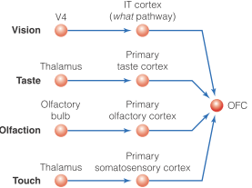
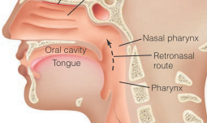

OFC Properties
- taste & olfaction 1st combined
- bimodal neurons
- respond to similar quality across modalities; ex. If respond to sweet taste, also responds to sweet smell
- respond to more than one sense
- OFC firing tells how much food animal will consume, reflect food pleasantness
- $↓$firing as animal eats more food

*individual differences in taste buds & receptor sensitivity determine PROP & PTC tasting

Tasters, Nontastesrs, Super tasters
- PROP & PTC tasters specialized receptors
- $↑$Receptor Density
- $↑$Response amplification
- $tasters$have more taste buds
- $tasters$Have specialized receptors for these compounds
- review in the textbook for differences
- supertasters are more sensitive to bitter substances
- taste experience is subjective

