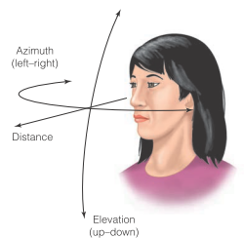
Sensation II Ch 12 Notes

Auditory space- perception of where sounds located in space; extends around head in all directions

Auditory Localization- locating objects in space

Azimuth- locations on horizontal plane; left & right of head

Elevation- locations on vertical plane; up and down of head

Distance- specifies how far source is from listener

Location cues- cues that provide locational information

Binaural Cues
- ITD (Interaural Time Difference)- time difference between sound reaching 2 ears
- **sound reaches closer ear first
- For low f
- ITD become larger as sound more towards 90 degrees
- ILD (Interaural Level Difference)- difference in sound pressure reaching 2 ears
- Sound more intense for closer ear
- For high f; head blocks some sounds
- Sound shadow needed for ILD to work; thus $λ$ must be smaller than head size

Acoustic Shadow- soundwave disruption; decreasing sound intensity to far ear

**ILD & ITD compliment each other; but only provide info about azimuth

Confusion Cone- all points possessing same ILD & ITD, providing ambiguous location info
- Directly above, below, infront, behind, and all along a sagital plane

Monaural Cues- cues depending on info from one ear
- Spectral cues

Spectral Cue- differences in f`s due to interactions of sounds with head & pinnae
- Provide elevation cues, especially high f

***Pinnae important for elevation localization

Pinnae Smoothing Study (Gardner & Gardner)
- Inserted foam into ear; smoothing pinnae
- Localization along elevation completely deteriorated, azimuth estimation still remained
- Localizaton remained excellent after molds removed; training created new set of correlations between spectral cues & location without effect old set
- **different neuron set involved in new spectral cue set
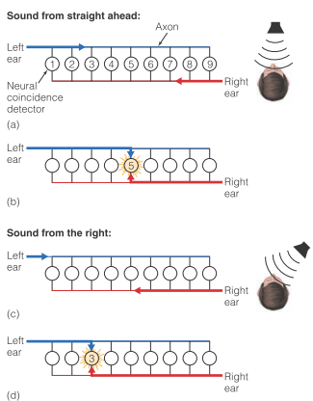
Narrowly Tuned ITD Neurons
- Specificity coding for ITD
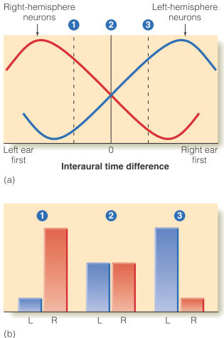
- Series of neurons that respond best to speicific ITDs
- Jeffress model
- Coincidence detectors- cells only fire when signal arrives from both ears simulataneously
- If sound comes from ahead; both reach same cell at same time, with same distance
- If sound comes from one side, will have head start and will reach a coincidence detector farther from that ear

Broadly Based ITD Neurons (McAlpine)
- Neurons in right hemisphere respond best when sound coming from left & visa versa
- Sound location indicated by ratio of left & right hemisphere activation

Auditory Problem: How does it seperate one sound from another?
- Each sound source produces own signal; but all are combined into one when entering ear, cochlea has no info about which signal produced by what object as it is all one big message
Auditory Scene- around of sound sources in environment

Auditory Scene Analysis- seperating seperate stimuli into seperate percepts

Principles of Auditory Groups- similar to gestalt grouping in vision
- Onset Time- different onset times usually mean different objects
- Location- one source usually comes from one location; moving object usually follows smooth path producing moving sound
- Pitch & Timbre Similiarity- same pitch/timbre usually produced by same source
- Proximity in Time- sounds starting/stoping @ same time usually come from same source
- Auditory Continunity- sounds that stay constant/change smoothly usually produced by same source

Auditory Stream Segregation- when playing rapidly alternating high & low tones, listener percieves two seperate melodies
- Aka implied polyphony aka compound melodic line
- Bach did this
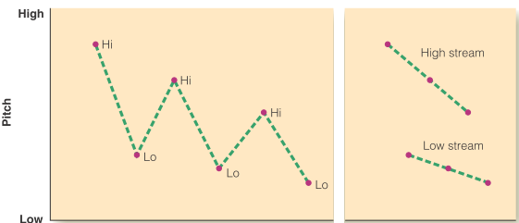
Stream Segregation Study (Bregman & Campbell)
- Played hi-lo-hi-lo
- Results: perceptually grouped into two auditory streams; listener percieved two seperate sound streams; one high pitched & one low pitched
Distractor/Captor Study (Bregman & Rudnicky)
- Asked participants order of tone: was it XY or YX
- First presented with X & Y Tone; easily percieved
- When distractor sandwiched tones; became difficult to judge tone order
- Distractor effect eliminated when captor tone added (same pitch as distractor)

Scale Illusion Study (Deutsch)
- Presented notes jumping up & down in each ear
- Percieved higher notes in one ear and lower notes in other ear
- Brain mistakenly assigned similar pitches to same ear when really coming from different ears

Melody Schema- stored representation of familiar melody
- When person knows which melody is present (by telling them), they can percieve melody

Direct Sound | Indirect Sound
- Directly from source | - Indirectly to listener  - Reflected off different surfaces

Precedence Effect- sound appearing to originate from lead speaker when time difference is 5-10ms
- Governs most of indoor experience; allows for stable percept of one source even though indirect sound arriving at different times

Architectural Acoustics- study of how sounds reflected in rooms
- How indirect sound changes quality of sounds we hear in rooms

Factors Influencing Indirect Sound
- Amount absorbed by environment
- Amount reflected
- Room size/shape

Reverberation Time(RVT)- time for sound to decrease $\frac{1}{1000}$th of its original pressure (aka decrease 60 db)
- Long RVT= muddled sound; reflected sound persists too long
- Short RVT= music sound dead
- Ideal RVT= 2
**ideal RVT doesnt always predict good acoustics

Physical Measurse Associated to Music Perception in Halls
- Intimacy Time- t between direct sound & first reflection arives
- Ideal: 20 ms
- Bass Ratio- ratio of low f to middle f reflected off surfaces
- Ideal: high bass ratio
- Spaciousness Factor- fraction of all indirect sound recieved
- High spaciousness factor

**Disney`s concert hall designed hall so accoustics independent of audience members; seat cushions had same absorption properties as average person

**Ideal RVT for classroom: 0.4-0.6s

Classrooms have more background noise

Signal to Noise Ratio= Teachers voice(db) – background noise
- Ideal +10-+15 or more

Visual Capture (aka Vantriloquis Effect)- sounds appearing to be coming from apparent visual source when actually originating from other location
- Ex. Watching movie in theatre; think sounds coming from screen when really from speakers along sides

Percieved Smashing Balls Study (Sekular)
- Showed two balls moving perpendicular to each other
- No sound: balls went past each other
- Click added in middle: percieved balls smashing and moving in opposite direction
- **should hearing influences vision
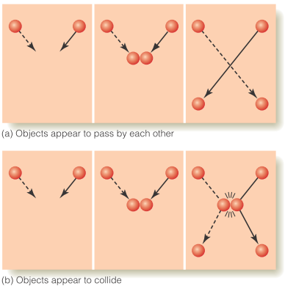

**loss of one sense can enhance another; vision loss causes increase auditory sensations

Auditory Looming- hearing approaching sound source get louder

