4.2.8. Cardiac Cycle
- Systole: the periods of contraction
- Diastole: the periods of relaxation
- Cardiac Cycle: includes all the events associated with the blood flow through the heart during one complete heart beat (atrial systole and diastole followed by ventricle systole and diastole)
- Marked by a succession of pressure and blood volume changes
- The starting point is an arbitrary one since blood flows continuously
- Ventricular filline: mid to late diastole:
- Pressure in the heart is low
- Blood returning to the heart is flowing passively through the atria and the open AV valves into the ventricle
- Aortic and pulmonary valves are closed
- More than 80% of ventricular filling occurs during this period
- Following depolarization (p phase of the ECG) the atria contracts, compressing the blood
- This cause a slight rise in atrial pressure which propels the remaining 20% of residual blood out of the atria and into the ventricle
- Ventricles are at the last stage of diastole and contain the maximum amount of blood
- This is called end diastolic volume (EDV)
- The atria relaxes and the ventricle depolarizes (QRS complex)
- Atrial diastole persists through the rest of the cycle
- Ventricular systole (atria in diastole):
- ventricle’s walls close in on the blood and ventricular pressure rises rapidly and sharply closing the AV valves
- During the split second when the ventricles are completely closed chambers and the blood volume in the chambers remains constant
- As the ventricles contract it is known as the isovolumetric contraction phase
- Ventricular pressure continues to rise
- When it finally exceeds the pressure in the large arteries issuing from the ventricles, the isovolumetric stage ends
- The SL (semilunar) valves are forced open and blood rushes from the ventricles into the aorta and pulmonary trunk
- The pressure of the aorta normally reaches 120 mmHg during this stage
- Isometric relaxation (early diastole)
- Brief stage following the T wave, the ventricles are relaxed
- The blood remaining in their chambers (end systolic volme ESV) is no longer compressed
- Ventricle pressure drops rapidly and blood in the aorta and pulmonary trunk flows back toward the heart, closing the SL valves
- Aortic pressure raises when the aortic valve closes
- This is caused by the blackflowing blood rebounding off the closed valve cusps, an event beginning at the dicrotic notch
- Once again the ventricles are totally closed chambers
4.2.8.1. Pressure changes in the heart
- When blood pressure on the atrial side of the AV valves exceeds that in the ventricles, the AV valves open and ventricular filling occurs
- Atrial pressure drops to its lowest point and ventricular pressure rises
- The same process occurs on the right as the left, the only difference is the pressure
- The systole and diastole are typical 24/10 mmHg rather then 120/80 mmHg
- Both sides eject the same amount of blood
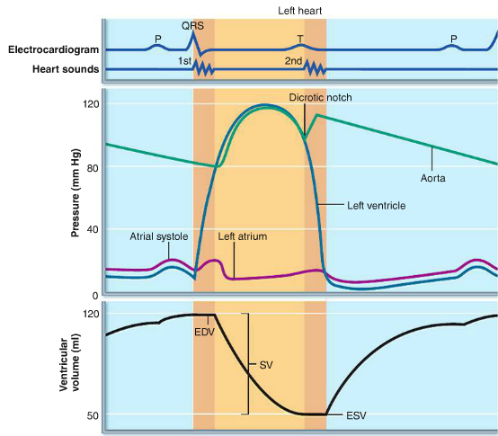

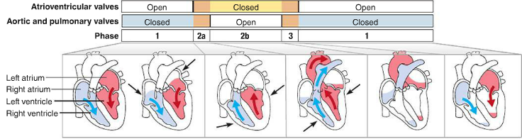

4.2.8.3. Sounds of the Heart
- The pause indicates the period when the heart is relaxing
- The ‘lub’ or first sound occurs as the AV valves are closing
- Signifies the point when ventricular pressure rises above atrial pressure
- Tends to be longer, louder and more resonant then the second sound
- The ‘dub’ or second sound occurs as the SL valves snap shut
- Results in a short, snap sound
4.2.8.4. Heart Murmurs
- Caused by obstructions of blood flow
- Fairly common in young children and some elderly people with perfectly healthy hearts
- Probably caused because the heart walls are relatively thin and vibrate with rushing blood
- Often caused by valve problems
- An insufficient or incompetent valve fails to close completely
- There is a swishing sound as blood backflows or regurgitates through the partially open valve after the valve has supposedly closed
- A stenotic valve fails to open completely and it restricts the blood through the valve
- Results in a high pitch or click sound during ventricular contraction
4.2.9. Cardiac Output (CO)
- The amount of blood pumped out by each ventricle in 1 minute
- Is a product of heart rate and stroke volume (CO= HR x SV)
- The normal adult blood volume is about 5 L (male) 4L for a female
4.2.9.2. Stroke Volume
- Stroke volume is a function of EDV and ESV (SV=EDV-ESV)
- Normal stoke volume is about 70mL/beats (120 mL/beats-50mL/beats)
4.2.9.3. The heart and Exercise
- Cardiac reserve is the difference between resting and maximal CO
- In nonathletic people the CR is normally 4-5 times the CO (20-25 L/min)
- In an athlete the CR may reach 7 times the CO (35 L/min)
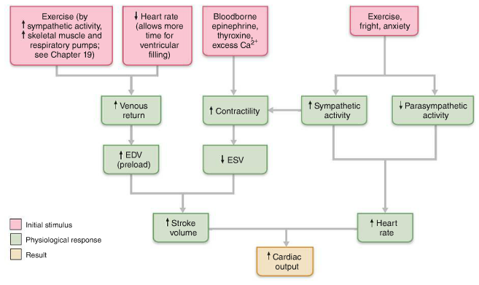
4.2.10. Mechanisms to Regulate the Heart
- When the blood volume drops rapidly, so does the SV but CO is maintained by an increase in HR
- Factors that increase HR are called positive chronotropic factors
- Factors that decrease HR are negative chronotropic factors
4.2.10.1. What effects the Rate of SA node Depolarization
- The Autonomic Nervous System:
- Exerts the most important extrinsic controls effecting HR
- Emotional of physical stressors (fright, anxiety, or exercise) activate the sympathetic nervous system, which then releases norepinephrine at their cardiac synapses
- Norepinepherine binds to $β_{i}$-adrenergic receptors in the heart, causing threshold to be reached more quickly
- As a result the SA node fires more rapidly and the heart responds by beating faster
- Sympathetic stimulation also enhances contractility and speeds relaxation.
- It does this by enhancing Ca2+ movements in contractile cells.
- Enhanced contractility lowers ESV, so SV does not decline as it would if HR increased
- The parasympathetic divisions opposes sympathetic effects and effectively reduces HR when a stressful situation has passed
- Parasympathetic-initiated cardiac responses are mediated by acetylcholine, which hyperpolarizes the membranes of its effector cells by opening the K+ channels
- Parasympathetic activity as little or no effect on cardiac contractility
- Chemical Regulation:
- Hormones:
- Epinepherine, liberated by the adrenal medulla during sympathetic nervous system activation, produces the same cardiac effects as norepinerpherine
- Enhances HR and contractility
- Thyroxine: is a thyroid gland hormone that increases metabolic rate and production of body heat. When released in large quantities it results in a sustained increases in HR
- Acts directly on the heart but also enhances the effects of epinephrine/norepinepherine
- Ions:
- Normal heart function depends on normal levels of intracellular and extracellular ions
- Plasma electrolyte imbalances pose real dangers to the hearts
- Reduced Ca2+ levels (hypocalcemia) depress the heart
- Increased Ca2+ levels cause hypercalcemia with increase HR and contractility
- Very high Ca2+ levels can cause life-threatening arythmias
- High or low K+ levels are very dangerous
Excessive levels can cause hyperkanlemia which alters electric activity in the heart by depolarizing the resting potential. This may lead to heart block and cardiac arrest
Hypokalemia is also life threatening, in that the heart beats feebly and arrhythmically
- Body Temperature:
- Enhances the metabolic rate of cardiac cells; rapid, pounding heart beat
- Cold directly decreases HR
4.2.10.2. Frank Starling Law of the Heart:
- Preload: The degree to which cardiac muscle cells are stretched just before they contract, it controls stroke volume
- In a normal heart the higher the preload, the higher the stroke volume will be
- The relationship between preload and SV is called the Frank-Starling Law of the Heart
4.2.10.3. Afterload
- The pressure that ventricles must overcome to eject blood
- The back pressure that arterial blood exerts on the aortic and pulmonary valves
- About 80 mmHg in the aorta and 10 mm Hg in the pulmonary trunk

4.2.10.4. Extrinsic Influences on SV
- Contractility rise more when Ca2+ enters the cytoplasm from the extracellular fluid in the SR.
- Enhanced contractility means more blood is ejected from the heart, this means a greater SV
- Increased sympathetic fibers serve not only the intrinsic conduction system but the entire heart
- Norepinephrine and epinephrine binding intiates cAMP second messenger system that increases CA2+ entry.
- This promotes more cross bridge binding and enhances ventricular contractility
4.3. Blood Vessels and hemodynamic
4.3.1.1. Veins, Arteries and Capillaries
- Arteries: Carry blood away from the heart and are said to branch, diverge or fork
- Carry oxygen rich blood in the systematic circulation
- Carry oxygen poor blood in the pulmonary circulation
- Veins: Carry blood to the hearts and are said to join. Merge and converge
- Carry oxygen poor blood in the systematic circulation
- Carry oxygen rich blood in the pulmonary circulation
- Capillaries: Only vessels to have intimate contact with tissue cells
- Exchanged between the blood and tissue cells occur primarily through the gossamer-thin capillary walls
4.3.1.2. The 3 Tunics of Blood Vessels
- Tunica Intima: Innermost tunic
- Intimate contact with the blood and the lumen
- Contains the endothelium, the simple squamous epithelium that lines the lumen of all vessels
- Endothelium is continuos with the endocardial lining of the heart and its flat cells fit closely together forming a slick surface that minimizes friction
- In vessel with a diameter larger then 1 mm a subendothelial layer, consisting of a basement membrane and loose connective tissue supports the endothelium
- Tunica Media: Middle tunic
- mostly circularly arranged smooth muscle cells and sheets of elastin
- the activity of smooth muscle is regulated by sympathetic vasomotor nerve fibers of the ANS and a whole battery of chemicals
- depending on the body’s needs at any given moment either vasoconstriction or vasodilation can occur (lumen diameter decrease/increases respectively)
- it’s activities are critical in regulating circulatory dynamics because small changes in vessel diameter greatly influence blood flow and pressure
- generally is the bulkiest layer in arteries
- Tinica Externa: Outermost layer
- Composed largely of loosely woven collagen fibers that protect and reinforce the vessel and anchor it to surrounding structures
- Infiltrated with nerve fibers, lymphatic vessels and in larger vessels and veins a network of elastic fibers
- In larger vessels the tunica externa contains system of tiny blood vessels vasa vasorum (vessels of the vessels) that nourish the tunica externa
- Generally the bulkiest layer in veins
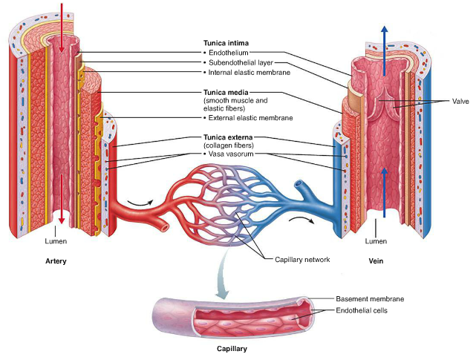
4.3.2. 3Types of Arterial Vessels
- Elastic Arteries: thick walled arteries near the heart- aorta and it’s major branches (d= 2.5-1cm)
- Most elastic of all arteries, contain more elastin
- Large lumens make them a low-resistance pathway
- Sometimes called conducting arteries
- Contain substantial amounts of smooth muscle but are inactive in vasoconstriction
- They are reservoirs, expanding and recoiling as the heart ejects blood
- Consequently blood flows rather continuously rather than sopping with the pulsating rhythm of the heart
- If the vessesls become hard and unyielding, as in atherosclerosis blood flows more intermittently
- This causes the walls of the arteries to experience higher pressure and they may eventually burst
- Muscular Arteris: Distal to elastic arteries and deliver blood to specific body organs
- Sometimes called distributing arteries
- Diameter ranges from that of the pinky or a pencil lead
- Have the thickest tunica media of all vessels
- More active in vasoconstriction than elastic arteries because their tunica media contain more smooth muscle tissue and less elastic tissue
- There is an elastic membrane on each face of the tunica media

- Arterioles: Smallest of all artiers
- Have a diameter of 0.3mm-10 micro meters
- Larger arterioles have all three tunics, but their tunica media is purely smooth muscle with scattered bits of elastic fibers
- When they constrict the tissues have a reduction in blood flow, and when they dilate blood flow into the capillaries greatly increases blood flow
4.3.3. 3 types of Capillaries
- Continuous Capillaries: abundant in the skin and muscles and are the most common
- Continuous in the fact that their endothelial cells are connected by tight junctions
- These junctions are usually incomplete leaving gaps of unjoined membrane called intercellular clefts
- Large enough to allow for limited passage of fluids and small solutes
- Typically the endothelial cell cytoplasm contains numerous pinocytotic vesicles that ferry fluids across the capillary wall
- In the brain the tight junctions are complete and extend around the entire perimeter of the endothelial cells
- Fenestrated Capillaries: the endothelial cells are riddled with oval pores or fenestrations
- A delicated membrane usually covers the fenestrations
- Much more permeable to fluids and small solutes
- Found wherever active capillary absorption or filtrate formation occurs
- Small intestines
- Endocrine organs
- Kidneys
- Sinusoid Caplillaries: highly modified leaky capillaries
- Found only in the liver, bone marrow, spleen and adrenal medulla
- Have large irregularly shaped lumens ad are usually fenestrated
- Endothelial lining has fewer tight junctions and more intercellular clefts than ordinary capillaries
- They allow large molecules and even blood cells to pass
- In the liver the endothelial of sinusoid capillaries is discontinuous and its lining contains large stellate macrophages that remove and destroy bacteria
- Blood flow is sluggish allowing time for it to be modified in various ways
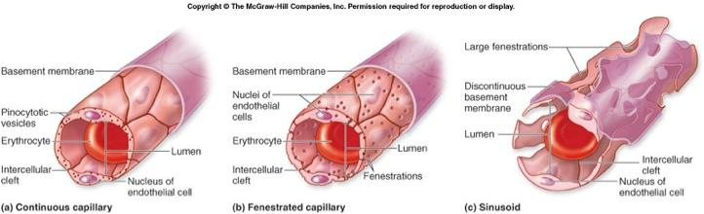

4.3.3.1. Definitions
- Microcirculation: the flow of blood from an arteriole to a venule (through a capillary bed)
- Terminal arteriole: an arteriole that feeds a capillary bed
- Vascular shunt: a short vessel that directly attaches he arteriole and venule at opposite ends of the blood
- True capillary: the actual exchange vessels
- Metarteriole: a vessel structurally intermediate between arteriole and a capillary
- Thoroughfare channel: intermediate between a capillary and a venule
- Preapillary sphincter: a cuff of smooth muscle fibers
- Postcapillary venule: drains out of the capillary bed
4.3.4. Veins and Venules
- Venules: Capillaries unit to form venules
- 8-100 micrometers in diameter
- Smallest venules are the postcapillary venules
- consist entirely of endothelium around which pericytes conjugate
- extremely porous
- fluid and white blood cells move easily through their walls
- a good indication of inflammation is adhesion of white blood cells to the walls
- large venules have one or two layers of smooth muscle cells and a thin tunica externa
4.3.4.1/2. Anatomy of a Vein
- have the same three tunics as arteries, but their walls are always thinner and lumens larger than those of the corresponding arteries
- in hitological preparations veins are usually collapsed and their lumens appear slitlike
- tunica media contains little smooth muscle or elastin and tend to be thin
- the tunica externa is the thickest wall layer
- consists of thick longitudinal bundles of collagen fibers and elastic networks
- Called capacitance vessels or blood reservoirs because they can hold up to 65% of the bodys blood supply at any given time
- Their walls can be much thinner then arteries because they have less pressure exerted on them so they will no rupture
- Adaptations:
- Large-diameter lumens which offer relatively little resistance to blood flow
- Valves that prevent back flow which resemble the semilunar valve of the heart
- Most abundant in the veins of the limbs
- Varicose Veins
- Dilated because of leaky valves
- More than 15% of adults
- Several things can cause them such as; hereditary and conditions that hinder venous return (prolonged standing, obesity, pregnancy), elevated blood pressure
- Hemorrhoids are varicose anal veins
- Venous Sinuses
- Highly specialized flattened veins with extremely thin walls composed only of endothelium.
- Coronary sinus of the heart
- Dural venous sinuses of the brain
4.3.5.1. Definitions
- Blood Flow: the volume of blood flowing through a vessel, an organ, or the entire system at a given time (mL/min)
- the blood flow of the entire system is equal to cardiac output
- Blood Pressure: The force per unit area exerted on a vessel wall by the contained blood (mmHg)
- Resistance: measure of the amount of friction blood encounters as it passes through vessels
- Peripheral Resistance: resistance that occurs in the peripheral (systemic) circulation
4.3.5.2. Changes in Blood Pressure
- Blood pressure is highest in the aorta and declines throughout the pathway to finally reach 0mmHg in the right atrium
- The steepest drop in blood pressure occurs in the arterioles which offers the most resistance to blood flow
- Arteriole Blood pressure: Reflects two main points
- How much the elastic arteries close to the heart can stretch (their compliance)
- The volume of blood forced into them at any time
- blood pressure is pulsatile and it rises and falls, therefore the amount of blood entering the arteries is not equal to the amount leaving and pressure is not constant
- as the left ventricle contracts it transfers kinetic energy to the blood expelling it into the aorta, this is when the aortic pressure reaches it peak
- this is known as systolic pressure and averages 120mmHg in a healthy person
- blood moves forward in the arterial bed because it has higher pressure than that of the more distal vessels
- during diastole the aortic valves close stoping blood from flowing back into the heart
- the walls of the aorta recoil, maintaining sufficient pressure to keep the blood flowing forward into the smaller vessels
- during this time the aortic pressure drops to 70-80 mmHg (diastolic pressure)
- the difference between systolic and diastolic pressures is called pulse pressure
- in order to determine the aortic pressure we must take a mean:

$$MAP=Diastolic pressure+\frac{pulse pressure}{3}$$
- MAP and pulse pressure both decline with increasing distance from the heart
- The MAP loses ground to the nerve ending friction between blood and the vessel walls
- Pulse pressure is gradually phased out
- Capillary Blood Pressure: Have very low pressures
- 35 mmHg when the blood enters the capillaries and 17 mmHg when it leaves
- Low pressure is desirable because capillaries are fragile and most capillaries are extremely permeable so they force solute containing fluids out
- Venous Blood Pressure: Steady ad changes very little
- pressure is only about 15 mmHg
- the low pressures reflect the cumulative resistance of peripheral resistance
- Three Functional Adaptations of Venous Return:
- Muscular Pump: Consists of skeletal muscle activity, as they contract and relax they guide the blood back up toward the heart
- Respiratory Pump: push blood up toward the heart ad pressure changes in the ventral body cavity change during breathing
- As we inhale, abdominal pressure increases, squeezing local veins and forcing blood toward the heart
- At the same time the pressure in the chest decreases allowing thoracic veins to expand, thus speeding blood return into the right atrium
- Sympathetic Venoconstricton: Reduces the volume of blood in the veins, pushing blood toward the heart

4.3.8. Definitions
- Systolic Pressure: the pressure peak generated by ventricular contraction
- Diastolic Pressure: the walls of the aorta recoil, maintain sufficient presses to keep the blood flowing forward into smaller vessel and the aortic pressure drops.
- Pulse Pressure: the difference between systolic and diastolic pressure
- Mean Arteriole Pressure (MAP): the pressure that propels blood into the tissues (it is equal to diastolic pressure + 1/3 pulse pressure)
4.3.10 Blood Pressure
- Blood flow (F) is directly proportional to blood pressure (ΔP) and indirectly proportional to peripheral resistance (R)
- R is far more important than P when it comes to influencing F because R can easily be changed by altering blood vessel diameter
4.3.10.1. Pulse
- A rhythmic throbbing of the arteries as blood is propelled through them
- It is measured in beats per minute (bpm)
- the alternating expansion and recoil of arteries during each cardiac cycle
- When measuring blood pressure you:
- Wrap the blood pressure cuff snugly around the person’s arm just superior to the elbow
- Inflate the cuff until it’s pressure exceeds the systolic pressure, at this point blood flow into the arm stops and a brachial pulse cannot be found
- Reduce the cudd pressure gradually and listen with a stethoscope for sounds of the brachial artery.
- When the first soft tapping sounds can be heard this indicates the systolic pressure
4.3.10.2 Definitions
- Hypotension: Low blood pressure (below 90/60mmHg)
- is usually associated with long life and an old age free of cardiovascular disease
- only a concern is it leads to inadequate blood flow to the tissues
- Hypertension: chronically elevated blood ressure
4.3.11.1 Neural and Chemical Mechanisms for Regulation of Blood Pressure
- The depression of vasomotor center of brain can cause a loss of vasomotor tone of blood vessels, resulting in massive dialation of veins
- This will result in a condition called neurogenic shock
- Vasomotor tone is the resistance to flow that must be overcome to push blood through the circulatory system.
- Vasomotor center is a portion of the medulla oblongata that regulates blood pressure
- Upon increase in blood carbon dioxide level it stimulates the sympathetic system to constrict vessels which increase otherwise low blood pressure
4.3.11.2.Chemical Receptors
- Baroreceptors: When arterial blood pressure rises baroreceptors are stretched and send a rapid stream of impulses to the cardiovascular centers and cardioinhibitory center.
- This results in a decrease in blood pressure, three mechanisms brings this about:
- Arteriolar Vasodilation: Decreased outpt from the vasomotocenter allows arterioles to dilate. As peripheral resistance falls, so does MAP
- Venodilation: Decreased output from the vasomotor center also allows veins to dilate, which shifts blood to the venous reservoirs. This decreases venous return and CO
- Decreased CO: impulses to the cardiac centers inhibit sympathetic activity and stimulate parasympathetic activity, reducing HR and contractile force. A CO falls, so does MAP
- A decline in MAP initiates reflex in vasoconstriction and increases CO, bringing blood pressure back up.
- Rapidly responding baroreceptors protect the circulation against short-term changes in blood pressure
- Chemoreceptor Reflexes: are found in the aortic arch and large arteries of the neck, and are activated when CO2 levels rise, pH drops, or O2 content of the blood drops
- They transmit impulses to the cardioacceleratory center, in which then increases CO and to the vasomotor center, when then causes reflex casoconstriction.
- The rise in blood pressure that follows speeds the return of blood to the heart and lungs
4.3.11.3.Higher Brain Centers
- Reflexes that regulate blood pressure are integrated in the medulla oblongata of the brain stem
- The hypothalamus and cerebral cortex can modify arterial pressure via the medullary center (i.e. fight or flight response)
- Hypothalamus also mediates the redistribution of blood flow and other cardiovascular responses that occur during exercise and changes in body temperature
Hormones:
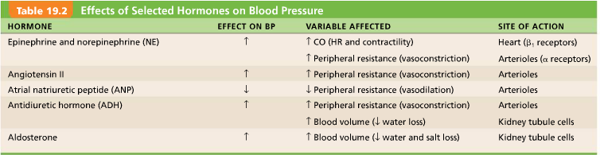

4.3.12. The Kidneys and Long-term regulation
- Effects blood volume rather than CO like short term regulation
- Blood volume is approximately 5L for males and 4L for females
- An increase in blood volume is followed by a rise in blood pressure
- Sudden drop in blood pressure often signals internal bleeding
- Increase in blood volume that raise blood pressure also stimulate the kidneys to eliminate water which reduces blood volume and blood pressure
- Like wise a decrease in blood volume will cause the renal mechanisms to increase blood volume and blood pressure.
4.3.1.3 auto regulation:
- The automatic adjustment of blood flow to each tissue in proportion to the tissue’s requirements at any instant. Local conditions regulate this process independent of control by nerves or hormones. MAP Is the same everywhere in the body and homeostatic mechanisms adjust cardiac output. As needed to maintain that constant pressure. Changed in blood flow through individual organs are controlled intrinsically by modifying the diameter of local arterioles feeding the capillaries.
Local factors causing vasodilation include:
- Decreases in O₂ or nutrient levels
- Increases in CO₂ levels in that area
- Decrease in pH
- Increases in adenosine, lactic acid, cAMP, cGMP, K⁺, heat, inflammatory chemicals and nitric oxide (NO)

Metabolic controls:
- If blood flow is too low, oxygen levels decline and metabolic products accumulate
- Metabolic factors that regulate blood flow are low oxygen levels and increase H+, k+, adenosine, and prostaglandins
- Act directly to relax vascular smooth muscle, but some may act by causing vascular endothelial cells to release nitric oxide
Myogenic Controls (Local!):
• vascular smooth muscle responds to increased stretch with increased tone »» stretch is resisted »» vasoconstriction
• decreased stretch results in vasodilation
• result: tissue perfusion homeostasis so cells not deprived/capillaries not damaged
** Both physical (myogenic) and chemical (metabolic) factors determine final autoregulatory response in tissues.
4.3.14.2 Mechanisms for exchange:
- Diffusion (a passive process)
- Vesciular transport (endocytosis and exocytosis)
- Bulk flow (filtration and absorption) - a movement of a fluid (liquid or gas) from region of higher pressure to one of lower pressure (a passive process)
Capillary transport mechanism:
- Diffusion or active transport of some small molecules through endothelial membranes
- Diffusion through intercellula clefts (pores);most substances including water, small hydrophilic molecules
- Passage of large molecules through endothelial fenestrations (little windows)
- Passage of some larger molecules through endothelial tissue via pinocytic vesicles
Hydrostatic pressure:
- due to a fluid against a boundary
- HP pushes fluid across the boundary
- In blood vessels, is due to blood pressure
Osmotic pressure:
- Due to nondiffusible solutes that cannot cross the boundary
- OP pulls fluid across the boundary
- In blood vessels, is due top plasma proteins



