- Radio emission from our Galaxy:
  - 1945: Dutch astronomers predicted theoretically that Hydrogen atoms naturally emit a 21-cm radio wave when their e- flips over
  - 1950s: Radio astronomers detected our Galaxy’s 21-cm emission, revealing its stellar H-gas and spiral structure
- Radio emission from the Sun:
  - 1942: Hey detected radio emission from solar flares (eruptions of radiation which trace out magnetic field lines from sunspots
  - Unlike solid Earth, the Sun (a fluid) spins differentially (ie. its rotation speed decreases with latitude)
  - As a result, its magnetic field is not a simple bar-magnet, but a complex field which twists and untwists every 11 years
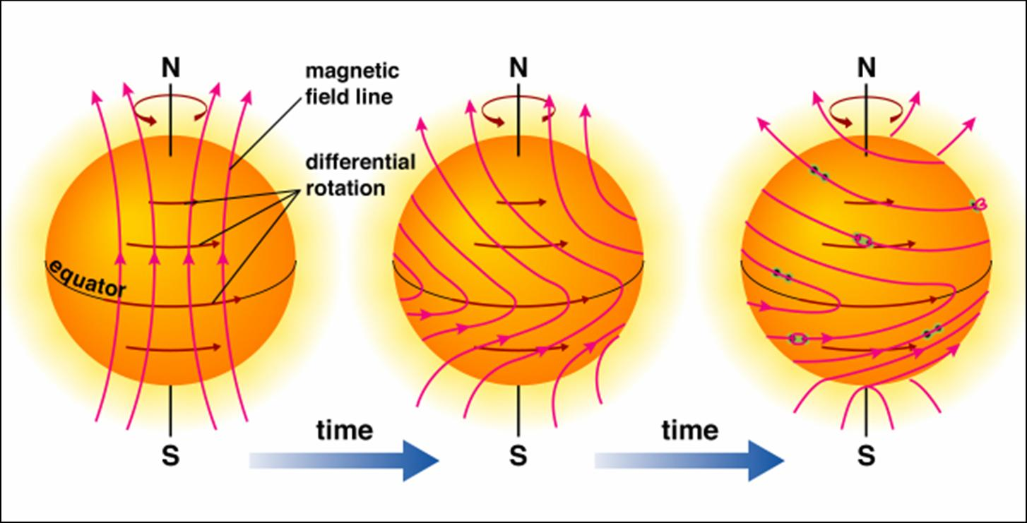
  - This causes the frequency of sunspots and flares to increase every 11 years
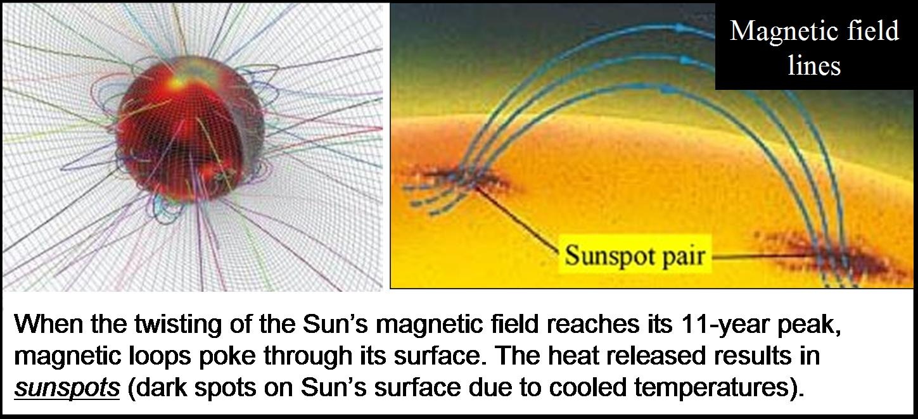
  - 1850s: the frequency of magnetic storms and auroras on Earth were found to follow the 11-year solar cycle. Both are due to the winds of charged particles produced by sunspots 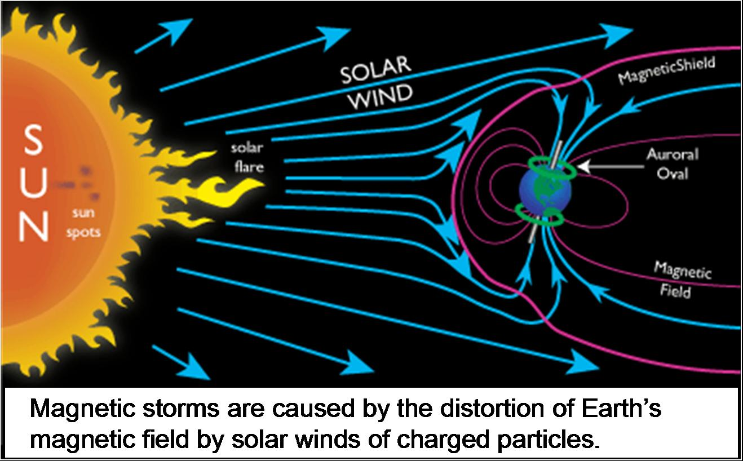 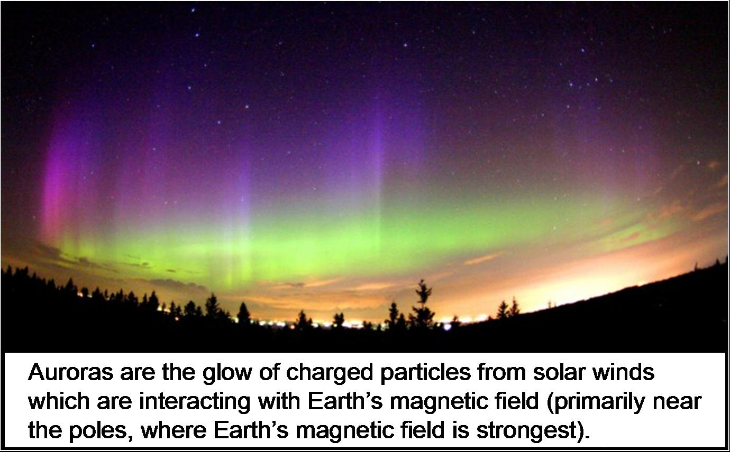
- 1960s: Multiple radio dishes (radio arrays) were combined to achieve the power of one enormous dish
- Radio arrays have detected the most distant objects ever observed, giving us a view of the early Universe
- Pulsars:
  - 1960s: Pulsating radio signals were detected from the cores of supernova remnants
  - Named “pulsars”, these are neutron stars whose radio beams are periodically aimed at Earth
  - 1980s: Binary pulsars were found to tick slower when closest to their centre of mass, providing the prediction of General Relativity that time slows down in a strong gravity field (time dilation).
- Radio galaxies and quasars:
- 1946: Hey identified the 1st radio source associated with a galaxy. Radio galaxies are typically giant elliptical with jets of radio emission from the galaxy’s nucleus.
- 1960s: Spectra were obtained of star-like objects at the same coordinates as strong radio sources. The spectra were indicative of galaxies with huge redshifts (i.e. billions of ly away).
- The objects were called Quasi-Stellar Radio Sources (Quasars).
- The theory: the bright star-like appearance is a huge accretion disk of swirling matter around a supermassive black hole (up to billions of solar masses) at the galaxy’s centre.
- The theory: the strong radio lobes are a result of the strong magnetic field produced from the black hold’s spin.
- The evidence: high-res images of radio galaxies reveal huge disks of hot gas and dust around a central dark object.
- Since only distant quasars are seen, they may be a young phase, when galaxy cores were denser (more fuel for black hole).
- All galaxies likely have a central black hole, but most are presently quiet, having consumed all nearby matter.
X- Ray Astronomy

- Since X-rays can’t penetrate Earth’s atmosphere, X-ray light from space can only be seen with space telescopes.
- 1960s: The strongest Galactic X-ray source was discovered (Cygnus X-1) and proposed to be from an accretion disk around a stellar black hole.
- Proof of black holes was found in 1972, when optical images of Cygnus X-1 revealed a massive star in orbit around an unseen companion.
- The optical images were obtained by a U of T professor at the David Dunlop Observatory in .. Richmond Hill, Ontario.

