PART 3: BPS 1101 Exam
Allergy
- Adverse reaction to harmless material
- Allergy requires prior exposure
  - Immune system responds to something
    - Epitopes of molecules from pathogens
  - Immune system “remembers” that material
    - Memory cells giving a strong response to the next encounter
  - Subsequent exposure produces reaction
    - Protection from pathogens
    - Allergy to harmless material

- Hay fever is a reaction to pollen
  - Cold-like symptoms
  - Some people get a geographic tongue
  - Was rare and now is the most common allergy

- Atopic dermatitis (rashes) from surface exposure
  - Contact dermatitis from irritants
    - Hand washing makes it worse
    - Common with industrial powders with exposure to large amounts (dose vs. poison)
      - Sand – carcinogen when breathed in
  - Contact dermatitis from immune reaction ex. Poison ivy
    - Hype immune reactions at the site of contact
      - Urushiol produces the reaction
      - Latex from rubber tree sap
      - Nickel is a common allergen, gives the strongest immune response
        - Nickel alloys are common
        - Many piercings made of stainless steel (Nickel)
      - Allergies to henna tattoos on skin

- Dust allergies are common and are caused by dust mites feces
  - Mattresses can contain large amounts of droppings

- Allergies to pets mostly due to their saliva
- Mold and fungi produce many allergies and are the most dangerous

- Food can give allergy or intolerance
    - Allergy
      - Immune system reacts to the food
    - Intolerance
      - Substances in food produce adverse reaction (ex. HEADACHES!!)
  - Food allergies affect about 4 % of adults
  - Food intolerance affects about 30 % of adults
    - Lactose intolerance is inability to digest lactose
      - Bacteria digest food instead
      - Lactase is available as a supplement
    - Spices can irritate stomach (NOT allergy!)
- Signs of food allergy –
    - bags under eyes
    - dark under eyes (from constant inflammation)

- Common food allergens
    - Seafood, fish, milk, eggs, nuts…
- Peanut allergy common in North America RARE outside
    - We roast our peanuts
    - Peanut free schools common only in last 30 years in North America
- Spider and insect bites can give strong reactions

- Rare allergies
    - allergy to sunlight : activates marigold in skin
    - Aquagenic allergy : allergy to water, rash, even if we are water (60%)
    - 20th Century disease : “allergy” to man-made substances
      - Psychological, usually people who had a traumatic event or have anxiety
      - Get rash, runny nose, etc.

- Allergy is a disease of the developed world
  - Rates have doubled since 1980
    - exposed to new substances
    - Industrial pollution more common in developing world
- Most allergies involve natural substances, to man-made is very rare

- Hygiene hypothesis for allergy
    - More clean and so, less exposed than before
- Immunization and antibiotics reduce infection rates causing more allergy but less illness
- Children in daycare less likely to be allergic (exposed)
- Children in large families have less allergies (exposed)
- Less if child plays in dirt, more if too clean

- East Berlin had poor health care and pollution
- More allergies in West Berlin

- Allergy requires prior exposure
  - Involves immune system memory
  - Hypersensitivity on 1st exposure
    - Unknown previous exposure

- Mast cells display IgE antibodies
1. Allergin contacts the IgE molecules
- Mast cell degranulation releases histamine
3. Histamine produces allergy symptoms

- Managing allergy
  - Avoidance
  - Antihistamines
  - Decongestants
  - Immune modulators
  - Immunotherapy

- Allergy tests look for reactions
- Avoidance best for food allergy
  - Difficulty may be finding out what to avoid
  - Processed foods contain variable ingredients
    - Need to track down food allergy using logbook

- First generation antihistamines can enter the brain
- Antihistamines are often taken – Diphenhydramine (Benadryl)
    - histamine antagonists
    - Generic versions are available
    - Makes you sleepy

- Chlorpheniramine is in Chlor-Tripolon
    - Side effect is drowsiness
    - in cold medications
    - Rare in america
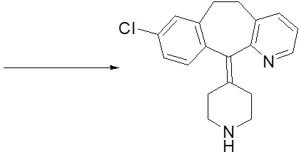
- Second generation antihistamine does not enter the brain
- Loratadine is a prodrug (Claritin)
    - Body converts Loratadine to Desloratadine
    - Desloratidine is in Aerius

- Seldane contained terfenadine which was converted to fexofenadine
    - FIRST non-drowsy treatment
    - Ketoconazole inhibited the liver causing the activation of terfenadine (toxic)
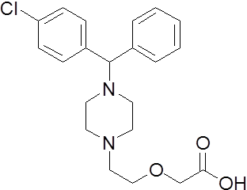
      - This caused cardiac arythmia
- Third generation antihistamine
- Allegra contains fexofenadine
- Reactine contains cetirizine
- Various generations of antihistamines
- First generation (drowsiness) cetirizine
  - Diphenhydramine (1940’s, Benadryl, generic available)
  - Chlorpheniramine (1940’s, Chlor-Tripolon, generic available)
- Second generation (non-drowsy)
  - Loratadine (1989, Claritin, generic available)
  - Desloratadine (2002, Aerius, generic available)
- Third generation (non-drowsy)
  - Fexofenadine (1996, Allegra, generic available)
  - Cetirizine (1996, Reactine, generic available)

- Buyer beware! Price for 100 tablets
  - Generic can be more expensive puts less tablets to look cheaper
  - Buying in bulk is best value

- Pseudoephedrine for decongestion
- Steroid decongestants are for structure not anabolic
    - Rhinocort spray
    - Pulmicort is an anti-inflammatory steroid

- Anaphylaxis is very serious
  - Body protects itself by swelling causing the airway to close
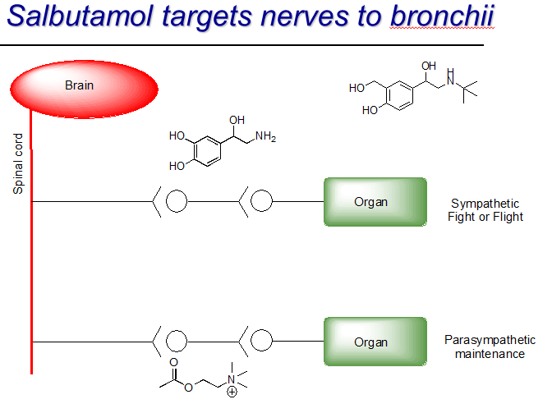
- Epi-Pen for strong allergic reactions
  - Adrenaline (short term)
  - Know how to use it

- Up to 50 % of allergies progress to asthma
- Original drugs targeted nerve signals
- Salbutamol
  - targets nerves to bronchi
  - selective adrenaline agonist
    - open airways in the lungs (fight or flight)
  - High doses will stimulate the heart
    - Over use caused heart attacks
- Flovent inhaler delivers measured doses

- Leukotrienes associated with asthma ( cause oxidation of arichdonic acid
  - Singulair is a leukotriene antagonist and very effective
/
- Persistence pays off
  - Identify the allergen
    - Avoid it when you can
  - Try antihistamines
    - First, second or third generation
    - Experiment and see which works best for you
  - Prescription steroids

Drugs in the Body
- Drugs pass many barriers entering the body
  - Each barrier removes some of the drug

- Most drugs pass through the digestive system
  - The stomach is the first barrier:
    - the drug must survive acid(pH) and dissolve in water
  - Most drugs absorbed by small intestine
    - the drug must dissolve in water
    - Drug must survive digestive enzymes (pH)

- Drugs pass through intestinal cells
  - Molecules pass through membranes
    - From the outside cell (water) to the inside cell (water)
    - The cell membrane acts as an oil

- Liver removes poisons from food
  - Acetaminophen – uses Glucuronyl transferase to remove poisons from the body.

- Drugs pass many barriers to reach target organ:
  - Stomach Intestine Membrane Liver
  - Therefore to find a cure is much easier than getting the drug where it needs to go

- Drugs interact with biological molecules
  - All drugs have to stick to some biological material in your body
  - molecules don’t stick at a low concentration but do at high concentration
    - There is a minimum dose to make drugs stick
    - Administered dose: 300 mg the effective dose is 25 mg and have 30 mg after passing the barriers.
      - Two factors: ability to cross barriers and binding to target receptors
      - Base dosage on how much can get through
- Drug + desired target = desired effect
  - Reaction goes beyond this and cause other side effects

- Side effects are undesired effects
  - Drug goes everywhere in body
  - Undesired effects : harmful or beneficial, reflex response
  - Can arise in many ways
  - You must balance the risk & benefit i.e. Cancer medication

- Reflex response produces an undesired effect
  - Drug and target desired response reflex response
  - Vaccines may cause fever: Simulated infection is a beneficial effect
  - the drug is working correctly in the wrong location: causing a side effect
- Aspirin can cause stomach irritation:
  - Prostaglandin inhibition
    - In muscles gives pain relief
    - In stomach gives irritation

- Sometimes drug interacts with the wrong biological molecule causing an undesired response
  - ex. Diphenhydramine causes drowsiness
  - Capsaicin used for topical pain relief & found in chili peppers
  - Taste is also a biological response (flavour molecules)

- Capsaicin binds to heat sensing neurons
  - The temperature depends on the dose
Scoville scale ranks hotness
Pure Capsaicin is highest: dangerous, extreme reaction to the powder, requires protective equipment
Ghost peppers (1mil) (high amounts : tearing, runny nose ; extreme amounts: emesis (vomit) ring of fire)
Chipotle Morita (5000) : flushing, sweating: increasing blood flow to cool
Pulla Peppers (700) – warm sensation
Sweet bells is lowest (0) – dose is low, drug has no effect

- Water doesn’t help
  - Capsaicin does not dissolve in water or in cold
  - It dissolves in your tissues
- Antidote must be high in fat
  - Capsaicin dissolves in fat

- Initial safety testing at Panlabs in the Philippines
  - All done robotically: test anything in plate, test tube, petrie dish
  - Determines level of risk, anything at high risk is immediately stopped

- Safety testing: 60mil total
  - Small animals (30 million rodent a year
  - 200 dogs/yr
  - primates: 50 000 /yr : expensive so they try to re-use
    - ex. Insulin originally isolated from dogs
    - Surgical procedures developed on animals

- Animal rights movement oppose testing
  - it is necessary, many things need to be tested in mammals
  - the complexity of a living animal cannot be simulated
  - ex. Sulfanilamide tragedy result of no testing
    - Thalidomide effects result of limited testing (only done in rats) – teratogen

- Pro-test movement: Although not ideal, they find animal testing necessary
  - All animal testing subject to ethical review
  - Experiment must have a reason , a discovery
  - Must follow a set of rules and regulations

- Pills contain more than the drug
  - Excipients
    - Fillers to measure doses from pill to pill, consists of things that are in your diet anyway
      - Very important for safety
    - Stabilizers: protect drugs from oxygen, increases shelf life
    - Preservatives: protect drugs from microbes (mold)
    - Binders, Absorption enhancers and Flavours
- Food additives are used
- Colours: safety feature, standardized

- Clinical trials
  - Most drug development spent here
  - 90% failure rate
  - Testing for safety and efficacy in humans
  - Ads for volunteers
    - Volunteers were mostly students looking for money

    - Phase 1 trials: 100 healthy volunteers
ex. TGN 1412 : anaphylaxis, administered 12 at the same time, comas
    - Phase II trials for safety, efficacy, dosing
100 to 300 patients who could use the drug
    - Phase III trials for rare side effects: 1000s of patients
- Double blind used: patients & doctors do not know if it is drug or placebo
  - Requires large numbers to find statistical differences

- Nuremberg code for research on humans
  - Informed consent
  - Prior animal studies
  - Benefits outweigh risks
  - Qualified scientists
  - No suffering

- Nazi's crossed the line in concentration camps (Auschwitz)
  - How long to do something will it take someone to die, Freeze, boil, starve
  - Difference between self-inflicted wounds and wounds from others
- Drug development requires 8 to 10 yrs
  - Patent protection lasts 20 yrs: - Manufacture and sell drugs once patent expires
  - Large profits recoup investment quickly
  - Companies need exclusivity to recover costs

- Drug companies spend more on marketing: 23% of costs
  - 60% of this towards doctors
- Research & development: only 16% of costs: spend 1 billion$

- Receive 20 years of patent protection
  - Clock starts when substance is made
  - Usually 8-12 years to market exclusivity
- Patent protection is important to ensure the supply of new drugs!!!

- Some provinces allow generic substitution
- Ask the doctor for generic versions of prescription drugs:
  - Companies advertise to doctors (60%) for D.A.W. dispense as written
  - Companies spend 50, 000$ per doctor: funding their research in return
    - Use interesting data to trick them
- Generics pharmaceutical companies are required to be biologically equivalents with same dose
- Manufacture and sell drugs once patents expire
- Generic drugs are equivalent to “name brand” drugs
  - Same substance
  - Same dose
  - Same biological activity
- Generic drugs are cheaper

- Omeprazole molecule comes right or left handed form esomeprazole is only right

- When possible buy generic
  - 20 year patent protection ensures profit for ethical companies to develop new drugs
    - Companies recoup costs
    - Companies continue to sell after patents expire
  - Generic drugs cost less
    - Only available after patents expire
    - By law, generics work the same as name brand drugs

- Each year, incorrect prescriptions kill 10, 000
- writing should be legible
_______________________________________________________________________________________________

Heart Medications

- Heart has been recognized since ancient times : Gladiator wounds provide first glimpse of function, way it moves

- William Harvey 1578 - 1657 (1600s) "the heart guy"
  - did careful diagrams of the heart & Correctly described circulatory system
  - got credit for discovering heart
- Ibn Al-Nafis 1210 - 1288 (1200s)
  - Discovered the heart 500 years before Will, but got no credit
  - The pulmonary circulation
  - Davinci drew pictures

- Heart pumps 2.6 billion times during your life
  - 5 to 6 litres each minute
  - 100,000 Km of blood vessels

- Heart anatomy: Coronary vessels feed the heart

- Much cancer death is avoidable:
  - Tobacco
  - Diet: salt or saturated fats need frutis and vegetables instead!
  - Obesity : kills by overworking the heart
  - Viruses : infection
  - alcohol
  - lack of exercise
  - UV radiation
  - environmental exposure (2 - 4 %) Genetics
(being male 10x higher risk of heart disease)
medical procedures (X-rays and chemotherapy)
Being male (10x higher risk of heart disease)
- Heart attack avoidable
  - Tobacco, obesity, diet: salt, saturated fats ; Stress, lack of exercise,
  - Being male x10 more chances, genetics , infection
  - Variety in diet is very important to minimize same toxins and to have greater benefits

- Smoking kills by poisoning the heart (though it goes directly to your lungs)
  - Hemoglobin carries O2 in the blood
  - CO sticks to hemoglobin better than O2
  - Lack of O2 damages the heart and blood vessels

- Heart attack:
- weak / rapid pulse
- tightness in chest (may grab at it, discomfort) & shortness of breath
- denial
- pale/ sweating / light headedness
- nausea

- Need variable nutrition
- Heart attack risk for men x10 more but women equalize after menopause
  - Estrogen replacement has no effect
- Stress dramatically increases your chances
- Need exercise to strengthen your heart by going 5x times your normal heart rate

- Family history of heart disease
  - Heart disease: name given to all heart problems (valve issue, blood pressure, congenital-an umbrella term)

- Many microbes linked to heart disease, generally associated with inflammation
  - Herpes virus
  - Cytomegalovirus
  - Chlamydia pneumoniae
  - Prophyromonas gingivalis
Example: Gingivitis: healthy gums for a healthy heart

- Homocysteine levels linked to heart problems
  - Homocysteine broken down with metabolism, vitamin B6 and B12 to be converted into Methionine
- B vitamin supplements do not give a benefit
  - Homocysteine lowering with Folic Acid and B Vitamins in Vascular disease
  - If your young and have never had heart disease you do not know if it useful for you

- Problems that can arise with your heart
  - Improper functioning of the valves
  - Impaired neural activity
  - High blood pressure
  - Failure to pump enough blood
  - Reduced flow through coronary arteries

Solutions & Drugs
- Valve function corrected by surgery: opening size of vessels or valve replacements (mechanical / pig)

- Problems with a heart’s neural system
  - Sympathetic: you want to perform, something is scary
Parasympathetic: getting heart at normal rate, keeping it going
    - If there is a trigger, and your heart is stimulated - it is by SYMPATHETIC nerves

  - Noradrenaline antagonist is needed to block adrenaline from stimulating a 2nd messager for faster heart
  - β-blockers keep heart rate under control
    - Propanalol - one of the first beta blockers developed

- High blood pressure is the silent killer: no physical detections
  - Two blood pressures are measured
    - Normal value is about 120/80
    - First number is the systolic pressure
      - Pressure when heart squeezes
      - About 40 – 50 mm of mercury higher than diastolic
    - Second number is the diastolic pressure
      - Residual Pressure when heart rests

- ** Pay attention to the diastolic pressure
  - < 90 OK
  - 90 – 104 mild hypertension
  - 105 – 115 moderate hypertension
  - > 115 severe hypertension

  - Each 5 mm increase in diastolic pressure increases heart attack risk by 25 %

- Hypertension affects 20 % of adults
  - Essential / Primary Hypertension (95% of the case)
    - High sodium
    - Irreversible (not always true)
  - Secondary hypertension
    - Renal failure etc.
    - Controlled by an enzyme system
    - Treatable with drugs

- Salt is required for life: needed for transmission of nerve impulses, etc.
  - Was used as currency before
- However, We often get too much salt
  - Ex. Processed and fast foods contain lots of salt to add flavour which was lost during process
- Health Canada suggest half a teaspoon/day (1000 to 1500 mg)
- Cheap and easy first try (after exercise, diet, etc.)
  - Systemic vasodilators open blood vessels

- Pit Viper venom lowers blood pressure to 0
  - Bothrops jararaca
    - Venom is a potent vasodilator
    - blood stops circulating, causing death

- Snake venom is not "Drug-like"
Issues with big molecules:
  - Harder & expensive to make
  - Hard to control dose
  - Severe side effects
  - Requires i.v. injection (so that it will not be digested)
    - molecule is not very soluble, does not dissolve well in water

- What makes a chemical Drug-like?
  - Simple chemical structure
    - Cheap to produce (less chance of them making a mistake)
  - High activity
    - Low dose
    - Fewer side effects
  - Convenient dosing
    - Avoid i.v. injection (hard to administer)
    - Pills will sell the best
    - Long lasting
  - Patentable (companies want to protect what they’ve made, produce it exclusively)

- Venom blocks the formation of Angiotensin II a vasoconstrictor with ACE after ango I
  - Ang II antagonist for hypertension and no cough
- We want a drug that’s like the venom to block ACE to a certain extent, but not completely
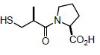
  - Drug was designed using venom as inspiration
    - Small compared to venom, sulfur molecule (stink)

- Captopril was the first ACE inhibitor
  - Had annoying side effects
    - Cough& “Coppery” taste
    - They are not harmful, but they can lead people to not want to take their medication

- Enalapril had improved side effect profile: NO SULFUR
  - 100 X more potent than captopril: Smaller doses required
  - No “coppery” taste

- Another type of problem is congestive heart failure
  - The blood is not getting around your body often enough
  - you can see a swollen abdomen in men
  - You can have liquid pooling in areas of the body, especially feet with gravity

- Many causes of congestive heart failure:
  - Coronary heart disease
  - High blood pressure
  - Heart valve problems
  - Abnormal rhythms
  - Thyroid problems

- William Withering discovers a heart drug
  - He "discovered" that foxglove plant (Witch's bells) stimulates heart
  - This had been known in folklore for 100s of years
  - he was the first to document it and isolate the ingredient: Digitalis
    - Digitalis boosts heart function
- Plant extracts could be risky
  - Different plants produce different amounts of the drug: risk of overdose
  - Still used today
- Digitalis has narrow therapeutic window:
  - Gap between the effective dose and the dangerous dose
    - Aspirin: 325 mg in a pill vs. Digoxin: 0.25 mg in digoxin (less than a grain of sand)
60 aspirin to die vs. 1 pill to have the effect , two pills are harmful, 4 drugs - you die

- Digoxin has been misused
  - Digoxin at Hospital for Sick Children in Toronto: children die due to contaminated equipment
  - Charles Cullen kills over 40 people - used digoxin, insulin & others to kill people

- Dietary supplement
  - Coenzyme Q10 for congestive heart failure
  - Has been promoted to help prevent heart failure (not scientifically proven, no benefit)

Heart failure
- Heart not doing its job enough (swelling)
- Angina (pain)
  - Generally caused by impaired blood flow to the heart
  - Usually associated with other problems
- Nitroglycerin under tongue to treat angina found by mine workers
  - many blood vessels under our tongue (faster absorption)
  - acts as a vasodilator (allowing blood to get through helps stop the pain)
  - can also come as a nasal spray & a patch for slow dosing(so that it doesn’t metabolize quickly)
  - extreme vasodilation or extreme vasoconstriction is associated with headaches
  - Fear that Nitro is an explosive compound some people exploded from defribulator not proven

- Before Viagra there was nitro
- It worked for Erectile dysfunction: they were called impotent
- Health Canada warns against arginine for angina
  - Nitroglycerine and arginine make NO in the body
  - Clinical work shows no benefit to arginine
    - Need high dose of arginine for effect but a high dose induces an increased risk of heart attack
- Arterial blockages involved cholesterol (NOT blocking itself)
  - High blood cholesterol associated with heart attack (since the 1960s)
  - Framing Ham: Half of heart attack patients have normal cholesterol levels
      - Other half is due to high PA, smoking, etc.

- Cholesterol is found in all animal cells (unique to animal cells)
  - Not in fruits and vegetable
  - Necessary material, it’s a steroid (a structural material, gives cells a 3d shape)
- Where does our cholesterol come from?
  - Diet makes a very small contribution (our body dumps half of it, and its actually very hard for cholesterol to get through in our body)
    - Animal foods
  - Majority of our cholesterol is made in liver
    - Saturated fats DANGEROUS, cholesterol from food is not!!!

- Dietary sources of cholesterol (does not contribute to blood cholesterol)
  - Egg yolk 300 mg - led to marketing problem for egg farmers
  - Shrimp 181 mg, Crab 113 mg, Lobster 94 mg, Chicken 91 mg, Fish 74 mg

- Egg substitutes are available
- Omega-3 eggs are great for marketing
- Benefit: Omega-3 fatty acids (artificial) from fish reduce irregular heart beat
  - examined areas which ate large amounts of fish (like Inuit’s with high fat diet)
  - Feed Chicken with fish meal - the omega 3 fatty acids end up in the eggs
    - Side effect: eggs tend to smell like fish
- Chickens are instead fed flax seed (omega-3) which does not work the same way
  - no benefit since it is a different molecule

- Buyer beware omega 3 fish oil supplements only two omega 3 benefit you:
  - Eicosapentaenoic acid
  - Docosahexanaeoic acid
  - Watch out for companies which don’t state this
  - Best source of omega-3 fatty acids is fish
    - rotate around with different fish, this will avoid intake of mercury

- Cholesterol made in the liver from saturated fat
  - Excess cholesterol is stored and builds up in arterial lining (walls) – plaque
    - very dangerous : can create bulges & blockages
  - Cholesterol in the plaque becomes oxidized: as the blood flows past the arteries, the oxygen fuses to the cholesterol and creating an oxidation reaction giving a product named cholestenone
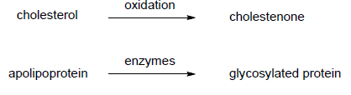
- Antioxidant supplements provide no benefit
  - Usually the effect of antioxidant in a living person are not beneficial
  - But foods containing antioxidants are lower in fat, healthier in diet
  - A lot of advertisement for antioxidant

- Oxidized cholesterol attracts macrophages
- Macrophages consume cholesterol becoming foam cells
- Inflammation causes plaques to burst: creating a tear
- Blood clots that form over the burst plaque

- C-reactive protein signals an increased risk: high cholesterol, danger of having a blood clot form
- Very high level of CRP from bacterial infections : you don’t want CRPs within blood stream
  - Not strongly affected by viral or fungal infections
- Cholesterol is made in the liver: we require a balanced dose
  - cholesterol is about as soluble as sand - does not dissolve in water
- Body uses lipoprotein to transport cholesterol, there are two types of lipoproteins:
  - Low density lipoprotein LDL (bad cholesterol)
    - Transports from the liver to the rest of the body
    - It stimulates the creation of more & Excess LDL is stored
    - The problem is storage location (artery wall)
  - High density lipoprotein HDL (good cholesterol)
- LDL protein transports from body to liver
- LDL protein deposits cholesterol at LDL receptors
  - The excess LDL is stored in arteriole lining when cells are full
- HDL protein transports from body to liver
  - Liver disposes/recycles it after it is brought back

- Total blood cholesterol is important
  - Not enough or too much is dangerous

LDL/HDL Ratio:  Total blood cholesterol (mmol/L)  • <5.2 normal  • 5.2 – 6.2 borderline  • >6.2 high  Low risk <3  High risk >5  - look for about 5:1 ratio | LDL  Low density lipoprotein-bad  • <3.4 normal  • 3.4 – 4.1 borderline  • >4.1 high  Lower numbers: cholesterol is being transported away from the arteries | HDL blood levels (mmol/L)  High density lipoprotein  • <1.0 not good  • >1.56 good

- Lipids contain long carbon chains
- Fats (animals) & Oils (plants) are Required in our diet
  - Energy source
  - Cell membranes
  - Steroids and hormones

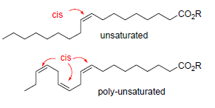
- Fats come from animals - solids
  - Solids contain saturated or mono-unsaturated fatty acid esters
  - Cis bonds have a 30 degree angle

- Oils come from plants - liquid
- Contain unsaturated and poly-unsaturated (several double-bonded) fatty esters
  - Each double bond is unsaturated
- Hydrogenation of oils for texture
  - Convert oils (liquids) to fats (solids)
    - People prefer to eat creamy solids (mouth feel--oily and fatty)
    - Oils with lots of double bonds (oxidation) become rancid easily
    - Partial Hydrogenation gives the best texture
      - with cheap oils to eliminate some double bonds for a cis/trans mixture

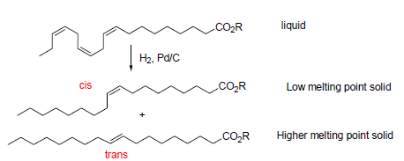
- Trans fat double bonds
  - flips the cis double bond to trans bond: provides creaminess
  - Trans fats for more than 100 years (8gs of trans fat a day)
    - Provides right mouth feel for processed foods
      - Partially hydrogenated
      - Processed foods (margarine, junk food)

- Trans fats alter the LDL/HDL ratio
  - Body makes too much LDL
  - Body does not make enough HDL
  - Trans fat is ‘’easy’’ to avoid

- Akira Endo discovers first statins
  - Allow you to control amounts of cholesterol in your body
  - Family compound called "statins" Found in fungus

  - Statins block cholesterol biosynthesis from fat
    - Block HMG-CoA reductase
  - Lovostatin from Aspergillus terrus was the first statin drug

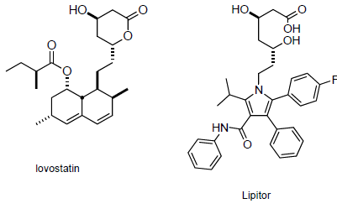
- Doctors initially afraid to prescribe statins
  - afraid of lowering cholesterol too much, and unknown side effects
    - thought it would cause heart attacks

- To counter this: A Four-S study of Simvastatin
  - Scandinavian Simvastatin Survival Study of 4444 patients
  - 35 % reduction in cholesterol
  - 42 % less likely to die of heart attack
  - Non-heart related deaths at normal rates
  - Sales of all statin drugs rose

- Bruce Roth makes Lipitor in 1985
Same effects/no better as lovastatin: But FDA wants every new drug to be better

- Other problem: Lipitor would be the fourth statin drug reaching the market
  - 5 is maximum and top three make the most money
- • Lovostatin (Merck) • Simvastatin (Merck) • Pravastatin (Sankyo)

- They wanted to convince the board in order to allow them to go into clinical trials- Roger Newton
  - Clinical trial with 24 company employees: 38 % drop in cholesterol at 10 mg
  - Lipitor was better at 10 mg than the next drug at 20 mg

- Pfizer gambles with the dose
  - Most statins given at 20 mg
  - Lipitor was more effective at 10 mg (and safer due to a lower dose)
    - Was still safe at 80mg
    - The 10 mg dose has a larger molecules
    - mgs are actually irrelevant from a safety point of view, but doctors work in mgs

- Pfizer convinces FDA to fast track approval
- Lipitor on market by directing it toward Orphan drug (rare diseases): Familial hypercholesterolemia
  - Produces access cholesterol
      - physically visible with bumps on knees, eyes : seen on Mona Lisa
- Lipitor became the #1 drug in the world (Now off-patent)

- Statins lower heart attack risk by 36%
  - Crestor study: 100% reduction in heart attacks – which isn’t really true
    - Statin group: – 83 heart attacks in 8901 patients
    - Placebo group: – 157 heart attacks in 8901 patients
    - But – must give drug to 120 people to prevent 1 heart attack.. 290,000$

- 1.5 million heart attacks per year
  - 25 % die immediately
  - 25 % unaware (experience no symptoms whatsoever)
    - After the first hour, your chances decreases by an exponential amount
Street Drugs

- Humans have always used mind altering substances
  - Chemicals for religious purposes (all religions)

- Incensole acetate from Frankincense (a sense of awe, a feeling of significance, hallucinations, catholic)
- Hallucinogens in witchcraft (Ergotamine from ergot)
- Fermenting cow manure give of methane gas, this gets you high
- Solvents often abused in schools (white-out, paint thinner, perm. Markers)
- Nitrous oxide whipped cream

- Drugs are illegal because they are dangerous
  - Health: Adverse effects
  - Personal life
    - Employability (they aren't reliable)
    - Destruction of relationships and families : drug becomes all you care about
- Society
    - Health costs
    - Economic impact

- Drugs are dangerous because they are Illegal
  - Fines: 200$ AND MORE
  - Jail time (up to life) & Criminal record (limits employability/ travel)
  - Buyer beware
    - Street drugs are not pure substances/ can contain anything
- Secondary crime
    - Up to 75 % of property crime is drug related
    - Violent crime

- Marijuana
  - Most popular recreational drug in North America
  - Plant is easy to grow
    - U.S. Navy was a large legal grower for hemp rope, up until the 1960s (they switched to nylon)
- Buds with high THC (tetrahydrocannibanol) content are smoked
- Resin on the plant surface
  - Scraped off for ASH

- Marijuana brought to Europe by Napoleon, Marijuana brought to America by Mexican workers
- 1937: High crime in New Orleans @ shipping port associated with marijuana
  - politicians looked for a scapegoat for the crime
    - "The people who smoke marijuana are more likely to commit crimes"

- Marijuana Tax Act
  - They controlled this initially with the Tax Act : requiring a stamp (never given)
- Reefer madness and government exaggeration
  - Paid Hollywood to help with propaganda films, People going "drug crazy"
  - George Washington drinking wine - In later versions the artwork modified without the alcohol.
- Marijuana was very popular in the 1960’s: a mainstream thing
  - Use declined in late 1970’s: problems with soldiers of Vietnam, many came back addicted to drugs
    - Backlash against ALL illegal drugs. Led to a decline in the consumption.
- Active ingredient is THC
  - Produced by the plant as a poison - to protect itself from bugs, etc.
  - Effect is variable : a placebo effect associated with this material
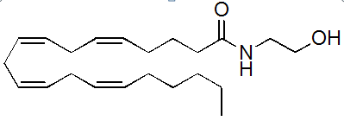
- THC is an anandamide agonist
  - thought that this creates a feeling of euphoria
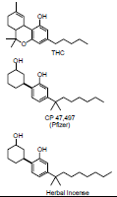
- Anandamide in THC impairs memory
  - the most severe side-effect in heavy users
- THC Slows reaction time - similar to drinking and driving

- Pharmaceutical grade THC made synthetically (orphan drug market)
  - not extracted from the plant, better to make sympathetically from oil
- THC used for AIDS related anorexia
  - Marinol (from marijuana): used to stimulate appetite

- Prescribed for glaucoma
- Sativex for multiple sclerosis : pill or nasal spray
  - Control/reduce muscle spasms
- Medical benefits are questionable
  - Very strong placebo effect with pain relief
- 1.5 million users in Canada • 600,000 criminal records
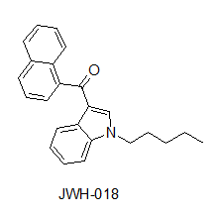
- Penalties for marijuana: Fines for less than 15 g, Criminal charge above 15 g, Crim. record, prison

- “Fake” pot in herbal incense: now illegal
  - Leaves spiked with synthetic analgesics (Pfizer, herbal incense)
  - Leaves spiked with synthetic cannabinoids
    - JWH-018 is more potent (5x more active than THC)

- Cocaine used as a stimulant for centuries
  - used in the same way as coffee
  - Coke: probably contained cocaine
- Stepan Chemical in New Jersey
  - legally licenced to transport cocaine
  - de-cocaine the leaves
  - extract is used in pharmaceuticals

- Cocaine in patent medicines : like shampoo
  - cocaine is soluble in alcohol - mariani: Coca-cola is the non-alcoholic version of this beverage

- Harrison Tax Act 1914 (similar to that of marijuana)
  - Available for doctor
  - Taxed for transport

- Apparent that cocaine had harmful properties
  - Costs outweigh benefits
  - Only doctors could still prescribe cocaine

- Pharmaceutical grade cocaine in surgery
  - Topical anesthetics designed from cocaine : Benzococaine
  - stops bleeding
  - Dental anesthetics inspired by cocaine: Novocaine
- Most cocaine today is illegal
  - Cocaine manufactures in a pit - uses lime or sulfuric acid, someone walks around in the pit

- Snorting cocaine hydrochloride
  - second word, hydrochloride, is a stabilizer
    - soluble in water
- Cocaine gets around: most money (bills) in North America have traces of cocaine on them

- Cocaine addiction is very strong: Animals & Humans prefer cocaine to food or sex
  - No tolerance
  - No physical withdrawal
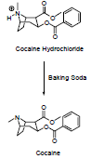
  - Very strong psychological effect
  - Cocaine is the most unsatisfying drug
    - effect wears of quickly
    - a few seconds after taking it, you want more

- Freebased cocaine forms cracks
  - before you had to be rich to support the habit
  - freebase makes it cheaper (2$ dose of crack does the same is 100/200$ dose of cocaine)
  - mix it with a base (baking soda) to become insoluble to water and dry out
  - Crack requires lower dose than hydrochloride
- Crack is usually smoked
  - heat it as the end of a tube, inhale the vaporized crack
  - Instant rush creates a strong psychological connection

- Cocaine prevents dopamine reuptake: excess joy
  - Dopamine reinforces behaviour which helps you survive (i.e. you feel good after you eat)

- Side effects of cocaine
  - Seizures
  - Psychiatric disturbances Coke bugs
  - Stroke & Cardiac arrhythmia
  - Death
- Other effects of illegal cocaine: psychological dependence

- Amphetamines discovered by Gordon Alles
  - Amphetamine (methamphetamine) use in World War II
- First amphetamines abuse in military prison where prisoners altered the dose
  - Low doses cold medication fight or flight for vasoconstriction
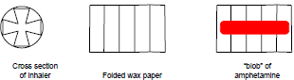
  - high: dopamine release, euphoria
- Got the substance in cold medication
  - Benzedrine inhaler contained 250 mg

- A blob of amphetamine in each gap of the cross section
  - take the cross section paper out & put it into a glass of coca cola TO EXTRACT IT
  - stories that guards would make a lot of money selling cold medications, not knowing why

- Amphetamines used to treat depression
  - tablets would give higher dose of material
  - prescribed to a lot of people in 1950s

- Amphetamines prescribed to the rich and famous: Andy Warhol, JFK
- Max Jacobson (doctor feel-good) was JFK’s doctor
  - prescribed crystal meth for John F Kennedy

- Amphetamine psychosis (speed freaks) led to a decline in use in the 1960s due to the side effects:
  - Stereotypy
    - Repetitive behaviors
  - Formication
    - Feeling of bugs under the skin
  - Extreme aggression
  - Auditory and visual hallucinations
    - Appearance of schizophenia
  - Paranoid psychosis:
    - Users accumulate weapons
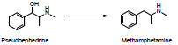
- Methamphetamine makes a comeback in 1990’s
  - Also known as "ice"
- Pseudoephedrine to make methamphetamine
- Chemical companies supplied underground Trade
  - Used for cold medications, never realized it was used for anything else
  - Half worldwide was shipped for underground use
  - Now you need special permits, registration, identification

- Smurfing provided the raw material
  - Drug users just switched the source
    - Clear out Sudafed: drug stores couldn't keep it in stock

- Pseudoephedrine replaced with phenylephrine (not as good)

- Methamphetamine is a potent vasoconstrictor
  - high doses over a long period of time starved the tissues in your face
  - "Meth teeth" - teeth rot in their mouth, "meth face" known as narcosis - tissue in the face is dying
  - High dependence
Opiates
- Derived from poppy latex
- Opium consumed in ancient China @ beginning of recorded history
  - strong pain killer, induces sleep, euphoria, cough remedy

- Opium found in laudanum & patented
  - Legal up until about 1914

- Opium was used in patent medicine
  - for children teething, cough medicine
  - most of the time they just added it for the euphoric effect
- Side effect: induces sleepiness: Morphine in opium named for Morpheus, God of Sleep

- Hypodermic syringe invented in 1856 (increased use)
- Morphine use became common after Civil war: to control pain & created addicts

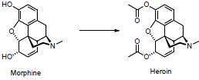
- Bayer company converted morphine to heroin
  - Use less (not), therefore less addictive..
  - Heroin was in fact way more addictive than morphine
  - Heroin was sold as a non-addictive cough suppressant

- Harrison Narcotic Act 1914
  - same act that made cocaine illegal
  - Heroin is usually injected: - damages the veins, they collapse creating black veins

- Today morphine is used for legitimate purposed
- Codeine is the most common medicinal opiate
- Tylenol 3 & Vikaden: have acetaminophen and codeine
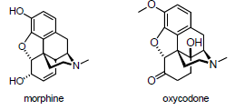
- Oxycodone first marketed in 1939
  - Made from a waste product from opium known as thebaine – 40%
- Oxycontin is Hillbilly Heroin
  - Less dangerous than heroin
  - The most stolen pharmaceutical drug
  - Using the drug recreationally
    - this is a heavily prescribed medication
- Opiates depress the central nervous system (morphine/morpheus)
  - Analgesia • Drowsiness • Apathy • Lethargy • Unconsciousness

- Opiates depress bodily functions
  - Cough reflex • Respiration • Peristalsis (digestion) • Endocrine secretion

- Opiates produce a strong physical addiction
  - Tolerance • Dependence • Withdrawal (about a week to get off the drug)

- “Retail” market in heroin is $12 billion
  - high dollar value & crime rate associated with this drug
  - DEA estimates 75 % of property crime is drug related
  - • Hospital costs • Prison costs • Enforcement costs • Rehabilitation costs
- Opium receptor binds to endorphins
  - Endorphin are small proteins made by the body
    - Natural painkillers for severe wounds
      - Placebo effects

- Opiates are important painkillers
- Many doctors are becoming afraid to prescribe opiates to people in terminal condition
  - Fear of liability, don't want them to become addicted

Hallucinogens
- Hallucinations have always been popular (rec, religious)
- Many hallucinogens mimic serotonin
  - Used in primitive parts of your brain
    - At the end of the spinal cord (lower functions)

- Magic mushrooms contain psilocybin
- Cane toads provide bufotenine
  - Protective poison from the toad (when its frightened)
- PCP in Angel Dust
  - Powerful hallucinogen
  - Dangerous : psychotic, hyper strong, violent
  - Introduced in 60s as a tranquilizer, still used as an animal tranquilizer
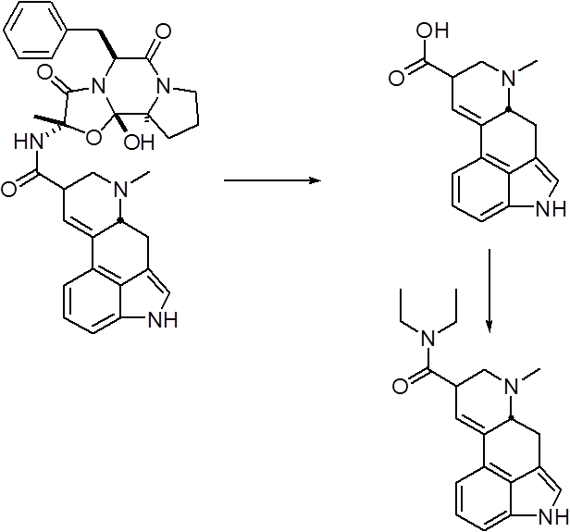
- Ergotamine from ergot
  - Generally not consumed deliberately: accidental poisoning
    - St Anthony’s fire
- Ergot in witchcraft
- Ergotamine can be converted to lysergic acid (LSD)
  - Drug attempt to use ergotamine for drug purposes

- Albert Hoffman discovers LSD by accident
  - experimenting to be used for psychiatric conditions
  - licked his fingers, experienced a hallucination
  - bicycle day first bad trip
- LSD was used by the CIA at McGill in 1950’s
  - used for psychiatric therapies
  - MK-ultra: psychological warfare
    - Causing suicides/ flashbacks from dependence
- LSD hallucinations have religious significance
  - sense of awe you are connected to the universe
  - has a religious effect, believe to talk with God

- Timothy Leary at Harvard
  - "prophet" , psych prof at Harvard: “Tune in turn on and drop out”
  - LSD hallucinations often involve a sensation of flying
  - people will jump off of buildings
  - going blind from staring at the sun

- “The End” on 10,000 mikes (of LSD)
  - Jim Morrison of the Doors - dose of LSD 10 micrograms

- Atropine from the deadly nightshade (plant) /belladonna
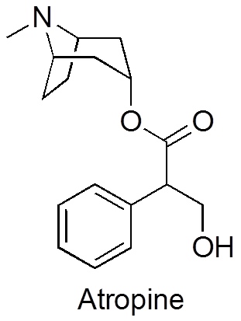
  - toxic material
  - had been used as a beauty feature in ancient cultures: dilates their pupils (large)

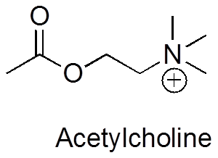
- Atropine is an acetylcholine antagonist
  - Acetylcholine transmits nerve signals in brain
  - Atropine often used in surgery to shut down digestive system
    - Restarts the gastric systems after surgery

- Related material: Hyoscine is also called scopolamine
  - Scopolamine in truth serum ; a hypnotic: really they just say random garbage

- Atropine and Hyoscine in witchcraft
  - hallucinations with strong sensation of flying

- Chemical properties: Atropine and Hyoscine are not water soluble
  - Best trans-dermal absorption through mucus membranes
- Original narcotic laws were very specific
  - very strict, legal materials used for medicinal purpose
- 1970s : Designer drugs provided a way around the law
  - Existing drugs were the starting point
- Original practitioners were chemists
  - required specialized knowledge
    - figure out what the drug companies knew
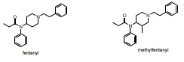
    - suspected that it was graduate students at universities

- Fentanyl is an industrial strength pain killer taken before surgery
- Methylfentanyl was initially legal

- Profit margins on designer drugs were enormous
  - 200 g of heroin worth $1 million
  - 200 g of methylfentanyl worth $1 billion (1000x more potent, and legal)
    - Addicts often died from overdose
    - China white (synthetic), heroin is usually brown

- Methylfentanyl is a chemical warfare agent
  - Kolokol-1 (gas): used by special forces in Russia

- Used at the Moscow theater hostage crisis
  - separatists took hostages in a theatre
  - some hostages killed by methylfentanyl
- Easy to overdose on fentanyl

- Gordon Alles takes the first Ecstasy trip
  - Originally tested as an appetite depressant

- “SKF-5” tested in the 1950’s for psychotic depression - unsuccessful

- MDMA was a mild hallucinogen (associated with amphetamines)
  - Amphetamine family – Did not stimulate fight or flight
  - Hallucinogenic effects had no religious significance : You feel disconnected from your body
    - Tend to relax user (empathy)
- MDMA was tested by the military
- Users rave on Ecstasy
  - Makes you more social by impairing judgement
  - Auditory hallucination
  - Increases sexuality

- Made illegal in 1988
  - Euphoria • Empathy • Reduced inhibitions • Auditory hallucinations • Sexuality
  - Hyperthermia: interferes with body temperature regulation
    - Liver, kidney, heart failure
    - Death
  - Loss of appetite • Dehydration • Depression • Lack of Judgment

- Ecstasy is made in under-ground labs
  - ecstasy tabs are usually not very pure
    - Metallic Mercury as a biproduct (manufactured on the street)
    - Ecstasy tabs contain heavy metals
    - Can find mercury, arsenic (can be 1% of the weight of the ecstasy tab)
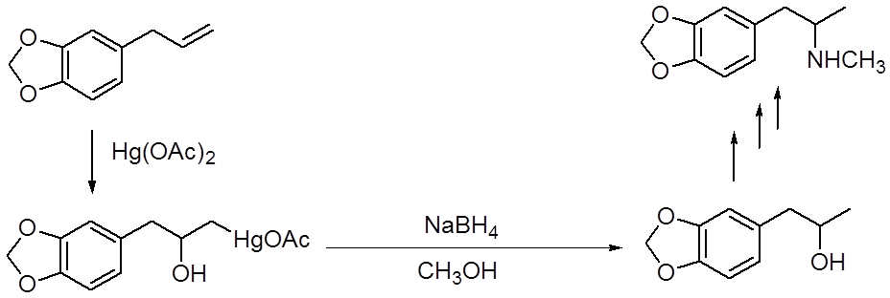
- Additives to Ecstasy tabs
  - Methylenedioxyamphetamine,
  - Paramethoxyamphetamine
    - Neurotoxic
    - PMMA is 5-6x more dangerous
  - Dextromethorphan
    - Effects similar to PCP at high doses
  - Ketamine
    - Veterinary anesthetic (effects similar to PCP)
  - GHB : erase memory
    - “Date-Rape” drug
  - Methamphetamine : an extremely addictive substance

- With confiscated ecstasy tabs, they found they aren’t ecstasy tabs
  - Usually substituted for methamphetamine
- Ecstasy is a predatory drug
- they tend to increase feelings of sexuality, they impair judgement, and erase material
  - Ecstasy
  - GHB (also called the date rape drug, sex slavery, serial killings) impairs memory
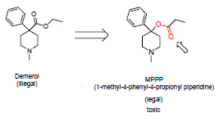
  - Ketamine
  - Rohypnol

- Khat contains cathionine : leaves chewed
  - Like caffeine in low doses
  - Stimulant in high doses by dopamine release
    - Hallucinogen, increased aggression and confidence
  - Afternoon the soldiers are too aggressive
  - Synthetic versions tested as appetite suppressants
  - Side effects were too dangerous
    - Extreme dehydration
    - Massive weight loss
    - Highly addictive
    - Hallucinations
    - Psychosis
      - Paranoia and extreme violence

  - Synthetic cathionines were legal until recently when recreation use started in 2002
    - Crystals are large and salt like (bath salts)
    - High doses cause violent psychosis and are blamed for violent killings
    - Hard to identify fingerprints since new versions are constantly produced
- Demerol is a systemic painkiller (MJ)
- Designer version of the real drug (MPPP)
  - attempt to make legal version of drug in 1980s
  - also a toxic material
    - Couldn’t use animals for Parkinson research but now had

- Lead to case of the "frozen addicts" 1991
  - they lost the ability to move - program called "Nova"
    - became paralyzed in 24 hours all from the same batch
    - affected part of the brain for movement – irreversible !

- Sloppy chemistry was the culprit, HCL build-up creating MPTP which destroyed brain tissue
  - Couldn’t use animals for Parkinson research but now had patients which helped produce the Parkinson treatments we have to this day
  - Partial reprieve with L-DOPA

- Laws were changed to restrict designer drugs
  - Controlled similar chemical structures by limiting access to original drug

- The ethics of smart drugs
  - Caffeine and nicotine are stimulants
  - Iodine very important for brain, in salt
    - If not in salt, causes impairment
    - 10-15 IQ compared to non-iodine countries
  - Ephedra cold med./ no prescription close to methamphetamine
  - Piracetam to improve cognitive function
  - Some drugs improve cognitive function
    - Alzheimer’s
    - Demetia
    - Aphasia
    - Schizophrenia
  - Small improvement for sleep deprived
    - Drugs for narcolepsy kept you awake, all nighter not good
  - Amphetamines improve concentration
  - NO for : Omega 3 (stabilises heart ) ; B vitamins ; Gingo
  - Ritalin improves behaviour in ADHD
- Benefits are highly questionable
  - they affect dopamine which is a parabola and has a maximum amount
  - not sure if you need more or less dopamine and don’t know how much
  - If effects exist they are small or if memory goes up, concentration goes down to equilibrate
- Counterfeit more $ sold than illicit
  - 1% of U.S
  - Developing countries have 50-60% counterfeit
- Drugs are illegal because they are dangerous
  - Health
    - Adverse effects so Buyer beware
  - Personal life
    - Destruction of relationships and families
  - Society
    - Health costs and secondary economic impact
- Drugs are dangerous because they are Illegal
  - Fines
  - Jail time
    - New mandatory minimum sentences
  - Criminal record
    - Limits employment opportunities/travel
  - Criminal lifestyle
Nutraceuticals

  - Modern migration towards herbal remedies
    - Regulated as foods
      - no inspection or testing
  - Organic products are becoming popular
No additives No synthetic pesticides No synthetic fertilizer No genetically modified organisms
    - Have some rules
    - natural pesticides

  - No regulation of the term "natural"
  - Herbal remedies is kind of like the patent agency
    - 40% of the population
    - $20 billion business
    - mass produced
      - popular ones are mass cultivated
      - often used pesticides
    - Herbal industry has very few rules

- Modern Drugs are standardized unlike herbal remedies
  - purified substances with consistent doses
  - herbal are variable depending on the plant
Which omega-3 is in your fish oil?
Eicosapentaenoic acid
Docosahexaenoic acid
Testing is limited or nonexistent
- Safety & efficacy is based on “past history”
- Adverse event reporting not required
- efficacy is based on previous reports which are:
i. Doctrine of signatures ii. Doctrine of humors….iii. Anecdotal evidence
- Quality of science is highly variable: ‘immune system support’

Echinacea has been sold for 200 years and is the most popular herbal today: Purple flower
  - Often used to treat cold "immune system support"
  - Original patent medicines – native recipe (snake oil)
  - Snake oil: doctrine of signatures: snake oil allows spines to be flexible: this will lubricate joints
  - Not effective for cold but can give you a rash
  - Advertised as a native recipe

  - Cold-FX most popular cold remedy
  - Clinical studies are low quality
    - Combined different experiments which had different protocols to hand pick to have ‘results’

- Ginseng in cold-fX
  - Ginseng root resembles a human body (doctrine of signatures)

- Ginko biloba contains ginkolides
  - increases circulation in the brain (HOW MUCH?): claims that it improves memory
  - interferes with blood clotting
  - Testing proved no increase in memory capacity, circulation doesn’t mean memory

- Saw palmento for benign prostate hyperplasia
  - no difference between saw palmento and placebo groups
  - label is carefully written

- Garlic used by Egyptians to improve strength
  - Adolphus Hohensee and garlic cleansing
    - clove of garlic inserted into rectum - absorbed into the body (mucus membrane)
    - smell of breath: visible effect (like citric acid and alkaselter) of toxins coming out
- Allicin thought to affect cholesterol
  - Garlic uses allicin for protection
  - Allicin is unstable - gas exchange in lungs so your breath smells not mouth!!
    - Fresh garlic contains the most allin, Supplements contain variable amounts.
- Garlic does not reduce cholesterol

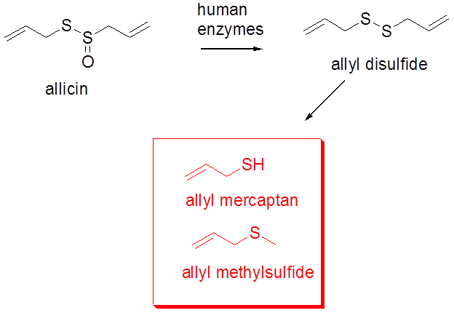
- St .Johns Wort is a popular supplement
  - Taken for depression, doesn’t help severe only mild
  - positive mental outlook (can't say depression or it’s a drug)

  - Herbal remedies are regulated as foods
- Even though a clinical trial does something, it doesn’t mean anything
i.e. You could do it with two patients, and its published
Look for high quality science: High quality: placebo, double blinds, many patients

- Labels are very carefully written
  - careful to not claim a specific therapeutic use
  - No efficacy testing is required (could be any plant, any claim: no rules)

- Many clinical trials with herbals are poorly done
  - • No placebo is used • Small groups of subjects • High attrition rates (people drop out)
  - Publication biases: nobody publishes negative results BUT positives are written up, published and increase quality
  - Small studies are an easy way to get positive results

- Many natural supplements do not contain active ingredient
  - Can sell the same material several times: i.e. Decaffinated tea i.e. tea leaves, extract, caffeine
    - the plant: extract something from it
    - the extract: remove the active substance
    - the active substance: 60-70% an herbal remedy does not contain the active ingredient

- Purity of natural supplements is questionable
  - Pesticide residues
  - Heavy metals
  - Undeclared pharmaceutical: Prescription drugs added to produce effects (Viagra)
- Natural materials can interact with pharmaceuticals (tell your doctor)
- Ginkoba interferes with anticoagulants (coagulation)

- St. John’s Wort induces liver enzymes
  - Increased liver function prevents absorption which protects against foreign substances
    - Increased liver function prevents drug absorption
    - Can affect up to 50% of all medications (i.e. Tylenol)
- Other examples: Grapefruit inhibits liver function (no filtration)
  - Decreased liver function can produce drug overdose
- Kava Kava for a feeling of well-being (supposed to be chewed by a virgin)
  - Kevalactones can damage the liver
  - Kava removed from the market in 2002 - outlawed in US, risks > benefits
  - Still available “under the counter” (70%):
    - The sales staff recommended the product as an antidepressant or anxiety

- Weight loss drugs do not burn fat
  - Appetite suppressants & slow down metabolism
    - They are all amphetamines
    - When they stop losing weight they take more drug, over-stimulating the heart
  - Sympathetic nervous system supresses digestion since para is responsible for digestion
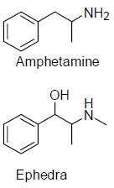
  - Easy to lose ten pounds, but after need exercise

- Ephedra is an amphetamine
  - 15,000 complaints
  - • Heart attacks • Strokes • Seizures • Deaths

- Ephedra was banned in U.S. in 2003
  - However it is still available under the counter
  - Fines are nothing compared to $ made

- Some people use bitter orange instead
  - Bitter orange contains amphetamine-like compounds
  - Health Canada warns against bitter orange

- Scientific discoveries are often twisted
i.e. Radithor: radiation kills cancer cells

- Cartilage: Glucosamine does not improve joint function
  - marketed as joint support, body makes it anyways
  - Glucosamine and chondroitin sulfate alone or in combination did not reduce pain in osteoarthritis

- Dr. Henry K. Beecher and the Powerful Placebo 35.2 +/- 2.2%
    - 1955: quoted from the original paper: JAMA
  - Placebo use in clinical trials is important
  - Can be difficult to create placebos for things like acupunture or leeches

- Comparisons of different placebos is interesting:
  - The color of the pills is important: pink (previous notes had yellow) works better than other colours
  - Bitter pills work better than sweet : people believe if it taste bad it works better
  - Capsules work better than tablets
  - Injected placebos work better than pills: belief that the drug is more heavy duty
  - Expensive fake medicine more effective than cheap fake medicine: 2$ pills vs 10cent pills
- However, Placebo enhancement is overrated
- Some drugs are so effective that placebos are not required like antibiotic
- Conditions that consistently report placebo effects: how do I feel?
  - Pain • Depression (30% different from 55’ paper but is wrong
  - High drop out from placebo some have side effects

- Plausibility is important
  - Supplement should contain substance with biological activity
    - Willow bark : Salicin - will reduce your headache and fever
    - There are many natural materials that can be used as drugs

- Coffee contains a drug that works
  - a natural drug that works: plausible

- What’s in an extract? There could be 1000's of materials in an extract
- St Johns wart does have hypericin but it can’t get into your brain to have an effect
- People who take herbals feel better since they expect to
  - Is ignorance really bliss?
    - They can be harmed since they are not getting the proper treatment
    - Sometimes remedies are toxic
- i.e. Almonds have cyanide: They would call it Vitamin B17 (no such thing)
  - sold as a safe treatment for cancer: actually kills faster
- Canada has introduced some rules (as opposed to U.S)
  - Natural health products directorate
    - • Products are standardized • Accurate labeling • Products properly manufactured
    - • Product is safe based on past history • Clinical trials have been done
- Clinical trials mean nothing
- Efficacy testing is not required
  - Herbals cannot be patented
  - Companies cannot afford clinical trials for efficacy
  - Adverse event reporting on honor system

- Government approval gives false impression that it is both safe and effective
  - Limited or no efficacy testing (not required)
    - Standards are “flexible”
  - Limited or no safety testing
    - “past experience”
  - No enforcement
    - No inspections
*FDA inspects drugs & facilities, and sometimes go to other countries
- Top 10 health frauds compiled by FDA
- Arthritis products: Copper bracelets, mega-vitamins, herbal remedies
- Cancer treatments: Laetrile, vitamins, minerals
- AIDS cures: Antibiotics, vaccines, herbal tea
- Weight loss: Amphetamines, vitamins, herbals
- Sexual aids: Aphrodesiacs, erectile dysfunction, male enhancement
- Baldness cures and Bust enlargers: Only minoxidil is approved for baldness
- Chelation therapy: EDTA, vitamins, minerals
- False nutritional schemes: Bee pollen, wheat germ capsules
- Muscle stimulators: Medical use only
- Candidiasis - fake cures for yeast infections

- Bloodletting was common in 1800 - painful, unpleasant
  - Samuel Hahnemann opposed bloodletting
- Hahnemann applied the doctrine of signatures: - developed serial dilutions for treatment
  - Thought that remedies became stronger when diluted
    - Idea that the water "magnifies" the drug
  - Succussion was thought to be important: shaken, not stirred
  - Final treatment contains only water
    - dilution is too extremes& all drug molecules have been removed

- Homeopathy is the ultimate placebo
  - still exists today - NO side effects: NO DRUG
  - Homeopaths place emphasis upon relationship: They make you feel special, makes you feel good
  - Appearance of the patient is important
  - Homeopath diagnosed with appearance
  - Dilution and the homeopathic effect (memory to water for response)

Sex & Drugs

Emotions result from chemical interactions
Formation and maintenance of relationships
• Attraction • Romantic love • Attachment
• Love • Pleasure • Sex • Addiction

Chemistry of attraction - pheromones
• Substance produced by an organism that elicits a specific unlearned response in another member of the same species
Female silkworm moth secretes bombykol
Male moth has specialized antennae engineered to detect bombykol

Pheromones are messenger molecules
Pheromones are used for pest control (Used to bait lures and traps)
• Relatively non-toxic (fragrance)
• Species specific
• Tiny amounts required
- Integrated pest management works better than traps and bait

Periplanone is the most potent pheromone known by cockroaches
• 75,000 virgin cockroaches to obtain 20 μg
• Detection threshold < 0.000001 μg
Used by CIA
Chiloglottis trapeziformis uses wasp pheromones
Male wasps: Flower pheromone is more attractive than female wasps

Ophrys exaltata (orchid) uses bee pheromones
- emits sex pheromones, used within species, used for their own purposes
- Mixture of chemicals: • (Z)-7-hexacosene • (Z)-7-pentacosene • (Z)-7-tricosene

Overlapping pheromones - Autographa californica…moth & elephants created in the females urine
Female dogs in heat secrete methyl paraben (not a pheromone)
A dog lysol: Sprays to mask your dog
Methyl paraben is a common preservative in make-up

Truffles grow underground near oak trees: Female pigs are used to find truffles
Truffles and boars produce androstenone: smelt by a female pig, thinks it’s a male pig
Androstenone is also present in human sweat
- Male sweat smell relaxes women: The effect is real but small

Andron - first perfume to use androstenone
- started in 1970's - scientifically engineered to attract the opposite sex
Now found in many perfums : Axe contains androstenone
* scientifically proven ingredient : attracts both sexes : but we don’t have the receptor

Skatole produced by intestinal bacteria (feces)
- in pure form is worse than feces
Skatole is also produced by oral bacteria
Flavor and fragrance industry makes large amounts
Skatole is called civetole in perfumes: Sounds like civet oil from civet cat worth 600$ a kilo (from anal glands)
Cheaper: civetole instead of civet oil, used for glamour
Difference between pleasant and unplesant
High concentrations: smells bad
Low concentrations: smell good
Skatole naturally present in flowers
- artificial flavour : present in ice cream, cigarettes, also in most jams and jellies

Musk is a very expensive substance $100,000 per Kg
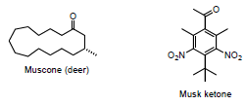
- Harvest anal glands - very expensive, often illegal to harvest

Synthetic musk is now used
Axe also contains musk ketone

Animals: olfactory epithelium & Vomeronasal organ
Do human pheromones exist?
- women who live together often have their menstrual cycle syncs
- They synchronise through the smell of sweat
- We don’t have vomeronasal organ to detect pheromones

Human attraction is primarily visual
- Chemical changes in the brain occur which lead to a chemical attraction
Phenethylamine released during romantic love increases dopamine levels (reward center)
• Effects similar to cocaine, tobacco and amphetamines • “feel-good” drugs

Phenylethylamine found in chocolate
Dietary PEA cannot enter the brain - this particular material cannot cross into the brain

Increased dopamine during early stages of love causes serotonin to decrease
Serotonin controls mood
• High levels = anxiety • Normal levels = balanced personality • Low levels = depression, Obsessive Compulsive

Long term attachment and bonding
- oxytocin (primates)(women) & vasopressin (men): long term bonds in mammals
-Mesotocin (birds, fish, reptiles)
- Isotocin (fish)

Oxytocin released during labour
Oxytocin released during lactation THESE ALL CREATE BONDS
Women release oxytocin and men release vasopressin during sex

Most mammals are not monogamous
-Prairie voles produce oxytocin and are monogamous
- Mountain voles do not produce much oxytocin and are promiscuous
Injecting oxytocin does not produce monogamy in mountain voles
Molecules associate at high concentration and dissociate at low concentration
• Mountain voles lack the receptors - become more friendly, but will not become monogamous

Are humans monogamous?
• Divorce • Adultery • Pornography • Polygamy

Aphrodisiacs from the doctrine of signatures (decoding nature)
Rhino horn is a phallic symbol - only one horn: same stuff as your fingernails
Aggressive animals have macho signature - looking for macho animals: different concoctions
Common stinkhorn is just a mushroom - plant, shape is like a male penis
Oysters served as aphrodisiac - resemble female genitalia
Get your goat boots on with horny goat weed
Chocolate: phenylephredrine… does not travel to the brain however
Testosterone increases sex drive in men and women
Cocaine may promote hypersexuality: increases confidence
Ecstasy reduces inhibitions and judgement…

The Spanish fly is a beetle - spanish fly on penis: strong irritant
- Crushed beetles used for bull breeding: makes them urinate, when continues to irritate, provokes sexual activity
Cantharidin (in spanish fly) is a dangerous irritant and not an aphrodisiac
Internet versions contain capsaicin.
Number 1 aphrodisiac: alcohol Side effect: Too much alcohol impairs performance

Yohimbine from Yohimbe is not an aphrodisiac but used as one
Sold under prescription as treatment for erectile disfunction
Drugs for erectile dysfuntion are not aphrodisiacs
Non-prescription yohimbine is dangerous
- herbal (lacks testing)
- some men who don’t have this problem cannot have this product
- erections for too long will constrict vessels, and impede blood circulation (priasprisme) causing nacrosis
Drugs for erectile dysfunction are not aphrodisiacs
Before 1980, erectile dysfunction was considered to be a psychological problem
• What is the biochemical basis? After 1980: there is a physical reason

Vasodilatation produces an erection
Nerve impulses block vasodilatation
- associated with both sympathetic and parasympathetic systems

Block the nerve signal to get an erection
• Giles Brindley at the 1982 meeting of the American Urological Association

Penile prosthesis semi-rigid rod
- inserted into the penis - effective - "permanent erection

Penile prosthesis inflatable chambers
Surgically implanted male enhancement, you need only pump your scrotum!
- you can feel prosthesis

Alprostadil was effective but sales were poor
- had to be injected directly into the penis
- it had a lasting effect: this is dangerous

Viagra was a drug in search of a disease: a program to inhibit a known enzyme in the body
• Safe • Rapidly entered the body • Inhibited a known enzyme • What is the disease?

Viagra was a failed blood pressure drug (hypertension): because it promotes vasodilation

Viagra was useless for angina (impaired blood flow to the heart)
- during the second clinical trials some healthy men got involuntary erections
- discovered to be a drug for impotence:
- Drug had been developed for hypertension
  - Failed
- Drug was tested in clinic for angina
  - Failed
- Side effect suggested use for impotence
  - Was this real?
- Before investing additional $$ company needed to verify the result

Biochemical basis:
Drugs which produce NO (nitrous oxide), produce erections
NO is a molecular messenger
- Healthy men produce enough NO to get erections
- Impotent men do not make enough NO
- Viagra blocks messenger recycling: blocks the PDE (phosphodiesterase) enzyme
Pilot study reported 83 % improvement with 1 dose
Is there a market for this material?
Market thought small since analysis showed 2% of men reported impotence (cultural reasons)
- patients lined up for clinical trials: can go as high as 40% (huge potential market)
How to conduct clinical trials?
Diaries were used. - control group, viagra group.
NOBODY returned Viagra - Patients in clinical trials begged to be kept on drug (first time this ever happened)

U.S. is a conservative country
- strong christian fundamentalist presence

Bob Dole was a stroke of marketing genius: helped destroy the social stigma
• Republican senator – conservative / christian fundamentalist
• War hero – Lost right arm in WWII
• Presidential candidate – 1996
Viagra changed the marketing of drugs
- before viagra, drugs were advertised to doctors only
- now they were being advertied to the people: they would go in to talk to their doctors

