Week 1: Chapter 1 Overview of marketing
- What is marketing?
  - Marketing is a set of business practices designed to plan for and present an organization’s products or services in ways that build effective customer relationships.
- Marketer’s Responsibilities
  - Marketers must address the ethical implications of their actions on society in general.
- Value
  - The fundamental purpose of marketing is to create value for both the firm and customer.
  - Value is in essence what you get for what you give up.
- Marketing’s 6 Core Aspects
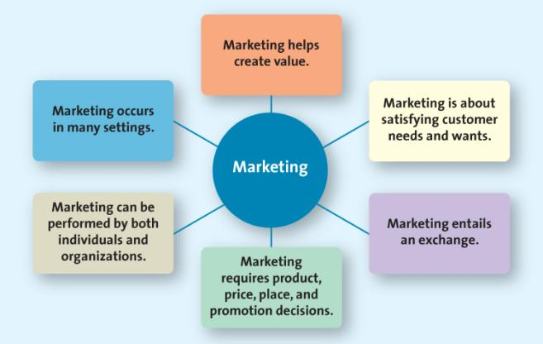

  - #1: Satisfying customer Needs and Wants
    - Begins with understanding their needs and wants
    - Developing products and service
  - #2: Marketing Entails Value Exchange
    - Exchange: the trade of things of value between the buyer and the seller so that each is better off as a result
    - The exchange can occur between any two parties
    - Not simply a buyer and seller exchanging money for a good or service
    - Can be an exchange of information for convenience

  - #3: Marketing Requires Product, Price, Place, and Promotion Decisions
    - Product
      - Goods
      - Services
      - Ideas
    - Price-Everything the buyer giver up in exchange for the product
      - Money
      - Time
      - Energy
    - Place: Marketing Channels Distribution Strategy
      - All activities necessary to get the product to the right customer when that customer wants is
      - Supply chain management is the field that examines these activities
    - Promotion
      - The communication activities of marketing
      - Used to inform, persuade and remind potential buyers
      - Used to influence their opinions or elicit a response
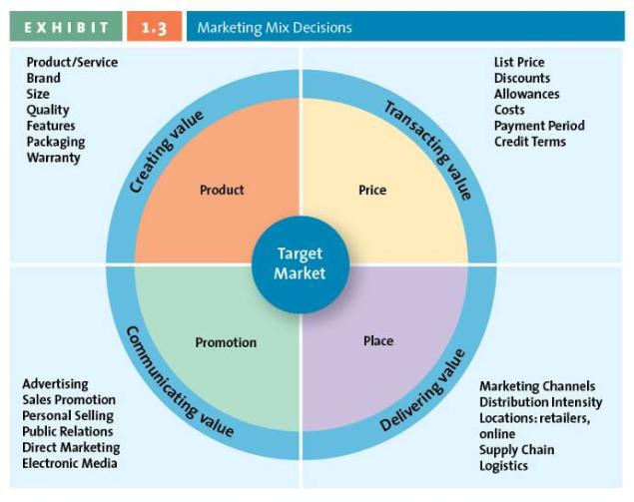
  - #4: Marketing Can Be Performed by Both Individuals and Organizations
    - B2B: Wholesaling is often only Business to Business
    - B2C: All retailing is Business to Consumer Selling
    - C2C: Swap Meets, EBay, yard sales
  - #5: Marketing Occurs in Many Settings
    - Both profit and non-profit entities
    - Developing economies
    - Entire industries
  - #6: Marketing Helps Create Value
    - Production-oriented era
      - Focus on developing and distributing innovative products with little concern about whether the products best satisfy customers’ needs
    - Sales-orientated era
      - Try to sell as many of their products as possible rather than focus on making products consumers really want
    - Market-orientated era
      - Focus on what consumers want and need before they design, make, or attempt to sell their products and services.
    - Value-based marking era
      - Firms must offer customer something is excess of that being offered by the competitors
      - Firms must understand how each aspect of their product/service create value for customer
      - The goal is to find the most desirable balance between providing benefits to customers and minimizing costs
- How Firms Compete on the Basis of Value
  - Constantly changing consumer perceptions
  - Firms must constantly monitor the marketplace in order to create value
- How Firms Become Value-Driven
  - Sharing information
    - Share information about customers and competitors that has been collected through customer relationship management, and integrate it across the firm’s various departments.
  - Balancing Benefits with Costs
    - Understand key benefits
    - Focus on key benefits
    - Eliminate cost of less strategic benefit
  - Building Relationships With Customers
    - Take a long term view of customer relationships
    - Use data to assist in maintaining the relationship
- Why is Marketing Important?
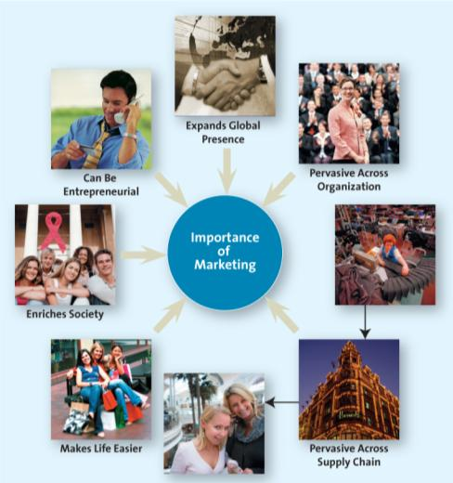

Week 2: Chapter 2 Developing a Marketing Plan and Marketing Strategies
- The Strategic Marketing Planning Process
  - Step 1: Defining the Business Mission and Objectives
    - A broad description of a firm’s objectives and the scope of activities it plans to undertake
      - What type of business are we in?
      - What do we need to do to accomplish our goals and objectives?
  - Step 2: Conduct a Situation Analysis Using SWOT 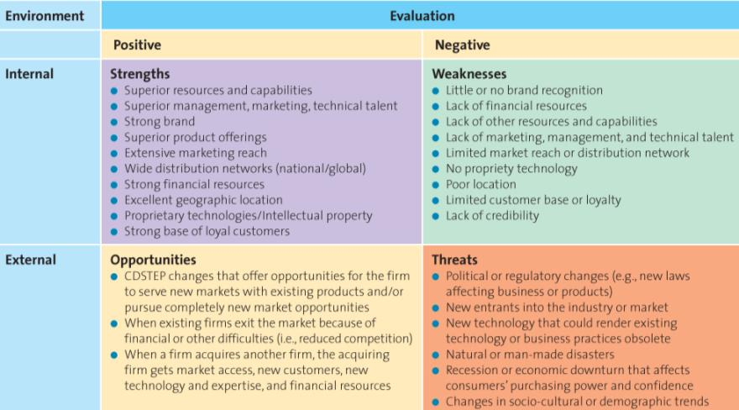
  - Step 3: Identifying and Evaluating Opportunities Using STP
    - Segmentation
      - The process of dividing the market into distinct groups of customers where each individual group has similar needs, wants, or characteristics -who therefore might appreciate products or services geared especially for them in similar ways
    - Targeting
      - The process of evaluating the attractiveness of various segments and then deciding which to pursue as a market
    - Positioning
      - Involves the process of defining the marketing mix variables so that target customers have a target customers have a clear, distinct, desirable understanding of what that product does or represents in comparison with competing products.
  - Step 4: Implement Marketing Mix and Allocate Resources
    - Product and Value Creation
      - Because the key to the success of any marketing program is the creation of value, firm attempt to develop products and services that customers perceive as valuable enough to buy
    - Price and Value for Money
      - Price should be based on the value the customer perceives
    - Place and Value Delivery
      - Product must be readily accessible
        - Direct Vs. Indirect
          - Manufacturer to Consumer
          - Manufacturer to Retailer to Consumer
          - Manufacturer to Wholesaler to Retailer to Consumer
        - Intensity
          - Intensive
          - Exclusive
          - Selective
    - Promotion and Value Communication
      - Television
      - Radio
      - Magazines
      - Sales force
      - New Media
  - Step 5: Evaluate Performance and Market Adjustments
      - The “BCG Matrix”
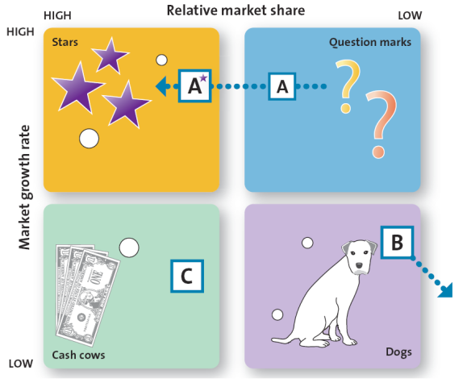

- Growth Strategies
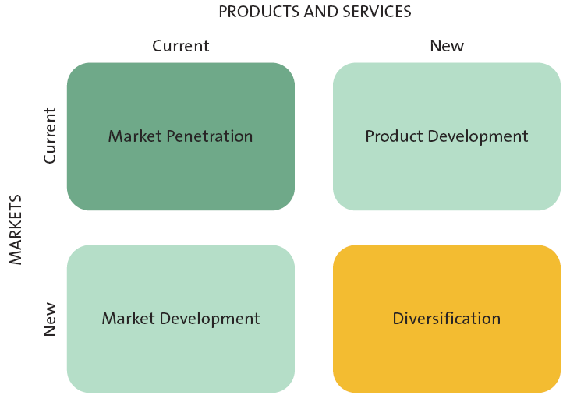
  - Market Penetration
    - Uses the existing marketing mix and focuses on existing customers
    - Encourage current customers to patronize the firm OR
    - Attract new customers from within the firm’s existing target market
  - Market Development
    - Employs the existing marketing offering to reach new market segments
  - Product Development
    - Offers a new product or service to the current target market
  - Diversification
    - Introduces a new product or service to a new market segment
- Sustainable Competitive Advantage
  - Something the firm can persistently do better than persistently do better than its competitors that is not easily copied and thus can be maintained over a long period of time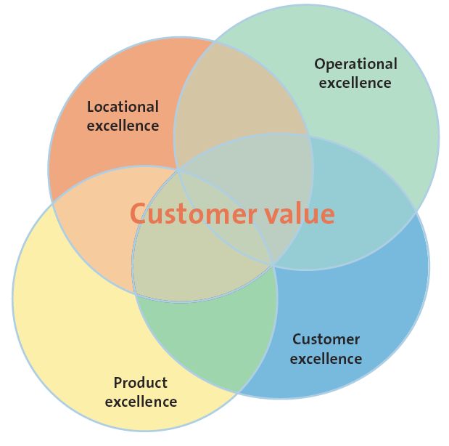
  - Customer Excellence
    - Retaining loyal customers
    - Customer service
  - Operational Excellence
    - Achieved through efficient operations and excellent supply chain and human resource management
  - Product Excellence
    - A strong brand
    - Unique positioning in the marketplace
    - High perceived value
  - Locational Excellence
    - The three most important things in retailing are location, location, and location.

Week 3: Chapter 3 Analyzing the Marketing Environment

- Analyzing the Marketing Environment
  - At the heart of the marketing environment is the consumer
  - Consumers are influenced by many things
    - Actions of the company
      - Pricing
      - Advertising
      - Ethics
      - Social responsibility
      - Depiction by the press
      - Quality assurance
    - Actions of the company’s competition
      - Pricing
      - Advertising
      - Ethics
      - Social responsibility
      - Depiction by the press
      - Quality assurance
    - Corporate partners in the supply chain
      - Quality
      - Reliability
      - Timelines
      - Conflict
      - Ethics
      - Social responsibility
      - Relationship with other partners

- A Marketing Environment Analysis Framework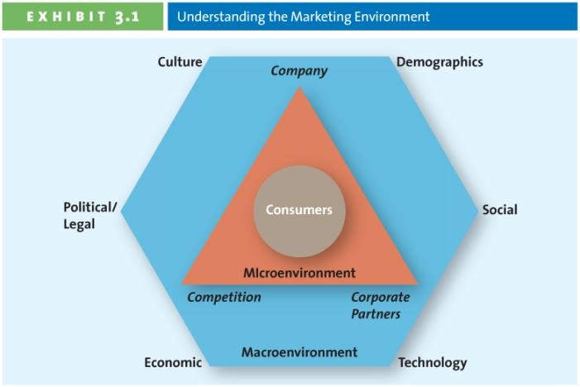

- Micro Environmental Factors
  - Successfully Leveraging Company Capabilities
    - Successful marketing firms focus their effects on satisfying customer needs that match their core competencies
    - Existing knowledge, facilities, patents, etc. applied to New markets, new products, etc.
  - Competitors
    - Identify and analyze direct and indirect competitors
    - Know strengths & weaknesses
    - Competitive intelligence (CI) is used by companies to collect and synthesize information with respect to their rivals
      - Sending an employee to a competitive store to check merchandise, prices, traffic
      - Other more sophisticated methods
  - Corporate Partners
    - Firms are part of alliances
    - Align with competitors, suppliers, etc.
    - Just in Time Delivery System (JIT)
    - From factory to Retailer
- Macro Environmental Factors
  - Culture
    - Culture, Country Culture, and Regional Culture
    - Shared meanings, beliefs, morals, values, and customers of a group of people
    - Transmitted by words, literature, and institutions; passed down from generation to generation and learned over time
  - Demographics – the characteristics of human populations and segments especially those used to identity consumer markets
    - Provides an easily understood snapshot of the typical consumer in a specific target market
    - Age Demographics: Generational Cohorts
      - Tweens
      - Gen Y
      - Gen X
      - Baby Boomers
      - Seniors
    - Income
      - Purchasing power is tied to income
        - Upper class
        - Middle Class
        - Working Class
        - Under Class
    - Education
      - Education is related to income, which determines spending power
    - Gender
      - Male/Female roles have been shifting
      - Marketing has changed to reflect these shifts
  - Social Trends
    - Green Consumers
      - Customers who appreciate the efforts of companies to supply them with environmentally friendly merchandise
    - Privacy Concerns
      - Loss of privacy
      - Identity theft
      - Do not call
      - Do not e-mail
    - Time- Poor Society
      - In the majority of families, most parents work
      - Consumers have many more choices regarding leisure time
      - Many consumers multitask
  - Technological Advances
    - Technology has impacted every aspect of marketing:
      - New products
      - New forms of communication
      - New retail channels
  - Economic Situation
    - Foreign currency fluctuations
    - Combined with inflation and interest rates affect a firm’s ability to market goods and services
  - Political/ Regulatory Environment
    - Competition Act
    - Consumer Packaging and Labeling Act
    - Food and Drugs Act
    - Access to information Act
    - Patent Act North American Free Trade Agreement (NAFTA)
- Marketing Research
  - Consists of a set of techniques and principles for systematically collecting, recoding, analyzing and interpreting data that can aid decision makers involved in marketing goods, services or ideas.
- The Marketing Research Process
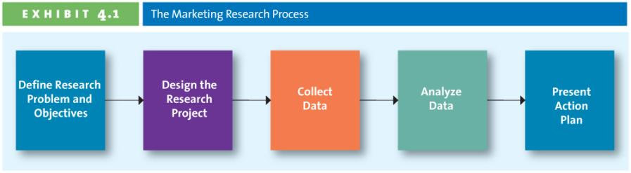
  - Step 1: Defining the objectives and research needs
  - Step 2: Designing the Research Project
    - Type of data
      - Advantages and Disadvantages of Secondary and Primary Data
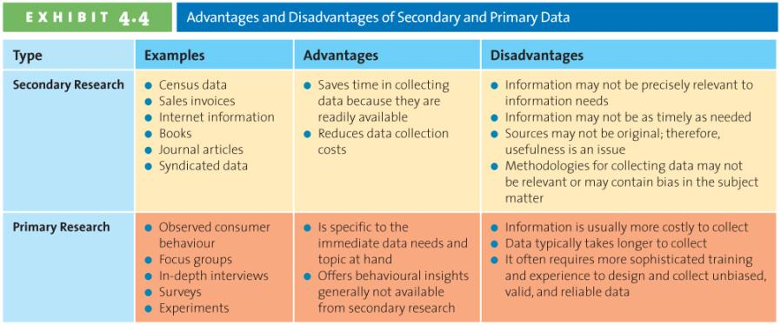
    - Type of research
      - Collecting Primary Data: Research Study must be Reliable and Valid
        - Reliability is the extent you will get the same result if the study is repeated under identical situations
        - Validity is the extent to which the study actually measure what it is supposed to measure
  - Step 3: Data Collection Methods
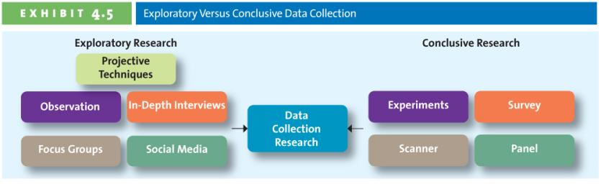
    - Exploratory Research Methods
      - Observation
      - In-depth interview
      - Focus Group
    - Conclusive Research Methods
      - Can be either: Descriptive or Experimental
    - Survey Research
      - What not to do when designing a questionnaire
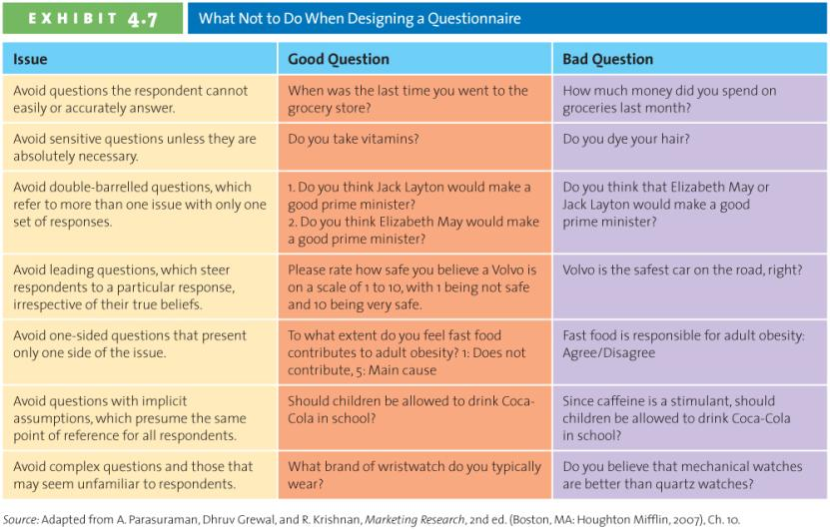
    - Web Surveying
      - Response rates are relatively high
      - Respondents may lie less
      - It is inexpensive
      - Results are processed are received quickly
    - Experimental Research
    - Scanner Research
    - Panel Research
  - Step 4: Analyzing Data
    - Converting data into information to explain, predict and/or evaluate a particular situation
  - Step 5: Presenting Results
    - Executive Summary
    - Body
    - Conclusions
    - Limitations
    - Supplements
      - Tables
      - Figures
      - Appendixes
- The Ethics of Using Customer Information
  - Bottom line: Marketing research should be used only to produce unbiased, factual information

Week 4: Chapter 4 Marketing Research

- The consumer Decision Process
  - Need Recognition
    - Functional needs
    - Psychological needs
  - Information Search
    - Internal Search for Information
      - A buyer’s own memory and knowledge about the product
    - External Search for Information
      - Information outside the buyer’s personal knowledge base:
        - Friends, family
        - Commercial media
        - Magazines
        - TV
        - Internet
        - Social media
    - Factors affecting Consumers’ search process
        - Perceived Benefits = Perceived Costs
        - Internal Locus of Control
        - External Locus of Control
        - Actual VS Perceived Risk
          - Performance Risk
          - Financial Risk
          - Social Risk
            - The fears that consumers suffer when they worry other might not regard their purchases positively
          - Physiological Risk
            - Refers to the fear of an actual harm should the product or perform properly
          - Psychological Risk
            - The risks associated with the way people will feel it the product does not convey right image.
          - Type of product or Service
  - Alternative Evaluation
    - Decision Heuristics
      - Price
      - Product Presentation
      - Brand
  - Purchase
  - Post-purchase Evaluation- Customer Satisfaction
    - Dissonance
      - Firm’s attempt to reduce dissonance by reinforcing the decision
      - Thank you letters, congratulation letters, quality ratings
- Factors Influencing the Consumer Decision Process
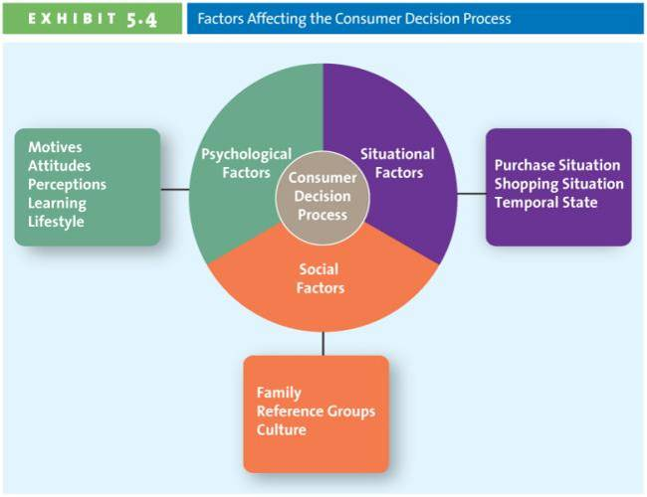
  - Psychological Factors:
    - Motives
    - Attitude
    - Learning
      - Affects both attitudes and perceptions
      - Affected by social experiences
    - Perception
    - The process by which we select, organize, and interpret information to form a meaningful picture of the world
  - Social Factors:
    - Family
      - Parents are the decision markers
      - Children are the influencers
    - Reference Groups
      - Groups: Family, Friends, Coworkers, Famous people
      - Provide: information, rewards, self-image
    - Culture
  - Situational Factors
    - Purchase Situation: Customers predisposed to purchase certain products or services because of some underlying psychological trait or social factor
    - Shopping
    - Store atmosphere Salespeople Crowding
- Involvement and Consumer Buying Decisions

- Week 6 Chapter 9 Product, Branding, and packaging Decisions
- Complexity of Products
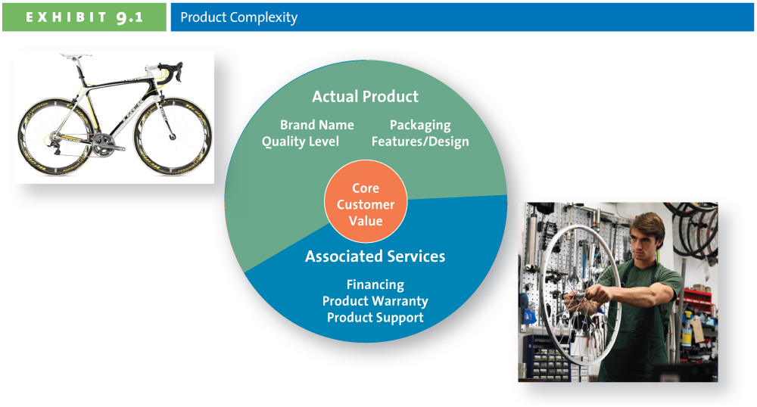
- Types of Products
  - Specialty Products/ Service
    - Products and service toward which customers show such a strong preference that they will expand considerable effort to search for the best supplies
  - Shopping Products/ Services
    - Products and services, such as furniture, apparel, fragrances, appliances, and travel alternatives, for which consumers will spend a fair amount of time comparing alternatives
  - Convenience Products/ Service
    - Products or services for which the consumer is not willing to spend any effort to evaluate prior purchase
  - Unsought Products/ Services
    - Products consumers either do not normally think of buying or do not know about
- Product Mix and Product Line Decisions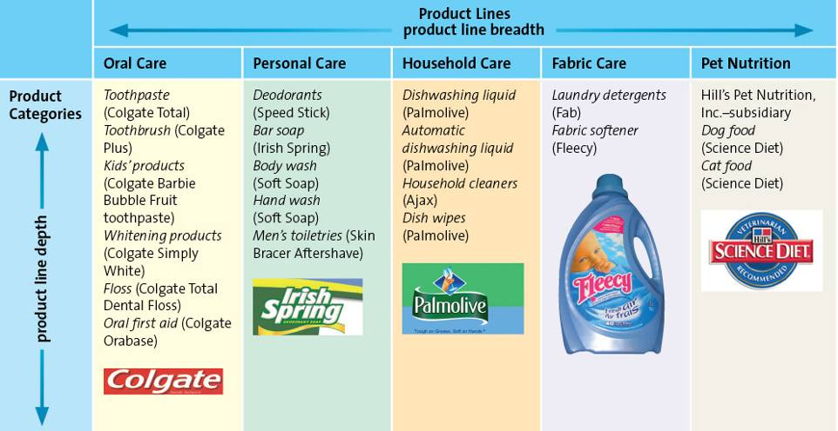
  - Breadth
    - Number of product lines
  - Depth
    - Number of categories within a product line
  - Change Product Mix Breadth
    - Increase Breadth
      - New product line
    - Decrease Breadth
      - Dropping a product line
  - Change Product Mix Depth
    - Increase Depth
      - Band-Aid now has over 40 products to heal cuts
    - Decrease Depth
      - McCormick spices eliminates dozens of products each year
- Branding
  - A company lives or dies based on brand awareness
  - A brand can use: Name, logo symbols, characters, slogans, ingles and even distinctive packages
  - Value of Branding for the Customer and the Marketer
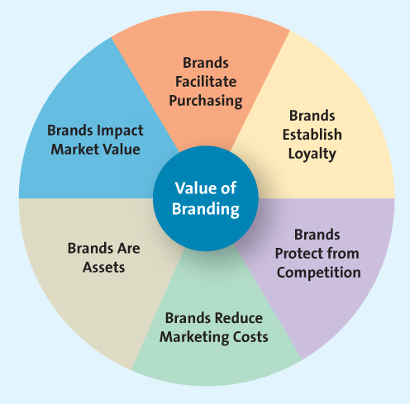
- Brand Equity: Awareness
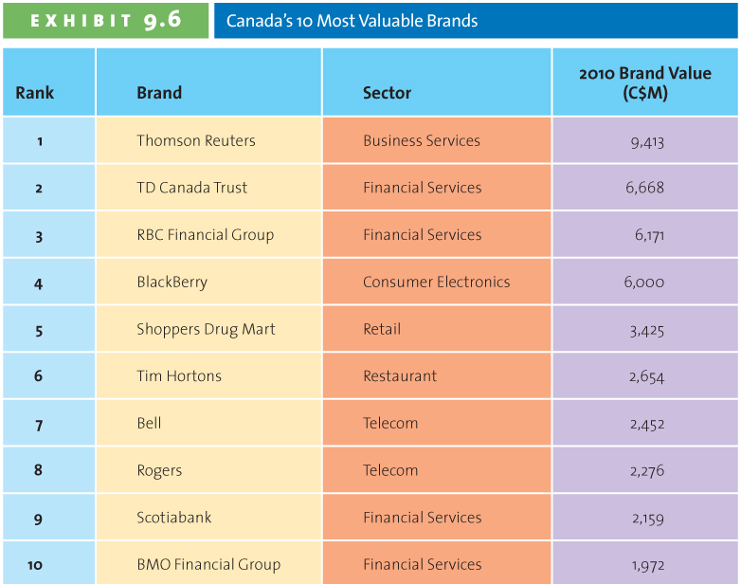
  - Brand awareness measures how many consumers in a market are familiar with the brand and what it stands for, and have an opinion about that brand
  - Marketers create brand awareness through repeated exposures of the various brand element in the firm’s communications to consumers
- Brand Equity: Perceived Value
  - Perceived value is the relationship between a product or service’s benefits and its cost.
- Brand Equity: Brand Associations
  - The mental links that consumers make between a brand and its key product attributes, such as a logo, slogan, or famous personality
  - Brand personality refers to a set of human characteristics associated with a brand, which has symbolic or self-expressive meanings for consumers
- Brand Equity: Brand Loyalty
  - Brand loyalty occurs when a consumer buys the same brand’s product or service repeatedly over time rather than buying from multiple suppliers within the same category
  - Consumers are often less sensitive to price
  - Marketing costs are much lower
  - Firm insulated from the competition
- Brand Strategies
  - Brand Ownership
    - Manufacturer brands are owned and managed by the manufacturer, are also known as national brands
    - Brands that are owned and managed by retailers, in contrast, are called private-label brands or store brands
    - Generic products are those sold without brand names, typically in commodities makers
  - Naming Brands and Product Lines
    - When al products are sold under one corporate brand or family brand, the individual brands benefit from the overall brand awareness associated with the family name
    - A firm also could use combinations of the corporate and product line brands to distinguish its products
    - A firm can use individual brand names for each of its products.
    - Choosing a Brand Name: Desirable Qualities
      - Suggest benefits and qualities
      - Easy to pronounce recognize & remember
      - Capable of registration & legal protection
      - Translated easily
  - Brand Extension
    - Brand extension refers to the use of the same brand name for new products being introduced to the same or new markets
    - Benefits of brand extension
      - Well established name
      - Brand known for high quality
      - Lower marketing costs
      - Synergy among products
      - Boost sales of the core brand
  - Brand Dilution
    - Occurs when a brand extension adversely affects consumer perceptions about the attributes the core brand is believed to hold
    - Evaluate the fit between the product class of the core brand and the extension
    - Evaluate consumer perceptions of the attributes of the core brand and seek out extensions with similar attributes
    - Refrain from extending the brand name to too many products
    - Is the brand extension distanced enough from the core brand?
  - Cobranding
    - Cobranding is the practice of marketing two or more brands together, on the same package or promotion
  - Brand Licensing
    - Brand licensing is a contractual arrangement between firms, whereby one firm allows another to use its brand name, logo, symbols, and/or characters in exchange for a negotiated fee.
- Packaging
  - More tangible or physical benefits than the other brand elements
  - Some packaging changes designed to make the product more ecological
- Labeling

Week 8 A: Chapter 10 Service: The Intangible Product

- Service
  - Any intangible offering that involves a deed, performance, or effort that cannot be physically possessed
- The Service Product Continuum
  - You buy the product because of your demand; you demand to deserve a better quality of life. So it is kind of service for the product too.
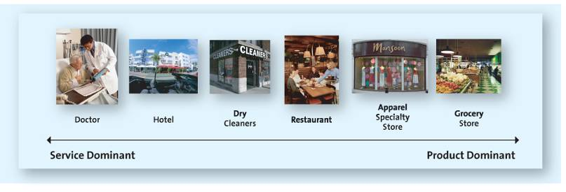
- Services Marketing Differs from Product Marketing
  - Intangible
    - Cannot be touched, tasted or seen
    - It can’t be shown directly to customer
  - Inseparable Production and Consumption
    - Production and consumption are simultaneous
    - Little opportunity to test a service before use
      - Delivery service
      - Dentist/Physician
      - Hotel
      - Commercial flight
      - University
    - Inconsistent (Variable)
      - Technology
      - Training
      - Automation
      - Attitude
      - Ex: style of different professor teach, and the quality of different professor
    - Inventory
      - Can not be hold inventory
- Providing Greet Service: The Gaps Model
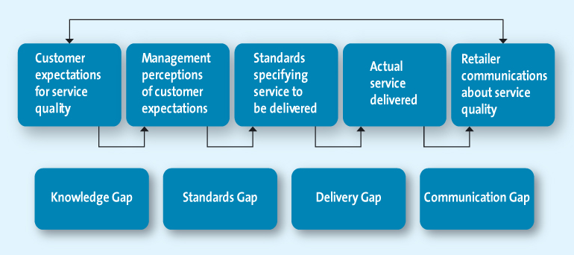
  - The Knowledge Gap: Knowing what Customers Want
    - Understanding customer Expectation
      - Difference between customers’ expectations and the firm’s perception of those customer expectations
      - Expectations are based on knowledge and experience
      - Expectation vary according to type of service
      - Expectations vary depending on the situation
    - Evaluating Service Quality
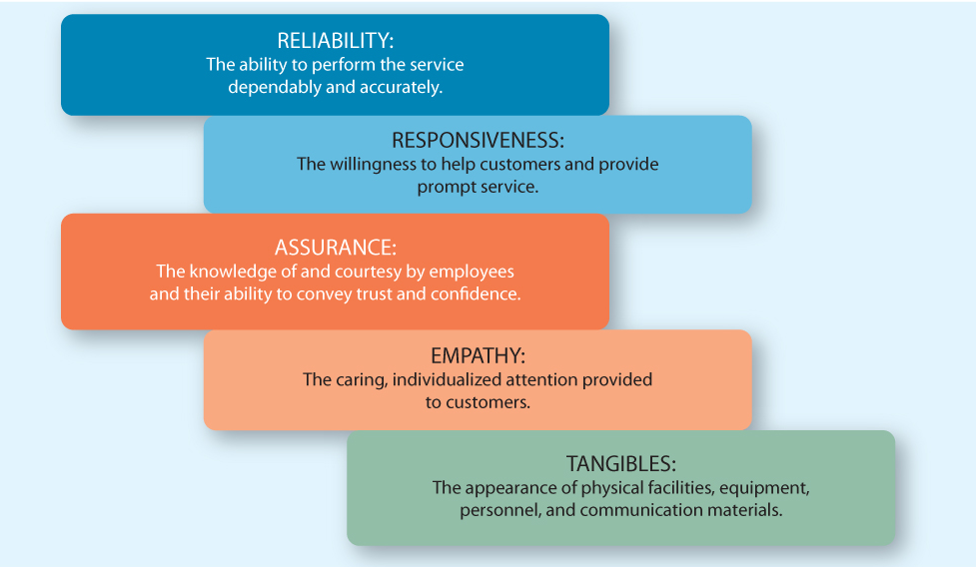
    - Zone of Tolerance: the area between customers’ expectations regarding their desired service and the minimum level of acceptable service-that is, the difference between what the customer really wants and what he or she will accept before going elsewhere
  - The Standards Gap: Setting Service Standards
    - Difference between the firm’s service standards and the actual service it provides to customers
    - Setting standards for quality
    - Developing systems to ensure high-quality service
  - The Delivery Gap: Delivering Service Quality
    - Difference between the firm’s service standards and the actual service it provides to customer
    - Empowering Service Providers
      - Allowing employees to make decisions about how service is provided to customers
    - Providing Support and Incentives
    - To deducing delivery gap
      - Provide emotional support to service providers
      - Provide support necessary to deliver service
      - Consistent and coherent management
      - Reward employees for excellent service
    - Use of Technology
      - Customers can buy more quickly, more easily, and do so with more information
  - The Communications Gap: Communicating the Service Promise
    - Difference between the actual service provided to customers and the service that the firm’s promotion program promises
    - Manage customers expectations
    - Promise only what you can deliver
    - Communicate service expectations
- Service Recovery
  - Listen to the customer
    - Customers get emotional over a service failure
    - Often customers just want someone to listen
  - Resolver problems quickly
    - The longer it takes to resolver service failure, more irritated the customers
    - It is in the firms best interest to solver problem quickly
  - Provide a fair solution
    - Distributive fairness (benefits received vs. inconvenience)
    - Procedural fairness (Perceived fairness of the process used to resolve complaints)
- Video: Online telephone Service
  - Unique
  - Information speeds quickly
  - Professional, know product, understand customers
  - Make or break company’s reputation

Week 8 B: Chapter 14 Integrated Marketing Communications
- Integrated Marketing Communication Tools

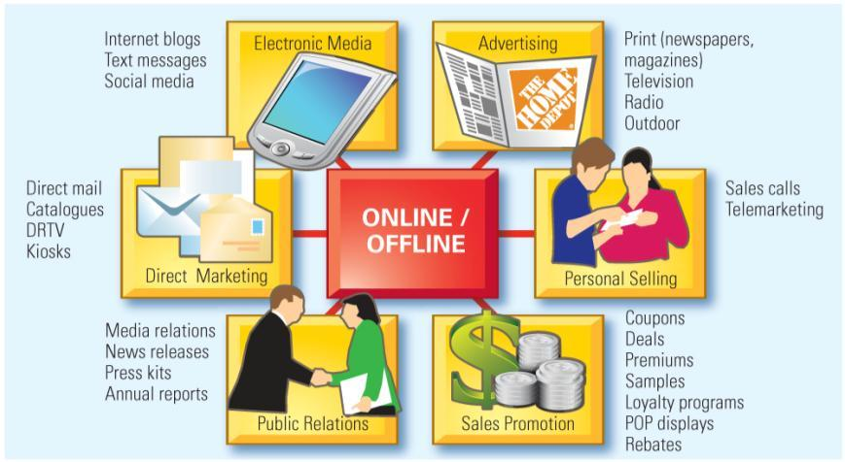
  - Advertising
    - Most visible element of IMC
    - Extremely effective at creating awareness and generating interest
  - Personal Selling
    - Some products require the help of a salesperson
    - More expensive than other forms of promotion
    - Salespeople can add significant value, which makes the expense worth it
  - Sales Promotions
    - Can be aimed at both end user consumers or channel members
    - Used in conjunction with other forms of IMC
    - Can be used for both short-term and long-term objectives
- Direct Marketing Characteristics
  - Targeted
  - Motivate an action
  - Measurable
  - Can provide information for a marketing database
- Forms of Direct Marketing
  - Direct Mail targeted, printed communication sent to a prospective consumer’s mailbox
  - Catalogues
    - Hard copy and online
    - Welcomed in 80% of Canadian homes
    - E.g. Sears, Ikea, and Business Depot
  - DRTV (Direct Response TV)
    - Short television commercials and/ or infomercials
    - Strong call to action via 1-800 number, mail or website
  - Kiosks
    - Facilitate service delivery, e.g. airline ticket printing
    - Selling services and products to consumers, e.g. Dell, Virgin Mobile, Hallmark
- Online Marketing
  - Websites
  - Blogs
  - Social Media
  - Public Relations (PR): the organizational function that manages the firm’s communications to achieve a variety of objectives, including building and maintaining a positive image, handing or heading off unfavorable stories or events, and maintaining positive relationships with the media
    - Manages the firms’ communications to achieve a Varity of objectives:
      - Building/ Maintaining a positive image
      - Handing unfavorable stories or events
      - Maintaining positive relationships with the media
    - Generated free media attention
- Video: PR
  - The PR Phenomenon
    - =Art of persuasion
    - Influence
    - Differs form advertising
    - Free media coverage
  - The PR Campion
    - SMART principle
    - Return on investment
    - Need product or service
    - Aim to improve image
    - Measured by required creativity’
  - Crisis management
    - Mange company’s experience negative public
    - Smart PR
- Steps in Planning an IMC Campaign
  - 1. Identity Target Audience
  - 2. Set Objectives
    - Pull Strategy: designed to get consumers to pull the product into the supply chain by demanding retailers carry it
    - Push Strategy: Designed to increase demand by focusing on wholesalers, distributors, or salespeople, who push the product to consumers via distribution channels
    - Nature of the Market
    - Nature of the product
    - Stage in the product life cycle
  - 3. Determine Budget
    - Considerations:
      - Role that advertising plays in their attempt to meet their overall promotional objectives
      - Expenditures vary over the course of the product life cycle
      - Nature of the market and the product influence the size of the budget
    - Budgeting Methods
      - Objective- and –task method: Sets communication objectives first, then determines best tools and media to reach target markets
      - Competitive parity: Match budgets of competitors
      - Percentage of sales: Fixed percentage of forecast sales
      - Affordable budgeting: money available after accounting for operating costs and profits
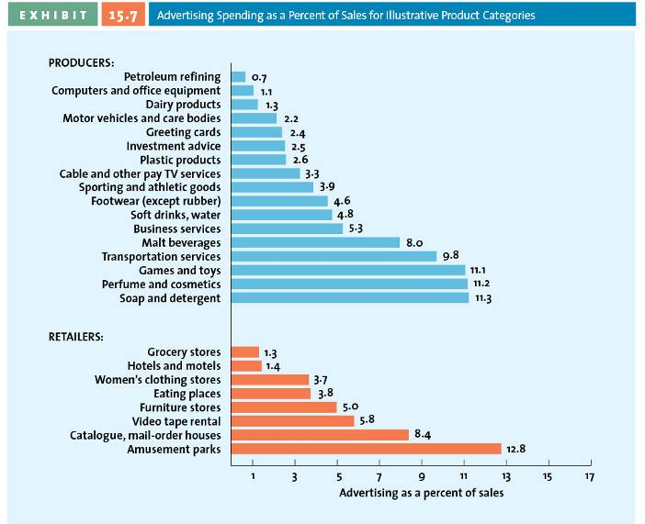
  - 4. Convey the Message
    - Unique selling proposition (USP) which is often the common theme or slogan in an advertising campaign
    - Rational appeals help consumers make purchase decisions by offering factual information and strong arguments built around relevant issues that encourage consumers to evaluate the brand favorably on the basis of the key benefits it provides
    - Emotional appeals aims to satisfy consumers’ emotional desires rather than their utilitarian needs
  - 5. Evaluate and Select Media
    - Media planning
    - Media mix
    - Media buy
    - Mass and Niche Media (can be both)
      - Mass media reach large anonymous audience
      - Niche media reach a smaller more targeted audience
    - Choosing the Right Medium
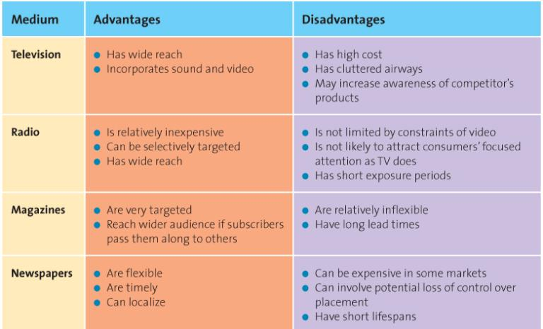
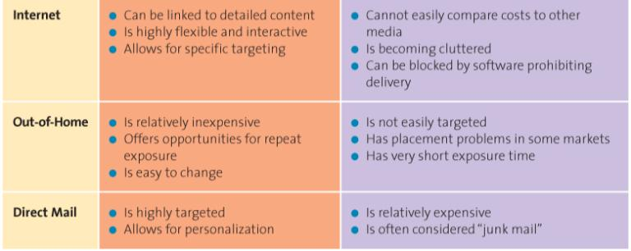
    - Determine the advertising Schedule
      - Continuous: runs steadily throughout the year and therefore is suited to products and services that are consumed continually at relatively steady rates
      - Flighting: implement in spurts, with periods of heavy advertising followed by periods of no advertising
      - Pulsing: maintaining a based level of advertising but increasing advertising intensity during certain periods.
  - 6. Create Communications
    - The type of medium determines the execution style
    - Creativity plays a major role in the execution stage
    - Creativity should not overshadow the message
    - The execution style must match the medium and objectives
  - 7. Assess Impact Using Marketing Metrics
    - Pretesting: assessments performed before an ad campaign is implemented to ensure that the carious elements are working in an integrated fashion and doing what they are intended to do
    - Tracking: monitoring key indicators, such as daily or weekly sales volume, while the advertisement is running to shed light on any problems with the message or the medium
    - Post testing: evaluation of the campaign’s impact after it has been implemented
- Results: Measuring IMC Success
  - Understand desired outcome at outset
  - Short-term or Long-term
  - Should be explicitly defined and measured
    - Frequency
      - Frequency of exposure- how often the target audience is exposed to a communication within a specified period of time
    - Reach
      - Measure of customers’ exposure to marketing communications
    - Gross rating points(
    - Web Tracking

Week 9 Chapter 15 Advertising, Sales Promotion and Personal Selling
- The AIDA Model
  - Awareness
    - Senders first must gain the attention of the consumers
    - A multichannel approach increases the likelihood the message will be received
  - Interest
    - After the customer is aware they must be persuaded
    - The customer must want to further investigate the product/Service
  - Desire
    - I like it
    - I want it
  - Action
    - Purchase is just one type of action
    - What other actions can consumers be asked to take?
      - Behavioral changes (do not drink and drive)
      - Attitude changes (This product is high quality)
      - Physical actions (log on the website, volunteer, donate)
    - Lagged Effect
      - Advertising does not always have an immediate impact
      - Multiple exposures are often necessary
      - Difficult to determine which exposure led to purchase
- Advertising
  - Paid message
  - Delivered through media
  - Must have identifiable source
  - Designed to persuade
- Advertising Objectives
  - Informative advertising
    - Early in the product lifecycle, firms use informative advertising to educate consumers about the product/service
  - Persuade
    - Generally occurs in the growth and early maturity stages of the PLC when competition is most intense
    - In the later stage of the PLC may be used to reposition an established brand
  - Remind
    - After the products have gained market acceptance
    - Top-of-the-mind-awareness
- Focus of Advertisements
  - Institutional advertisements
    - Used to inform, persuade, and remind consumers about issues related to places, politics, an industry, or a particular corporation
  - Product-focused advertisements
    - Used to inform, persuade, or remind consumers about a specific product or service
- Social Marketing
  - Public Service Advertising (PSA)
  - Under Canadian Radio-television and Telecommunications Commission rules broadcasters must devote a specific amount of free airtime of PSAs
- Regulatory and Ethical Issues in Advertising
  - Puffery
    - The legal exaggeration of praise, stopping just short of deception, lavished on a product
    - Ex: “Buy the item, and do 5 minutes a day. You will be the guy in the picture”
  - Stealth Marketing
    - A strategy used to attract consumers that employs promotional tactics which deliver a sales message in a unconventional ways, often without the target audience knowing that the message even has a selling intent.
- Types of Consumer Sales Promotion
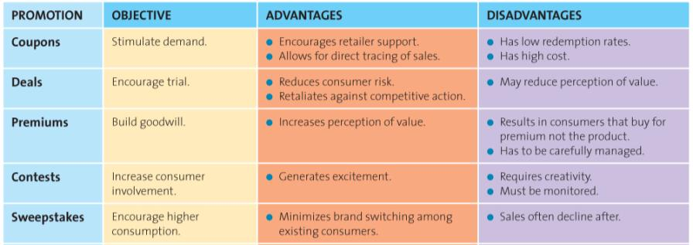
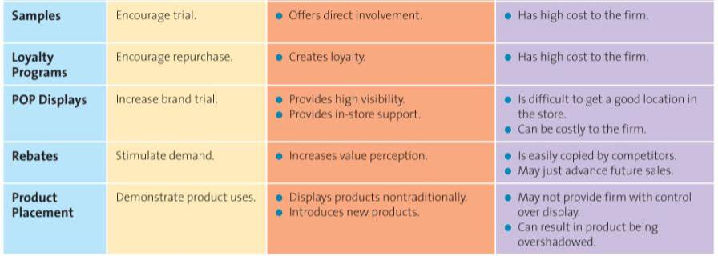
- Sales Promotions
  - Can be targeted at either the end user consumers or channel members
  - Can be used in either push or pull strategies
- Types of Trade Sales Promotion
  - Discounts and Allowances
    - Effective incentives used to maintain increase inventory levels in the distribution channel
  - Co-operative Advertising
    - Helps to compensate trade channel members for money they spend promoting products and encourages them to feature products more often
  - Sales force Training
    - Manufactures may offer to train the retailer’s sales staff
- Using Sales Promotion Tools
  - Pop-up stores
    - Temporary storefronts that exist for only a limited time and generally focus on a new product or a limited group of products offered buy a retailer, manufacturer, or service provider; given consumers a chance to interact with the brand and build brand awareness
  - Cross-Promoting
    - Effects of two or more firms joining together to reach a specific target market
- Evaluating Sales Promotion using Marketing Metrics
  - The realized margin from the promotion
  - The cost of the additional inventory carried because of buying more than the normal amount of the product
  - The potential increase in sales from the promoted merchandise
  - The long-term impact on sales of the promotions
  - The potential loss suffered when customers switch to the promoted merchandise from more profitable TVs
  - The additional sales made to customers attracted to the store by the promotion
- Video: Marketing Research
  - The Diet Coke with mentos
  - Great advertising, and interest
- The scope and Nature of Personal Selling
  - Internet
  - Telephone
  - Face to face
  - Teleconference
- The Value Added by Personal Selling
  - Salespeople educate and provide advice
  - Salespeople save time and simplify buying
- The Personal Selling Process
  - Generate and Qualify Leads
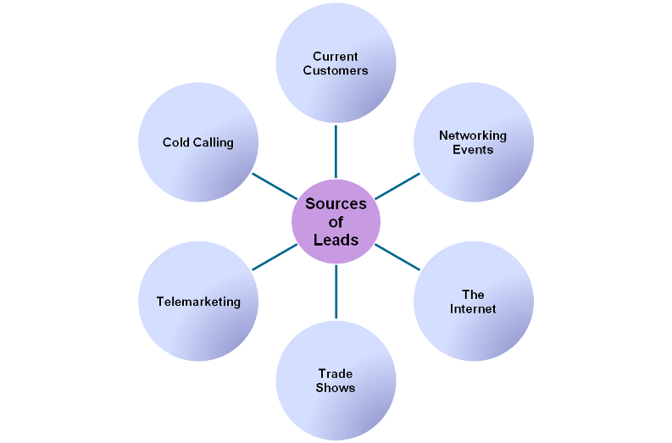
  - Pre approach
    - Occurs prior to meeting the customer for the first time and extends the qualification of leads procedure
  - Sales Presentations and Overcoming Objections
    - The presentation
    - Handing Objectives
  - Closing the Sale
    - Getting the order
    - Often most stressful part of sales process
    - A “no” one day many be foundation for a “yes” another
  - Follow-up
    - Five Service Quality Dimensions
      - Reliability
      - Responsiveness
      - Assurance
      - Empathy
      - Tangibles
- Managing the sales Force
  - Impact of Technology on personal Selling
    - Instant access to their customers
    - Access to customer research and information
    - Training programs are more effective, easier to operate, less expensive
    - Less time on order tracking

Week 10 Chapter 11 Pricing Concepts and Strategies for Establishing Value
- Price is a Signal
  - Prices can be both too high and too low
  - Price too low may signal poor quality
  - Price set too high might signal low value
- Role of Price in the Marketing Mix
  - Price is usually ranked as one of most important factors in purchase decisions
  - Price is the only element in the marketing mix that generates revenue
- The five Cs of Pricing
  - First C: Company Objectives
    - Profit Orientation
      - Maximize Profits
        - Mathematical determination of the price at which profits are maximized
        - Based on all the factors required to explain sales and profits
        - Based on economic theory
      - Target Return Pricing
        - Focus in on the rate at which profits are generated relative to their investments
        - Designed to produce a specific return on investment
      - Target Profit Pricing
        - Focus is on a predetermined profit goal
        - Price is used to stimulate a certain level of sales at a certain profit per unit
    - Sales Orientation
      - Focus on increasing sales
      - More concerned with overall market share
      - Does not always imply low setting low prices
      - Many first adopt this orientation to establish a position is the market by getting the most price sensitive consumers to change brands
    - Competitor Orientation
      - The firm measures itself against its competition
      - Value is not part of this pricing strategy
      - This strategy is particularly common among smaller firms that lack knowledge or experience in setting prices
      - Non-market leader firms also use it to signal they are similar to the market leader
      - In many instances new brands will set prices equal to the competitors they wish to be compared with knowing that consumers use reference prices to indicate quality
    - Customer Orientation
      - Focus on customer expectations by matching prices to customer expectations
      - A diamond ring from Costco vs. Birks or Jubilee Jewelers
  - Second C: Customers
    - Understanding customers’ reactions to different prices
    - Price elasticity of demand
      - Elastic (Price Sensitive)
      - Inelastic (Price Sensitive)
      - Consumers less sensitive to price increase for necessities
      - Pe= % change in quantity demanded/ % change in price
      - Elasticity affected by
        - Cross-price elasticity
        - Substitution effect
        - Income effect
  - Third C: Costs
    - Variable Costs
    - Fixed Costs
    - Total Costs
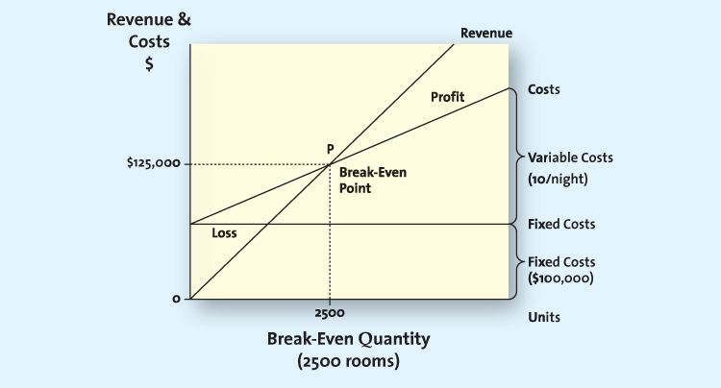
  - Forth C: Competition
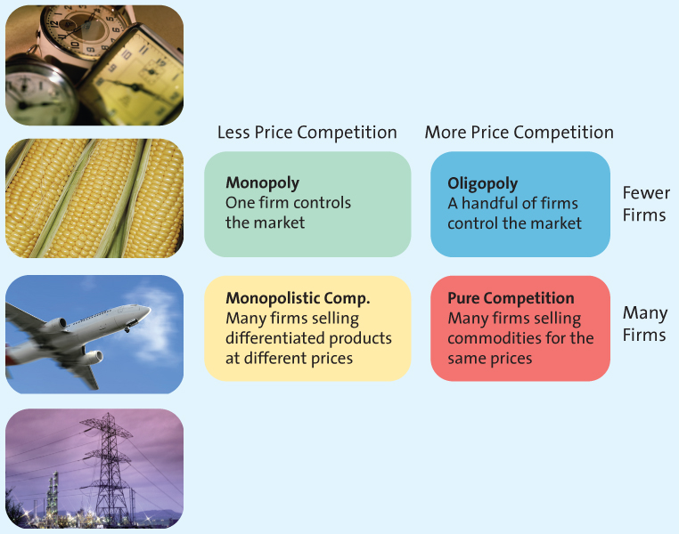
  - Fifth C: Channel Members
    - Manufacturers, wholesalers and retailers can have different perspectives on pricing strategies
    - Manufactures must protect against grey market transactions

  - Other Influences on Pricing
    - The Internet
      - Increased price sensitivity
      - Growth of online auctions
    - Economic Factors
      - Local economic conditions
      - Increasing disposable income
      - Increasing globalization
      - Cross-shopping
      - Increase status consciousness
- Price Strategies
  - Cost-Based Methods
    - Cost-base pricing methods start with cost
    - All costs calculated on per unit basis
    - Assumes costs don’t vary for different levels of production
  - Competitor-Based Methods
    - Set prices to signal information of how product compares with competitors
    - Premium pricing: the firm deliberately prices a product abouve the prices set for competing products a capture those consumers who always shop for the best of for whom price does not matter
  - Value-Based Methods
    - Setting prices that focus on the overall value of the product
    - Improvement Value Method: an estimate of how much more or less consumers are willing to pat foe a product relative to other comparable products
    - Cost of Ownership Method: consumers may be willing to pay more for a particular product because, over its entire lifetime, it will eventually cost less to own than a cheaper alternative
- New Product Pricing Strategies
  - Market Penetration Pricing: A price strategy of setting the initial price low for the introduction of the new product or service, with the objective of building sales, market share, and profits quickly
  - Price skimming
- Psychological Factors Affecting Pricing Strategies
  - Reference Prices: the price against which buyers compare the actual selling price of the product and that facilitates their evaluation process
    - Internal reference price: to judge a price offering by accessing price information stored in their memory
    - External reference price: a higher price to which the consumer can compare the selling price to evaluate the deal
  - Everyday Low Pricing (EDLP)
    - Value is created in different ways
    - EDLP saves search costs of finding lowest overall prices
    - High/low provides the thrill of the chase for the lowest price
  - Odd Prices
    - Odd prices may be so traditional that sellers are afraid to round them off
    - May suggest a good deal
    - May suggest low quality
- Pricing Tactics
  - Pricing strategy Long Term
  - Pricing tactics Short Term
- Business to Business Pricing Tactics and Discounts
  - Seasonal Discounts
    - Designed to spur buyers into purchasing merchandise early
  - Cash Discounts
    - Reduced invoice cost if buyer pays prior to the end of the discount period
    - Encourages buyers to pay before the discount period ends
    - Ex: 3/10, n/30
  - Allowances
    - Lowers the final cost in return for specific behavior
    - Advertising allowance: offers a price reduction to channel members if they agree to feature the manufacturer’s product in their advertising and promotional effects
    - Listing allowance: fees paid to retailers simply to get new products into stores or to gain more or better shelf space for their products
  - Quantity Discounts
    - Cumulative quantity discount: use the amount purchased over a specified time period and usually involves several transactions
    - Non cumulative quantity discount: Pricing tactic that offers a discount based on only the amount purchased in a single order
  - Uniform Delivered vs. Geographic Pricing
    - Uniform delivered pricing: the shipper charges one rate, no matter where the buyer is located
    - Geographic pricing: the setting of different prices depending on a geographic division of the delivery areas
    - Addresses the impact of shipping, which is often a major cost for manufactures
- Pricing Tactics Aimed at Consumers
  - Prices Lining
    - Marketers establish a price floor and a price ceiling for an entire line of similar products and then set a few other price points in between to represent distinct differences in quality
    - Allows for easy comparison
  - Price Bundling
    - When firms are stuck with a slow-moving item, to encourage sales, they sometimes will ”bundle” it with a faster-moving item and price the bundle below what the two items would cost separately
    - Encourage sales of slow moving items
    - Encourage stock up
    - Encourage trial of new brand
    - Incentive to purchase
  - Leader Pricing
    - Leader pricing is a tactic that attempts to build store traffic by aggressively pricing and advertising a regularly purchased item, often priced at or just above the store’s cost
    - Enticing consumers into the store with the popular aggressively prices item and hoping they will pick up other items while shopping
- Consumer Price Reductions
  - Markdowns
    - The reductions retailers take on the initial selling price of the product or service
    - An integral component of high/low pricing strategy
    - Enable retailers to get rid of slow moving or obsolete merchandise
    - Used to generate store traffic
  - Quantity Discounts for Consumers
    - Size discount
    - The more you buy the cheaper the unit cost
  - Seasonal Discounts
    - Encourage consumers to use services to purchase products year round
  - Coupons and Rebates
    - Coupons- Retailer handles
    - Rebate- Manufacturer issues
- Legal and Ethical Aspects of Pricing
  - Deceptive Reference Prices
  - Loss Leader Pricing: Loss leader pricing takes the tactic of leader pricing one step further by lowering the pricing the price below the store’s cost
  - Predatory Pricing: A firm’s practice of setting a very low price for one or more of its products with the intent of driving its competition out of business
  - Price Discrimination: When firms sell the same product to different resellers at different prices
  - Pricing fixing: the practice of colluding with other firms to control prices
- Video:
  - The law of demand and supply
  - Consumer income
  - Related goods: Substitute
- Market type
  - Perfect competition
    - Many sellers
    - Small market share
    - No differentiation
    - Free entry
    - Price Taker
  - Monopolistic competition
    - Many firms
    - Small market share
    - Low entry barriers
    - Differentiation
    - Advertising
  - Oligopoly
    - Few firms
    - High entry barriers
    - Price setters
    - Competition interdependent
  - Monopoly
    - One supplier
    - No competition
    - High barriers

Week 10 Lecture 2 Chapter 12 Distribution Strategy
- Distribution Components
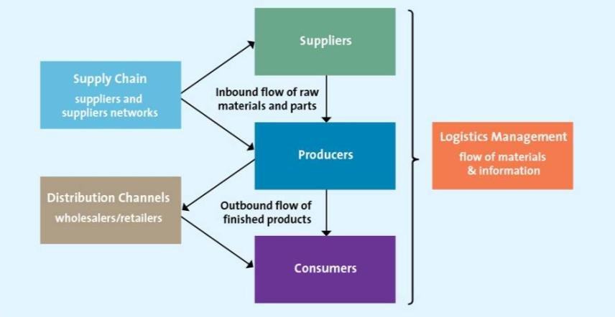
- Functions Performed by Intermediaries
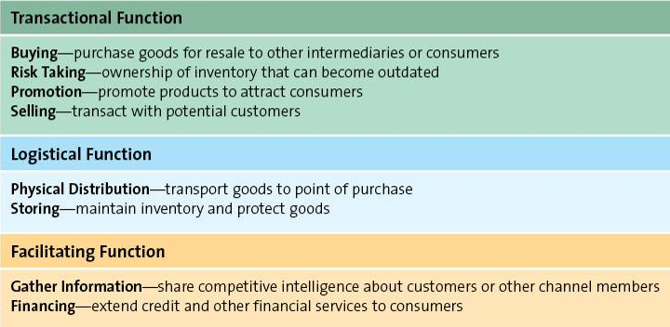
- Designing Distribution Channels
  - Channel Structure
    - Direct Distribution
    - Indirect distribution
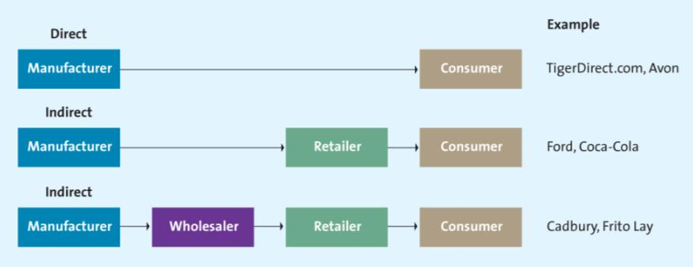
    - Multichannel distribution or some combination of these forms
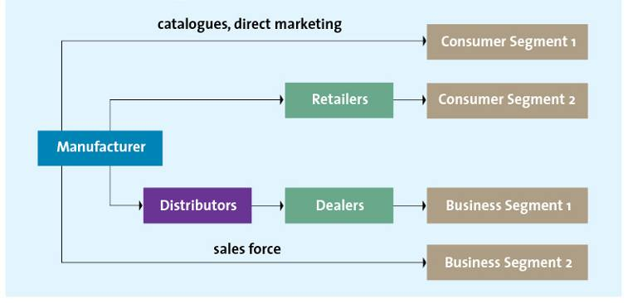
- Influences on Distribution Channel Structure
  - Customer expectations
  - Channel member characteristics
    - Generally, the larger and more sophisticated the channel member, the less likely that it will use intermediaries
  - Distribution Intensity: the number of channel members to use at each level of the supply chain
    - Manufactures want to get products to as many outlets as possible-the more exposure, the more sales
    - Manufacturers use a few selected companies in a territory
    - Manufactures grant exclusive geographic territories to one or a few retailers
- Managing Distribution channels: Vertical Integration
  - Independent or conventional supply chain
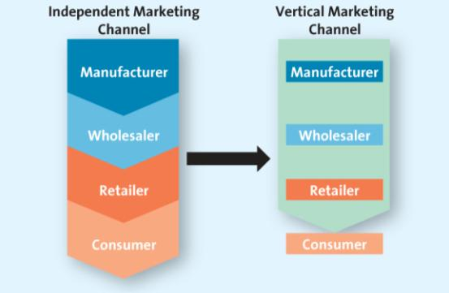
  - Types of Vertical Marketing Systems: Vertical marketing system is a supply chain in which the members act as a unified system
    - Administered vertical marketing system
      - No common ownership, no contractual relationships, but the dominant channel members controls the channel relationship
        - Ex: Dominant Channel member could dictate what is to be produced, when it should be delivered
    - Contractual vertical marketing system
      - Independent firms at different levels of the supply chain join together through contracts to obtain economics of scale and coordination to deduce conflict
        - Contracts could dictate minimum purchasing amount, price, penalties
        - Franchising is the classical example
    - Corporate vertical marketing system
      - Typically exemplified when a parent company has complete control and can dictate the priorities and objective of the supply chain
        - It may own facilities including manufacturing plants, warehouse facilities, retail outlets- in other words, it owns the Channel
- Supply Chain Management 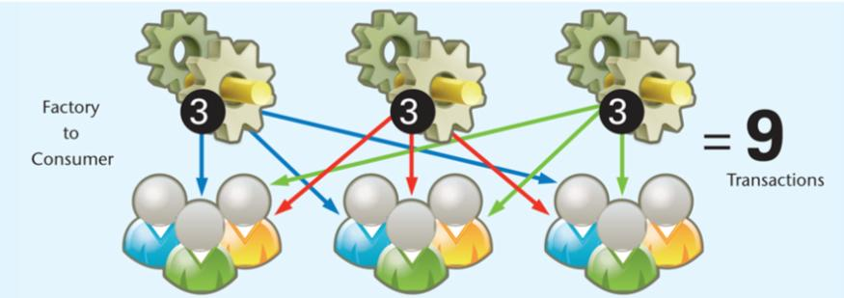
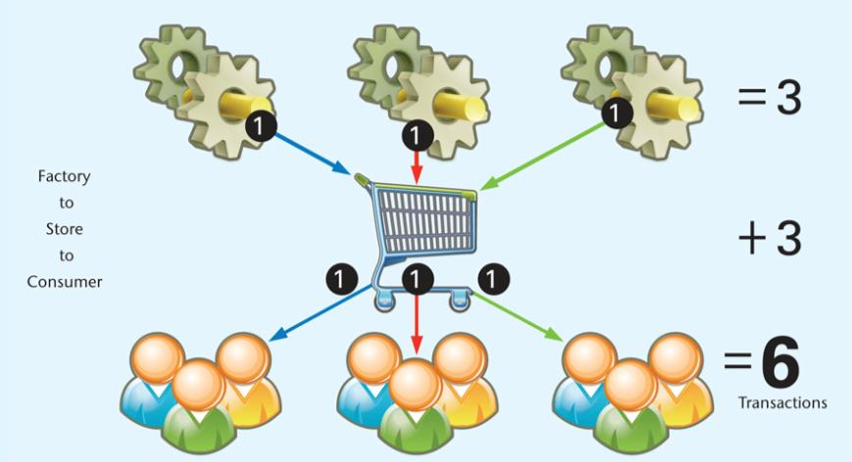
  - Supply Chains Streamline Distribution
    - Reduce number of transactions
    - Increase value for consumers
    - More efficient and effective
  - Supply Chain Management Affects Marketing
    - Fulfilling delivery promises
    - Meeting customers expectations
    - Reliant on an efficient supply chain
    - Five interrelated activities emerge in supply chain management: designing, distribution channels, making information flow, managing the relationships among supply chain partners, making merchandise flow, and managing inventory
- Logistics Management: Making information Flow
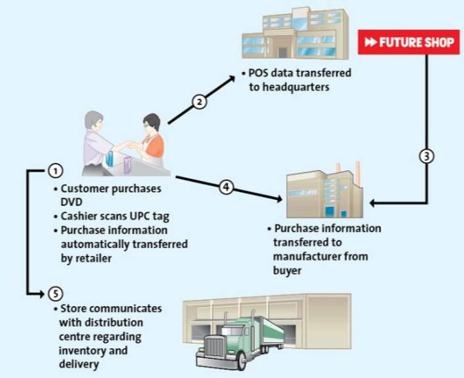
  - Data Warehouse: customers’ purchase data collected at the point of sale goes into a huge warehouse
  - Electronic Data Interchange
    - Reduces cycle time
    - Improves quality of communication through better record keeping
    - Data transmitted can be used for a variety of tasks
- Logistics Management: Making Merchandise Flow
  - Management of inbound transportation
  - Receiving and checking using UPC and RFID
  - Shoring and Cross-Docking
  - Getting Merchandise Floor Ready
  - Preparing to ship
  - Shipping to Store
  - Inventory Management Through Just-In-Time Systems
    - JIT inventory systems, also known as quick-response systems in retailing, are inventory management systems designed to deliver less merchandise on a more frequent basis than traditional inventory systems
    - Benefits of JIT System: Reduced lead time; increased product availability and lower inventory investment

Lecture 12 Lecture 1 Chapter 13 Retailing
- Retailing: The set of business activities that add value to products and services sold to consumers for their personal use
- Choosing Retail Partners
  - Channel Structure
  - Customer Expectations
- Types of Retailers
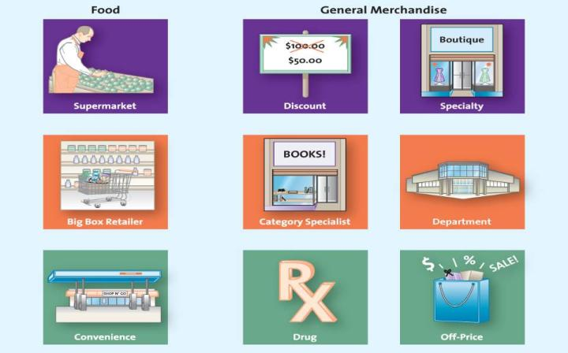
  - Food Retailers
    - Conventional Supermarkets: offers groceries, meat, and produce with limited sale of nonfood items, such as health and beauty aids and general merchandise, in a self-service format.
      - EX; Safeway, Sobeys
    - Big Box Food Retailers: Comes in three types: supercenter, hypermarket, and warehouse club; larger than a conventional supermarket; carries both food and nonfood items
      - EX: Supercenters and warehouse clubs
    - Convenience Stores: Provides a limited number of items at convenient locations in small stores with speedy checkout
      - EX: 7-Eleven generally charge higher prices than most other types of food stores
  - General Merchandise Retailers
    - Department Stores: Brand variety and deep assortment
    - Full-line Discount: Brand variety at low prices
    - Specialty: Limited merchandise with service in small store
    - Drugstores: Specialty for pharmaceutical and health
    - Category Specialist: Discount with narrow but deep assortment
    - Extreme Value: Full line, limited, very low prices
    - Off-price: Inconsistent assortment of brand name at low price
- Creating a Retail Strategy
  - Product: Providing the right mix of merchandise and services
  - Price: Price defined the value of both the merchandise and the service provided
  - Promotion: Retailers use a wide variety of promotions, both within their retail environment and through mass media
  - Place: Convenience is a key ingredient to success
- The Changing Retail Landscape
  - The wheel of Retailing offers one view of how new forms of retail outlets compete in the market.
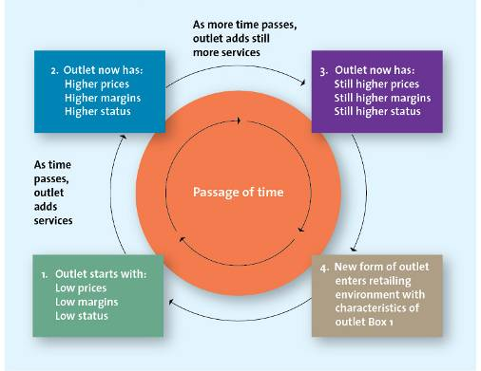
- Channels For Selling to Consumers
  - Store Channel
    - Benefits of Stores for Consumers
      - Browsing
      - Touching and Feeling
      - Cash and credit
      - Entertainment and Social interaction
      - Instant Gratification
      - Risk Reduction
  - Kiosk Channel
    - Benefits of Kiosk for Consumers
      - Broader selection
      - Access to items online that are out of stock in store
      - Access to loyalty program information
  - Catalogue Channel
    - Benefits of Catalogue for Consumers
      - Place an order 24-7
      - Convenience
      - Information
      - Safety
  - Internet Channel
    - Benefits of the internet and Multichannel Retailing
      - Deeper and Broader Selection
      - Personalization
      - Grain insights into Consumer shopping Behavior
      - Increase Customer Satisfaction and Loyalty
      - Expand Market Presence
    - Perceived Risk in Internet Shopping
      - The security of credit card transactions on the Internet
      - Potential privacy violations
- Evolution Toward Multichannel Marketing
  - Overcoming the Limitations of an Existing Format
    - The size of their stores
    - Inconsistent Execution
  - Expanding Market Presence
  - Increasing Share of Wallet
    - Multichannel consumers spend substantially more than those who shop at a single channel- between 25 to 100 percent more
  - Gaining insights into Customers’ shopping Behaviors
  - Manufacturers will not bypass retailers and sell directly to consumers

Week 12 Lecture 2 Chapter 16 Global Marketing
- Assessing Global Markets (PEST)
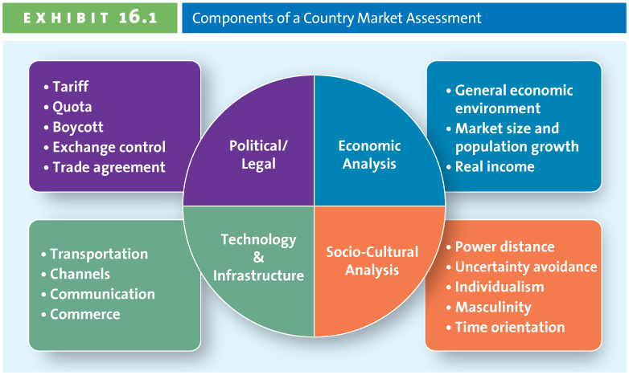
  - Analyzing the Political/Legal Environment
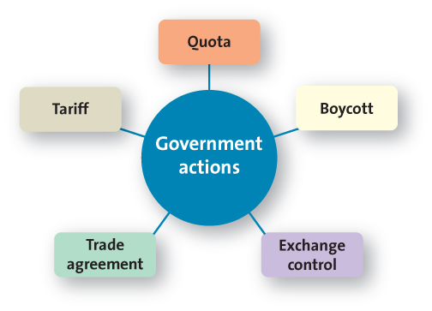
    - Trade Sanctions: penalties or restrictions imposed by one country over another country for importing and exporting of goods, services, and investments
    - Tariffs (duty): a tax levied on a good imported into a country
      - Tax
      - Artificially raised prices
      - Lowers demand
      - General Agreement on Tariffs and Trade- World Trade Organization
    - Quotas: designates the maximum quantity of a product that may be brought into a country during a specified time period
      - Maximum limit
      - Reduces availability of imported goods
      - Tariff and Quotas are both benefit domestically made products because they reduce foreign competition
    - Boycott: group’s refusal to deal commercially with some organization to protest against its policies
      - Dissatisfied global consumers
      - Voiced dissatisfaction with U.S. war policy
      - Avoidance of U.S. products and services
      - Groups such as Ethical Consumer publish current boycott lists
    - Exchange Control: refer to the regulation of a country’s currency exchange rate.
      - Exchange rate: the measure of how much one currency is worth in relation to another
      - Countertrade: trade between two countries where goods are traded for other goods and not for hard currency
      - Trade Agreements
        - North American Free Trade Agreement (NAFTA)
        - Central American Free Trade Agreement (CAFTA)
        - Association of Southeast Asian Nations (ASEAN)
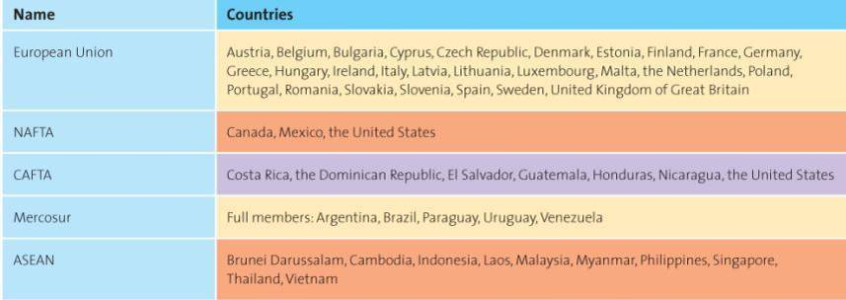
  - Analyzing the Economic Environment
    - Evaluating the General Economic Environment
      - Trade deficit: the country imports more goods than it exports
      - Trade surplus: a higher level of exports than imports
      - Gross domestic product: market value of the goods and services produced by a country in a year
        - GDP growth means that production and consumption in the country is expanding
      - Purchasing power parity: a theory that states that if the exchange rates of two countries are in equilibrium, a product purchased in one will cost the same in the other, expressed in the same currency
      - Human development index: a composite measure of three indicators of the quality of life in different countries: life expectancy at birth, educational attainment, and whether the average incomes, according to PPP estimates, are sufficient ot meet the basic needs of life in that country
    - Evaluating Marketing Size and Population Growth Rate
      - The countries with the highest purchasing power today may become less attractive in the future for many products and services because of stagnated growth
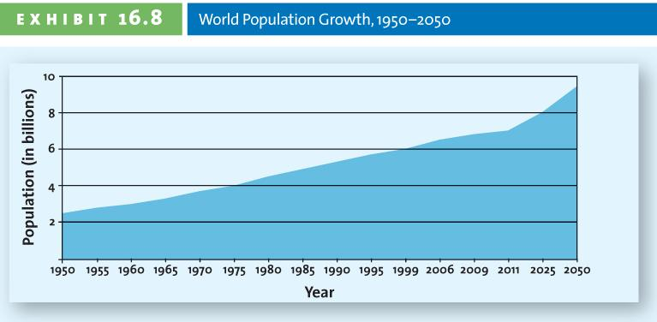
    - Evaluating Real Income
      - Firms can make adjustment to an existing product or change the price to meet the unique needs of a particular country market
  - Analyzing Sociocultural Factors
    - Hosfstede believes cultures differ on five dimensions:
      - Power distance: willingness to accept social inequality as natural
      - Uncertainty avoidance: The extent to which the society relies on orderliness, consistency, structure, and formalized procedures to address situations that arise in daily life
      - Individualism: Perceived obligation to and dependence on groups
      - Masculinity: The extent to which dominant values are male-oriented. A lower masculinity ranking indicates that men and women are treated equally in all aspects of society; a higher masculinity ranking suggests that men dominate in positions of power
      - Time Orientation: Short-versus long-term oriented. A country that tends to have a long-term orientations values long-term commitments and is willing to accept a long time horizon for, say, the success of a new product introduction.
  - Analyzing Infrastructure and Technological Capabilities
    - Infrastructure is defined as the basic facilities, and installations needed for a community or society to function, such as transportation and communications systems, water and power lines, and public institutions such as schools, post offices and prisons.
    - Four components are essential to development of an efficient marketing system:
      - Transport goods throughout the various markets and to consumers in geographically disperse marketplaces
      - Distribution channels must exist to deliver products in a timely manner and at a reasonable cost
      - Communications system must be sufficiently developed to allow consumers access to information about the products and services available in the markets
      - The commercial infrastructure consists of the legal, banking, and regulatory systems that allow markets to function
- Choosing a Global Entry Strategy
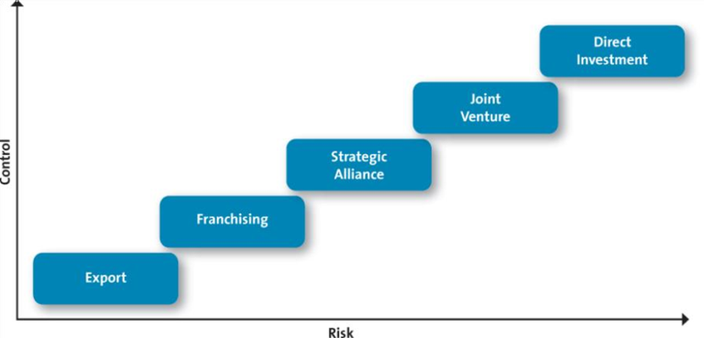
  - Strategic Alliance: collaborative relationships between independent firms, though the partnering firms do not create an equity partnership; that is, they do not invest in one other.
  - Joint venture is formed when a firm entering a new market pools its resources with those of a local firm to form a new company in which ownership, control, and profits and shared.
  - Direct investment requires a firm to maintain 100 percent ownership of its plants, operation facilities, and offices in a foreign country, often through the formation of wholly owned subsidiaries
- Choosing a Global Marketing Strategy: Target Market
  - Global segmentation, Targeting, and Position is more complicated than domestic STP for several reasons
    - Firms considering a global expansion have much more difficulty understanding the cultural nuances of other countries
    - Subcultures within each country also must be considered
    - Consumers often view products and their role as consumers differently in different countries.
    - A product or service often must be positioned differently in different markets
    - Adaptation
    - Single positioning strategy
  - The Global Marketing Mix
    - Sell the same product or service in both the home country market and host country
    - Sell a product or service similar to that sold in home country but include minor adaptations
    - Sell totally new products or services
    - Pricing Strategies
      - Tariffs, quotas, anti-dumping laws, and currency exchange policies, can also affect pricing decisions.
    - Global Distribution Strategies
      - Some global channels are very long and complex
      - Consumers shop local small local stores
      - Suppliers must be creative in delivering to these outlets
    - Communication Strategies
      - Literacy levels vary by country
      - Firms choose whether to adapt to language differences
      - Culture and religious differences also matter
- Ethical Issues in Global Marketing
  - Environmental Concerns
    - Waste Management
    - 80/20 Rule: 80% of waste created by 20% of the population
    - Many developing countries don’t manage waste well
  - Global Labor Issues
    - Fair wages
    - Working conditions
    - Child labor
  - Impact on Host Country Culture
    - Cultural imperialism: The belief that one’s own culture is superior to that of other nations; can take the form of an active, formal policy or a more subtle general attitude
    - Active, formal policy
    - Subtle, general attitude

