PSY1101 Mid-Term Review (1)
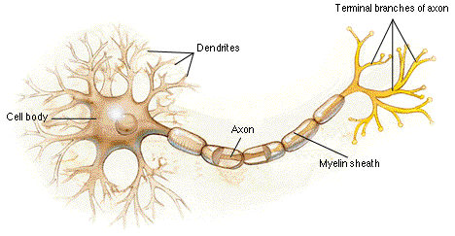
Diagram 1 – Neuron (A nerve cell; the basic building block of the nervous system)
Cell Body – Also known as the soma; this is the cell’s life-support center
Nucleus – Contains the DNA that tells it that it’s a nerve cell
Dendrites – Bushy, branching extensions of a neuron that receives messages from other cells and conducts impulses toward cell body
Axon – The extension of the neuron that passes messages away from cell body to other neurons, glands or muscles
Myelin Sheath – A layer of fatty tissue that covers the axon of some neurons and helps speed neural impulses
Terminal ending – Forms junctions with other cells

Types of Neurons:
Sensory Neurons – Carry information from the sensory receptors
Motor Neurons – Neurons that carry outgoing information from the brain and spinal cord to the muscles and the glands
Interneurons – Neurons within the brain and spinal cord that communicate internally and intervene between the sensory inputs and motor outputs

How Does the Neuron Transmit Information:
A neuron sends signals through its axon and receives information through the dendrites. If the combined signals are strong enough, the neuron fires, transmitting an electrical impulse (action potential) down its axon by a chemistry to electricity process. The neurons reaction is an all-or-nothing process (action potential will travel down axon; increasing intensity of stimulation will not cause the action potential to get larger)

PSY1101 Mid-Term Review (2)
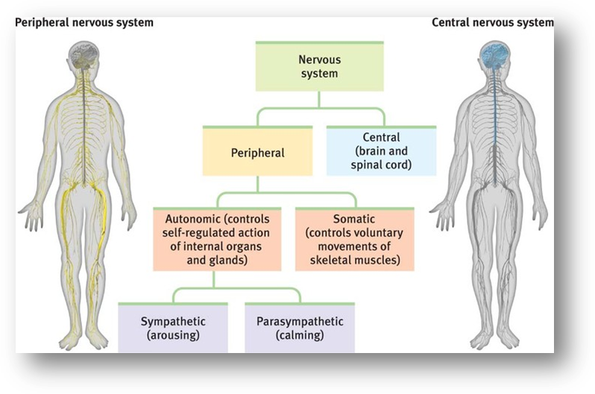

Diagram 2 – The Nervous System (The body’s speedy electrochemical communication network, consisting of all the nerve cells of the peripheral and central nervous system)
Central Nervous System (CNS) – The brain and the spinal cord
Peripheral Nervous System (PNS) – The sensory and motor neurons that connect the central nervous system to the rest of the body
Somatic Nervous System – The division of the peripheral nervous system that controls the body’s skeletal muscles (also called the skeletal nervous system)
Autonomic Nervous System – The part of the peripheral nervous system that controls the glands and the muscles of the internal organs (such as the heart). Its sympathetic system arouses while the parasympathetic system calms
Sympathetic Nervous System – The division of the autonomic nervous system that arouses the body, mobilizing its energy in stressful situations
Parasympathetic Nervous System - The division of the autonomic nervous system that calms the body, conserving its energy

