Chapter 2: Neuroscience and Behaviour
- the Ancient philosopher Plato correctly located the mind in the spherical head, his student Aristotle believed the mind was in the heart which pumped warmth and vitality to the body.
- Alhtought the heart is considered to the symbol of love it is actually the brain, the brain controls all emotions and feelings
- German Physician Franz Gall invented PRENOLOGY
  - Phrenology is the theory the claimed bumps on the skull could reveal our mental abilities and character traits
  - At one point there were 29 phrenological societies and phrenologists that traveled North America to give skull readings
  - Biological psychology: a branch of psychologicay concerned with the links between biology and behavior. They are gaining better understanding of sleep, dreams, depression and schizophrenia, hunger, sex, disease and stress.
Neural Communication
- The body’s information system is built from billions of interconnected cells called NEURONS.
- Tiny cells organize to form such body organs as the stomach, heart and brain. Theses organs form the larger system for digestion, circulation and information processing
- Information processing is how we take information, how we organize, interpret, store and how we use it.
- Information system of humans and other animals operate similarly, so similar that you could not distinguish between the brain of a monkey from a human. This allows researchers to study relatively simple animals
Neurons
- There are many different types of neurons but all of them have the same idea
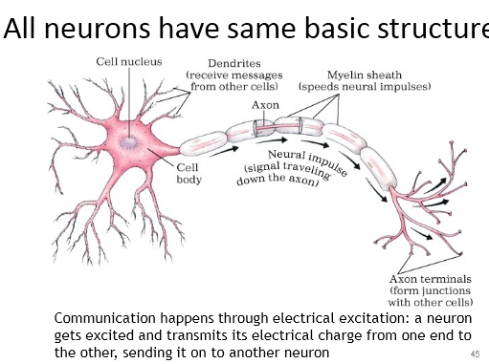
- NEURONS: a nerve cell, the basic building black of the nervous system
  - Each consists of a cell body and its branching fibers
- DENDRITES: The branching fibers of the neuron
  - Receive message from other cells and conduct it towards the cell body
  - The bushy, branching extension of a neuron that receives messages and conduct impulses towards the cell body
- From there the AXON FIBER pass the message along to other neurons or to muscles or glands
- AXON: the extension of the neuron, ending in branching terminal fibers, through which messages pass to other neurons or to the muscles or glands.
  - AXON speak, DENDRITES listen
  - AXONS can be very long , projecting several feet through the body.
  - Motor neurons, which control muscles are the neural system’s giant redwood
  - A neuron carrying orders to a leg muscle ha a cell body and axon roughly the scale of a basketball attached to a rope 4 miles long.
- MYELIN SHEATH: a layer of fatty tissue
  - Layer of fatty tissue segmentally encasing the fivers of many neurons; enables vastly greater transmission speed of neural impulses as impulses hops from one node to the next
  - The myelin sheath insulated the axon of some neurons and helps speed their impulses. 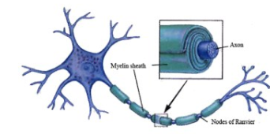
  - The importance of the sheath is evident in multiple sclerosis (a disease which deteriorates the myelin sheath)
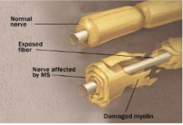
- Depending on the type of fiber, the neural impulse travels at speed ranging from a sluggish 2 miles per hour to 200 or more miles per hour
- Brain activity is measured in milliseconds, the brain is not faster than a computer when executing simple responses
  - A neuron fiber fires an impulses when it receives a message from sense receptors stimulated by pressure, heat or light, or when it is stimulated by chemical messages from neighboring neurons.
- The impulses, called ACTION POTENTIAL is a brief chemical charge that travels down the axon
  - ACTION POTENTIAL: is generated by the movement of positive charged atoms in and out of channels in the axon membrane.
  - IONS: the chemistry to electricity process involves the exchange of electrically charged atoms
- the INTERIOR fluid of the resting axon has an excessive of NEGATIVELY charged ions, while the fluid OUTSIDE the axon membrane has more PSOTIVELY charged ions
- the posistive-outside/negative inside state is called resting potential
  - the axon surface is selective about what it allows in
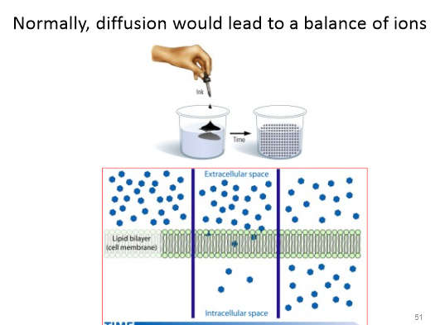
- When a neuron fires, the first bit of the axon opens its gate and the positively charged sodium ions flood in through the membrane.
- This depolarizes that part of the axon causing the axon channel to open and then the next like dominoes
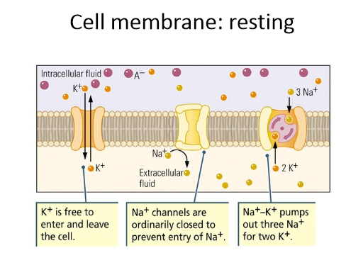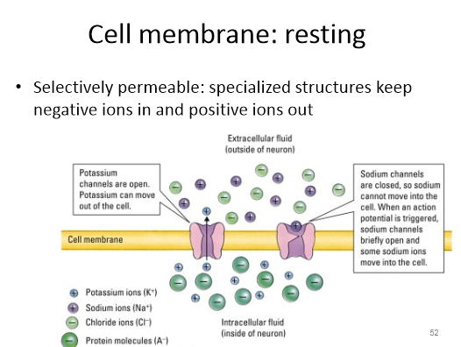
- During a resting pause (THE REFRACTORY PERIOD) the neuron pumps the positively charged sodium ions back outside
- Then it can fire again
- The action potential sped up by hopping from one myelin area to the next
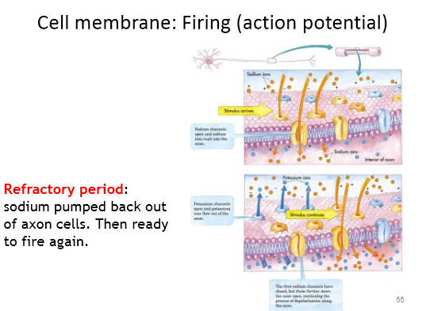
- The neuron is a miniature decision making device that performs some complex calculations. From hundreds of thousands of other neurons, it receives signals on its dendrites and cell body
- Most of the signals are excitatory (which accelerate) others are inhibitory (don’t move as much or are completely still)
- If the excitatory signal minus inhibitory signal exceeds a minimum intensity is called the THRESHOLD, the combined signals trigger action potential
- THRESHOLD: the level of stimulation required to trigger a neural impulse
  - The action potential transmits down the axon, which branches into junctions with hundreds or thousands of other neurons and with the body’s muscle glands
- Increasing the stimulus above the threshold, will not increase the action potential’s intensity
  - The neuron’s reaction is an all or nothing response
How Neurons Communicate
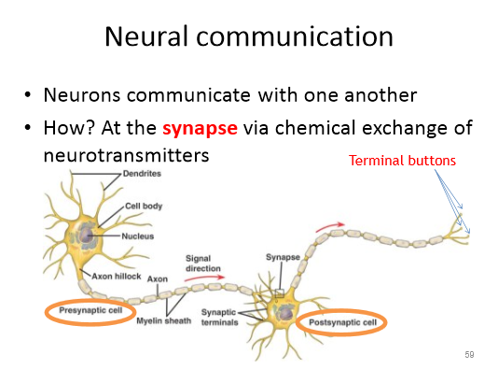
- Axon terminal of the neuron is in fact separated from the receiving neuron by a gap less than a millionths of an inch wide
- Charles Sherrington called this SYNAPSE and the gap is called the SYNAPTIC GAP or CLEFT
  - Dendrites and axons don’t quite touch
  - So how does information move: when the action potential reaches the knoblike terminals at an axon’s end, it triggers the release of chemical messengers called NEUROTRANSMITTERS
- NEUROTRANSMITTERS: chemical messengers that travel the synaptic gap between neurons. When released by the sending neuron, neurotransmitters travel across the synapse and bind to receptor sites on the receiving neuron, thereby influencing whether that neuron will generate a neural impulse neuron
  - Within 1/10 000th of a second, the neurotransmitter molecules cross the synapse gap and bind to the receptor sites on the receiving
  - This allows the ions to enter the recieving neuron thereby exciting or inhibiting the readiness to fire. Excess neurotransmitters are reabsorbed by the sending neuron in a process called reuptake
- REPUTAKE: the sending neuron normally reabsorbs excess neurotransmitter molecules
- Neural pathway in the brain may use only one or two neurotransmitters
  - ACETYLCHOLINE (ACh) is one of the best understood neurotransmitter. In addition to its role in learning and memory, ACh is the messanger at every junction btween motor neuron and skeletal muscle. When ACh is released to our muscle cells, the muscle contracts. If ACh transmission is blocked the muscle cannot contract
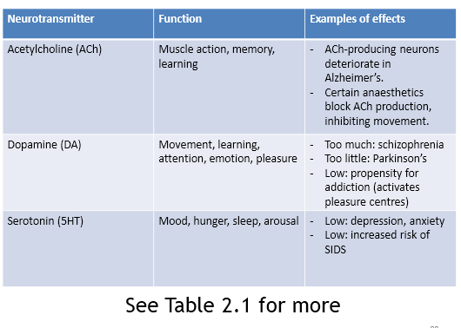
- Candice Pert discovered that morphine, an opiate drug that elevated mood and eases pain, bound to receptors in areas linked with mood and pain sensation could be tracked in animals brains
- Reserachers soon confirmed thst the brain does indeed contain several types of neurotransmitter molecules similar to the morphine.
  - This is also known as ENDORPHINS (short for endogenous morphine), these natural opiates re released in response to pain and vigorous exercise. They may therefore help explain good feelings such as runner’s high
How Drugs and other Chemicals Alter Neurotransmission
- Cannot flood brain with endorphins because the brain may stop producing its own natural opiates
  - These drugs can trigger unpleasant lingering after effects
- Various drugs affect communication at the synapse often by either exciting or inhibiting neuron’s firing.
- AGONISTS EXCITE
- the agonists molecule may be similar enough to the neurotransmitter to mimic its effects or it may block the transmitter’s reuptake
  - Some opiate drugs produce temporary high by amplifying normal sensations of arousal or pleasure
- ANTAGONIST INHIBIT
- An antagonist can be a drug molecule that inhibits neurotransmitter release
  - or it may be enough like the natural neurotransmitter to occupy its receptor site and block its effect but not similar enough to stimulate the receptor
- neurotransmitter research is leading to new therapeutic drugs to alleviate depression, schizophrenia and other disorders. Creating a drug is harder than it sounds.
- Scientists know, for example that the tremors of Parkinson’s disease result from the death of nerve cells that produce dopamine. Giving the patient dopamine doesn’t help because dopamine cannot cross the blood brain barrier. But some chemicals can slither through this barrier. One L-dopa, a raw material the brain can convert to dopamine, enables many patient to regain better muscular control.
The Nervous System
- Neurons are the elementary components of the nervous system, our body’s speedy electrochemical information network. The brain and spinal cord form the CENTRAL NERVOUS SYSTEM (CNS). The PERIPHERAL NERVOUS SYSTEM (PNS) links the central nervous system with the body’s sense receptors, muscles, and glands
  - NERVOUS SYSTEM: the body’s speedy electrochemical communication network, consists of all the nerve cell of the peripheral and central nervous system
  - CENTRAL NERVOUS SYSTEM: the brain and spinal cord
  - PERIPHERAL NERVOUS SYSTEM: the sensory and motor neurons that connect the central nervous system (CNS) to the rest of the body.
- The axon carrying this PNS information are bundled into the electric cables that aare knwn as nerves
  - NERVES: neural cables containing many axons, these bundled axons, which are part of the peripheral nervous system, connect to the central nervous systm with muscles, glands and sense organs.
- E.G: The optic nerve bundles a million axon fibers into single cable carrying the information that each eye sends to the brain
- Information travels in the nervous system through three types of neurons, the sensory neurons, motor neuron, interneurons
  - SENSORY NEURONS: sends information from the body’s tissues and sensory organs inwards to the central nervous systeem’s brain and spinal cord which process the m’s brain and spinal cord which process the m’s brain and spinal cord which process the information. The central nervous system then sends instructions out to the body’s tissues via MOTOR NEURONS. In between the sensory input and the motor output, information is processed by the central nervous system’s internal communication via INTERNEURONS. Our complexity mostly resides in our interneuron system.
  - SENSORY NEURONS: neurons that carry incoming information from the sense receptors to the central nervous system
  - MOTOR NEURONS: neurons that carry outgoing information from the central nervous system to the muscles and glands
  - INTERNEURONS: central nervous system neurons that internally communicate and intervene between the sensory inputs and motor outputs
The Peripheral Nervous System
Peripheral nervous system has 2 componenets-SOMATIC AND AUTOMATIC
- SOMATIC NERVOUS SYSTEM: enables voluntary control of our skeletal muscles
  - Somatic nervous system: the division of the peripheral nervous system that controls the body’s skeletal muscles. Also called the skeletal nervous system
  - The somatic nervous system will report to your brain the current state of your skeletal muscles and carry instructions back triggering your hand or leg etc..
- AUTONOMIC NERVOUS SYSTEM: controls glands and the muscles of our internal organs
  - Usually operates on its own-heart beat, digestion and glandular activity
  - AUTONOMIC NERVOUS SYSTEM: the part of the peripheral nervous system that controls the glands and the system that controls the glands and the muscles of the internal organs such as the heart. Its sympathetic tic division arouses its parasympathetic division calms.
- The automatic nervous system is a dual system
- THE SYMPATHETIC NERVOUS SYSTEM: if something alarms,v enrages or challenges you they sympathetic system will accelerate your heartbeat raise your blood sugar and cool with perspiration, making you alert and ready for action.
  - THE SYMPATHETIC NERVOUS SYSTEM: the division of the automatic nervous system that arouses the body, mobilizing its energy in stressful situations
- THE PARASYMPATHETIC NERVOUS SYSTEM: produces opposite effects. It conserves energy as it calms you by decreasing your heartbeat etc..
  - THE PARASYMPATHETIC NERVOUS SYSTEM: the division of the automatic nercous system that calms the body, conserving energy
- The sympathetic and parasympathetic nervous system work together to keep us in a steady state.
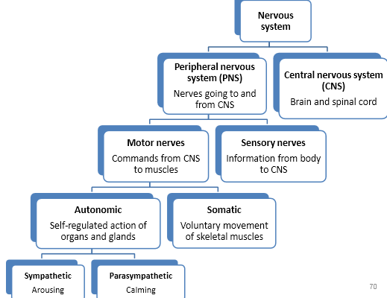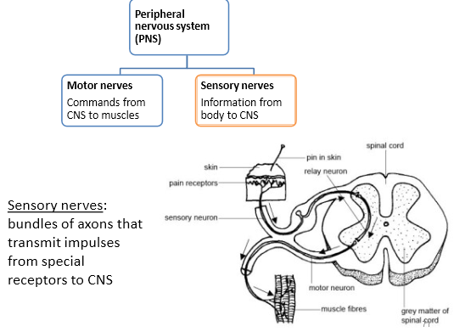
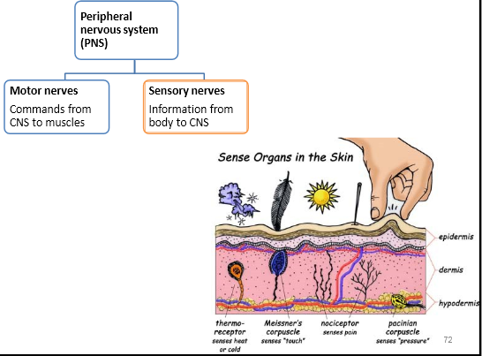
The Central nervous system
- The central nervous system’s spinal cord is an information highway connecting the peripheral nervous system to the brain. Ascending neural fibers send up sensory information, and descending fibers send back motor control information
- The neural pathway is connected to our reflexes,
  - A simple spinal reflex pathway is composed of single sensory neuron and single motor neuron and often communicate through a interneuron. These interneurons resond by activating motor neurons to the muscle in your arm
- REFLEX: a simple automatic inborn response to a sensory stimulus, such as the knee jerk response
The brain and neural networks
- The brain receives information and interprets it and decides responses. Each neuron connects with thousands of others. Neuron cluster into working groups called NEURON NETWORKS
  - Neuron networks work with nearby neurons. The cells in each layer of a neural network connect with various cells in the next layer. Learning occurs as feedback strengthens connections that produce certain results, such as practicing the piano. Neurons that fire together wire together.
- NEURAL NETWORK: interconnected neural cells. With experience, networks can learn, as feedback strengthens or inhibits connections tht produce certain results. Computer simulations of neural networks show analogous learning.
- One neural network is interconnected with other networks that do different things in our brain.
The Endocrine system
- Interconnected with the nervous system is the ENDOCRINE SYSTEM
- The endocrine system’s glands secrete another form of chemical messenger, hormones. Hormones originate in one tissue, travel through the bloodstream, and affect other tissues, including the brain. When they act on the brain, they influence our interest in sex, food, and aggression
  - ENDOCRINE SYSTEM: the body’s slow chemical system, a set of glands that secrete hormones into the blood stream
  - HORMONES: chemical messengers. Mostly those manufactured by the endocrine glands, that are produced in one tissue and affect another
- Some hormones are chemically identical to neurotransmitters. The endocrine system and the nervous system are therefore kindred systems. They both secrete molecules that activate receptors elsewhere
- Endocrine messages are not fast like the nervous system, they are vastly slower
  - Several seconds or more may elapse before the bloodstream carries a hormone from an endocrine gland to its target tissue.
  - These endocrine messages are often worth the wait because their effects usually outlast the effects of a neural message. And helps explain why sometimes after our conscious mind is distracted from stressful news, we have a lingering feeling something is not right. Under the infleucne of hormones and nonverbal brain areas, the feeling outlasts the thought—until we recapture the awareness and perhaps feel relief at recalling the reason for our discomfort.
- The endocrine system’s hormones influence many aspects of our life-growth, reproduction, metabolism, mood—working to keep everything in balance while we reponse the the exertion of our own thoughts
  - During a moment of danger the ADRENAL GLANDS on top of the kidenys release epinephrine and norepinephrine (also called adrenaline and noradrenaline) these hormones increase heart rate, blood pressure and blood sugar providing us with engery
  - ADRENAL GLANDS: a pair of endocrine glands just above the kidneys. The adrenals secrete the hormones epinephrine (adrenaline) and norepinephrine (noradrenaline) which helps arouse the body in times of stress
  - The most infleunctial endocrine gland is the PITUITARY GLAND, a pea sized structure located in the core of the brain, where it is controlled by an adjacent brain area called the HYPOTHALAMUS. The pituitary releases hormones that influence growth and its secretion also influences the release of hormones by other endocrine glands.
  - PITUITARY GLAND: the endocrine system’s most influential gland. Under the influence of the hypothalamus, the pituitary regulates growth and controls other endocrine glands.
- The feedbalc system (brain -> pituitary -> other glands -> hormones -> brain) reveals the intimare connection of the nervous and endocrine system: the nervous system.
- The endocrine system: is a set of glands that secretes hormones into the bloodsteam. These chemical messangers travel through the body and effect other tissues, including the brain. Some hormones are chemically identitcal to neurotransmitter. The endocrine system’s master gland, the pitutitary gland, inlfuences hormines release by other glands. In an intricate feedback system, the brain’s hypothalamus influences the pituitary gland, which influences other glands, which release hormones which inter influence the brain.
The Brain
- The brain enables the mind, seeing, hearing, smeling, feeling etc..
- Selective lesions can be used to get rid of tiny clusters or normal or defective brain cells, leaving their surrounding unharmed
  - LESION: tissue destruction. A brain lesion is a naturally or experimentally caused destruction of brain tissue
- Clinical observation:
  - Oldest method of brain observation
  - Observation of certain abnormalities seen amongst people have helped researchers to map out the brain
- Manipulating the brain:
  - Scientists can chemically or mangnetically stimulate various parts of the brain and note the effects. They can also surgically lesion tissue in specific brain areas in aminals
  - Shows activity but not location
- Recording the brain’s electrical activity
  - Electrival activity in the brain’s billions of neurons sweep in regular waves across its surface. The Electroencephalogram (EEG) is an amplified reading out of the waves.
- Neuroimaging Techniques
  - Position emission tomography scan (PET) depicts brain activity by showing each area’s consumption of its chemical fuel, the sugar gluscose. Active neurons are glucose hogs, a person is given a temporaily radioactive form of glucose and the PE scan locates and measures radioactivity, and determines its location
  - PET scans shows location when thing of something or talking about something or touching something
  - MRI (magnetic resonance imaging): the head is put in a strong magnetic field which aligns spinning atoms. The brief pulse of radio waves disorientate the atoms momentarily. When the atoms return to their normal spin, they release signals the provide images if their concentrations, resulting in detailed pictures of the brain’s soft tissue. The MRI scan can reveal a larger than average neural area in different people e.g musicians have a larger neural activity on the left brain
  - fMRI (functional MRI) can reveal the brain’s function as well as its structure
    - a person looking at a face for example, the fMRI machine detects blood rushing to the back of the brain, which processes visual information
    - Daniel Langdon and his collegues discovered that fMRI scans located increased brain activity associated with lying.
      - Increased two areas of the brain: the cingulated cortex- the area that is active when we typically experience conflicting urges, and
- Older brain structures
- • Indicators about an aminal’s capacities comes from its brain structures. In primitive animals, such as sharks , a not-so complex brain primarily regulates basic survival functions; breathing, resting and feeding
- • Rodents have more complex brain which enables emotion and greater memory
- o A brain that processes more information enables foresight as well
- The brainstem
- • The brain’s oldest and innermost region is the BRAINSTEM. It begins where the spinal cord swells slightly after entering the skull. This slight swelling is the MEDULLA. The MEDULLA is where the controls for you heartbeat and breathing are. Just above the medulla is the PONS which helps coordinate movement
- o BRAINSTEM: the oldest part and central core of the brain. Beginning where the spinal cord swells as it enters the skull. The brainstem is responsible for automatic survival functions
- the THALAMUS
  - sitting at the top of the brainstem is the thalamus. This joined with the egg shaped structure acts as the brains sensory switchboard. It receives information from all the senses EXCEPT SMELL (so hearing, seeing, tasting, and touching are controlled by the thalamus)
  - THALAMUS: the braiN’s sensory switchboard located on top of the brainstem, it directs messages to the sensory recieinvg areas in the cortex and transmits replies to the cerebellum and medulla
- the CEREBELLUM
  - enables one type of nonverbal learning and memory . it helps us judge time, modulate our emotions and discriminate colors and textures. It also coordinates voluntary movement
  - if you injured your cerebellum you would have issues walking , keeping your balance, or shaking hands -> movements would be jerky and exaggerated
  - our brain processes most of information outside of our awareness. We are aware of the results of our brain’s labour but not how we construct the visual image
  - CEREBELLUM: the little brain at the rear of the brainstem; functions include processing sensory input and coordinating movement output and balance.
The Lymbic system
- The boarder between the older parts of the brain and the cerebral hemisphere –the two halves of the brain –is the LYMBIC SYTEM
The Amygdala
- Process fear and rage, including perception of those emotions and the process of emotional memories
- The two bean shaped neural clusters influence aggression and fear
- Henrich and Bucy surgically lesions part of the rhesus moneky’s brain that included the amygdala. The monkey who was normally ill tempered turned mellow
- If the brain is electrically stimulated, revert back to irrational behavior
THE HYPOTHALAMUS
- just below the thalamus in the hypothalamus an important link in the chain of command governing bodily maintenance. Some neural clusters in the hypothalamus influences hunger , other regulate thirst, body temp and sexual behavior
- the hypothalamus both monitors blood chemistry and takes order from the other parts of the brain
  - e.g thinking about sex can stimulate you hypothalamus to secrete hormones. The hormones in tune trigger the adjacent master glands
    - we interplay between the nervous system and endocrine system: the brains influences the endocrine system which in turn influences the brain
  - Olds an Milner incorrectly placed the electrodes in what they later discovered was the rat’s hypothalamus, rats kept returning back to the stimulus
- Experimenters have found news ways of using the limbic stimulation to controlling animals actions
  - Sanjiv Talwar trained caged rats to navigate natural environments
  - To calm violent patients one neurosurgeon implanted electrodes in such areas which stimulated mild pleasure

