Chapter 2 – The Cell
2.1 Basic Features of Cell Structure and Function
1. Plasma Membrane (with lipids and proteins)
2. Hereditary Information – DNA or RNA
3. Metabolic Activities
4. Homeostasis - self-regulate and respond to environmental changes
5. Reproduction – self-replicating
Sizes of cells:  -Largest single cell: an egg, especially an ostrich egg (~13cm)  -Prokaryotes: 1-5 µm  -Eukaryotes: 10-30 µm  The human eye cannot see anything smaller than 0.1 mm (27).  Figure 2.3 (27)  Microscopy – technique to produce images of objects otherwise too small for the human eye | 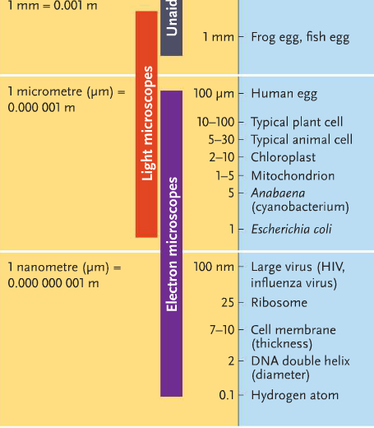

Why are cells so small? (27)
Cells are small to optimize surface to volume ratio (SA:V) to enhance:
- Exchange surfaces (nutrients entering in, wastes exiting etc)
An increase in the surface available for exchange raises the amount of exchange
taking place simultaneously.
- Diffusion is more effective over a shorter distance. Diffusion rates are very slow.
For example, (from class) oxygen diffuses at a rate of 78 days/m.
- Concentrations of substrate for metabolic processes
A certain concentration of substrate is required for a process to take place. If the volume is smaller, the cell does not have to dispense as much energy creating a lot of substrate.
Components of the Cell

Plasma Membrane (28)
-hydrophobic, phospholipid bilayer with embedded proteins
-semi-permeable to selective water-soluble substances
-protein channels and transport proteins for ease of moving specific substances across the cell
membrane

Cytoplasm (29)
Cytosol + Organelles + Cytoskeleton
-Synthesis of molecules and metabolism occurs in the cytoplasm
-Cytoplasm contains a lot of enzymes
-also conducts reactions to respond to cell signalling
Cytosol (29)
Aqueous solution of organic molecules and salts in the cell

2.2 Prokaryotic Cell

In prokaryotes, the single, circular DNA is found in the nucleoid region of the cytoplasm.

Cell Wall Glycocalyx
The cell wall provides rigidity to prokaryotic cells, and with the capsule, protects the cell from physical damages. In many prokaryotes, the wall is coat with an external layer of polysaccharides called glycocalyx. (31)
When the glycocalyx is diffused and loosely associated with the cell, it’s the slime layer.
gelatinous and firmly attached to the cell, it’s the capsule.
The glycocalyx allows the prokaryote to attach to a surface.
(Advantage: food source, avoid phagocytosis etc)

Plasma Membrane
*transport of material in/out of the cell, across the membrane
*metabolic systems, for example to generate ATP or photosynthesize, are found on the surface of the cell in prokaryotes (31)

Bacterial Flagellum

Sex Pili

2.3 Eukaryotic Cells
Plasma Membrane and Cell Wall

Proteins embedded in eukaryotic plasma membrane can function as (31):
1. Receptors for cell signalling
2. Important markers for identifying the cell to the immune system
3. Transport across the membrane (ex. protein channels)
4. In animal cells, recognition and adhesion proteins to the surface molecules of another cell
Cell wall – chitin for fungi
cellulose for plant cells

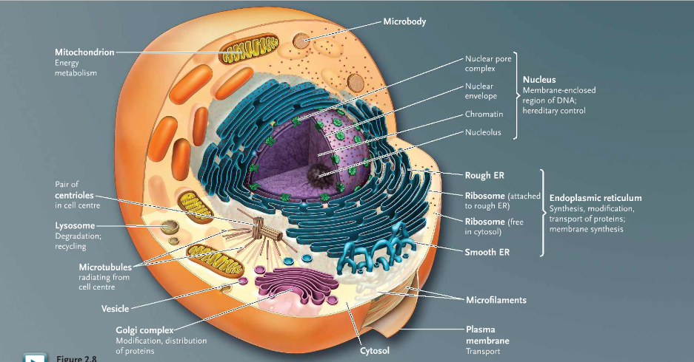
Figure 2.8: The animal cell (32)

Nuclear component (33)
Nuclear envelope:
-2 layers of membrane
-lamins line, network of protein filaments structuring the inner nuclear membrane
type of intermediate filament
Nuclear pore complex is composed of many nucleoporins, proteins that exchange components
between the cytoplasm and the nucleus.
Nucleoplasm is the fluid of organic substances and salts within the nucleus.

Chromatin = DNA + proteins
Chromosome = DNA only – one complete DNA molecule only
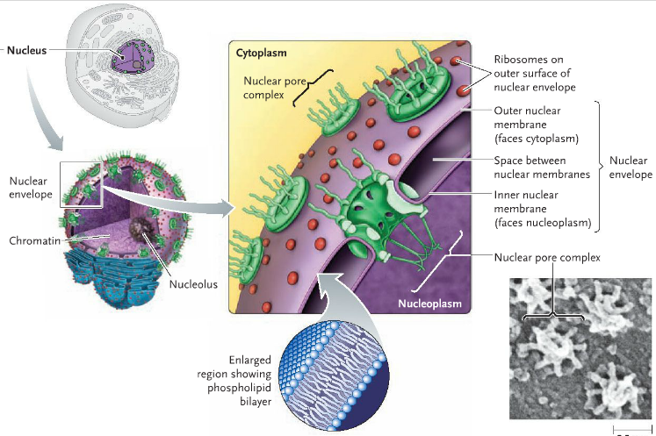
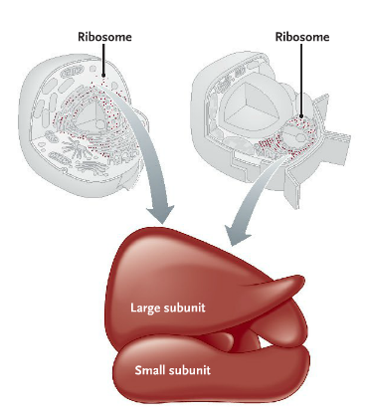
Nucleoli – contains genes for rRNA and synthesizes the rRNA

Ribosomes (34)
-synthesized in the nucleolus
-composed of 2 subunits
-function: protein translation
-can be attached to membrane surfaces
(ex. Rough endoplasmic reticulum) or free-floating in
the cytosol
Endomembrane system
includes the nuclear envelope, endoplasmic reticulum, Golgi complex, vesicles, lysosomes and plasma membrane. (34)
Vesicles: small membrane-bound compartments (cup-like) that transfers substances b/w parts of the endomembrane system
Endoplasmic reticulum: (35)
ER lumen: space between the enclosed membrane folding

Rough ER:
Ribosomes stud on the surface --> translation and protein synthesis
RER lumen --> protein folding and modifications
The proteins, made on ribosomes attached to the ER, enter the ER lumen where they fold into their final form. Chemical modifications (ex. addition of carbohydrate
groups to create glycoproteins) occur in the ER lumen. Proteins are then delivered to
other parts of the cell by pinching off in small vesicles from the ER membrane.
Smooth ER: (35)
-synthesis of lipids and steroids
-detoxification
For example, in liver cells, Smooth ER contains enzymes to convert drugs, poisons and toxic by-products into substances more tolerated by the body or more easily removed.

Cells have both rough ER and smooth ER, but the ratio between the two can vary depending on cell type.
For example, cells highly active in making proteins to release to outside the cell
(ex. pancreatic cells that make digestive enzymes) are packed with rough
ER, but have relatively little smooth ER
cells that primarily breakdown toxins (ex. liver cells) are packed with
smooth ER, but have less rough ER
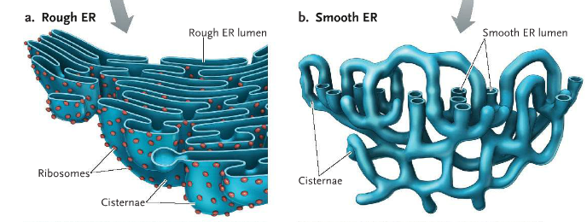

Golgi Apparatus/Complex: (36)
-consists of stacks of separated, flattened membrane sacs, called cisternae
-typically, there are 3-8 cisternae
-cells can have more than one Golgi complex. The number and size of Golgi complexes vary
between cell types.

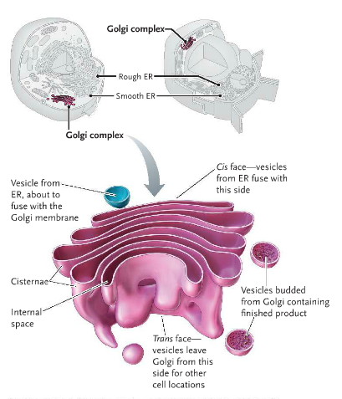
-Function:
- Modification of proteins within the Golgi complex
a) Modifying functional groups
ex. removing segments of amino acid chains to be replaced with small functional groups,
lipid units or carbohydrate units
b) Adding destination proteins and recognition proteins (36)
c) Sorting Proteins
- Transport – import compounds from the ER at the cis face
The Golgi complex receives proteins made in the ER and transported to the complex in vesicles.
The vesicle fuses with the membrane at the Golgi’s cis face, thus releasing their contents directly into the Golgi complex.
- Transport – export compounds from the Golgi complex at the trans face
Secretory vesicles – specialized vesicles that release the contents to the exterior of the
plasma membrane, by exocytosis
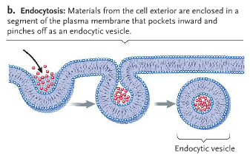
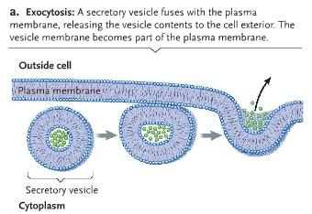

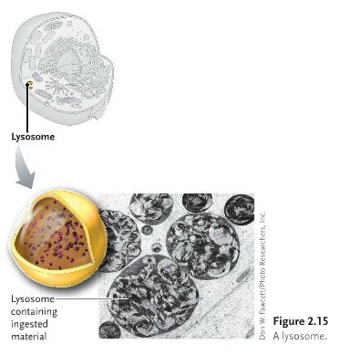
Lysosomes: (37)
-Membrane-bound vesicle organelle that contain more than 30 hydrolytic enzymes for digestion
of macromolecules
-Small (0.1-0.5 µm in diameter)
-pH within the lysosome is acidic, pH = 5 in a lysosome compared to pH=7.2 in the cytosol

Lysosomes are found in animal cells only, not in plants.
(The functions of lysosomes are carried out by the central vacuole in plants)

Lysosomes are formed by budding from the Golgi Complex and by having the enzymes dumping in at the same time. The enzymes are synthesized in the rough ER’s ribosomes and modified in the ER lumen. Afterwards, enzymes are transported through vesicles from the ER to the Golgi Complex to be packaged with a lysosome budding off.

Lysosomes digest food molecules entering the cell by endocytosis when the endocytic vesicle fuses with a lysosome.

Lysosomes have hydrolases.
Peroxisomes contain catalases.

In autophagy, lysosomes digest organelles that are not functioning correctly.
Phagocytosis

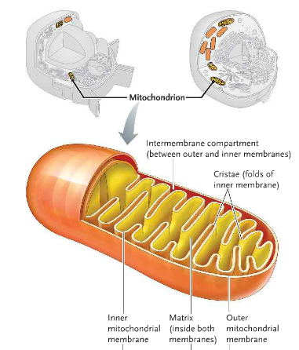
Mitochondria
~2 µm
-double membrane, cristae (see picture)
-oxidative metabolism yielding ATP
-has its own circular mDNA
-reproduce by binary fission, independently of the cell

2.4: Plant Organelles
Plastids (43)
are a family of plant organelles.

Amyloplasts – colourless plastids that store starch
Chromoplasts – contain red and yellow pigments, for protection
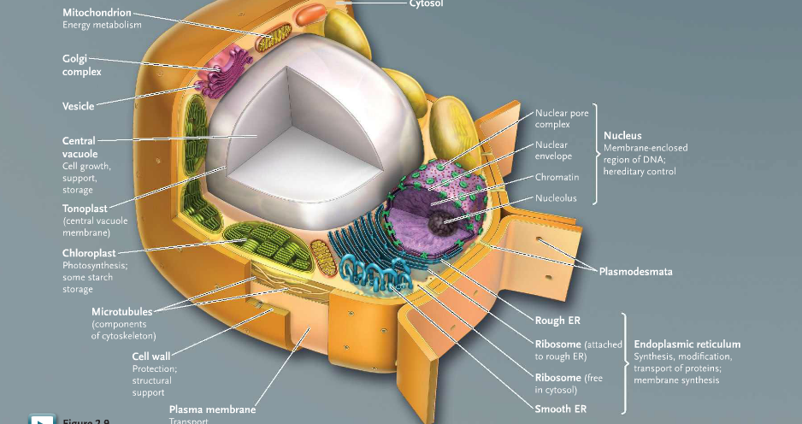
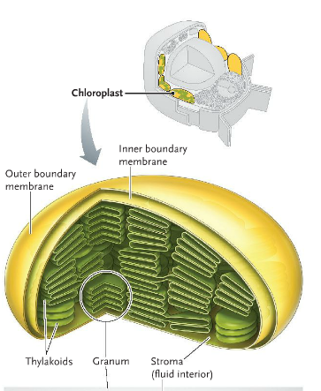
Figure 2.9: The plant cell (32)

Chloroplasts
~5 µm
-double membrane with thylakoids
-conversion of light energy into carbohydrates (photosynthesis)
-has its own circular cpDNA
-reproduces by binary fission, independent of the cell

Central vacuole:
-Turgor pressure
-Storage
-enzymes in vacuole to breakdown substances
Tonoplasts: membrane that surrounds the central vacuole
contains transport proteins to move substances into/out of the central vacuole

Plasmodesmata between cells at the cell wall

Endosymbiosis theory
Notes are in Chapter 3 *too lazy and unmotivated*
Support:
A. Similarities between prokaryotes and mitochondria/chloroplasts
1. Circular DNA, with no associated proteins
2. Binary fission reproduction, especially independent of the cell
3. Size: Prokaryote ~1-5 µm, Mitochondria ~ 3µm and Chloroplast ~ 5µm
4. Double membranes in chloroplasts/mitochondria

B. Parallelism with Elysia chlorotica

