ADM 1300 Notes:
September 13, 2011:
- Idea of management process.
-Describe the 4 basic functions that constitute the management process
- Management process of planning, organization, leading and controlling an enterprise’s financial, physical, human, and information resources to achieve the organization’s goals of supplying various product and services.
-Management efficiency means achieving the greatest level of output with a given amount of input; (doing things right)
-Management effictiveness means achieving the goals that have been set. (Doing things right)
-Managers can focus on being effective and will likely be efficient, but not vice versa.
2. The functions that are necessary in the management process:
-All managers plan, organize, direct and control day-to-day operations.
-POLC is involved. (Planning, Organizing, Leading, Controlling)
Steps of Planning:
- Goals are established for the organization
- Management identify weather a gap exists between desires and position (there is always a gap)
- Management develop plans to achieve desired goals. Goal = result desired, plans = how these goals are to be achieved.
- Thinking is converted into action. Therefore, the plans that have been decided upon are implemented.
- Effectiveness is assessed.
  - Actual results are compared with planned performance.
  - Plans may have to be modified and a different goal may have to be set.
A hierarchy of Plans:
- Strategic Plans: Set by top management
  - Reflect decisions about resource allocations, company priorities, and the steps needed to meet strategic goals
Tactical plans: Set by middle management
- Shorter range plans concerned with implementing specific aspects of the company’s strategic plans.
- They typically involve upper and middle management
Operational Plans: developed by middle management and lower-level managers that set short term targets for daily, weekly, and monthly performances.
Organizing: Involves mobilizing the resources that are required to complete a required task.
- Managers create the structure of the working relationship between organizational members that best allows them to work together and achieve goals.
- Managers will also lay out lines of authority and responsibility for members.
Leading: Involves interactions between management and their sub-coordinates as both work to meet the firm’s objectives.
- Leading is much more than just giving orders.
- Attempt to guide and motivate employees to work in the best interests of the organization.
- The outcome of the leading function is a high level of motivation and commitment from employees to the organization.
Controlling: Monitoring a firm’s performance to make sure that a firm meets its goals.
- Can show where performance is better than expected and thus can serve as a basis for providing rewards or reducing costs.
- Managers will monitor individuals departments, and the organization to determine if desired performance has been reached
- Managers will also take action to increase performance as required.
- The outcome of the controlling function is the accurate measurement of performance and regulation of efficiency and effectiveness.
Areas of Management:
- HR managers : Provide assistance to other managers when they are hiring employees, training them, evaluation their performance, and determining their compensation level.
- Operations Managers: They are responsible for the production systems that create goods and services
- Information Managers: They are responsible for designing and implementing systems that gather, process, and disseminate information
  - Dramatic increases in both the amount of information available to manage and the ability to mange it have lead to the EMERGANCE of this important function.
The Basic management skills:
- Technical: People develop their technical skills through education and experience. Those skills are associated with performing specialized task within a company
- Human relations: those skills are very important at all levels, but they are probably most important for middle managers, who must often act as bridges between top and first line managers, and managers from other areas of the organization.
  - Effective managers possess communication skills that help them to understand others and that can go a long way in maintaining good relations in an organization.
  - Thus, they are skills that enable managers to understand and get along with other people.

The basic management skills:
- Conceptual: A person’s ability to think in the abstract, to diagnose and analyze different situations and to see beyond the present situation.
  - They can also help managers analyze the probable outcomes of their decisions
- Time Management: The productive use that managers make of their time
  - Paperwork, telephone, meetings and email.
- Decision making: Choosing one alternative from one among several options,
  - Decision-making skills are the skills in defining problems and selecting the best courses of action.
September 20, 2011
The rational decision making process:
- The sparkle: Recognizing that a solution is necessary
  - The stimulus for a decision maybe either a problem or an opportunity
- Problem decision: A decision that is necessary when actual results do not conform to those expected
- Opportunity decision: taking new initiatives or doing a current activity more efficiently even if no problem exists
- Step One: Recognizing and defining the decision situation
  - Stimulus +/-
- Step two: Identifying Alternatives
  - Obvious and creative
  - The more important the decision, the more alternatives should be generated
  - Factors such as legal restriction, moral, and ethical norms and available technology can limit alternatives.
- Step Three: Evaluating alternatives
  - Feasibility, satisfactoriness and consequences
- Step Four: Selecting the best alternative
  - Choose the alternative that best fits the managers solution
  - It is the real crux of decision making
  - Decision makers should also remember that finding multiple acceptable alternatives may be possible, so selecting just one alternative and rejecting all others might not be a good decision.

- Step Five: Implementing the chosen alternative
  - The chosen alternative is implemented to the organizational system
  - One of the key things that mangers must deal with during implementation is employee resistance to change.
  - The reason for such resistance include insecurity, inconvenience, and fear of the unknown
  - Unanticipated consequences are still possible.
- Step Six: Following up and evaluating the results
  - The decision making processes requires managers to:
  - 1. Evaluate the effectiveness of their decision
  - 2. Make sure that the chosen alternative has served its original purpose
  - 3.Adpot an alternative that had previously been discarded
  - 4. Recognize that the situation was not correctly defined to behind and start the process all over again.

- The factors that inhibit accurate problem identification analysis
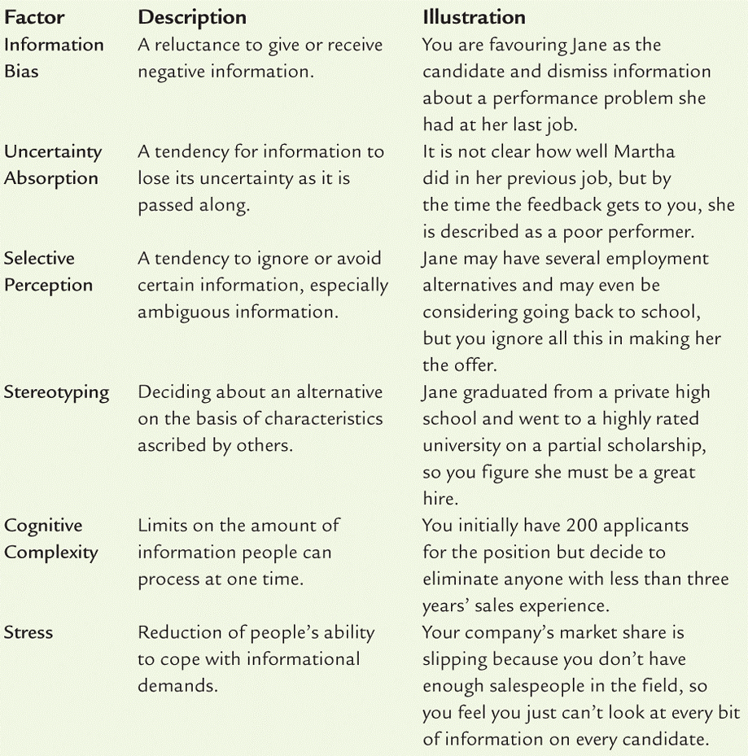

- Influences on the decision making process:
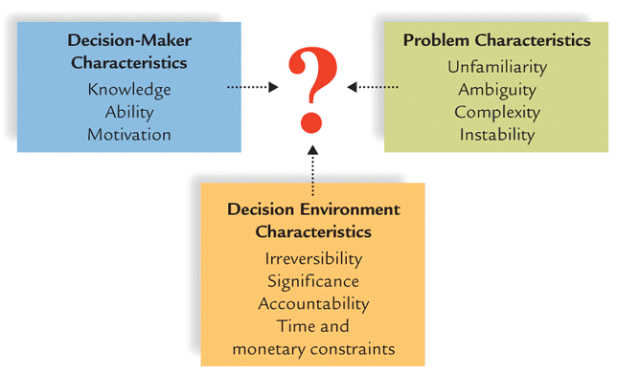

The behavioural aspects of decision making
- Non logical and emotional factors often influence managerial decision making
- Organizational politics: The acion that people take as they try to get what they want. (Organizational power and personal power)
- Intuition: An “Inner sense” or “hunch” usually based on years of experience and practice in making decisions in similar situations
- Escalation of commitment: When a manager makes a decision and the remains commited to its implementation in spite of clear evidence that it was a bad decision.
- Risk propensity: How much a manager is willing to gamble when making decisions. (Take risk?)
The strategic goals:
The starting point in effective management is setting strategic goals…
- Strategic management goals are the overall objectives that the business wants to achieve
  - What it itends to do in 1st step of an organiziation
  - Maybe the organization needs a strategy to achive its goals]

- Strategy: is the braod set of organizational plans for implementing the decisions made for achieveing goals.
- The four main purposes in organizational goal setting.
- Provides direction, guidance and motivation for all managers
- Helps firms allocate resources
- Helps to define corporate cultre
- Helps managers assess performance.

- The Mission Statement: An organization’s statement of how it will achieve its purpose in the enviroment in which it conducts its business.
  - Regardless of a company’s purpose and mission, ever firm needs to set long-term (5year or more into the future), Intermediate (1 to 5 years) and short-term goals. (less then one year)

SMART goals : Specific, Measureable, Achievable, Relevant
The strategy formulation involves three baisc steps:
- Setting strategic (smart) goals: what are thee kings of goals?
- Analyzing the organization and its enviroment (see SWOT)
- Matching the organiation and its enviroement

SWOT analysis is the identifcation and analysis of organizational strengthsand weaknesses and environmental OPPORTUNITIES AND THREATS as part of strategy formulation
Step 3:
- Is the heart of strategy forumuatlion.
- Matching enviromental threats and opportunities with corperate strenths and weaknesses
- This process may determinewhether a firm typically takes risks or behaves more conservatively.
Levels of Strategies:
- What is a corporate level strategy:
  - Identifies the various business that a compan will be in and how these businesses will relate to each other
- What is a business level strategy:
  - Identifies the ways a business will compete in its chosen line of products and or services.
- What is a functional strategy:
  - Identify the basic courses of action that each department in the firm will pursue so that it contributes to the attainment of businesses.

- A corporate level strategy could be:
  - A concetration strategy which involves focusing the company on one product or product line.
  - A growth strategy. All of which focuses on interal activities that will result in growth (Market penetration, products development and geographic expansion)
  - An intergraton strategy which focus on external activites that will result in growth. (Horizontal and Vertical intergration) or competitors vs. inputs and or Channels.
  - A diversification strategy means expanding into related prodcuts or market segments
    - Related diversification: Adding new, but related, prodcuts or serbices to an existing business
    - Conglomerate diversification: diversifying into produces or markets that are not related to the firm`s present business.
  - An investment reduction strategy means reducing the company`s investment in one or more of its lines of business.
    - Retrenchment: which means the reduction of activity or operations
    - Divestment: selling or liquidating one or more of a firm`s business.
- Business level (competivite) strategies are:
  - Cost leadership: becoming the low-cost leader in an industry.
  - Differentiation: Occurs when a firms tries to be unique in its industry along some dimension that is valued by buyers
  - Focus: selecting a market segment and serving the customers in that market niche better than competitiors.
- Functional strategies:
  - When the business level strategies are translated into supporting functional strategies ( see ares on management, chapter 1)
  - A functional strategy is the basic course of action that each depratment follows so that the business accomplishes its overall goals.
- A corporate culter is essential. This is the personality or the identity of a company.
- A corporate cultute represent the shared experiences, stories, beliefs, norms and ethical stance that characterize an organization.
- A strong corporate culture guides everyone to work toward the same goals and helps newcomers learn accepted behavious.
- The corporate culture is shaped by four fources which are fudamental:
  - The values held by top management help set the tone of the organization and influence its business goals and strategies:
  - A firm`s history also helps shape its culture;
  - Stories and legends are also important
  - A stonr behavioural norms help define and sustain corporate cultures.
- Communicating the culture:
  - Managers themselves must have a clear understanding of the culture
  - They must transmit the culture to others in the organization, specially to the newcomers;
  - A clear and meangingful statement of the organization`s missions is also a valuable communication tool
  - Managers can maintain the culture by rewarding and promoting those who understand and work towards mantaining it.
Sept. 23 2011: (Chapter Two)
- The managerial roles are about how managers spend their time at work. In other words, this typology was proposed by Henry Mitzberg and is based on the analysis of detailed accouints of work done by real managers.
- It is a classification of behaviours according to the roles that managers should develop earlier in their career
- The three major categories:
  - Interpersonal Roles
  - Informatonal Roles
  - Decisionial Roles
- Interpersonal roles: are composed of three types of behaviour and according to Mintzberg, are derived direectly from the manager’s formal authority granted byt the organization.
  - Figurehead: Involves taking part in ceremonial activities as a representatitve of the company
  - Leader: Influencing and directing others.
  - Liason: Maintaining contacts outside the formal chain of ommand and even outside of the company
- Informational Roles: This set of roles builds on the interpersonal relationships that a manager establishes and it underlines the importance of the network of contacts buit up and maintained by a manager
  - Moontior: Information seeking and gathering
  - Disseminator: Seeing that information gets to those who need acess to it
  - Spokesperson: Reporesenting the work of the product of a unit.
    - Students frequently have difficulity differentiating this role from that of the figurehead. IT may help to remind students that the figurehead is an interpoersonal role and spokesperson is an informational role.
    - Also, the figurehead usually represents the entire company in a ceremonial manner, where as the spokesperson repots information from his/her work group.
- Decisonal Roles: Classification system who relates to the decision making requirements of a managerial position.
  - Entrepreneur: Engaging in activites dealing with new projects, deciding which projects to adpot and which to close down.
  - Disturbance Handler: Settling conflicts among employees.
  - Resource allocator: Deciding how resources under one’s control will be distributed.
  - Negotiator: Representing the unit of organization in mediating agreements.
Managerial Job dimensions by stewart:
- Stewart proposed this typology as a way of directly comparing different jobs even when they seem totally dissimilar.
- Demands: What a managater MUST do. ( activities or duties)
  - Ex. Include travel, number of meetings each week, number of direct reports, etc.
- Constraints: Factors thatl imit a potential respones by the manger to various demands (time, budgets, technology attridues, and regulartions)
  - Constaints can be their yearly buget, time to complete a project, any other scarce resource.
- Choices: The range and amount of discretion allowed to a manager in responding to demands. Despite demands, depsite contraints there is always room for some abount of discretionary behaviour in any managerial job.
  - Choices could be sales area, workgroup personnel,and scheduling of tasks.
Five key questions: Q1, Q4, Q6, Q15, Q17 page 76 in the textbook.

Chapter Three:
Quick facts according to industry canada:
- A business must have at least one paid employee and annual sales revenue of 30,000 or more or be incorporated.
- A goods-producing business if it has fewter than 100 employees, while a service producing business is considered small if it has fewer then 50 employees.
- There are 2.3 million “business establishment” in Canada, and about 2.5 millon people who are “self-employed”
- The majority of businesses in Canada have no employees (just the owner) 97.7% of all employer businesses in canada are “Small”
- Account for over 2/3 employment in for industries:
  - Non-insitutional health care
  - Construction
  - Accodomoation and food
  - Other services

- Definiation of a small business:
  - An owner managed business with fewer then 100 employees.
- A business is considered to be new if it has become operational within the previous 12 months
- If it adpots any of the main organizational forms such as proprietorship, partnership, corporation, or co-operative…
- If it sells goods or services
- Defition of new venture:
  - A recently formed commerical organization that procies good and/or services for sale.
- The Family Business:
  - About 2/3 of canadian business enterpries are controlled by famalies. (Usually through private corporations)
  - It is estimated there are 10000 family businesses in canada with two or more genrations as owners or managers
  - Family businesses control about ½ of the 100 largest companies in Canada
  - Founder or family members are in executive positions
  - Family members hold sufficent shares to make ecisions and control operations
  - Approximatley 25% of family businesses survive the founder’s demise; about 10% survive beyone two generations and 3% beyond the third.
- Over the last centruty the canadian business sector has seen a shift from a system of enterprises more or less lososely connected by competition through the marketplace to a corporate system that now dominates the scene.
- Reasons for success
  - Hard work, drive, dedication;
  - Market demand for the product or service;
  - Managerial competence;
  - Luck….
- Reasons for failure:
  - Managerial incompetence, or inexperience
  - Neglect
  - Weak control systems
  - Insufficent captial
- External enviroment: A set of forces and conditions outside the organization that can potenitally influence its performance.
  - Divided into two related distince categories
    - External general enivroment
    - External task enviroment
- General Enviroment: Forces that typically influence organization’s external task enviroment and thus the organization itself.

149 – 1 2 3 4 12 17

Social responsibility
- Corporate social responsibility (CSR); refers to the way in which a business tries to balance its commitments to organizational stakeholders
Social responsibility: The manager’s duty to nurture, protect and enhance the welfare of stakeholders.
- Social responsibility perspective (firms have responsibilities and obligations to society as a whole, not just shareholders)
Stakeholders
- Customers, emploees, financiers. Suppliers, communities, society at large and shareholdeers
- To maximize the return to shareholds wouldt ake away returns owned to the other stakeholders
- Concerns with social resposibility perspective
- Defining exactly what is reasonable or legitimate returns
- Shareholders have confliting and competing concerns
Enviromental responsibility issues
- Air pollution
- Water pollution
- Land pollution
Customer reponsibility issues
- Rights of concerns
- Unfair pricing
- Ethics in advertising
Consumer rights issues:
Consumerism
- Social movement that seeks to protect and expand the rights of consumers in their dealings with the business
Consumers rights
- Right to safe products
- Right to be informed
- Right to be heard
- Right to choose what they buy
- The right to be educated about purchases
- The right to couretous service
Unfair pricing issues
- Illegal pricing practices may occur due to intentional limiting of competition
- Collusion
  - A group of companies conspiring to fix prices
  - Results in inflated prices and a lack of competition
- Price gouging during shortages
Ethics in advertising
- Truth in advertising claims
- Advertising of counterfeit brands
- Stealth (undercover) advertising
  - Paying individuals to speak well of a product but not admit they are being paid to do so
- Morally objectionable advertising
Empolyee responsibility issues:
- Human resource management issues
  - Provide equal opportunity for rewards and advancement without discrimination
- Social resposibility issues
  - Safe workplace, no abuse
- Privavy issues
- Drug testing
- Computer monitoring
- Encouraging ethical behaviour
  - Whistle blowers

Encouraging ethical employee behaviour
- Top management support for ethical behaviour is critial
- Whistle blowers are employees who call attention to unethical behaviour
- The company should support its whistle blowers rather than threatening them with dismissal or other penalties
- There is no legislation to protect whistle blowers.
Responsibility towards investors
- Improper financial management
- Kiting cheques
- Insider trading
- Misrepresentation of finances
Improper financial management
In the ppt presentation

Cheque kiting
- Illegal practice of writing cheques against money that has not yet arrived in the bank account.
- A creative cheque kiter can write cheques from account to account with very little money to back it up
Insider Trading
- Using cofidential information to gain from the sale of stock
- Involves gaining knowledge of inside information about the company prior to making the purchase
- Can involve thecollusion of investors buying and selling stock at the appropriate time to make huge profits.
Misrepresenting finanical information
- Companies must conform to accounting guidelines called (GAAPs)
- Failure to follow GAAp in order to inflate expected profits figures can mislead investors
Approaches to social responsibility
- Accommodative sapproach: managers realize they need for social responsibility
  - Try to balnce the interests of all stakeholders
- Proactive approach: manage actively embrase social responsibility
  - Go out of their way to learn about and help stakeholders
Arguments for social responsibility
Business helped to create manyt of the social problems that exist today, so it should play a significant role in solving them. Especially in the areas of pollution reduction and cleanup
Business should be more responsible because they have the financial and technical resources to help solve social prolmes
As members of soceity businesses should do their fair share to help others
Socially responsible decision making by businesses can prevent increased govt regulation
Socialr esponsiblity is necessary to ensure economic survival: if businesses want educated and healthy eomplyees, customers with bmoney to spend, and suppliers with quality goods and services in years to come, they must take stepts to helpsolvesocial and eviromental problems that exist today
- Participation in social programs give businesses greater power, perhaps at the expennsse of particular segments of society
- Some people question whether business has the expertise needed to assess and make decision s about social problems

