Lesson 1
1a.) 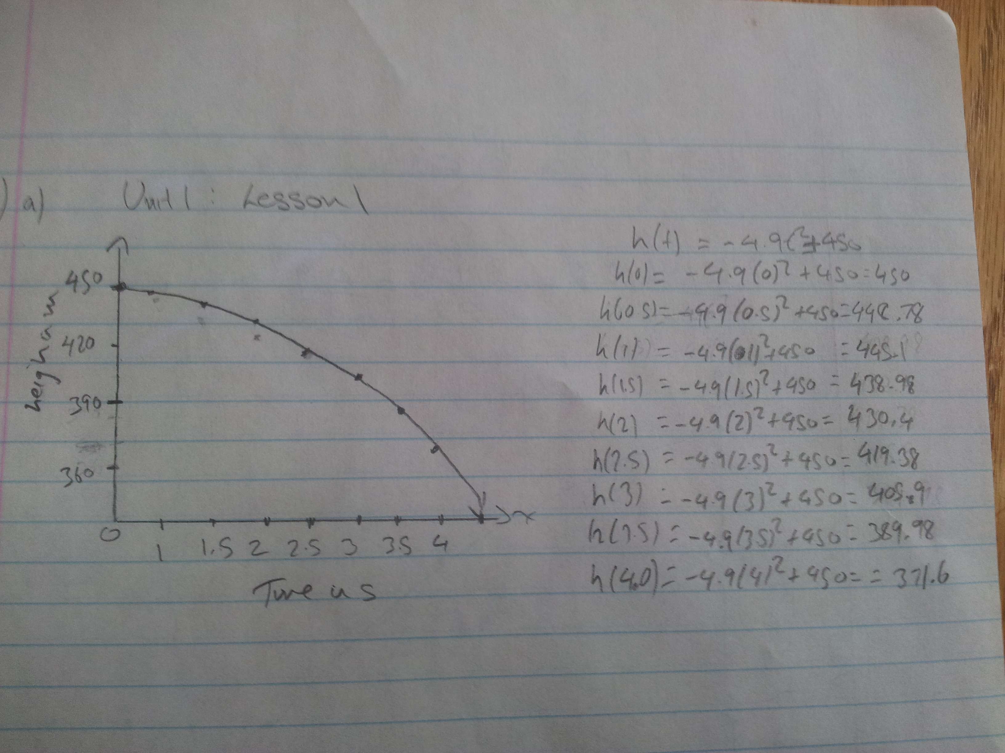

1b.) Find the average rate of velocity for the first 2 seconds after the ball was dropped.
Answer: the average velocity of the ball between t=0 and t=2
= $\frac{h\left(2\right)-h\left(0\right)}{2-0}$
$=\frac{430.4-450}{2}$
= -9.8

1c.) Find the average velocity for the following intervals:
Answers:
i) 1$≤$ t $≤$ 4
$= \frac{h\left(4\right)-h\left(1\right)}{4-1}$
$= \frac{371.6-445.1}{3}$
$= -24.5$ seconds

ii) 1$≤$ t $≤$ 2
$= \frac{h\left(2\right)-h\left(1\right)}{2-1}$
$= \frac{430.4-445.1}{1}$
$= -14.7$ seconds
iii) 1$≤$ t $≤$ 1.5
$= \frac{h\left(1.5\right)-h\left(1\right)}{1.5-1}$
$= \frac{438.98-445.1}{0.5}$
$= -12.24$ seconds

1d.) Use the secant method to approximate the instantaneous velocity are t = 1 second.
Answer:
$= \frac{h\left(1\right)-h\left(0.9\right)}{1-0.9}$
$= \frac{445.1-446}{0.1}$
$= -9$

2a.) When will all the sugar dissolve?
Answers:
M= 10.5 – 0.4$t^{2}$
0 = 10.5 – 0.4$t^{2}$
-10.5 = – 0.4$t^{2}$
$$\frac{-10.5}{-0.4}= \frac{-0.4t^{2}}{-0.4}$$
$\sqrt{26.25}$ = $\sqrt{t^{2}}$
5.12 s = t
2b.) Find the average rate of change at the interval $0 ≤t ≤1$
= 10.5 – 0.4${(0)}^{2}$ =10.5 – 0.4${(1)}^{2}$
= 10.5 = 10.1
$=\frac{10.1-10.5}{0.1}$
$=\frac{-0.4}{-1}$
$=0.4$ seconds

2c.) 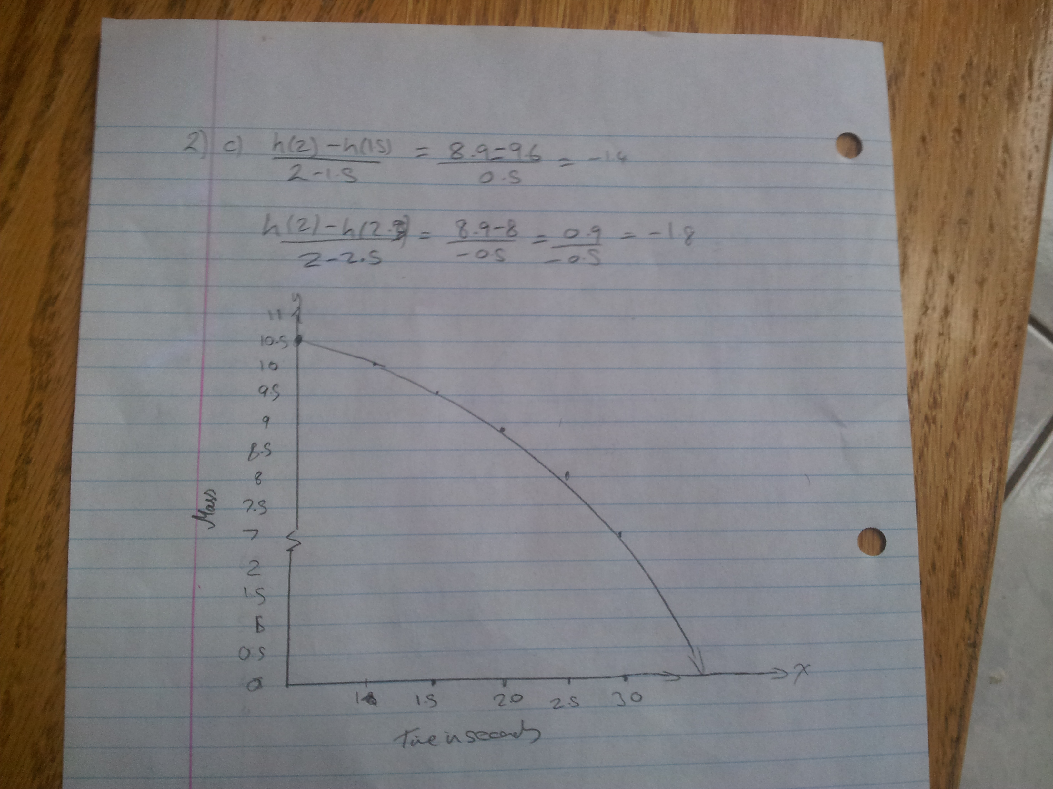

3a)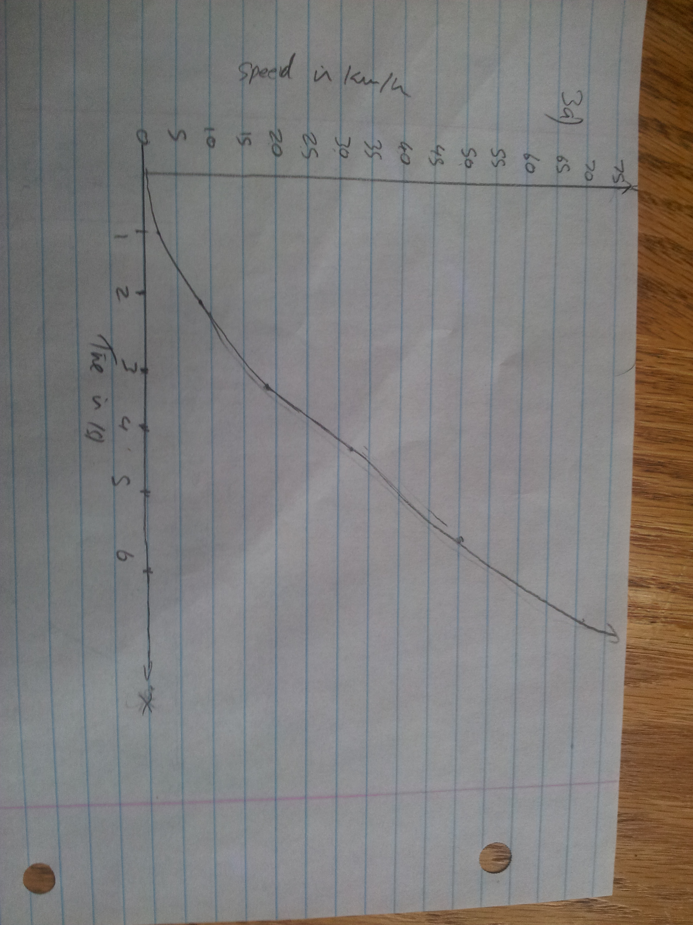

3b.) Calculate the average speed when $4 ≤t ≤7.$
$= \frac{d\left(7\right)-d\left(4\right)}{7-4}$
$= \frac{98-32}{7-4}$
$= \frac{66}{3}$
$= 22$ km/h
3c.) Use the secant method to approximate the instantaneous velocity at t = 4 seconds.
$= \frac{d\left(4\right)-d\left(3.5\right)}{4-3.5}$
$= \frac{32-24.5}{4-3.5}$
$= \frac{7.5}{0.5}$
$= 15$ km/h

Lesson 2

4a) Since we are trying to determine the Instantaneous Rate of Change of a specific point, but the formula $\frac{f\left(a+h\right)-f(a)}{\left(a+h\right)-a}$ only allows us to calculate the average rate of change of 2 separate points. In order to compensate for this, you need to develop 2 points that are VERY close to each other. In order to select the second point you would have to select a second point in the form of (a+h), f(a+h), where h is 0.1, 0.001, 0.0001. Once that is accomplished, you can calculate the rate of change at a specific point “a” using the formula
$=\frac{f\left(a+h\right)-f(a)}{\left(a+h\right)-a}$

4b.) Evaluate the following limits:

i) $\lim_{x→0}{\frac{x-3}{2x^{2}-5}}$
= $\lim_{x→0}{\frac{0-3}{2{(0)}^{2}-5}}$
$= \frac{-3}{-5}$
$= \frac{3}{5}$
ii) $\lim_{x→2}{\frac{2x^{2}-7x+6}{x-2}}$
$= \lim_{x→2}{\frac{(2x-3)(x-2)}{x-2}}$
$= \lim_{x→2}{2x-3}$
$= 1$
5a.) What is the instantaneous velocity of the ball at t = 2 seconds?
$$\lim_{h→0}{\frac{f\left(a+h\right)-f(a)}{h}}$$
$$\lim_{h→0}{\frac{\left[-5\left(2+h\right){}^{2}+20\left(2+h\right)+1 \right]-(-5{\left(2\right)}^{2}+20\left(2\right)+1}{h}}$$
$$\lim_{h→0}{\frac{5h^{2}}{h}}$$
$$\lim_{h→0}{\begin{aligned}5h=0 \\ \end{aligned}}$$
Therefore the Instantaneous Velocity at t=2 is 0m/s

5b.) Show that the particle is at rest when t = 4.

$$\lim_{h→0}{\frac{f\left(a+h\right)-f(a)}{h}}$$
$$\lim_{h→0}{\frac{\left[\left(4+h\right){}^{2}-8\left(4+h\right)+15 \right]-[4^{2}-8\left(4\right)+15]}{h}}$$
$$\lim_{h→0}{\frac{\left[16+8h+ h{}^{2}-32-8h=+15 \right]-[-1]}{h}}$$
$$\lim_{h→0}{\frac{h^{2}}{h}}$$
$$\lim_{h→0}{h=0}$$
Therefore the Instantaneous Velocity of the particle at t=4 is 0m/s,
This would imply that the particle was at a stationary position at 4 seconds.

Lesson 3
6a.) The function is increasing $x<-1 and x>1$, hence its instantaneous rate of change is positive. The function is decreasing when $-1<x<1$, hence its instantaneous rate of change is negative.

6b.) The rate of change is zero at $x= -1 and x=1.$

6c.) $f\left(-1\right) is the local maximum and it is 2.$
$f\left(1\right) is the local minmum and it is-2$.

7a,)
At x=0
f(0+h) – f(0) =2(0+h)³ – 7(0+h)² + 4(0+h) +1 -2(0)³ -7(0)² +4(0) + 1
f(0+h) – f(0) =2(h)³ – 7(h)² – 4h + 0
$$\lim_{x→0}{\frac{h\left(2h^{2 }-7h-4\right)}{h}}$$
$$\lim_{x→0}{f\left(x\right)=4}$$
The IRC at x = 0 is 4

At x=1
f(1+h) – f(1) =2(1+h)³ – 7(1+h)² + 4(1+h) +1 -2(1)³ -7(1)² +4(1) + 1
f(1+h) – f(1) =2(h)³ – (h)² – 4h + 0
$$\lim_{x→0}{\frac{h\left(2h^{2 }-h-4\right)}{h}}$$
$$\lim_{x→0}{f\left(x\right)=-4}$$
The IRC at x=1 is -4

7b.) The function is increasing at x = 0, and decreasing at x = 1, since at x =0 it is at 4, but then at x=1 it decreases down to -4.

7c.) Yes there will be a local max as it increases at x=0 and then decreases at x=1. Also given that it is a quadratic function, it is logical to assume that there will be a local max between x=0 and x=1
Lesson 4

8a.) $f\left(x\right)= x^{2}-2x+1$
$\frac{f\left(x+h\right)-f(x)}{h}= \frac{{\left(x=h\right)}^{2}-2\left(x+h\right)+1-x^{2}+2x-1}{h}$
$= \frac{x^{2}+2xh+h^{2}-2x-2h+1-x^{2}+2x-1}{h}$
$= \frac{2xh+h^{2}-2h}{h}$
$=2x+h-2$
$\lim_{h→0}{\frac{f\left(x+h\right)-f\left(x\right)}{h}}= \lim_{h→0}{2x+h-2}$
$=2x-2$

8b.) $f\left(x\right)=x^{3}-3x^{2}$
$\frac{f\left(x+h\right)-f\left(x\right)}{h}= \frac{{\left(x+h\right)}^{3}-3{\left(x+h\right)}^{2}-x^{3}-3x^{2}}{h}$
$=\frac{x^{3}+x^{2}h+2x^{2}h+2xh^{2}+xh^{2}+h^{3}-3x^{2}-6xh-3h^{2}-x^{3}+3x^{2}}{h}$
$=\frac{3x^{2}h+3xh^{2}+h^{3}-6xh-3h^{2}}{h}$
$=\frac{h\left(3x^{2}+3xh+h^{2}-6x-3h\right)}{h}$
$=3x^{2}+3xh+h^{2}-6x-3h$
$$\lim_{h→0}{3x^{2}+3xh+h^{2}-6x-3h}=3x^{2}+0+0-6x-0$$
$=3x^{2}-6x$
8c.) $f\left(x\right)=\sqrt{2x}$
$\frac{f\left(x+h\right)-f\left(x\right)}{h}= \frac{\sqrt{2\left(x+h\right)}- \sqrt{2x}}{h}$
$= \frac{\sqrt{2\left(x+h\right)}- \sqrt{2x}}{h} x \frac{\sqrt{2(x+h)}+ \sqrt{2x}}{\sqrt{2(x+h)}+ \sqrt{2x}}$
$= \frac{\left({\left(\sqrt{\left(2x+h\right)}\right)}^{2}-{\left(\sqrt{2x}\right)}^{2}\right)}{h\left(\sqrt{2\left(x+h\right)}+ \sqrt{2x}\right)}$
$= \frac{2x+2h-2x}{h\left(\sqrt{2\left(x+h\right)}+ \sqrt{2x}\right)}$
$=\frac{2h}{h\left(\sqrt{2\left(x+h\right)}+ \sqrt{2x}\right)}$
$= \frac{2}{\sqrt{2\left(x+h\right)}+ \sqrt{2x}}$
$\lim_{h→0}{\frac{2}{\sqrt{2\left(x+h\right)}+ \sqrt{2x}}}= \frac{2}{2\sqrt{2x}}$
$= \frac{1}{\sqrt{2x}}$
8d.) $f\left(x\right)= \frac{4}{x+1}$
$\frac{f\left(x+h\right)-f\left(x\right)}{h}= \frac{\frac{4}{x+h+1} – \frac{4}{x+1}}{h}$
$= \frac{\frac{4x+4-4x-4h-4}{\left(x+h+1\right)\left(x+1\right)}}{h}$
$= \frac{-4h}{h\left(x+h+1\right)\left(X+1\right)}$
$= \frac{-4}{\left(x+h+1\right)\left(X+1\right)}$
$\lim_{h→0}{\frac{-4}{\left(x+h+1\right)\left(X+1\right)}} = \frac{-4}{(x+1)(x+1)}$
$= \frac{-4}{{\left(x+1\right)}^{2}}$

9.) We can use the difference table as well as the first difference principles to find the derivative. For each x value on the cubic function there is a tangent to an individual x value. SO you make ordered pairs for each individual value and the respective slope of the tangent for each x value. Now we can calculate the second differences. If the second differences are all equal than we can come to an answer that the derivative of a cubic function is indeed a quadratic.

Lesson 5
10a.) $f\left(x\right)=x^{4}-2x^{2}+x$
$=4x^{3}-4x+1$

10b.) $f\left(x\right)={\left(x^{2}-3x\right)}^{2}$
$=2{\left(2x-3\right)}^{'}\left(x^{2}-3x\right)$

10c.) $f\left(x\right)=\left(x^{2}+2\right)\left(2x^{3}-5x^{2}+4x\right)$
$=\left(x^{2}+2\right)\left(6x^{2}-10x+4\right)+\left(2x\right)\left(2x^{3}-5x^{2}+4x\right)$
$=6x^{4}-10x^{3}+4x^{2}+12x^{2}-20x+8+4x^{4}-10x^{3}+8x^{2}$
$={10}^{4}-20x^{3}+24x^{2}-20x+8$

10d.) $f\left(x\right)= \sqrt{x}-\sqrt[3]{x}$
$=x^{\frac{1}{2}}-x^{\frac{1}{3}}$
$= \frac{1}{2}x^{-\frac{1}{2}}-\frac{1}{3}x^{-\frac{2}{3}}$
$= \frac{1}{2\sqrt{x}}- \frac{1}{3\sqrt[3]{x}}$

10e.) $f\left(x\right)= \frac{-6x^{2}}{{(x}^{2}+4)^2}+\frac{3x}{x^{2}+4}$
$= \frac{\left({-3x}^{2}+12\right)}{{\left(x^{2}+4\right)}^{2}}$

$= \frac{-3\left(x^{2}-4\right)}{{\left(x^{2}+4\right)}^{2}}$

11.) $y=\frac{2}{3x-2}, paralel line y= -\frac{3}{2}x-1$
$y=\frac{\left(3x-2\right)\left(2\right)-\left(3x-2\right)\left(2\right)}{{\left(3x-2\right)}^{2}}$
$$y=\frac{\left(0\right)-\left(3\right)\left(2\right)}{{\left(3x-2\right)}^{2}}$$
$$y={-6{\left(3x-2\right)}^{-2} \atop }$$
$$\frac{-3}{2}={-6{\left(3x-2\right)}^{-2} \atop }$$
-3(3x-2)² = 4
x = $\frac{4}{3}$ or x = 0

y = $\frac{2}{3\left(\frac{4}{3}\right)-2}$
y = $\frac{2}{2}$
y = 1

or

y = $\frac{2}{3\left(0\right)-2}$
y = -1
Therefore the two points are ($\frac{4}{3}$,1) and (0,-1)

12.) $y=x^{2}-3x-4, parallel to line y=7x+3$

$y=2x-3$
$7=2x-3$
$$\frac{10}{2}=\frac{2x}{2}$$
$5=x$

$y=5^{2}-3\left(5\right)-4$
$y=25-25-4$
$y=6$
(5,6)
Y-intercept
$$y=7x+b$$
$$6=7\left(5\right)+b$$
$$6-35=b$$
$$-29=b$$
$$Equation of the tangent is y=7x-29$$

