Lab Report
GNG1106E

- Problem identification and statement.
- Display an array featuring car engine temperatures
- Use functions to calculate sums
- Use a function to Calculate car engine temperature for t=1.5 min and t=4.3 mins
- Calculate car engine temperature for any other value
- Use loops to go back to the main menu
- Gathering of information and input/output description.
Information needed:

First, we need to initialize two 1D array.
Second, we need to use linear regression.
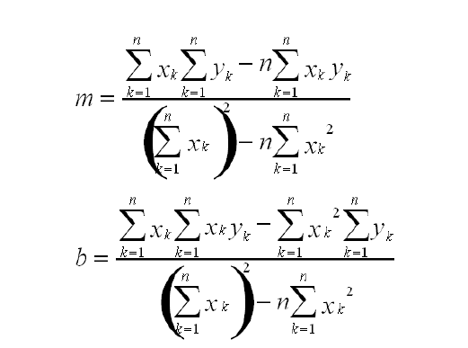

In this process, we use nested loops in several functions to calculate the sums then we calculate m, and b.
Then we create the function to calculate the temperature.
We are going to use a loop so that the program can come back to the main menu.

Input/Output:

The inputs are:
- Any integer (hopefully between 0 and 5)
- -1 to quit the program
The outputs are:
- The table of car engine temperature
- The temperature at t=1.5 mins and t=4.3 mins
- The temperature at any time
- Test Cases and Design of algorithm.
Test Case Table
Here is provided the test case table
Test Case | Try 1 | Try 2 | Try 3 | Try 4 | Try 5 | Try 6
1 (Game 1) | You lose | You lose | You Lose | You lose | You win
User | 6 | 8 | 11 | 12 | 9
Cpu | 4 | 6 | 7 | 10 | 9
Test Case | Try 1 | Try 2 | Try 3 | Try 4 | Try 5 | Try 6
2 (Game 2) | Too high | Too high | Too high | Too low | Right on
User | 55 | 30 | 20 | 10 | 13
CPU |  |  |  |  | 13
Out of range number | n/a | n/a | n/a | n/a | n/a | n/a

Algorithms

- The sum function

Assign 0 to sum
for (i=0; i<SIZE; i++)
Assign to sum, arr[i]+ arr[i+1]+…+arr[SIZE]
return sum;

- The product sum

Assign 0 to sum
for (i=0; i<SIZE; i++)
Assign to sum, arr[i] *arr2[i]+ arr[i+1]*arr2[i+1]+…+arr[SIZE]*arr2[SIZE]
return sum;

- Game 2
guess()
Assign to cpu a random number between 0 and 100
Assign value to user
while user =/= cpu
if user < cpu
Print Too low
ctr++
Else if user > cpu
Print Too high
ctr++
Else
Print “You win”

- Implementation.
/*-------------------------------------------------*/
/* Name: */
/* Date: Feb. 15, 2013 */
/* Program: games.c */
/* Description: This program plays two games */
/* */
/*-------------------------------------------------*/

#include <stdio.h>
#include <math.h>
#include <stdlib.h>
#include <time.h>

/* This is function 1 */
void dice()

{
int cpu1, cpu2, cpu, user, ctr;

srand(time(NULL));
cpu1 = 1 + rand() % 6 ;
cpu2 = 1 + rand() % 6 ;
cpu = cpu1 + cpu2 ;
printf("\n\nPlease give out your number between 2 and 12 \n\n");
scanf("%d", &user);
printf("\nThe first dice gave : %d \n\n", cpu1);
printf("The second dice gave : %d \n\n", cpu2);
if (user != cpu)
printf("\n\n You LOSE !!!! The actual number the CPU chose is %d \n\n", cpu);
else
printf("You win!!!! Right on!! \n\n", cpu);

}

/* This is function 2 */

void guess()

{
int cpu, user;
int ctrr = 0;

srand(time(NULL));
cpu = rand() % 101;
while (user!=cpu)

{printf("\n\nPlease give out your number between 0 and 100 \n\n");

scanf("%d", &user);

if (user < cpu)
{
printf("Too low \n\n");
ctrr ++;}

else if (user > cpu)
{printf("Too high \n\n");
ctrr ++;}

else if (user == cpu)
{printf("Right on\n\n");
printf("This is the number wanted \n\n You have done it in %d tries\n\n\n", ctrr);
ctrr ++;}}

}

int main()
{
int choice;
/* We initialize ctr2 to 443 */
int ctr2=443;
/* We use a loop that stops when the user key 3 for choice. Thus we exit the program */
while (choice!=3)
{

printf("Welcome to Casino 2.0 !! \n\nPlease choose your game. \n\nThe options are: \n\n\t 1)Dice\n\n\t 2)Guess\n\n \t 3)Exit\n\n\n");
scanf("%d", &choice);

/* We use a switch, because the values 1, 2, 3 are integers*/

switch (choice)

{
/* First option */
case 1 :

{

/* We initialize ctr2 to 443 */
ctr2=443;
/* We use a loop that stops when the user key 444 for choice. When the user exits the loop, the user goes back to the main menu */
while (ctr2!=444)

{
dice();
printf("\n\n\n\nDo you want to play again? \n\n Any key for yes \n 444 for no\n\n\n\n\n\n)");
scanf("%d", &ctr2);
if (ctr2==444)
printf("\n\n\n We're going back to the main menu\n\n\n\n\n\n\n\n\n\n\n\n");
else
printf("We gonna play again");
}
break;
}

/* Second option */
case 2:

{

/* We initialize ctr2 to 443 */
ctr2=443;
/* We use a loop that stops when the user key 444 for choice. When the user exits the loop, the user goes back to the main menu */
while (ctr2!=444)
{
guess();
printf("Do you want to play again? \n\n Any key for yes \n 444 for no\n\n\n\n\n\n)");
scanf("%d", &ctr2);
if (ctr2==444)
printf("\n\n\n We're going back to the main menu\n\n\n\n\n\n\n\n\n\n\n\n");
else
printf("\n\n\n We gonna play again");}
break;
}

/* Default option */
default:

{

{printf("\n\n\n\n\n\n\n\n\n\n\nOut of range.\n\n\n");}
break;
}

}}

return 0;
}

/*--------------------------End---------------------*/

- Software testing and verification.

Test cases

Let’s compare the test cases.
Test Case | Try 1 | Try 2 | Try 3 | Try 4 | Try 5 | Try 6
1 (Game 1) | You lose | You lose | You Lose | You lose | You win
User | 6 | 8 | 11 | 12 | 9
Cpu | 4 | 6 | 7 | 10 | 9
Test Case | Try 1 | Try 2 | Try 3 | Try 4 | Try 5 | Try 6
2 (Game 2) | Too high | Too high | Too high | Too low | Right on
User | 55 | 30 | 20 | 10 | 13
CPU |  |  |  |  | 13
Out of range number | n/a | n/a | n/a | n/a | n/a | n/a

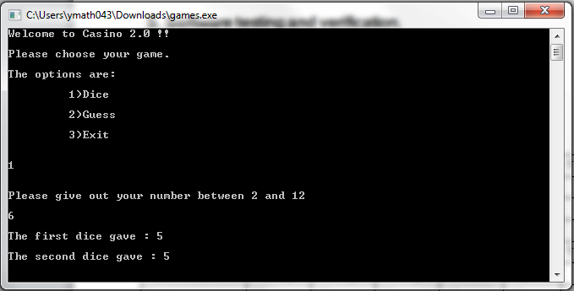
Test case 1:

Test case 2
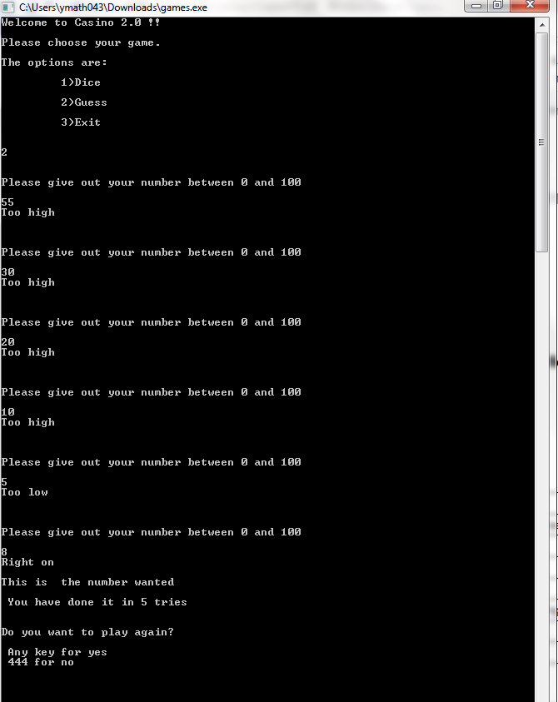

Test case 3:

Test case 4:

Test case 5:

We can conclude that the program is functioning correctly.

