Katelyn Good January 10, 2013
COMM 226
Business Technology Management

Chapter 1
IT For Business and Business Professionals

Moores’ Law: (Gordon Moore Co-founded) -Intel
- States that computing power roughly doubles every 18 months ( as measured by the # of transistors in an integrated circuit)
- More performance @ less cost

Information System
- An organized collection of people, information, business processes, and information technology, designed to transform inputs into outputs, in order to achieve a goal
- Enhance knowledge, work, decision making, problem solving, communication and coordination

IS Components

Concept | Definition
Input | Items entered into a system to transform them into outputs
Process | A series of one or more steps used by a business to transform inputs into outputs
Output | The end result of a process. Information is the result of the transformation (processing) of data. From an organizational perspective, the output of a process is a product or a service
Data | Raw, unorganized facts
Information | Processed/organized/transformed data that is useful to a person
Knowledge | Information plus human experience and judgment  Explicit-readily codified Tacit – gained through experience
System | A recognizable whole that consists of a collection of interrelated parts that interact with each other to transform inputs into outputs to achieve a goal
People | People or organizations that have both an interest in and an influence on the creation, implementation, or operation of an IS
Information Technology | The physical components, typically hardware, software and connectivity, that make up an IS. Technology enables processes to perform the steps they were designed to accomplish
Decision | A choice made from one or more alternatives to follow or avoid some course of action
Business Value | A positive return on the investment of resources that is created through the effective and efficient integration of an organization’s people, information, information technology and business processes

Information Technology
Information System | Information Technology
Enhances knowledge, work decision making problem solving communication and coordination | Collection of tools hardware, software and connectivity that enables individuals/ business to achieve goals
Combines people, info & technology to address business needs | Irrelevant without goal, process and people
The Productivity Zone
- A collection of tools – hardware, software and connectivity – that enable individuals or businesses to achieve their goals.
- Physical components that make up the IT portion of an IS. Technology is the enabler for processes to perform the steps they were designed to.

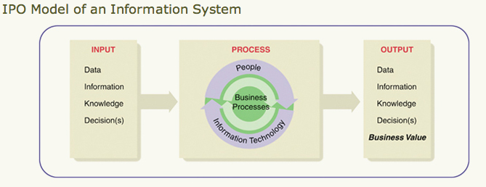

The Productivity Zone
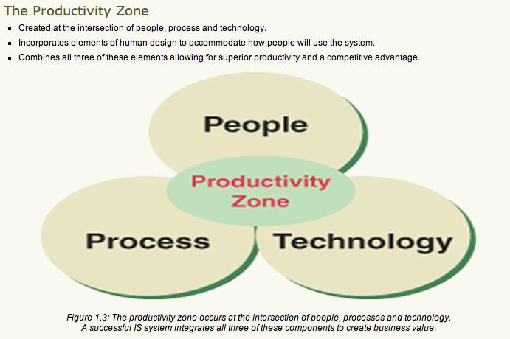

The Internet
- most widely used component = the World Wide Web
- Carrying out commerce in the global marketplace

- Communication
  - Generates business value by making it possible for profesionals to share information allows us to transfer text, images, audio and video, as gives us new ways of buying and selling goods
- Information
  - WWW has reduced the effort required to find info in a timely manner
    - The ease of creating and distributing info has the potential for information overload and an absence of quality means
- Commerce
  - The buying and selling of goods
  - E-commerce: the use of information systems, technologies and computer networks by individuals and organizations to create business value

Business Organizations and the Business Environment (IT for an ORGANIZATION)
- Business
  - An organization with one or more people who:
    - Decide on common goals to pursue
    - Work together to locate and organize resources
    - Create processes to achieve the desired goal or goals

- Business Environment
  - Complex collection of political, economic, social and technological actors that organizational leaders must consider when making decision regarding goals, organizational forms and the creation of business value
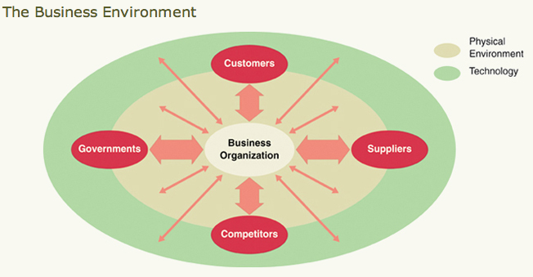

- Globalization (IT for Society)
  - Modern businesses use information technology to:
    - Expand their market to customers around the globe
    - To find the lowest-cost suppliers regardless of location
    - Create 24hour business days by shuttling work across time zones and nations
  - Much built around the Internet, which is simply a large number of cooperating computer networks that use the same rules for sending messages.
  - Information and communications technology is a major contributor to the economy of the world in all industries.
  - IT is critical to the success of business around the globe.

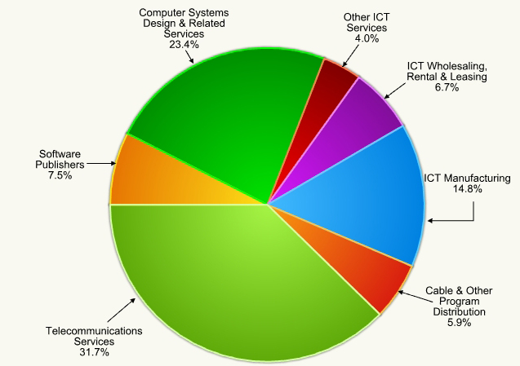
Types of IS
- Transaction Processing Systems (TPS)
  - What do they do? Capture and process transactions to make them available to the organization.
  - How does this create business value? It enables a business to efficiently and accurately track the transactions that are at the heart of all business activities. Captured transaction data can then be used to support decision making.
  - Transaction: the exchange for something of value the business produces for something in return they value
    - Atomicity – unequivocally completed
    - Consistency – data must preserved
    - Isolation – execute independently
    - Durability – permanent

- Management Information Systems (MIS)
  - What do they do? Provide analytical and visualization tools to support and enhance decision making – keeps record of transaction
  - How does this create business value? It enables decision makers to make decisions based on data and to discover new business opportunities through the use of tools provided by the IS. – input from TPS

- Decision Support Systems (DSS)
  - What do they do? Integrate and standardize processes and centralize and standardize the storage and management of data.
  - How does this create business value? This can reduce costs associated with duplication of processes and effort. It can also reduce decision-making mistakes made because of multiple versions of the same data, information and knowledge.

- Enterprise Resource Planning (ERP) Systems
  - What do they do? Integrate data collection, transformation, storage and analysis of customer transaction data, including purchases, service requests and other forms of customer contact.
  - How does this create business value? This greatly increases understanding of customers’ purchasing and service behaviors and needs. It facilitates timely and proactive management of customers

- Customer Relationship Management (CRM) Systems
  - What do they do? Integrate data collection, transformation, storage and analysis of customer transaction data, including purchases, service requests and other forms of customer contact.
  - How does this create business value? This greatly increases understanding of customers’ purchasing and service behaviors and needs. It facilitates timely and proactive management of customers.
Tech Guide A

Baby boomers: Born between 1940 to mid 1960, post WW2
Millennial: children of the baby boomers 1980-1990
Generation Y: this generation aka the new generation grew up with new technologies

CCICT: represents over 20 of the largest ICT employees in Canada. ICT industry is growing by an average rate of 5.1%, which is overall faster then the Canadian economy

ICT one of the measurable sectors of the world economies upon which nations GDPs are based

ICT Council a program that works to establish develop support national partnerships to address the processing need for ICT workers
Jobs 2.0 a term coined by Ticoll o describe ICT career environment

Resume
- Foundation skills begin with personal and interpersonal skills include communication skills, time management and personal motivation, ability to understand business concepts and technologies
- Core skills ability to apply technology in a business environment and ability to manage business processes and change
- Integrative skills ability to combine all ski;;s together to provide appropriate business/ technology solutions that are relevant and realistic

Networking
- Join a professional network
  - AIS – asso for info systems
  - AITP – asso for info tech professionals
  - CMC – certified management consultants
- Conduct information interviews
  - Ask a senior associate for coffee to discuss career path questions
Job Titles
- Business information systems analyst
- Info system consultant
- Database administrator
- Webmaster/designer/developer
- Electronic commerce expert
- IS product manager
- Network administrator
- Auditor -> business process and system analysis – forensic accountant

Chapter 2
Technology Essentials
Components of IT
All IT devices are limited to the following capabilities:
- Accepting and storing data and information
- Performing mathematical calculations
- Applying logic to make decisions
- Retrieving, displaying and sending information
- Consistently repeating the above actions many times

Information Technology 3 Categories
- Hardware: The electronic and mechanical components you can see and touch
- Software: The set of instructions that direct the hardware
- Network technology: Increases the power of IT by allowing the sharing of resources

Hardware Categories - PMIOSC
- Processing:
  - Directs execution of instructions and the transformation of data
  - Transformation of data using transistors (an electronic switch). A tiny chip made up of transistors called a micro processor
- Memory Temporarily
  - Stores data and instructions before and after processing
  - There are two types of memory:
    - Long-term memory (ROM) Read Only Memory
- Contains instructions that are not meant to be changed, or changed infrequently
- ROM is present in most IT devices.
- In computers, ROM holds instructions used to control the start-up process.
- There are far fewer ROM chips than RAM chips in a computer.

    - Short-term memory (RAM) Random Access Memory
- The predominant form of memory in a computer.
- The CPU can access any item stored in RAM directly (randomly).
- RAM is temporary memory, so anything in RAM is lost when the computer is shut down.
- Increasing RAM capacity is the easiest way to increase a computer’s effectiveness.
  - Both types of memory are stored on memory chips
    - Both are measured in number of bytes stored:
- Thousands (kilobytes – KB)
- Millions (megabytes – MB)
- Billions (gigabytes – GB)
- Input
  - Provides the interface used for data entry into a device
  - Input devices provide one interface between the internal processes of an IS and its environment.
  - They allow us to enter data and commands.
  - Input devices include:
    - Keyboards
    - Pointing devices like a mouse
    - Scanning devices like a barcode scanner

- Output
  - Provides the interface to retrieve information from a device
  - Convert IT-processed information into a usable form for people or other machines.
  - Quality and speed of output are important when choosing an output device.
  - Common output devices include:
    - Display devices such as liquid crystal displays (LCDs)
    - Printers, typically laser or inkjet as well as plotters
    - Speakers

- Storage
  - Stores data, information and instructions for the long term
  - Hardware media and devices used to contain large amounts of data and instructions for the long term.
  - Storage is much slower to access than memory.
  - Examples of storage include:
    - Hard drive
    - CDs and DVDs
    - USB flash memory

- Communications:
  - Connects one IT device to another
  - Network interface cards (NIC):
    - Provide the physical connection between the computer and a local network.
  - They can either be wired or wireless.
  - Modems
    - Allow you to connect to a remote network over a telecommunications line (telephone line or cable TV service).
  - Serial Parts
    - Transmits one bit of data at a time and connects slow-speed devices such as a mouse keyboard or modem
  - Parallel Port
    - Connects devices that can transmit more than on bit at a time such as a printer – speed measure in PPH
Software Categories
- Software is information that specifies how a device should work with other data, information and knowledge.
- Software is legally protected by copyright laws, just like music and books.
- Firmware is software built into chips (hardware), like that in cell phones and PDAs.

2 main types of software:
  - System software
    - Controls the hardware associated with a system.
    - Supports the execution of application software.

Types of systems software:
- Operating system (OS) software:
Coordinates and handles the details of working with the computer hardware.
- Utility software:
Provides additional tools to maintain and service your system (many utility software tasks are now included in the OS).
- Middleware software:
Links applications that use dissimilar software or hardware platforms and acts as a messenger/translator to manage the exchange of information

  - Application software
    - Is a complete, self-contained program or set of programs for performing a specific job
    - Application software is the software you use to get things done.

- Productivity software
Software used by business professionals to work with data, information and knowledge (for example, MS Office and Intuit’s Quicken software).
- Open Source Software
Software that can be used, modified, improved and redistributed.
Examples include:
Linux – operating system for servers
Apache – Web server software application
MySql – database management system
Perl, PHP, or Python – script programming languages
Ruby on Rails (RoR) – a Web application framework
The initial cost to purchase the code is zero. • Changes to the code can be made in-house or by contractors to suit the specific needs of the business. One disadvantage of open-source software is that there is no guaranteed support by the software developer if the software fails to perform properly.
Connecting over Networks
- Networks are everywhere
- Consists of nodes that represent computer hardware and the networks users, with various types software and communication media forming the link between nodes

Networks consist of 4 primary components:
- Data
- Special hardware
- Software that allows computers to share data
- Communications media to link computers together

Network Categories
Computer networks are commonly described by the physical size of the network.
      - A Local Area Network (LAN) is confined to a relatively small area like a building.
      - A Wide Area Network (WAN) connects computers over regions, countries and continents.

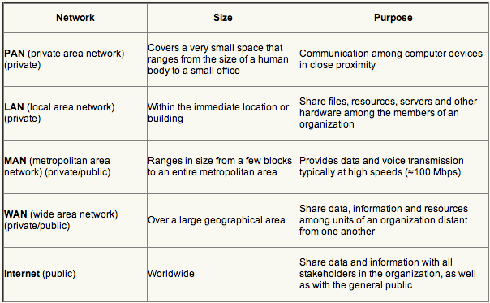

Network Hardware
There are three basic categories of network hardware:
- Hardware to connect a device to a network
  - Modems, cable modems, network interface cards, wireless cards
  - A physical link that forms network connection is a carrier
    - POTS, coaxial fiber optic cables (fastest)
- Specialized hardware for handling network traffic
  - Routers, bridges, repeaters, hubs
- Specialized computers that control the network and delivery of data on the network
  - Servers

Network Software
- Network operating system
Software manages network functions and the flow of data over a computer network.
- Network application software
Provides the instructions that allow for the creation of data and for transformation to fit appropriate protocols for transmission over a network.

Protocol is a standard set of rules that allows the communication of data between nodes on a network.
Encryption
TCP/IP
For network connection layer
HTTP
Layer Protocals:
Product Order
Simple mail transfer protocol (SMTP) for email
Hypertext transfer protocol (HTTP)
Electronic Data interchange (EDI)

The Internet (1962)
- Any computer network that connects several networks together
- Typically we refer to the single largest and most popular internet as the “Internet”.
- It is estimated that in 2010 over 1.7 billion people will have access and are using the Internet.
- The Internet uses the TCP/IP suite of packet switching protocols.
- Any computer using software compatible with TCP/IP, regardless of OS, can connect and communicate over the Internet.

Accessing the Internet
- Home users access the Internet through dial-up over traditional telephone lines or broadband through cable or DSL.
- Most users connect through an Internet Service Provider (ISP) using Internet access software.
- Internet access has moved into libraries, airports, or coffee shops using Wi-Fi.
- Wi-Fi stands for 802.11 standards for wireless network access.
- Voice Over Internet Protocol (VoIP) allows making calls anywhere in the world.
- Cloud computing allows users to use any Internet connection to access their resources on virtual computers.
Operations:
Email, FTP (downloading/ uploading files to a server), Newsgroups, telnet (work on a comp elsewhere on the internet), Internet relay chat, WWW
How it works: domain name identifies the website-suffixes identify country or category, each domain associated with IP address, CIRA manages registration process
The World Wide Web
- One of the two most popular Internet applications (e-mail is the other)
- The Web provides a hypertext system that operates over the Internet.
  - Hypertext provides an easy way to publish information on a network in documents that incorporate hyperlinks to other information on the network.
- Web browser software enables users to view hypertext documents and use hyperlinks to browse other related documents.

Basic Components of the World Wide Web
The Web relies on three basic standards:
- Uniform Resource Locator (URL): which specifies a unique address for each page that indicates the location of a document.
- Hypertext Transfer Protocol (HTTP): which provides rules used by browsers and servers as they respond to each other.
- Hypertext Markup Language (HTML): which provides a language for encoding the information so a variety of IT devices can display it.
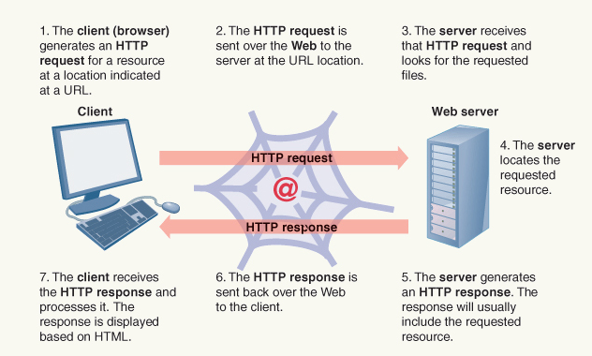

Search Technologies
Users search the Web to find new or updated Web pages using search engines.
Following an algorithm, the submitted pages are organized and stored in a database.
Search engine tools let you query the database for sites that match your search criteria.

The Technology of E-Commerce
- E-commerce is a transaction carried out using computer networks.
- Users can search for information on a wide variety of products and purchase the items.
- Comparative data on products can help with the purchase.
- Using credit/ debit cards, withdrawing money from ATM, online shopping

E-commerce Generations
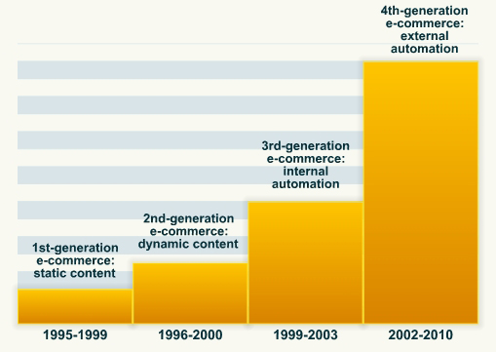

Four Generations of E-Commerce
- FIRST Generation
Static content, such as company information, online marketing and company brochures.
  - Basic technologies are still used:
Client/server networks: the networks over which data travel.
Browser: the application software that lets users request and view web pages.
HTTP protocol: the standardized rules for exchanging data over the Web.
HTML: the language that guides the display of a requested page.

- SECOND Generation
Dynamic content where the web page changes depending on a number of factors such as time and date, user profile, or browser location..
  - The process involves:
    - Obtaining input data
    - Passing data to Web server
    - Holding data in memory
    - Executing the programming instructions to process the data
  - Input data comes from several sources:
    - Web page header information about user
    - Server resources like the system clock
    - Stored data about the user from a cookie
    - Data input using an HTML form

Storing Data on the Client Side
- To carry out e-commerce transactions, it is necessary to store data about the customer.
- One way to do this is to use a cookie, a small bit of data stored on the client machine and passed back and forth between it and the Web server.
- When data remain on the client machine for a period of time, it is known as persistent data.
- Cookies do create privacy concerns when they are used to track browsing habits.

Making the Client Side Dynamic and Interactive
- To make the interaction with the client machine dynamic, some sort of programming is required; this can occur on the client side or the server side.
- Scripting languages like JavaScript are built into the web page to add dynamic interaction, like data validation.
- For more complex tasks, specialized components such as Microsoft’s ActiveX technology, Java applets and browser plug-ins are used.
  - ActiveX technology is used for sharing information among different technologies.
  - An applet is a small program that a browser can download and execute.
  - A browser plug-in is a small software module that can work with the browser.

Server-Side Programming
- When programs run on the Web server to provide dynamic interaction, this is known as server-side programming.
- It is more powerful than client-side scripting and allows the web page owner to retain control over the programs.
- With server-side programming, a business can:
  - Deliver content that it customized for each user
  - Dynamically modify content for any page
  - Access data stored on a server-side database and send it to the client’s browser
  - Take action on queries and data sent from the client
  - Provide access control and security for a website
  - Optimally manage traffic to the site

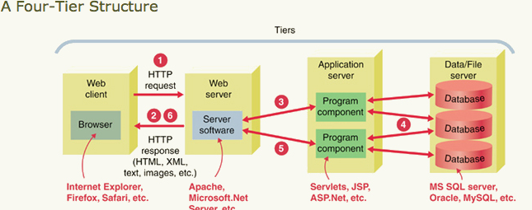

- THIRD Generation
Growth in businesses’ ability to support transactions on the Web.
  - Businesses recognized that they must deal with three issues to be successful
    - Making it possible for customers to find information about companies, products and services
    - Making it possible for customers to order and pay online for goods and services
    - Providing secure and private transactions
Order and Payment Systems
- All e-commerce sites must have components for processing orders and accepting payments.
  - The four primary components of a typical e-commerce site are:
    - The shopping and ordering system
    - The merchant account
    - The payment gateway
    - The security system
- Most e-commerce systems use a secure HTML order form or an in-house shopping cart system.
- Smaller businesses often use third-party merchant accounts, like that available from PayPal.
- The shopping cart system is the most popular e-commerce system for larger businesses where a customer wants to buy multiple products, usually using a credit card.

Merchant Accounts *important aspect
- A bank account that allows the merchant to receive the proceeds of credit card purchases.
- Secure gateway provider is a company that provides a network to process encrypted transactions from a merchant’s website; it then passes the transactions on to the issuing banks for credit card approval.
  - A secure gateway provider will usually provide a payment gateway and a processor; the payment gateway links the e-commerce site to the banking system.
- The processor accepts data from the shopping cart, formats it and enters it into the banking network.

Steps in the E-Commerce Process
- The customer places order through e-commerce website.
- The payment gateway provider detects the placement of an order, securely encrypts the transaction data and passes an authorization request to the bank to verify the customer’s credit card account and available funds.
- The gateway provider returns a response, indicating whether or not the transaction is authorized, to the e-commerce merchant; this process typically takes less than three seconds.
- Upon approval, the e-commerce merchant notifies the user and fulfills the customer’s order.
- The gateway provider sends a settlement request to the merchant account’s bank.
- The merchant account’s bank deposits the transaction funds into the e-commerce merchant’s account.

- FOURTH Generation
Increasing integration with external partners on the Web, including allowing transactions between Web applications.
  - XML and Web services are moving us into the realm of automatic interaction between computers at one business with computers at another business.
  - For e-commerce, these technologies are improving the ability to exchange small amounts of data via the Web and to standardize transactions.

eXtensible Markup Language (XML)
- XML organizes data based on its meaning rather than how it should appear.
- HTML describes how to display data.
- XML has become a major component in a set of technologies that are helping make the Web more interactive.

Web Services
- A standardized way for one computer program to request and run another computer program over the Internet.
- A web service is platform-independent software component that can be:
  - Described using a standard description language
  - Published to a public registry of services
  - Discovered using a standard method
  - Requested through an application program interface (API)
  - Combined with other services and procedures to compose an application
- Give companies the ability to do more e-commerce business, with more potential business partners and in different ways than before at a reasonable cost.
- Based on a number of accepted standards that allow everybody to work from the same basic design.
- Enable different systems to interact more efficiently and quickly link and share data.
- Continue to gain in use and popularity as they save time and create value.

Security Threats
- Malware
The use of malicious codes as a part of a subversive organized scheme (intrusion into sensitive financial and intellectual property areas)
- Scareware
A type of malware designed to trick victim into purchasing/ downloading useless and potentially dangerous software
- Virus
A program that is able to copy itself and infects a computer, designed to spread to as many computers as possible and usually need human action
- Worm
Destructive software that spreads by itself through emails creates a “back door” used to further propagate viruses and malware
- Spam
Unsolicited and undesired emails
- Phishing
An attempt to gain personal/ confidential information for fraudulent purpose
- Denial of Service Attack (DoS)
An attempt to male a website unavailable to users

Internet Security
The following actions can minimize Internet security threats:
- Install, and keep up to date, antivirus software and a personal firewall.
- Update software to patch security holes or move to less vulnerable systems.
- Do not open e-mail messages or attachments from unknown sources.
- Follow safe computing practices, such as effective password policies.
To ensure that your password remains as strong as possible, you should:
- Use at least eight characters.
- Include digits, punctuation and nonprinting characters.
- Use both upper and lowercase characters.
- Use different passwords on different accounts.
- Change your password regularly and do not reuse passwords.

Tech Guide C
OPEN SOURCE SOFTWARE
ADVANTAGES | DISADVANTAGES
Stability | Learning Curve
Cost and fees | Equivalent application software
Platform independent | Technical support
Security | New hardware drivers
Support

Network Architecture:
The design of a complex system or network
Clients:
Network computers running client software that request services from the servers
The simplest form of Client/Server computing involves File Server
3-tiered client/server architecture:
Uses a client- a application server and a database
Strength: its capacity to string together a series of servers to respond to c request while maintaining a single central base

Client/Server SYSTEMS
ADVANTAGES | DISADVANTAGES
Computing burden is shared among servers and clients | Moe complex programing relationship
Specialized servers handle one task | System requires upgrading of all clients and servers regardless of location
Can be upgraded in small steps | More complex computer and network security issues due to increase # of users
Loss of on client does not stop other clients from accessing server

Peer-to-Peer Networks:
Where each computer in the network is on the same kevel as other computers and each is equally responsible for overseeing the functions of the network
Two computers can communicate directly with no central server

Chapter 3
Creating Business Value

Business Organization and Business Processes
A number of different tasks need to be coordinated to deliver a product or service.
A company therefore needs
A business strategy:
A strategy is a broad-based formula for how a business is going to compete, what its goals should be and what plans and policies will be needed to carry out those goals.

Porter’s Five Forces
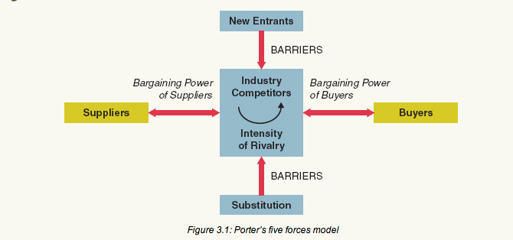

Open System Model:
- Indicates that a business operates by transforming inputs into outputs by constantly interacting with its environment
- Organizations use various resources, processes and structures to create business.
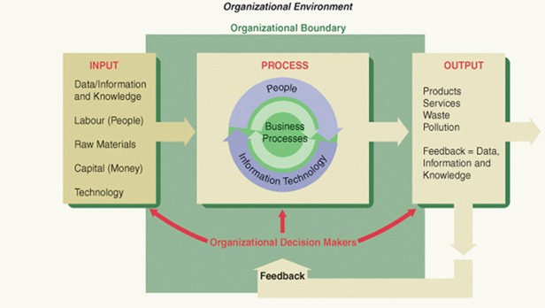
Stakeholders and Boundaries in the Business Environment
- Stakeholder:
A person or entity that has a interest in and an influence on how a business will function to succeed. The influence is the important part can be actual or potential.
- A stakeholder can be external or internal relative to the business.
- All open systems have an organizational boundary that separates them from their environment but still allows them to interact with their environment.

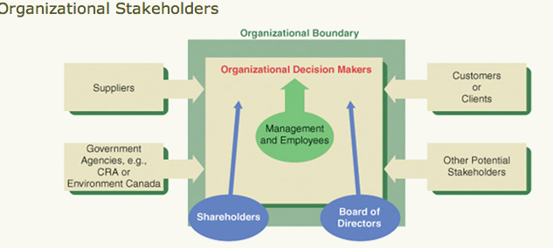

How Businesses Organize to Create Value
- All business organizations possess structures that organize information, responsibility and authority.
- Types of organizational structures include functional, decentralized and matrix structures.
- In functional and decentralized structures lines of authority are vertically oriented.
- A matrix organization is a blend of functional and decentralized organizations that uses teams.
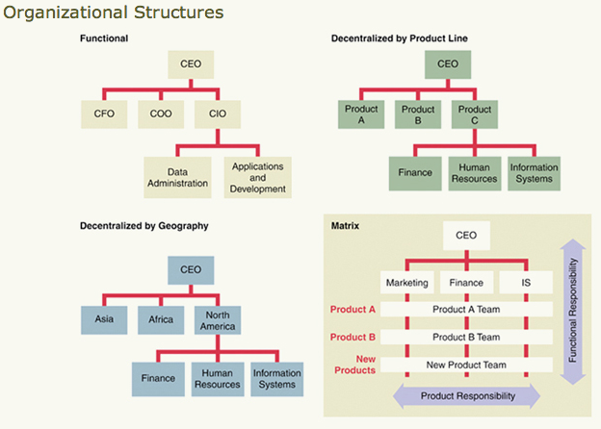
Organizational Form | Advantages
Functional | - Economies of scale  - Technical expertise in functional areas  - Clear chain of authority and communications
Decentralized | - Faster response and greater flexibility  - Greater communication and coordination  - Greater development of breadth of skills
Matrix | - Increased flexibility and responsiveness  - Enhanced problem solving, cooperation, communication and resource sharing  - Decision making lower in organization

Business Process
To transform inputs into outputs (goods and services) organizations need to perform a series of steps known as a business process.
Sub-process: is 1 or more taste that accomplish a significant portion or stage of process

The IGOE model of the analyzing processes:

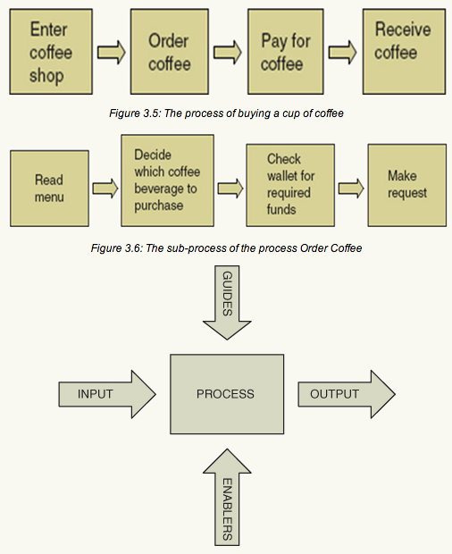
Enablers
Special Input
Guides
Rules/ Polices

Example of Inputs:
Input Type | Description
Data, information and knowledge | Raw facts, summaries, information from research, expert knowledge
Labour | Employees who carry out a business process
Raw Materials | “Ingredients” from which a company makes products
Capital | Money required by businesses to operate
Technology | Machines, IT hardware and software

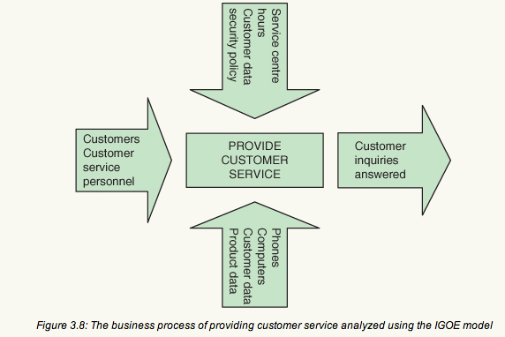

Defining Competitive Advantage

CA = quality of insight + speed of execution + cost competitiveness

Applying IT to Create Business Value
IT can be applied to value chain activities to create business value in three ways:
- Automating
- Informating
- Transforming

- Automating
  - Uses technology to perform tedious or repetitive tasks faster, cheaper and more consistently.
  - Doing the same things as before, but with greater efficiency and accuracy, and also to do new things.
Example:
Industry | Automation | Benefits
Banking | ATM machines, online banking | - Reduces costs associated with the processing of transactions  - Increases flexibility and improves access to services
Grocery/Retail | Barcode inventory systems | - Increases speed and accuracy of transactions  - Reduces costs and transfers control to customers
Travel | Reservation and scheduling systems | - Faster and more efficient processing of reservations  - Allows transfer of processes to customers through online services

- Informating
  - Recognizing that executing processes also creates new data and information.
  - Can process these new data to improve its decision-making or improve the process itself.
  - IT can deliver more long-term benefits than from automation alone.
  - To use businesses need to determine if the IT stores data so that it can be used for learning and decision-making.

- Transforming to Gain Comp. Advantage
  - Most businesses have a transforming view of IT, that is, to use IT to acquire or continue a competitive advantage over competitors.
  - There are two ways to obtain a competitive advantage:
    - A company gains a cost advantage when it delivers the same benefits to customers as its competitors at a lower cost.
    - A company gains a differentiation advantage when it delivers superior benefits to customers.

Decision Making
- Rational decision
A choice about actions to take (or not take) in a given situation.
- Structured decision
Is one that can be programmed; it is routine or repetitive.
- Semi-structured decision
One that involves some uncertainty or doubt about the outcome.
- Unstructured decision
One that involves a significant amount of uncertainty about the outcome.

Using Information in Decision Making
Rational decision-making is all about using information to reduce uncertainty.
Information systems help businesses by providing information to decision makers.

Good Decisions Require Quality Information
Information Characteristic | Example
Complete | Your new project team member’s cell phone is 555-1212. Is this enough information?
Accurate | You check your printed course schedule and find out that your Intro to IS class meets at 11 p.m. You suspect the schedule is wrong.
Reliable | You receive an unsolicited e-mail offering you a share in millions of dollars if you will help this person transfer money out of his home country. Is this information reliable?
Timely | Timely information includes “recent” information, but also requires that the information arrive close enough to the decision to be useful to the decision maker.

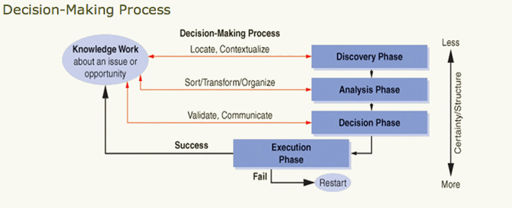

Problem Solving
- A problem exists when we find ourselves in a current situation that fails to meet our goals, needs, or expectations.
- Problems are often the result of a past series of events or lack of events.

Problem solving refers to a series of steps or a process (a logical sequence of activities) taken in response to some event or activity. - IADD

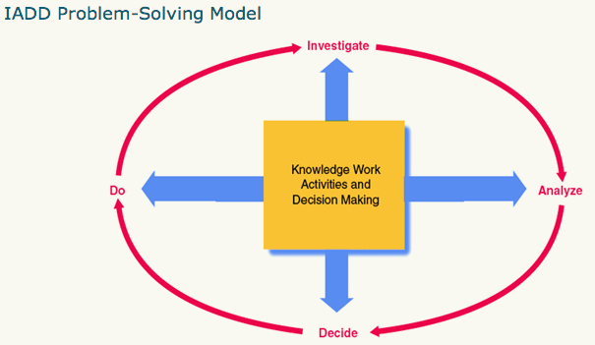
The IADD Model
The IADD model consists of four major steps:
- Investigate:
  - Determine if there is a problem or an opportunity and if it is possible to solve the problem or take advantage of the opportunity.
  - Problems tend to be defined or identified in terms of what went wrong with a process or action.
  - Comparing your current situation to a desired current or future state and noticing a difference.
  - Problems can also be defined as opportunities or challenges.

- Analyze: Gather data that are relevant to the problem or opportunity.
  - Look for clues that will help determine what has happened.
  - Generate alternative solutions and determine criteria that will be used in selecting a solution.
  - IS can help with analysis:
    - Databases/software are tools for organizing and storing data.
    - Tools are provided to manipulate data and ask questions of your database — querying and data mining.

- Decide: Evaluate solutions and make choices regarding how to implement the solution.
  - Choose the best solution – how will it solve the problem, meet the challenge, or capitalize on the opportunity.
  - Synthesize the best ideas from the alternative solutions into a “best” solution.
  - It all depends on the criteria they established and the agreed-upon decision-making process.

- Do: Implement the solution and monitor the results
  - Tasks and other physical activities are carried out according to your solution.
  - Requires planning, scheduling, managing and supervising; project management skills are often required.
  - Do it! Watch what happens, modify, revise and learn.

Investigate | Identify a challenge or problem and gather preliminary data to determine if something can be done to meet the challenge or solve the problem.
Analyze | Describe the problem or challenge as well as all of the factors that influence the situation. Gather additional data as necessary. Generate possible solutions and develop criteria that will help you choose the “best” solution.
Decide | Choose the best solution and describe how the solution will solve the problem.
Do | Do it! Watch what happens, modify, revise and learn.
Chapter 4
Enterprise Systems
The Value Chain:
A connected series of activities, each of which adds value or supports the addition of value to the firm’s goods or services.

- Inbound Logistics
Include the receiving, warehousing, and inventory control of raw materials required to create a product or service
- Operations:
Are the value-creating and often proprietary activities that transform the raw inputs into the final product
- Outbound Logistics:
Are the activities required to get the finished product to the customer, including packaging, warehousing, and order fulfillment.
- Marketing and Sales:
Are all activities associated with getting buyers to purchase the product, including working with distributors, retailers, or online channels
- Service Activities:
Maintain and enhance product value, customer support, repair, and warranty

Primary Activities:
Those directly related to the production and distribution of the organization’s products and services
Support Activities:
- Firm infrastructure
- Technology development
- HR management
- Procurement

Supply Chain:
System of organizations, people, technology, activities, information, and resources involved in moving a product or service from supplier to customer.

Enterprise Systems (ES)
- Complex and powerful information systems
- SAP Enterprise Resource Planning (ERP) system is world’s most popular.
- Runs applications form a single database – ensures the compatibility via common data storage

Architecture of Enterprise Systems
- Client-Server
- Service-Oriented
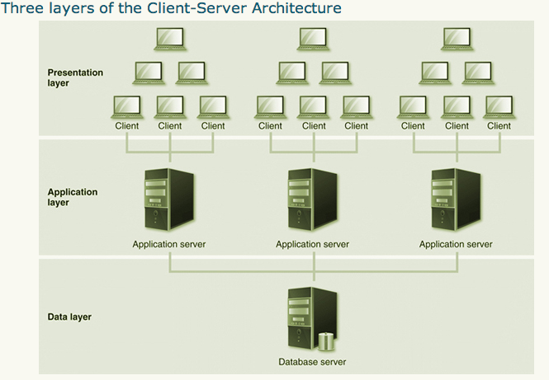

Service-Oriented Architecture
- Web services
  - Used to expose ES (and other system) functionality
  - Standard interface — input and output
- Composite applications
  - Connect multiple applications via web services
  - Build new capabilities without changing the underlying applications

Enterprise Resource Planning Systems
- Focus primary on internal operations of an organization
- Integrate functional and cross-functional business processes
- SAP is a fully integrated, global ERP system.
- Supports multiple languages and currencies

The SAP ERP Solution Map
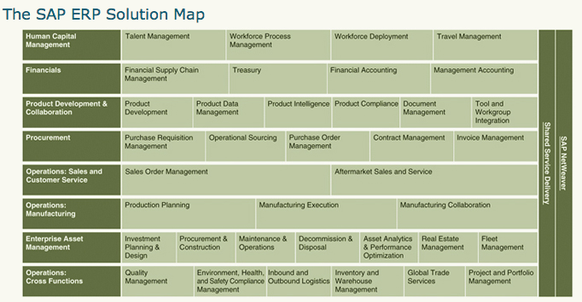
SAP ERP Modules
- Production Planning (PP)
- Materials Management (MM)
- Sales and Distribution (SD)
- Plant Maintenance (PM)
- Project Systems (PS)
- Quality Management (QM)
- Financial Accounting (FI)
- Management Accounting / Controlling (CO)
- Human Resources (HR)
- Business Intelligence (BI)

Enterprise Systems Application Suite
- Enterprise Resource Planning (ERP)
- Supply Chain Management (SCM)
- Supplier Relationship Management (SRM)
- Product Lifecycle Management (PLM)
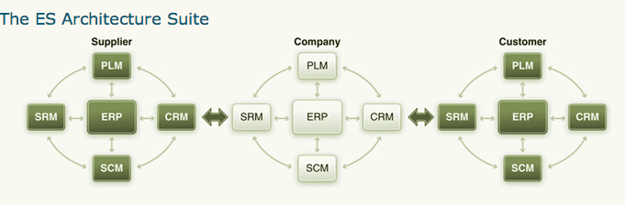

Applications Platforms
- Enterprise Operating System
- SAP NetWeaver introduced in 2003
  - Integral part of SAP ERP and SAP Business Suite
  - Toolset for composite application and plug-in software
  - Integrates non-SAP applications
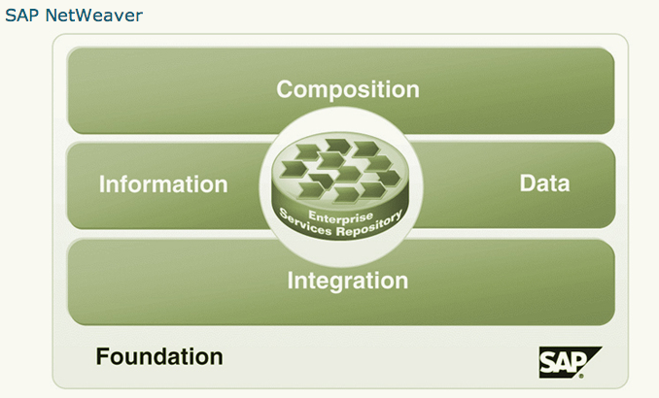

Data in an Enterprise System
- Organizational data (levels, elements)
- Master data
- Transaction data
  - Associated with process step

Organizational Data
- Defines the structure of the enterprise in terms of legal or business purposes
- Examples include:
  - Legal entities, plants, storage areas, sales organizations, profit centers
- Data rarely changes.

Organizational Level — Client
- Highest organizational level
- Represents the enterprise; comprised of many companies

Organizational Level — Company Code
- Central organizational element in financial accounting
  - Books are maintained at this level for legal reporting.
- Identifies legal entities in an enterprise (Client)
- Legally independent from other companies in the enterprise
- Client can have multiple company codes.
- Company code must belong to only one client.

Organizational Level — Plant
- Performs multiple functions
- Used by many processes
- Represents factory, warehouse, office, distribution center, etc.
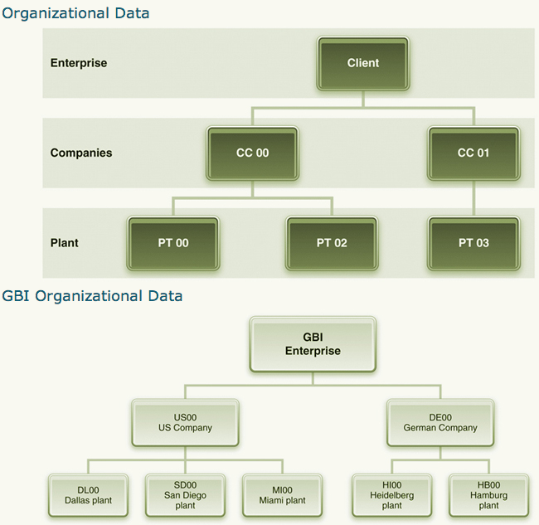

Master Data
Long-term data that typically represent entities associated with various processes:
- Customer
- Vendor
- Material
Typically include:
- General data (across company codes)
- Financial data (CC specific)
- Area-specific data (Sales, Purchasing, Plant)

Material Master
- Material master data is used in numerous processes.
  - Procurement
  - Fulfillment
  - Production
  - Material planning
  - Asset management
  - Project systems
  - Lifecycle data management
- Data are grouped based on:
  - Process
  - Material type
  - Organization element
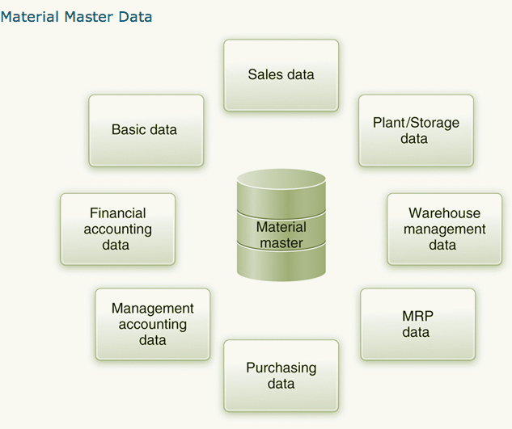

Material Types
- Raw materials (ROH)
  - Purchased, not sold, used in production
  - Purchasing- and production-related views
  - No sales-related view
- Semi-finished goods (HALB)
  - Produced using other materials (ROH, HALB)
  - Used in the production of other materials (HALB, FERT)
  - Not purchased or sold
- Finished goods (FERT)
  - Produced using other materials (ROH, HALB)
  - Sold to customers
- Trading goods (HAWA)
  - Purchased and resold without additional processing
- Numerous other types

Organizational Level
Same material can be used differently by different organizational levels.
- Different company codes
  - HALB in one, FERT in another
- Different plants
  - Only exports or imports in specified plants, not all
- Different sales-related organizational elements
  - Wholesale vs. retail

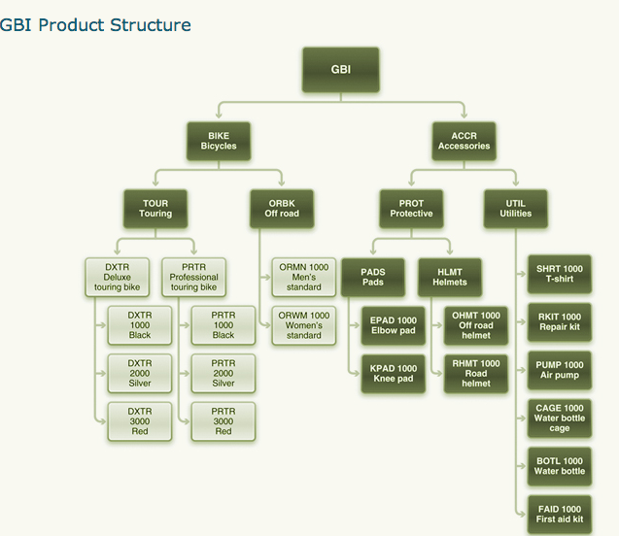
Transaction Data
Data generated during execution of process steps
Requires:
- Organizational data
- Master data
- Situational data
Example: Sales order creation
- Organizational elements: Client, Company Code, Sales Area
- Master Data: Customer, Material
- Situational data: Date, Time, Person
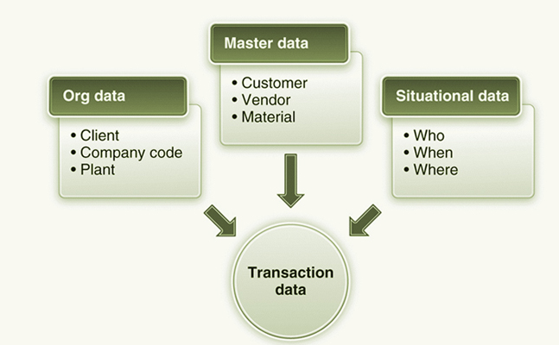

Documents
Record of transactions
- Transaction documents
  - Requisition, purchase order, invoice, delivery document, etc.
- FI documents
  - Record the impact on financial accounting
- CO documents
  - Record the impact on management accounting
- Material documents
  - Record the impact on material status (value, location)

Reporting
- Transactional system (OLTP) vs. informational system (OLAP)
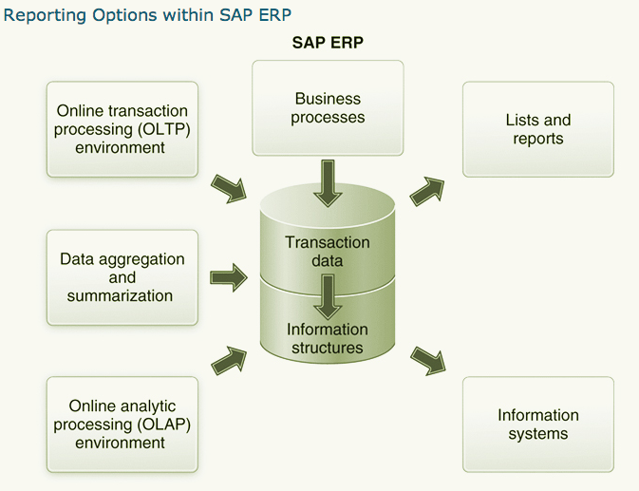
- Types of reporting (options)
  - Work lists in SAP ERP
  - Online lists in SAP ERP
  - Analytics in SAP ERP
  - Analytics in SAP BW

Transactional vs. Informational
- OLTP (transactional)
  - Detailed, transactional data
  - Data warehouse
- Data aggregation and reduction using
  - Qualitative reduction by aggregating by time period
  - Quantitative reduction by selecting key figures (KPI)
  - In ERP: Information structures
  - In BW: Infocubes, info providers, etc.
- OLAP (informational)
  - Various analysis tools
  - In ERP: Information systems (OLAP lite)
  - In BW: Various reporting tools

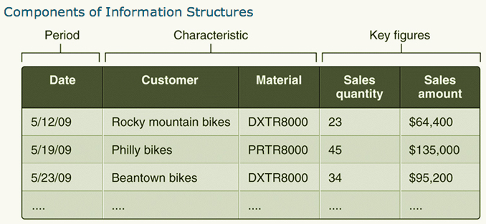

Work Lists
List of work to be completed:
- Picking due list
- Billing due list
- Delivery due list

Online Lists
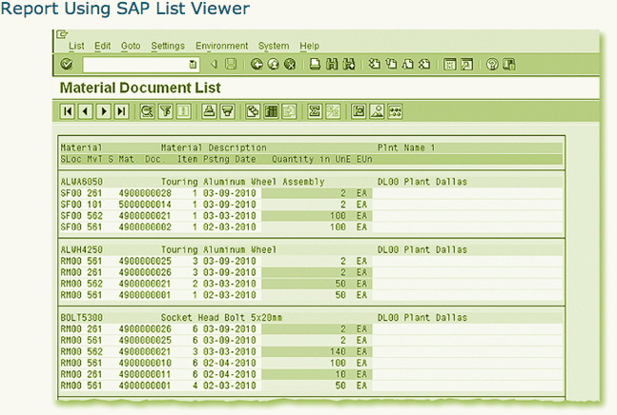
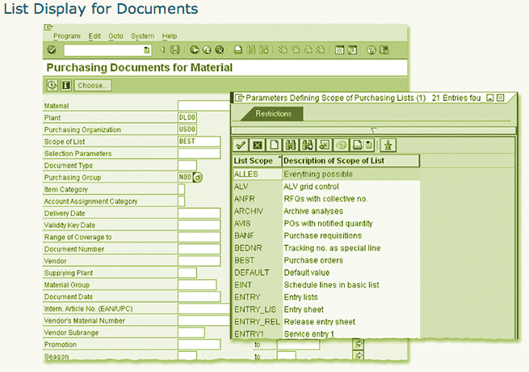
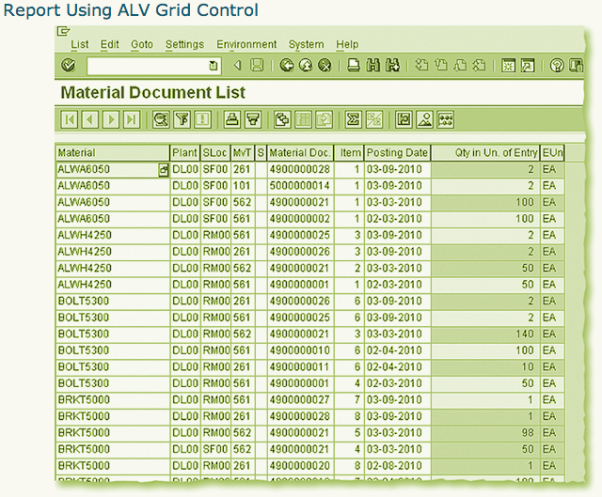

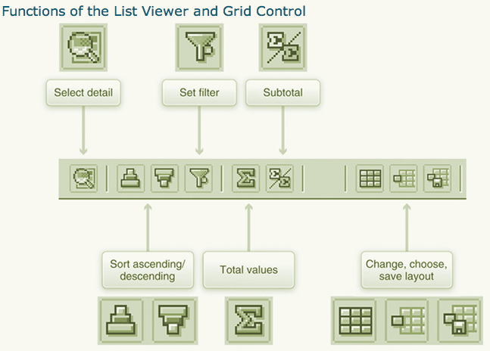

Information Systems
- Logistics information systems
  - Purchasing IS
  - Sales IS
  - Inventory control IS
  - Shop floor IS
- Financial information systems
  - GL reporting (B/S, I/S, Cash flows)
  - Receivables, payables
- Human resource information systems
  - Personnel, positions, payroll
- Information Structures
  - Standard (predefined)
  - User-defined information structures
  - Standard analysis (predefined analytics)
  - Flexible analysis (user-define content and format)
- DLAP provides reporting based on aggregated data in information structures.
- SAP BW receives data from SAP ERP, SAP Business Suite, and non-SAP systems.
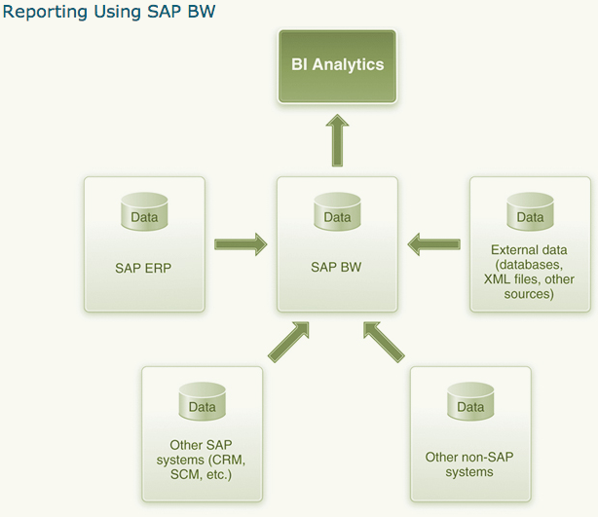

Chapter 5
E-Commerce

E-Commerce Defined
- E-commerce is the use of information systems, technologies and computer networks by individuals and organizations to carry out transactions in order to create or support the creation of business value.
- E-commerce includes all types of computer networks, transactions and business relationships including:
  - Electronic funds transfers
  - EDI over private networks
  - Retail sales and wholesale exchanges over public networks like the Internet

Types of E-Commerce Transactions and Examples of Websites
 | Description | Examples of Websites | Examples of Physical Goods | Examples of Electronic Goods
B2C | Online equivalent of retail store as well as other services | www.chapters.indigo.ca  www.telus.ca  www.amazon.ca | CD, DVD | iTunes, ring tones
B2B | Electronic exchanges between companies | www.manheim.com  www.boeing.com | Office furniture | Virus protection software, databases
B2G | Online sales to government agencies | www.ppitpb.gov.on.ca  (Ontario government) | Technical manuals, regulations and other printed material | Document conversion from hard copy to XML/Web-based documents
C2G | Electronic payment of taxes | www.netfile.gc.ca | Printed and mailed income tax return or license application | Electronically filed income tax return or license application
C2C | Use of online auctions | www.ebay.ca  auctions.yahoo.com | Elvis PezTM, comic books | Shareware programs, self-published e-books

E-Commerce and Products: Physical and Digital
Products can be divided into two primary categories: physical and electronic.
- Physical products: anything that requires an actual shipment of a package to the buyer.
- Digital products: can be received directly over the Internet or other computer network.
- E-commerce companies must have back-office elements to handle order fulfillment and returns for physical goods.
- Companies experienced in order fulfillment and returns have tended to be successful in e-commerce.
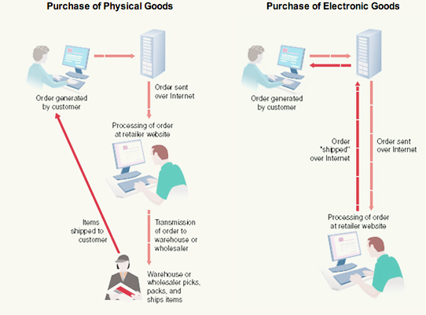

Types of E-Commerce Transactions and Associated Goods
See table above

E-Commerce Business Models
- A business model defines how a company will meet the needs of its customers while making a profit.
- An e-commerce business model combines a specific type of website with a successful revenue model that produces profits for the website owner.

Business Model | Description | Examples
Brokerage | Brokers bring buyers and sellers together for a fee | eBay, Priceline, PayPal
Advertising | An extension of the traditional media broadcasting model where ads appear on websites | Yahoo!, Netscape,  CNN.com, Google
Merchant | Sells products, both physical and electronic, to consumers | Amazon.ca, CanadianTire.ca,  Walmart.ca, iTunes
Manufacturer Direct | Make and sell products directly to consumer | Dell, IBM, Microsoft, McAfee
Affiliate | Affiliate websites are paid a fee when purchases come through them | Amazon.ca fees to  affiliate websites
Community | Based on user loyalty because of high investment of time and emotion | MySpace  Evite
Subscription | Users are charged fees to subscribe to service or information source | Classmates,  globeandmail.com
Infomediary | Provides data on consumers and consumption habits | DoubleClick, NetRatings, Edmunds
Co-operative | Enables competitors to cooperate on a website | AutoTrader.com,  VRBO.com, Craigslist

E-Commerce Website Purpose
- Purpose of e-commerce website = bring in customers, or at least visitors.
- It will not generate a profit if not associated with an appealing website.
- There are eight commonly accepted types of websites: as follows
- A number of these match up with multiple business models.

Websites Classified By Purpose

 | Purpose | Examples | Business Model
Portal | A gateway to many other websites | Netscape, Yahoo!,  MSN | Advertising, Affiliate
Search Engine | Finds websites that contain a word or phrase | Google, Yahoo!,  MSN, DogPile | Advertising, Affiliate,  Infomediary
Browse or  Search and Buy | Sell goods and services | Dell, LandsEnd,  iTunes | Merchant, Infomediary, Manufacturer Direct,  Co-operative
Sales Support | Provide information on a product before or after the sale | Microsoft, BMW,  McAfee, Telus | Community, Infomediary
Information Service | Provide news, information, commentary, etc. | National Post,  TSN, Economist | Subscription, Community, Affiliate
Auction | Facilitate sales between third parties | eBay, PayPal | Brokerage
Travel | Sells travel tickets and tours | Delta, Travelocity,  Orbitz, itravel2000 | Merchant, Brokerage,  Co-operatitive
Special Interest  or Services | Provide information, product sales and support and contacts between visitors | Lavalife,  Microsoft support groups | Community, Merchant, Affiliate, Infomediary, Advertising

The E-Commerce Advantage
- The use of computer networks to carry out transactions is creating a tangible “e-commerce advantage” in our economy, especially with regard to:
  - Technology
  - Competition
  - Strategy
- Over 1.5 billion potential customers in the marketplace due to increasing Internet access.
- Universal standards make it work the same way no matter where in the world you are.
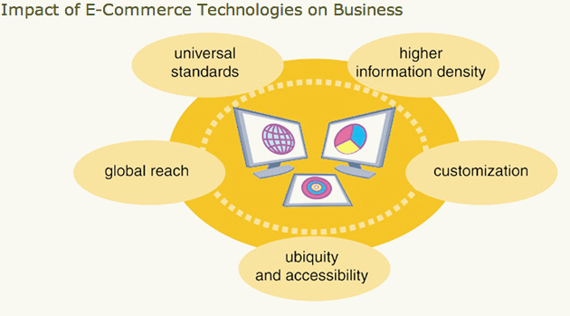

Information Clutter
- The expansion of global e-commerce has produced global competition with sellers being able to reach any potential buyer worldwide.
- Technology has increased information density — the quality and quantity of information about products and services.
- Customers can obtain product guides, reviews and prices from a number of websites due to online advertising and search engine optimization.

Mass Customization and Personalization
- Information density response = create business value based on a customization approach to e-commerce.
- Two approaches to customization are mass customization and personalization.
  - Mass customization is the ability to create custom products or services on demand (e.g., Dell Computer).
  - Personalization is a personalized marketing message for each potential customer based on searching, browsing, or buying habits (e.g., Amazon.ca).

E-Commerce Competitive Difference
- A dramatic effect on competition between organizations in a number of ways:
  - Reducing barriers to entry
  - Preventing any company from “owning” the market
  - Enhanced collaboration/alliances
  - Multiplying market niches
  - Changing marketplace drivers (forces that make things happen in the market, e.g., consumer preferences, number of suppliers a business can choose from, etc.)

E-Commerce and Business Strategy
- Technology advances have changed business strategy.
- A strategy is a broad-based formula for how a business is going to compete, what its goals should be and what plans and policies will be needed to carry out those goals.
- An e-commerce strategy is a general term for how a business is going to use Web-based networks and information systems to compete in a global marketplace.
- Building an e-commerce strategy requires two views of an organization’s strategy:
  - What it wants to do (conceptual)
  - How it will do it (technology strategy)

- One strategy being used by many companies is customer relationship management (CRM), which enables them to create one-to-one marketing experiences for their customers.
- Other e-commerce strategies include:
  - Virtual showrooms
  - Increased channel choices
  - Wider component choice
  - Use of mobile technology
- Mobile commerce is the use of laptops, mobile phones and PDAs to connect to the Internet and Web to conduct many of the activities associated with e-commerce.

Benefits and Limitations for Customers
Benefits | Limitations
Lower prices | Delay in receiving goods
Shopping 24/7 | Slow download speeds
Greater searchability for products | Security and privacy concerns
Shorter delivery times | Inability to touch, feel, smell, try out, or try on products prior to purchasing
More sharing of information with other consumers | Unavailability of micropayments
Improved customer service

Benefits and Limitations for Business
Benefits | Limitations
Expansion of marketplace to global proportions | Increased competition
Cheaper electronic transaction | Ease of comparison between competing products drives prices down
Greater customer loyalty | Customers want specific choices and will not accept substitutes
Expansion of niche marketing opportunities | Customers control flow of information instead of companies
Direct communication with customers via websites

E-Commerce between Organizations
- Doing business with other organizations (B2B) is by far larger than with consumers (B2C).
- It is also quite different in terms of the scope of the purchases and the complexity involved in them — especially in the decision-making process required to make a purchase.
  - For example, while you buy one PC, a company may buy thousands.
- Interorganizational systems (IOS) are the information systems that handle the information flow between trading partners.

B2B Transactions and Business Models
- B2B transactions can be divided into two types:
  - Spot buying
    - Purchases are made at market prices from an unknown seller.
    - Often use spot buying to purchase commodities (gasoline, paper, cleaning supplies, etc.).
  - Strategic sourcing.
    - Prices are set through negotiation in a long-term relationship with a company known to the buyer.
    - A company’s large-scale computer purchases often result from strategic sourcing.
- B2B Business models:
  - One-to-one business model:
    - Two companies form a trading relationship with neither company dominating the relationship.
  - Company-centric business model
    - A company is either a seller to many companies (one-to-many) or a buyer from many companies (many-to-one).
  - Electronic data interchange (EDI) or an extranet
    - Uses private networks to allow the exchange of structured information between two computers application with minimal human involvement. Links trading partners.
  - E-procurement
    - Often the name for B2B e-commerce in the many-to-one business model.
    - In a reverse auction the buyer posts projects, seller responds with bids – lowest bid wins
  - Aggregating catalogues Model
    - Assembles together the catalogues from all suppliers on the buyers server, buyer then uses them to make all purchases – tends to centralize the process
  - Group purchasing
    - Two or more buyers work together to achieve lower prices from suppliers
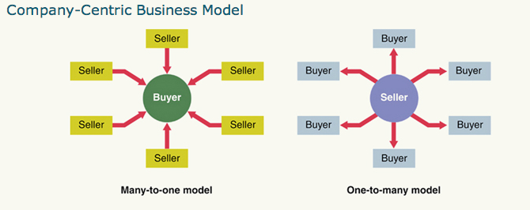

Exchange Model
Many companies use an exchange to buy and sell from each other through spot-buying transactions.
Vertical exchanges meet the needs of a single industry ex. Retailing
Horizontal exchanges deal with products and services that all companies need
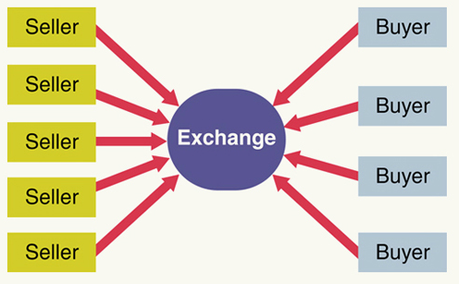

Using B2B E-Commerce to Improve Supply Chain Efficiency
- Supply chain
  - A network of facilities and distribution options that performs the functions of procurement of materials, transformation of these materials into intermediate and finished products, and distribution of these finished products to customers.
- Procurement is a big part of the supply chain, and using e-commerce for procurement has resulted in cost savings.

Traditional Procurement Process
In the traditional procurement process, there are five steps involving three elements — purchase order, invoice and receipt of goods:
- Purchase order (PO) to vendor
  - – document from one org to another requesting to supply something
- Goods to buyer along with bill of lading (BOL)
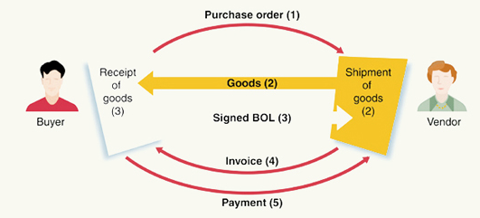
- Upon receipt of goods and BOL, signed copy of BOL returned to vendor and receipt of goods is filed
- Vendor sends invoice to buyer
- Buyer’s accounting department compares PO to receipt of goods and invoice. If there is a match, buyer pays the vendor

Interorganizational Systems (IOS)
- An interorganizational system (IOS) is a networked information system used by two or more separate organizations to perform a joint business function.
- The two most common forms of IOS are EDI and extranets.
  - Electronic Data Interchange (EDI)
    - Uses private networks to allow the exchange of structured information between two computer applications with a minimum of human involvement.
    - EDI remains the engine behind the majority of e-commerce transactions worldwide.
    - It is too expensive for most small businesses

  - Extranets
    - Collaborative networks that use Internet technology to link businesses with their customers.
    - Security measures keep data secure and XML is used to transfer the data.
    - An extranet can be thought of as two connected intranets.

Comparing EDI and Extranets-Enabled B2B E-Commerce
 | EDI | Extranet
Security | More secure because uses private networks | Less secure than EDI because uses the Internet
Cost | More costly because of proprietary software and private networks | Less costly because it uses existing networks and Internet apps
Flexibility | Less flexible — proprietary software limits use | More flexible because the Internet allows for greater customization
Trend | Gradually being replaced by extranet-based apps | Gaining wider acceptance because of lower costs
Chapter 6
Database management and Business Intelligence

What are Data, Information and Knowledge?
- Data are raw unorganized facts, numbers, pictures, and so on.
- Information is data that have been organized and are useful to a person.
- Knowledge is created when a person combines experience and judgment with information.
  - Explicit knowledge is readily codified, such as the knowledge in a textbook.
  - Tacit knowledge is gained through experience, insight and discovery.

- Wisdom adds insight and ethics to the experience and professional judgment inherent in knowledge.
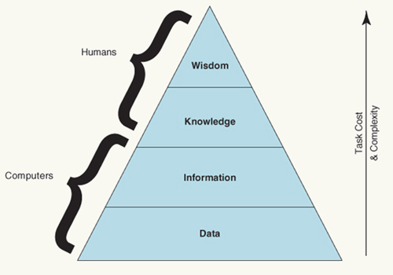

Knowledge Work Activities – “Work flows”
- Discovery
  - The finding of data, information and knowledge relevant to a task, problem, issue, or opportunity.
  - Search engines are an important part of the discovery process.
  - Intranets contain data about the company that can be searched by employees to find “best practices”.
- Analysis
  - Involves thoughtful investigation and examination of the available data, information and knowledge.
  - Spreadsheet software is widely used for the analysis process.
- Transformation
  - Involves organizing the results of analysis activities.
  - Often transforming data using databases into information that can be used to create business value.
  - Database management systems (DBMS) are important to the transformation process.
- Synthesis
  - The discovery of trends or patterns to possibly explain courses of action for the future.
  - Often creating a whole from various parts is one way of synthesizing data into useful information and knowledge.
  - An accurate and complete synthesis of the results of an analysis is essential to solving the right problem and making sound decisions.
- Communication
  - The sharing of analysis, ideas and solutions with others.
  - Some communication technologies such as e-mail and instant messaging focus on physically sharing a message. Or help in scheduling meetings.
  - Presentation and document creation software are also important communication tools.

Activity | Example
Discovery | Find weekly sales data for our company and for competitors
Analysis | Identify any trends in data and compare to competitor and industry
Transformation | Compare sales data for one week to similar data for previous months
Synthesis | Suggest ways to capitalize on company strengths and overcome weaknesses
Communication | Present findings and suggestions to management

Databases: The Primary Data Storage for Organizations
- All business information systems rely on stored data to make decisions.
- The primary technology for data storage is the database.
- A database consists of interrelated data that are stored in files for easy access.
- A database management system (DBMS) is a collection of software that allows users to create and work with a database.

The Data Hierarchy
A way of organizing stored data in progressively larger levels of complexity.
- Bit
- Character
- Field
- Record
- File
- Database

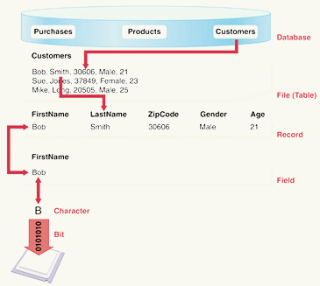

The Relational Data Model
Stores data in one or more tables corresponding to entities and the relationships between these entities
- Tables consist of records that correspond to rows in the tables.
- A record stores data about a single instance of an entity.
  - A record consists of one or more fields.
- Fields are attributes and correspond to columns of the tables.
- Primary Key is the unique value for each record
- Foreign Key is created when a second table use the primary key of one of the tables as a reference field

The relational data model is a method of logically storing data in a database that is independent of the method used to physically store the data.
Relational database management systems (RDBMS) are the most popular way of storing large amounts of data.
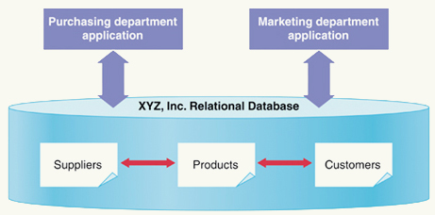

ERDs and Logical Data Models
Two types of models are commonly used to design the organization of relational database:
- The entity-relationship diagram (ERD)
  - Indicates the entities and how they are related.
- The logical data model
  - Translates the ERD into a diagram of the tables in the database.
Partial ERD and Data Model for an E-voting System
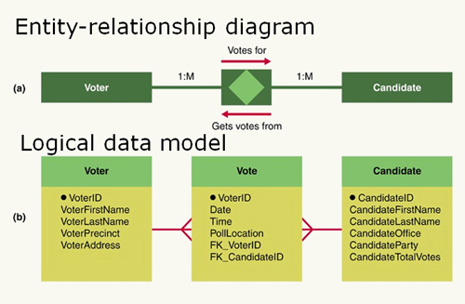

Data Flow Diagrams
A traditional IS model that depicts how data move through a system.
It includes:
- External entities that send input or receive output from a system.
- Processes that show activities that move or transform data.
- Data stores that usually correspond to tables in the data model.
- Data flows that connect the components.
Data Flow Diagram
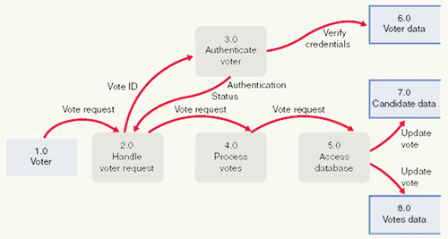

Other Methods to Store Data, Information and Knowledge
In addition to using databases, there are a number of other ways to store data, information and knowledge.
These include (but are not limited to):
- Data warehouses
- Management information systems
- Knowledge management
- Collaborative software

Using Data Warehouses
- Is a way of storing and managing data for information access.
- It consists of transaction data that has been cleaned and restructured to fit the data warehouse model.
- It is meant to support queries, summary reports and analysis.

Database versus Data Warehouse
 | Database | Data Warehouse
Supported Activity | Operational | Analytical
Response Time | Fast | Can be slow
Age of Data | Current transaction | Historical data
Scope | Limited area within organization | Provides view of entire organization
Data Variability | Changes often | Infrequent changes
Source | Transactions | Multiple sources
Data Model | Business rules | Aligns with overall business structure

Data Warehouses
- Work with tools that allow users to deal with vast amounts of data.
- Often provide support for organizing multidimensional data. Retrieving data organized this way is called slicing-and-dicing.
- Data marts
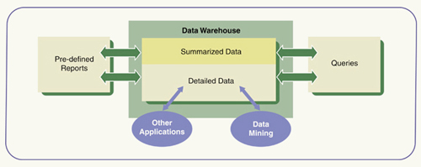
  - Used to extract and reorganize specific data according to needs.
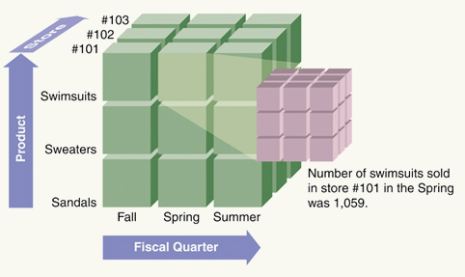

Using a Data Warehouse
- Automatic production of reports and queries.
- Queries against summary or detailed data.
- Data mining for detailed data to find trends or patterns in large sets of data.
- Interfacing with other applications and data stores.

Business Intelligence (BI)
- Is a process for gaining competitive advantage through the intelligent use of data and information in decision making.
- Data and information must go through several stages to be used in decision making.

Stages of Business Intelligence

Stage | Description
1. Data sourcing | Mining data and information from text documents, images, media files and web pages
2. Data analysis | Producing useful knowledge from collected data and information
3. Situation awareness | Culling out and relating the useful facts and knowledge
4. Risk assessment | Identifying decision options and evaluating them
5. Decision support | Using interactive software tools to identify and select intelligent decisions and strategies

The Business Intelligence Pyramid

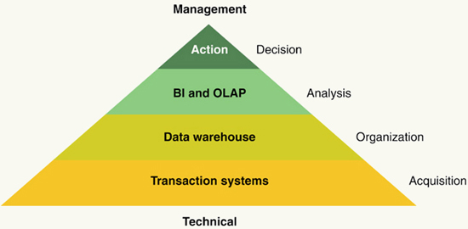

Chapter 7
Database management and Business Intelligence

Critical Pre-Development Questions
Pre-development questions happen before an organization decides to start a system design project. Some questions to consider are:
- What are we planning and why?
- Is the project feasible?
- Should we build or buy/lease?
- If we build, should we do it in-house or outsource it?

Is the Project Feasible? – The FEASABILITY Study
- A detailed investigation and analysis of a proposed project.
- Is the project technically feasible? Is the technology available to solve the problem and is the company technically capable of acquiring and using the technology?
- Is the project financially feasible? Is the company able to pay for the project, and does the project represent a good use of financial resources?

Determining Financial Feasibility
Organizations use financial measures to determine financial feasibility:
- Return on investment (ROI)
- Net present value (NPV)
- Internal rate of return (IRR)
- Payback period
Some costs and benefits are tangible and some are intangible.

Using Spreadsheets to Determine Financial Feasibility
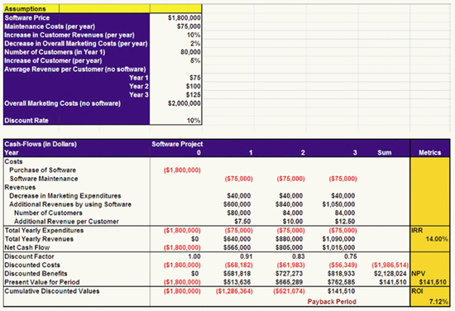
Should We Build or Buy/Lease?
Organizations usually choose one of three primary options for obtaining an IS:
- Build
  - Ensures the best match of IS with an organization’s requirements and is the best option for obtaining competitive advantage. long and costly process.
- Acquire When time and cost are the most important criteria
- Lease
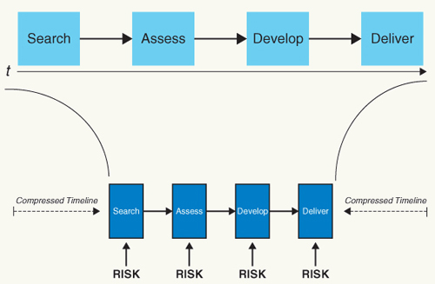

Advantages and Disadvantages of Buying, Leasing or Building
 | Advantages | Disadvantages
Buying | - Generally faster and less costly than building entire system from scratch | - Little or no competitive advantage  - May need to compromise on some features  - Dependent on vendor for product updates
Leasing | - Lowest cost and fastest  - Vendors handle maintenance and updates  - Does not require IS staff | - No competitive advantage  - No control over features  - Dependence on vendor  - Can get bad contract
Building | - Provides competitive advantage  - Retain control over system  - Customization of systems | - Takes the longest time and highest cost  - Requires IS staff with time and development knowledge

Should We Develop In-House or Outsource?
If an organization chooses to build, the next question is whether to use its own staff (in-house development) or hire another company to do it (outsourcing).
 | Advantages | Disadvantages
In-house | - Firm retains control  - Process builds internal knowledge | - More time and costs  - Distraction of in-house staff
Outsource | - High level of skill and expertise  - Internal project oversight  - Lower time and costs | - Lost control of project  - Less opportunity for internal staff to learn  - Requires good contracts and oversight
IS Development Teams

The Importance of Stakeholders
- Attitudes toward a project can dramatically impact success/failure
- A stakeholder analysis should be part of the feasibility study and should continue during the course of the project.
  - Begins with a list of stakeholders, what each has at stake and the degree of impact each stakeholder could have on the project.
  - A project manager should assign team members to different stakeholders with an anticipated strategy for dealing with each one.

A Typical IS Project Team
- The size of an IS development team varies depending on the project.
- Most IS development teams possess the following:
  - Project sponsor
  - Project manager
  - Account management
  - Architecture and design
  - Analysts
  - Developers
  - Specialists (SMEs – subject matter experts)
  - Client interface (Business Systems Analysis)

The Stages and Importance of the System Development Cycle (SDLC)
- Concept:
The environment within the organization hopefully fosters ideas that use IS to improve its bottom line.
- Inception:
The organization has an idea; focus is on understanding the problem and planning the project.
- Elaboration:
Systems team finalizes requirements for system and creates conceptual models of the systems.
- Construction:
Team builds initial running system.
- Transition:
Team finalizes system and puts it in place; final training of users and management is completed.
- Production:
After system is up and running, it must be monitored, maintained, and evaluated; system must be kept up to date.
- Retirement:
System loses its value to the company and must be replaced.

Traditional Waterfall Methodology
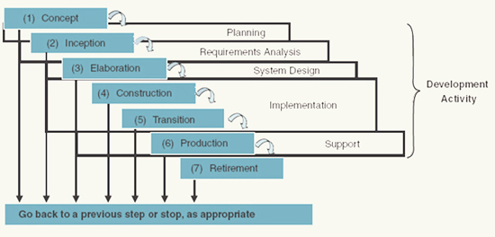

Standard IS Methodology
- Provides a framework for management/ technical processes of the project.
- Provides a project team with structure to ensure working toward the same project goals.
- Will define most of the development activities that are part of the plan developed by the project manager.
- Initially, systems developers used an ad hoc approach called the build-and-fix model, in which the system is built based on customer interviews and then tested.

Traditional IS Methodology: The Waterfall Model
- The first life cycle model to gain acceptance was the waterfall model.
- In this model, there are a number of phases, and a new phase begins only after the preceding phase is acceptably completed.
- If problems are found, it is possible to cycle back to a previous phase.
- Development activities tend to move downstream through the phases in a formal, detailed manner.

Importance of Methodology to IS Development
Advantages | Disadvantages
- Methodologies help teams use best practices  - Should avoid repeating tasks in the event of changing requirements  - Helps to identify and manage risks  - Helps detect errors early, when they are easier to correct  - Focuses on customers’ needs and desires  - Makes it easy to identify and organize the project activities  - Helps target resources toward the activities that need them most | - Some methodologies can be overly rigid and bureaucratic, discouraging creativity and inspired solutions  - Cost

Modern IS Methodologies
An evolutionary model is an approach to development whereby developers produce a partial running system that is evaluated, revised and enhanced.

Evolutionary Development Life Cycle
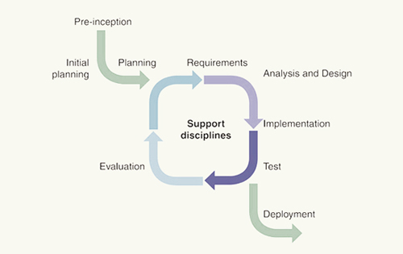

Prototyping
One approach to the evolutionary life cycle is to use prototyping.
Prototyping
  - The project team works with customers to progressively build the system, starting with an initial version called the prototype.
  - The process helps team members and users better understand requirements.
A problem with the evolutionary life cycle model can be the failure to create a well-defined set of documents, making it difficult to monitor and control the project.

Agile Development
- A current trend is to use agile development to create an IS.
- With agile development, the development team develops software in short development cycles or increments.
- Each cycle may include all of the primary phases of the process.

IS Modeling
A model is a simplified representation of something real (e.g. a building, a weather pattern, or an information system).
- Can be a set of mathematical equations, a computer simulation, a graph or chart, or a number of other types.
Usually includes one or more diagrams that developers use to examine, evaluate and adjust to understand the system requirements and performance.

Unified Modeling Language (UML)- popular modeling tool
- The UML is made up of several graphical elements that are combined to form a set of diagrams.
- As a language, the UML has a grammar or rule for combining these elements into diagrams.
UML: Use Case Diagram
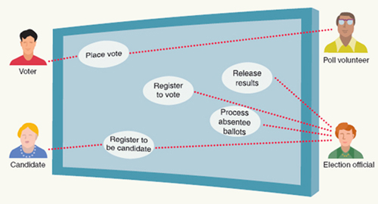

IS Tools for IS Development
- Integrated Development Environments (IDEs): allow developers to complete several programming tasks within the same software application.
- Developers use graphical diagrams to define system components and how they are related with code generation.
- Computer-aided software engineering (CASE) is the use of computer-based support in the software development process.
  - BENEFITS
  - Increased productivity: There is automation of tedious systems development activities, which saves time.
  - Improved quality: CASE tools can reduce or eliminate errors in specification and design.
  - Improved documentation: CASE tools help keep documentation current, reducing misunderstandings.
  - Reduced system maintenance costs: CASE tools reduce the cost of keeping documentation current.

Managing an IS Project
- Project management is “the application of knowledge skills, tools, and techniques to project activities to meet project requirements”.
- For IS development, a project manager oversees three main project elements:
- Project scope: what the project should accomplish.
- Resources needed: people, equipment, material, and money.
- Time to complete it.
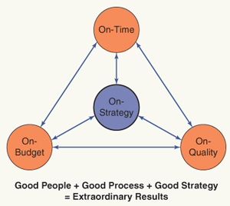
Figure 7.9: The project management triple constraint

Overview of Project Management Tasks
Four core functions lead to specific project objectives:
- Project scope management: identify and manage all tasks required to complete a project.
- Time management: estimate duration of project, develop acceptable schedule and manage project to ensure timely completion.
- Cost management: prepare a budget and manage the costs of the project.
- Quality management: ensure that the finished project satisfies its defined goals.

A Project Management Framework
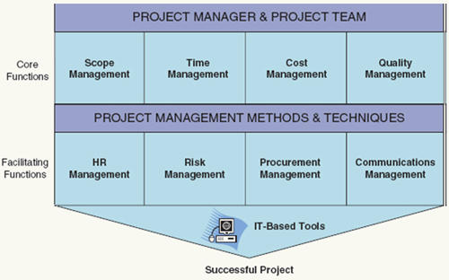

Project Integration
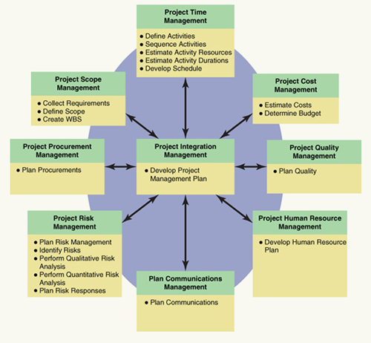

Project Time Management
Controlling the schedule is second only to budgeting in importance.
Project time management includes:
- Define activities: identifying the activities that team members need to do to complete the project.
- Estimate activity resources: estimating type and quantity of resources.
- Estimate activity duration: determining how long each activity will take.
- Develop schedule: creating a deliverable schedule.
- Control schedule: keeping the project on schedule.
Gantt Chart
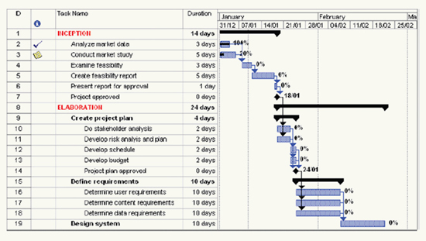

Risk Management
The job of risk management is to recognize, address and eliminate sources of risk before they become a threat.
Common Areas of Project Risk
- Feature creep  - Shortchanged quality  - Inadequate design  - Research-oriented development  - Friction with customers | - Requirements goldplating  - Overly optimistic schedule  - Silver bullet syndrome  - Weak personnel

Risk Management Matrix
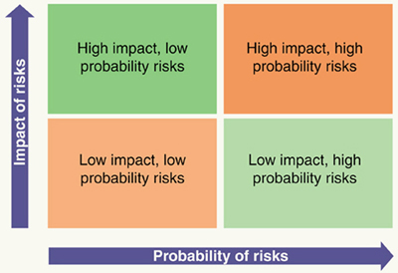
Responses to Risk
- Risk Transfer: Move the risk to somebody better able to deal with it.
- Risk Deferral: Adjust the schedule to move some activities to a later date when the risk might be lessened.
- Risk Reduction: Either reduce probability of the risk occurring or lessen the impact.
- Risk Acceptance: Accept the risk, but make sure contingency plans are in place.
- Risk Avoidance: Eliminate the possibility of the risk occurring.

Program and Portfolio Management
Portfolio management is ultimately about selecting and approving projects that will accomplish the organization’s strategic objectives. While often considered as part of project management, it is actually a planning process that precedes the project management process by defining which projects will get activated and assigned to a project manager and project team.

Project Management Software
Project management (PM) software is designed to support and automate the tasks of project management and to help project managers make decisions.
- Low-level packages include tools for basic scheduling, project control, reporting, filtering and sorting.
- Mid-level packages add resource leveling, resource allocation, cost control and flexible charting.
- High-level packages add advanced functions like scheduling by user-defined rules, programming languages, resource management for multiple projects and risk management.

PERT Chart
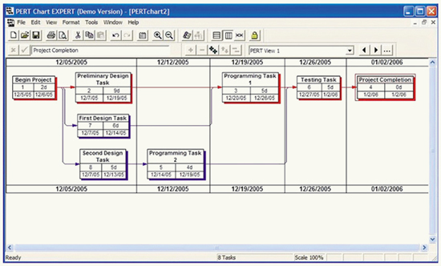

Chapter 8
Web 2.0, Social Media, Online Trends

Introduction of Web 2.0
- Refers to an interactive web and allows movement from a site that displays information to a site that permits interaction with users.
- Supported by audio and video capabilities combined with user-generated content (UGC) such as blogs and conversation threads.

New Technologies for Web 2.0 Social Media
- Adobe Flash allows interactivity, animation and audio and video streaming.
- Javascript is the communicator between the computer and the Internet.
- Through the use of Application Protocol Interface (API), developers can access established programs and use their functionality.

Defining Social Technologies and Utility
- Developers replicate paradigms of human social interactions online by linking form to function.
- The primary purpose of social websites is to connect us with friends, family, partners and colleagues.
- Social utility: suggests that people spend time on sites that provide social value, contributing to social satisfaction.
- The Three Pillars of Sociability apply to both real life and the online world.
  - The desire to affiliate, participate and be validated by others.

Three Pillars of Sociability
- Affiliation essentially the need to belong, want to be affiliated with group
- Participation understanding of rules of behavior and conduct.
- Validation how to validate the users social experiencing therefore constantly reinforcing the social utility of the website
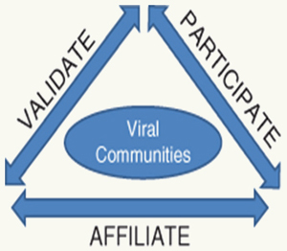

Design and Usability
- Design esthetic and easy usability are critical to building a successful interactive media site.
- Simple navigation as well as changing and refining the technology flow encourages use.
- Eliminating barriers and complexities so users can easily find and use a specific function.

Business Utility
- Translating online social utility into business utility helps drive value for companies and organizations.
- Consumers and clients will share information if they get something back in return that they want (e.g. products and services, information, access to other buyers).

Technology Implications
- Web 2.0 sites are more expensive to create and run than traditional websites.
- Compression technologies help to reduce the costs of storage and transmission.

Privacy and Security
- Users must trust that sites where they post and share public and private information are secure.
- Privacy protection and other related codes create obligations that companies and organizations must adhere to or this can become a legal risk.

User-Generated Content
- Social websites provide a context in which users provide the content.
- User-generated content is fundamental to most social sites.
- Creating a participating identity allows the user to create and post content.
- Self-regulating sites allow members to report negative conduct to a moderator.

User-Generated Content and Brand Risk
- Always be aware of undertaking any social campaign that may backfire.
- Mashups and brandstorms can be very negative and damaging to companies as they are created by implications, not on the basis of fact

Finding Content
- Tagging associates keywords within your content to make it searchable so other users can locate it.
- A folksonomy is a collective cloud tag that assists users in accessing information quickly and efficiently.
- Viral social interactions occur when content instantly spreads online around the world.

Creating Business Utility Using Social Media Tools and E-Marketing
- Direct marketing: messages, offers, or promotions come directly from the company to the consumer.
- Indirect marketing : sources such as word of mouth, product and ranking review sites.

Phase 1: Early on, marketing's use of IT technology rested solely on gathering and using e-info data
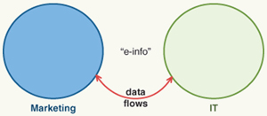
E- INFO

Phase 2: As the Web began to grow, most companies began to use IT as a way to communicate directly with their customers. However, the communication was still only one way — from company to consumer
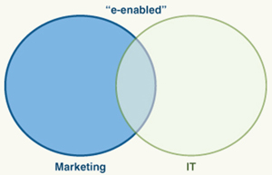
E- enabled

Phase 3: As the social web began to take over, marketing became e-dominated, where use of the Web is an integral part of marketing's communications with consumers
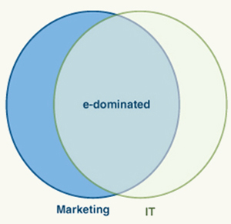
E- dominated

Harnessing the Power of Social Media
- Facilitate employer/employee engagement.
- Create brand-related clubs/forums.
- Manage online communities.
- Facilitate online review sites.
- Promote geo-purposed sites.
- Media transparency ensures branding and advertising messages are coherent and consistent.

The Social and Business Impacts of Web 2.0
Traditional marketing and advertising are changing as a result of Web 2.0.
Companies are realizing the importance of social media in their marketing efforts.
Advertising $$ are moving from search and banner ads to social media sites.
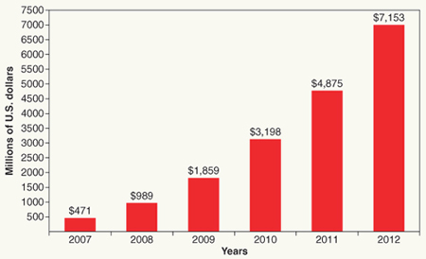
U.S. online video advertising spending, 2007-2012
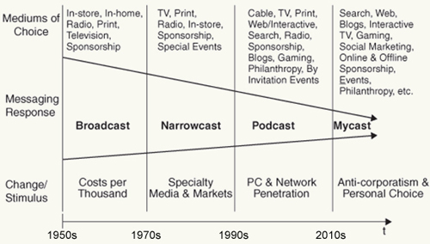
The way advertisers reach consumers has changed significantly since the advent of the Internet. We have moved from an age of broadcasting to mycasting, and the ability of advertisers to target their audience has narrowed in the process

Social Business Models
- Conducting online focus groups for new product development.
- Running viral campaigns to launch new products.
- Holding virtual recruiting and job fairs.
- Replacing annual online surveys with virtual equivalents.
- Moving from broadcast to podcast models for training and development.

Chapter 9
Ethics and Professional Practice in IT

An Introduction to Ethics and Morality
- Ethics is a widely shared understanding of right and wrong.
- Personal values are fundamental beliefs you hold as true.
- Ethical decisions are based on personal moral codes.
- Society’s legal codes define what is right and wrong.

Business Ethics and Conduct
Tangible business benefits and corporate social responsibility:
- Shielding employees from litigation and negative publicity.
- Reducing compliance and audit costs.
- Creating a brand built on integrity and ethical conduct.
- Gaining goodwill in local communities.
- Ensuring that an organization will be accepted as it expands.
- Attracting quality employees.

Corporate and IT Governance
- Corporate governance: managers are accountable to stakeholders.
  - Technology impacts, necessitating IT governance.
- IT governance is “the distribution of IT decision-making rights, duties, and procedures among enterprise stakeholders, and monitoring strategic decisions regarding IT”.
- IT governance begins as a very high-level process that specifies:
- How the organization will set goals, objectives, priorities and policies for IT;
- How it will integrate IT with business strategies and goals; and
- Which organizational members will make decisions regarding, and be responsible for, the successful completion of these tasks (the “who” of IT governance).
The CIO
The Chief Information Officer (CIO):
- Leads the organization’s information and technology efforts.
- Ensures proper and secure use of all the organization’s info resources.
- Understands both business and technology.
- Communicates IS goals and aligns them with business strategies.

Related Law and Regulations
- Personal Information Protection and Electronic Documents Act (PIPEDA)
- Bill 198
- EU Data Protection Directive
- Basel II Accord: International Convergence on Capital Measurement and Capital Standards
- Sarbanes-Oxley Act
- Multilateral Instrument 85-109

Professional Codes of Conduct and Practice
- Codes of conduct guide professionals in terms of what is and is not acceptable and ethical behavior.
- Codes are often in place in organizations with high-risk profiles where unethical behavior has high financial and human costs.
- Example of code of conduct principles:
  - Upholding the law
  - Confidentiality
  - Fairness
  - Corporate responsibility
  - Honoring our trust in you
  - Objectivity
  - Integrity
  - Individual responsibility

Common Ethical Dilemmas Involving IT
- Copyright and privacy
- Patent violations
- Reverse engineering
- Spam and privacy codes
- Security breaches
- Competitive intelligence
- Hiring practices, equity and equal opportunity
- Green IT

The Personal Implications of Ethics and Governance
- Ethical thinking relies on each person having values, morals and knowledge of the law.
- Ensure that you are prepared to confront ethical dilemmas when they arise.
- Take responsibility to protect your personal character and reputation.
- In some areas, it is up to the IT profession to ensure that the industry acts ethically.

