CHM1321 Organic Chemistry I

Class 1A & 1B Read:
Chapter 1: 1-8, 10, 11
Chapter 2: 1-2

Defining Organic Chemistry

Organic Chemistry:
- Study of carbon compounds
- Carbon is very unique due to the fact that it can form bonds with itself
  - (Resulting in chains and complex structures)
  - It is the only element that can do this
- All organic molecules contain carbon
- Almost all organic compounds will contain hydrogen
- Most carbon heteroatoms (C, H)
  - Most common: O, N, F, Cl, Br, I
- Organic Molecules:
  - Plants/Animals
  - Drugs/Plastics/Perfumes

Inorganic Chemistry:
- Everything else

Organic Periodic Table
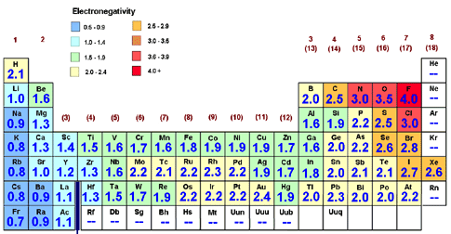

Electronegativity
- Ability of an atom to attract electrons
- Carbon: 2.5
- Hydrogen: 2.1
- Across the row and up the column, electronegativies increase with Fluorine having the highest electronegativity (4.0)
- Indicates what types of bonds we have and allows us to understand reactivity

Chemical Bonds
- Covalent Bonds: A—B
- Implies the electrons are shared, however does not specify how equally
- Bonds will be covalent if the difference in EN ≤ 2
- ie: C—H 0.4 EN difference (always covalent)

- Ionic Bonds
- Bonds will be covalent if the difference in EN > 2
  - ie: Na—Cl 2.1 EN difference (always ionic)

Chemical Structures
Molecular Formula: lists the number of each atom in a molecule
- (C₆H₁₂O₆): Problem C structure

- Condensed Structures:
- See the connections in a compact way
- CH₃CH₂CH₂CH₃ (attached to C preceding them)

- Lewis Structures:
- Able to see how many bonds each makes and to where
- Also shows the lone pairs and unpaired electrons
- Second Period (B, C, N, O, F) can never have more than 4 bonds
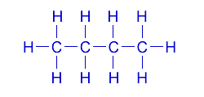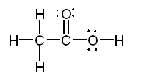
Butane Lewis structure C₄H₁₀ Acetic acid Lewis structure CH₃COOH

- Count the total number of valence electrons
- Draw a single bond between each atom
- Add the leftover electrons
- Add them to the structure starting with the most electronegative atoms
- Calculate the formal charge and add double or triple bonds to minimize charges/follow octet rule (see acetic acid Lewis structure)
Formal Charge = (atoms group) – (#bonds) – (#non-bonding electrons)

- Line Structures:
- Show each carbon and the way they bond to each other
- Does not have bonds going to any hydrogens (assumed at each vertex)
- Every heteroatom is shown as an extra bond
- Hydrogens are only shown when bonded to another atom

3-methylbutanoic acid
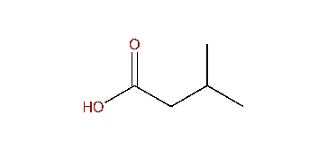

Molecular Orbital Theory
- Covalent bonds re made by mixing atomic orbitals
- Orbital: region of space around the atom where you have a high probability of finding electrons
- Electrons move around the nucleus in a wave motion (similar to a sine curve) that involve a positive phase and a negative phase
- When 2 atoms form a bond orbitals (waves) must mix
When waves are added in phase: constructive interference occurs and a bond is formed

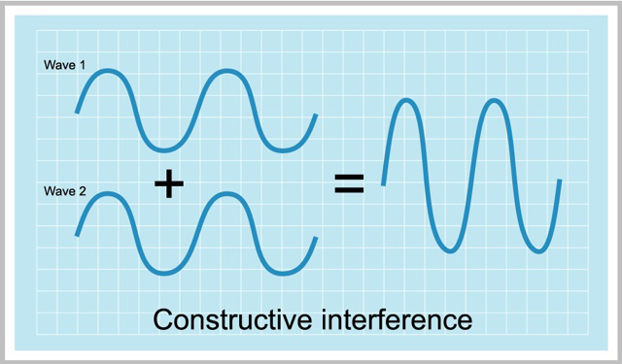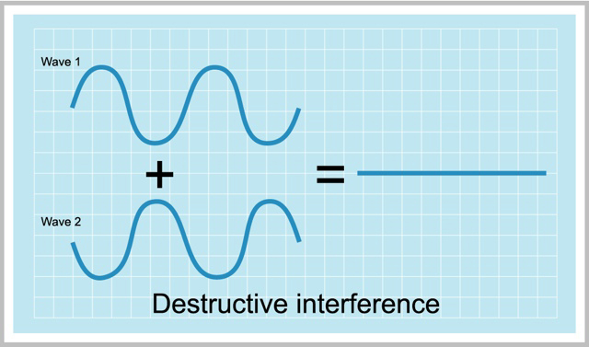

When waves are added out of phase: destructive interference occurs (2 orbitals from atoms are not synced and a bond does not form because the product does not have a density)

Bonds
- Bonds are molecular orbitals (MO) made by mixing atomic orbitals (AO)
- H₂ H—H Bond MO made of a mix of AOs
- H atom is composed of 1s orbital (AO): can be positive or negative in phase
- Positive is shown by a shaded orbital and negative is shown by a black orbital

- There are 2 ways to mix orbitals in H₂
- In phase: both hydrogen atoms have shaded AOs that bond to create a MO (or bonding orbital) sigma bond (still shaded because it is still in phase)
- Out of phase: one positive phase and one negative phase come together to create repulsion between the 2 to create a sigma* bond (still an MO) described as an anti-bonding orbital
- Whenever 2 AOs are mixed, 2 new MOs must be created
- Both phases are equally likely to happen, resulting in both occurring at the same time
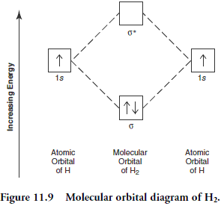
- Energy Diagram shows why this works (MO Formation)

The one that is lower in energy is the formation of the constructive interference
- The one higher in energy is the H₂ molecule that went through destructive interference
- The orbitals are not equally filled with electrons (obviously)
- The effect of the sigma* orbital does not make a difference to the system
- The sigma orbital (MO) has lower energy that either of the 1s orbitals (AO) that originally existed

- Putting electrons in sigma bonds is stabilizing
- Bonding Orbitals: holding atoms together (not shaded)
- Anti-bonding Orbitals: forcing the atoms apart from one another (shaded)

Molecular Shape
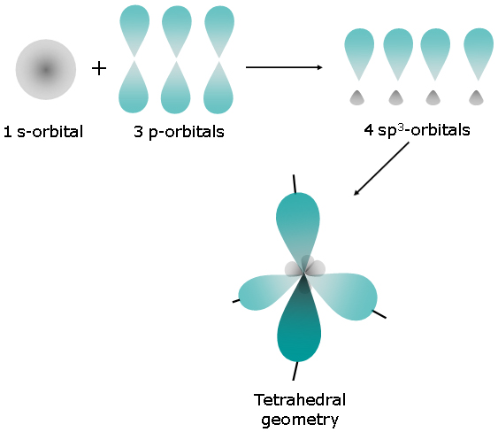
Location of the bonds in a 3-D version of the molecule will determine the shape
Mixing orbitals makes bonds
H₂ H—H Bond is linear!
CH₄ hybridizes to create a tetrahedral arrangement around the chiral carbon
4AOs create 4 sp³ orbitals
Tetrahedral arrangement has an angle of 109.5 between each bond
All bonds created in CH₄ are sigma bonds (C—H)
- AO’s 1s, 2s, 2p, sp³, sp², sp
- MO’s σ, σ*, π, π*

Linear Combination of Atomic Orbitals
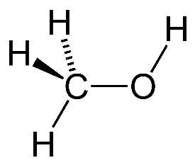
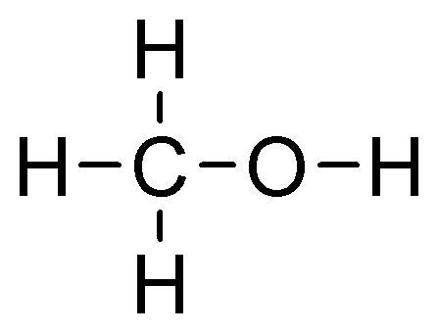
- Shows orbitals in 3D
ie: Drawing Methanol using LCAO (CH₃OH)
- 4 things bonded to C and O
- 4 different orbitals equally distanced

Molecular Shapes
- Try to minimize interactions/electron repulsion
- Overall 3 possibilities with Carbon (single, double, triple):

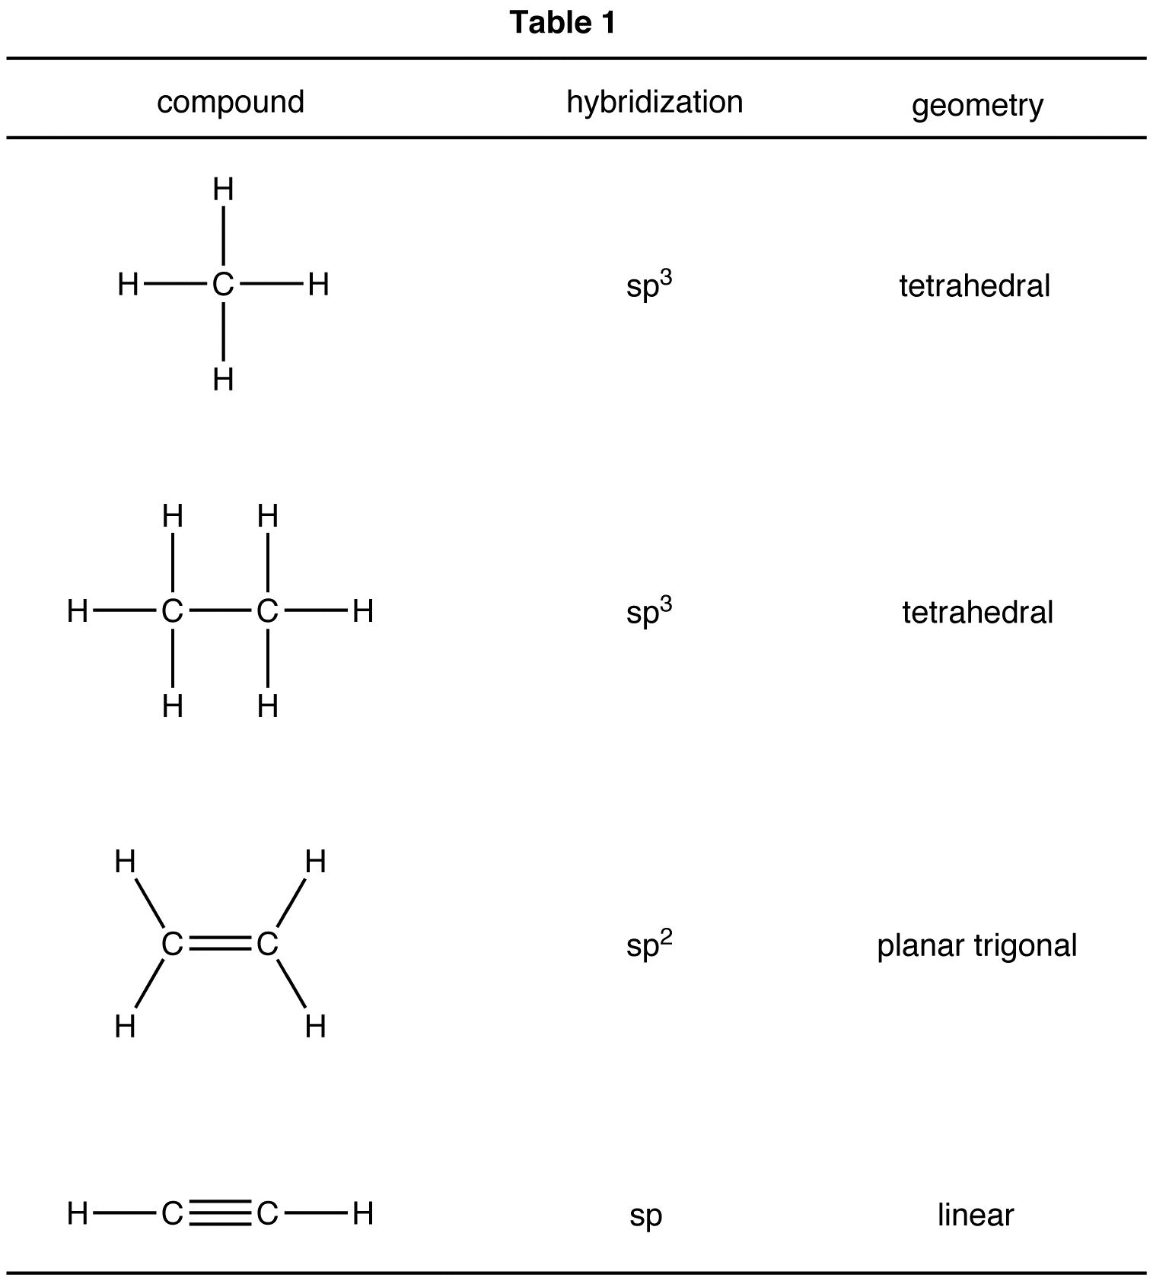

ie: LCAO of Formaldehyde (CH₂O)
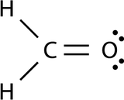
- FC: (O) = 6-2-4 = 0
- FC: (C) = 4-4-0 = 0
- Carbon connects to H, H, O: three straight bonds (3σ bonds)
- Trigonal geometry: sp² (3 AO’s)
- Both C and O have a leftover p orbital that bond together to create a π bond

- 2 Types of Bonds:
- σ Bonds:
- Electron density along the axis between atoms
- Formed by overlap between s, sp, sp², sp³
- Determine the shape/geometry
- π Bonds:
- Electron density above and below the axis between 2 atoms
- Formed only with p orbitals
- Prevents rotation

ie: LCAO of Acetylene (C₂H₂)

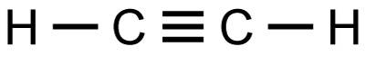
- 2σ: linear geometry
- 4 AO’s including 2σ and 2π bonds
- π bonds have a higher energy than the σ bonds
- (only draw 2 π bonds not 4)

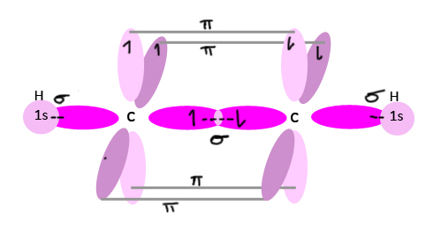

Alkanes
- Contain only C, H
- All sp³ carbons
- Undergo combustion/some radical reactions
- Otherwise fairly unreactive

ie: pentane C₂H₁₂ 2-methylbutane C₂H₁₂
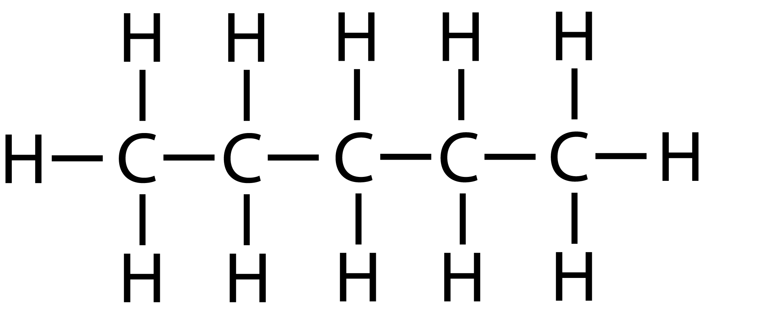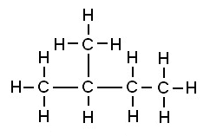

Conformations
- σ bonds can rotate
- Conformers: temporary structures that can be obtained through the rotation of σ bonds (single bonds) (π bonds prevent rotation)
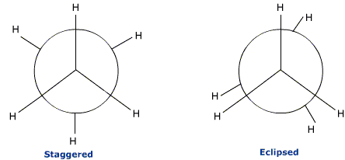
- Newman Projections
- Allow us to clearly illustrate conformations
- Use a perspective along the axis of a bond
- Staggered is preferred based on stability because the carbons are farther apart
- 60° difference
- As you rotate, you alternate between staggered and eclipsed conformations or points of higher and lower energy
- Propane, butane, etc conformations are similar but have different energies
- Propane: 3.2kcal/mol
- Butane: 3.6-4.9 (ranging due to different conformations) (see butane conformers)

- For butane:
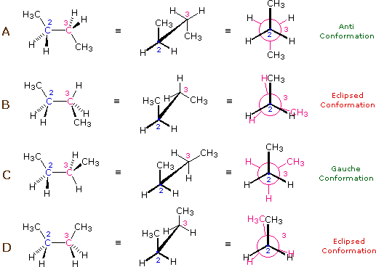
- Anti-staggered, CH₃s are 180° apart (most stable)
- Eclipsed, steric hindrance (less stable)
- Gauche staggered, large groups 60° apart from each other (more stable)
- Eclipsed, largest groups eclipsed create steric effect (least stable)

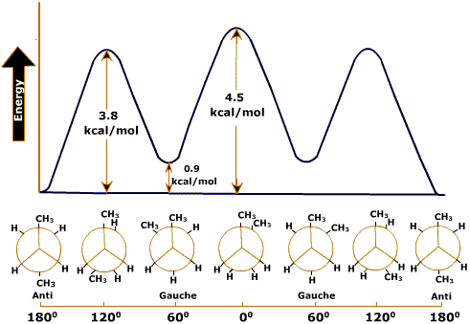

Most stable
A > C > B > D Least stable

Cyclic Alkanes
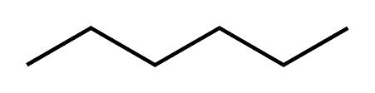
- Tons of possible conformations
- Can rotate around itself

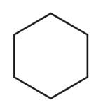
- More rigid
- Molecules can pack better
- Higher MP/BP
- Can have any size
- Cyclohexane has the least tension due to bond angles

- Cyclic alkanes can have substituents which creates stereoisomers
- Cis (same side) or Trans (different sides)
- Cyclohexane is special (due to its chair structure)
- Strain-free
- 109° angles
- No eclipsing Hydrogens (in the original chair structure)

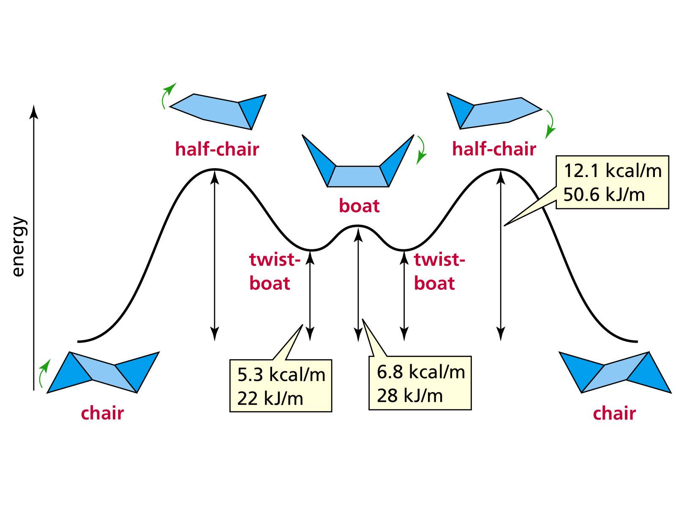

The Newman Projection for the Chair Conformation of Cyclohexane:

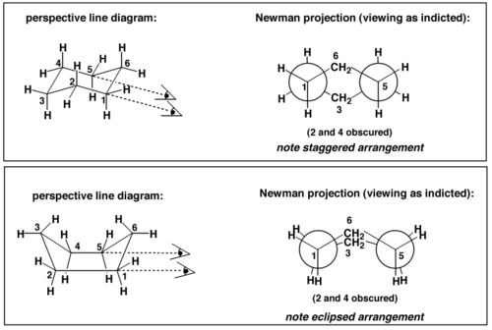

How to Draw a Chair
See How to Draw a Chair for Extra Steps on drawing substituents
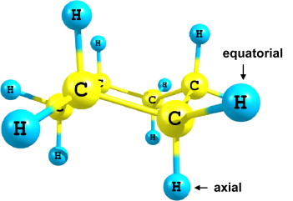
All create a tetrahedral shape around themselves because they have 1 axial and 1 equatorial going in different directions
Cyclohexanes can interconvert between 2 different chair conformations
Compounds prefer when big groups or substituents are in the equatorial position

ie: 1-chloro-4-hydroxycyclohexane

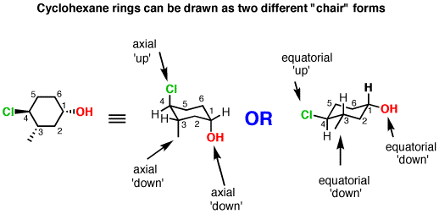
- Switches to boat conformation to put the substituents in the equatorial state because it is more stable
- The Chlorine and Hydroxyl groups are in open space resulting in a lower energy (see energy/chair graph above)
- When we invert the chair:
- Everything that’s up/down stays the same
- Everything that’s axial/equatorial will flip

Isomers

Different Connections between atoms
Constitutional (Structural)

Diastereomers: stereoisomers that are not enantiomers
Isomers
Stereoisomers:
Same connections but different spatial arrangements
Enantiomers: molecule and its mirror image that is non-superimposable

Chirality

- Objects/molecules that can exist as non-superposable mirror images or chiral
- Molecule whose mirror image can be superposed are “Achiral” (plane of symmetry)
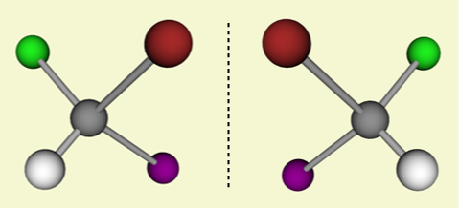
Different from each other
Can’t be superposed
Enantiomers
The 2 molecules are chiral

- An atom with 4 different substituents is called the best
- Stereogenic center
- Stereo center
- Chiral center
- Compounds with 1 sterocenter are chiral
- Compounds with >1 stereocenter may or may not be chiral
- If an atom has 2 identical groups (substituents not stereogenic) and the mirror image can be superposed, it is not chiral

Absolute Configuration
- System for naming stereogenic centers unambiguously
- CAHN, INGOLP, PRELOG RULES (R,S)

R, S Notation
- Assign a priority to each group of the stereogenic center
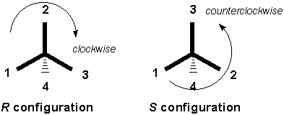
Higher atomic # gets higher priority (starting at 1)
Only look at the first atom bonded

- Place lowest priority (H) at the back of the molecule and assign R&S depending on the order in which they meet
- In case of ties, use next atom along a chain and compare 1 at a time using highest atomic numbers.
- In the case of double/triple bonds: imagine π bond breaks and duplicates at both ends

Fischer Projections
- Special method to draw stereogenic centers (like a cross)
ie: (s) Lactic Acid

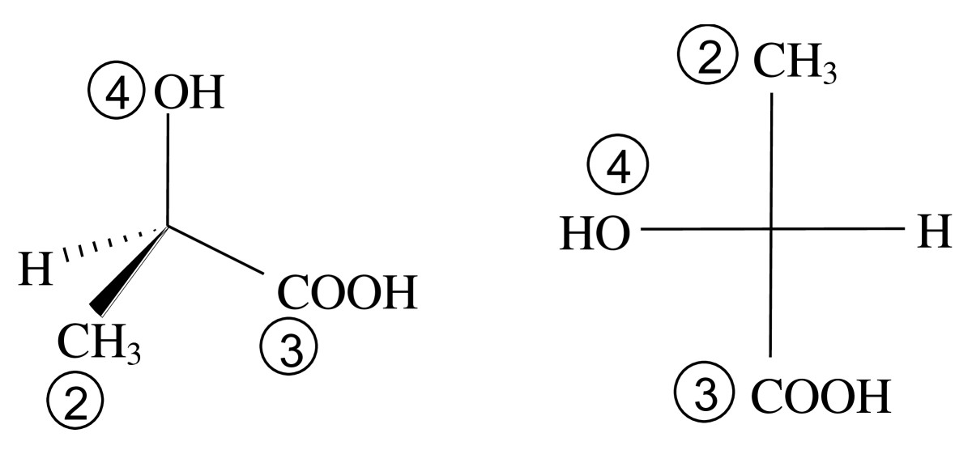

How to Draw Enantiomers
- Mirror image
- Flip 2 groups (front and back)

Diastereomers
- Stereoisomers that are not mirror images of one another

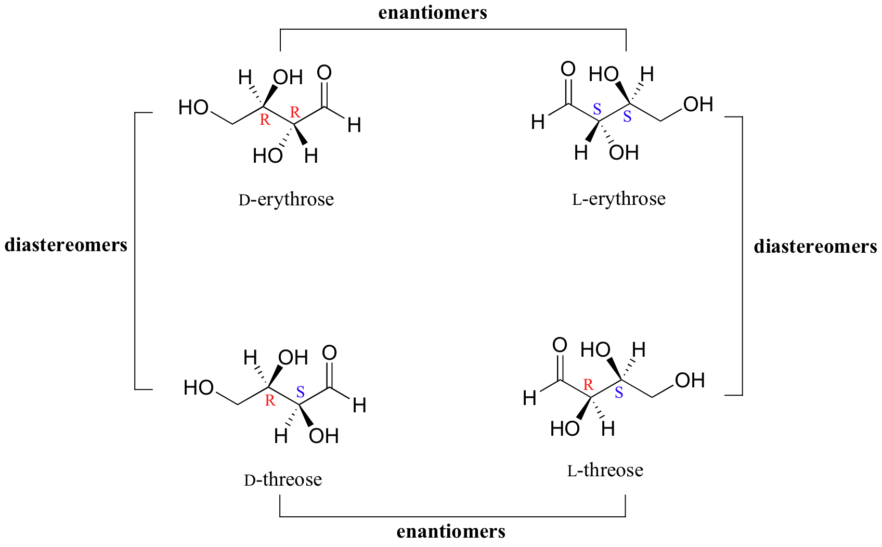
Diastereomers
In enantiomers the molecules are mirror images and all stereocenters are inverted
Diasteromers: only some stereocenters are inverted
Overall: 4 different stereoisomers
How many stereoisomers are possible?
Max is 2^{n} (where n=# of stereogenic centers) but it is possible to have less

Meso Compound
Molecule that has two or more stereogenic centers BUT that is superposable on its mirror image (for one of the centers)
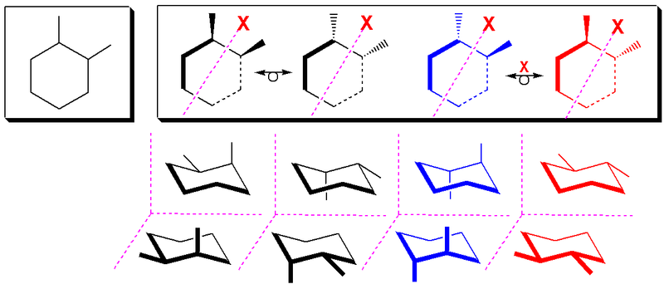
One carbon is chiral and one is achiral
Total number of stereoisomers: 3
Contains a plane of symmetry although sometimes it is not evident

Properties of Enantiomers and Diastereomers

Diastereomers | Enantiomers
- Different compounds  - Have different physical and chemical  - BP and MP  - Solubility  - Reactivity | - Essentially the same molecule (mirror image)  - Same BP and MP  - Same solubility  - Same basic chemical reactivity  2 exceptions:  - They rotate polarized light in opposite directions  - They react differently with other chiral molecules (solvent/enzymes/proteins)

ie: Thalidomide is an exception
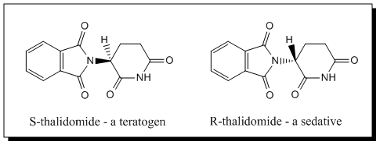
Rotates polarized light different
Reacts with other chiral carbons in the body to create malformations
Solution of 1 Enantiomer
Plane Polarized Light

Other enantiomer produces the same thing in the other direction

- If a compound rotates light:
- Clockwise: dextrorotary (+) or (d) (S enantiomer)
- Counterclockwise: levorotary (-) or (l) (R enantiomer)
- Angle d is dependent on concentration
- Specific rotation is more useful

Where T=temperature (usually room temp), λ=wavelength of the light, (100*d)=observed rotation, (c)=concentration of sample (in g/100mL), (l)=cell length (dmdecimeters)
[d]^{T}_{λ} = (100*d)/(l*c)
- Pure solutions of one enantiomer are possible: said to be 100% optically pure
- More often we’ll have a mixture of enantiomers
- (+) Enantiomers rotate right
- (-) Enantiomers rotate left
Result: smaller rotation angle

Optical Purity:

This means something at the molecular level: Enantiomers excess: EE
EE for a mixture of (+) & (-) isomers

EE = *100%

Note: Reacemic Mixture: (50% l, 50% d)
0 optical purity = EE = 0%

How to Make Pure Enantiomers
- Take a racemic mixture of enantiomers (R&S) and react them with a pure compound (one enantiomer)
- Forming diastereomers/separate the 2
- Regenerate our enantiomers

ie: 2-Butanol (the product will have 2 diastereomers which can be separated)
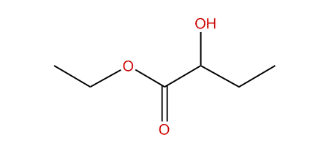
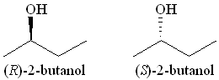
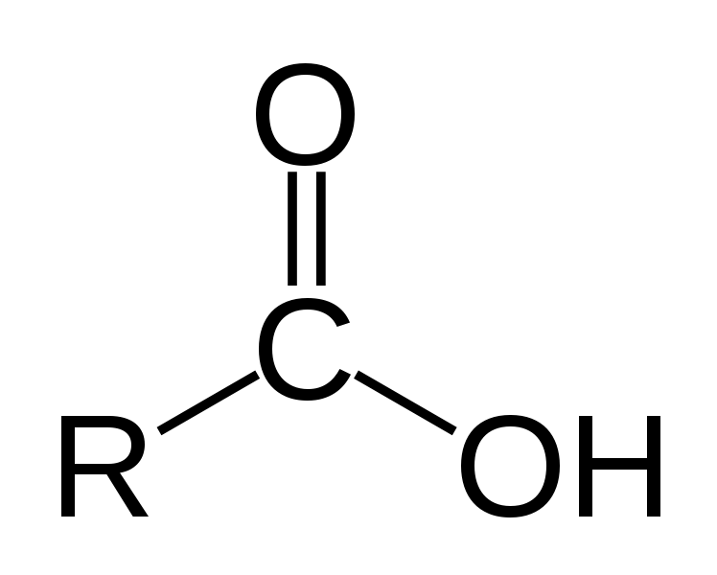

+ =

Dipoles
- Electronegativity: previously seen
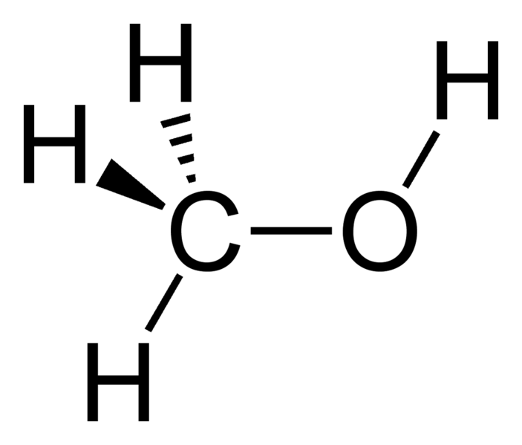
- Covalent bonds: <2 difference in electronegativity
Dipole Moment
0.86 D
- Ionic bonds: >2
- Still a wide range of different covalent bonds
δ+
- More EN usually creates a stronger dipole
δ-
- Units Debyes (D)
- Partial positive and negative charges shown by bigger or smaller dipoles and arrows
- A molecule is polar if:
- There are polar bonds in it
- Net dipole is not 0

Intermolecular Interactions
- Dipole-Dipole
Will affect BP/MP, and solubility
- Hydrogen Bonds
- Van der Walls

All weaker than ionic/covalent bonds

- Dipole-Dipole
- Most organic molecules have a permanent (net) dipole due to their polar bonds
- Creates a positive end (δ+) and a negative end (δ-)

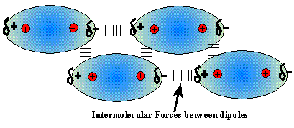
- Between molecules, these attract one another
- The opposite dipoles arrange themselves in space to react with each other
- When melting or boiling a compound within a net dipole BP/MP is increased
- Stronger dipole harder to break the attraction
- Hydrogen Bonding
- Observed as (dipole-dipole interaction) when a molecule possesses an N-H, OH, H-F bond, and another molecule (or the same) has an O, N, F
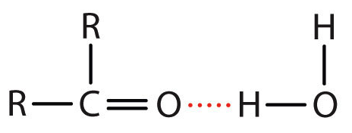
ie: Water Acetone
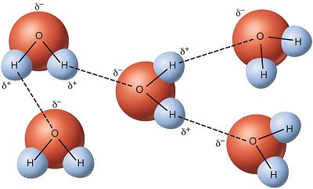

- H-Bond Donor: molecule that has CH, N-H, F-H that gives its hydrogen
- H-Bond Acceptor: molecule that has N, O, F that receives the hydrogen bond
- The more hydrogen bonding occurring, the higher MP/BP

- Van Der Walls Interactions
- Present in all molecules
- Much weaker
- Become important when dealing with alkanes/non-polar molecules
- Temporary dipoles created (last only a fraction of a second), temporary electron movement that creates an attraction
- Bigger molecules have more potential for Van Der Walls
- Linear molecules have more contact surfaces

Solubility
“Like dissolves like”

Most organic molecules:
- Will be polar
- Dissolve well in organic solvent
- Insoluble in water

Exceptions: can be soluble in water if:
- Can form hydrogen bonds (compared to its size)
ie: methanol; hydrogen bonding will make it dissolve
Nonanol; too large and does not form enough H-bonds; not soluble
- If molecules are charged (ionic)

Mechanisms

Organic reactions occur when electrons move
General Chemistry: collision between molecules (good orientations with enough energy)
Organic Chemistry: A region of high electron density (δ-) reacts with a region of low electron density (δ+)

Types of Arrows
- Reaction Arrows (A+BC)
- Reversible Reaction
- Retrosynthesis
- Resonance (equivalent)
- Mechanism Arrows
- Are curved movement of electrons
- Start where electrons are (δ-) and go towards a region that lacks electrons (δ+)
- Double headed: 2 electrons moving
- Single headed: 1 electron moving (radical chemistry)

Resonance
- Important in many functional groups (other than alkanes)
- When we have ≥2 Lewis Structure that can represent the same molecule
ie: Acetate anion
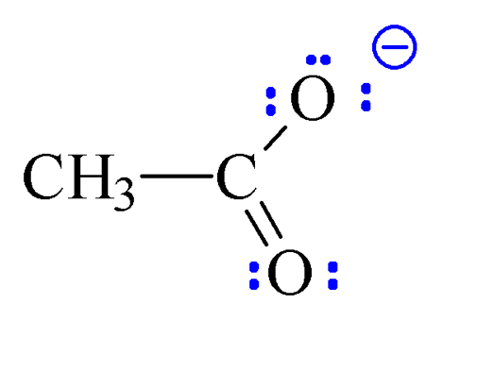
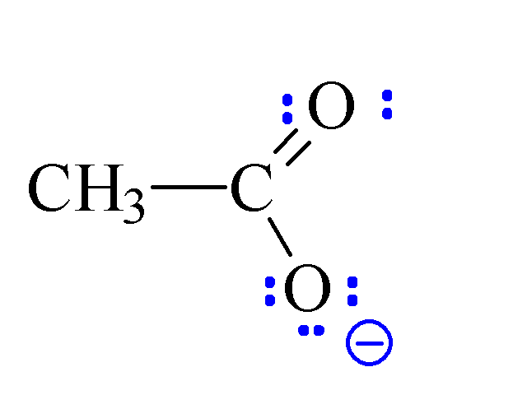
Key for Resonance Structures:
We have not changed the connectivity but instead shown different locations for π bonds and lone pairs of electrons

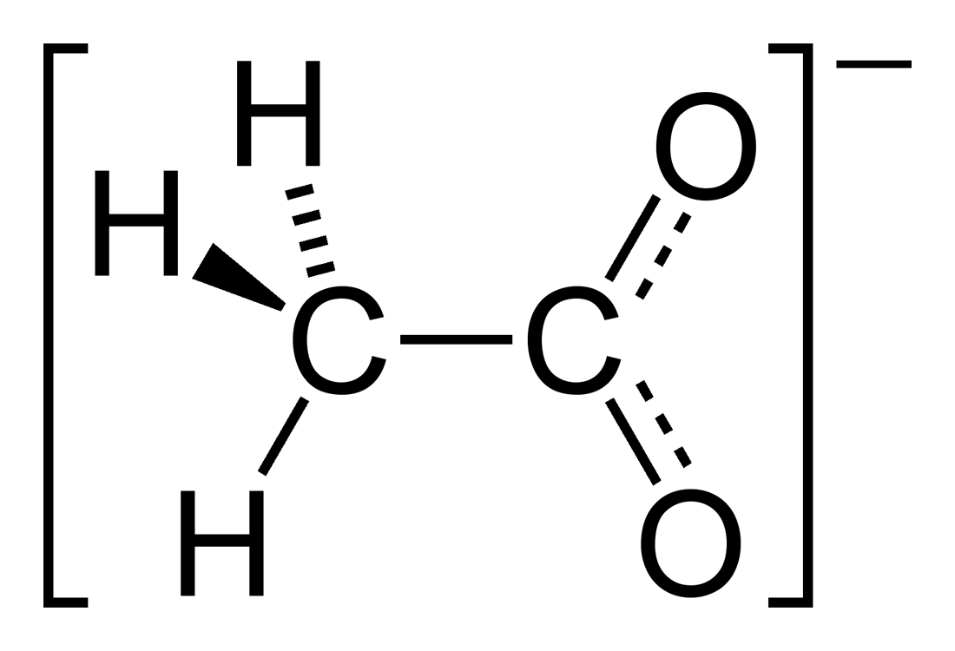
What is the real structure of the acetate anion?
- A hybrid (mix) of all the different resonance forms
- Partial double bond for both CO
- Partial negative charge for each bond
- This is what the molecule looks like in solution because it is more stable
- For mechanisms we will only be using one of the resonance forms
Not all resonance forms are of equal importance! (More stable forms will contribute more)
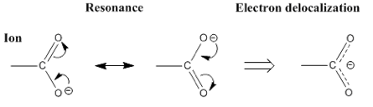
More charged atoms are less stable
Bad insignificant

Hybrid:

In general:
The best resonance forms will have the following characteristics (listed in decreasing order of importance)
- Full octets for all atoms
- Fewest formal charges
- Negative charges on electronegative atoms
- Positive charges on electropositive atoms
- Maximum charge separation of similar charges (-/- or +/+)
- Minimum charge separation of opposite charges (-/+)

When constructing resonance forms:
- Do not break single bonds
- Do not put more than 8 electrons around an atom (octet rule)

Examples: Concepts and Tricks
- Always more electrons towards most electronegative atom
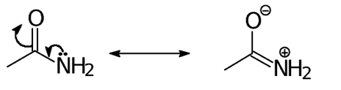
Both structures have full octets and no single bonds were broken
Major Intermediate
Charge is equal on both
(Minor is not shown)

- Look at positron of lone pairs and π bonds and neighboring charges, atom lacking octet other π-bond
ie: Methyl-butenone

- All octets
- No octets on 1 carbon
- 2 atoms with no octets, 4 charges insignificant
- No octets on 1 carbon
Insignificant structure A>B>D>>C
- When we start with a negative charge, we must break more bonds to avoid breaking the octet rule

Hybrid:

- A negative charge “pushes” electrons, a positive charge “pulls” electrons in

Acids and Bases

Mechanism
Always the same mechanism
- Negative dipole is formed when more electronegative atom (base) donates a pair of electrons to the more positive hydrogen on the acid forming a positive dipole on the hydrogen and a negative dipole on the atom
- At equilibrium there will be a conjugate acid and conjugate base with chlorine atoms and hydrogen fluoride and fluorine atoms and hydrogen chloride
Draw mechanism
How to determine the direction of the equilibrium:
- Compare the pKa of the acids

H₃C-H 50 very weak acid conjugate base is more basic
HO-H 16 weak acid
Cl-H -7 strong acid conjugate base is less basic

Reduction of a Carbonyl
- (H: )⁻ (NaH, KH) good base/bad nucleophile so instead we use NaBH₄ because it is a good nucleophile and a source of hydride (H: )⁻
- If bond breaks, H will leave with electrons
- Mechanism (simplified)
- Nucleophilic Attack

- Acidic Work-up

