OB Chapter 6
I. Money as a Motivator
The money that employees receive in exchange for organizational membership is usually a package made up of pay and various other fringe benefits that have dollar values, such as insurance plans, sick leave, and vacation time. We are mainly concerned with the motivational characteristics of pay. Employees and managers, however, seriously underestimate the importance of pay as a motivator.
Motivation theories suggest that money can be a motivator to the extent that it satisfies a variety of needs, is highly valent, and it is clearly tied to performance. Research has found that financial incentives and pay-for-performance plans increase performance and lower turnover. In general, the ability to earn money for outstanding performance is a competitive advantage for attracting, motivating, and retaining employees.
A. Linking Pay to Performance on Production Jobs
The prototype of all schemes to link pay to performance on production jobs is piece-rate. Under a piece-rate system, workers are paid a certain sum of money for each completed unit of production completed. Various schemes that link pay to performance on production jobs are called wage incentive plans which often offer a bonus for production over a minimum quota. These wage incentives have often resulted in increases in productivity.
B. Potential Problems with Wage Incentives
Despite their theoretical and practical attractiveness, wage incentives have some potential problems when they are not managed with care.
Lowered Quality. It is sometimes argued that wage incentives can increase productivity at the expense of quality. While adequate systems can usually be put in place to monitor and maintain quality in manufacturing operations, wage incentives that increase "through-put" in service contexts are more difficult to control.
Differential Opportunity. A threat to the establishment of wage incentives exists when workers have differential opportunities to produce at a high level. Sometimes access to raw materials or the quality of production equipment can give some workers an unfair advantage over others in their opportunity to earn incentives.
Reduced Cooperation. Wage incentives that reward individual productivity might decrease cooperation among workers who might hoard materials intended for common use or neglect common tasks like house-keeping that do not contribute directly to production quotas.
Incompatible Job Design. In some cases, the way jobs are designed can make it very difficult to install wage incentives. It is very difficult to identify individual productivity in such contexts as assembly line work or where teams are large. As the size of the team increases, the relationship between any individual’s productivity and his or her pay decreases
Restriction of Productivity. A chief psychological impediment to the use of wage incentives is the tendency for workers to restrict productivity. Restriction of productivity refers to the artificial limitation of work output that can occur under wage incentive plans. Workers come to an informal agreement about what constitutes a fair day's work and artificially limit their work output.
C. Linking Pay to Performance on White-Collar Jobs
Compared with production jobs, evaluating white-collar performance is more difficult because there are fewer objective performance criteria to which pay can be tied. Attempts to link pay to performance on white-collar jobs are often called merit pay plans. Just as straight piece-rate is the prototype for most wage incentive plans, there is also a prototype for most merit pay plans: Periodically (usually yearly), managers are required to evaluate the performance of employees on some form of rating scale or by means of a written description of performance. Using these evaluations, the managers then recommend that some amount of merit pay be awarded to individuals over and above their basic salaries. This pay is usually incorporated into the subsequent year’s salary. Most companies employ these plans, although their implementation is often ineffective since many individuals do not perceive a link between their job performance and their pay.
D. Potential Problems with Merit Pay Plans
As with wage incentive plans, merit pay plans have several potential problems if employers do not manage them carefully.
Low Discrimination. A major flaw with merit pay plans is that managers might be unable or unwilling to discriminate between good performers and poor performers.
Small Increases. Merit increases are often simply too small to act as effective motivators, especially if they are spread out over an entire year and combined with other things like cost of living allowances. To overcome this problem, some companies pay a lump sum bonus which is merit pay that is awarded in a single payment and not built into base pay.
Pay Secrecy. Since most companies consider salary information confidential, employees that receive merit pay have no ability to assess the relative value of what they receive which reduces its motivation potential. Further, research has shown that, in the absence of accurate information, managers tend to overestimate the salaries of peers and subordinates, while underestimating the salaries of superiors.
E. Using Pay to Motivate Teamwork
Given the highly individual orientation of wage incentives and merit pay, some organizations have either replaced or supplemented individual incentive pay with plans designed to foster more cooperation and teamwork.
Profit Sharing. Profit sharing is one of the most commonly used group-oriented incentive systems. In years in which the firm makes a profit, some of this is returned to employees in the form of a cash bonus or a retirement supplement. However, it is unlikely that these plans are highly motivational. Too many factors beyond the control of individual employees can intervene in the determination of a company’s profit. It is also difficult to see the impact of one's efforts on overall outcomes. They work best in smaller firms that regularly turn a profit.
Employee Stock Ownership Plans (ESOPs). Employee stock ownership plans (ESOPs) are incentive plans that allow employees to own a set amount of a company’s shares and provide employees with a stake in the company’s future earnings and success. Employees are sometimes allowed to purchase shares at a fixed price and in some cases the organization will match employee contributions. However, like profit sharing, these programs work best in small firms that regularly turn a profit. Besides being difficult to see the connection between one’s own efforts and company profits, ESOPs lose their motivational potential in a weak economy when a company’s share price goes down.
Gainsharing Plans. Gainsharing plans are group incentive plans based on improved productivity or performance over which the workforce has some control. This often includes reductions in the cost of labour, material, or supplies. When measured costs decrease, the company pays a monthly bonus according to a predetermined formula that shares this “gain” between employees and the firm. The most common of these plans is the Scanlon Plan.
Skill-Based Pay. Also called "pay for knowledge", skill-based pay is a system in which people are paid according to the number of job skills they have acquired. The idea is to motivate employees to learn a wide variety of work tasks irrespective of the job that they might be doing at any given time. Skill based pay can provide incentives for a more flexible work force, but training costs are high.
II. Job Design as a Motivator
The use of job design as a motivator represents an attempt to capitalize on intrinsic motivation. The goal of job design is to identify the characteristics that make some tasks more motivating than others and to capture these characteristics in the design of jobs.
A. Traditional Views of Job Design
From the advent of the Industrial Revolution until the 1960s, the prevailing philosophy regarding the design of most non-managerial jobs was job simplification. The zenith of job simplification occurred in the early 1900s when industrial engineer Frederick Winslow Taylor developed his principles of Scientific Management. Taylor advocated extreme division of labour and specialization, and careful standardization and regulation of work activities and rest pauses.
  - Job simplification
  - Extreme division of labour and specialization.
  - Careful standardization and regulation of work activities and rest pauses.
  - Motivational strategies: close supervision and piece-rate pay.

While responsible for initial gains in both workplace productivity and employee standard of living, in recent years, behavioural scientists have begun to question the impact of job simplification on performance, customer satisfaction, and the quality of working life.
B. Job Scope and Motivation
Job scope can be defined as the breadth and depth of a job. Breadth refers to the number of different activities on the job, while depth refers to the degree of discretion or control the worker has over how the job is performed. The classic example of a low-scope job is the traditional assembly line job. High scope jobs that are both broad and deep provide more intrinsic motivation and are the most satisfying to workers.
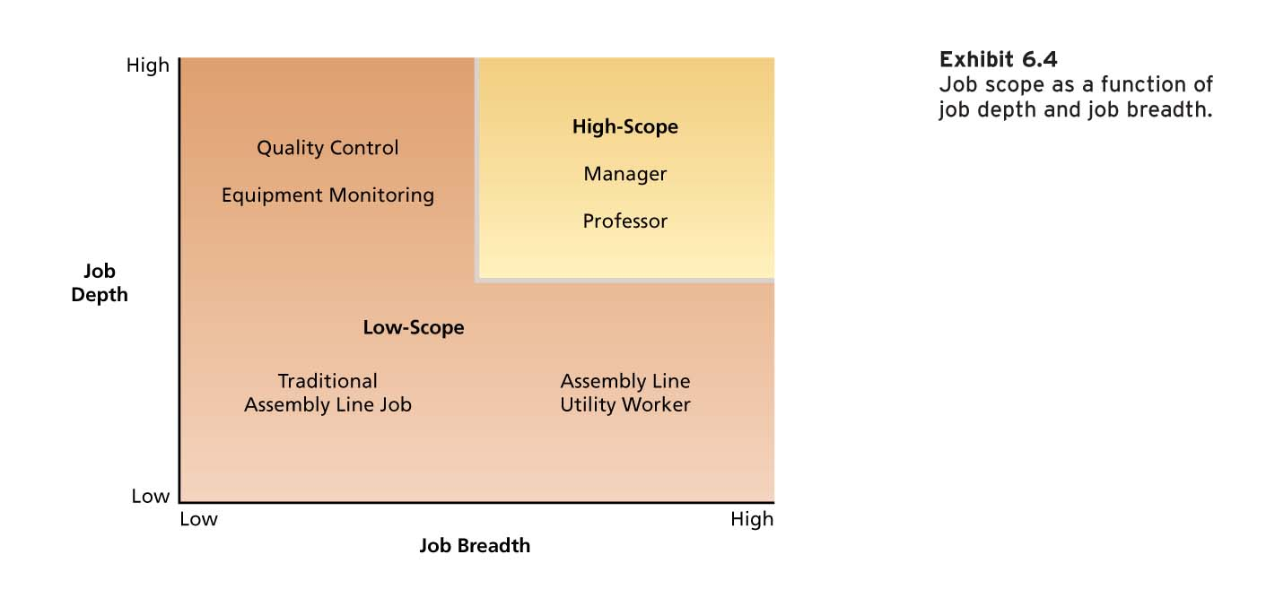
One way to increase the scope of a job is to assign employees stretch assignments that offer employees challenging opportunities to broaden their skills by working on a variety of tasks with new responsibilities.
C. The Job Characteristics Model
The Job Characteristics Model proposes that there are several “core” job characteristics that have a certain psychological impact on workers. In turn, the psychological states induced by the nature of the job lead to certain outcomes that are relevant to the worker and the organization. Several other factors known as moderators influence the extent to which these relationships hold true.
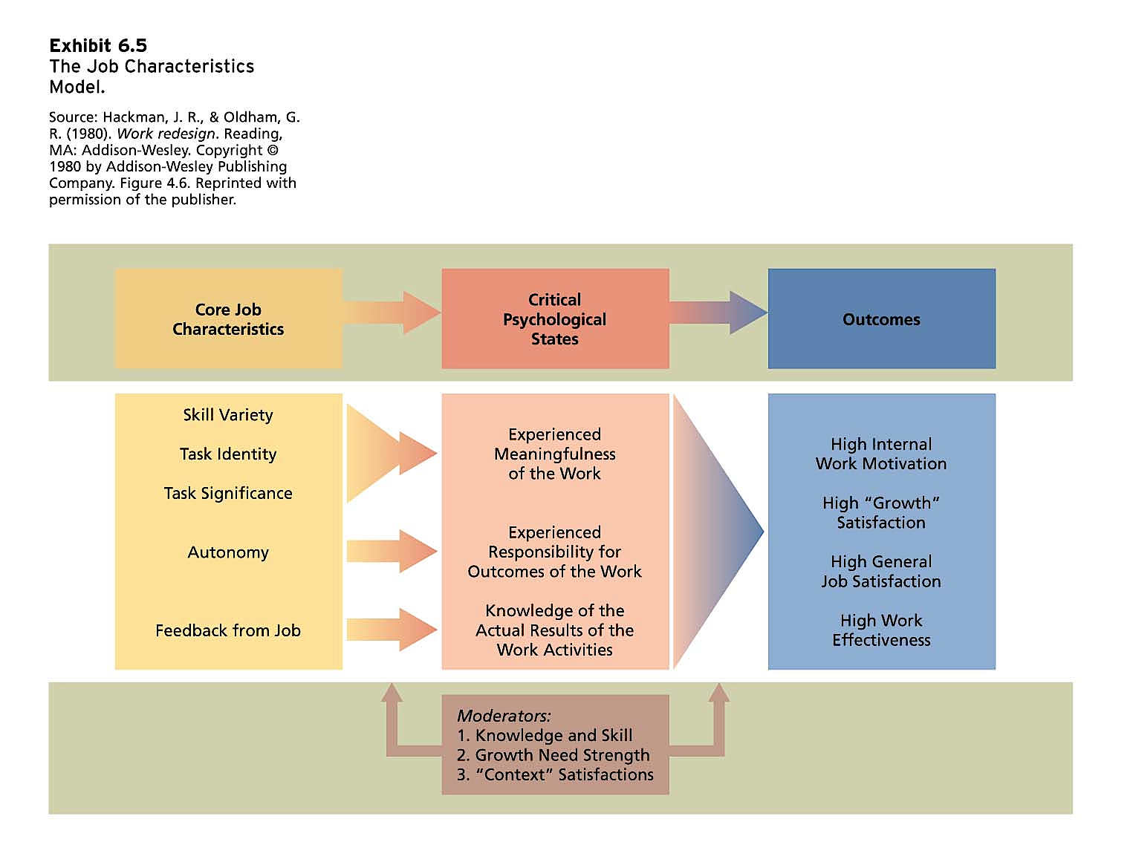
Core Job Characteristics. There are five core job characteristics that affect worker motivation. Higher levels of these characteristics should lead to more favourable outcomes. Skill variety is the degree to which a job provides the opportunity to do a variety of different activities using various skills and talents. Autonomy is the degree to which the job provides freedom to schedule one’s own work activities and decide work procedures. Task significance is the extent to which the job has a substantial impact on other people. Task identity is the extent to which a job involves doing a complete piece of work, from beginning to end. Feedback is information about the effectiveness of one’s work performance.
A questionnaire called the Job Diagnostic Survey (JDS) is used to measure the core characteristics of jobs and is used to determine the motivating potential of a job. The motivating potential of a job measures how well a given job scores in motivating workers. The overall motivating potential of a job can be calculated by the following formula:
Motivating Potential Score = [(Skill Variety + Task Identity + Task Significance)/3] x Autonomy x Job Feedback
Critical Psychological States. The Job Characteristics Model argues that work will be intrinsically motivating when it is perceived as meaningful, when the worker feels responsible for the outcomes of the work, and when the worker has knowledge about his or her work progress. Skill variety, task identity, and task significance affect the meaningfulness of the job; autonomy affects responsibility; and feedback affects knowledge of results.
Outcomes. The presence of the critical psychological states leads to a number of outcomes that are relevant to both the individual and the organization including high intrinsic work motivation, high "growth" satisfaction, high general job satisfaction, and high work effectiveness.
Moderators. Jobs that are high in motivating potential do not always lead to favourable outcomes. Certain moderator or contingency variables intervene between job characteristics and outcomes. One of these is the job-relevant knowledge and skill of the worker which must be high if workers are to respond favourably to jobs that are high in motivating potential. Growth need strength refers to the extent to which people desire to achieve higher-order need satisfaction by performing their jobs. Generally, workers with high growth needs will be most responsive to challenging work. Finally, workers who are dissatisfied with the context factors surrounding the job (such as pay, supervision, and company policy) will be less responsive to challenging work than more satisfied workers.
Research Evidence. Tests of the Job Characteristics Model have been very supportive of the basic prediction of the model in that workers tend to respond more favourably to jobs that are high in motivating potential. Where the model seems to falter is in its predictions about growth needs and context satisfaction. Evidence that these factors influence reactions to job design is weak or contradictory.
D. Job Enrichment
Job enrichment is the design of jobs to enhance intrinsic motivation, quality of working life, and job involvement. Job involvement is a cognitive state of psychological identification with one’s job and the importance of work to one’s total self-image. Employees who have enriched jobs tend to have higher levels of job involvement, and job involvement is positively related to job satisfaction and organizational commitment. Employees who are more involved in their job are less likely to quit.
In general, enrichment involves increasing the motivating potential of jobs via the arrangement of their core characteristics. Many job enrichment schemes combine tasks, establish client relationships, reduce supervision, form teams, or make feedback more direct.
Combining tasks. This involves assigning tasks that might be performed by different workers to a single individual.
Establishing external client relationships. This involves putting employees in touch with people outside the organization who depend on products or services.
Establishing internal client relationships. This involves putting employees in touch with people who depend on their products or services within the organization.
Reducing supervision or reliance on others. The goal here is to increase autonomy and control over one’s own work.
Forming work teams. Management can use this format as an alternative to a sequence of “small” jobs that individual workers perform when a product or service is too large or complex for one person to complete alone.
Making feedback more direct. This technique is usually used in conjunction with other job design aspects that permit workers to be identified with their “own” product or service.
E. Potential Problems with Job Enrichment
Despite the theoretical attractiveness of job enrichment as a motivational strategy, enrichment can encounter a number of challenging problems.
Poor Diagnosis. A lack of careful diagnosis can bring about errors like increasing job breadth without changing any other critical job characteristics, a practice known as job enlargement. The result is simply more tasks at the same level without any changes in the other core characteristics. Also, jobs may be enriched that are already seen as too rich by those working in them (some refer to this a job engorgement).
Lack of Desire or Skill. Some workers do not desire the added responsibility that an enriched job often entails. Alternatively, they may lack the skills and competence necessary to perform enriched jobs effectively.
Demand for Rewards. The development of new skills and greater responsibility that accompany job enrichment often encourage workers to seek additional extrinsic rewards like extra pay.
Union Resistance. Traditionally, North American unions have not been enthusiastic about job enrichment. Unions have tended to equate narrow job specialization with the preservation of jobs and resist the combination of tasks and team approaches.
Supervisory Resistance. Often the autonomy that workers obtain through job enrichment is seen by their supervisors as "disenriching" their own jobs. Some organizations have responded to this problem by effectively doing away with direct supervision of workers performing enriched jobs. Others use the supervisor as a trainer and developer of individuals on enriched jobs.
III. Management by Objectives
Management by Objectives (MBO) is an elaborate, systematic, ongoing program designed to facilitate goal establishment, goal accomplishment, and employee development. In a well-designed MBO program, objectives for the organization as a whole are developed by top management and diffused down through the organization through the MBO process.
Research Evidence. MBO has been shown to result in productivity gains although a number of factors are associated with the failure of MBO programs.

IV. Alternate Working Schedules as Motivators for a Diverse Workforce
Although most workers in North America work a forty-hour, five-day week, many organizations have begun to experiment with modifying traditional working schedules. The purpose of these modifications is to meet the diverse workforce needs and promote job satisfaction. Common forms of alternative working schedules include flex-time, the compressed workweek, job sharing, and telecommuting.
A. Flex-time
Flex-time is an alternative work schedule in which arrival and quitting times are flexible. Employees are expected to work eight hours each day and to be in attendance during "core hours". Flex-time has generally been limited to white-collar personnel and office environments where jobs are not highly interdependent.
Research Evidence. A review of research on flex-time concluded that it has a positive effect on productivity, job satisfaction, satisfaction with work schedule, and lowers employee absenteeism.
B. Compressed Workweek
The compressed workweek is an alternative work schedule in which employees work fewer than the normal five days a week but still put in a normal number of hours per week. The most common approach is the 4-40 system in which employees put in four ten-hour days. Firms or departments may then either choose to operate four days a week or institute a system of rotation to cover more days.
Research Evidence. A review of research on the compressed work schedule concluded that it has a positive effect on job satisfaction and satisfaction with work schedule but no effect on absenteeism or productivity.
C. Job Sharing
Job sharing is an alternative work schedule in which two part-time employees divide the work of a full-time job. Job sharing is particularly attractive to people who want to spend more time with small children or elders than a conventional work routine allows. It is also an effective strategy for avoiding layoffs.
Research Evidence. There is virtually no hard research on job sharing. However, anecdotal reports suggest that the job sharers must make a concerted effort to communicate well with each other as well as with superiors, co-workers, and clients. Such communication is greatly facilitated by contemporary computer technology and voice mail.
D. Telecommuting
Telecommuting is a system by which employees are able to work at home but stay in touch with their offices through the use of communications technology, such as a computer network, voice mail, and electronic messages. Telework centres provide workers all of the amenities of a home office in a location close to their home. Distributed work programs involve a combination of remote work arrangements that allow employees to work at their business office, a satellite office, and a home office.
Research Evidence. There is some evidence that telecommuting has benefits for employees and organizations. Organizations benefit from lower costs as a result of a reduction in turnover and the need for less office space and equipment, and they can attract employees who see it as a desirable benefit. The results of one survey found that telecommuting had a positive effect on productivity, flexibility, and work–life balance. Employees benefit by having greater flexibility and work-life balance. Potential problems include distractions in the home environment, feelings of isolation, and overwork.

