Chandler
Major claim: big firms are essential for industrial success [but, a firm shouldn't be so big us to go into unrelated diversification)
- successful firms are the ones that first capitalized on economies of scale and scope, create management structures and invest in research and development which allows them to stay ahead of the competition
- Once a firm loses the opportunity to be a first mover, it is difficult to regain competitive bondage.
Economies of scale: mass production. The more you produce, the lower the cost. Doing things on a greater scale makes things cheaper.
Economies of scope: Companies can use the same raw materials and intermediate production process to make a wider range of products.
Research and development
International and national growth
RONA | DWR
National Expansion – (Art. 1 para. 6 )  expanded outside Quebec  19% Market share | International Growth
Not first mover | Forbes:  First Movers  good design wasn’t really available – pg.92 “The finer things in life…weren’t available to most of us” – Forbes made it available to the public- launched business in 1999
Brunner:
Related Diversification
a. Tools for living
b. Kitchens
Bauer
Vertical expansion
a. Becoming their own designers
b. Opening stores – added 63 stores in 2002-2006

Greiner
Organizational growth is characterized as a series of developmental phases. Management practices that work while in one phase bring on the crisis in the next.
RONA | DWR
Crises of Control:  Field operations become diverse and inefficiencies creep into the system. Top management lose control over planning, money, technology, and manpower. Management must solve this issue by bringing in special coordination techniques.  - "Top managers whose style is no longer appropriate should remove themselves"  OR  Delegation  - Decentralized structure  - Top managers manage by exception  - Use of profit sharing and bonuses for incentives  - Management becomes active in acquisitions  - Communication from the top is infrequent | Crises of Control:  Field operations become diverse and inefficiencies creep into the system. Top management lose control over planning, money, technology, and manpower. Management must solve this issue by bringing in special coordination techniques.  Coordination:  – Decentralized units are merged into products  – formal planning procedures are established and reviewed  – staff is hired at headquarters to initiate companywide programs  – capital expenditures are reviewed and distributed across the organization  – return-on-capital becomes the criteria for measuring field operations  – certain technical functions, such as data processing, centralized  – stock options and profit-sharing are used to encourage identity with the firm
RONA passed Delegation. They are now in the crisis of control, they fired the CEO, and inefficiency is creeping into the system, (Art. 1. Para 7; “their deployment failed, as these vast stores struggled against a nimbler completion”). They are moving to the phase of Coordination. Management are trying to regain control and are hoping to make “proximity stores that are to be run more efficiently”.  OR  Delegation phase for 20 years Dutton stays with his own management style  Board of directors and shareholder were tired of him board had enough tired of his management style  Stayed at the delegation phase for too long didn’t do anything—stayed with the same strategy for 20 years…  Others came: home depot… lost battle… big box game  5 steps—he provides national pricing each manager in each region decide their own price—delegation  Nothing improved after that. | DWR is at the end of the Control Crises.  There were inefficiencies in the system which led the board to fire the CEO; they are still trying to find a CEO and implement the strategy for better coordination. They are not yet in the Coordination Phase; they are moving into it. Management style is watchdog (pg 96; “If we had not stepped in, there might not be a company today”). Consolidation of organization. Decentralized units are merged into product groups:  “we are looking at tools for living as the growth engine for the company” (pg.96, 3rd para.).

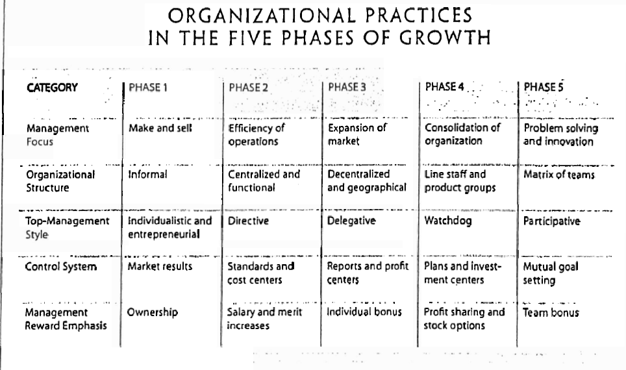

Compare how evidence from Article 1 is Different from Article 2.
Sufficiency: an author must present sufficient evidence. Not only from one source, but from many. Ex. Researchers studied 36 firms, or teacher asked 3 students. Don’t make a general assumption from only one person.
Accuracy: Is the information true to what you already know? Trivial errors like grammar and spelling mistakes, or inaccurate quotations, undermine confidence in the author’s reliability and make the argument less persuasive.
Clarity of Expression: The significance of the evidence should be clearly stated. Numbers do not speak for themselves, they need to be interpreted and explained to the reader. This also apples to direct quotations.
Representativeness: Is the information a representation of all people involved? The variety in the sources of evidence should match the variety in the population relevant to the claim. We should not be persuaded by evidence that does not come from a fair sample of information.
Authority: When people have special training and professional credentials, or considerable experience in a particular area, we call them authorities and pay close attention to the evidence they provide. Also, current writing is usually more authoritative than older sources.
Precision: the use of actual numbers instead of using words like “a great deal, many, often, a high probability, few, and usually. Using numbers and providing direct quotations of what people actually said are the common ways of increasing the precision of our evidence.

Underlying assumptions & Claims
RONA | DWR
Value Assumption:  Jobs should stay in Canada Ex. Guarantee jobs and spending in Quebec… (Second last paragraph in article 1)  Reality assumption:  Share price is a good indication of company performance.  M & A is good for the company. | Reality assumption:  Public statements reflect personal values/opinions. Pg. 95, para. 3, “If creative minds…”  Claim:  DWR made a good decision of firing Brunner or else the company would have kept copying designs.  Evidence: Copying led to disappointed suppliers, who no longer wanted to work with them, and irritated designers, who filed law suits against them. Profit also fell.  Value Assumption:  It’s unethical/wrong to copy (plagiarize): should not be done.  Reality assumption:  If companies copy designs, they will not be as successful in business.  Brunner was a bad CEO; he was a cheater by nature, therefore he didn’t see copying as wrong.
RONA | DWR
Causal claim  Dutton left because profits slumped.  Reverse Causation  Profits slumped because of bad management.  Rival Claim  Profits slumped because of bad economy  3rd variable  The economy | Causal Claim  The company drifted from its original core values; therefore, it suffered reputation-wise, and also financially.  They changed the core values because the company was doing bad  Reverse Causation  The company was doing poorly, therefore they changed core values.  Rival Claim  Profits fell because of bad management / changing trends/ started to copy.  3rd variable  changing vision
BARNEY
 | RONA | DWR
S | national expansion (article 1 pg 6)  #1 hardware store  name recognition | perceived as authentic  Each one of their designs have a story p.96  p. 94. Pg. 1 right after “the Ray Show”.
W | Late to the big box game  they don’t have CEO  will take time to adapt to a new leader | bad historypublic image, reputation is bad, lack of CEO CEO mismanagement
O | Merger and Acquisition | economy is growing, tax cuts
T | Government intervention | Suppliers threat to stop supplyinglawsuits, bad relationship with suppliers (p. 95 top right & p. 96, top left)

Resource: National Pricing—
Organizational resource Reputation Resource: Brand name – DWR
V | Can adapt to market demands faster than the competitions | People are willing to pay more for this product  can’t put a price on design p.96 top right  ”won’t see this stuff at your friend’s house…it’s important” (p.96 top right)  Brand promotes goodwill  Enables them to exploit opportunities (growing when they have a chance—Brand is important) and neutralize threats (because they have a valuable brand name they were able to hide the “wrongdoings” that were happening in the company & are also strong against competitors).
R | No one else has it. | Not many housewares have a very admired and known Brand name  - They are known for goodwill  - Have the hipsters coming
I | Small decisions are the hardest to imitate. No one knows what it is  - It’s possible to imitate but it takes much time and organization to do it  costly time-wise | They have evolved into a big company  - Would take a lot of time, money, to get there establishing Brand recognition is hard and takes much time and money
O | They are able to exploit the full competitive potential of its national pricing. The firm knows it is valuable, rare, costly-to-imitate and they use it to their full potential to make the most out of it.  - It’s self-sufficient | They are able to exploit the full competitive potential of its brand name. The firm knows it has a well-known, valuable, rare, costly-to-imitate brand name and they use it to their full potential to make the most out of it.

Kalpan & Norton – Balanced Scorecard
** It’s not only about the bottom-line
**What you measure is what you get
Four Perspectives for a Balanced Scorecard: Measures that drive performance
RONA
Financial:  % increase in share price  % decrease in cost – merger will decrease costs | Innovation & Learning  Increase in R&D increase time and money invested in it  Increase # hours for training employees  .
Operational  Increase in number of human resources/expert management  % increase in efficiency (amount of employees, the more input, more sales? )  Increase in inventory turnover how fast you’re selling | Customers  Increase in satisfaction rankingcan conduct customer surveys  larger selection of goods

DWR
Financial  % increase in profit  % increase in revenue from tools for living  % increase in market share | Innovation & Learning  # of new original designs  # of hours training designers  # of new designers.
Operational  Increase number of stores open  Decrease time take to ship products quicker shipping  They were producing at a ready-to-ship rate, which was advertised to the customers. They found skilled designers who were able to create desirable products. They gave their customers a story behind each piece of furniture. This was able to satisfy the needs and wants of their customers, as well as meet customer expectations. To assess this, they could measure how many new, unique products that are designed each year. | Customers  # of returning customers  customers saw this company as new and innovative. This modern-European design was desirable to many customers. “Design not yet Within Reach”. Not having the same run-of-the-mill Pottery Barn furniture that everyone else has matters most to customers. To assess this, they could measure the customer satisfaction by handing out a customer survey.

Collins & Porras
 | RONA | DWR
Core Ideology  - Core Value  - Core Purpose | Core Value:  To provide good customer service  Core Purpose  To run more efficiently  To serve the needs of young people so they can build a better, fairer and healthier world. | Core Value  To educate and to be furniture tastemakers.  Core Purpose  To democratize designer furniture
Envisioned Future  - BHAG  - Vivid Description | BHAG  To be the #1 hardware retailer in North America  Vivid Description  Will be as recognized as John Deer if not more. Will be the first choice of every contractor, handyman/woman in North America. | BHAG  To become number one designer of high end furniture in North America, in quality (in the designer market) and the rest of the World.  Vivid Description  Will be a globally known company.

Herzberg
Hygiene Factors: Supervision, salary, company policy, interpersonal relationships, status, security, working conditions. These lead mostly to dissatisfaction.
Motivation Factors: Work itself, responsibility, achievement, advancement, and recognition. These lead mostly to satisfaction.
Horizontal Job Loading/Job Enlargement: more of the same work.
Vertical Job loading/ Job Enrichment: providing companies with the opportunity to grow and advance.

RONA
Job enrichment = more responsibility is given to Dutton
- Dutton is motivated by vertical job loading (article 3 pg. 4) the higher he got the more recognition, advancement, achievement he gets
- He was picked as a solution *article 3 pg. 5. At such a young age

DWR
Herzberg: designers for recognition, pg 2 “To their greatest credit, …” also job enrichment.
- Supplier relationships. look at Liker & Choi
- Doesn’t offer motivation factors may just offer hygienic factors

Mintzberg
Major Claim: A manager must give serious attention to issues that require it, step back in order to see the broad picture, make use of analytical inputs, and respond quickly to numerous and varying problems.
Interpersonal Roles: formal authority and interpersonal relationships
- Figurehead: ceremonial
- Leader: motivate, encourage, hire/fire
- Liaison: outside networking, vertical chain of demand
Informational Roles: communication is their work
- Monitor: scanning for information
- Disseminator: information sharing
- Spokesperson: external communications with clients/suppliers/press
Decisional Roles: major role in unit’s decision-making system
- Entrepreneur: focus on improvement and adaptation
- Disturbance Counsellor: involuntary response to pressures (strikes)
- Resource Allocator: who gets what
- Negotiator: internal with employees, external with suppliers

 | RONA (Dutton) | DWR(Brunner) | DWR (Krevlin) ???
Figurehead | Yes |  | ?
Leader | he’s responsible for loss of profit |  | Yes – firing and hiring
Liaison |  | Yes | Yes – wants to contact upset suppliers
Monitor | Yes - overseeing “all the …” article 3 pg. 3 |  | Yes – oversees company
Disseminator | ?
Spokesperson | Yes | Yes | Yes—Talks to suppliers
Entrepreneur | Yes – national pricing policy  - Finance for ads | Yes | Yes—Trying to fix the company
Disturbance Counsellor | Yes – foreign takeover |  | Yes—Trying to revive the company
Resource Allocator | Yes–allocates moneyads | Yes decides who gets the project | Yes
Negotiator | Yes national pricing-- does salaries

French & Raven
Reward Power: power whose basis is the ability to reward
Expert Power: based on the perception that another has a special knowledge or expertise.
Coercive Power: based on the perception that another has the ability to mediate punishments over them.
Legitimate Power: based on the assumption that another has the legitimate right to prescribe behavior for him. (employer/employee)
Referent Power: based on the person’s identification with another. (celebrities)

RONA
 | Shareholder | CEO | Government
Reward |  | With staff
Coercive
Legitimate | Firing CEO |  | Block M&A
Expert |  | With shareholders and staff
Referent

Financial Minister- Expert
DWR
 | Brunner | Board | Suppliers
Reward
Coercive |  | Can fire | Uniting -- Suing company
Legitimate | CEO
Expert |  | Changed other stores
Referent

Liker & Choi

Supplier Relationships: Would you find it motivating to work for DWR?
- DWR making their own shit is rivalry into opportunity
- Develop them stories
- Share information relationships p. 97 pg. second last
- Joint improvement-not doing? …..

HANDY
The Sigmoid Curve
First Dip in Curve: Period of initial learning
Point A: begin building a new curve
Point B: Too Late! Depleted resources.
Area Between Curves: Confusion

RONA
Handy Peek when they have 19% market share then they decided to do nothing
They are at B doing bad

DWR
4th curve in the learning dip were doing bad
Pg 92. Last par bottom right. In October,
He failed in reviving the company
They tried to start a new curve but Brunner failed. Started the curve after the peek. Brunner couldn’t save it.
Peek is when they went on the market. Bauer. 2004.
Krevlin fired Brunner in the learning dip… The company didn’t grow – people were complaining.. didn’t have profit with brunner fired him in the dip.
Reason why they fired brunner-- Didn’t have the same vision
When you have 92% stake you take it in any direction you like

