Module 3 Notes

Session 1 Database Management Systems

Data and Information
- Data: raw facts that describe the characteristics of an event.
- Information: data converted into a meaningful and useful context.
- Database – maintains information about various types of objects (inventory), events (transactions), people (employees), and places (warehouses)
  - Data vs. Information: an Example
- Raw Data:
- Shares exchanged in the stock market
- Information:
- How did a particular stock perform during the last 6 month?
- How did it perform compare to other stocks?

Importance of Data Management
- Data is everywhere in an organization
- Data have become central and even vital to organizations.
- Organizations need to manage their data assets very carefully to make sure that the data are easily accessed by managers and employees across the organization.
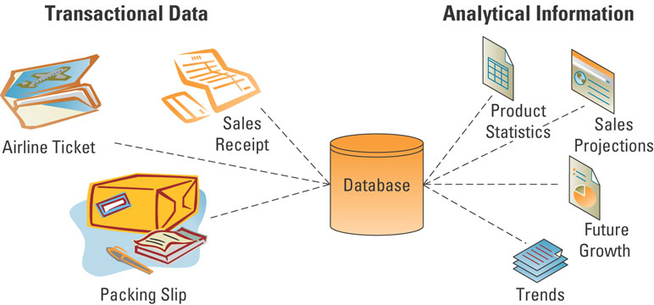
  - Transactional Data and Analytical Information

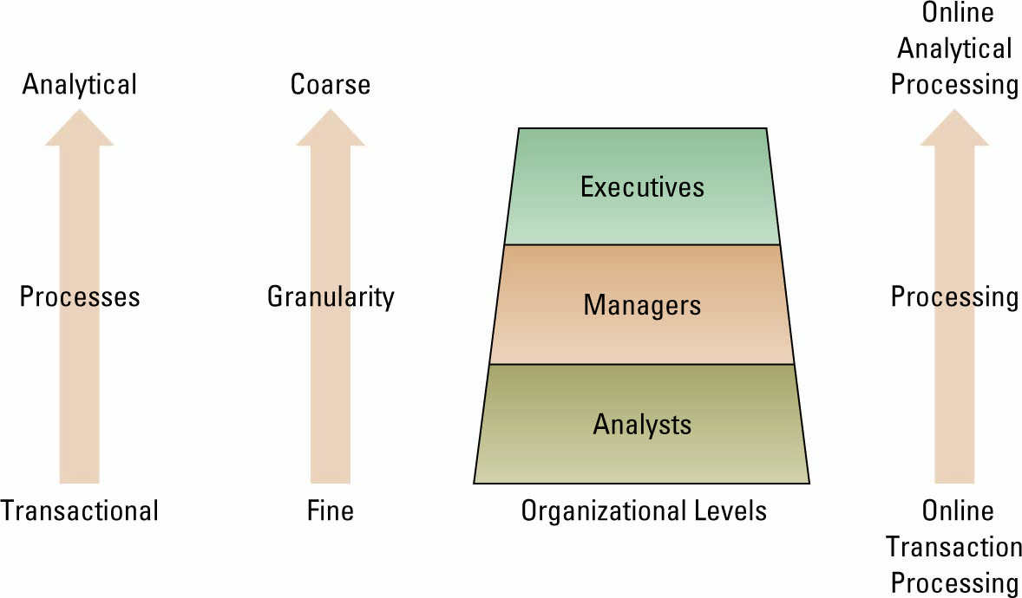

Data Management
- Data management is a structured approach for capturing, storing, processing, integrating, distributing, securing, and archiving data effectively throughout their life cycle.
  - Why does data management matter?
- No enterprise can be effective without high quality data that is accessible when needed.
- Organizations with at least 1,000 knowledge workers lose ~ $5.7 million annually in time wasted by employees reformatting data as they move among applications.
  - What is the goal of data management?
- To provide the infrastructure and tools to transform raw data into usable information of the highest quality.
  - Data Principles
- Principle of diminishing data value
- Principle of 90/90 data use
- Principle of data in context
  - Data Management Challenges
- Volume of data is increasing exponentially.
- Data is scattered throughout the organization.
- Data is created and used offline without going through quality control checks.
- Data may be redundant and out-of-date, creating a huge maintenance problem.
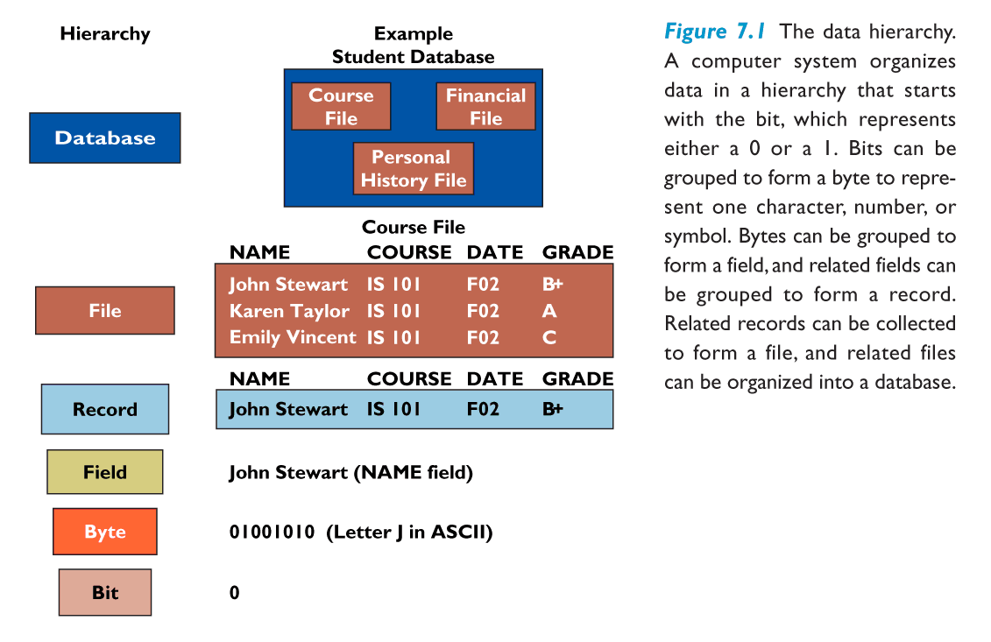
File Organization
- File: Group of records of same type
- Record: Group of related fields
- Field: Group of words or a complete number
- Byte: Group of bits that represents a single character
- Bit: Smallest unit of data; binary digit (0,1)

Traditional (stand-alone) File Environment
- When organizations began using computers, they started with one application at a time, usually accounting, billing, and payroll. Each app was designed to be a stand-alone system, which led to data problems.

Problems with Traditional (stand-alone) File Organization
  - Data redundancy:
- The presence of duplicate data in multiple data files so that the same data are stored in more than one place or location
  - Data inconsistency:
- The same attribute may have different values.
  - Data Isolation, Lack of data sharing and availability
- Information cannot flow freely across different functional areas or different parts of the organization.
  - Poor security
- Management may have no knowledge of who is accessing or making changes to the organization’s data

The Database Management System (DBMS)
- A software package to create and maintain databases
- Acts as interface between application programs and physical data files
- Separates logical and physical views of data
- Many data sources
- clickstream data from Web and e-commerce applications
- detailed data from POS terminals
- filtered data from CRM, supply chain, and enterprise resource planning applications
- DBMS permits an organization to centralize data, manage them efficiently, and give application programs access to the stored data.

Entities, Entity Classes, and Attributes
- Entity – a person, place, transaction, or event about which information is stored
- The rows in each table contain the entities
- Entity class (table) – a collection of similar entities
- CUSTOMER, ORDER, ORDER LINE, DISTRIBUTOR, and PRODUCT entity classes
- Attributes (fields, columns) – characteristics or properties of an entity class
- The columns in each table contain the attributes
- Customer ID
- Customer Name
- Contact Name
- Phone

Relational DBMS
- Represents data as two-dimensional tables
- Relates data across tables based on common data element
- Examples of Relational DBMS: MS Access, DB2, Oracle, MS SQL Server

Key and Relationships
- Primary keys and foreign keys identify the various entity classes (tables) in the database
- Primary key – a field (or group of fields) that uniquely identifies a given entity in a table
- Foreign key – a primary key of one table that appears as an attribute in another table and acts to provide a logical relationship between the two tables

Three Basic Operations in a Relational DBMS
- Select: Creates subset of rows that meet specific criteria
- Join: Combines relational tables to provide users with information
- Project: Enables users to create new tables containing only relevant information

Querying Databases; SQL
- SQL Structured Query Language
Example:
SELECT part_Number, Part_Description, Unit_Price
FROM PART
WHERE Unit_Price < 25.00
The results of using a conditional selection to select only parts that meet the condition of having unit prices less than $25.

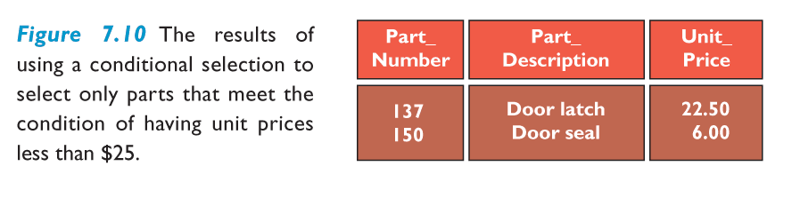
Functions of a Database Management System
- Data filtering and profiling: Inspecting the data for errors, inconsistencies, redundancies, and incomplete information.
- Data quality: Correcting, standardizing, and verifying the integrity of the data.
- Data synchronization: Integrating, matching, or linking data from disparate sources.
- Data enrichment: Enhancing data using information from internal and external data sources.
- Data maintenance: Checking and controlling data integrity over time.

Session 2 Data Warehouse, Document Management, and Enterprise Content Management

Data Quality
- Some sources of low-quality information include:
- Data or information from different systems have different entry standards and formats
- Call center operators enter abbreviated or erroneous information by accident or to save time
- Third party and external information contains inconsistencies, inaccuracies, and errors

Understanding the Costs of Poor Information
- Potential business impacts resulting from low quality data and information include:
- Inability to accurately track customers
- Difficulty identifying valuable customers
- Inability to identify selling opportunities
- Marketing to nonexistent customers
- Difficulty tracking revenue due to inaccurate invoices
- Inability to build strong customer relationships

Information Cleansing or Scrubbing
- A process that weeds out and fixes or discards inconsistent, incorrect, or incomplete information
- Standardizing Customer name from Operational Systems

IT at Work 3.1
- Benefits from data synchronization in the healthcare sector and supply chain:
- Easier and faster product sourcing because of accurate and consistent item information
- Significantly reduces the amount of fraud or unauthorized purchasing
- Reduces unnecessary inventories
- Lowers prices because purchase volumes became apparent
- Improves patient safety

Data Warehouse
- For organizational learning purposes, data from many sources and over many time periods must be gathered together and organized in a consistent and useful way
- A data warehouse is a copy of transaction data specifically structured for querying, analysis, reporting, and more rigorous data mining
- Note that the data warehouse contains a copy of the transactions which are not updated or changed later by the transaction system
- A massive database that store current and historical data
- Data are standardized into a common data model
- Data warehousing is a data store and a process for bringing together disparate data from throughout an organization for decision-support purposes.
- Consolidates data for management analysis and decision making
- Relational Database Management Systems (RDBMS), such as Oracle, DB2, SQL Server are often used for data warehousing.

Model of an Enterprise Data Warehouse
- Data from various sources are extracted, transformed, & loaded (ETL) into a data warehouse; then used to support functions and apps throughout the enterprise.

Data Warehouse Fundamentals
- Extraction, transformation, and loading (ETL) – a process that extracts information from internal and external databases, transforms the information using a common set of enterprise definitions, and loads the information into a data warehouse
- Data mart – contains a subset of data warehouse information

Data Mart
- Subset of data warehouse
- Contains summarized or highly focused portion of data for a specified business unit or group of users

Suitability of Data Warehouse
- Data warehousing is most appropriate for organizations that have some of the following characteristics:
- End users need to access large amounts of data
- Operational data are stored in different systems
- The organization serves a large, diverse customer base
- The same data are represented differently in different systems
- Extensive end-user computing is performed

Data Centers
- Host and integrate networks, computer systems, and storage devices
- High reliability and availability (redundant power supplies, redundant hardware, etc.)
- High security (physical and data/software)
- Example: Christus Health Medical Center in Texas
- $23 million
- 48,000 square-feet
- Stores patient’s insurance records, CT scan, etc.

Distributed Database
- A database that is stored in more than one physical location
- Reduce the vulnerability of a single, massive central site
- Increase service and responsiveness to local users
- Can often run on smaller, less expensive computers
- Depend on high-quality telecommunications lines
- Can be decentralized either by partitioning or by replicating
- Partitioned database:
- Parts of the database are stored in different physical locations
- Replicated database:
- Duplicate the entire database at all remote locations
  - 2 Types of Databases
- Centralized database
- Distributed database with complete or partial copies of the central database in more than one location

Document Management
- Business records:
- Contracts, research and development, accounting, memos, meeting minutes, customer communications
- Document management:
- Control of imaged and electronic documents, spreadsheets, emails, word processing docs, voice and other documents through their life cycle from initial creation to final archiving or destruction.

Document Management Systems
- Hardware and software to archive e-documents, convert paper documents to e-documents, then index and store them according to company policy.
- DMS increases productivity and efficiency by:
- Cutting labour cost by automating business process
- Faster search in documents to support decision making
- Minimizing the cost associated with printing and storing documents
- Improving the security of the contents

Enterprise Content Management
- ECM includes:
- electronic document management
- Web content management
- digital asset management, and
- electronic records management (ERM)
Unstructured Business Records
- Businesses generate volumes of documents, messages, and memos that, by their nature, contain unstructured content that cannot be put into a database.
- Many of these materials are business records that must be retained and made available when requested by auditors, investigators, the SEC, the IRS, or other authorities.
- To be retrievable, business records must be organized and indexed.
- Records are not needed for current operations or decisions, are archived—moved into longer-term storage.

Business Value of E-Record Management
- Companies need to be prepared to respond to an audit, federal investigation, lawsuit, or other legal action against it.
- Examples of lawsuits: patent violations, fraud, product safety negligence, theft of intellectual property, breach of contract, wrongful termination, harassment, and discrimination
- E-discovery is the process of gathering electronically stored information in preparation for trial, legal or regulatory investigation, or administrative action as required by law.
- When a company receives an e-discovery request, the company must produce what is requested—or face charges of obstructing justice or being in contempt of court.

Session 3 Data Analytics

Data Usage and Life Cycle

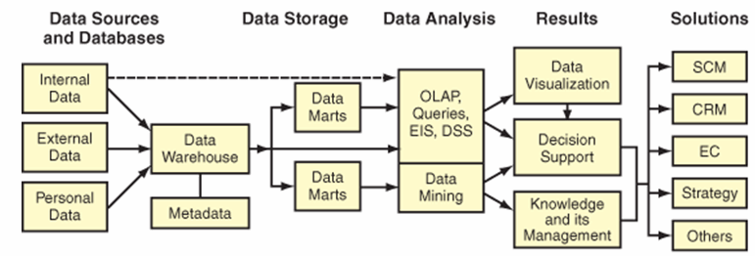
Multidimensional Data Analysis
- Also called Online Analytical Processing (OLAP)
- Interactive, exploratory analysis of multidimensional data from multiple dimensions/perspectives

Data Mining
- Tools for deep down analysis of large pools of data
- To find hidden patters
- To predict future behavior
- To infer rules to guide decision-making
- Data Mining techniques make use of the data in a Data Warehouse
- Concern of Privacy!
  - Data Mining Techniques
- Data-mining uses a variety of techniques to find patterns and relationships in large volumes of information and infers rules that predict future behaviour and guide decision making.
- Common forms of data-mining analysis capabilities include:
- Classification
- Cluster analysis
- Association detection
  - Classification
- Classes are pre-defined
- Assign each data point to one class
- Example Applications
- Grades {A, B, C, D}
- Customer Credit Assessment {Low, Medium, High}
- Fraud detection: {Legitimate, Fraudulent}
- Medical treatments {Critical, NonCritical}
- Pattern Recognition {A, B, C, …}

Clustering
- Clustering is a technique to divide an information set into mutually exclusive groups such that the members of each group are as close together as possible to one another and the different groups are as far apart as possible.
- CRM systems depend on cluster analysis to segment customer information and identify behavioral traits.

Data Mining and Target Marketing
- Exclusion according to geography, age, ability to pay, need for product/service, etc.
- Data mining can help in prospecting:
- Identifying good prospects
- Choosing appropriate communication channels
- Picking suitable messages

Data Mining and Customer Relationship Management
- Matching campaigns to customers
- Exclusion according to geography, age, ability to pay, need for product/service, etc.
- Cross-sell campaign, up-sell campaign, loyalty program
- Customer Segmentation
- Finding behavioral segments
- Reducing exposure to credit risk
- Predicting who will default

Association Detection
- Association detection – reveals the degree to which variables are related and the nature and frequency of these relationships in the information
- Market basket analysis – analyzes such items as Web sites and checkout scanner information to detect customers’ buying behaviour and predict future behaviour by identifying affinities among customers’ choices of products and services

Text Mining
- Interpreting words and concepts in context
- Discovery of trends and patterns from textual information.
- Exploration
- Word counts, creating topics
- Pre-processing
- Misspelled words, abbreviations (btw, lvm, …)
- Modeling
- Building a decision tree, neural network, etc.

Quiz Questions

Session 1:
- What is (are) the important asset(s) of an organization?
- Its Capital
- Its People
- Its Information
- All of the above

- Which one of the following statements is NOT correct?
- Transactional data capture close interactions with customers
- Executive use Transactional data to make strategic decisions
- Transactional data are usually large, and with so many details

- Which one of the following is NOT a problem with traditional file organization?
- Data Redundancy
- Data Inconsistency
- Program-Data Dependence
- Files are organized as records and fields
- Lack of Flexibility in Reporting

- Which one of the following is NOT correct about Relational Database Management Systems?
- Relational DBMS consists of two-dimensional tables
- Microsoft Access is an example of relational DBMS
- Relational DBMS increases the chance of data redundancy
- Relational DBMS generates reports combining multiple tables

Session 2
- Data warehouse keeps a copy of transactional data, which are cleaned and transformed
True or False?

- Which of the following statements is NOT correct about distributed database systems?
- Reduced the vulnerability of a single, massive central site
- Depend on high-quality
- Often run on expensive and complex computers

Session 3
- Which of the following statements is NOT true about OLAP?
- OLAP is a one-dimensional data analysis
- OLAP database is in a form of a cube
- IBM us one of vendors of OLAP products
- Slice-and-Dice is one of the functionalities supported by OLAP

- Floor planning in stores is an application of
- Clustering
- Statistical Analysis
- Association Rules
- Classification

