Module 1 Lecture Notes Craig Kuziemsky

Lecture 1

High Level Overview of Information Systems
What is an Information System?
Purpose: To provide accurate, timely and useful information
Each element must be present and all of the elements must work together
An Information System consists of FIVE PARTS, including:
- People,
- Procedures,
- Software,
- Hardware, and
- Data
Information system (IS) = IT plus procedures, and people that produce & utilize information.
- IT = hardware + software + data
  - Products
  - Methods
  - Inventions
  - Standards

Do not try to buy an IS; you cannot do it. That is because you cannot buy people or processes.

Three core activities of information systems:
- Input: Captures raw data from organization or external environment
- Processing: Converts raw data into meaningful form
- Output: Transfers processed information to people or activities that use it

Digital firms use information systems to enable the seamless flow of information between different parts of the organization as well as between the organization and its suppliers and customers
Conducting business electronically enables new levels of efficiency, competitiveness, and profitability (i.e. strategy)

Lecture 2
- Information and Communications Technology (ICT) is the largest single component of capital investment
- The success of your business in the future may well depend on how you make ICT investment decisions
Social Media:
Social Media is a group of Internet-based applications that build on the ideological and technological foundations of Web 2.0, and that allow the creation and exchange of User Generated Content.

Long Tail and Social Media
- distribution and inventory costs of businesses successfully applying this strategy allow them to realize significant profit out of selling small volumes of hard-to-find items to many customers instead of only selling large volumes of a reduced number of popular items. The total sales of this large number of "non-hit items" is called "the long tail".

Business Process
- Manner in which work is organized, coordinated, and focused to produce a valuable product or service
- Concrete work flows of material, information, and knowledge – sets of activities
- Unique ways to coordinate work, information, and knowledge
- Ways in which management coordinates work
Manufacturing and production:
- Assembling product, checking quality, producing bills of materials
Sales and marketing:
- Identifying customers, creating customer awareness, selling
Cross-Functional Business Processes:
Transcend boundary between sales, marketing, manufacturing, and research and development
- Group employees from different functional specialties to a complete piece of work
- Example: Order Fulfillment Process

Lecture 3
Competitive advantage – a product or service that an organization’s customers place a greater value on than similar offerings from a competitor
First-mover advantage – occurs when an organization can significantly impact its market share by being first to market with a competitive advantage

Buyer power - high when buyers have many choices of whom to buy from and low when their choices are few
Use IT to reduce buyer power (thus creating a competitive advantage) through loyalty programs
Five factors to consider when assessing impact of IT on Business:
- Internet growth and technology convergence
- Transformation of the business enterprise
- Growth of a globally connected economy
- Growth of knowledge and information-based economies
- Emergence of the digital firm

Economics of Digital Goods
- Cost of producing first unit is almost the entire cost of the product: marginal cost of producing 2nd unit is almost zero
- Costs of delivery over the Internet are very low
- Marketing costs remain the same
- Consumer costs are also reduced
Other Revenue Generation Strategies in Social Networks
- Offer premium service for monthly or per service fee
- Organizations partner with the social networks, paying them a monthly service fee
- Some social networks have a network of thousands of local physical venues where members can meet; these venues may pay a fee to be associated with the network

Lecture 4

Wikis
- A wiki is a website or similar online resource which allows users to add and edit content collectively
- Wikis are collaboration tools
  - Blogs and chats are more turned towards conversation
- Wikis are intended to maintain a series of unique documents as their content evolves
- Wikis have built-in version control
  - No changes can be made without creating a record of who made those changes
  - Reversion to an earlier version is always possible

“The world is flat”
- The global economic playing field has been leveled
- Competition is worldwide
- Few jobs or markets are constrained by geographic boundaries
- Successful managers must be able to leverage technology to be successful in this world
- Flattening organizations, more virtual firms, increasing flexibility
Globalization 3.0 created a new world that is characterized by:
- Worldwide communication
- Worldwide collaboration without barriers
In Globalization 3.0, individuals and small groups play important roles:
individuals who:
- command more information,
- have more options,
- exchange information more conveniently,
- coordinate actions,
- influence (peers, companies, governments)
Ten flatteners

  - Fall of the Berlin Wall
  - Netscape goes public
  - Development of workflow software
  - Uploading/open sourcing
  - Outsourcing
  - Offshoring
  - Supply Chaining
  - In-sourcing
  - In-forming
  - The Steroids

Flattener #4: Uploading / Open-Sourcing:
- Self-Organizing Collaborative Communities.
- Individuals as consumers and producers of content.
- Fast dissemination of information, news and events.
- Collaboration on open-source & free software.
Collective Intelligence:
- people and computers who are connected and act collectively more intelligently than individuals, groups, or computers have ever done before
Ideation Communities:
- platforms where customers can post news, stories, ideas, case studies etc and other people can rate, vote for the best ideas, comment and share ideas etc

Flattener #9: Informing
- In-forming is the ability to build and deploy your own supply chain of information, knowledge and entertainment
- It is the antithesis of being told or taught. It is about self-empowering; empowering individuals to do what they think best with the information they want.
- The opportunity for people to have private, semiprivate, or public gatherings on the Internet regardless of geography and time

Flattener #10: Steroids
The new technologies that are amplifying and turbo-charging all other flatteners.
- Computing speed and capacity
- Instant messaging
- Videoconferencing
- Computer graphics
- Wireless technologies and devices
  - virtual - these processes can be done at high speed with total ease;
  - mobile - can be done anywhere, anytime by anyone;
  - personal - can be done by you.
  - digital – all content and process are being digitized
What were the three specific examples of Digital Steroids cited by Friedman?
1: Computing Speed / Storage / Portability ;
2: Peer-to-Peer Features (IM, File Sharing);
3: Voice over IP (e.g. Skype)

Impact of Flattening on Business
- Opportunities to alter how business processes are conducted (e.g. efficiency)
- New opportunities for building brands and developing customer relationships (e.g. CRM)
- Companies that are better at using IS in general and the Internet in particular do a better job of dealing with Porter’s 5 threats
- Substitute products or services
  - New substitutes emerge (e.g., online music lowers the value of record stores)
- Customers’ bargaining power
  - Customers have access to info on products & pricing, thus can bargain
- Suppliers’ bargaining power
  - Suppliers have more options to sell their products

- Threat of new entrants
  - The Internet reduces barriers to entry, such as physical location and changes the business environment (e.g. Blockbuster & www.netflix.ca )
- Rivalry among existing competitors
  - The Internet widens geographic market, increasing the number of competitors, pressure to lower prices

Globalization has created a set of unprecedented challenges:
    - Governmental challenges
    - Geoeconomical challenges
    - Demographic challenges
    - Cultural challenges

Flattening and Business Strategies
Multidomestic Business Strategy
- Lower degree of global integration
- Higher degree of local responsiveness
Global Business Strategy
- Higher degree of global integration
- Lower degree of local responsiveness
Transnational Business Strategy
- Some operations centralized
- while others decentralized

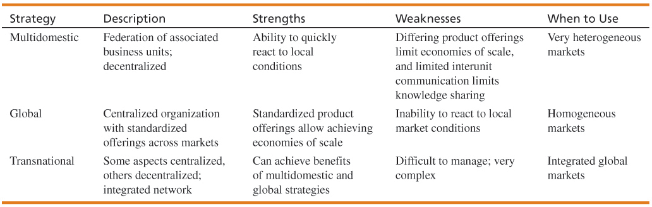

Lecture 5
Social Media Crisis:
- a crises issue that arises in or is amplified by social media, and results in negative mainstream media coverage, a change in business process, or financial loss.
Characteristics:
- technology helps create a negative buzz around a brand, product, or service.
- ground-up phenomenon that is largely out of the control of the business being affected.

groundswell, “…spontaneous movement of people using online tools to connect, take charge of their own experience and get what they need – information, support, ideas, products, and bargaining power – from each other.”
- Markets are conversations.
- These networked conversations are enabling powerful new forms of social organization and knowledge exchange to emerge.
- As a result, markets are getting smarter, more informed, more organized. Participation in a networked market changes people fundamentally.
- People in networked markets have figured out that they get far better information and support from one another than from vendors.

RSS Feeds
- RSS (Really Simple Syndication): used to publish frequently updated content such as blog entries and news headlines
- An RSS feed (i.e., document) contains either a summary of content from a website or the full text
- RSS enables people to keep up with their favorite websites in an automated manner
- RSS content is read using software called "feed reader" or "aggregator"
  - The user subscribes to a feed by entering the feed's link into the reader
  - The reader checks the user's subscribed feeds regularly for new content, downloading any updates it finds

Web 2.0
…software as a continually-updated service that gets better the more people use it, consuming and remixing data from multiple sources, including individual users, while providing their own data and services in a form that allows remixing by others, creating network effects through an architecture of participation
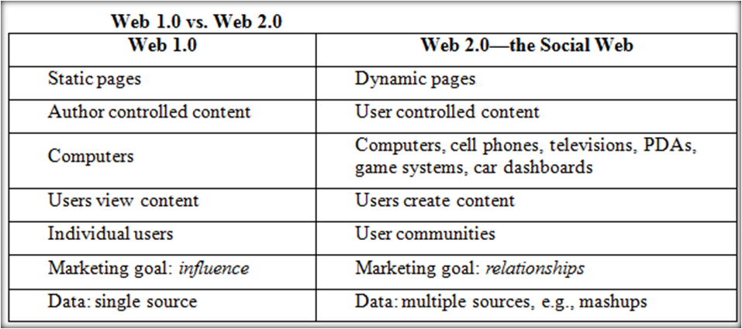

Mash-ups
A mashup is a web application that combines data or functionality from more than one source into a single integrated interface or tool:
- applications or interfaces generated by combining content, presentation, or application functionality from disparate sources.
Content used in mashups is typically sourced from a third party via a public interface or API (Application Programming Interface):
- API (Application Programming Interface):
  - an abstraction that defines and describes an interface for interaction with a set of functions used by components of a software system.
  - Abstraction is the process of taking away or hiding or removing characteristics from an object in order to reduce it to a set of essential characteristics.
  - For the consumer or user, abstraction helps focus on the essential elements with unwanted detail omitted.

- Mashups are applications generated by combining content, presentation, or application functionality from disparate sources.
- Web Mashups are composite web applications partially constructed from the services and content from other web sites.
- Mashups have an emphasis on GUI and programming-less specification.
  - the concept of mashups originated from the understanding that the number of applications available on the Web and the needs to combine them to meet user requirements are growing very rapidly.
- Creating mashups is all about finding data, functionality, and services and using them to both solve problems and create opportunities.

Mash-ups and 2.0
- Web 2.0 movement talks about cooperation, instead of control:
  - mashup is created from several data sources and services, mashing up (combining, stitching together) the sources and services to create something new, or add value in some way.
- The popularity of mashups stems from emphasis on interactive user participation.
- Mashups offer an informal, quick, low-barrier, and relatively effort-free integration that can be deployed with simple tools and techniques.

Social Networking
- It Involves relationships defined as: An extended group of people with similar interests or concerns who interact and remain in informal contact for mutual assistance or support. A logical or natural association between two or more things: connection, correlation, interconnection, interdependence, interrelationship, link, linkage, relation, tie-in.
- It involves building “Social Capital”.
- Social capital is a core concept in business, economics, organizational behavior, political science, and sociology, defined as the advantage created by a person's location in a structure of relationships. It explains how some people gain more success in a particular setting through their superior connections to other people.
- Remember business is about building relationships of all sorts to create “Social Capital.” – these relationships can be with customers, suppliers, media etc.

Social Network Analysis (SNA)
- SNA is the mapping and measuring of relationships and flows between people, groups, organizations, computers, or other information or knowledge processing entities
- The mapping and measuring of relationships and information flows among people, groups, organizations, computers, and other information- or knowledge-processing entities. The nodes in the network are the people and groups, whereas the links show relationships or flows between the nodes. SNAs provide both visual and mathematical analyses of relationships

Network Classification
- Aggregators: Linkedin, Facebook, Xing, Ecademy etc. etc..
- Geographic: “Link to” sites: Chicago, Charlotte, Nashville, New York etc. etc..
- Industry: Wireless Factors, Wine & Spirits, Motor Sports, Entrepreneurs etc. etc..
- Topical: Politics, Music, Sports Investments, etc etc..

Internet Business Models
Virtual Storefront
- Sells products directly to consumers (B2C) or businesses (B2B)
Information Broker
- Provides product, pricing, and availability information to individuals and businesses
- Revenue from advertising or from directing buyers to sellers
Transaction Broker
- Saves users time and money by processing online sales transactions
- Fee paid per transaction
Online Marketplace
- Buyers and sellers meet, search for products, display products and establish prices
- Revenue from transaction fees
Content Provider
- Provides digital content
- Customer pays for access
- Advertising can also provide revenue

Online Service Provider
- Provides a service
- Revenue from transaction fees, advertising, or by collecting marketing info from users
Virtual Community
- Provides chat room, online meeting place, etc. for people of similar interests
www.KidsHelp.sympatico.ca
Portal
- Provides initial point of entry to the web, specialized content, services
www.msn.ca

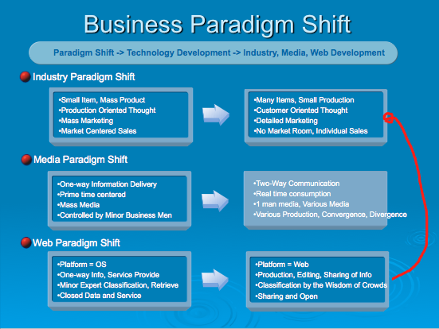

Lecture 6

Enterprise 2.0
Enterprise 2.0 refers to Web 2.0 technologies used for some business purpose:
- Promote collaboration and knowledge exchange among employees, consultants and company partners
- Advertise and build brand awareness, e.g., BlendTec on Youtube.com
Business use of Web 2.0 technologies:
- Recruiting and professional networking
- Marketing, promotion, and sales
- Internal collaboration and communication
- Supply chain management 2.0
BUSINESS SOCIAL NETWORKING: CONCEPTS AND BENEFITS
- To build better customer relationships
- To improve knowledge management
- To facilitate recruiting and retention
- To increase business opportunities
- To build a community
- To gain expert advice
- To improve tradeshow experiences
- To improve communication and collaboration
ENTERPRISE SOCIAL NETWORKS
- Allow employees to collaborate and communicate in an employee-driven system
- Promote the use of enterprise wikis via demonstrations
- Set up internal blogs and incorporate them into internal directories
- Set up enterprise social bookmarking systems
- CIOs involvement from the beginning to make sure the right infrastructure and tools are in place

Social Media Metrics
Tool-Based Metrics:
- Metrics a company uses are determined by what the company is trying to achieve.
- In some cases, a company will define its objectives based on a specific Web 2.0 tool.
Tactical Metrics:
- Another way for organizations to define their objectives for social media is by tactical objectives.
- Based on these tactical objectives, companies can develop specific actions that support the objectives and then monitor progress.
- Examples of Tactical Objectives:
  - Increase traffic to our Web site by 10%
  - Increase requests for product information via our Web site by 15%
  - Increase number of people who create a user account on our Web site by 12%
Strategic Metrics:
- aim to more fully capture the potential of social media than what is described by focusing on a specific Web 2.0 tool or tactical objectives.
- 5 Categories of Social Media Use Objectives:
  - Listening: Pay attention to what customers are saying online
  - Talking: Communicate with your customers by engaging in conversations
  - Energizing: Encourage customers and fans to spread the word through ratings, reviews and other positive “buzz”
  - Support: Provide information and online resources, such as user forums, knowledge bases and other tools
  - Embracing: Invite customers to generate ideas for new products and services

Web 3.0
Web 3.0 = (4C + P + VS)
- 3C = Content, Commerce, Community
- 4th C = Context:
  - defines the intent of the user; for example, trying to purchase music, find a job, or share memories with friends and family.
- P = Personalization:
  - refers to the user’s personal characteristics that impact how relevant
- VS = Vertical Search:
  - refers to a search strategy that focuses on finding information in a particular content area, such as travel, finance, legal, and medical.

