Managing Information Systems

Chapter 1: IT For Business and Business Professionals
- Moore’s Law: computing power roughly doubles every 18 months
What Is An Information System?
- Information System (IS): an organized collection of people, information, business processes, and information technology (IT), designed to transform inputs into outputs in order to achieve a goal.
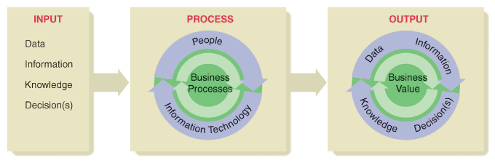
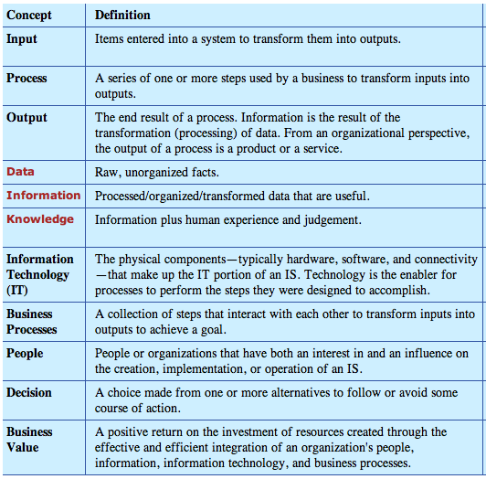
IS versus IT
- IT: a collection of tools-hardware, software, connectivity- that enable individuals or businesses to achieve their goals
The Productivity Zone
- Productivity zone occurs at the intersection of people, process and technology.
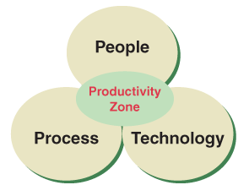
- Successful IS system integrates people, process, and technology to create business value and enhance competitive advantage
The Internet
- Integral part of our personal and business lives for the following reasons: communication, information and commerce
What’s In IT For Me?
IT for Your Personal Productivity and Entertainment
IT is Fundamental for Your Career
What’s In IT For Society?
- IT can help increase revenue per customer, gain new customers, increase efficiency and reduce costs
- Cross-selling or up-selling has been made very simple using technology that matches your customer profile to your buying behavior
Business Organizations and the Business Environment
- Business: any organization with one or more people who:
- decide on common goals to pursue
- work together to locate and organize resources
- create processes to achieve the desired goals
- Business environment: complex collection of political, economic, social, and technological factors that organizational leaders must consider when making decisions regarding goals, organizational forms, and the creation of business value
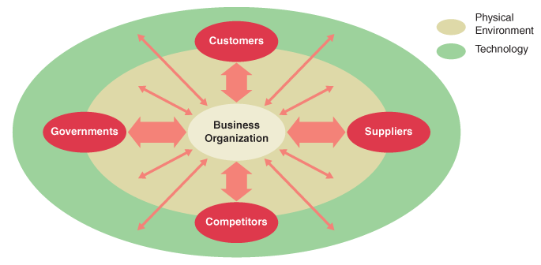

- Advanced IS’s help flatten organizations- making the flow of information easier and faster and making the organization more responsive to the business environment
- Advanced IS: DSS (decision support systems), ERP (enterprise resource planning systems)
Types of IS Found in Business

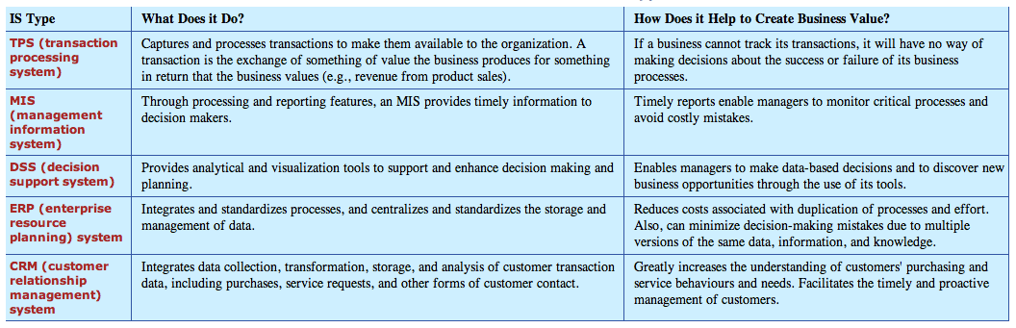
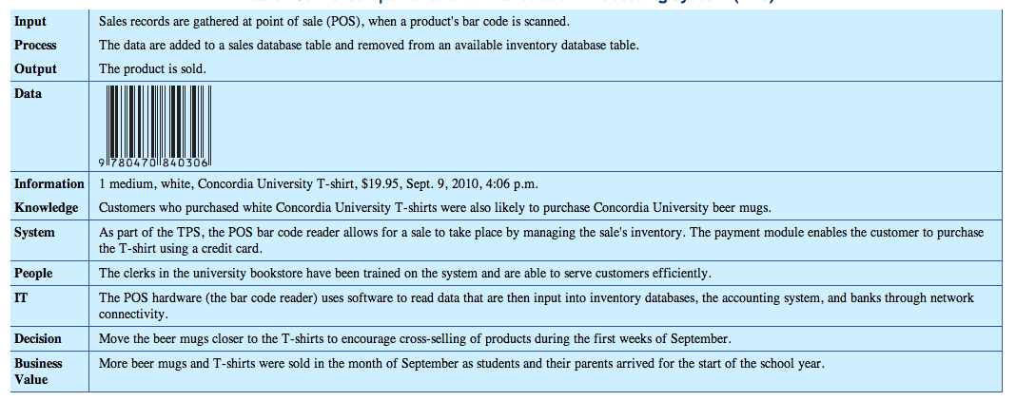
What’s In IT For Society?
- IT has contributed to globalization; therefore, impacting the way business is done around the world
- Technology ahs flattened the world just as it has flattened organizations by requiring fewer organizational layers
The Economy
- ICT: information and communication technology
- ICT sector is a major contributor to the economies of the world
Chapter Summary
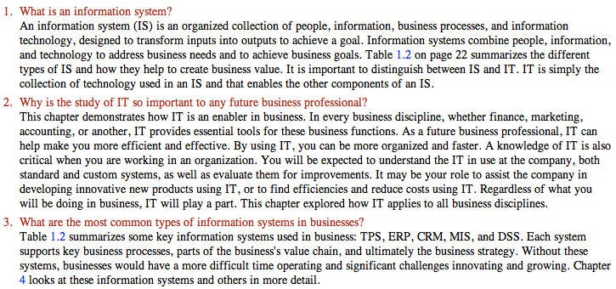
Chapter 2

-IT allows you to communicate with others, enables transactions between you and the organization with which you deal, helps you obtain, organize, analyze and store data and information, finally it can provide entertainment.
Components of IT
-Hardware= electronic and mechanical components that you can see and touch.
-Software= the set of instructions that direct the hardware.
-Network= increases their power by allowing users to share resources, including hardware, software and information.
-These three categories create a platform
Hardware
-The working parts of IT hardware consist primarily of electronic devices with some electromechanical parts used with input, output and storage devices.
1) Processing Hardware:
- Directs the execution of instructions and the transformation of data using transistors
- A transistor is an electronic switch that can be either on (1) or off (2)
- A tiny chip made of transistors is called a microprocessor
- The chip contains most of the components that make up the central processing unit (CPU)
- You notice the speed of the CPU when you are performing tasks
- The speed is called the clock speed and it is measured in megahertz (MHz), millions of cycles per second, or gigahertz (GHz), billions of cycles per second.
- Higher clock speeds mean faster performance
- Computer hierarchy categorizes processors according to their power:
    - Supercomputer= largest and fastest; performs processor intensive computations using parallel processing.
    - Mainframe=large; carries out many of the organizational processing needs using high-speed processing chips and large amounts of memory.
    - Server farms=medium/many; allows multiple servers to handle network processing activities
    - Personal Computer (PC)= small to medium; enables users to carry out processing tasks needed to perform their job; usually networked together.
    - Personal digital assistant (PDA)/smart phones= very small; provides users with portable computing power often used to communicate with PC or other users.
    - Embedded processors= extremely small; provides low-scale processing, embedded in appliances and products. They are programmable chips embedded into processors to make them smart. Example is a digital signal processor (DSP) which is a special microprocessor that includes math-related functions in their instruction set.
2) Memory:
- Temporarily locates data and instructions before processing
- Memory capacity is measured in number of bytes that the ROM and Ram chops store.
- Read only memory (ROM) contains instructions and data that only special devices can alter.
- Random access memory (RAM) stores data only until they are no longer needed/ until you shut down the computer. CPU can access any item stored in RAM directly (randomly).
3) Input hardware:
- Provides the interface used for data entry into a device.
- Choice on input device should be tailored to the task to be performed.
- Examples include keyboards, pointing devices (Wii, mouse or touchpad, scanners and digital cameras.
4) Output hardware:
- Provides and interface used to retrieve information from a device.
- Output devices convert IT-processed information into a usable form
- Display devices make-up the most common category of output devices, such as computer monitors. LCD screens of modern monitors are light, thin and consume less energy.
- Other examples are printers (output data to paper), speakers, MP3 players...
5) Storage hardware:
- Stores data, information and instructions for the long-term.
- Examples are computer hard drive, CDs, DVDs, USB flash memory and external hard drives.
6) Communications hardware:
- Connects one IT device to another.
- Network interface card (NIC) provides the physical connection between a computer and a local network.
- Modems allow you to connect to a remote network over a telecommunications line. It converts (modulates) the digital signals going out from your computer into an analog signal appropriate for the connection medium used. When receiving a signal it converts (demodulates) the analog signal back into a digital signal that your computer can recognize.
- Modem speeds are measured in bits per second (bps)
Software
-Software is information that specifies how hardware device should work with other data, information and knowledge.
-When your turn a computer on, firmware built into ROM chips allows the computer to start and prepare for use. Once the computer is ready, the CPU loads more software into RAM and the computer can get to work.
1) System software:
- Includes any software required to control the hardware components and to support the execution of application software.
- The operating system (OS) software= coordinates and handles the details of working with the computer hardware. After the boot program in ROM successfully tests and starts up the hardware, CPU loads the OS software into the computer’s memory. Performs tasks of managing and handling the hardware and software resources of he computer and it provides a stable and consistent interface between application programs and the hardware.
- Utility software provides additional tools that you can use to maintain and service your system. Examples are firewall applications, security programs…
2) Application software:
- Complete, self-contained program or set of programs for performing a specific job.
- Productivity software:
  - Document preparation software= creating documents composed of images and supporting graphics.
  - Electronic spreadsheet software= performing general calculations and analyses, such as financial analysis, budgeting and forecasting/
  - Presentation graphics software= preparing professional-quality slides and graphics for business presentations.
  - Database management system (DBMS)= for designing, creating , updating and querying data.
  - Personal information management (PIM)= for managing personal information (to-do lists, schedules, email).
3) Middleware:
- More common in enterprises
- Link applications that use dissimilar software or hardware platforms and act like a specialized messenger/translator to manage exchange of information.
- Often essential when an organization is implementing new types of software that need to communicate with existing systems.
4) Open source software:
- Software that can be used, modified, improved and redistributed
- Often free and have very low cost.
- Commonly used open source software in e-commerce is Linux, Apache, MySql, Perl, RoR…
Networks
-Consists of nodes that represent computer hardware and network users, with various types of hardware, software and communications media forming the links between the nodes.
-Primary components:
- Data that computers share on the network
- Special hardware
- Software that allows computers to communicate and share the data
- Communication media to link the computers together
-Networks of connected computers support the core function of data transfer in an organization.
-Provide a platform for collaboration, allowing users to share data, information and knowledge.
-Network Categories:
- PAN (private area network): covers a very small space that ranges from the size of the human body to a small office. Its purpose is communication among computer devices in close proximity.
- LAN (local area network): size is within the immediate location or building. Purpose is to share files, resources, servers and other hardware among organization members
- MAN (metropolitan area network): size ranges from a few blocks to an entire metropolitan area. Purpose is it provides data and voice transmission typically at high speeds.
- WAN (wide area network): size is over a large geographical area. Purpose is to share data, information and resource units of an organization distant from on another.
- Internet: Size is worldwide. Purpose is to share data and information with all stakeholders in the organization, as well as general public.
-Network hardware:
- Hardware to connect a device to a network: modems, cable modems, network interface cards (NICs), and wireless cards. Carrier or communications medium is a physical link that forms a network connection. Examples are plain old telephone system (POTS), which is most common for transmitting electrical signals, coaxial and fiber optic cables can transmit info at faster speeds. Technologies such as infrared light, radio waves and microwaves also allow networks to transmit signals through the air.
- Specialized hardware for handling network traffic: devices that help coordinate data traffic on a network include routers, bridges, repeaters and hubs. A bridge is a device that lets you connect to a network or break a large network into two smaller more efficient networks. A router connects, translates and then directs data that cross between two networks. A hub (concentrator) serves as a central connection point for cables from the devices on the network. A repeater is sometimes needed to strengthen or amplify signals that are sent along a long transmission route. A wireless access point (AP) is a special bridge that connects between wireless devices and a wired network.
- Specialized computers that control the network and the delivery of data on the network. Servers manage the various functions of the network. Servers are often assigned a specific task such as handling email (email server), Web traffic (Web server) or running programs (application server). A file server is a fast computer that requires a large amount of RAM and storage space because is stores and run the network OS software, it also stores shared applications and data files and manages all communication between the devices on the network. Any computer connected to the file server on a network is called a client or a workstation.
-Network Software:
- Can divide network software into OS software and application software.
- Network OS software manages network functions and the flow of data traffic over a comp network.
- Network application software provides instructions that allow for creation of data and for the transformation to fit appropriate protocols for transmission over a network.
- Protocol is a standard set of rules that allows the communication of data between nodes on a network.
- Example is sending an email to a friend over the Internet.
The Internet
- The foundation technology that makes the Internet possible is the adoption of standard protocols.
- Uses TCP/IP suite or packet switching protocols. (Set of communication rules) Makes it possible for any computer regardless of platform, processor and OS to connect and communicate over the Internet.
- Committees that discuss and propose Internet standards are the Internet Engineering Task Force (IETF), the Internet Architecture Board (IAB) and the World Wide Web Consortium (W3C). Developed Internet protocol suite such as HTTP, SMTP and FTP.
- At home users access Internet through dial-up (traditional phone lines) or broadband (cable or ISDN) and at work they connect directly to the organizations LAN or WAN.
- Most users do not connect directly to Internet but to an Internet service provider (ISP). ISP’s provide connections for customers to use via dial-up or cable.
- Software used to make connection includes OS utilities and special software that the ISP usually provides. To access and process content, Internet users also need application software such as email client and a Web browser.
- Wi-Fi hotspots are wireless Internet access in public locations. Wi-Fi is the popular name for 802.11 standards for wireless network access.
- Voice over Internet protocol (VoIP) allows you to make calls anywhere in the world and bypass traditional switched telephone networks. It uses the Internet’s foundation technologies of packet switching and TCP/IP to carry voice instead of data. Converts analog voice signals to digital, creating packets and sending the packets. VoIP can be used for telephone calls, faxing voicemail and more over a single network, which can significantly decrease infrastructure costs.
- Cloud computing= computing over the Internet. Users can use any Internet connection to access their resources on virtual computers anywhere in the cloud. Benefits are reduced costs because technical infrastructure is not required, scalability on demand, accessibility.
The World Wide Web
-Internet is the technology platform and the web is an application that works on that platform.
-Technologies that make the web work:
- Client/Server Networks: when you open a Web browser on your computer, you start a client application. Uniform resource locator (URL) specifies a unique address for each page that indicates the location of a document. When you type the URL into your browser or click a hyperlink, the browser sends a request out over the Web that makes its way to the corresponding server. The browser formulates the request under the rules of HTTP so that all computers on the Web will know how to handle it. When the request reaches its destination, server generates a response that includes the requested item and conforms to the HTTP. The server then simply loads the text data from storage, adds the appropriate HTTP info and sends the item back to the client. A static web page file will typically hold a combination of text content and hypertext markup language (HTML) commands.
- Web browser: software application that allows you to easily navigate the Web and to view the content that you find there. It will let you request, either by typing a URL or clicking on a hyperlink, and display a hypertext-based file. Hypertext organizes content into units that are connected using associations called links.
- Hypertext transfer protocol (HTTP): comprises the set of rules for exchanging messages on the WWW. HTTP governs both the request for the file and the transmission of the requested file.
- Hypertext markup language (HTML): primary language for creating web pages. Browser software interprets HTML instructions through the use of tag, which are interspersed with content. The tags, surrounded by angle brackets (<>) mark the placement and appearance of various components of the page.
Search Technologies
- Internet search engines follow the following process:
- Crawlers and humans search the Web to find new or updated Web pages (HTML form-based).
- Following an algorithm, the submitted pages are organized and stored in a database.
- Search engine tools let you query the databases for sites that match your search criteria.
- The database if Web locations is created and organized by using either special software called Web crawlers, human submissions or a combo of the two.
- Many web pages incorporate special tags, known as meta tags, which contain info that describe what the site is about. Crawlers move around from site to site to read these meta tags and report the data back to their database for storage.
- Human submissions are often of higher quality or fit a specific profile better than the sites found by crawlers.
- Each search engine uses a different algorithm for indexing the data and applying the search criteria to query the indexed data.
- Metasearch engine= allows you to review the search results generated by other search engines. It sends out a query to other search engines and then returns the list to you.
E-Commerce
-Transaction carried out using computer networks.
-Growth in e-commerce results from the ease with which computer users can search for info on a wide variety of products, jump to those products web pages and then purchase with just a few clicks of the mouse.
-E-commerce has been through several distinct generations of growth (both number of users and technology capability)
- First-Generation E-Commerce Technologies: Establishing a Web Presence
- Available technologies delivered static content (fixed info such as company info, online marketing and electronic versions of company brochures) through a web presence.
- A web presence means the business has established its existence on the WWB by creating a set of pages that users can access.
- The standard technologies used include client server networks, web browsers, HTTP protocol and HTML…these limit websites to only providing static content but are low-cost and easy way for new businesses to begin e-commerce transactions.
- Brochureware (websites with only static content)
- Second-Generation: Providing Interaction
- Dynamic content= info on web page can change depending on a number of factors.
- Dynamics and interaction occur based on input data and programming instructions.
- To create dynamic content: obtain input data, pass data to the server, hold data in memory, and execute programming instructions to process data.
- Input data can come from:
  - Header in the HTTP request contains data about the client requesting the page
  - Server system clock
  - Client data from a cookie along with the request. Cookie= small bit of data, usually created by programs running on the server, stored on the client machine and passed back and forth in the HTTP request and response. With a cookie, server can store one or more data items on the client that may be need for subsequent requests.
  - User input in an HTML form. Components of a page that allow you to enter input are called HTML form controls. HTML forms are primary means by which a business can get the data it needs for online transactions. From components must fit the data needs of the transaction and a business select the form components for ease of use and to minimize chance of incorrect data entry.
- Now that a cookie can be stored on the client side, data can be retrieved that identifies the client and the application can then respond specifically to that client. Cookie data can remain until the user returns to the website/
- Persistent data= when data remain available for a period of time.
- Because the main use of the cookie is to identify the user, this allows websites to provide personalization.
- A database is an essential component of interactive e-commerce site and provides another means of maintaining the state of client interactions with the server and storing persistent data on the server side.
- On the client side of a Web application, browser generally executes instructions by using a scripting language (high-level computer language that another program-browser- interprets when executed), downloadable code components or a plug in.
- Most common client-side scripting language is JavaScript.
- Scripts are primarily used for simple processing tasks such as enabling pop-up windows
- For more complex task:
  - ActiveX= allows you to link data from one document to another (Microsoft).
  - Java applet= Java program typically used for online games
  - Plug-ins= Adobe, Google toolbar, media player…
- Server-side programming= programs that run on server in response to browser requests, more powerful and can do much more than client-side scripting. Allow owners to retain control over their programs so that they can better manage their websites.
- Server-side programming allows businesses to:
  - Deliver content that it customizes for individual user
  - Dynamically modify content for any page
  - Access data stored in a server-side database and sent it to client’s browser
  - Take actions on queries and data sent from HTML forms
  - Provide access control and security for a website
  - Optimally manage traffic to the site
- 2nd generations e-commerce implements in a tier system (four-tier e-commerce system):
- By entering a URL, clicking a button, you send a HTTP request to a Web server.
- Web server receives request an determines hot to generate a response. If request is for static HTML file, server simple retrieves the file and sends it back as part of response to client’s browser
- If request requires dynamic response, Web server acts as a controller that routes message and data between client and the application server.
- When needed, applications contact data server to perform queries on the databases it controls. Application uses the data to perform its tasks.
- Results of an executed application will be formulated into a browser compatible web page that combines the output of the application with the appropriate HTML tags.
- Web server includes dynamically generated page in HTTP response and then sends the result to the browser.
(Web client-Web Server- Application Server- Data/file server)
- Third-Generation: Supporting transactions
- Demand for technologies that would extend to support real-time, online transactions
- Automated transactions enabled advanced capabilities of the Web, such as data mining and delivery on instant status information through portals.
- Four primary components of a typical e-commerce site are: the shopping and ordering system, the merchant account, the payment gateway,
- and the security system.
- Manage the shopping and ordering processes on their own servers/ privately leased servers. Main tasks are to track products that the user selects to purchase during browsing and then record order for those products sot that firm can gather and ship them to user. Methods to doing this are: a non-secure HTML order form with the results sent to the firm’s email address, a secure HTML order form with the results sent to firm’s email address, a “shopping cart” system that tracks customer orders using a database, or a shopping car service provided by a third party.
- Payment options: deferred payment= billing for payment by cheque or by manually processing credit card info. Smaller sites with limited infrastructure can use third-party merchant accounts like PayPall, CCBill and ClickBank. These sites process payments between customer and merchant for a transaction fee. For larger sites, use real-time credit or debit card authorization that they process themselves. Requires merchant account
- Merchant account is basically a bank account that allows merchants to receive the proceeds of credit card purchases.
- A secure gateway provider is a company that provides a network to process encrypted transactions from a merchants website. It then passes the transactions on to issuing banks of the customer’s credit cards for approval. (Verisign, Symantec, Authorize.net)
- A secure gateway provider will generally offer a payment gateway(links e-commerce site with the banking network) and a processor (handles financial data submitted by the shopping cart application by accepting data from shopping car, properly formatting it and entering it into the banking network).
- Steps to payment system:
- Customer places an order with merchant through e-commerce site
- Payment gateway provides detects the placement of an order. Provider securely encrypts the transaction data and passes an authorization request to the back to verify the customer’s credit card account and available funds.
- Gateway provider returns a response, indicating whether or not the action is authorized, to the e-commerce merchant.
- Upon approval, e-commerce merchant notifies the user and fulfills the customer’s order.
- Gateway provider sends a settlement request to the merchant account’s bank
- Merchant account’s bank deposits the transaction funds into the e-commerce merchant’s account.
- Most e-commerce security technologies relate to the secure socket layer (SSL) protocol. SSL allows a client and server to communicate in a way that prevents eavesdropping, message forgery and tampering.
- A server that encrypts data using the SSL protocol is known as a secure server.
- URL of a secure server starts with HTTPS instead of HTTP, may also see a closed lock icon in the lower corner of your browser.
- A website can signal that it uses SSL to encrypt data by purchasing an SSL site certificate. When you connect to a secure server, it will first identify itself to your browser by using the SSL certificate.
- SSL is being replaced by a newer protocol called the transport layer security (TLS)
- Microsoft, Netscape, Visa and MasterCard use another security standard called the secure electronic transaction (SET) protocol.
- Payment and security systems may not work without cookies. Often use cookies to authenticate users or to hold data to match users with their shopping cart.
- Fourth Generation: Transformation Process
- Characterized by increasing integration of all enterprise systems with external customers, partners and suppliers all linked over the WWB.
- E-commerce technologies now allow computers at one business to interact with computers at another business.
- Improving ability to exchange small amounts of data via Web and to standardize the support of transactions.
- The eXtensible markup language (XML) organizes data based on its meaning rather than how it should appear.
- HTML’s goal is to describe how to display data. By combining XML with JavaScript and dynamic HTML and HTTP protocols, a technology called AJAX is being used to allow web pages to respond more quickly to user actions.
- With AJAX most of the processing related to user actions happens on the client side rather than sending a request to the server and having the user wait for the server’s response. This speeds up overall interaction for the user because an AJAX engine on the client side can handle any action that doesn’t require a request from the server, like simple data validation.
- Web services are a standardized way for one computer program to request and run another computer program over the Internet. Two applications may reside on different computers that are connected in some way, by LAN or Internet.
- Web service is a platform-independent software component that can be described using standard description language, published to a public registry of service, discovered using a standard method, requested through application program interface (API) and combined with other services and procedures to compose an application.
- Allow partners to more efficiently and quickly link data
- A Web service is a spare part, which can be incorporated into any program is has access. It provides a way for two computers to automatically pass data between each other.
- Service-oriented architecture (SOA) is an infrastructure that supports full-scale Web services.
- A mashup is a Web application that seamlessly combines info from more than one source into an integrated experience.
Internet Security
-Risks of threats increased with social networking since it provides a breeding ground for malware.
-Authentication is the process of identifying individuals and ensuring they are who they claim to be. Passwords should use at least 8 characters, include digits, punctuation and nonprinting characters, use both upper and lowercase letters, use diff passwords on diff accounts, change regularly.
-If using an unprotected network, beware of drive-by hackers to access your files.
-Cloud computing makes it easier for hackers to access the info as they no longer need to worry about an individual’s authentication, OS or firewall.
MEMORIZE
Common Internet Security threats:
- Malware: The use of malicious code as part of a subversive, organized scheme. Such schemes are resulting in massive intrusions into sensitive financial and intellectual property areas. Viruses, worms, and trojans are all types of malware.
- Scareware: A type of malware designed to trick victims into purchasing and downloading useless and potentially dangerous software. Ironically, scareware is often disguised as virus protection software and shows a window telling you that your PC is not being protected or is currently infected.
- Virus: A program that is able to copy itself and infect a computer. Viruses are designed to spread to as many computers as possible. It usually needs some human action, like opening an email attachment, to occur in order to spread. There are thousands of known viruses on the Web. Most PC users use anti-virus software to prevent viruses.
- Worm: Destructive software that can spread by itself, such as MyDoom and its later version, DoomJuice. The MyDoom worm is particularly nasty. Once started on a computer (by clicking an email attachment), it automatically sends out infected emails to everybody in the user's address book, using one or more of the names on the address book as the sender. In addition to overwhelming email servers around the world (at one point, the virus generated as many as one in three emails in circulation), it creates a “back door” to allow a system to be used to further propagate viruses and malware.
- Spam (electronic): Unsolicited and undesired emails. Aside from being annoying, spam may facilitate the installation of malware or phishing.
- Phishing: An attempt to gain personal and confidential information (e.g., passwords, credit card information) for fraudulent purposes such as identity theft.
- Denial of Service Attack (DoS): An attempt to make a website unavailable to its users. An attacker will do this by sending a target so many communication requests that the target server eventually goes down and becomes unavailable. No website is safe from DoS attacks. Both Twitter and Facebook have been the victims of DoS attacks.
Meaningful applications of technology
Collaboration
- Groupware: help individuals and teams keep scheduled meetings, monitor projects, share work files and even conference online. (Blackboard, Microsoft Groove). Groove is made for small-medium sized businesses or ventures to help manage small project teams. SharePoint offers information repository, a work flow manager, ability to manage content, all readily available over secure Internet connection, orgs use to share and store all their files.
- Intranets: set of services for distributing private info throughout the org using a collection of private computer networks brought together to form an organization- wide, private network (LAN to WAN). Paper reduction, support automated internal transactions, improve communication, teamwork and knowledge management. Intranets transmit data according to TCP/IP and HTTP protocols of the Internet. Employees can access intranet using any platform (PC, MAC)—platform independence (not the case with LANS and WANS).
- Instant Messaging (IM): Skype, IM is an online communications service that allows users to communicate in real time over the Internet. Public (Skype, MSN) or enterprise (EIM) is two IM applications. EIM provides features such as restricted access, security precautions such as encryption (ONE instant messaging, IBM Lotus IM)
- Virtual Meetings: Goto meeting offers web meetings, voice and chat for invited participants.

Chapter 3: Creating Business Value
- Technology is a means to an end- a collection of tools that enable
- From a business perspective, technology enables strategy, business processes, problem solving and decision making
Business Organization and Business Processes
- Companies need business strategies
- The strategy becomes a road map for what needs to be done to create business value and competitive advantage
- Porter states that strategy is: a broad-based formula for how a business is going to compete, what its goals should be, and what plans and policies will be needed to carry out those goals
- Porter claims that the intensity of the competitive rivalry in an industry can be attributed to forces that define that industry: entry barriers, threat of consumers substituting a new product or service for existing ones, bargaining power of both suppliers and buyers, competitors all factors to consider when constructing business strategy to gain competitive advantage
- Porter’s five forces model:
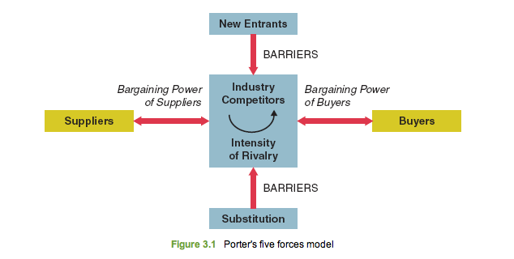
- It is an essential element of business strategy
- IT products must created to help businesses deliver their intended end results
Businesses as Open Systems
- The open systems model indicates a business operates by transforming inputs into outputs and by constantly interacting with its environment

- Two significant components of the business environment: stakeholders and boundaries
Stakeholders and Boundaries in the Business Environment:
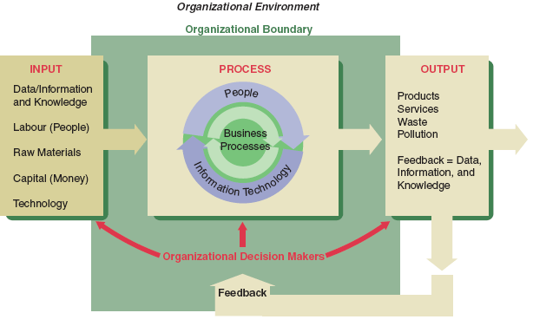
- Different businesses face different business environments- how they adapt to their environment contributes greatly to the development of their structure and whether they succeed or fail
- Stakeholders are a part of the business environment that have a large effect on organizations
- Stakeholder: a person or entity that has an interest in and an influence on how a business will function in order to succeed
- May be external or internal
- Organizational boundary: an important aspect of an open system- the perimeter of the green rectangle in the figure)
- Businesses must remain open to their environment to receive inputs and produce outputs, to remain competitive by responding to outside opportunities or threats, to use external information for daily processes
- Interaction with the environment carries risk
How Businesses Organize to Create Value
- All business organizations possess structures that organize information, responsibility and authority
- Organizational structure helps get the job done when used properly
- 4 types of organization structures: Functional, Decentralized by Geography, Decentralized by Product Line, Matrix
- Companies adapt these structures to their unique business situation to suit their competitive environment, strategy and preferences
- In functional and decentralized the lines of authority and communication are vertically oriented
- The matrix structure blends the functional and decentralized organizational structures: top to bottom the matrix is a functional structure, left-to-right the matrix has product-focused structure that uses teams
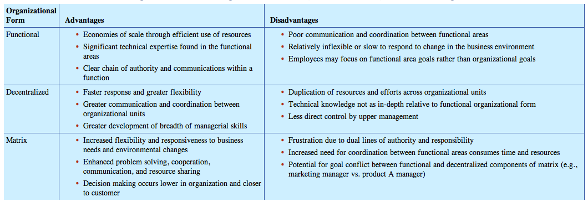
Business Process
- Organizations perform a series of steps known as a business process in order to transform inputs into their main outputs
- Business process: a collection of activities that takes one or more kinds of input and creates an output that is of value to the customer
- Some create an output while others create a service
- Process is shown as inputprocessoutput
- Process receives inputs, undertakes some actions, and then produces outputs
- Hundreds of processes link together and interact to achieve the various goals of the business
- Processes can be complex and layered
- Sub-process is one or more tasks that accomplish a significant portion or stage of a process
- IGOE: project mapping method used to analyze and better understand processes- illustrates the inputs, guides, outputs and enablers of a process
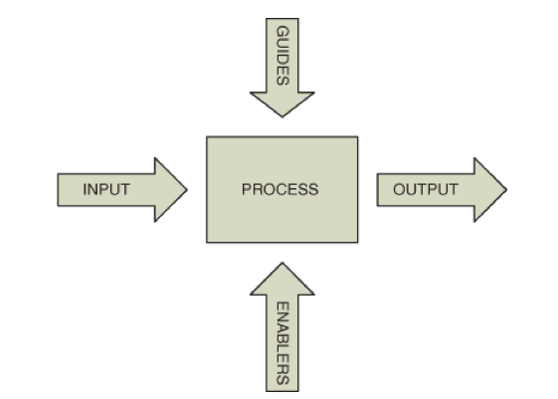
- Inputs to a process: those resources needed to start a process (data, information, knowledge, labor, raw materials, capital, technology)
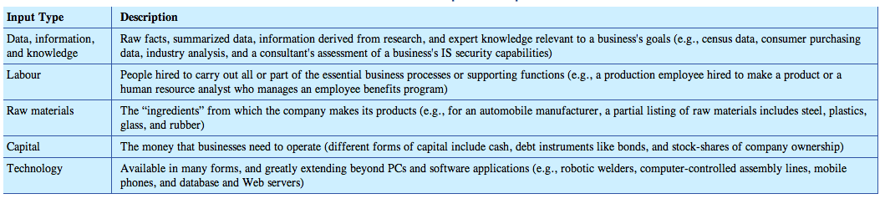
- Guides: rules or policies within which a process must operate
- Outputs: results of a process
- Enablers: special kind of input or resource that facilitates the process
- Feedback’s role in business processes: special kind of measurement created by a business process that is then returned to the system to control it’s future inputs, processes and outputs
- Business Process Reengineering (BPR): the study of business processes to find ways of making them more efficient. Goals are to reduce cost, increase speed and throughput, and increase quality and service in order to increase competitive advantage
Defining Competitive Advantage
- Continuous improvement: all organizations must focus on improving results all the time in order to be successful
- Competitive advantage as an equation:
Competitive advantage =
quality of insight + speed of execution + cost competitiveness
- good IT systems are employed to improve the quality of insight of the employees making decisions, to improve the speed of execution by those employees, to reduce costs, and/or to increase the efficiency of processes
Applying IT to Create Business Value
- 3 aspects of strategically applying IT to create business value and competitive advantage: automating, informating and transforming
Automating to Do Things Faster
- Automating: using automation to execute repetitive, routine tasks without human intervention
- Frees up human employees to focus on tasks that have potential to add high value, or that require judgment or insight to complete
- Complete tasks with more speed, economy, consistency and possibly accuracy
- Businesses usually apply technology to do the same tings as before when automating a process, but with greater efficiency and accuracy. Later, the organization may look to use the technology to do new things
- When applying automation, management usually thinks in terms of improving a single process
- Most critical issue is related to how the process fits the business organization and its goals
Informating to Do Things Better
- Informating: recognizing that executing processes also creates new data and information
- Organization may then process the new data to improve its decision making
- Companies derive automating and informating benefits from some of the same applications of IT
- With an informating view, IT can deliver more long-term benefits than from automation alone
- Informating allows a business to identify flaws in processes and then use the new-found knowledge to do things in entirely new ways
- To gain the benefits of informating when applying IT to a process, need to step back and ask 3 questions:
  - Does the IT store data so it can be used for learning and decision-making?
  - Is the business process being IT-enabled already optimized for high performance?
  - How could IT enable a better business process or capability that delivers higher value or additional competitive advantage?
Transforming to Gain Competitive Advantage
- Primary goal of businesses is to gain sustainable competitive advantage that results in high profits- a company possesses competitive advantage when it achieves higher-than-average profits for its industry
- Companies are concerned with competitive necessity/continuous improvement
- Most businesses have a transforming view of IT
- They use IT to keep them at a advantage
- Not-for-profit organizations often have efficiency as their objective but view IT in a similar transformative light
- 2 basic ways of obtaining competitive advantage: cost and differentiation
  - Cost advantage: when a company delivers the same benefits to customers as competitors but at a lower cost – through automation with IT
  - Differentiation advantage: when a company delivers superior benefits to customers- through informating with IT
Decision Making
- Company needs to decide how to best apply the information it has gathered in order to truly create business value
- Rational decision: a choice that you make about what actions you will take in a given situation after analyzing the consequences of each option
- Some decisions may be routine while others are difficult, involving ethical considerations
Classifying Decisions by Type
- Structured decision: a decision that can be programmed; it is routine and repetitive
- Semi-structured decision: not as clear cut, increased uncertainty or doubt about consequences and outcomes associated with the decision
- Unstructured decision: novel, complex situation with no obvious or single correct decision or decision process
Using Information in Decision Making
- Rational decision making is all about using information to reduce uncertainty in the outcomes of your decisions
- Information systems help reduce uncertainty
- Business professionals have the responsibility of recognizing that there is no such thing as perfect information to eliminate uncertainty completely, to know when they have enough valuable information to go ahead with a decision, valuate new information …
How to Make More-Informed Decisions
- The quality of your decision as a decision-maker depends on the quality of the inputs you use to inform your decision
- Consider the characteristics of the information: the source, the completeness, accuracy, reliability, up-to-datedness, timeliness…
- Information Evaluation Criteria:
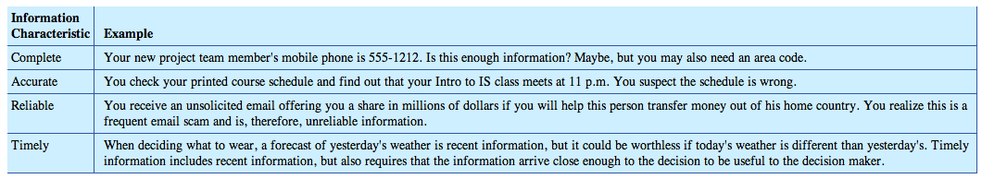
- All of the information characteristics affect the usefulness of data and information for decision making
The Decision-Making Process
- First you must engage in knowledge work activities so you can make an effective choice about some issue or challenge
- Discovery Phase: carefully consider the quality of the data, information and knowledge and put it into proper context
- Analysis Phase: sort, transform, and organize the data to define options
- Decision Phase: narrow the options to the final decision
- Execution Phase: communicate the conclusion to the organization so it can be implemented
- Quality of the final output (the decision) depends on the quality of the inputs (the information and analysis you create)
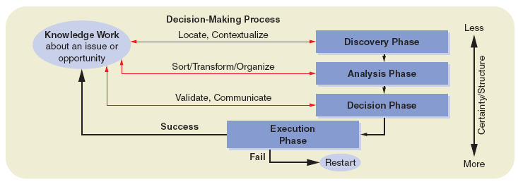
Problem Solving
- Purpose of decision making is often to solve a problem
- Problem exists when you find yourself in a situation that fails to meet your goals, needs or expectations
- First step in problem solving is to recognize that a problem exists and why this problem exists
- Problem solving: a series of steps or a process taken in response to some event or activity
- Each step of the process may require individual decisions that use the decision-making process
- IADD Problem-Solving Model: steps in the model provide a tool that you can apply to most problems
IADD Model
- More formal expression of the problem-solving process you already use intuitively
- 4 major steps:
  - Investigate: determine if there is a problem or an opportunity, and if it is possible to solve the problem or take advantage of the opportunity
  - Analyze: gather data that are relevant to the heart of the problem, or that pertain to the benefits, challenges and risks associated with a given opportunity
  - Decide: evaluate solutions and make choices regarding how to implement the solution
  - Do: implement the solution and monitor the results
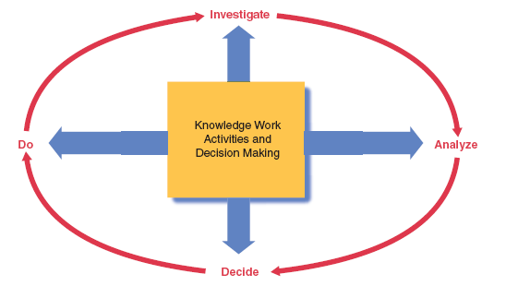
- Investigate:
  - Problems tend to be defined in terms of what went wrong with a process or action, or may be defined by comparing a desired future state to the current situation
  - Problem scan be identified as opportunities or challenges
  - Take action and find information that will help solve your problem
- Analyze:
  - Brain needs to go into ‘detective mode’
  - Information systems can help with the analyze step of problem-solving
  - With a complex problem or opportunity, you will have a lot of data to classify, organize, store and so on
  - Databases and database management systems (DBMS) software are excellent for organizing and storing data
  - Some DBMS harness the power of the relationships that exist in the data. Once the data and relationships are organized and stored you can use other tools to manipulate the data. Ask questions of your database using structured query language (SQL) queries.
  - At the end of this stage you will determine alternative solutions or choices
  - To analyze the choices you must determine selection criteria
  - Criteria: the factors that you think are important and relevant and relevant to solving the problem
  - Think about the positive characteristics and benefits of each proposed solution
- Decide:
  - Choose the best solution from those available and describe how it will solve the problem, meet the challenge or capitalize the opportunity
  - Determine the what, when, where, how of implementing the chosen solution
- Do:
  - Carry out the actions necessary to make the solution a success
  - Can use an action grid to help with the task of making a solution work
- IT can play a part in the decision-making and problem-solving by providing critical information and organizing it to increase the quality of the information
- IT can also be part of the solution

Chapter 4: Enterprise Systems
- Businesses and organization are made up of one or more people and creates products or provides services to earn a profit or satisfy a societal or client need through core processes that it designs and manages to add value
- To become successful, businesses must manage many activities
- Putting all of the various processes a company must complete comprises the value chain
- We discuss here the value chain and how IT is used to support it
The Value Chain
- Porter’s Value Chain- provides a way to understand what businesses do
- In this section we review all the components of the value chain and discuss how businesses use IT, particularly enterprise systems, to optimize the value chain
Building an Understanding of the Value Chain
- Value chain: connected series of activities, each which adds value or supports he addition of value to the firm’s goods or services
- Five core components of a typical value chain:
  - Inbound logistics: include the receiving, warehousing, and inventory control of raw materials required to create a product or service
  - Operations: value-creating and often proprietary activities that transform the raw materials into the final product
  - Outbound logistics: the activities required to get the final products to the customer, including packaging, warehousing, and order fulfillment
  - Marketing and sales: activities associated with getting buyers to purchase the product (includes working with distributors, retailers, online channels, marketing, advertising and pricing)
  - Service activities: those that maintain and enhance the product’s value (consumer support, repair services, and warranty and recall)
  - 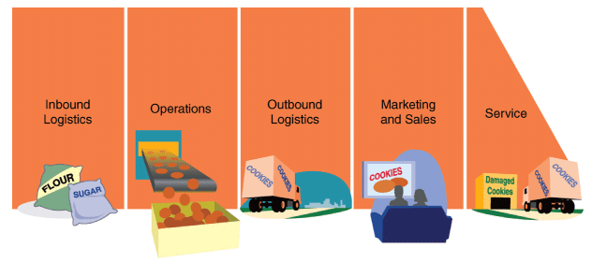
- the value chain components can be further classified into primary and secondary activities
- Primary activities: those directly related to the production and distribution of the organization’s products and services
- Support activities: value chain activities that an organization conducts to support the creation of business value by primary activities
- 4 critical support activities as defined by Porter:
  - firm infrastructure (administration)
  - technology development
  - human resource (HR) management
  - procurement
- Organization’s value chain is a sum of the firm’s support and primary activities, working together to create business value for the organization and customers
- Value chain is a useful tool for defining an organization’s core processes and the activities and competencies that it can use to gain a sustained competitive advantage
- Using IT, a business can increase its competitive advantage by changing the value-adding activities themselves or by making it possible to configure the value chain in a new way
Information Systems That Support Business Activities
- Some of the most commonly used general information systems that support the value chain include:
  - Functional Information Systems
  - Workflow Management Systems
  - Transaction Processing Systems
  - Management Information and Document Management Systems
  - Knowledge Management Systems
  - Decision Support Systems
  - Supply Chain Management
  - Enterprise Resource Planning
Functional Information Systems
- FIS focus on the activities of the functional department to improve its efficiency and effectiveness
- Examples: accounting IS, marketing IS, HR IS, financial IS, manufacturing IS
- FIS remain popular today but many companies find they need to integrate these systems with the rest of their organization by using middleware (software that links separate systems) or turning to large enterprise systems
- FIS are used in specialized areas or for a specific purpose
Workflow Management Systems
- Workflow: steps, organizational resources, input and output data, and tools needed to complete a business process
- Workflow Management System (WMS) (aka business process management BPM) supports activities that several departments of the organization may carry out by focusing on a business process from beginning to end
- Provides tools for modeling the steps of the process
- The model shows the flow of work
- Leads to several benefits:
  - less misplaced or stalled work- improves efficiency and quality
  - managers can focus more time on business decisions rather than on tracking work
  - more analysis and tighter control of the processes often result
  - …
Transaction Processing Systems
- Business transactions are critical to the core activities of an organization
- Transaction: an exchange of goods or services (value) between two or more parties (businesses, individuals, or a combination of the two) that creates a relationship between the two parties
- Transaction Processing Systems (TPS) enable transaction activities and capture key data created by the transaction
- Transaction is a unit of work that has the following characteristics: ACID:
  - Atomicity: transaction must be unequivocally completed
  - Consistency: all unchanging properties of data must be preserved
  - Isolation: each transaction should execute independently of others
  - Durability: characteristics of a completed transaction should be permanent
- ACID together allow businesses to create systems that can handle large numbers of simultaneous transactions
- TPS brings together the common components of IT: data storage, data processing, data capture, and software
- Processing must control the flow of the activities and data involved in the transaction
Management Information and Document Management Systems
- In the early days, Management Information Systems (MIS) were typically developed to meet the need of storing processed transaction data as reports for managers
- These MIS systems were basic and produced large volumes of information because of their limited ability to sort and process data to specific user needs
- MIS generate 3 types of reports:
  - Periodic reports
  - Exception reports
  - Demand reports
- Businesses began to create specific systems to serve specific needs. Example is executive information systems (EIS) which provide summary information about business performance
- Document Management Systems (DMS): enters, tracks, routes, and processes the many documents used in an organization including the 3 reports just mentioned
- DMS can create the documents electronically or convert them to electronic form using imaging technology
Knowledge Management Systems
- Knowledge is the most difficult to store and share
- Organizations rely on two types of knowledge:
  - explicit knowledge: includes anything that can be written down, stored, and codified
  - tacit knowledge: includes the know-how that people have through learning and experience
- Tacit knowledge is important to an organization and therefore represents a major challenge in the organization’s knowledge management (KM)
- Knowledge Management (KM): how the company recognizes, generates, manages, and shares knowledge
- KMs often rely on collaborative software known as groupware, which supports teamwork with technologies that enable communication and sharing of data and information
- Benefits of KM are difficult to calculate
Decision Support Systems
- Decision Support Systems (DSS): help businesses use communications technologies, knowledge, and models to organize and access data to perform decision-making activities
- 5 types of DSS each with a specific decision-making focus:
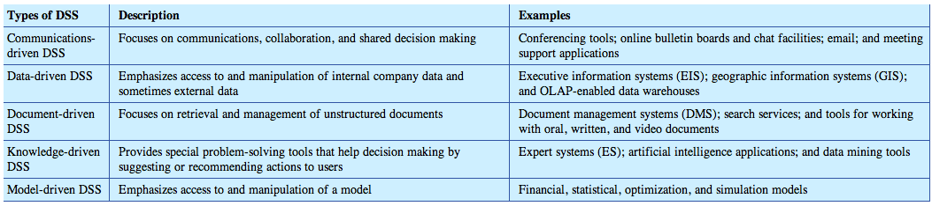
- Model-driven DSS is make the most significant contribution to to decision making
- Model-driven DSS provide tools to create and work with models including financial models, statistical models, optimization models, simulation modeling
Supply Chain Management
- Supply chain: system of organizations, people, technology, activities, information, and resources involved in moving a product or service from supplier to consumer
- An organizations supply chain includes several components of its value chain as well as links into the value chain of other organizations
- Supply Chain Management (SCM): manages materials, information, and finances as they move from supplier to manufacturer to wholesaler to retailer to consumer
- Seek to optimize the supply chain to create business value and competitive advantage
- Typical modules in supply chain management software:
  - Materials management
  - Inventory management
  - Order management
  - Logistics management
- Supply chain management is often the cornerstone and starting point of enterprise resource planning (ERP) system implementations because it encompasses so much of the value chain
Enterprise Resource Planning
- Enterprise Resource Planning Software (ERP): used to integrate the departments and functions across an organization
- Company runs all its applications from a single database
- Each functional unit of the company still uses its own supporting enterprise software but ERP links these applications
- Benefit: to streamline business processes
- ERP can support all areas of value chain, both primary and supporting processes, helping to achieve efficiencies that aren’t possible with independent systems
- Primary disadvantage: can become complex and difficult to manage; Customization for processes and rules it supports can become extensive
Enterprise Systems that Support the Value Chain
- Some IT systems are specific to a part of the value chain or organizational function and some are used across all parts of the value chain
- Enterprise Systems: large-scale applications that support business units or functions; another way IT may be applied to an organizations value chain
- 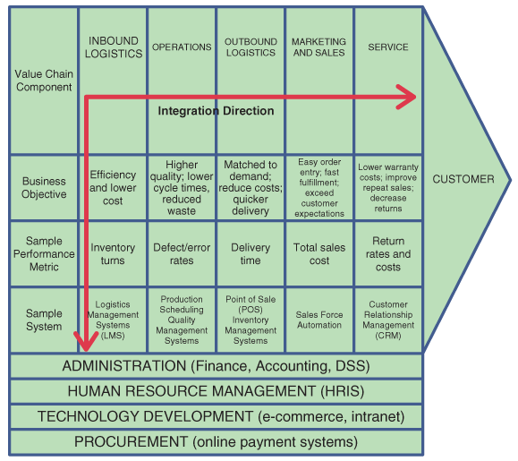
- Inbound Logistics:
  - Inbound logistics includes activities like raw material procurement and warehousing
  - Involves sourcing and ordering materials from suppliers, keeping track of expected arrival dates of materials, receiving ad checking the materials, approving the packing slip, authorizing payment, distributing the materials to the correct location, storing the materials, monitoring supply levels
  - Radio Frequency Identification (RFID) is becoming critical to inbound logistics
  - RFID tags are small and cheap and will probably replace the barcode- it doesn’t require ‘line-of-sight’ scanning
  - Uses radio waves to identify objects and transmit the information to an IT system
  - most common type stores a serial number on a microchip that is attached to an antenna
  - can assist in tracking inventory, picking orders, performing inventory counts…
  - radio waves can travel through and around matter so the tag is readable as long as it is within range of the reader
  - RFID or bar code scanning is part of most Logistics Management Systems (LMS)
  - LMS track materials and assets upon arrival into the warehouse and inventory
- Operations:
  - Operations contains all activities required to create a product or service and make it available to the marketplace
  - Supply chain management and enterprise resource planning systems are deployed in the operations of a company to monitor work in progress and the efficiency of the operations processes
  - Production scheduling tools
  - CAD/CAM (computer aided design/computer aided manufacturing) software assists in the design and manufacture of products by creating 3D design images and engineering documents
  - Quality management systems
- Outbound Logistics:
  - Outbound logistics involves the warehousing of finished products and the distribution of those goods to customers
  - Logistics management systems and RFID are used in outbound logistics as in inbound logistics
  - Transportation Management Systems (TMS) can be important
  - Transaction processing systems, like point of sale system (POS), are used in outbound logistics to get the product into the hands of the customer
  - Fulfillment systems are important as well- used when order something online or at a retail store
  - Inventory management systems (IMS) are used as transactions take place and products are transferred out of stock and into customers hands
- Marketing and Sales:
  - Marketing and sales investigates what customers need and determines the products and services that will meet those needs
  - Information-intense activities that rely on enterprise systems to provide and organize data
  - Customer relationship management (CRM) systems
- Service:
  - Service part of the value chain starts once the product is in the hands of the customer
  - CRM systems used to up-sell and cross-sell
- Administration and Finance Systems:
  - Administration is an important supporting activity in the value chain
  - Too expensive to perform manually
  - Several enterprise systems are aimed at automating and optimizing administrative processes to reduce costs and ensure the processes are efficient
  - Administrative activities relate to finance, accounting, payroll, legal, knowledge management, decision making…
- Human Resources:
  - Human resources component of the value chain is responsible for hiring and recruiting staff, and managing staff compensation and training
  - Human Resource Information Systems (HRIS) are enterprise systems that enable this component of the value chain
  - HRI house information about employees
  - Data stored in HRIS are important to organizational decision making
- Technology Development:
  - Specific to individual organizations
  - Purpose of technology development is to support the value-creating activities of the organization
  - Most companies have intranets now as a way of supporting value-creating activities
- Procurement:
  - Procurement supports all primary components of the value chain, especially inbound logistics
  - Businesses seek to automate many procurement functions using e-commerce and online payment because procurement can be time-consuming and document-intense
- Any system a business chooses to install should be linked to its value chain and to a measurable performance metric that helps it manage the impact of that system in overall success
- Enterprise systems support every component of the value chain and many ay be employed by an organization
- Some can be bough off-the-shelf and others require customization to work with specific business rules of an organization
- Enterprise systems can be very expensive; some possible alternatives can be software as a service or application service providers
Software as a Service (SaaS)
- Companies can use SaaS to acquire enterprise systems; they essentially rent software
- Salesforce.com is one of the most successful companies that provides on-demand, Utility Computing Services
- Utility computing provides services hosted on servers which can be accessed from anywhere
- Advantages for clients:
  - No longer have to develop and maintain the applications
  - Applications are available anywhere clients can gain access to the Web
  - Costs are reduced
- Cost for clients:
  - they must relinquish some of their control over the applications
  - they probably wont gain a competitive advantage using these applications
- Software as an Outsourced Service:
  - Application service provider (ASP) is an outsourced service provider
  - ASP is an online technology company that develops and delivers software tools on the internet
  - ASPs provide some advantages that are leading to their increased popularity
    - An outside company builds and operates the system when an organization uses an ASP
    - The organization doesn’t need to acquire the technical resources or expertise
    - The ASP operator bears the burden of keeping competitive advantage over other ASPs
    - Service is provided over the internet- accessed anywhere, anytime
- ASPs and SaaS are very similar
- Many ASPs are changing their business model to be more like Saas
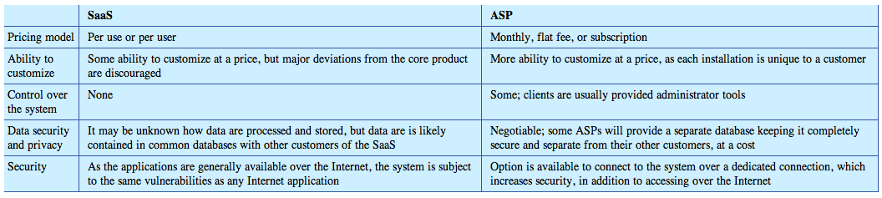
Strategically Fitting IT to the Organization
- We have introduced 4 views of how IT could provide benefits to business by applying to support the organization and its processes:
  - Support of the value chain
  - Automating
  - Informating
  - Transforming- gaining a competitive advantage
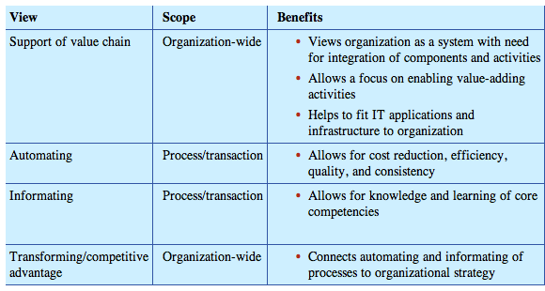
- The four different views are not mutually exclusive
- During the dot-com years of the late 1990s and early 2000s a widely-held view that companies can gain competitive advantage through an exclusive use or application of IT was believed
- Dr. Carr disagrees- he maintains that IT is an essential part of the infrastructure of a competitive company but inconsequential to strategy
Roles of IT Governance and Leadership in Creating Business Value
- Effective IT governance and leadership combine with Porter’s competitive strategies with the value chain model to help create business value
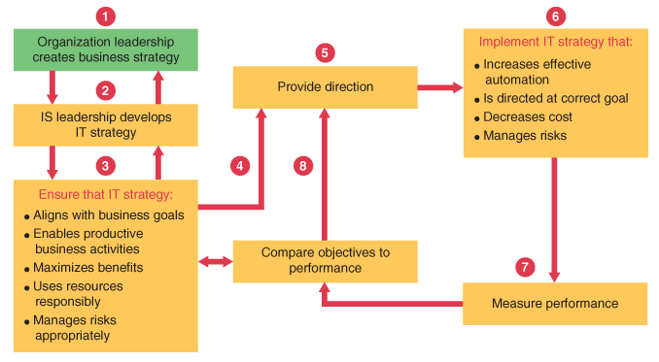
Enterprise Risk Management
- When planning and implementing a business strategy, a business must attempt to identify, address, and eliminate elements of risk before they threaten its success
- Businesses apply Enterprise Risk Management (ERM) to do this
- Everyone involved in planning for and enabling the success of the organization is responsible for figuring out what possibly can o wrong and how to manage it
- Also consists of deciding how much risk they can stand (risk appetite) and still achieve their business goals
- ERM integrated framework was developed to help identify risks and threats
- ERM framework identifies 4 overlapping categories of business objectives for focusing on risk assessment and management:
  - Strategic: high-level goals, aligned with the mission
  - Operations: effective and efficient use of its resources
  - Reporting: reliability of reporting
  - Compliance: compliance with applicable laws and regulations
- IT supports each of these categories
- IT can provide data for decision making in setting goals and strategies that align with the organizations mission
- IT can be used for automating, informating, transforming and implementing enterprise systems- all activities which support operations and enables the organization to be more efficient and effective
- IT is crucial support needed to achieve accurate, timely, reliable reporting
- IT supports compliance by ensuring that appropriate check and balances are in place in the systems used by the organization on a daily basis, and that information required for any external audits, accounting or system, is provided
Applying the Risk Framework
- First, identify and categorize potential risks
- Assess risks and threats using two primary criteria: impact and likelihood
- Manage applicable risk before it turns into high-impact/high-probability risk
- Note the immediacy of the risks
- Enterprise Risk Matrix that helps organizations classify risks:
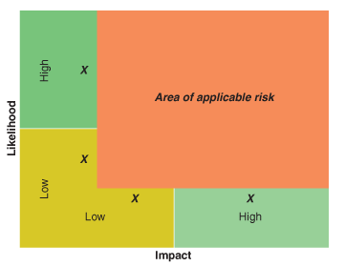
Risk Reduction Methods
- Once the risks are identified, the organization must decide how to respond to the risks
- Organizational responses to enterprise risk:
- 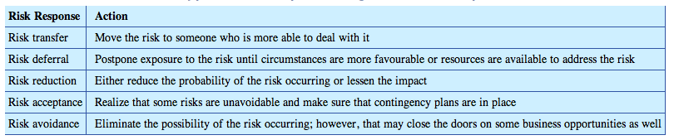
- IT is a critical enabler in responding to risk
- Risk Transfer:
  - Outsourcing can shift risk outside of an organization to another business that may be better equipped to mitigate risk
  - Organizations used for outsourcing are often held to service level agreements (SLA)
  - In-sourcing refers to the strategic decision made by a business to bring various services or functions back in-house, or keep them in-house, rather than globally source them
- Risk Deferral:
  - Sometimes IT is used to defer risks
  - Example: Y2K
- Risk Reduction:
  - One of the most common ways IT reduced risk is by enabling disaster recovery
  - Disaster recovery plan: allows an organization to resume operations after a major even that interrupts normal business processes
  - Business continuity plan: addresses problem prevention, response to crises, resumption of business, recovery of losses, and restoration of systems and processes
- Risk Acceptance:
  - Without risk there is no chance of greater return
  - Sometimes organizations must accept risk
  - It is prudent to have a contingency plan in place should something unexpected occur
  - Roll-back strategy: a n example of a contingency plan that involves being able to reverse every action that took place to make that change happen such that everything is returned to its original state with no damage done
  - Another common contingency is to plan a budget contingency should an unexpected expenditure occur on a risky venture
- Risk Avoidance:
  - Most popular risk response
  - Implement controls
Control and Controls
- Implementing controls is a way of avoiding risk but may also end up providing a control advantage through IT
- Control advantage: the strengthening of internal controls and compliance through the application of IT-based controls to business processes, policies, and procedures
- Defining Control and Controls:
  - Businesses generally base control around 3 concepts:
    - Control is a process that runs throughout the organization
    - Control influences how people behave at work
    - Control can only provide reasonable, not absolute, assurance of achieving objectives
  - Controls: specific actions, including policies and procedures, designed to ensure the achievement of business objectives
  - Effective controls prevent, detect, and correct actions that increase enterprise’s risk of failing to meet business goals
  - Preventative controls are designed to prevent increased exposure to risk by stopping some process before it occurs
  - Detective controls reduce risk by discovering when preventative controls have failed and providing notification that action must be taken
  - Corrective controls aim to remedy the situation and try to keep it from recurring
- Specific Internal Control Processes:
  - 7 generic categories of controls:
    - Segregation of duties
    - Authorization
    - Security
    - ID codes
    - Verification
    - Control totals
    - Supervisory review

Chapter 5
E-commerce Defined
-Build to order is a way for manufactures to solicit orders from consumers and deliver products directly, rather than relying on a global network of wholesales and distributors/dealers.
-Wholesales or business-to-business level is far larger and more important to global economy than the retail level.
-Ecommerce is the use of info systems, technologies and computer networks by individuals and organizations to carry out transactions in order to create or support business value.
- Business-to-consumer (B2C)=online equivalent of the retail store as well as other services
- Business-to-business (B2B)= electronic exchange between companies
- Business-to-government (B2G)= online sales to government agencies, as well as online payment of taxes
- Consumer-to-government (C2G)= electronic payment of taxes as well as purchase of various types of licenses
- Consumer-to-consumer (C2C)= use of online auctions like eBay and similar other sites
Web Integration: interface between the Web and enterprise’s existing computerized business systems (Online to offline)
Two Types of E-commerce business: Digital & Physical.
Companies experienced in order fulfillment and returns have tended to be successful in e-commerce
E-Commerce business model: combines a specific type (portal, search engine, sales support, travel, auction etc.) of website with a successful revenue model (advertising, selling goods, selling aggregate data, subscription etc.)
E-Commerce Advantage
-Frictionless transactions= the ability of the consumer to move from thought to action creates new opportunities for businesses to operate at lower costs by easing the burden of supply chain electronically. (Craigslist: in past it too much more effort, planning ad cost to sell the merchandise)
-As cost of posting an ad approaches 0 and is easy to do, sellers do it more often for even lower cost items.
-Computer network technologies offer benefit of:
- Universal standards
- Higher info density
- Global reach
- Ubiquity and accessibility
- Customization
- People around the world now have Internet access to varying degrees. This has resulted in the marketplace becoming a ubiquitous market space.
-Businesses can’t ignore this fast growing group of Internet users with significant buying power when they are making marketing plans.
-Internet relies on use of universal technical standards to make it available in same way, no matter what corner of the world you access it from.
-When combines with open-source software apps and development tools, universal standards increase accessibility to the marketplace while also lowering entry costs and encouraging innovation.
-Innovative uses of Internet in business have produces truly global competition. This moves us closer to the perfect market (highest consumption at lowest price for most goods).
-Allows the instant creation of niche businesses targeting small markets that would not be dense enough in any single geography to support a small retailer.
Information Clutter
-Expansion of global e-commerce has increased buyers level of info density= quality and quantity of info about products and services of interest to them.
-Websites like PCMag.com and CNet.com offer product guides, review and prices on many different kinds of technology.
-Businesses have responded to challenge of endless amounts of business info by creating business value based on customization-oriented approach (mass customization or personalization) linked to e-commerce, rather than solely on low-cost producer strategy.
- Online Advertising:
  - Attracting attention to your site.
  - Google AdWords is a way of linking your paid advertising to searches of keywords by consumers.
  - Can also buy coverage in the form of cost per click (CPC) maximums, work like an auction of those competing for placements against popular words and phrases.
  - Banner ad placements may help you reach your targeting market online.
- Search engine optimization:
  - All search engines use technology called spiders to crawl the Web and catalogue its content, including your org or businesses new website.
  - A variety of techniques are related to making your website more visible to search engines and more relevant to the way these search engines rank sites to increase likelihood of appearing higher in the list of any relevant search by consumers.
  - Ensuring your site uses technologies that are easy to search, creating lots of links between your site and others and making good use of meta-tags and content density to appear like a site that offers lots of info and value.
- Partnering and Traffic Trading
  - Partner with other sites and each of you can cross-list the others’ website and trade potential traffic that comes to one site.
  - Easy to track origin of traffic and reward the parent site with commission or fee related to sales it generates for you.
  - Low-cost method of online promotion since it only requires that you identify and contact potential parent sites.
-Once you have managed to get a potential customer (prospect) to your site, must find a way to capture interest and encourage purchase.
-Mass customization= ability to create customer products or services on-demand. (Dell, bmw.ca)
-Personalization is a marketing message that a business customizes for each potential customers interests based on their searching, browsing and buying habits. It makes marketing messages more effective and efficient. (Amazon.ca book recommendations) Often only possible because you previously shared info with the website.
Web Usage and Statistics
-Make sure you pay attention to how traffic that finds your site uses your site.
-Many Web stats reporting software programs are available (many free). Some require that you install software on your Web server; others operate as SaaS (software as a service).
-All software programs contain basic required Web metrics for various timeframes, (number unique visitors, number page views, where users are coming from…)
E-Commerce Competitive Difference
-Dramatically affects competition between orgs by:
- Reducing barriers to market entry
- Preventing any company from owning the market
- Enhancing collaboration/alliances
- Multiplying market niches
- Changing market drivers (READ RENTAL EX)
-Niche markets are one area where e-commerce has shown to be superior to almost nay existing form of marketing.
Co-operative websites: where sellers and buyers go on it.

E-commerce and Business Strategy
-Henry Mintzberg: business strategy is a plan, pattern, position and perspective. Strategy emerges and evolves over time in natural response to constantly energy competitive landscape and individual performance level of any competitor in that market space. A change in either a company’s performance in relation to the competition or a major change in competition (emergence of disruptive industry force, new competitor, innovations in business models or intro of new gov’t regulations), could necessitate revisiting business strategy. A strategy may start as a perspective vision that calls for a certain position, then evolve into a plan that is implemented and emerges as a pattern that is evident in actions and decisions.
-No business strategy would be complete without addressing how to integrate Web and e-commerce.
E-commerce strategy: how a business intends to use computer Web-based networks and info systems to compete in its global marketplace.
-Co-dependence between strategy formulation and impact of new technologies as a way of maintaining business performance and competitive position.
-Building a meaningful e-commerce strategy requires to diff views of orgs strategy: what it wants to do (conceptual strategy) and how it will do it (technology strategy). *Technology creates opportunity for strategy, which is enabled by technology.
-An important strategy is to connect their online Web strategy to their existing customer relationship management (CRM) to create and integrated one-to-one marketing experience for their customers. Web generates huge amounts of data on customer buying habits and preferences that can be stores and instantly recalled and applied with each new visit (cookies). With these data, companies can use CRM to tailor the products on their website to the individual buyer/ create customer-specific offers and campaigns or keep track of specific discount levels. This gives rise to privacy concerns since requires customers to give their consent to storing critical info about them.
-Value of overcoming privacy concerns is that use of CRM can also create switching costs for customers. Going to another seller means they will have to retrain a new website to understand their preferences.
M-Commerce
-Mobile commerce applications ensure consumers can immediately react in the moment to any marketing message.
-Use of laptops, mobile telephones and PDAs to connect to Internet and Web to conduct activities associated with e-commerce, but in real time and without regard to where user may be at the moment.
Benefits and Limitations of E-commerce
-Porter’s model suggests that e-commerce increases competition. This results in lower prices and better services for all consumers.
-Disadvantages in form of shipping time and costs, download speed, security and payment sizes that create some barriers to the use of this technology for some kinds of transactions or industries.
-Increased competition, lower prices and better services that consumers now expect can create problems for inefficient businesses as newer more tech-savvy competitors enter industry
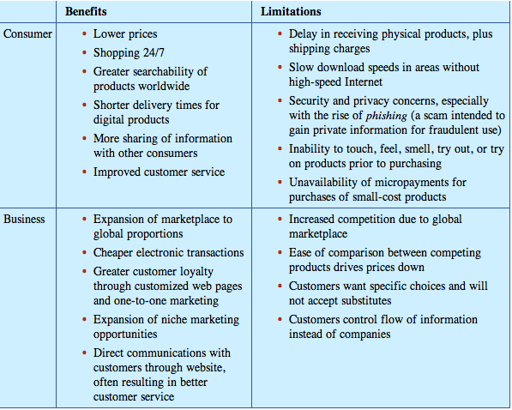
-Expansion of marketplace enables business to reach customers beyond their local area with minimal capital outlay.
-Businesses reduce their cost of dealing with paper-based transactions by carrying out transactions digitally over computer network.
-Customizing individual web pages to the interests of customers also creates greater customer loyalty.
-More direct communication with customers results in better customer service.
-A global marketplace means that companies from around the world can compete for a business’s local customers, creating a very intense industry rivalry.
-With a wide variety of advertising media, companies must know how to attract customers to their websites.
-As a result of consumer concerns, many online vendors resort to third party endorsements to their security practices to help build consumer confidence. (Ensure protections of sensitive data such as credit card info.)
-E-commerce sites often ask for credit card security codes during transactions to provide a higher level of security.
-Encryption is the most common method of providing security to e-commerce transactions.
-Private key encryption uses same private key to encrypt and decrypt message. A key is an algorithm used to encode and decode messages. (Difficult to send private key with message, time-consuming)
-Public key has two keys one private and the other public. Public key is freely distributed and used to encrypt messages coming to you. Private key remains secret and is only used to decrypt messages encrypted with your public key.

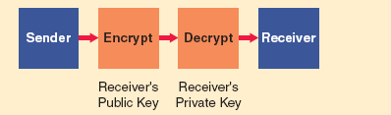

B2B Transactions and Business Models
-B2B have much larger market than B2C in terms of volume transactions and dollar amounts
Two Types
- Spot buying= buy at market prices determined by supply and demand from someone you do not know. Companies often engage in sport buying to purchase goods that are commodities (uniform in quality and differ only somewhat in price). Needs to find a public marketplace or exchange that sells these desired products and services. Most B2B e-commerce exchange transactions occur through an online intermediary.
- Strategic sourcing= forming long-term relationship with another company (set price through negotiation). Both buyer and seller are well known to each other and wish to continue trading into the future. (Large-scale computer purchases).
  - One-to-one marketing model= two companies collaborate to create a trading relationship that is good for both of them. Both trading partners win from the relationship. While they are not always the same size, neither company dominates the trading relationship.
  - Company-centric business model= company is either a seller to many other companies (one-to-many) or a buyer from many companies (many-to-one). The single company tends to dominate the market. It completely controls the info systems that support the transactions including supply chains between its smaller trading partners. Larger buyer/sellers wants to use e-commerce to improve its profitability by increasing prices/reducing costs of doing business with many smaller trading partners.

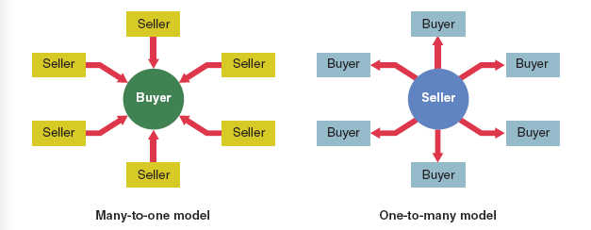

  - With 1-2-Many, seller often provides a Web-based private sales channel through a private network called an electronic data interchange (EDI), or through protected form of Internet, called an extranet, to link trading partners while keeping others out. Such sales can be at a set price or via an auction.
  - Because many-2-1 model provides single buyer with products that it needs to carry on business, this is part of a procurement process. (E-procurement). A buyer can conduct this process in a number of ways, include reverse auctions, aggregating catalogues or group purchasing.
  - With an e-procurement reverse auctions, buyer posts projects to a secure website to which sellers respond with bids for providing goods and services for that project. Bidder with lowest bids wins.
  - Aggregating catalogue model assembles together the catalogues from all suppliers on the buyer’s server.
  - Group purchasing, two or more buyers work together to achieve lower prices from their suppliers.
  - Exchange model= many companies use an exchange to buy and sell from each other through spot buying transactions. Vertical exchanges meet needs of a single industry (retailing). Horizontal exchanges deal with products and services that all companies need, regardless of service (office supplies). (Ex: workopolis.com)
-Procurement plays a large part in any supply chain and is an important way for orgs to save money.
Traditional Procurement Process
- Buyer sends a purchase order (PO) to a vendor, it is a document that requests another org to supply something in return for payment
- Vendor responds to PO by sending the goods to the buyer along with a bill of lading (BOL)
- After receiving the goods and BOL, buyer sends back-signed copy of BOL and internally files a receipt of goods.
- Vendor sends an invoice to buyer.
- Buyer’s accounting dept compares original PO with the receipt of goods and invoice to ensure they match. Buyer pays vendor.
Using E-commerce to improve Procurement Process
-Digital information replaces paper documents involved in traditional procurement process.
-E-procurement is evolving into a tighter integration and coordination of the activities of a supplier-buyer relationship through creation of IOS.
-Interorganizational system (IOS) is a networked info system used by separate orgs to perform a joint business function.
-IOS help create 24/7 communications between orgs and their suppliers and customers, as well as enable paperless transactions throughout supply chain.
-IOS often involves electronically linking a production company to its suppliers or to its customers in a way that raw materials are ordered, production takes place and finished goods are send to customer with no paper changing hands.
-IOS enable supplier and customer orgs to carry our transactions almost as if they were parts of same org.
Two forms of IOS:
- Electronic data interchange (EDI) use value added networks (VANs) or private networks instead of telephone system. Exchange of structured info between two computer applications, using minimum human involvement. EDI works because of set of agreed upon message standards that allow both apps to understand and process the exchanged data. Orgs those send/receive docs from each other are called trading partners. EDI system save unnecessary recapture of data, faster data transfer, fewer errors and a more streamlined business process. Can help reduce costs further and improve quality and speed of services by automating existing processes.
- Extranets, which are collaborative networks that use Internet technology to link businesses with their suppliers, customers or other businesses that share common goal. Interconnects the intranet of an org with the intranets of its business partners. Through extranet, costumers, suppliers and consultants can access selected sites and data available on the internal intranet. Security measures such as usernames and passwords control access to the extranet. (Encryption and firewalls too). An extranet is somewhere in-between a private intranet and the public Internet.
-Because EDI requires use of expensive VANs or private networks, most businesses find it too expensive. Through use of extranet, smaller companies can take advantage of IOS.
-Another way of connecting customers or partners is a customer portal. Available over the Internet and is secured through the use of https, protocol and customer/partner authentication.

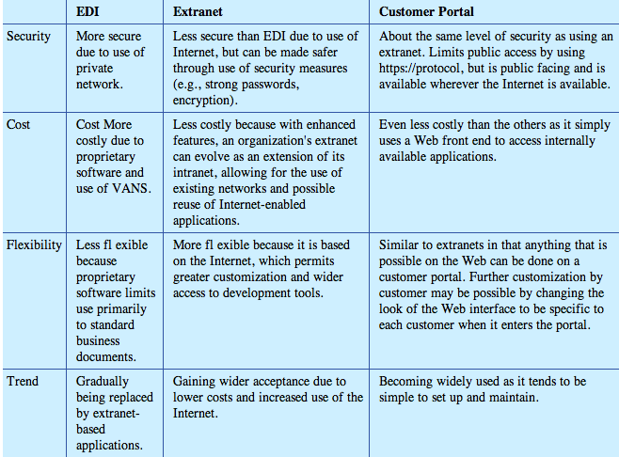
Chapter 6
Data-Information-Knowledge Continuum
-Data= raw unorganized facts, numbers and pictures
-Information= data that have been organized and are useful to a person
-Knowledge= created when a person combines experience and judgment with information. .
-Applying knowledge is how business people create and add value to an organization.
-Wisdom= adds insight and ethics to the experience and professional judgment inherent in knowledge.
-Wisdom enables business leaders to perceive the underlying meaning and nuanced of a business situation and ensures that knowledge from all relevant perspectives, disciplines and sources is considered in the final decision.
-Info technology and systems assist primarily with collecting, collating and analyzing data and information.
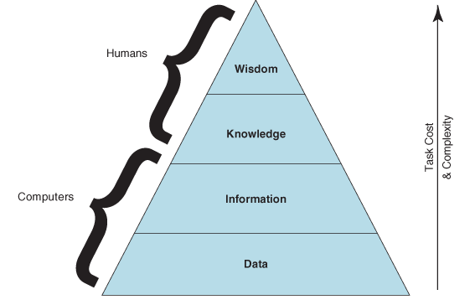

-Need to build on the two types of knowledge that you possess:
- Explicit knowledge= readily codified, such as knowledge in this textbook.
- Tacit knowledge= gain through experience, insight and discovery
-Both are complementary halves of a lifelong knowledge creation process.
Knowledge Work Activities
-Knowledge work involves discovery, analysis, transformation, synthesis and communication of data, information, and knowledge.

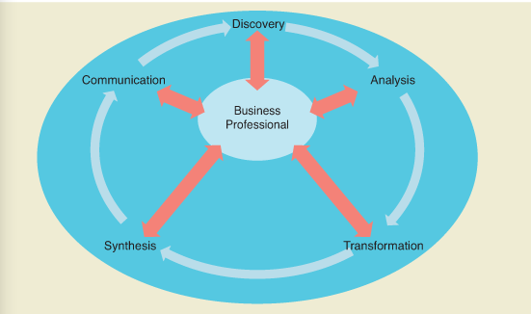
-These steps are workflows and the outcome of your effort is the work product.
- Discovery: finding data, information or knowledge relevant to a task, problem, issue or opportunity. You begin with an idea of what to look for and then reflect on where information related to the task may exist. You then retrieve the relevant data from those various sources and assess its value to the decision at hand. Strong Internet research skills, balanced with an awareness of the limitations of this source of data can help you create business value for your organization. Evaluating your search results is an important part of discovery process. The company you work for may have a private version of an Internet known as an intranet, which contains data about the company that only authorized employees, can access.
- Analysis: Investigating and examining the available data, information and knowledge. Often perform analysis such as process mapping (analyzing a business process), quality assurance (analyzing product quality), performance testing (assessing fitness or standards). Analysis is a critical knowledge activity that will help you answer questions and gain understanding through thoughtful investigation and examination of the available data and info. Once you have completed the analysis and put it into an appropriate org context and make a decision/recommendation, you have created knowledge. Include consideration of unintended consequences, ethical constraints or risks, put knowledge to create a sustainable competitive advantage= wisdom. Two information technologies that help answer questions about underlying patterns and correlations across large amounts of data are data warehouses and data mining.
- Transformation: use the results of your analysis to deepen your understanding of data and information. Larger orgs with many transactions often use database software for storing and transforming data. (Organizing discovery results)
- Synthesis: interpret trends or patterns that seem to explain the past and the present and may suggest courses of action likely to favorably influence that future. Essential element of synthesis knows which parts, when combines, will create higher total value than the value of the parts themselves. While systems can provide summary info, only people have ability to put this information into the proper context and draw conclusions from it.
- Communication: ability to share your analysis, ideas and solutions with others. Some technologies individuals use focus on physically sharing the message such as email and IM. Info systems and technology allow you to share the meaning behind the message. You use Microsoft PowerPoint to create a presentation…
-Any decision making and problem solving creates the need to engage in knowledge work activities of discovery, analysis and transformation, synthesis and communication.
Databases: Primary Data Storage for Organizations
-All business info systems rely on use and storage of data.
-Database is primary technology used to store, manage and allow efficient access to data.
-A database= interrelated data that are stored in files and organized so that computer programs can quickly and easily access specific pieces of data.
-Database management system (DBMS)= collection of software that allows users to create and work with a database.
-Together a database and a DBMS make up a database system.
-People who create and manage the database, known as database administrators (DBA), use tools in the DBMS to do their work.
-Other business professionals who need to access the databse typically do so through other application software that can connect to the DBMS and query the databases that it manages.

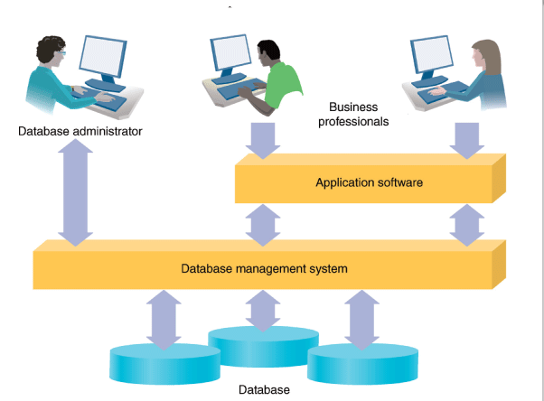
Data Hierarchy
-To organize data in a database, most users rely on the data hierarchy. It organizes stored data in increasing levels of complexity.
-At the lowest level, the data hierarchy stores all data using electronic bits that can be 1 (on) or 0 (off). A specific combo of bits represents each data character. The exact number of bits needed for a character depends on the type of data and the encoding scheme.
-The ASCII encoding scheme will use eight bits (one byte) to store a letter of the alphabet. Unicode will store the same letter using 16 bits (two bytes)
-A combo of characters representing a data items, such as a name, is known as a field.
-The next higher level stores collections of fields known as records. Then the hierarchy assembles records into a collection called a table or file. The top level compiles the organized collection of files into a database.
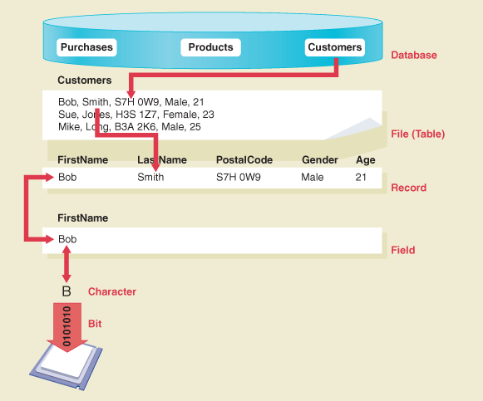
Advantages of database system:
-Organization of the data is independent of any one software application. This allows all applications to access the data in a standard manner.
-Organization of the data reduces data redundancy; a DBMS may need to store only one record of data for a particular product.
-The DBMS can include features for maintaining quality of data, handling security and synchronizing access by simultaneous users.
-The database system allows for capabilities such as improved data access, allowing different views of data for diff users and report generation.
Relational Data Model
-Dr. E. F. Codd developed method for logically organizing data in a database that was independent of the method used to physically store the data.
-Relational data model= store info about entities, such as suppliers and products for a retailer, and the relationships between those entities. Databases then use these defined relationships to store the connections between the entities, such as supplier provide which products.
-Become standard way of storing large amount of data.
-Systems based on Codd’s model are known as relational database management systems (RDBMS).
-RDM stores data in one or more tables, corresponding to entities. Tables consist of records, represented by the rows of the table. The records generally hold data about a single instance of an entity. A record consists of one or more fields often describe of an instance of an entity. Because the data values in the fields often describe an instance of entity, the fields are sometimes called attributes. Columns of the table represent the fields (column headings) of all the records.
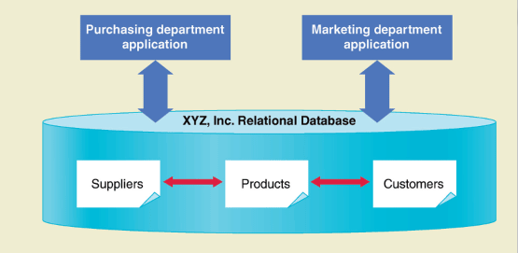
EX: (I find it complicated to know what’s what):
**For example, suppose that a company decides to create a relational database to store data about its products. It begins by identifying the generic category “Product” as an entity. The company then determines that an instance of the product category is a set of data about a specific product, such as “hiking boots.” The attributes of the hiking boots product include ItemCode (HB), ItemName (hiking boots), RetailPrice ($110.00), and ItemCost ($50.00). Because the company wants to store data about the same attributes for all of the products that it sells, its product table will include fields for ItemCode, ItemName, RetailPrice, and ItemCost. (You can imagine that the field names are the column headings for a table.) When the company fills in a row in the table with values for the attributes-HB, hiking boots, etc.-then it has a data record for a product.
-Example of related tables is a product and a vendor table. Both tables each store one field that has a unique value for each record, called the primary key. When a second table uses the primary key of one table as a reference field in its table, this field is called a foreign key.
-Primary method for accessing and using data in an RDBMS is a query.
-A query is a method for asking a question in a database.
-For relational database model, a standard language called Structured Query Language (SQL) provides general rules for formulating the queries on relational databases. (More details about SQL in tech guide D)
Designing a Relational Database
Data Modeling
-Is the process of analyzing the data required by the process of an org to support it both operationally and strategically. Data models are often the first, high level step in designing a relational database; in the process the required data is defined and integration with other systems is determined.
-Typical products of data modeling include a data dictionary, which documents the origin, format and meaning of the data and other more detailed models such as an entity relationship diagram and a data flow diagram.
-Entity relationship diagram (ERD) and the logical data model are the two most commonly used models for designing the org of a relational database.
-ERD indicates the entities and relationships for the data that the IS will store.
-The logical data model then translates the ERD into a diagram of the tables in the database.
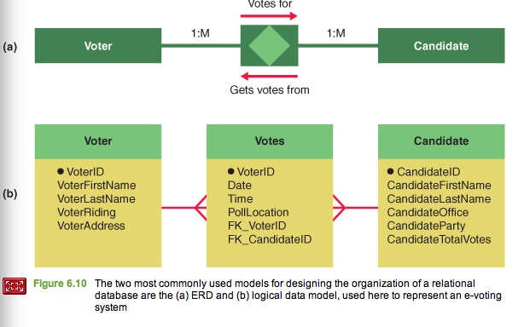
Data Flow Diagram
-DFD is a traditional IS model that depicts how data move or flow through a system:
- External entities (boxes) that send input or receive output from the system.
- Processes (boxes with rounded corners) that show activities that move or transform data)
- Data stores (open ended boxes) that usually correspond to tables in the data model
- Data flows (arrows) that connect the components
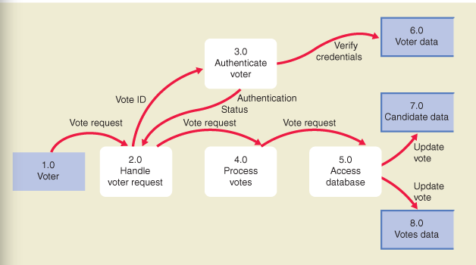
Storing and Accessing Data, Information and Knowledge
-Other ways IT can support the organization, storage and sharing of data.
Data Warehouses
-Means of storing and managing data for information access typically composed of data from one or more transaction database.
-Consists of transaction data, cleaned and restructures to fit the data warehouse model and to support queries, summary reports and analysis.
-Because data warehouses are very large (amount of data stored) compared with typical database, they work with tools that allow users to more easily deal with these vast amounts of data.
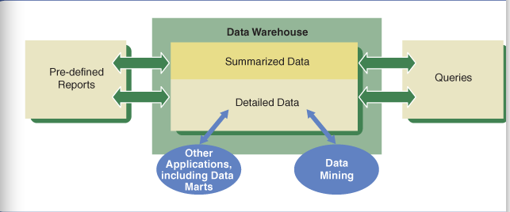

-Data mart extracts and reorganizes data subject-area-specific data to allow business professionals to focus on a specific subject area.
-Data warehouses often provide support for organizing multidimensional data, based on two or more characteristics such as time and place.
-Allows businesses to more easily identify trends.
-Retrieving data in this way is sometimes refereed to as slicing-and-dicing, process of cutting off portions of data until the needed info is obtained.
Businesses access and use data warehouses because:
- Automatic production of standard reports and queries: when users need a particular report, they simply view the report that the data warehouse already generated rather than creating one.
- Queries against summary or detailed data:
- Data mining in detailed data: includes set of techniques for finding trends and patterns in large sets of data. Data mining tools can incorporate advanced technologies such as artificial intelligence. Some provide aids for data visualization.
- Interfacing with other applications and data stores: connect a data warehouse to applications that use it as the source of data. May feed data to other data warehouses, data marts, or application programs
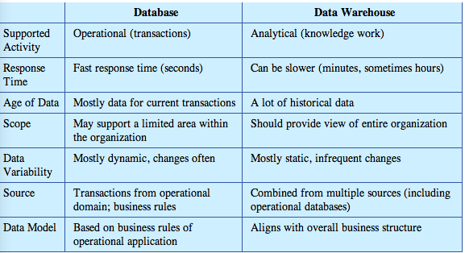

Business Intelligence
-BI= process for gaining competitive advantage through the intelligent use of data and information in decision-making.
-BI is key part of corporate information strategy. It enables business leaders to make better decisions, which translate into increased profitability.
-Company called SAS is leading provider of business intelligence.
Stages of business intelligences and IT used at every step:
- Data Sourcing (Acquisition): mining data and information from text documents, databases…
- Data analysis (Organization): producing useful knowledge from the collected data and info using tools such as data minding and text/image analysis techniques.
- Situation awareness (Analysis): culling out and relating the useful facts and knowledge, while filtering out irrelevant data.
- Risk assessment (Analysis): identifying decision options and evaluating them based on expectations of risk and reward
- Decision support (Decision): using interactive software tools to identify and select intelligent decisions and strategies.
-Hierarchy of how IT supports these stages:
- Transaction process systems (TPS) represent primary source of data from business ops.
- Businesses store and organize data in databases and at times, in data warehouses.
- Specializes BI and online analytic processing (OLAP) systems can help analyze, synthesize and create knowledge. BI systems, decision support systems (DSS), allow rapid creative knowledge creation by decision makers. Also might find knowledge management (KM) systems at this level. KM facilitates access and distribution of knowledge throughout an org or management information system (MIS), which stores management reports.
- Management uses the created knowledge to guide its actions and decision-making.

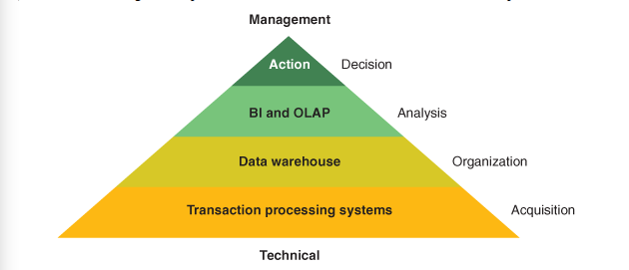
-A common way of organizing these systems is using a balanced scorecard, dashboard or measurement matrix. These mechanisms link an orgs strategy to a series of clear measures or indicators that they monitor or determine if they are on-track or not in an executing strategy.
-Tactical decisions are made every hour within orgs. The person doing the actual work, based on appropriate guidelines or policies, usually makes them.
-Operational decisions, as decision-making takes on more impact at a higher org level, see value of having data and info.
-Executives face strategic decisions. Data and info are not only critical, may come from both internal and external sources and might include actual data along with modeling, forecasting or other intelligent extensions of data to improve decision making.

Chapter 7: Creating IS Solutions and Managing IS Projects
Critical Pre-Development Questions
- More complex a system, the more complex it can be to build, buy and manage
- Not all organizational problems can be solved by building a new system
- Before implementing a new system, an organization needs to address four critical questions called “pre-development” questions because they happen before an organization decides to start a system design project- called the concept design and inception stage
- Questions to consider, in order, are:
  - What are we planning and why?
  - Is the project feasible?
  - Should we build or buy/lease?
  - If we build, should we do it in-house or outsource it?
What Are We Building and Why?
- An organization can plan to improve the performance of its business processes by automating, Informating, and transforming (to seek competitive advantage or out of competitive necessity)
- Should also looks for ways IS can add value to its new or existing products or services
- When the organization recognizes IS can be used to exploit an opportunity or solve a problem, the organization must decide the best IS design for its needs
- Questions is what are we building and why
- Answering this question allows the organization to understand its high level system requirements and the business case for why it makes sense to build
Is the Project Feasible?
- Feasibility study: detailed investigation and analysis of a proposed development project that is undertaken to determine whether it is technically and economically possible to successfully build the proposed system
- Project is technically feasible if the technology needed is available
- Must conclude that the company is technically capable of both acquiring and deploying the required technology
- Financial feasible: if the company can pay for the project, and the project presents a sound investment of the organization’s limited resources
- Must show that the company can afford to build or buy the IS and that it will financially benefit the firm
- Financial measures often used: NPV, ROI, IRR, payback period…
- Difficulty in calculating these measures is in obtaining the list of all costs and benefits, then placing monetary value on each
- Some costs and benefits are tangible, others are intangible
Should We Build or Buy/Lease?
- Organizations usually choose between three options for obtaining an IS: (1) buying, (2) leasing, (3) building
- Need to examine requirements and advantages and disadvantages of each option for the set of circumstances
- Building from scratch often ensures the best matching of an IS with the requirements of the organization
- Building is also the best option for obtaining a sustainable competitive advantage because the system is unique to the organization (systems capabilities are not easily copied by competitors)
- Building can be a long and costly process
- Time-to-market factor may be the most important factor in any decision about buying or building IS
- When buying an existing system, an organization may still need to make adjustments
- Buying saves time and costs over building
- For some systems it is possible to lease
- Leasing refers to using software as a service (SaaS) or using an application service provider (ASP)
- Leasing advantages include cost and time savings, but the main advantage is that the responsibility to maintain and update the system is the vendor’s
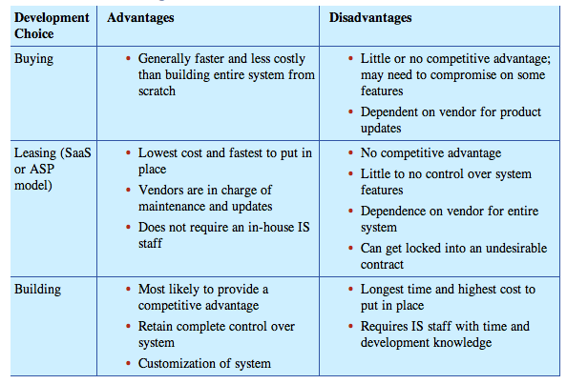
Should We Develop In-House or Outsource?
- If a company decides to build the system it must then decide whether to use its own employees (in-house development) or hire another company (outsource) to build part or all of it
- Outsourcing to a company outside of the country is known as off-shoring
- Organization must examine its present capabilities and situation and choose the option that most closely matches its needs
- Consider any time-to-market imperative, current financial performance, and risk tolerance
IS Development Teams
- People who are involved in the IS project usually fall into one or both of two teams: those on the actual project team and those who are stakeholders in the IS
- Stakeholders must design and use the IS
- Without an excellent IS development team the system cant be built
The Importance of Stakeholders
- Should identify the key stakeholders right from the beginning
- Stakeholder analysis should begin as part of the project feasibility study
- Stakeholder analysis begins with a list of the stakeholders, including what each has at stake, as well as the degree of impact each stakeholder can have on the project
- Analysis should consider whether the team can expect resources from the stakeholders
- Analysis should attempt to identify each stakeholder’s attitude toward the project and any risks
- Should assign team members to different stakeholders, with an anticipated strategy for dealing with each one
A Typical IS Project Team
- Size of the project team and the associated IS development team will vary with the characteristics of the projects
- Factors include scope of the project, budget, and available resources
- Project team’s skill requirements vary along these lines also
- IS development projects require teams to possess the following:
  - Project sponsor: individual who ensures that the project goals align with the organizations business objectives and is often a senior executive or someone in a position of authority. Must consider the strengths and weaknesses of both the business and the teams, identify opportunities and threats both internal and external to the organization, understand the financial aspects of the project like budget, ROI, and manage risks and planning needs.
  - Project manager: role demands knowledge of methods and techniques to ensure delivery of the project on time and on budget, and the ability to communicate project goals and requirements to the project team and to coordinate workflows of everyone on the project team
  - Account manager: this group is typically part of the development team when the project team works as an outsourcer. Responsible for contact to the client (the people who need the IS), as well as daily communication with the client
  - Architecture and design: members who work in this group must provide a well-designed interface.
  - Analysts: members in this group may have many titles. They all provide the methods and processes to translate high level requirements in their specific area to lower levels of details that can be turned into code by programmers
  - Developers: this group actually creates the system by coding and deploying the technical infrastructure of the system and programming it to perform. Requires knowledge of hardware and software needed by the system
  - Specialists: handles unique aspects of the project and members are often called SMEs (subject matter experts)
  - Client interface: a client may be an internal or external customer of the team’s organization. Client must define system requirements, negotiate contract terms, and maintain oversight of teams as the project progresses. May also need to supply resources.
- Team composition is possibly the most important aspect of project management
The Stages and Importance of the System Development Life Cycle (SDLC)
- System development life cycle (SDLC): common term used for the stages and activities of system development
- SDLC is composed of processes that occur from the beginning stages of a system to the end of its useful life
- Organizations are perpetually designing systems because systems do not and cannot last forever
- IS is far more than just technology; so, an IS project is more than just technology
- Those involved in the systems analysis and design process need to remember there are 4 pillars that impact IS and all 4 must be addressed for you to succeed
- 4 pillars for system analysis and design:
  - People: the right people with the right skills
  - Tools: the people must have the right tools to build the system
  - Methodology: the people must have the right methods to build the system
  - Management: need to manage the process carefully to ensure success
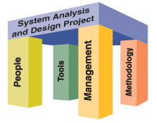
- Throughout the life cycle various departments or functions will be doing different things to support the IS as it progresses through the stages of the SDLC
- Diagrams show the phases/steps of the traditional SDLC as flowing from one to the next from top to bottom like a waterfall (call it the waterfall method)
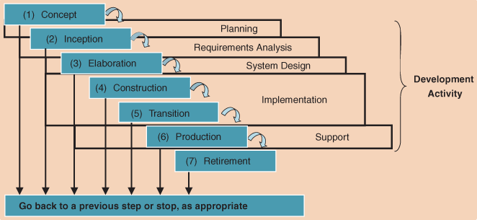
- At a high level the SDLC starts with an idea, the concept
- SDLC begins when there is an opportunity that likely involves technology or information systems and flows as follows:
- Concept: also known as pre-inception or idea phase: involves the environment within the organization that either promotes or inhibits the development of ideas for systems
- Inception: also known as feasibility or planning phase: begins when an organization has the idea to build an information system. Focus is on understanding the problem or opportunity, and planning the project. Early interactions with stakeholders take place in this phase
- Elaboration: project team finalizes the requirements for the system and the project plan, and designs the system architecture. Team creates the conceptual models of the systems and sub-systems.
- Construction: team builds the initial running system. Team usually implements core functionalities first, then incorporates additional features
- Transition: team finalizes the system and puts it in place. Team completes the final training of users and management of users.
- Production: organization must continuously monitors, maintain, and evaluate the system. Organization must also keep users of the system up to date with the latest modifications and procedures
- Retirement: system may lose its value to the company at some point. Replace the system with a new one. The old system may retain some usefulness as it is phased out over time.
Standard is Methodology
- A methodology provides a framework for executing both the project management and technical processes of an IS project throughout the life cycle
- Select a methodology that matches a project’s needs
- At a time, there was a single methodology within the IT profession that was derived from the SLDC called the waterfall methodology- it works well but is too structured and is sometimes seen as too slow to respond to the fast-changing business environment of today
Why Do Organizations Need an IS Methodology?
- System developers used to use the build-and-fix model where they worked in an ad-hoc way
- Build-and-Fix Model: Developers would meet briefly with the boss or customer to find out the requirements, wrote programs, created databases, and knit together hardware to create a rudimentary system. After building, developers tested and debugged it
- This approach often led to problems
- IT managers and developers began to think about improving the methods of the development life cycle so a project team could rely on structure to ensure that everyone, including the developers, were working toward the same project goals
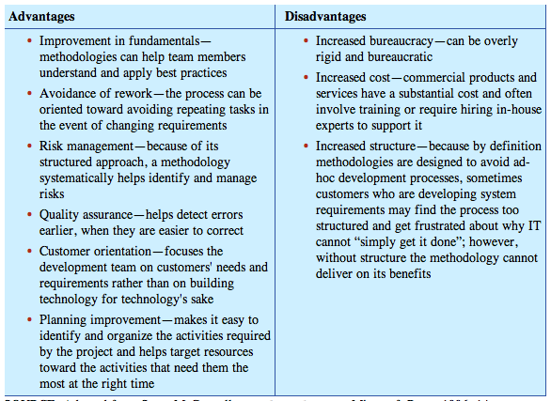
The Traditional IS Methodology: The Waterfall Model
- Waterfall model defines a set of phases and a new phase begins only after the completion of the preceding phase
- Document-driven and highly structured process
- Work during each phase generally produces a document or other type of deliverable
- Weaknesses of the Waterfall Model:
  - This method is too focused on output (documents) cannot sufficiently focused on outcomes; sometimes those working with developers on the IS find it too structured and oriented toward IT perspective rather than the business requirements
  - Usually only effective when users can express their exact needs
  - Precisely defining business requirements is crucial for this approach to work
  - Developers must understand the problem in detail so they can respond with effective system design
  - Users usually cant adequately express their requirements until they have a prototype to work with and see; with this method there is nothing to show the user until the entire process is complete
  - The sequential nature can delay progress
- Despite its weaknesses it is important to understand the waterfall model
- It is the most referenced model for describing the development process
- This approach defined the need for consistent documentation and specific requirements
- Waterfall model provided the basis for more modern methodologies
Modern IS Methodologies
- With more modern methodologies, developers produce a partial running system that they evaluate and then revise and enhance
- Evolutionary Model: developers first investigate, specify, and implement an important core part of the system with minimal functionality. The team then tests and evaluates this version of the system to plan for the next version. On each iteration of the cycle, the team adds new functionality and features to the system.
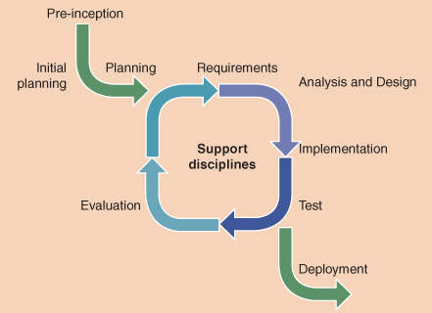
- Common approach of the evolutionary model is to use prototyping: the team works with customers to progressively build the system from an initial outline specification using mock-ups of screens, diagrams of data relationships, and similar tools that help users see what’s going on
- A problem with evolutionary model is that developers often neglect to create a well-defined set of documents
- Current trend is to develop using an agile development methodology
- Agile development: process designed to satisfy continuously changing requirements so the team develops software in short development cycles or increments
- Well-known agile development method is the rational unified process (RUP)
- RUP is based on six best practices that occur in each development phase: (1) develop iteratively, (2) manage requirements, (3) use component architecture, (4) model visually, (5) verify quality, (6) control changes
- In general, the greater the complexity and importance of the project to the mission of the company, the more formality is needed in the development process
IS Modelling
- Model: a simplified representation of something real
- Modeling system requirements is an important part of any IS development methodology
- Model usually includes one or more diagrams that developers can use to examine, evaluate, and adjust to understand the system and performance requirements
- Developers generally create models during the elaboration phase
- UML Diagrams:
  - Unified Modelling Language (UML): consists of several graphical elements that, when combined, form a set of diagrams
  - Has become a very popular modeling tool
  - Works particularly well for developing object-oriented systems
  - The set of UML diagrams together is known as the system model
  - UML model describes the purpose of the system but not how to implement it
  - UML diagrams include class, object, use case, state, sequence, activity, communication, component, and deployment diagrams
  - We focus on use case and sequence diagrams here
  - UML use case diagram captures all the possible ways to use a system- often used during the inception and elaboration phases of SDLC while gathering user requirements
  - Sometimes accompanied by a sequence diagram: shows the order of various activities and by who, and how they interact with the various system components as they occur in order
IT Tools For IS Development
- IT tools that project teams can use in IS development:
- Personal productivity tools like spreadsheet software, Word processing software…
IS Development Tools
- Software supports the execution of IS development tasks
- Project team needs software to model the system, write the software, and develop the database
- Integrated Development Environments (IDEs):
  - An IDE allows developers to complete several programming tasks within the same software application
  - Includes a text editor, a file system, a compiler, and debugging tools
  - Many IDEs feature visual editors
  - Examples of popular IDEs: Microsoft Visual Studio and an open source IDE Eclipse
- Modelling Tools and Code Generators:
  - A number of software packages offer a toolbox with common diagramming elements to make building diagrams easier
  - Code generation: a developer can use graphical diagrams to define a system’s components and how they are related, then with a click of a button a developer generate a code that corresponds to the diagram in a language like C++ or Java
- Case Tools:
  - Computer-aided software engineering (CASE): use of computer-based support in the software development process
  - CASE tools support the creation and maintenance of the many documents, diagrams, and data that the project team creates over the IS development life cycle and integrates them in a CASE environment accessible to all users
- There are some risks in using these software tools in the IS development process:
  - Common error is to focus on managing the software tools instead of the content of the project itself which can lead to quantity over quality outcome where the final product will not accomplish all the systems objectives
  - Common problem is known as the silver bullet syndrome: there is an overreliance on the tools for the success of the system, while neglecting the other pillars of a development project
- It is important to keep the tools in perspective and view them as support for the primary activities of the project
Managing an IS Project
- Project management: the application of knowledge skills, tools, and techniques to project activities to meet project requirements
- Project manager simultaneously oversees three main project elements: the scope of the project, the resources needed, the time to complete it, all balanced with a view toward accomplishing the organization’s strategy through successful project delivery
- Project scope defines what the project should accomplish
- Resources include people, equipment, material, and money
- Time estimates consider project activity times and how they depend on each other
- Descoping: client prefers to focus on a set time deadline or receiving the final software, often at the expense of incorporating every single last requirement
- Triple constraint or iron triangle:
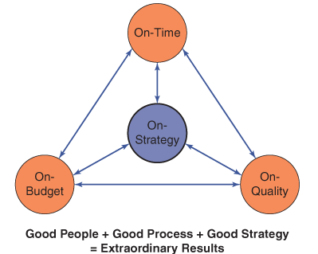
- Project scope is often the most important to manage: increases in scope will drive increases in time and/or resources needed
- Competitive pressure often require the delivery of all three
Overview of Project Management Tasks
- Project management tasks often begin at the point at which the organization has approved a project proposal and selected it to be executed as part of their project portfolio
- One important difference between SDLC and the project management activities to support a project: SLDC is a continuous stream of activities over time whereas a project has a beginning and end
- While many project activities begin before the system is constructed, most of the SLDC of the project doesn’t begin until the project is started
- Project ends when the system is in production and transitioned to day-to-day operational staff
- 9 key components of project management methodology that support the life cycle of the project: scope management, time management, cost management, quality management, HR management, risk management, procurement management, communications management, IT-Based tools
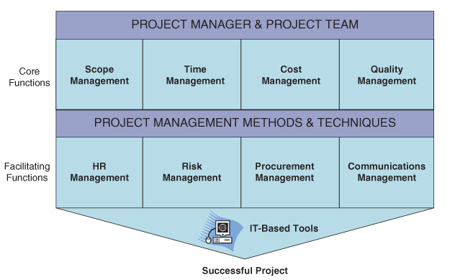
- Project manager should develop knowledge and skills in all nine areas
- 4 core functions lead to specific project objectives:
  - Time management: estimating the duration of the project, developing an acceptable schedule, and managing the project to ensure timely completion
  - Cost management: preparing a budget and managing the costs of the project to stay within budget
  - Scope management: identifying and managing all the tasks required to complete a project
  - Quality management: ensuring that the finished project satisfies its defined goals
- Facilitating functions support the project activities
  - HR management: focuses on making productive use of the team members
  - Communications management: supervision of shared project information
  - Risk management: project manger seeks to identify and prioritize risks, and develop contingency plans in case a risk occurs
  - Procurement management: acquiring the resource needed for the project
- Project Portfolio Management: PPM: selecting projects that are strategic; not only about doing projects right but also doing the right project
- PPM is emerging as a critical consideration for companies that are focused on competitive advantage
- The project manager must oversee any number of tasks within each of the nine key components of a project management methodology:
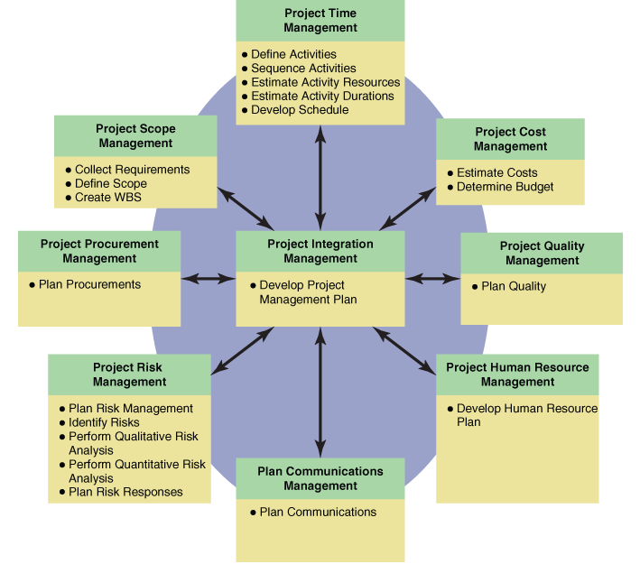
- Project management integration involves developing the project plan, executing it, and coordinating changes to the project plan as they occur
- Manager uses the project plan to coordinate all documentation and help guide the execution and control of the project
Project Time Management
- Most important function for project manager after budgeting is developing and controlling the project schedule
- Delays in completion of tasks usually go hand in hand with increases in costs
- Main activities of project time management:
  - Define activities
  - Sequence activities
  - Estimate activity resources
  - Estimate activity durations
  - Develop schedule
  - Control schedule
- Project managers often use a Gantt Chart to manage all these activities
- Gantt Chart: provide a standard format for displaying the results of the first fur time management activities (defining, sequencing, estimating resources and estimation durations of the activities)
- The chart lists the activities, along with their start and end dates in a calendar format. On the calendar, horizontal bars correspond to the duration of the activity. Patterns or colors represent the categories of activities. Arrows show when the start time of an activity depends upon the completion of other earlier activities. Project manager updates the chart while the project is ongoing.
Risk Management
- Risk management: recognize, address, and eliminate sources of risk before they threaten the successful completion of the project
- Risk management tasks fall into two main categories: (1) risk assessment, (2) risk control
- Risk assessment:
  - Identify potential project risks
  - Common areas of project risk:
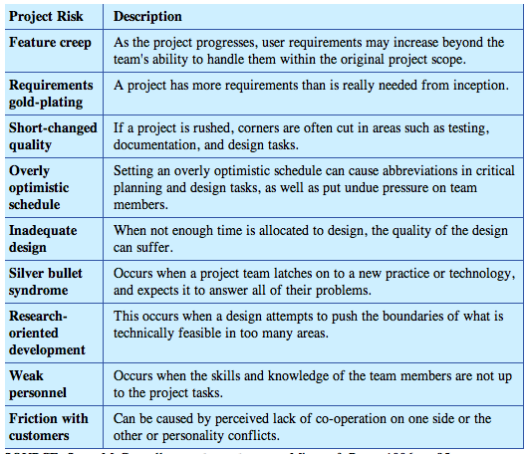
  - Assess the risks: analyze each risk for the likelihood and potential impact to the project. Assessment comes primarily from experience and knowledge of project stakeholders and others consulted during the risk analysis process
  - Project risk matrix helps managers focus on those risks that will have the biggest impact if they occur:
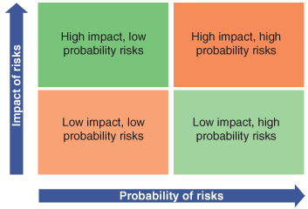
Program and Portfolio Management
- Program: breaking down a large project into a series of smaller, interrelated projects, or grouping a series of projects together into a single work effort
- Program management: managing several projects together: essentially the same tasks as for a single project, but across multiple teams
- Portfolio management: selecting and approving projects that will accomplish the organization’s strategic objective
- Projects are examined to determine which are the most critical and of the highest priority; then, resources are allocated across the projects in the portfolio
- Portfolio is always changing- new projects begin and others end and some are cancelled at any time, change priority…
Project Management Software
- Project management (PM) software: designed to support and automate project management and decision-making tasks
- 3 levels of PM:
  - Low-level packages: for entry-level users; include tools for basic scheduling, project control, reporting, filtering, and sorting
  - Mid-level software: adds to these functions by providing resource-leveling, resource-allocation, cost-control, flexible-charting capabilities; allows for effective management of large projects, with up to about 2000 tasks
  - High-level software: provides advanced functions like scheduling by user-defined rules, programming languages, resource management for multiple projects, risk management; can identify conflicting demands for multiple resources, and allow the manger to set priorities among projects that require the same resource
- Most PM software includes graphical tools for scheduling and tracking tasks like Gantt chart. Another tool is the program evaluation review technique (PERT) chart: uses a PERT chart to schedule and manage tasks within a project. Shows the project as a network of tasks that are linked by arrows. PERT chart clearly shows the sequence and dependencies of tasks. Each task is labeled with a number, start date, end date, and duration. PERT chart can be used to identify the critical path (the sequence of tasks that determines the overall completion time of the project). Any task on the critical path will delay the project time is it is delayed. Tasks not on the critical path have extra time called slack.

Chapter 8: Web 2.0, Social Media and Online Trends
- Term Web 2.0 was first coined by Tim O’Reilly (founder of O’Reilly Media) and used publicly in 2004
- Web 2.0 has come to represent what most people refer to as the interactive web- a site that permits interaction with users
- Interactive sites are often supported by multimedia combined with some form of user-generated content (UGC) like blogs and conversation threads
- Semantic web: next generation web that makes information sharing and exchange easier by focusing on content, searchability, ad interpretability at a technical level
- This trend has significant implications for businesses that use the web
- Any trend that has significant social impact will have a collateral business impact
Defining Social Technologies and Utility
- Social media technologies are those that find their centre in the psycho-social fundamentals of human interaction
- These sites are purpose-build collections of existing capabilities and tools
- This linking of form to function is an important point regarding the social web
- When we think about the social web, we are really thinking about things that humans have been doing forever (converse, connect, gather, join, belong) and translating that into online context
- Examples of websites in this category include: Facebook, MySpace, Orkut, Hi5, LinkedIn, Twitter
- Primary purpose is to connect you with friends, family, partners or colleagues
- They might enable you to discover new friends, or share your life; they may be oriented toward a specific demographic or aimed more generally at the world…
- The trend crosses all demographic ranges
- Social networking is the fourth most popular online application overall
- Social media trends follow basic social trends
- Form follows function to help create sites enabled by cool technology where people want to participate socially
Social Utility
- Social utility: suggests that you only spend time on sites that are useful to you, and the time invested on the site somehow contributes to your happiness and social satisfaction, or creates social opportunities for you
- Three Pillars of Sociability:
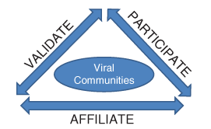
- Affiliation:
  - First step, beyond simply being aware of the opportunity to join something, is to ensure that users want to be affiliated with your group
  - Underlying psychological driver of this is the need to belong
  - Must trigger your target user the desire to be affiliated with your site
- Participation:
  - Once users want to join your site (once they have publicly declared their desire to affiliate), you must help them easily understand the rules of participation
  - Every group of humans has both spoken and unspoken rules regarding conduct in the group
  - Must find ways to make participation socially safe
  - Most successful social networking sites focus on an invitational design
  - Best sites encourage play and discovery and make the site design intuitive
- Validation:
  - Consider how to validate the user’s social experience, thereby constantly reinforcing the social utility of your website
  - Finding tangible ways of demonstrating social value
  - Powerful reasons why Facebook beat Friendster in dominating social computing in its early days may have had to do with two points:
    - Facebook initially appeared to be a focused and targeted site that has exclusivity; Friendster was a general purpose site that allowed anyone to join
    - Friend feature on Facebook enabled an instant form of social validation for its participants
  - Studies suggest that when a social media platform combines constant social validation of its users with a slight doe of competition as a way of encouraging users to compete for external forms of validation from other members, it drives up utility and interest in the site among both users and non-users
Design and Usability
- Design esthetic and usability are critical components to building a successful interactive media site
- Site has to look good and be attractive to users, while functioning well and being intuitively obvious to users
- Close working relationships between developers and designers need to be established to help each discipline maximize its contribution during development phase
- Successful sites normally employ a minimalist design perspective
- Best sites code and visually integrate good design concurrently and rapidly, constantly changing and refining the sites technology, flow, and architecture based on user’s feedback
Business Utility
- How to deploy social media platforms and technologies to create business outcomes that have real value for an enterprise but are also acceptable to users
- We will see a few examples of how social media and Web 2.0 technologies can help business later in the chapter
Technology Implications
- Several obvious issues: Cost of accumulating and storing all of the often multimedia intense content
  - Requires significant bandwidth
  - Massive amount of storage
  - Web 2.0 sites are more expensive to create and run then traditional websites
  - Increasing demand for compression technologies which help reduce the costs of storage and transmission
  - Increasing demand for developers who know how to code and implement systems that efficiently handle large amounts of information
- Privacy and Security:
  - Legal risk- must know which legal codes to understand and honor
  - Subject to privacy and security laws in every jurisdiction that the social website’s users reside in
  - Constant challenge for those who develop and implement new technologies like social media websites
User-Generated Content
Creating Content
- Ingredient fundamental to social media applications is user-generated content
- Social sites focus on providing the context in which users generate content themselves, rather then providing the actual content
- Users must actively join and self-identify in some form before they van participate in interactions
- Psychology suggests that before you affiliate with a group you must discover and trust its social motives and intentions; successful sites restrict visitors to watching, observing, learning about the site; before new users participate fully they must demonstrate a willingness to disclose or create a participating identity
- When you join various sites you may face restrictions, codes of conduct, user agreements, or requirements to participate
- Community may be self-regulating: members report conduct they feel is outside the group norms
Finding Content
- To make your own content useful to others you must label or tag it
- Tagging: associating keywords with your content to make it searchable so other users van locate it and interact with it
- Foksonomy: collective cloud tag that helps users access information quickly and efficiently
- The technology of tagging and searching is not new and was available in the days of Web 1.0
- Difference is how the technology is deployed to permit viral social interactions
User-Generated Content and Brand Risk
- One essential element of a company’s online social strategy should be an awareness of the risks of undertaking any kind of online social campaign that might backfire
- Brandstorm: situation where a traditional brand faces an online storm that can quite literally damage the value of its brand overnight
Creating Business Utility Using Social Media Tools and E-Marketing
- Phase 1: Early on, marketing’s use of IT technology rested solely on gathering and using e-info data
  - Early advent of desktop computers didn’t have much initial impact on marketing
  - During the 1980s, if you were working in marketing you were likely dealing with the need to get information through electronic data files and databases (e-info)
- Phase 2: the Web began to grow, most companies began to use IT as a way o communicate directly with their customers. However, the communication was still only one way- from company to customer.
  - World Wide Web started to become more prominent mostly through the mid 1990s
  - Marketers began to see WWW as a tool to enhance their direct brand marketing efforts
  - Companies and organizations began to create an online presence
  - Direct marketing: messages, offers, or promotions that come directly from the company to the consumer is some form
  - Companies moved into a new phase of computer-enabled marketing
  - This phase is associated with the creation of mostly passive-websites and the slow beginning of basic online marketing techniques like email lists
  - Companies began to refine their efforts to understand online customer behavior and online buying behavior to customize offers presented to customers and to refine marketing campaigns
  - Companies began to offer some method of buying products and services online, or at a minimum offered store or dealer locator features to make buying easier
  - However, customers were not yet interacting with the company and companies were still only putting traditional marketing materials and information online and were changing very little about the practice of marketing
- Phase 3: As the social web began to take over, marketing became e-dominated, where use of the web is an integral part of marketing’s communications with customers
  - Arrival of the social web
  - Consumers began to realize the power of interacting online
  - Consumers began to seek indirect sources fo information (ranking review sites, relying on work of mouth…)
  - Emerging distrust in some instances for direct marketing and emphasis placed on validating what companies were saying about their brands
  - WWW quickly became an important global source of influence on customers
  - World of marketing was changing so rapidly that marketing and IT became interdependent
  - E-dominated marketing emerged as a new paradigm
Harnessing the Power of Social Media
- Companies can use social media technologies in their business:
  - To facilitate employer/employee engagement
  - To create bran-related clubs/forums
  - To manage online communities
  - To facilitate online review sites
  - To promote geo-purposed sites
- Media transparency: making sure your brand and advertising messages are coherent and consistent
The Social and Business Impacts of Web 2.0
- Important development for business has been the generational impact of the Web on entertainment choices
- Decline in consumption of network TV as more choices become available and broadcast systems have increased their global penetration
- Decline in consumption of newspapers, magazines, radio, and most other forms of mass media
- This trend of online usage is rapidly rising across all demographics
- People spend more time online and are not responding to advertising the way they used to
- In the 1950s television rapidly displaced the earlier dominant technology of radio
- The way advertisers reach consumers has changed significantly since the advent of the Internet. We have moved from an age of broadcasting to mycasting, and the ability of advertisers to target their audience has narrowed in the process
- Presents a significant challenge for companies wanting to advertise
- Many companies are realizing the importance of social media in their marketing efforts and are putting more advertising dollars into these sites than more traditional online advertising, such as search and banner ads shutterstock
Social Business Models
- Social business models of the future? Answers are still emerging, but there are early sign to pay attention to
- Recent things being done in the social web which help define the business benefits of social computing in new ways:
  - Conducting online focus groups for new product development
  - Running viral campaigns to launch new products
  - Holding virtual recruiting and job fairs in Second Life
  - Replacing annual online employee engagement or satisfaction surveys with new virtual equivalents that run 24/7
  - Using social media tools to move from a broadcast to podcast model for training and development and internal communication with employees
- Opportunities to apply social media tools for any business are vast despite its size, geography, or industry
Conclusion
- As the usage of online social computing in all age groups continues to increase, business will have to adapt and figure out what his means for their target markets
- Can’t afford to ignore technology trends and contents outlines in this chapter

Chapter 9: Ethics and Professional Practice in IT
An Introduction to Ethics and Morality
- Ethics is closely linked to morality and a society’s widely shared understanding of what is right and wrong
- Morals are closely linked to individual’s personal values that are shaped by factor like age, sex, religious affiliation, ethnic or cultural influences…
- Personal values: fundamental beliefs that you hold as true about the way the world works and your role in it
- Ethical position on any decision is informed by your own values, moral code and life experiences
- Country’s or society’s legal codes also help define what is right and wrong
- Ethical dilemma: the result of issues where the law and some people’s moral or religious codes do not coincide
- Need to create your own hierarchy of values when facing an ethical dilemma
- Hierarchy of values helps you inform your personal decision making so you remain ethical
Business Ethics and Conduct
- Purely regulatory model would note work to enforce ethical decision making
- Government cant be responsible for the ethical conduct of all private businesses
Business Benefits of Acting Ethically
- Tangible business benefits to business remaining within the boundaries of ethical behavior:
  - Shielding you and employees from harmful and costly litigation and the associated negative publicity that unethical behavior draws
  - Reducing long-term compliance and audit costs
  - Creating a brand built on integrity and ethical conduct that can increase sales and encourage long-term customer loyalty
  - Gaining goodwill in your local community as an ethical and responsible corporate citizen
  - Ensuring your organization will be embraced and accepted as it expands to other jurisdictions
  - Attracting quality employees and supporting an excellent employee brand
- Corporate social responsibility: CSR: promotes making social agendas and social responsibilities equal to the profit imperative, and balancing economic and social factors (externalities) in all business decisions
- CSR is increasingly accepted; the movement is expected to continue to grow in the future
What Causes Ethical Misconduct in Business?
- If you work in the private sector, your organization’s main purpose is to make profits and maximize shareholder value
- Many businesses could make more money by acting illegally or unethically
- Greed and ego are powerful forces
- Power and ego satisfaction are offered to those who succeed in business. This often comes with respect and approval from society. Potential for many to confuse boundaries of right and wrong and act in more self-interest that in collective interest.
- Once an initial immoral, illegal, or unethical act is committed, a pattern of cover-ups and systematic deceit or corruption occurs to ensure the first occurrence remains hidden
Remedying Ethical Breaches
- Society tends to turn toward government regulation to restore public and investor confidence
- Sarbanes-Oxley Act of 2002: Sarbox: SOX:
  - Section 302: CEOs and CFOs must personally certify financial statements and disclosures in periodic reports, as well as the effectiveness of the company’s internal controls
  - Section 404: requires a separate annual internal controls management report and mandates internal controls that are well-defined, documented, and periodically evaluated by internal and external audits
  - Section 409: decreases time between reporting deadlines and increases reporting requirements
  - Section 906: requires additional CEO/CFO personal certifications of financial reporting and imposes criminal penalties for knowingly falsifying certifications
  - Section 201: prohibits a public accounting firm from performing both audit and non-audit services for the same client
- Solution like this impacts those who may offend, but also those who never would have
- Adds a layer of cost and complexity, potentially hinders economical growth in the long-term, and costs everyone something over time
- Society often tries to connect organizational outcomes with personal consequences when it comes to issues of corporate ethics

Corporate and IT Governance
- Corporate governance: the highest level of decision making, involving basic questions of status, strategy, and compliance within an organization
- Governance processes require IT
- Efficient governance is an enabler for success in the global economy, securing enterprise’s information resources, and gaining competitive advantage
- Efficient governance can be linked to improved financial performance
- Management of a business are responsible to its owners, the shareholders, for proper operation and financial control of the organization
- Deliberate and complete disclosure and reporting of results for a public company
- Businesses and governments are enacting laws, writing regulations, and establishing policies and guidelines for control of financial systems, as well as using existing laws and regulations
- Any requirements, especially reporting a disclosure requirements, rely on IT and the governance of IT
- IT governance: the distribution of IT decision-making rights and responsibilities among enterprise stakeholders, and the procedures and mechanisms for making and monitoring strategic decisions regarding IT
- IT governance specifies: (1) how the organization will set goals, objectives, priorities and policies for IT, (2) how it will integrate IT with business strategies and goals, (3) which organizational members will make decisions regarding the successful completion of these tasks (the ‘who’ of IT governance)
The CIO: Managing IT Governance
- CIO: Chief Information Officer: must ensure proper and secure use of all the organizations information resources, and particularly the organizations compliance with privacy laws and regulations
- A few of the applicable types of legislation that might apply to various IT operations of a typical organization:
  - Personal Information Protection and Electronic Documents Act (PIPEDA): federal government sets out ground rules for how private sector organizations may collect, use, disclose personal information during commercial activities,
  - Bill 198
  - EU Data Protection Directive: Each EU member nation must pass legislation requiring confidentiality and integrity controls for networks systems, and data containing personal information for both employees and customers
  - Basel II Accord: International Convergence on Capital Measurement and Capital Standards
  - Sarbanes-Oxley Act
  - Multilateral Instrument 52-109
  - Privacy Act
  - Provincial Privacy Legislation
- Not all organizations have a CIO
- Role of ensuring IT governance is responsibility of senior executive team and board of directors
- IT governance must me a forethought
Professional Codes of Conduct and Practice
- Codes of conduct: guide the professionals within the field in terms of what is and is not acceptable and ethical behavior
- Many large private companies also have internal codes of conduct that relate to employee conduct and maintaining high ethical standards
- These codes are usually in place in organizations with high risk profiles where risk of unethical conduct has high financial or human costs
Common Ethical Dilemmas Involving IT
Copyright and Piracy:
- One of the biggest plagues of the software industry
- Copying protected software
- “cutting and pasting”
Patent Violations:
- May be the result of ignorance, but much is intentional
- To use someone else’s invention without paying is not only unethical, it is theft of intellectual property
Reverse Engineering
- Used most often to find out how another manufacturer created a product, and then attempting to earn from this to either make a better one or find a way to replicate it in a different way to avoid infringing on copyright or paying royalties on a patent
- No ethical dilemmas when the process is used as an educational tool
Spam and Privacy Codes
- Criminal organizations use spam in phishing schemes
Security Breaches
- Ethical practice demands you to report security breaches
- A privacy breach is a serious matter and must be taken seriously
Competitive Intelligence
- Competitors gain insight into what others in the industry are doing so they can respond to the market and maintain market share
- Gaining insight though customers or partners, or from observation and deduction are all fine
- Beyond that there are a whole lot of practices that skirt the boundaries of ethical practice
Hiring Practices, Equity, and Equal Opportunity
- Exploiting workers
- Students in Canada coming from abroad having unequal opportunity
Green IT
- IT, like other industries, is a contributor to environmental damage
- Should promote recycling and reduce consumption to create a more sustainable global IT industry
The Personal Implications of Ethics and Governance
- How should an individual in a corporation react to knowing about unethical, illegal activity within the firm?
- Resign and avoid the dilemma
- Find an internal conduit for the information and suspicions you have, and deal with someone beyond reproach whose integrity you respect
- Third party might be an ombudsperson or integrity commissioner
- May have to use peers or supervisors if the organization doesn’t have employees in these positions
- Silence or tolerance is a form of complicit or implicit consent: law presumes you consented to act accordingly, either with or without intent, and therefore are complicit
- Whistle-blowing is filled with ethical dilemmas of its own
- Whether or not you should report your suspicions seems to depend on the extent to which you can back up any claims you make with supporting evidence
- Seek counsel of a professional (lawyer)

