Who are we? (Name and position)
Decision/Goals (short-term and long-term goals)
Market Analysis (Industry, environmental PEST analysis, competitor analysis, our corporate capabilities)
- Consumer 5 Ws and H
- Corp. Cap. HR, production objectives, financing, experience
- Competitors who, size and power (market share), pros and cons, target market, ADV
- Environment PEST
Qualitative analysis of different alternatives
Past financial analysis (statement of cash flows (operations, sources/uses, matching; ratios)
Differentials, cash budget
Make decision
Projected financial statements
Conclusion

Cost Behaviour
Cost: good/service generates revenue, recurring; vs.
Investment: benefits many periods; one time flow
Fixed costs: no change with activity level (rent, salary)
Variable: change directly with activity (r.m., labour)
Semi-Variable: portion changes directly (utilities)
Step: change in large amounts at distinct volumes
Unit Contribution
Amount of sale of one unit contributes toward recovery of fixed costs and then profit
UC = selling price – variable cost/unit
Contrib. margin is UC of product as % of sales price CMR = UC/Selling Price
Breakeven
B/E Units = FC/UC
B/E Sales = FC/CMR
Cash B/E Units = Cash FC/UC (cash Var. Costs)
Cash B/E Sales = Cash FC/CMR (cash Var. Costs)
Target Units = (FC + Target)/UC
Target Sales = (FC + Target)/CMR
Weighted Average CMR
= (CMR x % revenue) + (CMR x % revenue); OR
= (Var. Cost x % of units) + (Var. Cost x % of units)
Margin of Safety
= (Projected Sales – B/E Sales)/ Projected Sales
ROI = net cash flow/investment
Payback = investment/net cash flow

Segment Reporting
Segment Direct Costs: only costs traced directly to segment, used for S-T decisions
Fully Allocated Segment Costs: all business costs allocated to various segments using fair method; L-T

Cash Budgeting
Match cash inflows/outflows with periods incurred
Unprofitable can survive, but insolvent fails
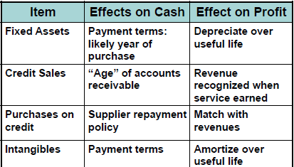
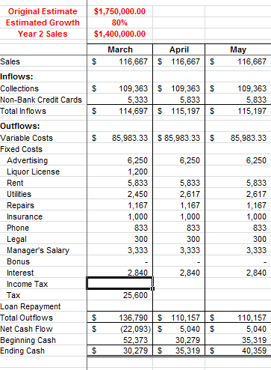

Marketing
Pull: directed at ultimate end user
Push: directed at channel of distribution

Statement Cash Flows
Operations: net income, add back non-cash, negate abnormal activities (loss), changes current accounts
Financing: changes in loans, stock, reconstruct Retained earnings to determine dividends
Investing: changes in non-current assets, reconstruct

 | Increase | Decrease
Asset | Use | Source
Liability | Source | Use
Equity | Source | Use
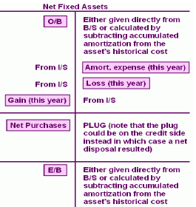
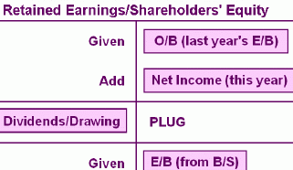

Matching: S-T sources = S-T uses?

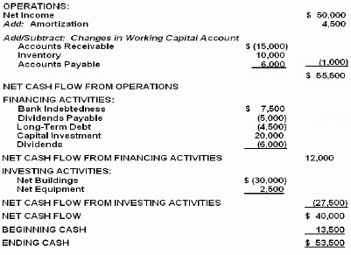
Ratios
COGS-Sales | COGS/Sales x 100 | Want lower
GP to Sales | Gross Prof/Sales x 100 | Want higher
Op XP-Sales | Op XP/Sales x 100 | Want lower
Net Inc-Sales | NI/Sales x 100 | Want higher
ROA | NI/Avg Total Assets | Higher = good return
ROE | NI/Avg Shareholder Equity | Higher = good return
Inventory TO | COGS/Avg. Inventory | Want higher
Fixed Ass TO | Net Sales/Avg. Net Fixed Ass | Higher better
Total Ass TO | Net Sales/ Avg. Total Assets | Higher better
Net Worth to Total Assets | Total Equity/Total Assets | % business owned by equity; want higher
Tot. Debt to Total Assets | Total Liab./Total Assets | Lower is safer
Debt-Equity | Total Liab./Total Equity | Lower safer
Interest Cov. | EBIT/Interest on L-T debt | Higher
Current | Current Ass/Current Liab. | Higher to point
Acid | (Curr.Ass – inven)/ Curr. Lia | Higher to point
Age A/R | A/R / Avg. Daily Sales | Close to industry avg
Age Invent. | Inventory/Avg. Daily COGS | Close to industry
Age A/P | A/P / Avg. Daily COGS | Close to industry
Profit Growth | (Profit2-Profit1)/Profit1 | Higher = growth
Sales Growth | (Sales2-Sales1)/Sales1 | Higher, proportional
Asset Growth | (Assets2-Assets1)/Assets1 | Higher, proportional

Projected Financial Statements
I.S. = Estimate sales, estimate expenses using vertical analysis, mgmt. policy, or past statements; apply tax rates
B.S = Owner’s equity last year plus projected net income plus investment less drawings
Projected A/R = Proj. Credit Sales x #days/360
Projected A/P = Proj. COGS x #days/360
Projected Inventory = Proj. COGS x #days/360
Include amortization from I.S.
Include planned debt financing, estimate other accounts
*if L&OE > Assets, PLUG for cash
*if Assets > L&OE, PLUG for additional financing

Costing Methods
Direct Cost: direct material, direct labour, direct selling expenses
Setting floor price, contribution analysis, breakeven calcs.
Absorption Cost: direct material, direct labour, FOH
Comparing relative plant efficiency, financial reporting
Full Cost: direct materials, direct labour, FOH, selling expenses, general and administrative charges, financing charges
L-T pricing strategy, defence and cost-plus contracts

Differential Analysis
Differential cash flow: future oriented, affect cash, recurring
Differential investment: future oriented, cash, one-time and working capital investment 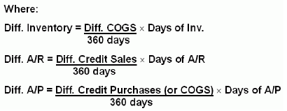
ROI and Payback

REMEMBER!!
- Cannibalization of sales

