Chandler
- Logic of Managerial Enterprise: logic of growth and completion that drives modern industrial capitalism
- Economies of Scale: The cost per unit drops as the volume of output of rises. (Success)
- Economies of Scope: Using raw and unfinished materials and intermediate production processes to make a variety of different products. (Success)
- Flow of materials must be constant.
- To succeed need to create national and international both marketing and distribution organizations.
- Also need to recruit teams of managers: lower and middle managers to coordinate the flow of products through production and distribution and top managers to coordinate and monitor current operations and plan and allocate resources for future activities. (Success)
- The ones that due the previous investments are called first movers.
- Adv. Of First Mover: Able to establish market first
- Innovation and strategy more powerful than price.
- Growing horizontally= combining with competitors
- Growing vertically=moving backward to control materials and forward to control outlets.
- Geographic expansion based on economies of scale, while moves into related product markets more often rested on economies of scope.
- Opportunity to make first mover investment and create a managerial enterprise is short lived. Once lost hard to regain.
- Develop a product specific facilities and skills essential to obtain and maintain a competitive position in world market. (Success)
- A lot of research of production will lead to company’s success.
- Being big is sometimes a disadvantage because more of a chance of stagnation.
- Growing through diversification, acquiring businesses in which they had few if any organizational capabilities to give them a competitive edge, is bad.
- One reason its bad is because most of the time company doesn’t have a competitive advantage in the market they are going to.
- Entrepreneurial companies that do not make investments to create organizational capabilities cannot achieve long-term success.
- Separation of top management (Middle vs. Top managers) Not good
- Reason: One top manager has little knowledge or experience with the tech. processes and markets of the divisions or subsidiaries they had acquired. Two: Large numbers of acquired businesses create an extraordinary overload in decisions making at the corporate office.
- Managerial weaknesses arising from the separation of management leads to the sale of operating units.
- People that invest in stock market create pressure for managers causing them to make irrational decisions that hinder the growth of the company.
- Short-term thinking is bad. (Short term thinking due to investors influence-want profits fast)

Greiner
- Companies go through a series of developmental phases
- Each phase begins with a period of evolution and ends with a revolutionary period
- The resolution of each revolutionary period determines whether or not a company will move forward into its next stage of evolutionary growth.
- Five key dimensions: organizations age and size, its stages of evolution and revolution and the growth rate of its industry.
- Age of Organization: life span of organization, same organizational practices not maintained throughout a long life span, management problems and principles are rooted in time.
- Decentralization: dispersing power among people. Managers giving employees power.
- Size of Organization: Companies problems and solutions tend to change markedly as the number of its employees and its sales increase therefore more managerial problems. Organizations that decide to stay small can still suffer these same managerial problems.
- Stages of Evolution: prolonged growth (evolutionary period), companies enjoy 4-8 yrs of growth until the next setback occurs.
- Stages of Revolution: Companies that are unable to abandon past practices and effect major organizational changes are likely to either fold or to level off in their growth rates. Critical task for management in each revolutionary stage is to find a new set of organizational practices.
- Growth Rate of Industry: Speed at which organization experience a phase is closely related to the market environment of industry. Evolutionary periods short in fast growing industries.
- Once dealt with a phase cannot go back and change it.
Creativity Phase #1: creating both a product and a market
- Founders of company entrepreneurial oriented. Making and selling product.
- Communication with employees is informal and frequent.
- Long hours of work rewarded by modest salaries.
- Management acts as customer reacts.
- As company grows large production required knowledge about efficiencies of manufacturing.
- Need managers to direct employees.
- Leadership Crisis occurs: strong manager needed. One who has necessary knowledge and skills to introduce new business techniques.
Direction Phase #2:
- Functional Organization structure is introduced
- Communication more formal
- New manager and his/her supervisors assume most responsibility.
- After a while employees feel restricted and come to possess more direct knowledge about markets and machinery then their superior.
- Crisis of autonomy occurs
- Company start delegating managerial positions to lower level employees
- Some employees leave because feel disenchanted.
Delegation Phase #3:
- More responsibility given to managers of plants
- Profit centers and bonuses motivate employees
- Communication from top is infrequent and usually occurs by telephone
- Top level executives limit themselves to managing
- Allows companies to expand by means of motivation of lower level managers
- Lower level managers can react more quickly as market changes and are able to penetrate larger markets
- Top level managers feel like they are losing control
- Crisis of control occurs
- Top managers try and regain control over company by attempting to return to a centralized management but that fails
Coordination Phase #4:
- Use of formal systems for achieving greater coordination and by top level executives taking responsibilities for the initiation and administration of new systems.
- Decentralized units merged into product groups
- Formal planning procedures are established
- Numerous staff members hired
- Capital expenditures are carefully weighed
- Certain centralized functions such as data processing stay centralized at HQ while daily operation decisions stay decentralized.
- Lack of confidence gradually builds btw line and staff and btw HQ and fields
- Red tape crisis occurs
- Line managers resent direction
- Staff people complain line managers are uninformed
- Everyone is complaining
- Company too large to be managed through formal programs and rigid systems

Collaboration Phase #5:
- Attempt to overcome red tape crisis.
- Solving problems quickly through team actions.
- Staff experts reduced.
- Teams are combined across functions to handle tasks.
- Matrix type structure used to assemble right teams for appropriate problems.
- Formal control systems are simplified.
- Economic rewards for team performance rather than individual achievement.
- Next revolution is unknown maybe new structures and programs that allow employees to periodically rest, reflect and revitalize themselves.
- Plan must solve current crisis and fit next phase of growth.
- Be aware which stage your at.
- Recognize limited range of solutions.

Barney
- SWOT framework suggests strengths, weaknesses, opportunities and threats that are important for understanding competitive advantage.
- Internal attributes=strengths and weaknesses. Referred as resources and capabilities (financial, physical, human and organizational assets)
- Financial= debt, equity, retained earnings
- Physical= machines, manufacturing facilities, buildings firms
- Human= experience, knowledge, judgment, risk taking, wisdom of individuals.
- Organizational= history, relationships, trust, organizational culture
- In completing SWOT one must address four Qs: question of value, rareness, imitability and organization.
- Q Value: Do a firm’s resources and capabilities add value by enabling it to exploit opportunities and or neutralize threats? Firm valuable only when exploit opportunities and or neutralize threats. Different types of value. (Rolex vs Timex)
- Q Rareness: How many competing firms already possess these valuable resources and capabilities? Not rare by themselves than cannot be a competitive advantage. But still important.
- Q Imitability: Do firms without a resource or capability face a cost disadvantage when trying to imitate compared to firms that already have it?
- Imitation is critical to understanding the ability of resources and capabilities to generate sustained competitive advantages
- Two ways to imitate: duplication (imitating firm builds from same resources as the firm it is imitating) and substitution (substituting resources. If substitute, resources must have same strategic implications and are less costly to develop then becomes a competitive advantage)
- As firm tries to imitate can be faced with a cost disadvantage because of importance of history, importance of numerous small decisions and importance of socially complex resources.
- As firm evolve pick up skills, abilities and resources that are unique to them reflecting their particular path. Can become a competitive advantage (Ex: Caterpillar)
- Small decisions within a company (for example managers) better than big decisions. Harder to see and imitate small ones.
- Resources that companies trying to imitate may be socially complex. Firms can imitate physical resources by buying them, dismantling them and duplicate tech. but socially complex resources and capabilities such as organizational phenomena like reputation, trust and friendship. Cant really imitate these things.
- Q of Organization: Is a firm organized to exploit its full competitive potential of its resources and capabilities?
- Formal reporting structure, explicit management control systems and its compensation policies= complementary resources (have limited ability to generate competitive advantage but in combination with other resources and capabilities they can enable a firm to realize its full competitive advantage.

Herzberg

- KITA-kick in the ass.
- Negative physical KITA: Literal application of the term. Three drawbacks: inelegant, contradicts the precious image of the benevolence that most organizations cherish and since it’s a physical attack it directly stimulates the autonomic nervous system which results to negative feedback.
- Negative Psychological KITA: does not show.
- Negative KITA leads to movement not motivation.
- Positive KITA: offer incentive or reward in order to motivate.
- Positive KITA = seduction
- Negative KITA = rape
- KITA results in short term movement.
- Motivators-intrinsic to the job (achievement, recognition for achievement, the work itself, responsibility and growth or advancement).
- Hygiene- extrinsic to the job (company policy and administration, interpersonal relationships, working conditions, salary, status and security)
- Motivators = primary cause of satisfaction
- Hygiene = primary cause of unhappiness
- Eternal Triangle = based on three philosophies of personal management (Organizational theory, industrial engineering and behavioral science).
- Organization theory = believed if jobs are organized in a proper manner the result will be the most efficient job structure and favorable job attitudes.
- Industrial Engineering = Goal of personnel management should be to connect the most appropriate incentive system and to design the specific working conditions in a way that facilitates the most efficient use of the human machine.
- Behavioral science = Personnel management is responsible to emphasize some form of human relations education which hopefully will instill healthy employee attitudes and an organizational climate that is considered appropriate to human values. Proper attitudes will lead to efficient job and organization structure.
- Motivation-hygiene theory = use person to full potential through job enrichment.
- Job enrichment (vertical job loading) = adding responsibilities to a person. (a way to motivate)
- Job enlargement (horizontal job loading) = adding tasks to the job without adding responsibilities.
- Hawthorne Effect = productivity and attitudes toward the job changed when employees sense that the company is paying more attention to them when they are doing something different.

Kaplan & Norton

- Balanced scorecard = a set of measures that gives the top managers a fast but comprehensive view of the business.
- Simply looking at the bottom line is not enough.
- Customer perspective (How do customers see us?) = deliver what customer wants while keeping company mission statement in mind.
- Internal Business Perspective (What must we excel at?) = what must the company do internally in order to meet its customers expectations.
- Innovation and Learning Perspective (Can we continue to improve and create value?) = a company’s ability to innovate, improve and learn ties directly to the company’s value. Ability to launch new products, create more value for customers and improve operating efficiencies continually can allow companies to penetrate new markets and increase revenue.
- Financial Perspective (How do we look to shareholders?) = Financial performance measures indicate whether the company’s strategy, implementation and execution are contributing to bottom-line improvement.

*FOCI= financial, operational, customer and innovation & learning

Handy

- Sigmoid curve = S curve (key to effective growth)
- Second Curve = new product, new way of operating, new strategy or new culture.
- Those who lead and start second curve have to be different.
- Responsibility of leaders of first curve is to keep it last long enough to support 2nd curve.
- Incremental change = slight change in initial product. (cassette tapes play 15 minutes and later 30 minutes)
- Discontinuous Change = Move from cd’s to mp3’s (Product to new-advanced technology)

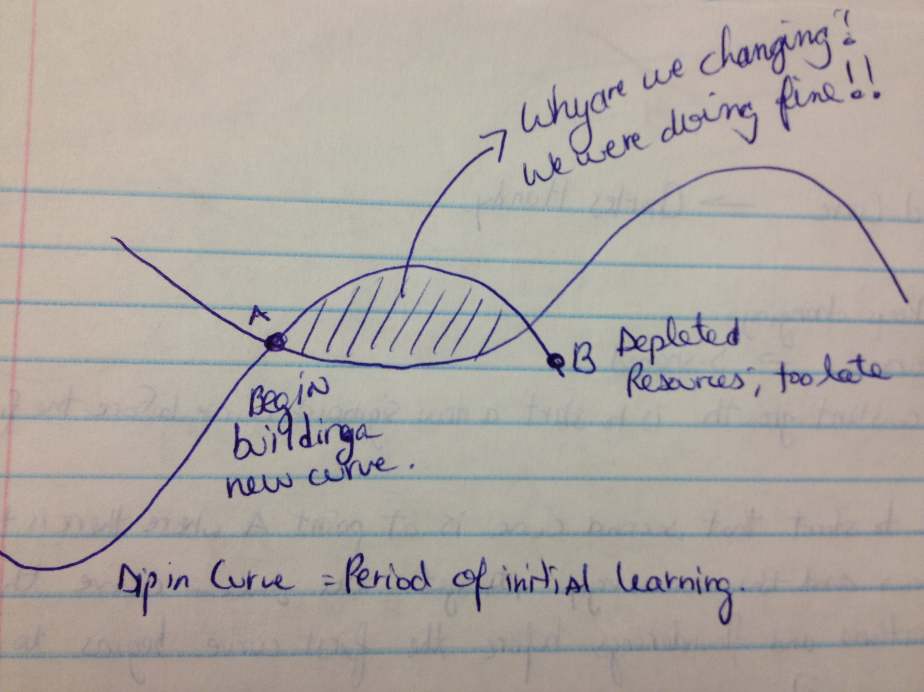
Mintzberg

- Managing myth: simply plan, organize, coordinate and control.
- Manager may not know everything but typically knows more than subordinates do.
- Reality: Mangers have interpersonal, informational & decisional roles.
- Interpersonal Roles: (Categories)
  - Figurehead = manger does meet and greet, holds meetings, gives awards
  - Leader = they are responsible for the work of the people of their unit and act as a leader ex: fix peoples individual problems, motivate employees
  - Liaison = talks to other managers which is done to connect with others to always have each other’s help.
- Informational Roles:
  - Monitor = gets info, inside scoop, what is happening
  - Disseminator = pass information to subordinates
  - Spokesperson = represents company outside. Means speaks to people from different companies about their company.
- Decisional Roles:
  - Entrepreneur: can start a project with all information with no levels of approval.
  - Disturbance: take care of unforeseen issues.
  - Resource allocator: distribute capital within company.
  - Negotiator: negotiate issues
- A manager must do all roles. They cannot be split.

French & Raven (Social Power)

- Reward Power, based on P’s perception that O has the ability to mediate rewards for him. Offer rewards to worker.
- Coercive Power, based on P’s perception that O has the ability to mediate punishments on him. Deliver punishment: Ability to fire.
- Legitimate Power, based on P’s perception that O has a legitimate right to prescribe behavior for him. O has the right to influence P: P must accept influence.
- Referent Power, based on P’s identification with O. P’s behavior is related to O.
- Expert Power, based on P’s perception that O has some special knowledge or expertise.

Liker & Choi


