- Javier (Office hours: Tuesday 3:30-5pm DMS 2127) jfiallos@uottawa.ca

- Chapter 1

- 1.
- (1 – radio, 2 – TV, 3 – newspaper, 4 – direct mail, 5 – email)

- Z = 7000x1 + 50,000x2 + 18,000x3 + 34,000x4 + 90,000x5

- Decision Variables:
  - x1 Radio
  - x2 TV
  - x3 Newspaper
  - x4 Direct Mail
  - x5 Email

- 3.
- Price is $24.95
- Labour and Supply $10 per tune up
- Operation is $5000 a month

- a) The monthly volume to break even.
  - Q bep = (Fixed Cost) / ([Revenue/per unit] – [Variable cost/ Per Unit])
    - = (F/[R – V])
    - = (5000/[24.95 – 10])
    - = 5000/14.95
    - = 334.45
    - 335 tune ups
- b) The profit if 375 tune ups are performed
  - Profit = [(Revenue / Per Unit) * (Quantity)] – [Fixed Cost + (Cost Variable/Per Unit) * (Quantity)]
    - = [(375 * 24.95) – (5000 + ((375 * 10)/3750))]
    - = $ 606.25 is the profit
- c)The monthly volume to break even (if tune up goes up to $15)
  - Q bep = (Fixed Cost) / ([Revenue/per unit] – [Variable cost/ Per Unit])
    - = (F/[R – V])
    - = (5000/[24.95 – 15])
    - = (5000/9.95)
    - = 502.51
    - 503 tune ups
- d) The break even monthly profit (15$) selling price goes up 5%.
  - Q bep = (Fixed Cost) / ([Revenue/per unit] – [Variable cost/ Per Unit])
    - = (F/[R – V])
    - = (5000/[24.95(1 + 5%) – 15])
    - = (5000/11.20)
    - = 446.43
    - 447 tune ups
  - Total Costs =[Fixed Cost + (Cost Variable/Per Unit) * (Quantity)]
    - = (5000 + (15 * 375))
    - = $10625
  - Profit
    - = (375 * (24.95(1 + %5)) – (5000 – (375 * 15)))
    - = $ - 800.94

- 4.
- $1 per bottle
- Retail = $ 2.19
- Fixed Cost = $3000

a) Total Cost, Revenue, and Profit (or Loss)
  - Total Revenue = (R/Per Unit) * Q
    - = (2.19 * 10,000)
    - = ($21900)
  - Total Cost = (F + (Variable Cost/Per Unit)*Q)
    - = (3000 + $1 * 10000)
    - = $13,000
  - Total Profit
    - = $21900 - $13000
    - = $8900

- 14.
- Each novel sold $45
- Fixed Cost = $65,000
- Production Cost = $8.50

- a) Q bep = (F/(R – V))
  - = (65000/(45 – 8.50))
  - = 65000/36.5
  - = 1780.82
  - = 1781 Copies

- b) Profit (or Loss), with demand 3500
  - Profit = (Revenue * Q – (Fixed cost +variable cost)
    - = 45 * 3500 – (65000 + 8.50*3500)
    - = $62750 Profit

- c) 3500 copies, minimum price
  - Break Even Volume: Q bep = (F/(R – V)) = 3500
    - (65000/(Price per copy – 8.5)) = (3500/1)
    - 65000 = 3500 * (price per copy – 8.5)
    - Price per copy = $27.08

- Chapter 2

- 1.
- Wood table, Chairs, Bookcases
- 60 hrs labour
- 16 hrs machine time
- 400 board feet of wood

  - x1: quantity of tables
  - x2: quantity of chairs
  - x3: quantity of bookcases

subject to:

Labour
    - 2x1 + 1x2 + 2.5x3 < 60hrs

Machine
    - 0.8x1 + 0.6x2 + 1.0x3 < 16hrs

Wood
    - 30x1 + 20x2 + 30x3 < 400 board feet

Tables
    - x1 > 10 tables
  - x1, x2, x3 > 0

- a) Main purpose is to determine the quantities of tables, chairs & bookcases to maximize the profit.

- b) Decision variables are quantity of tables, chairs, and bookcases

- c) Labour hours, machine hours & wood

- d) 2.5 is the number of hours to make a bookcase

- e) Company must produce at least 10 tables (x1 > 10)

- f) max 40x1 + 30x2 + 45x3
  - The amount of profit that will be realized from tables

- 3.
Chocolate bar 3.5 ounces: Cost = $0.22 Sell = $0.35
- Chocolate bar 6 ounces: Cost = $0.40 Sell = $0.55
- Total bar chocolate 15000

- a)
- The quantity of 3.5 ounce bar chocolate: x1
- The quantity of 6 ounce bar chocolate : x2

- b)
- Constraints are:
  - Chocolate supply, minimum quantity to produce for both bars
    - Profit 3.5: 0.35 – 0.22 = 0.13
    - Profit 6: 0.55 – 0.40 = 0.15
- c)
- Max 0.13x1 + 0.15x2
- Subject to :

3.5x1 + 6x2 < 15000

x1 > 1000

x2 > 1200

x1,x2 > 0

- 5.
- maximize z = 10x1 + 16x2 (profit)
- A. 8x1 + 20x2 < 120

8x1 + 20x2 = 120

x2 = 0

x1 = 120/8 = 15 (15,0)

x2 = 120/20 = 6 (0,6)
- B. 25x1 + 20x2 <200

x1 = 0

x2 = 200/20 = 10 (0,10)

x1 = 200/25 = 8 (8,0)

X1,x2 > 0
- a)

Graph the Constraints

b)

Shade in the feasible solution

c)

Test

z = 10x1 + 16x2

x1 = 0

x2 = 200/16 = 12.5 (0,12.5)

x2 = 0

x1 = 200/10 = 20 (20,0)

X2

X1

d)

Simultaneous Equation

8x1 + 20x2 = 120

25x1 + 20x2 = 200

= 17x1 = 80

x1 = 80/17 = 4.7

x2 = (120 – 8x1)/20

x2 = 4.12

The optimal value will be: (4.7,4.12)

Point | X1 | X2 | Z
(0,0) | 0 | 0 | 10(0) + 16(0) = 0
(0,6) | 0 | 6 | 10(0) + 16(6) = 96
(4.7,4.12) | 4.7 | 4.12 | 10(4.7) + 16(4.12) = 112.92
(8,0) | 15 | 0 | 10(8) + 16(0) = 80

12.

Constraints:
- 3.6x1 + 0.8x2 < 144 minutes

x1 = 0

x2 = 144/0.8 = 180

x2 = 0

x1 = 144/3.6 = 40
- 3.2x1 + 1.6x2 < 160 minutes

x1 = 0

x2 = 160/1.6 = 50

x2 = 0

x1 = 160/3.2 = 100
- 4.8x1 + 7.2x2 < 576 seconds

x1 = 0

x2 = 576/7.2 = 80

x2 = 0

x1 = 576/4.8 = 120
- x2 < 80 boxes

x2 = 80
- x1 > 20 boxes

x1 = 20
    - x1,x2 > 0

- Simultaneous Equation
- 2) 3.2x1 + 1.6x2 = 160

x1 = (160 – 1.6x2)/3.2

x1 = 15
- 3) 4.8x1 + 7.2x2 = 576

- 1.5(160 – 1.6x2) + 7.2x2 =576
- = 240 – 2.4x2 + 7.2x2 = 576
- = 4.8x2 = 336
- x2 = 70
- (15,70)

- 1) 3.6x1 + 0.8x2 = 144
- 2) 3.2x1 + 1.6x2 = 160
- x1 = 32
- x2 = 36
- (32,36)

- 1) 3.6x1 + 0.8x2 = 144
- 5) x2 = 20
- x1 = 35.5
- x2 = 20
- (33.5,20)

- Point | - X1 | - X2 | - Z
- (0,20) | - 0 | - 20 | - 0.4(0) + 0.3(20) = 6
- (0,80) | - 0 | - 80 | - 0.4(0) + 0.3(80) = 24
- (15,70) | - 15 | - 70 | - 0.4(15) + 0.3(70) = 27
- (32,36) | - 15 | - 0 | - 0.4(32) + 0.3(36) = 23.6

- They would have to produce 15 boxes of regular chips, and 70 boxes of crinkled cut chips in order to maximizes the profit which is 27.

- 17.
- minimize z = 2.40x1 + 1.50x2

subject to

Vitamin A 10x1 + 6x2 > 1200mg

Vitamin B 10x1 + 30x2 > 1800mg

x1,x2 >0

- a)
- Determine optimal solution

- x1 = 0
- x2 = 1200/6 = 200 (0,200)
- x2 = 0
- x1 = 1200/10 = 120 (120,0)

- Chapter 4

- 5.
- x1: Push type mower (number to produce)
- x2: Self propelled mower (number to produce)

- Max z = 45x1 + 70x2

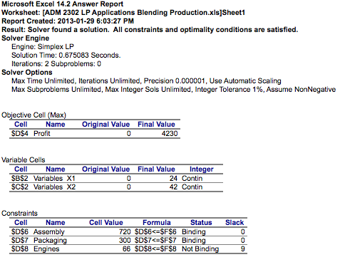

9.

xa10: litres of xa10 in the mix

xb11: litres of xb11 in the mix

xc12: litres of xc12 in the mix

min z = 0.7xa10 + 0.75xb11 + 0.82xc12

subject to

(0.87xa10 + 0.90xb11 + 0.98xc12) / (xa10 + xb11 + xc12) = 0.94

(xc12/xa10 < 3/1) xc12 – 3xa10 < 0

xa10, xb11, xc12 > 0

For Excel:

0.87xa10 + 0.90xb11 + 0.98xc12 = 0.94xa10 + 0.94xb11 + 0.94xc12
    - -0.07xa10 + -0.04xb11 + 0.04xc12 = 0
- 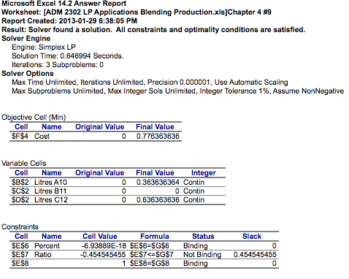

- 15.
- x1 = number of boxes to pre-package (trail mix)
- x2 = number of boxes to pre-package (subway mix)
- x3 = number of boxes to pre-package (bananas)
- x4 = number of boxes to pre-package (apricot)
- x5 = number of boxes to pre-package (coconut)
- x6 = number of boxes to pre-package (raisins)
- x7 = number of boxes to pre-package (walnuts)

- max z = 7x1 + 3x2 + 2.8x3 + 3.25x4 + 3.60x5 + 3.50x6 + 5.50x7

 | TRAIL MIX | SUBWAY Mix | Bananas | Apricots | Raisins | Walnuts

Bananas

Apricots

Coconut

Raisins

Walnuts

- Introduction to Business Decision Models
Management Science (MS) = Operations Research (OR) = Quantitative Methods = Quantitative Analysis (QA) = Decision Science = Decision Modeling

- To pass the course students must achieve a combined passing grade of 50% on the Mid-term and Final exams (i.e., MT+F must be at least 40% out of total value of 80%).

- What is Decision Modelling
  - It is the application of a scientific approach to solving management problems, in order to help managers make better decisions
  - Seeks the determination of the best (optimum) course of action of a decision problem under the restriction of limited resources

- The Decision Modelling Approach
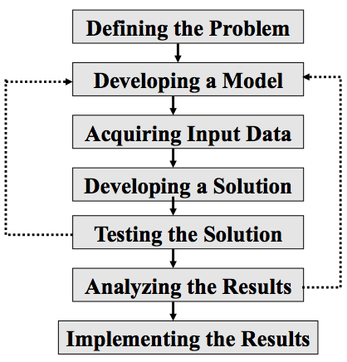 | Sensitivity Analysis:  - Sensitivity analysis is a way to predict the outcome of a decision if a situation turns out to be different compared to the key prediction

Definition of the Problem
  - Problems communicated in a vague, imprecise way
    - Perform a detailed analysis of the problem Present recommendation to management
  - Determine the appropriate objectives
    - Example: you have a manufacturing company and you want to introduce a new product in the market
    - Objective
    - Constraints

- Model Building
  - Pick out the Factors available that are important for the decision maker
    - Decision variables
    - Exogenous variables
    - Policies and Constraints
    - Criteria and Performance measures
  - Model = Set of relationships
  - If you have a decision Problem:
    - Is Decision Modeling advantageous to solve your decision problem?
    - If yes
      - Choose suitable mathematical techniques
      - Choose best parameter in such a way you can get the best solution of this method

- Decision Modelling Techniques
  - 1. Linear mathematical Programming
    - Week 1 – Week 9
      - Linear Programming Models
      - Graphical Analysis
      - Simplex Method
      - Minimization Models
      - Sensitivity Analysis
      - Transportation and Assignment
      - Integer Linear Programming
      - Binary Integer Programming
      - Goal Linear Programming
      - Deterministic Techniques
  - 2. Probabilistic Techniques
    - Week 10 & 11
      - Probability (Statistics)
      - Decision Analysis (ADM2302)
      - Game Theory
      - Markov Analysis
      - Queuing (ADM 3305)
      - Simulation (ADM 3305)
      - Forecasting (ADM3301/ADM 3307)
      - Statistical Quality Control (ADM3301)
  - 3. Inventory Techniques (ADM3301)
    - Certain demand
    - Uncertain demand
  - 4. Network Techniques
    - Week 12 & 13
      - Network Flow
      - CPM/PERT (Project Scheduling techniques)
  - 5. Other linear and nonlinear techniques
    - Dynamic Programming
    - Break-Even Analysis
    - Calculus-Based Solution Techniques

  - Decision Modeling techniques can be applied to solve problems in a variety of different types of organizations
    - Government, military, business, health care…
  - Decision Modeling consists of more than just collection of mathematical techniques.
    - Involves the philosophy of approaching a problem in a logical manner

- Frederic Taylor
  - First person to apply science to decision making

- Linear Programming (LP)

- Linear Programing
  - LP is a problem-solving approach in which we seek to maximize or minimize some objective function subject to a set of constraints that limit the degree to which the objective can be pursued.
  - LP has numerous applications
    - x + y = 20
      - Linear
    - y^2 = 50
      - Not Linear
    - t * s = 100
      - Not Linear

- Linear Programing Applications
  - Marketing
  - Media Selection (in advertising)
  - Manufacturing ( e.g. Product Mix, Production Scheduling)
  - Financial (e.g. Portfolio selection)
  - Scheduling (e.g. Assignment problems)
  - Ingredient Blending/Diet
  - Transportation/ Shipping

- Three Steps of Developing LP Problem
  - Formulation.
    - Process of translating problem scenario into simple LP model framework with set of mathematical relationships.
  - Solution.
    - Mathematical relationships resulting from formulation process are solved to identify optimal solution.
  - Interpretation and What-if Analysis.
    - Problem solver or analyst works with manager to
      - Interpret results and implications of problem solution.
      - Investigate changes in input parameters and model variables and impact on problem solution results.

- Example: A production Problem
  - Weekly supply of raw materials:
    - 8 small bricks
    - 6 large bricks
  - Products:
    - Table (Profit $20/Table) (2 large bricks & 2 small bricks)
    - Chair (Profit $15/Chair) (1 large brick & 2 small bricks)

  - 1) 3 tables & 0 chairs (feasible solution)
    - profit = $20(3) + $15(0) = $60
  - 2) 2 tables & 2 chairs (feasible solution)
    - profit = $20(2) + $15(2) = $70
  - 3) 0 tables & 4 chairs (feasible solution)
    - profit = $20(0) + $15(4) = $60
  - 4) 1 table & 3 chairs (feasible solution)
    - profit = $20(1) + $15(3) = $65
  - 5) 1 table & 4 chairs (infeasible solution)
    - profit = $20(1) + $15(4) = $80

- LP Model Formulation
  - Components of a LP Model:
  - Decision Variables
    - Mathematical symbol that represent a potential decision for the manager or the level of activities that we need to accomplish.
    - Set of activities
      - Building tables and chairs (How many should be built)
  - Objective Function
    - A linear mathematical relationship that describes the objective of the firm in terms of the decision variables. The objective function always consists of minimizing or maximizing a certain value.
    - Maximize profit
  - Model Constraints
    - A linear relationship of the decision variables, equation in function of decision variables, represent restrictions placed on the firm by the operating environment. (guidelines, resources, etc.)
    - Scarce resources
      - The Bricks
  - Model Parameters
    - A measurable quantities that usually have a known value; all the data in a problem that is known.
      - $20, $15, 6 large bricks, 8 small bricks (amount of bricks per product)

- Developing a Mathematical Model
  - Decision Variables:
    - What decisions need to be made?
    - What are the number of decisions variables?
      - Represent the decision variables symbolically
      - Example: (always write in full sentences!!)
        - C: number of chairs produced
        - T: number of tables produced
        - Z: Total profit
  - Objective Function:
    - What is the goal (objective) of the problem?
    - What is the company’s profit?
      - Write down the objective function
        - Maximize Z = $20T + $15C
  - Constraints:
    - How many resources are used for the production?
    - What resources are in short supply and/or what requirements must be met?
      - Formulate the constraints
        - Subject to: 2(T) + 1(C) < 6 (Large Bricks)
        - Subject to: 2(T) + 2(C) < 8 (Small Bricks)

- Summary of the LP Production Problem
  - Maximize Z= $ 15 C + 20 T
    - Subject to

C + 2 T ≤ 6 (Large Bricks Constraint)

2 C + 2 T ≤ 8 (Small Bricks Constraint)

C ≥ 0 , T ≥ 0 (Non-negativity Constraints)
  - C: number of chairs produced
  - T: number of tables produced

Solution to the LP Production Problem
  - Feasible solution
    - Solution that satisfies all constraints
  - Infeasible solution
    - Solution that violates at least one of the constraints
  - Optimal Solution
    - Feasible solution that results in the largest profit contribution (optimal production combination of Chairs and Tables)

- Requirements of a Linear Programming Problem
  - 1. All problems seek to maximize or minimize some quantity (the objective function)
  - 2. The presence of restrictions or constraints, limits the degree to which we can pursue our objective.
  - 3. There must be alternative courses of action to choose from
  - 4. The objective and constraints in linear programming problems must be expressed in terms of linear equations or inequalities
    - Symbols that can be used:
      - =, <, > (equal, great than/equal, less than/equal)

- Basic Assumptions of a LP Model
  - Conditions of certainty exist.
  - Proportionality in objective function and constraints (1 unit – 3 hours, 3 units 9 hours).
  - Additivity (total of all activities equals sum of individual activities).
  - Divisibility assumption that solutions need not necessarily be in whole numbers (integers).
  - Non-negativity

- Linear Programming: The Graphical Method

- The Graphical Method
  - 1. Problem description
  - 2. Formulate the problem as a linear program
  - 3. Plot the constraints
  - 4. Identify the feasible region
  - 5. Find the optimal solution
    - A. Isoprofit line solution method
    - B. Corner point solution method
  - Interpretation of the solution

- Example:
- RMC, Inc. is a firm that produces chemical based products. In a particular process three raw materials are used to produce two products. The Material requirements per ton are:

- Product Material 1 Material 2 Material 3
- Fuel additive 2/5 0 3/5
- Solvent base 1/2 1/5 3/10

- For the current production period RMC has available the following quantities of each raw material. Because of spoilage, any materials not used for current production must be discarded.

Number of Tons Material Available for Production
- Material 1 20
- Material 2 5
- Material 3 21
- If the contribution to the profit is $40 for each ton of fuel additive and $30 for each ton of solvent base, How many tons of each product should be produced in order to maximize the total contribution profit?
  - x1: number of tons of fuel additive that RMC produces
  - x2: number of tons of solvent base that RMC produces

  - Maximize Z = $ 40 x1 + 30 x2

Subject to:

2/5 x1 + 1/2 x2 ≤ 20 (Material 1)

1/5 x2 ≤ 5 (Material 2)

3/5 x1 + 3/10 x2 ≤ 21 (Material 3)

x1 ≥ 0, x2 ≥ 0

When graphing the line:

2/5 x1 + 1/2 x2 ≤ 20
      - x1 = 0 1/2x2 = 20 x2 = 40 (40,0)
      - x2 = 0 x1 = 50 (50,0)
        - Check: point (10,10)
          - (2/5)10 + (1/2)10
          - = 4 + 5
          - = 9 < 20

1/5x2 ≤ 5

3/5 x1 + 3/10 x2 ≤ 21
      - x1 = 0 3/10 x2 = 21 x2(21*10)/3 = 70 (0,70)
      - x2 = 0 3/5x1 = 21 x1 = 35 (35,0)
- 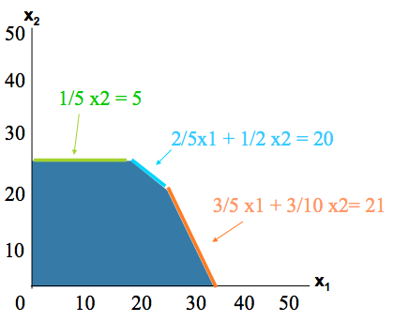
The Feasible Area
  - An overlapping area on the constraint that meats all constraint requirements. All the points in the feasible region must be with the boundary.
  - The boundaries shown in the above graph is bounding. The constraint is bounded.
  - Binding constraints is where the optimal solution lies (slack: 0)
    - Ex: Material 1 and 3
      - Non-Binding constraint is material 2 (slack: > 0)

The Optimal Solution
- The Isoprofit or Isocost Line Solution Method
  - Select value for profit or cost, and draw isoprofit / isocost line to reveal its slope
    - Z = $240
  - With a maximization problem, maintain same slope and move line up and right until it touches feasible region at one point. With minimization, move down and left until it touches only one point in feasible region.
  - Identify optimal solution as coordinates of point touched by highest possible isoprofit line or lowest possible isocost line.
  - Read optimal coordinates and compute optimal profit or cost.
- 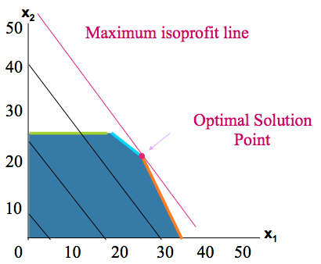

2/5 x1 + 1/2 x2 ≤ 20
    - x1 = 50 – 5/4x2

3/5[50 – 5/4x2] + 3/`0x2 = 21

30 – 3/4 x2 + 3/10x2 = 21

30 – 21 = 3/4x2 – 3/10x2

9 = (30 -12)/(40)x2

9 = 18/40x2
  - Line 1: 40x1 + 30x2 = 240
  - Line 2: 40x1 + 30x2 = 720
  - Line 3: 40x1 + 30x2 = 1200
  - Line 4: 40x1 + 30x2 = 40(25) + 30 (20)

= 1000 + 600 = 1600

(x1, x2) = (25,20)

Z = 1600
- Interpretation of the Solution
  - The solution indicates that if RMC, Inc. produces 25 tons of fuel additive and 20 tons of solvent base, it will receive $1600, the maximum profit possible given the Material constraints (resources constraints)
  - The solution tells management that the optimal solution will require all available material 1 and material 3, but only 4 of 5 tons of material 2. (the 1 ton of material 2 is referred as slack)

3/5(25) + 3/10(20) = 21 tons of material three (slack: 0)

1/5(20) = 4 tons of material two (slack: 1)

2/5(25) + 1/2(20) = 20 tons of material one (slack: 0)

- Corner Point Property
  - Very important property of Linear Programming problems:
  - Corner Point Property.
  - Property states optimal solution to LP problem will always occur at a corner point.
  - The solution point will be on the boundary of the feasible solution area and at one of the corners of the boundary where two constraint lines intersect
- 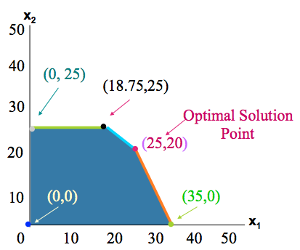
  - Corner Points from the example: (z = 40x1 + 30x2)
    - (0,25) = $750
    - (18.75,25) = $ 1500
    - (25,20) = $1600
    - (35,0) = $1400
    - (0,0) = $0

- A Minimization LP Problem
  - Many LP problems involve minimizing objective such as cost instead of maximizing profit function.
  - Examples:
    - Restaurant may wish to develop work schedule to meet staffing needs while minimizing total number of employees.
    - Manufacturer may seek to distribute its products from several factories to its many regional warehouses in such a way as to minimize total shipping costs.
    - Hospital may want to provide its patients with a daily meal plan that meets certain nutritional standards while minimizing food purchase costs.

- Example: Two Variable Minimization LP Problem
  - Holiday Meal Turkey Ranch
  - Buy two brands of feed for good, low-cost diet for turkeys.
  - Each feed may contain three nutritional ingredients (protein, vitamin, and iron).
  - One pound of Brand A contains:
    - 5 units of protein,
    - 4 units of vitamin, and
    - 0.5 units of iron.
  - One pound of Brand B contains:
    - 10 units of protein,
    - 3 units of vitamins, and
    - 0 units of iron.
  - Holiday Meal Turkey Ranch
    - Brand A feed costs ranch $0.02 per pound, while Brand B feed costs $0.03 per pound.
    - Ranch owner would like lowest-cost diet that meets minimum monthly intake requirements for each nutritional ingredient.
      - (see slides for graph examples)

- Summary of Graphical Solution Methods
  - Graph each constraint equation.
  - Identify feasible solution region, that is, area that satisfies all constraints simultaneously.
  - Select one of two following graphical solution techniques and proceed to solve problem.
    - Corner Point Method
      - Determine coordinates of each of corner points of feasible region by solving equations.
      - Compute profit or cost at each point by substitution of values of coordinates into objective function and solving for result.
      - Identify an optimal solution as a corner point with highest profit (maximization problem), or lowest cost (minimization).
    - Isoprofit or Isocost Method
      - Select value for profit or cost, and draw isoprofit / isocost line to reveal its slope.
      - With a maximization problem, maintain same slope and move line up and right until it touches feasible region at one point. With minimization, move down and left until it touches only one point in feasible region.
      - Identify optimal solution as coordinates of point touched by highest possible isoprofit line or lowest possible isocost line.
      - Read optimal coordinates and compute optimal profit or cost.

- Special Cases in LP
  - Infeasibility
    - A problem with no feasible region because of the presence of conflicting constraints
    - Consider the following 3 constraints:
      - X1 + 2X2 <= 6
      - 2X1 + X2 <= 8
      - X1 >= 7
      - 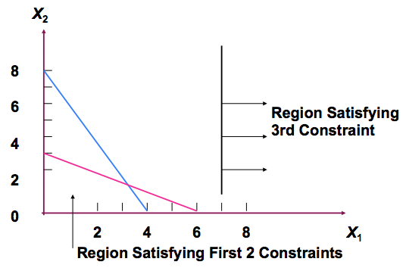
  - Unbounded Solutions (Unboundedness)
    - LP model does not have a finite solution
    - Consider the following example:
      - Max 3X1 + 5X2

Subject to
        - X1 >= 5
        - X2 <= 10
        - X1 + 2X2 >= 10
        - X1, X2 >= 0
    - 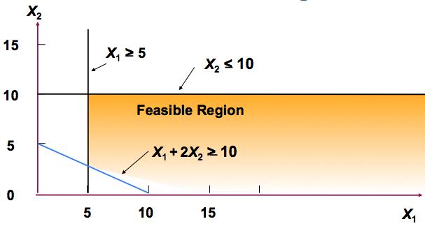
  - Redundancy
    - A redundant constraint is constraint that does not affect feasible region in any way.
    - Consider the following example:
      - Max X1 + 2X2

Subject to

X1 + X2 <= 20

2X1 + X2 <= 30

X1 <= 25

X1, X2 >= 0

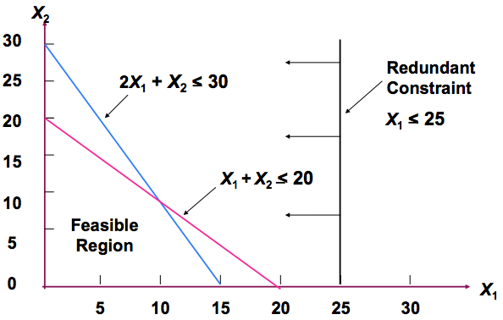
  - More Than One Optimal Solution (Alternate Optimal Solutions)
    - An LP problem may have more than one optimal solution.
      - Graphically, when the isoprofit (or isocost) line runs parallel to a constraint in problem which lies in direction in which isoprofit (or isocost) line is located.
      - In other words, when they have same slope.
    - Consider the following example:
      - Max 3X1 + 2X2

Subject to

6X1 + 4X2 <= 24 (A)

X1 <= 3

X1, X2 >= 0
3X1 + 2X2 = 8 (B)

3X1 + 2X2 = 12 (AB)

6x1 + 4x2 = 24 6(3) + 4x2 = 24

4x2 = 24 – 18

x2 = 3/2
    - 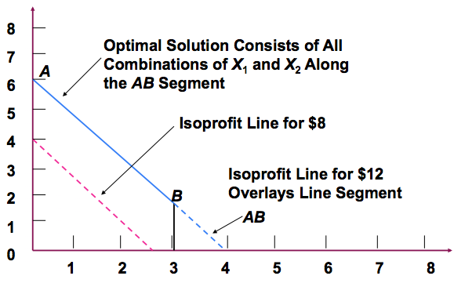

- Computer Solution

  - Max Z = $ 40 x1 + 30 x2

Subject to
    - 0.4 x1 + 0.5 x2 ≤ 20 (Material 1)
    - 0.2 x2 ≤ 5 (Material 2)
    - 0.6 x1 + 0.3 x2 ≤ 21 (Material 3)

x1 ≥ 0, x2 ≥ 0

x1: number of tons of fuel additive that RMC produces

x2: number of tons of solvent base that RMC produces

- LP: Computer Solution Using the Excel Solver
  - LP models are solved using the “Simplex” Method

- LP EXCEL and Solver Parts
  - Changing cells
    - Solver refers to decision variables as changing cells.
    - In RMC example, there are two decision variables cells B3 and C3 to represent number of tons of fuel additive to make (x1) and number of tons of solvent base to make (x2), respectively.
    - In the excel file (RMC.xsl), changing cells (decision variables) have been shaded yellow.
    - Solver will place the answers in these cells.
  - Target Cell
    - Objective function, referred to as target cell by solver,
      - = SUMPRODUCT(B5:C5,$B$3:$C$3)
      - This is equivalent to =B5*B3+C5*C3
    - In the excel file (RMC.xsl), target cell (objective function) have been shaded blue (cell D5)
  - Constraints
    - Each constraint has three parts -
      - A left hand side (LHS) part consisting of every term to left of equality or inequality sign. (shaded in pink, called the “output cells”. Refer to the equation in the cell D8:D10)
      - A right hand side (RHS) part consisting of all terms to right of equality or inequality sign (shaded in Red)
      - Equality or inequality sign.

- Entering Information in Solver
  - Invoke Solver by clicking Tools|Solver
    - Specify Target Cell (D5)
    - Specify Changing Cells (highlight B3, C3)

- Constraints
  - Specifying Constraints
    - Use "Add" constraints to enter relevant cell references for LHS and RHS.
    - Either add constraints one at a time or add blocks of constraints having same sign (<=, >=, or =) at same time.
    - Since all constraints have same <= sign one chose to highlight all LHS D8:D10 on left and F8:F10 on right with <= sign.

- Summary
  - Introduced a mathematical modeling technique called linear programming (LP).
  - LP models used to find an optimal solution to problems that have a series of constraints binding objective value.
  - Showed how models with only two decision variables can be solved graphically.
  - To solve LP models with numerous decision variables and constraints, one need a solution procedure such as Simplex algorithm.
  - Described how LP models can be set up on Excel and solved using Solver.

- Linear Problem Application

- Introduction
  - Applications exist in managerial decision making areas, such as:
    - production mix, labor scheduling, job assignment,
    - production scheduling, marketing research,
    - media selection, shipping and transportation,
    - ingredient mix, and financial portfolio selection.
  - Purpose is to show how one can use LP to modeling for decision-making in these areas.

- Financial Application
  - Portfolio Selection
    - The selection of specific investments from among a wide variety of alternatives
    - A problem encountered by managers of banks, mutual funds, investment services, insurance company…
    - Objective: to maximize expected return on investment
    - Constraints: legal, policy, risk…
    - Example (refer to “LP_Applications.doc”)

- Ingredient Blending
  - A. Diet and Feed Mix Problems
    - “Involves specifying a food or feed ingredient combination that satisfies stated nutritional requirements at a minimum cost level”
  - B. Ingredient Mix and Blending Problems
    - Decision regarding the blending of 2 or more resources to produce 1 or more products.
    - Resources contain 1 or more ingredients that must be blended so that each final product contains specific percentages of each ingredient.
    - Example (refer to “LP_Applications.doc”)
  - Min $ 0.1X_{1r} + 0.1X_{1o} + 0.15x_{2r} + 0.15 x_{2o}

Subject to

-.2 X_{1r} + 0.1 X_{2r} >= 0 (ingredient A in Regular)

0.1X_{1o} - 0.2 X_{2o} <= 0 (ingredient B in Octane)

X_{1r} + X_{2r} >= 800,000 (Demand for Regular)

X_{1o} + X_{2o} >= 500,000 (Demand for Octane)

X_{1r}, X_{2r}, X_{1o}, X_{2o} >= 0 (non negativity)
  - X_{ij} = number of gallons of crude i used to make product j
    - i = 1, 2 and j = r, o

- What-If Analysis (Sensitivity Analysis) for Linear Programming

- Introduction
  - Assumption: The parameters of the model were known with certainty
  - In Reality: the model parameters are simply estimates that are subject to change
- Example (RMC Problem)
  - RMC, Inc. is a firm that produces chemical based products. In a particular process three raw materials are used to produce two products. The Material requirements per ton are:
    - Product Material 1 Material 2 Material 3
  - Fuel additive 2/5 0 3/5
  - Solvent base 1/2 1/5 3/10
  - For the current production period RMC has available the following quantities of each raw material. Because of spoilage, any materials not used for current production must be discarded.
- Number of Tons Material Available for Production
- Material 1 20
- Material 2 5
- Material 3 21
  - If the contribution to the profit is $40 for each ton of fuel additive and $30 for each ton of solvent base, How many tons of each product should be produced in order to maximize the total contribution profit?
  - RMC Problem Formulation (refer also “RMC_problem.xsl”)

Max Z = $ 40 x1 + 30 x2

Subject to

2/5 x1 + 1/2 x2 ≤ 20

1/5 x2 ≤ 5

3/5 x1 + 3/10 x2 ≤ 21

x1 ≥ 0, x2 ≥ 0

x1: number of tons of fuel additive that RMC produces

x2: number of tons of solvent base that RMC produces

  - What_if Analysis = Sensitivity Analysis = Postoptimality Analysis = Parametric Programming = Optimality Analysis
  - The analysis of the effect of parameter changes (coefficient of the LP problem) on the optimal solution
  - Centered around “What-if question?”

- Outline
  - Changes in the Objective Functions Coefficients
  - Changes in the Right-Hand Sides (RHS) Values (changes in constraint quantity values)
    - Shadow Prices
    - Range of Feasibility
  - Simultaneous Changes in the Objective Function Coefficients
  - Simultaneous Changes in the RHS
  - Reduced cost
  - Pricing out New variables

- Changes in the Objective Function Coefficient
  - Definition:
    - c1: the objective function coefficient of x1 (c1= )
    - c2: the objective function coefficient of x2 (c2 = )
  - Purpose
    - Sensitivity analysis is performed to determine the range for cj over which the current solution remain optimal
      - This can be directly obtained from Excel’s sensitivity report
  - Graphically
    - Changes in the objective function coefficients values do not affect the size of the feasible region
  - The range of optimality
    - The range of values over which a variable’s coefficient can change without causing a change in the optimal solution (x1= 25, x2= 20) is:
      - 24 ≤ c1 ≤ 60 (refer to the Excel Sensitivity analysis report)
      - 20 ≤ c2 ≤ 50 (refer to the Excel Sensitivity analysis report)

  - What about the value of Z?
    - Zero value decision variable (unused activity)
      - The value of the objective function, Z, will not change.
    - Non Zero value decision variables
      - The value of Z, will change.

  - Question: What happen if the estimate of the unit profit of ONE of the RMC’s chemical based product is inaccurate?
  - Answer: The range of values is wide for both objective function coefficients. Thus we can still be confident that we have obtained the correct optimal solution.

- Changes in the Right-Hand Sides (RHS) Values
  - = Changes in constraints quantity values = changes in resources = changes in the managerial policy decisions
  - qi = the RHS value for constraint i
    - q1 = 20 , q2 = 5 and q3 = 21
  - Graphically
    - A change in qi usually affect the size of the feasible region and often the value of the optimal solution
- 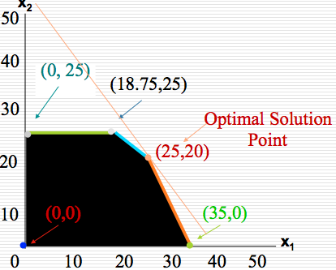
  - Shadow Price
    - The value of an additional unit of resources (e.g. an additional 1 ton of Material 1 will increase my profit by how much? Is it worth it?)
      - Shadow price of material 1 = 33.333 (if changed from 20 to 21)
      - Shadow price of material 2 = 0
      - Shadow price of material 3 = 44.44
  - How to find the value of the shadow price?
    - Increase the RHS by one in the spreadsheet, and solve
    - Look at the sensitivity report
  - Purpose
    - The effect on the optimal value if a small change were to be made in the RHS constraint (done for each constraint, one at a time).
    - We want to find the range value of qi over which the shadow prices remain valid the range over which the solution remain feasible (x1 and x2 remain different than zero, however their values may change)
  - Range of Feasibility
    - The range of values over which the value of the right hand side (qi) can vary without causing a change in the corresponding shadow price value
      - 14 <= q1 <= 21.5
      - 4 <= q2
      - 18.75 <= q3 <= 30
  - Changes in the right hand side of a binding constraint causes the value of the optimal solution to change.
  - What about changes in the right hand side of a none binding constraint?
    - The optimal solution will not change.

- Subjective Changes in the Objective Function Coefficients
  - The range of values discussed is based on the assumption that only one coefficient changes, and all the other coefficients remain the same (accurate)
  - Purpose
    - determine, without solving the problem, whether optimal solution may change if certain changes occur simultaneously in the coefficients of the objective function (given that those changes are within the corresponding range)

- 100 Percent Rule for Objective Function Coefficients
  - For all objective function coefficients that are changed, sum the percentage of the allowable increases and the allowable decreases represented by the changes. If the sum of the percentage changes does not exceed 100%, the optimal solution will not change
  - Σ (Change / Allowable change)*100 ≤ 100
  - Example (optimal solution does not change)
    - c1: 40 50 and c2: 30 35

Percentage allowable increase for c1

= (50-40)/ (allowable increase for c1) %

= (50-40)/20 (100) = 50 %

Percentage allowable increase for c2

= (35-30)/ (allowable increase for c2) %

= (5)/20 (100) = 25 %

Sum= 50% + 25% = 75% <100%
  - Example: c1: 40 25 and c2: 30 40

Percentage allowable decrease for c1

= (40-25)/ (allowable decrease for c1) %

= (15/16) (100) = 93.5 %

Percentage allowable increase for c2

= (40-30)/ (allowable increase for c2) %

= 10/20 (100) = 50 %

Sum= 93.5 % + 50% = 143.5% >100%

Since the 100% is not satisfied we must resolve the problem to determine if the optimal solution will change or not

- Simultaneous Change in the RHS
  - The 100 percent Rule:
    - For all right hand side that are changed (with their corresponding range of feasibility), sum percentages of allowable increases and allowable decreases. If the sum does not exceed 100% then the shadow prices will not change
  - Example:
    - Q1: 20 21 , 14 <= Q1 <=21.5
    - Q2: 5 4, 4 <= Q2
    - Q3: 21 24 , 18.75 <= Q3 <= 30
      - Q1: +1 (1)/1.5 * 100 = 66.67%
      - Q2: -1 (1)/1 * 100 = 100%
      - Q3: +3 (3)/9 * 100 = 33.33%
        - 200% > 100%
          - Shadow Price may or may not change.

- Reduced Cost
  - Reduced cost of an unused activity is:
    - The amount by which the profit contribution of an activity (objective function coefficient) needs to be increased before producing this activity
    - the amount by which the profit will decrease if 1 unit of this activity is forced into the solution

- Multiple Optimal Solution (assignment #3, problem 2)
  - Zero in the “final value” and reduced cost” column
  - zero in the “allowable increase” or “allowable decrease” columns of the adjustable cell table

- Pricing-out New Variables
  - Information given in sensitivity report can be used to study impact of introduction of new decision variables (products).
  - For example:
    - If problem is re-solved with a new product in model, will it be recommend that a new product be made?
    - Or, will it be recommend that a new product not be made, and continue making same products (that is, Fuel additive and solvent base)?
  - Checking validity of the shadow price using 100% rule
  - Compute the opportunity cost: marginal worth of the resources that would be diverted from existing product + cost of making the product (it is 0 in this example)
  - Opportunity cost > profit contribution
    - Do not produce the product
  - Suppose RMC, Inc. wants to produce another chemical based products ultra base (x3).
    - 0.1 ton of material 1
    - 0.1 ton of material 2
    - 0.8 ton of material 3
    - $35 for each ton

Max Z = $40x1 + 30x2 + 35x3
    - [(0.1)/6 + (0.01)/1 + (0.8)/2.25] * 100 = 47.23% < 100%
      - Conclude: Shadow prices remain valid.
    - Material 1 Shadow Price: 33.33 *(change: 0.1) = 3.33
    - Material 2 Shadow Price: 0 *(change: 0.1) = 0
    - Material 3 Shadow Price: 44.44 *(change: 0.8) = 35.55
      - = $38.88 (loss of $38.88)
      - Profit contribution: $35 < $38.88
      - CONCLUSION: Do NOT produce ultra base.

- SUMMARY – Objective Function Coefficients
  - Final Value
    - The value of the decision variables (changing cells) in the optimal solution.
  - Reduced Cost
    - Increase in the objective function value per unit increase in the value of a zero value variable (for small increases)—may be interpreted as the shadow price for the nonnegativity constraint.
  - Objective Coefficient
    - The current value of the objective coefficient.
  - Allowable Increase/Decrease
    - Defines the range of the coefficients in the objective function for which the current solution (value of the decision variables or changing cells in the optimal solution) will not change.

- SUMMARY – RHS
  - Final Value
    - The usage of the resource (or level of benefit achieved) in the optimal solution—the left-hand side of the constraint.
  - Shadow Price
    - The change in the value of the objective function per unit increase in the right-hand-side of the constraint (RHS):
∆Z = (Shadow Price)(∆RHS)
    - (Note: only valid if change is within the allowable range—see below.)
  - Constraint R.H. Side
    - The current value of the right-hand-side of the constraint.
  - Allowable Increase/Decrease
    - Defines the range of values for the RHS for which the shadow price is valid and hence for which the new objective function value can be calculated. (NOT the range for which the current solution will not change.)

- Transportation, Transshipments, and Assignment Problems

- Introduction
  - Problems belong to a special class of LP problems called Network Flow Problems
  - Can be solved using the Simplex method
  - There are specialized algorithms that are more efficient (northwest corner rule, minimum cost method, and stepping stone method, Hungarian Method)

- Transportation Model
  - Transportation of goods and services from a number of sources (supply points) to a number of destinations (demand points) at a minimum cost (objective)
  - Each source is able to supply a fixed number of units of the goods or services, and each destination has a fixed demand for the goods or services
  - Objective:
    - Most common objective of transportation problem is to schedule shipments from sources to destinations so that total production and transportation costs are minimized
  - Parameters of the model:
    - Supplies
    - Demands
    - Unit Costs
  - All the parameter of the model are included in a parameter table (summarizes the formulations of a transportation problem by giving all the unit costs, suppliers, and demands)

Example 1:
  - Wheat is harvested in the Midwest and stored in grain elevators in three different cities – Kansas City, Omaha, and Des Moines. These grain elevators supply three flour mills, located in Chicago, St. Louis, and Cincinnati. Grain is shipped to the mills in railroad cars, each car capable of holding one ton of wheat.
  - The cost of shipping one ton of wheat from each grain elevator to each mill, the demand of wheat per month for each mill, and the number of tons that each grain elevator is able to supply to the mills on a monthly basis are shown in the parameters table:
- 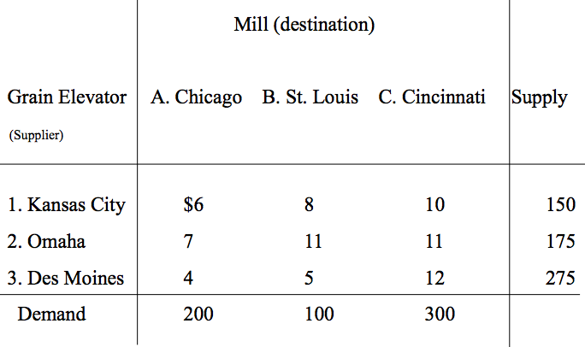
  - Determine how many tons of wheat to transport from each grain elevator to each mill on a monthly basis in order to minimize the total cost of transportation.
  - Goal:
    - Select the shipping routes and units to be shipped to minimize total transportation cost
- 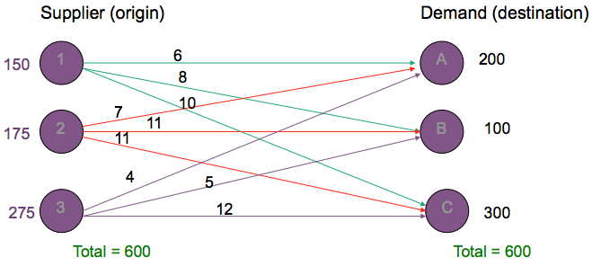
- Network Representation
  - Each supplier (s_{i},i= 1,2, …,m) and demand (d_{j}, j =1,2,…,n) point is represented by a node (circle)
  - Each possible shipping route is represented by an arc (represent the amounts shipped)
  - Direction of the flow is indicated by the arrows: Origin to Destination
  - The goods shipped from origin to destination represent flow of the network
  - Amount of the supply is written next to the origin node (s_{i})
  - Amount of the demand is written next to the destination node (d_{j})

- LP Model Formulation
- Decision Variables
  - The amount of goods or item to be transported from a numbers of origins to a number of destinations
  - Apply this definition to our Example
  - X_{ij}: The amount of tons of wheat transported from grain elevator i (where i= 1, 2, 3), to mill j (where j = A,B,C)
  - General Form:
    - X_{ij:}: number of units shipped from origin i to destination j. (where i = 1, 2,…, m and j = 1, 2, …, n)
    - The number of decision variables = numbers of arcs
- Objective Function
  - Minimize total transportation cost for all shipments
  - The sum of the individual shipping costs from each Grain Elevator to Each Mill:

min Z = $ 6x_{1A} + 8x_{1B} + 10x_{1c} + 7x_{2A}+ 11x_{2B} + 11x_{2C} + 4x_{3A} + 5x_{3B} + 12x_{3C}
- Constraints
  - Deal with the capacities at each origin (origin has a limited supply)
  - Deal with the requirements at each destinations (destination has specific demands)
  - Six constraints: One for each Elevator’s supply and one for each Mill’s demand
    - We write a constraint for each node in the network
  - Total supply is equal to total demand this is called Balanced Transportation Problem

- Subject to:

x1a + x1b + x1c = 150 (supply constraint)

x2a + x2b + x2c = 175 (supply constraint)

x3a + x3b + x3c = 275 (supply constraint)

x1a + x2a + x3a = 200 (demand constraint)

x1b + x2b + x3b = 100 (demand constraint)

x1c + x2c + x3c = 300 (demand constraint)

LP Model Formulation: Comments
  - In a balanced transportation model, supply equals demand such that all constraints are equalities (=)
  - In an unbalanced model, supply does not equal demand and one set of constraints is <=

The Optimal Solution
  - SHIP:
    - 150 tons of wheat from Kansas to Cincinnati,
    - 25 tons of wheat from Omaha to Chicago,
    - 150 tons of wheat from Omaha to Cincinnati,
    - 175 tons from Des Moines to Chicago,
    - and 100 tons of wheat Des Moines to St. Louis.
  - Total shipping cost is $4,525.
- 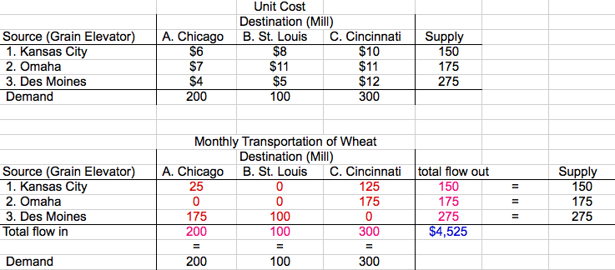

- Problem Variation
  - Total supply does not equal to total demand
  - Maximization objective function
  - Route capacities or route minimum
  - Unacceptable routes

- Total Supply not Equal to Total Demand
  - Total Supply > Total Demand:
    - “<=“ used in the supply constraints instead of “=“
    - Excess supply will appear as slack (unused supply or amount not shipped from the origin) in the LP solution
    - Example: refer to “Transportation_Promblem.xsl”
  - Total Supply < Total Demand:
    - “<=“ used in the demand constraints instead of “=“
    - Some destinations will experience a shortfall or unsatisfied demand
    - Example: Change the demand at Cincinnati to 350 tons
- 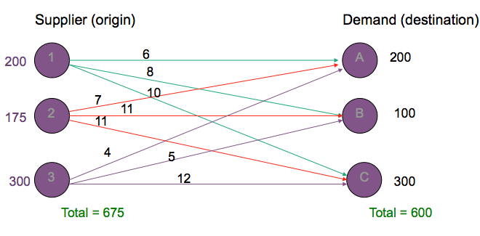
  - x1a + x1b + x1c = 200 (supply constraint)
  - x2a + x2b + x2c = 175 (supply constraint)
  - x3a + x3b + x3c = 300 (supply constraint)
  - x1a + x2a + x3a = 200 (demand constraint)
  - x1b + x2b + x3b = 100 (demand constraint)
  - x1c + x2c + x3c = 300 (demand constraint)

- Maximization Objective Function
  - Objective: Maximize total transportation profit
  - Solve as a maximization LP rather than minimization LP
  - The constraints are not affected

Route Capacities or Route Minimum
  - Constraints need to be added
    - Maximum route capacity, Lij:
      - Xij <= Lij
    - Minimum Route capacity, Mij:
      - Xij >=Mij

- Unacceptable Routes
  - Drop the corresponding arc from the network
  - Remove the corresponding variable from the linear programming formulation
  - If you want to keep the corresponding variable:
    - make the variables that correspond to unacceptable routes equal zero (Xij = 0 if the route from i to j is not possible)

- Example 2:
  - The U.S. government is auctioning off oil leases at two sites: 1 and 2. At each site, 100,000 acres of land are to be auctioned. Cliff Ewing, Blake Barnes, and Alexis Pickens are bidding for the oil. Government rules state that no bidder can receive more than 40% of the total land being auctioned.
  - Cliff has bid $1000/acre for site 1 land and $2000/acre for site 2 land.
  - Blake has bid $900/acre for site 1 land and 2200/acre for site 2 land.
  - Alexis has bid $1100 /acre for site 1 land and $1900/acre for site 2 land.
  - Draw the transportation network model that corresponds to the problem.
  - Formulate the linear programming (LP) model to maximize the government’s revenue. (Don’t forget to define the decision variables).
- 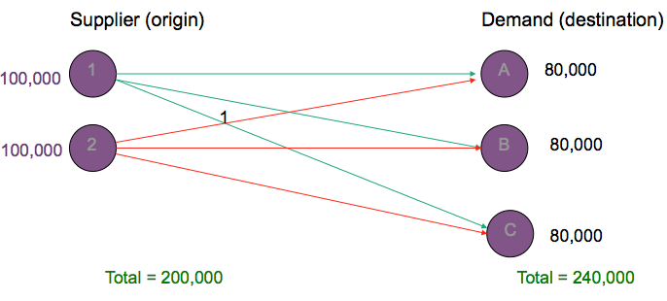

Transhipment Problems
  - Extension of transportation problem is called transshipment problem in which a point can have shipments that both arrive as well as leave.
  - Example would be a warehouse where shipments arrive from factories and then leave for retail outlets.
  - If total flow into a node is equal to total flow out from node, node represents a pure transshipment point.
    - Flow balance equation will have a zero RHS value.
  - It may be possible for firm to achieve cost savings (economies of scale) by consolidating shipments from several factories at warehouse and then sending them together to retail outlets.

- Example 3:
  - Five Star Manufacturing Company makes compressors for air conditioners. The compressors are produced in 3 plants, then shipped on to 4 heating, ventilation and air conditioning (HVAC) contractors.
  - A network model is shown on the next slide. Develop a LP model that five Star can solve to minimize the cost of shipping compressors from the plants through the warehouses and on to the HVAC contractors.
- 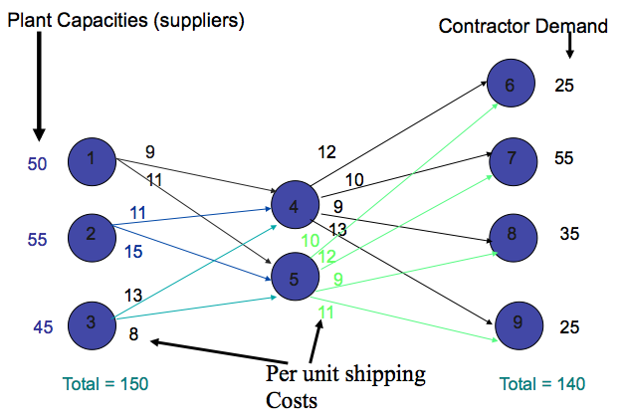
- Xij = # of compressors shipped from node I to node j

i = 1, 2, 3 (4, 5) j = (4, 5), 6, 7, 8, 9

# of arcs = number of decision variables = 14 decision variables

Min Z = 9x14 + 11x15 + 11x24 + 15x25 + 13x34 + 8x35 + 12x46 + ( 10x47 + 9x48 + 13x49) + 10x56 + 12x57 + 9x58 + 11x59
- Subject to:
  - x14 + x15 < 50 (node 1)
  - x24 + x25 < 55 (node 2)
  - x34 + x35 < 45 (node 3)
  - x14 + x24 +x34 = x46 + x47 + x48 + x49

-x14 – x24 – x34 + x46 + x47 + x48 + x49 = 0 (node 4)
  - x15 + x25 + x35 = x56 + x57 + x58 + x59

-x15 – x25 – x35 + x56 + x57 + x58 + x59 = 0 (node 5)
  - x46 + x56 = 25 (node 6)
  - x47 + x57 = 55 (node 7)
  - x48 + x58 = 35 (node 8)
  - x49 + x59 = 25 (node 9)

- Midterm:

  - Topics and Chapters from the Textbook:
    - Introduction to management science
      - Chapter 1
    - Linear programming basic concepts, formulation, applications, and solutions (graphical and computer)
      - Chapter 2, 4
    - Linear programming: sensitivity analysis and computer solution interpretation
      - Chapter 3
    - Transportation, and Transhipment
      - Chapter 5 (p 219-225, 23

- 2 hours in length
- (Potentially)
- 60 points
  - Problem: Graphical Method
  - Problem: Sensitivity Analysis
  - 2 Problems: LP Formulation
  - Problem: Multiple Choice (?) (fill in the blank, true/false, a/b/c/d, between 5-10 questions)

- Integer Programming

- Integer Programming (IP)
  - Constraints and Objective function similar to the LP model
    - Difference:
      - one or more of the decisions variables has to take on an integer value in the final solution.
- Example of IP: Harrison Electric Company
  - The Harrison Electric Company, located in Chicago’s old town area, Produces two products popular with home renovators: old-fashion Chandelier and ceiling fans. Both the chandeliers and fans require a two-step production process involving wiring and assembly.
  - It takes about 2 hours to wire each chandelier, and 3 hours to wire a ceiling fan. Final assembly of the chandeliers and fans requires 6 and 5 hours, respectively. The production capability is such that 12 hours of wiring time and 30 hours of assembly time are available. If each chandelier produced nets the firm $600 and each fan $700. Harison’s production mix decision can be formulated using LP as follows:

Maximize Profit = $ 600X1 + 700X2

Subject to

2X1 + 3X2 <= 12 (wiring hours)

6X1 + 5X2 <= 30 (assembly hours)

X1, X2 >= 0

X1 = number of chandeliers produced

X2 = number of ceiling fans produced
- 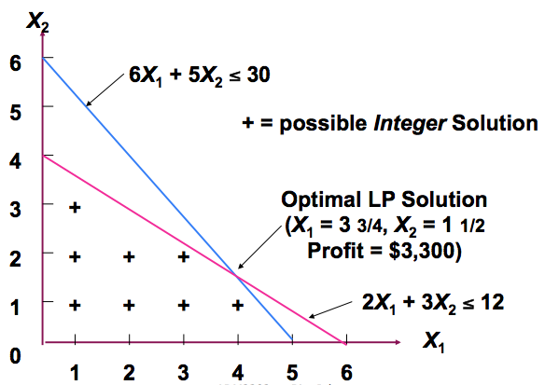
- x1 = 3.75 x2 = 1.5 z = $3,300 (round up/down, can’t have 0.5 product)
- x1 4 x2 2 (Infeasible solution)
- x1 4 x2 1 (Feasible solution)

- Comments on Reaching Integer Solution
  - Rounding off is one way to reach integer solution values, but it often does not yield the best solution.
  - Problems of Rounding:
    - An IP solution can never be better than the solution to the same LP problem. The integer problem is usually worse in terms of higher cost or lower profit.
    - Although enumeration is feasible for some small integer programming problems, it can be difficult or impossible for large ones.

- Integer Programming Techniques
  - Cutting Plane Method
    - A means of adding one or more constraints to LP problems to help produce an optimum integer solution
  - Branch and Bound Method
    - An algorithm for solving all-integer and mixed-integer LP and assignment problems. It divides the set of feasible solutions into subsets that are examined systematically.
    - Solver uses this method

- Formulating and Solving Spreadsheet Models for Integer Programming Problems
  - Similar to LP except we need to include the constraints that the decisions variables need to be integer
  - Changing Cells = integer
  - Solver Options
    - Take off the check mark from “Ignore Integer constraints”
    - Integer Optimality (%)
      - Set at 5% default value
    - Maximum Time Allowed
      - Max Time option set to 100 seconds default value
  - Refer to “BIP.xsl”

- Types of Integer Programming Problems
  - Pure Integer Programming
    - all variables must have integer solutions
  - Mixed Integer Programming
    - some, but not all variables have integer solutions
  - Binary (0-1) Integer Programming
    - all variables have values of 0 or 1
  - Mixed binary integer programming problems.
    - Some decision variables are binary, and other decision variables are either general integer or continuous valued.

- Binary Integer Programming

- Binary Integer Programming (BIP)
  - Binary Integer Programming (BIP): the model for a BIP is identical to that for a LP problem except that the non-negativity constraints for at least some of the variables are binary variables.
    - Pure PIB problem
    - Mixed PIB problem
  - Binary Variables:
    - A variable whose only possible values are 0 or 1.
      - Used when dealing with yes-or-no decisions
        - Example 2
      - OR used to help formulate the model constraints and/or objective function (do not represent a yes-or-no decision)
        - Called “auxiliary binary variable”
        - Example 3
  - Binary (zero-one) variables are defined as
- 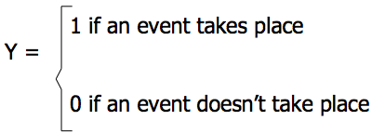

- Example 2 (Assignment)
  - The Department head of a management science department at a major Midwestern university will be scheduling faculty to teach courses during the coming autumn term. Four core courses need to be covered. The four courses are at the UG, MBA, MS, and Ph.D. levels. Four professors will be assigned to the courses, with each professor receiving one of the courses. Student evaluations of professors are available from previous terms. Based on a rating scale of 4 (excellent), 3 (very good), 2 (average), 1(fair), and 0(poor), the average student evaluations for each professor are shown:

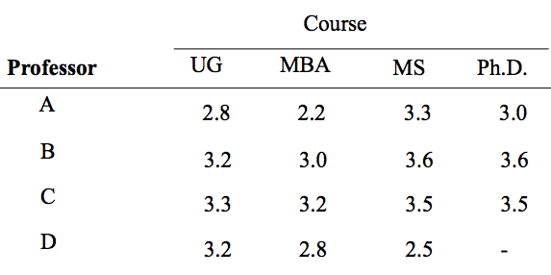
  - Professor D does not have a Ph.D. and cannot be assigned to teach the Ph.D.-level course. If the department head makes teaching assignments based on maximizing the student evaluation ratings over all four courses, what staffing assignments should be made?
    - Xij = (1 if professor i teach course j, 0 if professor i does not teach course j)
      - i = A, B, C, D
      - j = 1, 2, 3, 4 (1 – UG, 2 – MBA, 3 – MS, 4 – PhD)
    - Max Z = 2.8xa1 + 2.2xa2 + 3.3xa3 + 3.0xa4 + 3.2xb1 + 3.0xb2 + 3.6xb3 + 3.6xb4 + 3.3xc1 + 3.2xc2 +3.5 xc3 + 3.5xc4 + 3.2xd1 + 2.8xd2 + 2.5xd3 + -100xd4

Subject to:

xa1 + xa2 + xa3 + xa4 = 1 (Prof A)

xb1 + xb2 + xb3 + xb4 = 1 (Prof B)

xc1 + xc2 + xc3 + xc4 = 1 (Prof C)

xd1 + xd2 + xd3 + xd4 = 1 (Prof D)

xd4 = 0 (Prof D)

xa1 + xb1 + xc1 + xd1 = 1 (UG Course)

xa2 + xb2 + xc2 + xd2 = 1 (MBA Course)

xa3 + xb3 + xc3 + xd3 = 1 (MS Course)

xa4 + xb4 + xc4 + xd4 = 1 (PhD Course)

xij = 0 or 1 for all i = A, B, C, D, j = 1, 2, 3, 4

- Example 3
  - The Research and Development Division of the Progressive Company has been developing four possible new product lines. Management must now make a decision as to which of these four products actually will be produced and at what levels. Therefore, a management science study has been requested to find the most profitable product mix. A substantial cost is associated with beginning the production of any product, as given in the first row of the following table. Management’s objective is to find the product mix that maximizes the total profit (total net revenue minus start up costs).
- 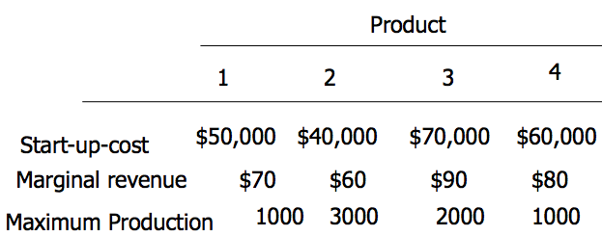
  - Let the Integer decisions variables x1, x2, x3, and x4 be the total number of units produced of products 1, 2, 3 and 4, respectively. Management has imposed the following policy constraints on these variables:
    - No more than two of the products can be produced
      - Yi = 1 if product i is produced, 0 if product i is not produced
      - Y1 + Y2 + Y3 + Y4 <= 2
      - Extension of the Mutually Exclusive Alternatives Constraints
      - Mutually exclusive constraint is a constraint requiring that the sum of two or more binary variables be less than or equal to 1. Thus if one of the variables is equal to 1 , the others must equal zero.
    - If product 3 or 4 is produced then product 1 or 2 must be produced
      - Contingent Decision (Conditional Decision) : It can be yes only if a certain other yes-or-no decision is yes.
      - Y3 <= Y1 + Y2
      - Y4 <= Y1 + Y2
      - Contingency Constraints: it involves binary variables that do not allow certain variables to equal 1 unless certain other variables are equal to 1
    - Either 5x1+3x2+6x3+4x4 <= 6,000 Or Either 4x1+6x2+3x3+5x4 <= 6,000
      - Either-or constraints are not allowed in Linear or Integer Programming
        - A pair of constraints such that either one can be chosen to be observed and then the other one would be ignored
      - Use binary variables to reformulate this model into a standard format, in order to be able to find the optimal solution.

 | 1 | 2 | 3 | 4 | Capacity
Plant 1 | 5 hrs | 3 hrs | 6 hrs | 4 hrs | 6000
Plant 2 | 4 hrs | 6 hrs | 3 hrs | 5 hrs | 6000

      - Y= 0 if 5x1+3x2+6x3+4x4 <= 6,000 must hold

Or 1 if 4x1+6x2+3x3+5x4 <= 6,000 must hold

5x1+3x2+6x3+4x4 <= 6,000 + 1,000,000Y

4x1+6x2+3x3+5x4 <= 6,000 + 1,000,000(1-Y)
    - Use binary decision variables to formulate and solve the mixed BIP model.
    - Production Cost: Setup Cost (= Startup Cost) + Variable Cost
      - Objective function

Max Z = $70x1 + 60x2 + 90x3 +80x4 -
        - We need to subtract from this expression each setup cost if the corresponding product will be produced, but we should not subtract the setup cost if the product will not be produced.
      - Y1 = 1 if x1 is produced

0 if x1 is not produced
      - Y2 = 1 if x2 is produced

0 if x2 is not produced
      - Y3 = 1 if x3 is produced

0 if x3 is not produced
      - Y4 = 1 if x4 is produced

0 if x4 is not produced
    - Objective Function for the Model:

The total Start-up Cost is:
        - $50,000Y1 + $40,000Y2 + $70,000Y3 + $60,000Y4
      - Max Z = $70x1 + $60x2 + $90x3 +$80x4 - $50,000Y1 - $40,000Y2 - $70,000Y3 - $60,000Y4

Constraints:

x1 <= 1000 Y1

x2 <= 3000 Y2

x3 <= 2000 Y3

x4 <= 1000 Y4
  - The Mixed BIP Model Summary:
    - Max Z = $70x1 + $60x2 + $90x3 +$80x4 - $50,000Y1 - $40,000Y2 - $70,000Y3 - $60,000Y4

Subject to

Y1 + Y2 + Y3 + Y4 <= 2

Y3 <= Y1 + Y2

Y 4 <= Y1 + Y2

5x1+3x2+6x3+4x4 <= 6,000 + 1,000,000Y

4x1+6x2+3x3+5x4 <= 6,000 + 1,000,00(1-Y)

x1 <= 1000Y1

x2 <= 3000Y2

x3 <= 2000Y3

x4 <= 1000Y4

x1, x2, x3, x4 >= 0 and integer; Y,Y1,Y2,Y3,Y4 = 0, 1

Summary:
  - Integer LP models have variety of applications including:
    - capital budgeting problems (individual projects are represented as binary variables)
    - facilities location problems (selecting a location is represented as a binary variable)
    - airline crew scheduling problems (assigning crew to a particular flight is represented as a binary variable)
    - knapsack problems (loading an item into a container is represented as a binary variable)

- Problem #3
  - Spencer Enterprise is attempting to choose among a series of new investment alternatives. The potential investment alternatives, the net present value of the future stream or returns, the capital requirements, and the available capital funds over the next three years are summarized as follows:
Net Capital Requirements ($)
- Present
- Alternative Value ($) Year1 Year2 Year3
- 1. Limited warehouse expansion 4,000 3,000 1,000 4,000
- 2. Extensive warehouse expansion 6,000 2,500 3,500 3,500
- 3. Test market new product 10,500 6,000 4,000 5,000
- 4. Advertising campaign 4,000 2,000 1,500 1,800
- 5. Basic research 8,000 5,000 1,000 4,000
- 6. Purchase new equipment 3,000 1,000 500 900
- Capital funds available 10,500 7,000 8,750
  - Assume that only one of the warehouse expansion projects can be implemented and suppose that, if test marketing of the new product is carried out, the advertising campaign also must be conducted and vice versa. Also, suppose that the Purchase of new equipment cannot be undertaken unless the basic research or the extensive warehouse expansion are implemented.
  - Formulate the corresponding model for maximizing the net present value subject to the restrictions stated above.
    - Yi ( 1 if investment alternative i is selected, 0 otherwise)
      - i = 1, 2, 3, 4, 5, 6

Max Z = $4000y1 + 6000y2 + 10,500y3 + 4000y4 + 8000y5 + 3000y6

Subject to:

y1 + y2 =< 1

y3 = y4 y3 – y4 = 0

y2 + y5 >= y6

3000y1 + 2500y2 + 6000y3 + 2000y4 + 5000y5 + 1000y6 =< 10,500 (year 1)

1000y1 + 3500y2 + 4000y3 + 1500y4 + 1000y5 + 500y6 =< 7000 (year 2)

4000y1 + 3500y2 + ... + 4000y6 =< 8750 (year 3)

Yi = 0 or 1

** to solve with Solver, unclick ignore integer constraints
- Goal Programming

- Goal Programming vs. Linear Programming
  - Multiple Goals (instead of one goal)
  - “Satisfices” (instead of optimize)
    - Coming as close as possible to reaching the goal
  - Objective function is the main difference
    - Deviational Variables Minimized (instead of maximizing profit or minimizing cost of LP)
  - Once the goal programming is formulated, we can solved it the same as a LP minimization problem
- Ex of Goal Programming:
  - Case presented earlier as IP problem:
  - Objective: maximize profit = $600X1 + $700X2

subject to 2X1 + 3X2 <= 12 (wiring hours)
- 6X1 + 5X2 <= 30 (assembly hours)
- X1, X2 >= 0 and integer

where

X1 = number of chandeliers produced

X2 = number of ceiling fans produced

Integer LP used to find single optimal solution (X1 = 3, X2= 2, profit=$3,200)
  - Firm to move to new location.
  - Maximizing profit not realistic goal during move horizon.
  - Management sets $3,000 profit level as satisfactory during adjustment period.
    - It is a goal Programming problem in which we want to find the production mix that achieves this goal as closely as possible given the production time constraints.

- Goal Programming Model Formulation
  - Define two deviational variables:
    - d₁⁻: underachievement of the profit target
    - d₁⁺ : overachievement of the profit target
  - Min. under-or-overachievement of Z = d₁⁻ + d₁⁺

Subject to

$600X1 + $700X2 + d₁⁻ - d₁⁺ = $3,000 (profit goal)

2X1 + 3X2 <= 12 (wiring hours)

6X1 + 5X2 <= 30 (assembly hours)

X1, X2, d₁⁻, d₁⁺ >= 0

600(3) + 700(2) + d₁⁻ - d₁⁺ = 3000

d₁⁺ = 200
- Comments on the GP Model
  - First constraint -
    - $600X1 + $700X2 + d₁⁻ - d₁⁺ = $3,000
  - Constraint contains over-achievement and under-achievement variables with respect to $3,000 revised target.
  - In event target exceeds $3,000, over-achievement variable will state amount over the target.
  - In event target not met, under-achievement variable will state amount under the target.
  - In event target amount achieved, the under- and over-achievement variables will equal zero.
- If Harrison’s management was only concerned with underachievement of the target goal, how would the objective function change?
  - d₁⁺ eliminated from the objective function

Min. underachievement of Z = d₁⁻
  - Overachievement acceptable the appropriate variable d_{i}⁺ can be eliminated from the objective function.
  - Underachievement acceptable the d_{i}⁻ variable should be dropped.
  - Seek to attain a goal exactly both d_{i}⁻ and d_{i}⁺ must appear in the objective function.

- Extension to Equally Important Multiple Goals
  - Goal 1: to produce as much profit above $3,000 as possible during the production period.
  - Goal 2: to fully utilize the available wiring department.
  - Goal 3: to avoid overtime in assembly department.
  - Goal 4: to meet a contract requirement to produce at least seven ceiling fans
- Definition of the Deviation Variables
  - d₁⁻: underachievement of the profit target
  - d₁⁺ : overachievement of the profit target
    - $600X1 + $700X2 + d₁⁻ - d₁⁺ = $3,000 (profit goal)
  - d₂⁻: idle time in the wiring department
  - d₂⁺ :overtime in the wiring department
    - 2X1 + 3X2 + d₂⁻ - d₂⁺= 12 (wiring hours)
  - d₃⁻: idle time in the assembly department
  - d₃⁺ :overtime in the assembly department
    - 6X1 + 5X2 + d₃⁻ - d₃⁺= 30 (assembly hours)
  - d₄⁻: underachievement of the ceiling fan goal
  - d₄⁺ :overachievement in the ceiling fan goal
    - X2 + d₄⁻ - d₄⁺ = 7
  - Min. total deviation Z = d₁⁻ + d₂⁻ + d₃⁺ + d₄⁻

- Ranking/Weighing Goals
  - A key idea in goal programming is that one goal is more important than another.
    - Priorities or weights are assigned to each deviational variable (e.g. P₁ is most important goal, P₂ the next most important, then P₃, and so on.)
  - Example: let’s say Harrison Electric sets the priorities shown in the following table:
- Ranking

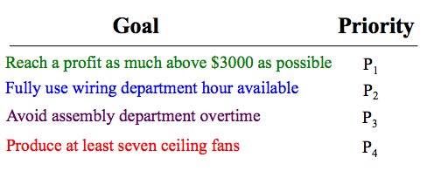
  - Objective function becomes:

Min. total deviation = P₁d₁⁻ + P₂d₂⁻ + P₃d₃⁺ + P₄d₄⁻
  - The constraints remain identical to the previous ones.
  - P1, P2, P3, P4 are NOT decision variables

- Weighted
- 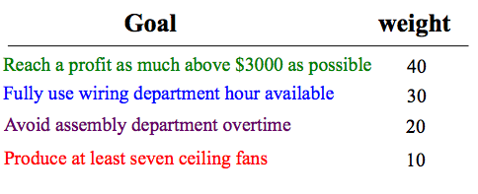
  - Objective function becomes:

Min. total deviation = 40d₁⁻ + 30d₂⁻ + 20d₃⁺ + 10d₄⁻
  - The constraints remain identical to the previous ones.

- Solving the Goal Programming Problem
  - Solve multiple goal program using
    - weighted goals approach
      - Weights can be used to distinguish between different goals (refer to the excel file)
      - The problem reduces to a simple LP model

Or
    - prioritized goals approach
      - Requires to solve a series of LP models
        - Four LP models in the case of our example
  - Solutions with weighted goals and ranked goals can be different for the same problem.

- Example (from past Final):
  - Michelow Ski Ldt. (MSL) is planning its winter production schedule for its top-end designer winter sports equipment. MSL manufactures three product lines: snowboards, downhill skis and cross-country skis. To produce a designer snowboard requires two hours of fabrication time and six hours of finishing time. Three hours of fabrication time and five hours of finishing time are needed to produce a pair of designer downhill skis, while a pair of cross-country skis requires 3.5 hours of fabrication time a 4.5 hours of finishing time. Profit per unit for the products is $600 for a snowboard, $700 for a pair of downhill skis and $675 for a pair of cross-country skis. There are 120 hours of fabrication time available, and 300 hours of finishing time.
  - MSL has three objectives it would like to meet. First, MSL would like to achieve a profit of at least $30,000. Second, MSL would like to produce exactly 55 snowboards. Finally, MSL would like to use all of the available fabrication time.
  - Develop a goal programming model for this problem.
    - Decision Variables:
      - SB: denote the number of snowboards to produce
      - DS: denote the number of downhill skis to produce
      - CC: denote the number of cross-country skis produced
      - Let di+ and di- denote the number of units by which the ith goal is under and overachieved respectively

Min Z = d1- + d2- + d2+ + d3-

Subject to

600SB + 700DS + 675CC + d1- - d1+ = 30,000 (Goal 1)

SB + d2- - d2+ = 55 (Goal 2)

2SB + 3DS + 3.5CC + d3- - d3+ = 120 (Goal 3)

6SB + 5DS + 4.5CC <= 300 (Fabrication)

SB, DS, CC >= 0 and integer
- Decision Models

- Introduction
  - LP models were all formulated under the assumption that certainty existed.
  - Several decision making techniques are available to aid the decision maker in dealing with the type of decision situation in which there is uncertainty.

- Components of Decision Making
  - Decisions themselves
  - States of Nature: the uncontrollable events that may occur in the future
  - Payoff Table:
    - A mean of organizing and illustrating the payoffs from the different decision (alternative), given the various states of nature in a decision problem.
- 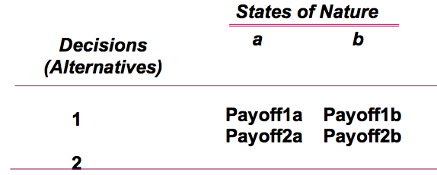

- Types of Decision Making Environments
  - Decision Making Under Certainty
    - Decision makers know with certainty the consequence of every alternative or decision choice, so they will choose the alternative that will maximize their well being, or will result in the best outcome.
  - Decision Making Under Risk (probability)
    - Decision makers know the probability of an outcome. So they attempt to maximize their expected well being, or their expected loss.
  - Decision Making Under Uncertainty (without probability)
    - Decision makers do not know the probability of various outcomes or the state of nature.

- The Six Steps in Decision Theory

1. Clearly define the problem at hand

2. List all the possible alternatives (decisions to be made)

3. Identify the possible outcomes (state of nature) of each alternative

4. List the payoff or the profit of each combination of alternatives and outcomes

5. Select one of the mathematical decision theory models (e.g. Decision Making under Risk)

6. Apply the model and make your decision
- Example:
  - An investor is going to purchase one of three types of real estate. The investor must decide among an apartment building, office building and a warehouse. The future states of nature that will determine how much profit the investor will make are good economic conditions and poor economic conditions.
  - The profits that will result from each decision in the event of each state of nature are shown in the following table.

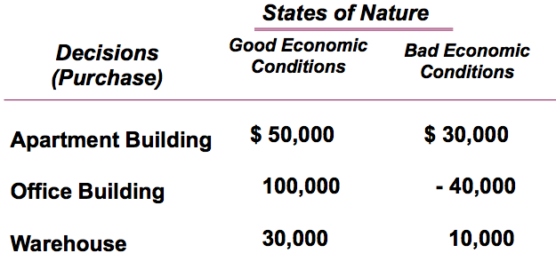

Decision Making Under Uncertainty
  - 1. MAXIMAX - find the alternative that maximizes the maximum outcome for every alternative
  - 2. MAXIMIN - find the alternative that maximizes the minimum outcomes for every alternative
  - 3. EQUALLY LIKELY- find the alternative with the highest average outcome
  - 4. MINIMAX REGRET- minimizes the maximum regret (regret is the difference between the payoff from the best decision and all the other decision payoffs)

- Optimistic Approach (MAXIMAX)
- 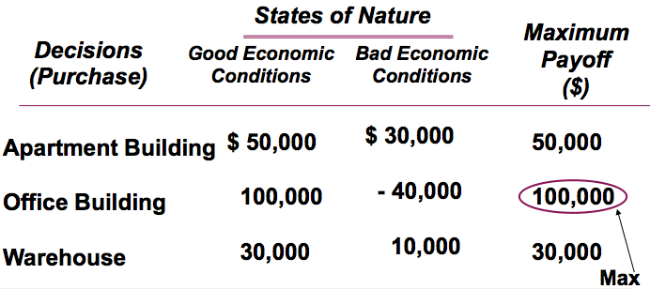
- Conservative Approach (MAXIMIN)
- 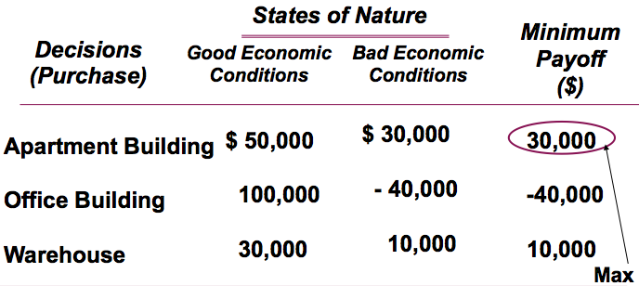
- Equally Likely Criterion (EQUALLY LIKELY)
- 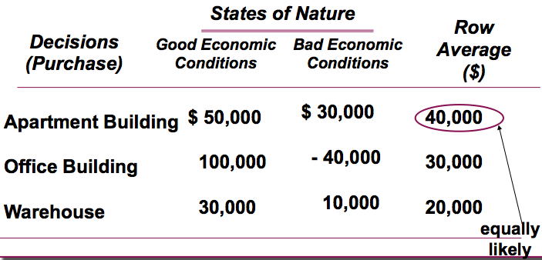
- The Minimax Regret Criterion (MINIMAX)
- 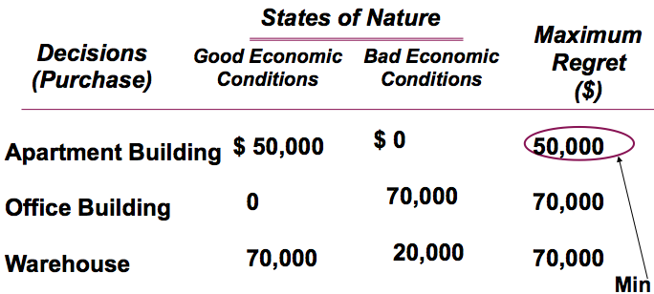
  - Construct a regret table by calculating for each state of nature the difference between each payoff and the best payoff for that state of nature.
  - Find the maximum regret for each alternative. Select the alternative with the minimum of these values
  - NEVER HAVE A NEGATIVE NUMBER in the regret table. (!!!)

- Decision Making Under Risk (probabilities assigned to the states of nature)
  - Decision Criteria
    - The Maximum Likehood Criterion
    - Expected Monetary Value (EMV) = Expected Payoff (EP)
    - The Expected Opportunity loss
  - Expected value of Perfect Information
  - Decision Maker must first estimate the probability of occurrence of each state of nature (prior probabilities)
  - Once these estimates have been made, then the decision criterion mentioned can be applied
- Example (Real estate):
  - Let us suppose that based on several economic forecasts, the investor is able to estimate 0.6 probability that good economic conditions will prevail and 0.4 probability that poor economic conditions will prevail in the future.
  - The Maximum Likehood Criterion
    - Identify the state of nature with the largest Probability.
    - Choose the decisions alternative that has the largest Payoff

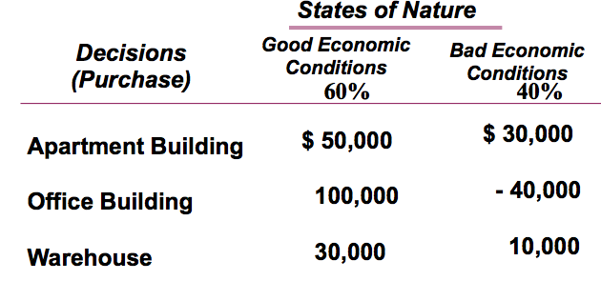

Expected Monetary Value (EMV) Criterion
  - EMV (alternative i/decision i) =
  - (outcome of first state of nature)*(its prob.) + (outcome of second state of nature)*(its prob.)+…+ (outcome of last state of nature) * (its prob.)
  - The Best decision is the one with the greatest EMV

  - EMV (Apartment) = 50000(0.6) + 30000(0.4) = 42,000
  - EMV (Office) = 100000(0.6) + -40000(0.4) = 44,000
  - EMV (Warehouse) = 30000(0.6) + 10000(0.4) = 22,000
    - Choose Office, because it has the maximum EMV.
  - The EMV means that if the decision situation of purchasing an office building occurred a large number of times, an average payoff of $44,000 would result
  - If the payoffs were in terms of costs, the best decision would be the one with the lowest EMV

- Decision Tree
  - A Graphical diagram used for making decisions. It represents the sequence of events in a decision situation.
  - What are the benefits and advantages of decision trees?
- Symbols used in decision tree:
  - :A decision node from which one of several alternatives may be selected. The branches emanating from them reflect the alternative decisions possible at that point.
  - :A state of nature node out of which one state of nature will occur. The branches emanating from them indicate the state of nature that can occur.
- The Five Steps:
  - Define the problem
  - Structure or draw the decision tree
  - Assign probabilities to the states of nature
  - Estimate the payoffs for each possible combination of alternative and state of nature Solve the problem by computing expected monetary value (EMV) for each state of nature node
  - Make your decision
- 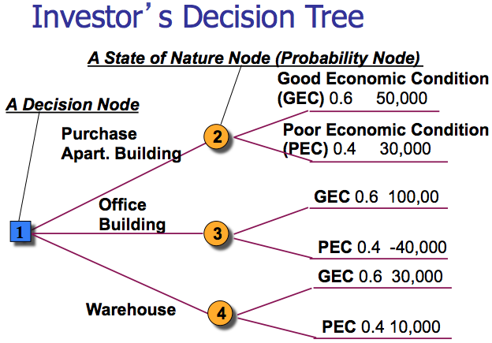

- How to Compute the EMV (Expected Monetary Value)
  - Start with the final outcomes(payoffs) and work backward through the decision tree towards node 1
  - EMV of the outcomes is computed at each probability node
    - EMV (Apartment) = (50,000)0.6 + (30,000)0.4 = 42,000

- Decision Analysis with Additional Information
  - Baye’s Theorem( Bayesian Analysis)
    - Used to incorporate additional information as it is made available
    - Help create Revised or Posterior Probabilities ==> We can take new or recent data, then revise and improve upon our old probability for an event.
  - Example: The real estate investment
    - Purchasing additional information:
      - Suppose that the investor has decided to hire a professional economic analyst who will provide additional information about future economic conditions. The analyst is constantly researching the economy, and the results of the research are what the investor will be purchasing.
      - The economic analyst will provide a report predicting one of two outcomes: positive report or negative report.
      - Based on the analyst’s past record in forecasting future economic conditions, the decision maker (the investor) can determine conditional probabilities of the different report outcomes given the occurrence of each state of nature in the future.
- 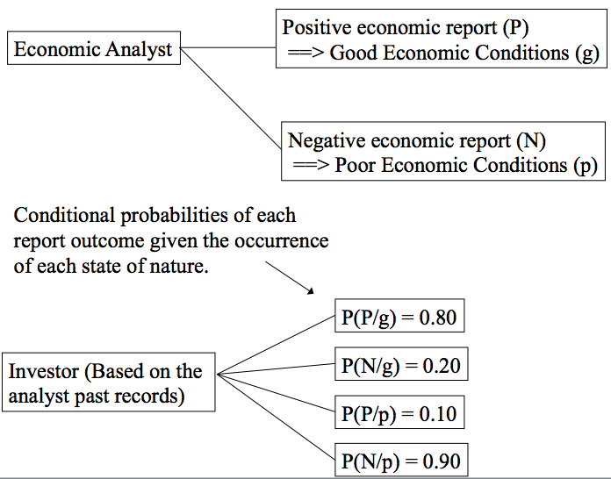
- 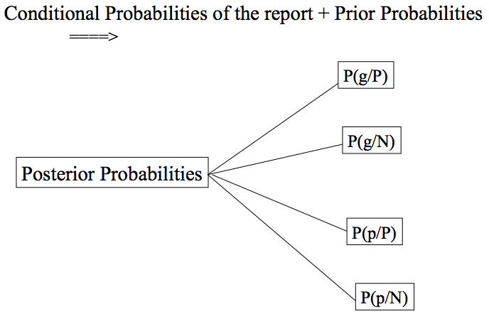
- P(g/P) + P(p/P) = 1
- P(g/N) + P(p/N) = 1

- Prior Probabilities
  - Is the estimated probabilities of the states of nature prior to obtaining additional information through a test or survey.
  - The prior probabilities that good or poor economic condition will occur in the future are:
    - P(g) = 0.60
    - P(p) = 0.40
- Posterior Probabilities
  - Given the Conditional Probabilities, the Prior Probabilities can be revised to form Posterior Probabilities by mean’s of Baye’s rule.
  - E.g. Posterior Probability of good economic conditions given a Positive report is:

P(g/P) = P(P/g) P(g) / P(P/g) P(g) + P(P/p) P(p)

= (0.8)0.6 / (0.8)(0.6) + (0.1)(0.4)

= 0.48 / 0.48 * 0.04

= 0.923

The probability of a positive economic report:
  - P(P) = P(P/g)P(g) + P(P/p)P(p)
- The probability of a negative economic report:
  - P(N) = P(N/g)P(g) + P(N/p)P(p)
- 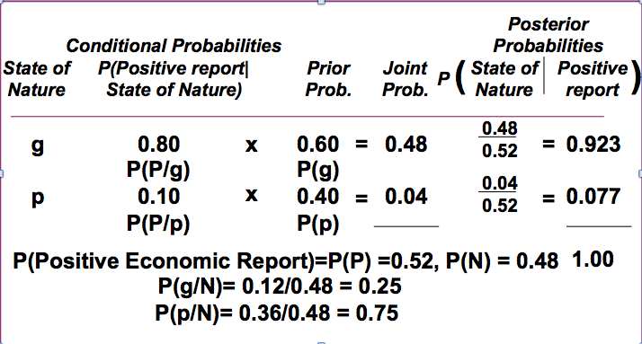
- Negative Report
- 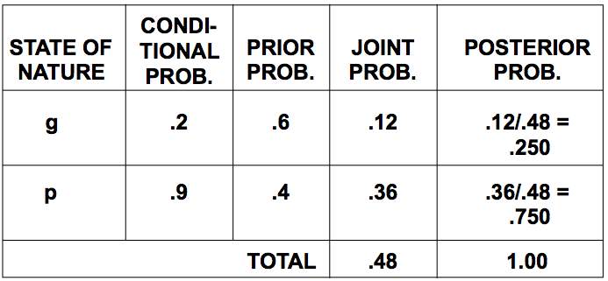

- TREE Analysis

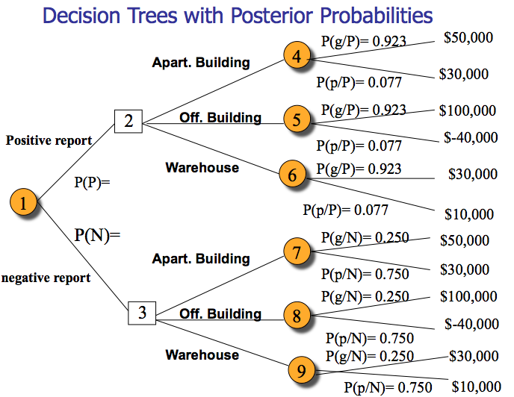
- P(P)= 0.52
- P(N)= 0.48
- EMV (Node 6) = (30,000)(0.923) + (10,000)(0.077)

= 28,460
- (Node 4) = 48,460
- (Node 5) = 89,220
- (Node 7) = 35,000
- (Node 8) = -5,000
- (Node 9) = 15,000

- Node 2 = 89,220
- Node 3 = 35,000

- EMV (Node 1) = (EMV of Hiring the consultant)

= (89,220)(0.52) + (35,000)(0.48)

= $63,194.4

Managerial Statement: Decision Strategy: Hire the analyst. If he predicts a good economic condition then invest in an office building. If he predicts poor economic condition then invest in apartment. The expected monetary value is 63,194.4.

Decision Strategy
  - A plan of decisions to be made given either a positive or negative report from economic analyst.
  - Example: the two results at node 2 and 3 are referred to as decisions strategies.
  - The Expected Monetary Value of a decision strategy given additional information(a report forecasting future economic condition generated by the economic analyst) is:
  - EMV (Decision Strategy) = $63,194.4

- The Expected Value of Sample Information (EVSI)
  - EVSI = Expected Value with information - Expected value without information
  - The investor would be willing to pay the economic analyst up to $19,194.4 for an economic report that forecasted future economic condition.
  - EVPI = $28,000 and EVSI = $19,194.4
    - Is this a logical Result?
      - Perfect information is rare, so this is a logical result.
      - We can determine how close to perfect our sample information is by computing the efficiency of sample information as follow:
        - To see how efficient the analyst is, you can divide EVSI over EVPI (19,194.4/28,000) = 0.68.
      - A high efficiency rating indicates that the information is very good, or close to being perfect information.
      - A low rating indicates that the additional information is not very good. ==> 0.68 is relatively high; thus it is doubtful that the investor would seek additional information from an alternative source.

- Project Planning, Scheduling, and Controlling

- 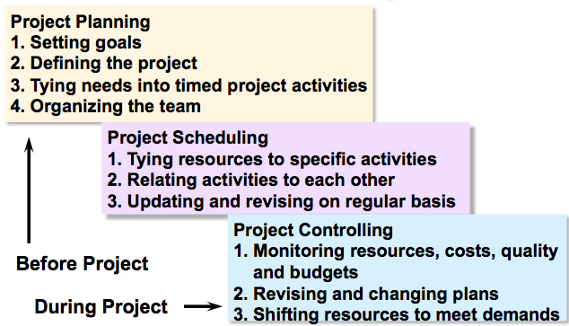

- Software Packages in Project Management
  - Managing large and complex projects has become easier due to availability of specialized project management software packages.
    - Microsoft Project (by Microsoft Corp.),
    - MacProject (by Apple Computer Corp.),
    - Microsoft Project 2000.

- Project Scheduling Techniques: CRM & PERT
  - Network Techniques
  - CPM: Critical Path Method
  - PERT: Project Evaluation and Review Technique

- CRM vs. PERT
  - Primary difference between PERT and CPM is how time needed for each activity in project is estimated.
    - CPM is a deterministic technique:
      - It estimates completion time of each activity using a single time estimate.
    - PERT is a probabilistic technique:
      - each activity has three time estimates that are combined to determine expected activity completion time and its variance
      - Allows you to find the probability that the entire project will be completed at a given date.

- Questions That May be Addressed by PERT and CPM

1. When will the project be completed?

2. What are the critical activities or tasks in the project?

3. Which are the noncritical activities?

4. What is the probability that the project will be completed by a specific date?

5. Is the project on schedule, ahead of schedule, or behind schedule?

6. Is the project over or under the budgeted amount?

7. Are there enough resources available to finish the project on time?

8. If the project must be finished in less than the scheduled amount of time, what is the best way to accomplish this at least cost?

- Six Steps Common to PERT & CPM

1. Define the project and all of its significant activities or tasks.

2. Develop relationships among the activities. Determine the intermediate predecessors (activities or tasks that must be completed before the current activities can begin).

3. Draw the network connecting all of the activities.

4. Assign time and/or cost estimates to each activity

5. Compute the longest time path through the network. This is called the critical path.

6. Use the network to help schedule, monitor, and control the project.

Example:
  - General Foundry, Inc., a metalwork plant in Milwaukee, has long been trying to avoid the expense of installing air pollution control equipment. The local environment protection group has recently given the foundry 16 weeks to install a complex air filter system on its main smokestack. General Foundry was warned that it will be forced to close unless the device is installed in the allotted period. Lester Harky, the managing partner, wants to make sure that installation of the filtering system progresses smoothly and on time.
  - When the project begins the building of the internal components for the device, and the modifications that are necessary for the floor and roof can be started. The construction of the collection stack can begin once the internal components are completed. Pouring the new concrete floor and installation of the frame can be completed as soon as the internal components are completed and the roof and floor have been modified. Once the collection stack has been constructed, the high-temperature burner can be built, and the installation of the pollution control system activity can begin. The air pollution device can be installed after the high-temperature burner has been built, the concrete floor has been poured, and the frame has been installed. Finally, after the control system, and pollution device have been installed, the system can be inspected and tested.
    - Define all project activities.
      - A) Build internal components
      - B) Modify roof and floor
      - C) Construct collection stack
      - D) Pour concrete and install frame
      - E) Build high temperature burner
      - F) Install control system
      - G) Install air pollution device
      - H) Inspection and testing
    - Determine the intermediate predecessors (activities/tasks that must be completed before the current activities can begin).
      - C) A
      - D) A,B
      - E) C
      - F) C
      - G) D, E
      - H) F,G
  - Draw the corresponding network.

- Network Fundamentals
  - Network: A graphical display of project that contains the activities and shows the precedence relationships among the activities.
  - Activity: A time consuming job or task that is a key subpart of the whole project.
    - Number of activities in project will depend:
      - On nature and scope of project.
      - On level of detail with which project manager monitors and controls project.

- Drawing Project Network
  - There are two approaches for drawing project network -- Activity on Node (AON), and Activity on Arc (AOA).
  - Although both approaches are popular in practice, many project management software packages, including Microsoft Project 2000, use AON networks.
  - Focus is on AON network:
    - The nodes of the network represent the activities.
    - The arcs (the line with arrows) represent/show the precedence relationships among the activities.

- Some Network Construction Rules
  - If activity A precedes activity B, activity A must be completed before starting activity B.
  - Each network has only one start and only one termination point.
    - If there are two activities or more that do not have any predecessors, then include a dummy activity called Start.
    - In case of two activities or more with no successors, all arrows must meet at the same Finish-of-project node. Include a dummy activity called Finish
    - Dummy activity does not really exist and takes up zero time and resources.
  - Two or more activities cannot share both the same start and end event (AOA)
    - Dummy activities may be needed in AOA networks to show all precedence relationships
- Activities on Node
- 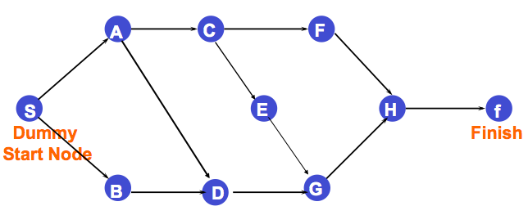
- With Times
- 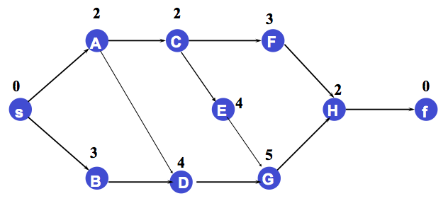
- Critical Path: s-A-C-E-G-H-f = 15 weeks

- Critical Path Method
  - Definition
    - The critical path is the longest time path route through the network.
  - To find out just how long the project will take, perform critical path analysis for network:
    - Find the Critical Path
  - How to find the Critical Path?
    - Determine: EST, EFT, LST, LFT, and slack time.

- What is EST and EFT?
  - Earliest Start Time (EST): Earliest time at which an activity can start, assuming all predecessors have been completed.
    - All predecessors activities must be completed before an activity can be started
  - Earliest Finish Time (EFT): Earliest time at which an activity can be finished.

Compute EST and EFT for each Activity
  - EF T = EST + t

= Earliest Start Time + activity time
  - EST : make a forward Pass through the network.

==>the earliest start time is the time when all the activities ending at the node have been completed

==> EST =Max{ EFT of all immediate predecessors}

Earliest Start (EST) and Earliest Finish (EFT) Times – AON

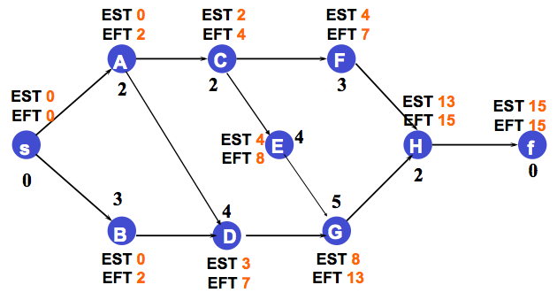

The earliest finish time of the last node/finish node in the network is the project completion time.

What is LST and LFT?
  - Latest Start Time (LST): Latest time at which an activity can start so as to not delay completion time of entire project.
  - Latest Finish Time (LFT): Latest time by which an activity has to finish so as to not delay the completion time of entire project.
- Compute LST and LFT for each Activity
  - For each activity, determine its LF value, followed by its LS value.
    - LST = LFT - t

= Latest Finish Time - activity time.
    - LFT: make a backward pass through the network (begins with last activity in project)

==> computed by making sure that the project will not be delayed for any activity
    - LFT = Min{ LST of all immediate following activities}
  - Slack = LST - EST

- Latest Start (LST) and Latest Finish (LFT) Times – AON
- 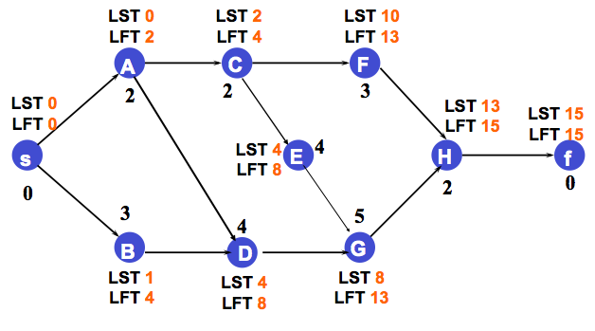

- Results of CPM: Activities Along Critical Path
- 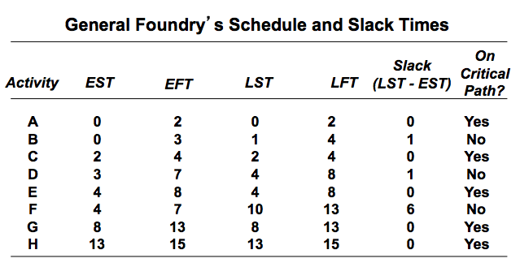
- Project Evaluation and Review Technique (PERT)
  - An alternative to CPM
  - Uses Probabilistic activities times
  - Same step as taken for the CPM Network Except:
  - on the fourth step instead of assuming a single time estimate we determine three time estimates for each activity: m, a, and b

- Three Time Estimates in PERT
  - Optimistic time (a)= time an activity will take if everything goes as planned.
  - Pessimistic time (b) = time an activity will take assuming very unfavorable conditions.
  - Most likely time (m) = most realistic estimate of time required to complete an activity.

- Expected Time and Variability
  - To find expected activity time, t, beta distribution weights three time estimates as follows:
    - t = (a + 4m + b) / 6
    - Most likely time (m) is given four times weight as optimistic time (a) and pessimistic time (b)
  - To compute dispersion or variance of activity completion time, use formula:
    - Variance = [ (b - a) / 6 ] ²
  - Standard deviation of activity completion time is square root of variance.
    - Standard deviation = √Variance = (b - a) / 6
- 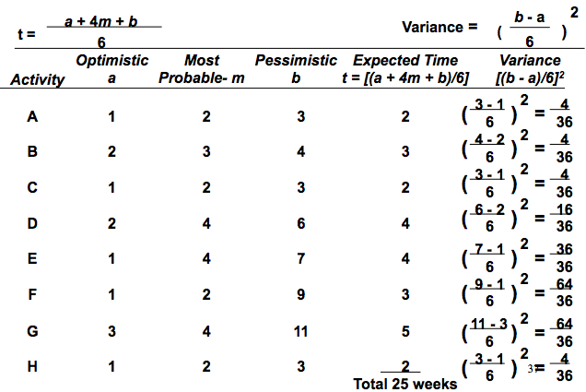

- tG = (a + 4m + b)/6 = (3 + 4(4) +11)/6 = 5 weeks
- vG = [(b – a)/6]^2 = [(11 – 3)/6]^2 = 64/36 = 1.78 week
- sG = [varG]^1/2 = (64/36)^1/2 = 8/6 = 1.33 weeks

- The Project Variance
  - PERT uses variance of critical path activities to help determine variance of overall project.
  - Project variance computed by summing variances of critical activities:
    - Project variance = S (variances of activities on critical path)
  - Variance of activities are:
  - A is 0.11, C is 0.11, E is 1.00, G is 1.78, and H is 0.11.
  - Total project variance and project standard deviation are computed as follows:
    - Project variance (s_{P}²) = 0.11 + 0.11 + 1.00 + 1.78 + 0.11 = 3.11 weeks²
  - Project standard deviation (s_{P}) = √(Project variance) = √(3.11) = 1.76 weeks

Probability and Z-scores
- 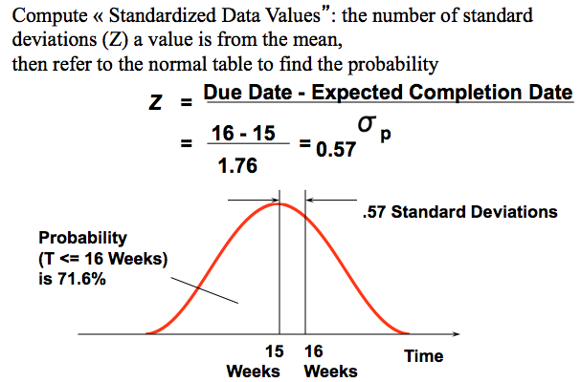
- Z = (due date - expected date of completion) / s_{P}

= (16 weeks - 15 weeks) / 1.76 weeks = 0.57
- Referring to Normal Table in Appendix page 470, there is 71.6% chance pollution control equipment can be put in place in 16 weeks or less (i.e. 0.2157+ 0.5 = 0.7157)

Determining Project Completion Time for Given Confidence Level
  - Project completion time follows normal probability distribution with mean of 15 weeks and standard deviation of 1.76 weeks.
  - Find due date deadline for 99% chance of project completion.
  - Determine Z value corresponding to 99%.
    - In Normal Table in Appendix page 470, identify a Z value of 2.33 as closest to a 0.99 probability (i.e. 0.5+0.4901).
  - Due Date = Expected completion time + Z x s_{P}
= 15 + 2.33 x 1.76 = 19.1 weeks

- Project Crashing

  - Project manager may be faced with either (or both) situations:

(1) the project is behind schedule, and/or

(2) the scheduled project completion time has been moved forward.
  - Some or all of remaining activities need to be expedited to finish project by desired due date.
  - Process to shorten duration of project in lowest cost possible is called project crashing.
  - Choose which activities to crash, and by how much to ensure:
    - Amount by which activity is crashed is permissible.
    - Shortened activity durations enable one to finish project by due date and
    - Total cost of crashing is as small as possible.

- Crashing Projects – Hand Calculations
  - Four Steps of Project Crashing

1. Compute crash cost per week for all activities in network.

If crash costs are assumed to be linear over time, following formula may be used:

Crash cost per period = (Crash cost - Normal cost)

(Normal time -Crash time)

2. Using current activity times, find critical path(s) in project network.
    - Identify the critical activities.

3. If there is only one critical path, then select activity on critical path that: (a) can still be crashed, and (b) has smallest crash cost per period.
    - Crash this activity by one period.
    - If there is more than one critical path, then select one activity from each critical path such that: (a) each selected activity can still be crashed, and (b) total crash cost per period of all selected activities is smallest.
    - Crash each activity by one period each.

4. Update all activity times.
    - If desired due date has been reached, stop.
    - If not, return to Step 2.
- 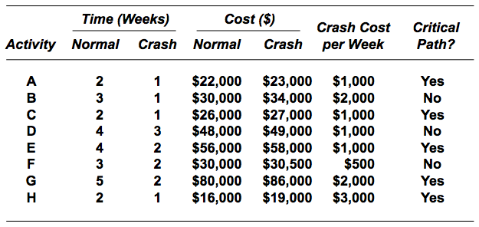

Crash project time from 15 weeks to 13 weeks

- Activity B:

3 weeks 1 week (crash by 2 weeks for a cost of 4,000)

30,000 34,000

crash cost/week = 4000/2 = 2,000

** Crash cost for B/week

= 34,000 – 30,000 / 3 – 1

= 4000/2

= 2000 per week

- A-C-E-G-H 15 Weeks (*Critical path*) 14 13
- B-D-G-H 14 Weeks 14 13
- A-D-G-H 13 Weeks 12 11
- A-C-F-H 9 Weeks 8 8

- Crash A by 1 week.

tA = 2 1 ($1000)

Crash D by 1 week.

tD = 4 3 ($1000)
- Crash E by 1 week.

tE = 4 3 ($1000)

Crash G by 1 week

tG = 5 4 weeks ($2000)

Crash and Normal Times and Costs

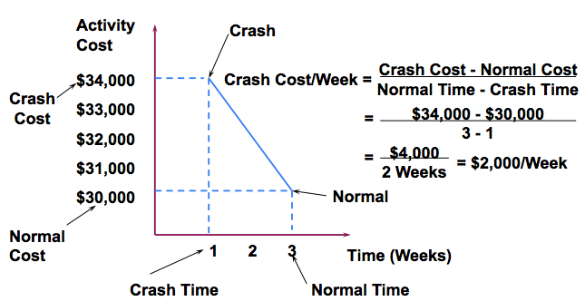

A Linear Programming Model For Crashing Decisions
  - Use Linear programming to determine which activities to crash and how much they should be crashed
  - Decision Variables

X_{fin}= the finish time of the project

Xi = the earliest start time for activity i

Yi = the amount of time activity i is crashed

i = A, B, C, D,E, F, G, H
  - Min Total Crash Cost = 1000YA + 2000YB + 1000YC + 1000YD + 1000YE + 500YF + 2000YG + 3000YH

  - Objective function
    - Minimize Crash Cost =
  - Constraints
    - Crash Time Constraints (maximum allowable crashing time for each activity)

Subject to:

YA < 1, YB < 2, YC < 1, YD < 1, YE < 2, YF < 1, YG < 3,

YH < 1

Xi = EST (Earliest Start Time) of activity i

i = A, B, C, D, E, F, G, H
  - Project Completion Constraint

X_{fin} <= 13
  - Constraints Describing the Network: Precedence Constraints. (EST of an activity)>= (EFT of the Immediate Predecessor activity)

EFT = EST + t
      - If EST the earliest start time for an activity is known, the effect of crashing a particular activity will be to reduce the t and hence EFT, the earliest finish time

Precedence Constraints

  - Duration of activity i may be reduced by Y_{i}.
  - If activity A starts the earliest at X_{A}, then the earliest finish (EFT) is at (X_{A}+2-Y_{A}).
  - Earliest start time of activity C (namely, X_{C}) can be no earlier than (X_{A}+2-Y_{A}).

X_{A} =0

X_{B} = 0

X_{C} ≥ X_{A} + 2 - Y_{A} (precedence AC)

X_{D} ≥ X_{A} + 2 – Y_{A} (precedence AD)

X_{D} ≥ X_{B} + 3 - Y_{B} (precedence BD)

X_{E} ≥ X_{C} + 2 - Y_{C} (precedence CE)

X_{F} ≥ X_{C} + 2 - Y_{C} (precedence CF)

X_{G} ≥ X_{D} + 4 - Y_{D} (precedence DG)

X_{G} ≥ X_{E} + 4 - Y_{E} (precedence EG)

X_{H} ≥ X_{F} + 3 - Y_{F} (precedence FH)

X_{H} ≥ X_{G} + 5 – Y_{G} (precedence GH)

X_{fin} ≥ X_{H} + 2 – Y_{H} (precedence HFin)

All X_{i} and Y_{i} ≥ 0 (non-negativity)

- The final covers all course materials except Graphical Method and Utility Theory.
  - You are responsible for everything discussed in class, assignments, and the assigned lab problems.
  - Topics and chapters in the textbook:
    - Linear Programming Basic Concepts, Formulation, Applications, and Solutions
      - Chapter 2 and 4
    - Linear Programming: Sensitivity Analysis and Computer Solution Interpretation
      - Chapter 3
    - Transportation, Transshipment and Assignment Problems
      - Chapter 5 (pages: 218-240)
    - Integer Programming and Binary Integer Programming
      - Chapter 6
    - Goal Programming
      - Chapter 9 (pages: 351-371)
    - Decision Analysis
      - Chapter 10 (pages: 405-442)
    - Project Scheduling: PERT/CPM
      - Chapter 8

- Office Hours
  - Office: DMS 5123, Telephone: Ext. 4776
  - E-mail: Discussion area on virtual campus
  - Thursday April 11th, 2013
    - 1:00 p.m. to 3:00 p.m.
  - Wednesday April 17th, 2013
    - 4:30 to 6:00 p.m.
  - Thursday April 18th, 2013
    - 1:00 p.m. to 3:00 p.m.
  - Friday April 19th, 2013
    - 4:30 p.m. to 6:00 p.m.
  - Monday April 22nd, 2013

10:30 to noon

