Cell Biology Lab Final
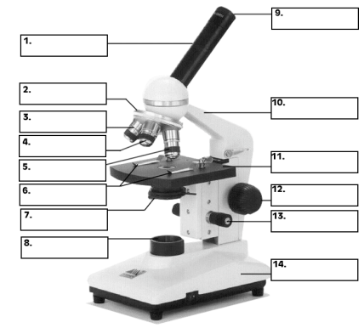
Lab #1: Introduction to microscopy

Olympus CX41
Parts of the Compound Microscope:
Revolving Nosepiece:
- Supports the various objective lenses
- Allows for simple change in magnification

Stage:
- Supports specimen
- System of knobs allows you to move the stage

Coarse Focus Knob:
- Allows for rapid change in distance between the specimen and objective (moves table)
- Rough focusing
- Do not use this knob when using objectives 40X or greater

Fine Focus Knob:
- Allows for small change in distance between the specimen and the objective
- Allows for final focusing adjustments

Ocular or Eye Piece:
- Magnifying element of microscope
- Usually 10X
- One looks through the ocular to view specimen
- Parfocal: When switching from one objective to the next, image is not lost

Objectives:
- Magnifying element closest to the specimen
- Magnification: 4X, 10X, 40X, 100X
- Numerical aperture: Determines resolving power of the objective
- Optical Tube length

Condenser:
- System of lenses that concentrates the light created from the luminator
- Do not magnify the object

Condenser Height Adjustment Knob:
- Allows one to focus the concentrated light onto the specimen

Aperture iris Diaphragm:
- Used to reduce the glare from unwanted light by adjusting angle of the cone of light that comes from the condenser
- Iris matches the numerical aperture of the condenser to the objective

*the objectives are the most important part of the microscope. All other parts are there to them produce the best image possible. The best image refers not to the largest image, but the clearest.

Working with the Compound microscope:
- Images appear upside down and reversed when looking through the microscope

- Working distance: distance between the objective and the slide
  - As magnification increases, the working distance decreases

- Depth of Field: Microscope can only focus on one depth of field. Surfaces lower or higher on the microscope will be out of focus.
  - Depth of field decreases as you increase magnification

Magnification:
Calculating Magnification: Formula
Magnification Factor = measured size of object / real size of object
Specimen Size and Magnification of the Picture:
Formula:
Real Size of object A = on-screen size of object A
Real Size of object B on-screen size of object B
First Method: Measuring an object using scale bar
Real size of object = on-screen length of object x real size of scale bar
on- screen length of scale bar
example: Larva is 60mm on screen. The scale bar on screen is 30mm, but represents 0.2mm
Real size of larva = 60mm x 0.2mm
30mm
= 0.4mm

Second Method: Measuring an object using the field of view
Real size of object = Real size of FOV x on-screen size of the object
on-screen size of FOV
** on-screen size of FOV measure FOV with ruler on computer screen

example: Snap shot using 4X, an insect has on-screen length of 10cm. The whole picture is 20cm wide.
Real size of object = 0.175cm x 10cm
20cm
= 0.0875 cm = 0.875mm
Stereoscopic (dissecting microscope) Microscope:
- This microscope is used to view objects to large or thick for the compound microscope
- Three-dimensional image
- Image is not inverted
- Provide range from 6.75X – 45X
- Zoom type lens system
- Can be used with reflected or transmitted light
  - Reflected Light is directed onto opaque specimens from above and reflected to the viewer
  - Transmitted used with translucent specimens and passes through the specimen from beneath the stage onto viewer’s eyes.

Prokaryotic and Eukaryotic Cells
Prokaryotic Cells:
- Characterized by the absence of nuclear membrane and membrane bound organelles.
- Most genetic material consists of circular DNA
- Cyanobacteria: looked at in lab
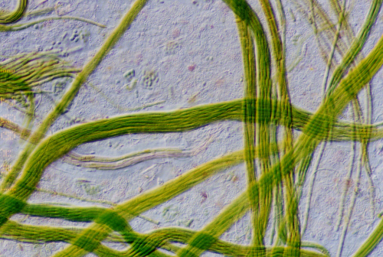

-the filaments were moving

Eukaryotic Cells:
- Membrane bound nucleus and membrane bound organelles
- Plant and animal cells
- Elodea cells: looked at in lab (showed below)
-chloroplasts=photosynthesis
-chlorophyll responsible for green pigment
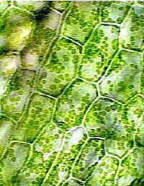

  - Plasmolysis- Contraction of protoplast of a plant cell resulting in water loss. (Shrinkage). This is accomplished by exposing the cell to a 5% NaCl solution.
  - Cyclosis -The streaming rotary motion of protoplasm within certain cells and one-celled organisms. Cytoplasmic streaming is the directed flow of cytosol (the liquid component of the cytoplasm) and organelles around large fungal and plant cells. This movement aids in the delivery of nutrients, metabolites, genetic information, and other materials to all parts of the cell.

-plasma membrane cannot be seen in plant cells because it is too thin to see under microscopes. In order to see the true limiting boundary of the cytoplasm you need to put the cells in a strong salt solution in order to withdraw the PM away from the cell wall. This will cause water to defuse out of the cell by osmosis, thereby decreasing the cell volume.
Metric System:1mm = 10^-3m = 10^-1cm = 10^3um

Lab #2- Permeability of the Red Blood Cell
Erythrocyte offers numerous advantages for the study of cell membrane permeability:
- one can obtain large quantities of homogeneous cells
- Can keep them in an isolated state for a long time
- Contain large quantities of pigment haemoglobin. When cell exceeds a certain volume the cell ruptures releasing the pigment. This is known as hemolysis
Tonicity relative concentrations of solute in the fluid inside and outside the cell
- In this experiment we examine the changes in tonicity in erythrocytes
- Hypotonic environment (solute greater outside the cell) water enters the cell and volume increases.
- Eventually the cell will reach a critical volume and undergo hemolysis
- Isosmotic Solution same osmotic pressure inside and outside the cell
  - Isosmotic solution can induce hemolysis if the solution is a penetrating substance (ex. Ethylene glycol).
  - This penetrating substance will enter the erythrocyte and change the tonicity and osmotic pressure.
  - He external environment becomes more hypotonic as the osmotic pressure inside the cell increases.
  - Water enters the cell and eventually undergoes hemolysis
- Time of hemolysis depends on the permeability of the membrane to the substrate present
- When 75% of the erythrocytes have hemolysized, the colour of the red blood cells appears to be transparent. This is what will be used to measure the time of hemolysis with erythrocytes in different substances.

A: Lab results:
Solution | Time of Hemolysis
Thiourea | 42.7 sec
Triton x-100 | < 2 sec
dd H20 | < 2 sec
Ethanol | < 2 sec
Dextrose | >1200 sec
Part B: Lab Results
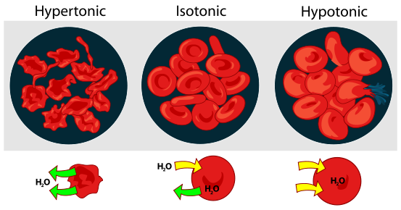
0.145M Isotonic Solution Cell shape remains the same
0.350M Hypotonic Solution Cell swells
0.065M Hypertonic Solution Cell Shrinks
Factors that affect hemolysis
- When a molecule is highly polar, the rate of hemolysis is longer because it requires the aid of transport proteins, which take part in facilitated diffusion.
- Essentially, the bigger the molecule is, the harder it is for it to penetrate the cell membrane of the red blood cell and the smaller the molecule, the easier it will be for it to penetrate the cell membrane.
Lab 3 – Cellular Processes in Amoeba Proteus
- Commonly found on the bottom of fresh water lakes and ponds, approx. 600 micrometers (0.6 mm)
- Single celled eukaryotic organism, protist, part of the Amoebozoa group
- Uses pseudopodia for moving and eating – food vacuoles digest food
- Sensitive to light and heat under a microscope
- Principal regions of cell (be able to identify)
  - Hyaline ectoplasm
  - Granular endoplasm (fluid or gelatinous)
  - Uroid
  - Hyaline cap (cytoplasm)

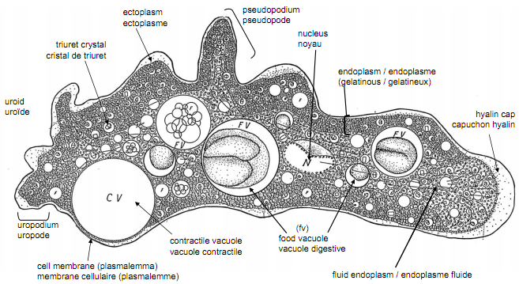

- Contractile vacuole expands and shrinks in a cycle
  - Diastole is the coalescence (merging or smaller CV’s) and continual growth
  - Systole is the release of CV contents to exterior
  - Approx. cycle is 4 to 6 minutes
- Endocytosis: process of cells absorbing/engulfing other molecules such as proteins, often cations

- Pinocytosis: cell drinking, also known as fluid endocytosis
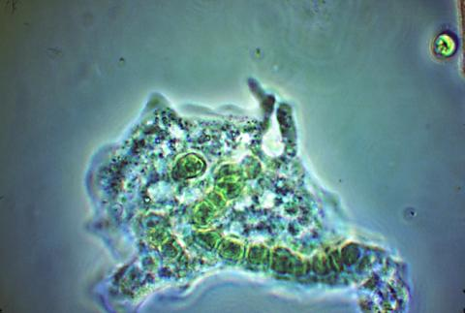
- Phagocytosis: engulfing solid matter such as bacteria or other organisms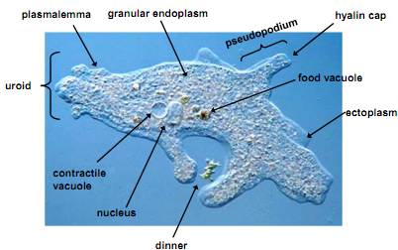

Lab #4 Mitosis
*the Fulgen stain specifically colors DNA structures magenta red. Purpose is to color nucleic acid and chromosomes so they can be seen- to measure amount of DNA present/absent.
How it works: DNA hydrolyzed in hot HCl- removes the purine bases and frees the aldehydes of deoxyribose sugar resulting in an Apurinic acid (DNA lacking purine).
Introduction to Mitosis:
- All organisms must reproduce during their lifetime.
- Single Celled organism (bacteria, protists and some fungi) rely on cell division (mitosis) to asexually reproduce.
- In other organisms, cell division (mitosis) plays an internal role in repair of worn-out cells

The Cell Cycle:
- A eukaryotic cell goes through a series of cell cycles during its lifetime.
- Cycle can range from hours (animal embryo’s or plant meristem) or years (adult bones)

Cell Cycle = M Phase (mitosis + cytokinesis) + Interphase (G1 (+/-G0) + S + G2)
Interphase (G1 (+/-G0) + S + G2):
- The phase separating the two cell divisions
- Period of growth and preparation for next M phase
- Cell spends most of its time in Interphase
- First Gap (G1):
  - Period of growth and active synthesis of all macromolecules (includes RNA’s and proteins)
  - Cytoplasmic organelles (like mitochondria, ribosome’s . . .) are duplicated
  - Length of stage varies (0.5 hours to months or years)
- Synthesis Phase (S)
  - Precise replication of all DNA
  - Synthesis of DNA associated proteins (ex histones) or microtubule associated proteins (ex. centrioles)
  - At the end of the phase each chromosome consists of 2 chromatids
  - Centromere- region that joins chromatids
  - Kinetochore- button-like structure which links chromosomes to the mitotic spindle.
  - Mitotic Spindle- lines chromosome in middle of cell (metaphase) and pulls chromosome apart (anaphase)
  - Not as variable in length (4.5 to 22 hours)
- Gap 2 (G2):
  - Protein Synthesis
  - Production of structures needed for mitosis (ex. Spindle fibres)
  - Shortest stage in Interphase (usually less than 4 hours)
- G0
  - Some cells may leave the cell cycle and enter this phase
  - May be permanent or temporary (eventually return to G1) withdrawal from cell cycle
- Most cells that stop dividing arrest in G1, instead of entering G0
- Good examples of cells that stop during Interphase are: cells of the central nervous system and muscle tissue in mammals.
- Cells stop dividing completely when their completely grown and differentiation is finished.

M Phase (mitosis + cytokinesis)- cell division
- Part of cell division which refers to nuclear division where chromosomes are equally distributed between two daughter nuclei
- Both daughter cells are identical to the parental cell
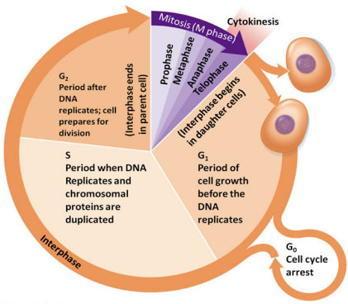
Phase of cell cycle | Description | Picture
Interphase | - Cell is between mitotic divisions  - Growth, synthesis of macromolecules  - Assembly of organelles  - DNA replication  - Clear cut nucleus  - Longest phase | 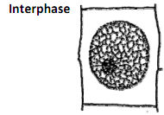
Prophase | - Chromosomes shorten and thicken  - Can be seen as 2 chromatids  - Each chromatid contains identically duplicated DNA (from interphase)  - Microtubules of cytoskeleton disassemble into tubulin subunits (these form the mitotic spindle)  - Centrosomes begin to migrate two opposite poles in animal cells (site of mitotic spindle production) | 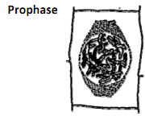
Prometaphase | - Breakdown of the nuclear membrane  - Centrosomes are found at the poles of cell  - Kinetchore forms on the centromere of each chromatid  - Kinetochore attaches to microtubules. This forces the chromosomes to migrate towards the equatorial Plate
Metaphase | - Mitotic Spindle is fully formed between poles  - Chromosomes are lined up at the equatorial plate  - Centrosomes start to separate | 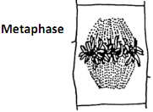
Anaphase | - Centromeres separated  - Each chromatid is now called daughter chromosome  - These move to opposite poles  - Cytokinesis begins | 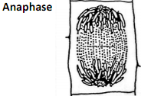
Telophase | - Chromosomes are at the poles  - Chromosomes de-condense, become longer and thinner  - Nuclear membrane reappears  - Nucleoli reform  - Spindle Dissapears  - Cytokinesis usually occurs  - Phragmoplast guides formation of new cell wall in plant cells  - Clevage Furrow pinches cell into two in animal cells | 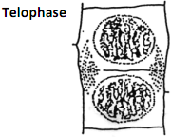

How Root Growth is accomplished:
Root Tip:
- Square cells undergoing mitosis
Root Cap:
- Around the end of the root tip
- Mass of irregular dead cells with thick walls
- Protect the apical meristem as root tip pushes through the soil
- Detects gravity and controls direction of root growth
Region of Apical Meristem:
- Directly above root cap
- Zone of cell division
Quiescent Center:
- At the base of the apical meristem
- Inactive region where cells are arrest in G1
Region of elongation:
- Above the apical meristem
- Most of the increase length of the root

Region of Maturation:
- Following the region of elongation
- Most of the cells of primary tissue mature
- Root hairs also produced in this region
Xylem Cells:
- Very narrow thick walled cells near the center
- Vascular bundle that transports water and salt from soil to rest of the plant
Phloem Cells:
- Transport carbohydrates from the photosynthetic parts of the plant to the roots.
- Roots do not have chloroplast to make their own food

Root Tip Diagram:
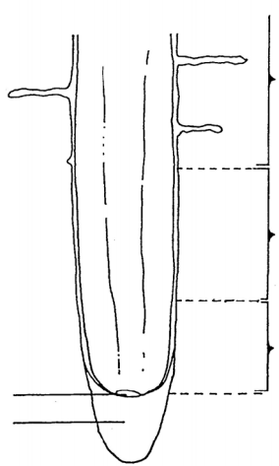
Region of maturation
Region of elongation
Region of apical meristem
Quiescent center
Root cap
Samples viewed in this lab:
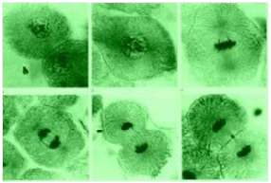
Broad Bean Squash (Vicia faba), onion root and whitefish blastula embryo
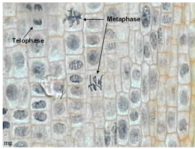

Animal Mitosis
Mitosis is similar to plant cells but there is no cell wall around the membrane and no cell plate is formed during telophase. At the end of nuclear division, the nuclear membrane simple pinches together and the cells divide.
In animal cells there is an aster which is a semi circle of fibrils around each end of the spindles.. there is no aster in plant cells.
Animal cells such as nerves, RBS’s do not divide.
White fish embryos = blastula
Onion root tip = allium cepa

Lab #5 Meiosis
- Process of nuclear reduction division; dna duplication followed by 2 divisions
  - Results in 4 non-identical daughter cells
- Each daughter cell only contains n chromosomes so that 2n is restored when paired with the other sex’s daughter cell
- Meiosis assures
  - Chromosome number is stable from generation to generation
  - Each offspring resulting from sexual reproduction will receive two entire sets of genetic instructions
  - Genetic diversity is promoted among its productions
- Plant life cycles alternate generation between diploid and haploid stages known as sporic
meiosis
  - Diploid generation (2n) meiosis haploid spores mitosis haploid generation (n) haploid gametes (n) (sperm + egg) fertilization zygote (2n) mitosis diploid generation (2n, sporophyte)
- Animals use gametic meiosis – diploid individual produces haploid gametes by gametogenesis (meiosis)
  - Diploid individual (2n) meiosis haploid gametes (n, male and female) fertilization zygote (2n) mitosis diploid organism (2n)
- Gametogenesis: when a diploid individual produces haploid gametes through meiosis

Stages of Meiosis 1
- Few differences between premeiotic Interphase and mitotic interphase
  - Premeiotic S may be up to 20 times longer than premitotic S in the same species
  - Sex chromosomes are replicated at the beginning of S – instead of DNA at the end of S in premitotic interphase
  - About 0.1 to 0.2 % of dna is not replicated until meiotic prophase
  - Nucleus grows to a greater volume than in mitotic interphase
    - Results in identical sister chromatids attached at the centromere.
- Prophase 1
  - Complex stage that can be broken in 5 sub stages
  - Longest part of meiosis, can take weeks to years depending on species
- Leptotene: initial condensation of chromosomes occurs so they appear to be fine single threads. Telomeres (tips of chromosomes) attach to nuclear membrane.
- Zygotene: lasting several hours to 3 days the maternally and paternally derived copies of each homologous pair of chromosomes line up along their length in a process called synapsis. As the chromatids between homologous chromosomes intertwine, a synaptonemal complex is formed.
- Pachytene: recombination occurs as adjacent chromatids break and join in a process called crossing over. This results in tetrads (4 chromatids). This stage last days to weeks.
- Diplotene: the separation between homologues increases so that 4 chromatids are visible. Chiasmata (region of crossing over) becomes visible. The synaptonemal complex disappears and chromosomes detach from the nuclear membrane. Extensive RNA transcription occurs in some species. The length of this stage is quite variable (up to 12 years).
- Diakinesis: RNA transcription stops, nucleoli disappear and chromosomes are ready for division.

- Metaphase 1

  - Nuclear membrane break down and paired homologues line up on equatorial plate
  - The pairing is completely random
- Anaphase 1

  - Key difference between meiosis and mitosis
  - Complete homologues are pulled away from each other to opposite poles, and not split as in mitosis
- Telophase 1

  - Chromosomes decondense, spindle breaks down, and nuclear membrane reforms
  - Resulting 2 daughter cells each have half the number of chromosomes, but each chromosome has two chromatids
- Interkinesis
  - Pause between meiosis 1 and 2, like interphase
  - Centrioles, if present, divide but do not duplicate, so that there is a single centriole found at each pole of the spindle in each daughter cell of prophase 2
- Prophase 2
  - if the nuclear membrane reformed and chromosomes decondensed in Telophase 1, the nucleoli disperse, the nuclear envelope breaks down and chromosomes recondense during this stage.
- Metaphase 2

  - Chromosomes (each has 2 chromatids) line up at metaphase plate also known as equatorial plate
- Anaphase 2
  - Sister chromatids separate and move to opposite spindle poles
  - Cytokinesis begins late in this phase
- Telophase 2

  - Chromosomes decondense, nuclear membrane forms, nucleoli reform, and cytokinesis finishes
  - The results is 4 potentially genetically different haploid cells
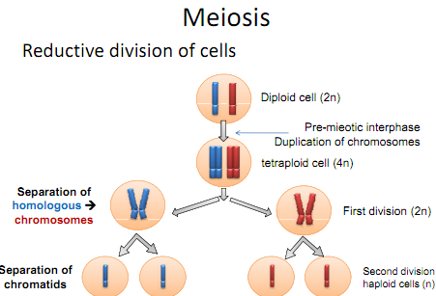
Characteristics of Mitosis versus Meiosis
Mitosis | Meiosis
Sister chromatids separate at anaphase | The first stage is a reductional division which separates homologous chromosomes at first anaphase; sister chromatids separate during anaphase 2.
One division per cycle | Two divisions per cycle
Chromosomes fail to synapse; no chiasma forms; genetic exchange between homologous chromosomes does not occur | Chromosomes synapse; chiasma forms; genetic exchange occurs between homologues
Two daughter cells produced per cycle | 4 gametes or spores produced per cycle
Genetic content in daughter cells is identical | Genetic content of products is different; chromosomes may be replicas or either maternal or paternal chromosomes or various combinations of both
Chromosome number in daughter cells is the same as mother cell | Chromosome number of meiotic products is half that of the mother
Mitotic products are usually capable of undergoing additional mitotic divisions | Meiotic products cannot undergo another meiotic division although they may undergo a mitotic division
Normally occurs in most somatic (body) cells | Occurs only in specialized cells of the germ line (sex cells)

Gametogenesis in Mammals
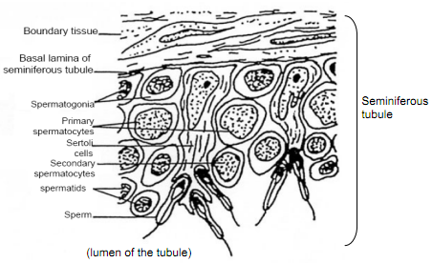
Spermatogenesis: the process by which the male germ cell undergoes division (sperm)
- Spermatogonia (2n) – These are the large darkly stained outer cells with well-defined nuclei. They divide by mitosis to produce more Spermatogonia. About half Spermatogonia undergo meiosis to become sperm while the other half undergoes mitosis to replenish the Spermatogonia.
- Primary spermatocytes (2n) – Located just below the Spermatogonia and not as darkly stained, the primary spermatocytes are larger cells undergoing the first meiotic division.
- Secondary Spermatocytes (n) – These slightly smaller cells are further toward the lumen of the tubule. They are the product of the first meiotic division. The secondary spermatocytes are difficult to observe because they rapidly undergo meiosis 2 to produce spermatids.
- Spermatids (n) – These very small circular cells will differentiate into functional spermatozoa.
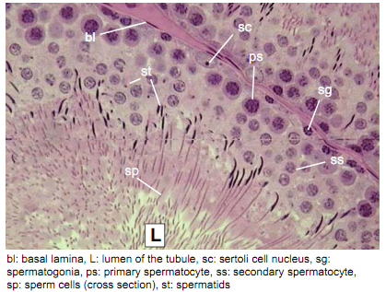
- Nurse or Sertoli cells – the large nurse cells are also found in the walls of the seminiferous tubule. These cells feed and regulate the differentiation of spermatids into mature spermatozoa.
Oogenesis: the process by which the female germ cell is created (egg cell or ovum)
- Primary Follicles – These are the numerous small round structures at the periphery of the ovary. Each primary follicle contains one oogonium (2n) filling most of the space within one layer of follicular cells.
- Growing follicles – These are larger follicles with a few layers of follicular cells. Each growing follicle contains a primary oocyte (2n) or a newly formed secondary oocyte (n) in its small fluid filled cavity.
- Graafian follicles – Most of the space of these very large follicles is occupied by a large clear fluid – filled cavity. Contains a mature oocyte (actually a secondary oocyte (n) stopped at metaphase 2) nestled in a bulge of follicular cells at the center of the follicle. 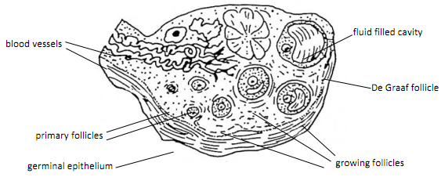
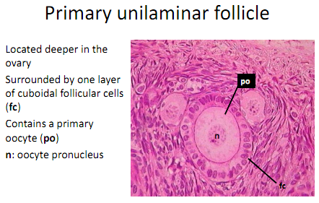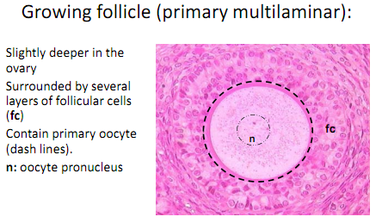
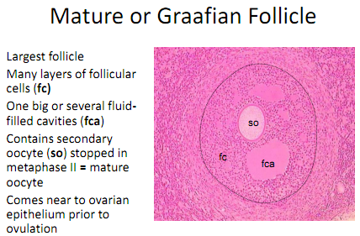
Meiosis in Plants
*Angiosperms are flowering plants
Male gametophytes formation in Lilium, for instance, occurs in a structure called anthers. Microspores are produced by a reduction division within the four microsporangia or pollen sacs of the anther. Early in differentiation of the anther, four fertile groups of cells (sporogenous cells) may be seen. There groups become surrounded by several layers of sterile cells. The innermost of these develop into cells which provide nutrition to the developing microspores (the tapetum) while the outermost layers form the wall of the microsporangium. The sporogenous cells develop into microsporocytes (microspore mother cells). These diploid cells divide by meiosis to produce four haploid, single celled microspores. The microspore then divides mitotically to form a tube cell and a generative cell (the microgametophyte). These two cells, together with the spore wall constitute a pollen grain.

Meiosis in Animals
Most things in the manual in this section are repetitive of information already in this document. There are just a few new points.
- One of the first products of the first division of meiosis is pushed out of the surface of the other as simply a nucleus without cytoplasm. The large cell is the egg; the small cell is called a polar body. In the second division the same thing happens. This one leaves one large egg and two small polar bodies which no not survive any further.
- A tetrad has 4 chromatids while a dyad has 2 chromatids
- When the sperm reaches the egg in the oviduct one penetrates each egg and meiosis begins and the egg loses its membrane and then the sperm stimulates the egg to undergo meiosis.
- The process of meiosis in fertilization provides the basis for bi-parental inheritance.. each parent contributes an equal amount of chromosome
- Genetic variation results from the phenomenon of crossing over. During prophase I of meiosis, when the homologous chromosomes are paired, crossing over may occur. At this time, the homologues are entwined around each other and pieces of a chromosome may break off and become reattached to its homologue. Thus, a chromosome which may have previously been carrying completely maternal information may now carry some paternal information.
- Ascaris is a parasitic round worm

