Lesson 2
Welcome to Canada: Introduction

This lesson introduces you to Canada, and some of the country’s basic characteristics, including its different terrestrial ecozones and its population distribution.

All of these factors have significant implications for the Canadian economy and politics. 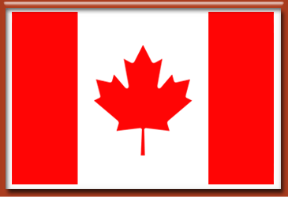

Canada's Varied Environment
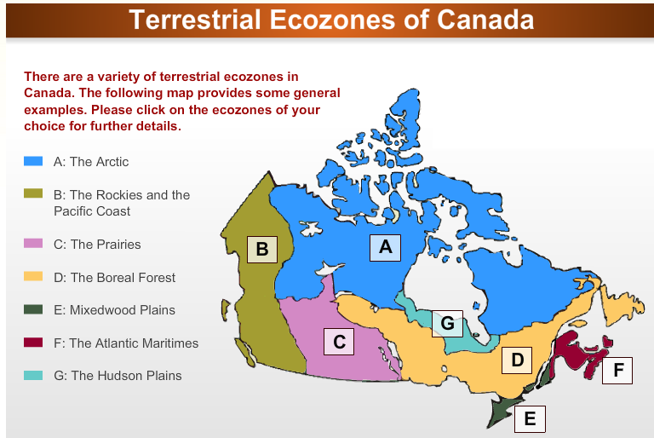• Canada’s diverse terrestrial environment has important implications. For one thing, it means that different natural resources are scattered throughout various parts of the country.
• These resources are relevant because they contribute to the creation of different economic sectors, which fluctuate in prosperity.
• This in turn contributes to the uneven distribution of wealth, which inevitably affects the nature of Canadian politics.

Canada's Economy

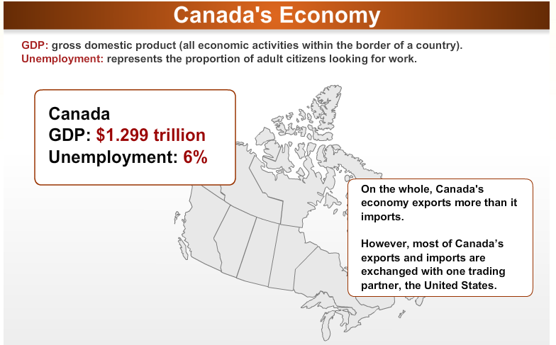
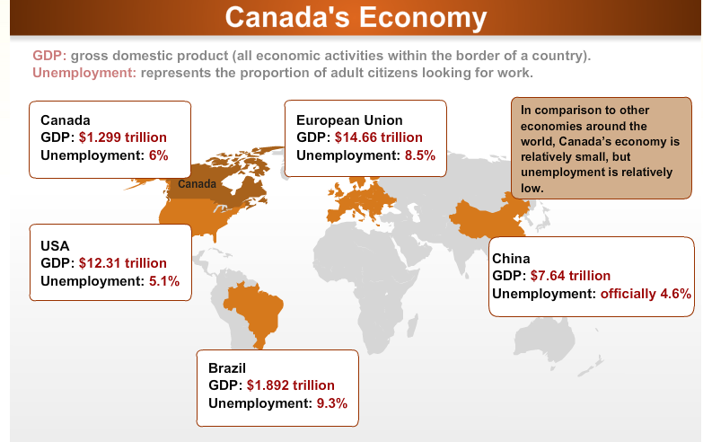
The preceding slides provided a very brief overview of some of the basic characteristics of Canada’s economy.
It is important to keep in mind, however, that economic conditions can and do vary for many different reasons, which need not always be domestic and solely related to differences in terrestrial ecozones.

It is also useful to note that the Canadian economy consists of multiple sectors, some of which contribute to GDP more than others. Also, regional economies are diversified to various degrees. For example, the primary sector of the Canadian economy currently represents about 30% of GDP, whereas at an earlier period in time, this sector used to play a bigger role.

Canada's Different Economic Sectors
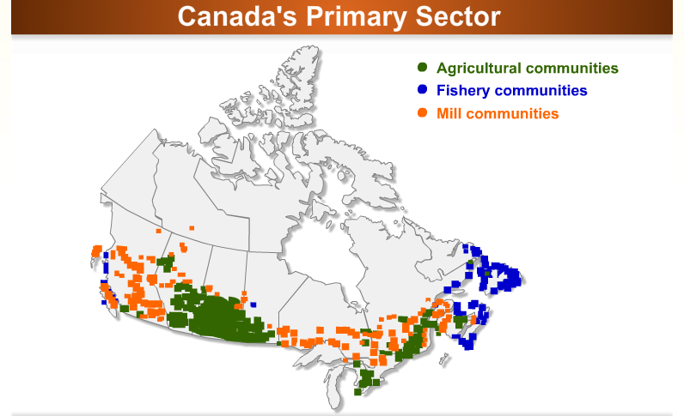• The secondary and tertiary sectors involve the transformation of natural resources and the provision of services. These two sectors represent 70% of Canada’s GDP and their significance - particularly the latter - has grown considerably over time.
• The bulk of Canada's service sector is currently located in large cosmopolitan areas in Ontario, Quebec, British Columbia and Alberta.

Canada’s Regional Economies (Cont'd)
The Quebec economy is more diverse than in Atlantic Canada and the lumber industry is one of the largest job suppliers in the northern part of Quebec. A variety of factors, however, have driven this industry into a state of crisis. Today, many mills are closing down, which means the loss of many jobs. Not surprisingly, this has become a political issue. Quebec also has large rivers that have great hydroelectric potential. Hydro-Quebéc, a Quebec Crown corporation, generates billions of dollars in revenues.
Quebec exports electricity throughout the continent’s eastern region. But because of environmental implications, each time a new hydroelectric project is considered it becomes a political issue.
The Ontario economy is also fairly diverse but concentrated heavily in the secondary and tertiary sectors of the economy.
For example, a large proportion of all North American cars are made in Ontario. This represents close to a $100 billion industry. Indeed, more cars are made in Ontario than Michigan. Just recently, the near collapse of this industry became highly political.
The economy in the West is based in large part on agriculture, fossil fuels and lumber.
Most of Canada's agricultural sector is centred in the Prairies, and recent fluctuations in grain prices have stimulated some heated political debates.
Moreover, Alberta has the second largest oil reserve in the world. This industry is at the heart of current economic growth in the West and it too has become highly political because of its environmental implications.
Timber is another important part of the Western economy. However, similar to Quebec, the lumber industry in the west is in crisis, and this too has had significant political implications.
Variations in Canada’s regional economies mean that some parts of the country contribute more to GDP than others. It also means that some regions of the country have more unemployment than others.
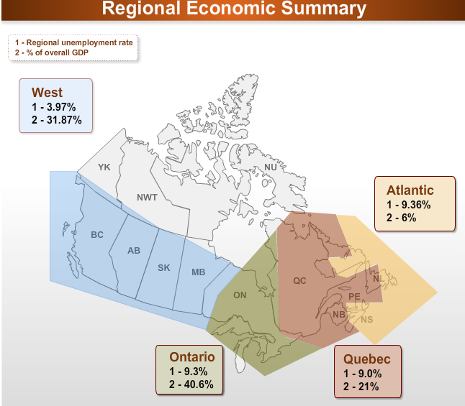The trickle-down effect is that some provinces boast higher average weekly earnings than others. All of this has implications for Canadian politics, particularly when it comes to the sorts of concerns that arise and take precedence, attention and emphasis that politicians and political parties give to different parts of the country.
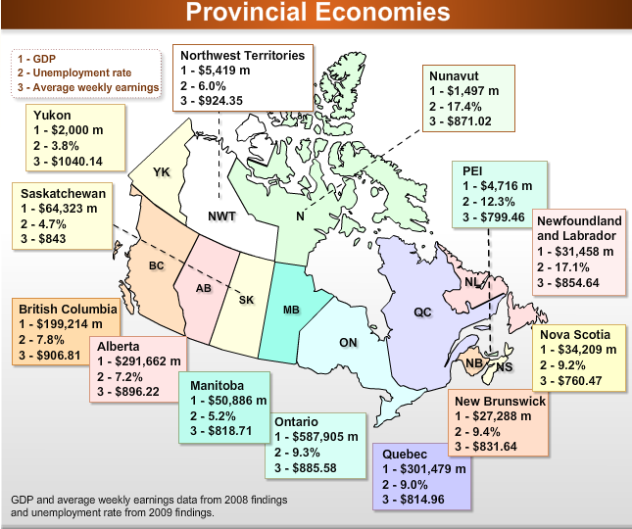

Canada's Population Distribution
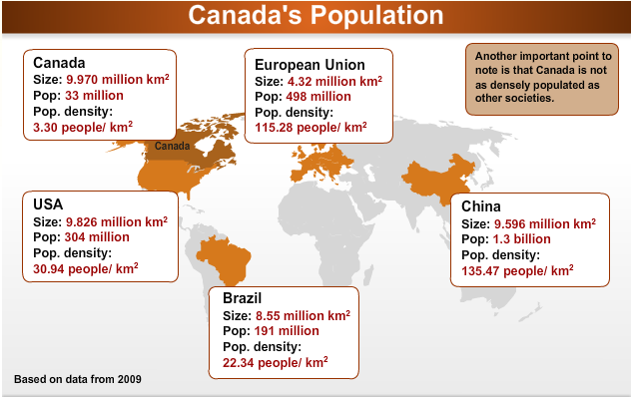
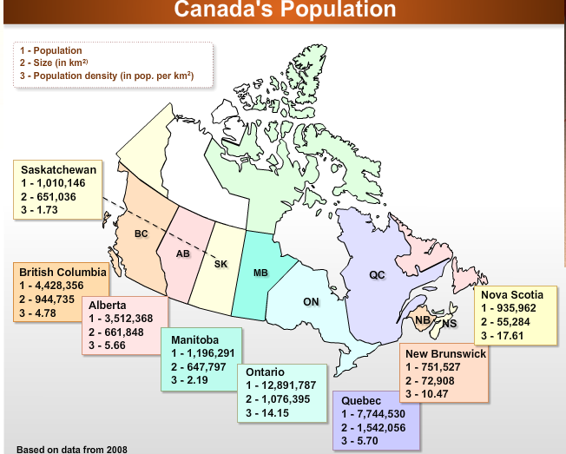
Most of Canada’s population is concentrated in Quebec and Ontario, and this also has implications for Canadian politics. For instance, during election campaigns this affects where parties and party leaders campaign. It also affects where campaign promises are made. It also influences the values that get heard and considered by the federal government.

Canada's Population Concentration
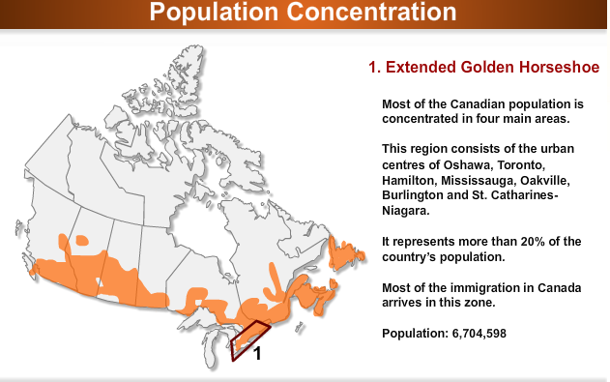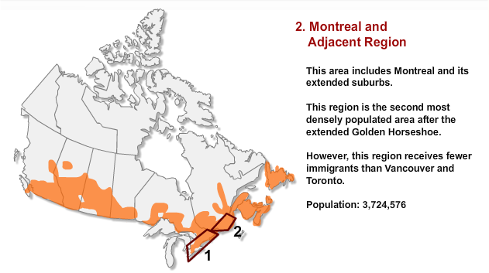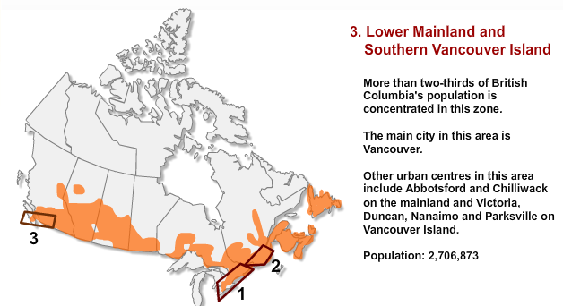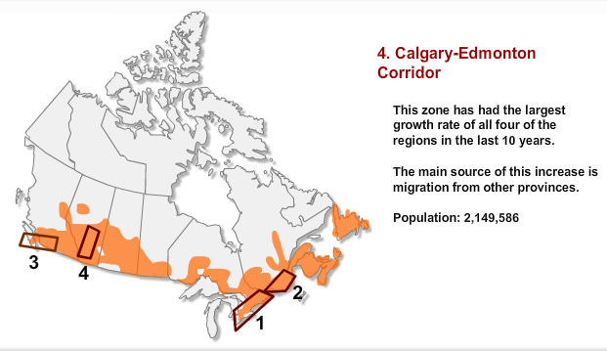

Readings
 |  | Required Reading  Stephen Brooks, Canadian Democracy: An Introduction, 7th ed. Toronto: Oxford University Press, 2012, Chapter 3.
- The size and diverse environment of Canada?
- The number of different resources available for economic use?
- The role of Canada’s environment in sustaining economic growth and prosperity for its population?
- How Canada’s population density compares to other countries?
- How Canada’s population is concentrated?

Lesson 3: In the Beginning

Introduction
Canada is a culturally diverse country and this too has important implications for Canadian politics. An understanding of how this diversity has developed over time, through various historical experiences and critical junctures, provides a better appreciation of contemporary Canadian politics and its underlying cleavage structure.

In this lesson, we begin by discussing some of the early history that connects aboriginal, French and English Canadians.

The First Peoples of Canada
The early history of the first peoples of Canada begins at the time of the Ice Age and its subsequent melting. In Canada, the terms ‘aboriginal’ or ‘native’ are often used to identify the first people who populated the land. The aboriginal community contains several distinct groups, with different cultural backgrounds and ancestral lands.  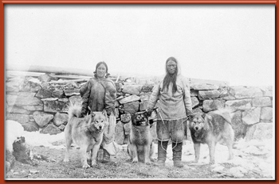  Inuit Man and Woman (Source: Canadian Archives) | 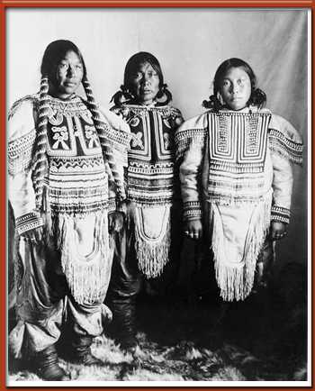  Native Women in Gala Dress (Source:

The First Peoples of Canada (Cont'd)
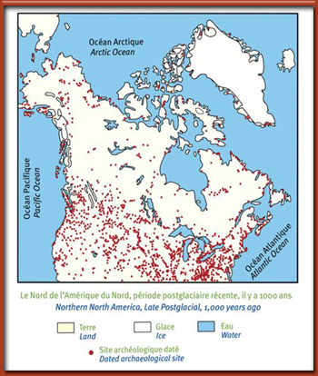
Source: "A History of the Aboriginal People of Canada - V. 1 - 10,000 to 1,000 B.C.,"...Civilization.ca athttp://www.civilization.ca/aborig/fp/fpz2f16f.html
During the late post-glacial period, traces of native people could be found all over North America.
In Canada, the aboriginals populated areas such as:
- the Plains
- the Canadian Shield
- the Maritimes
- the Great Lakes-St. Lawrence Seaway
- the Southwestern Coast
- the Northwestern Coast
- the Northwestern Interior
The following are examples of some of the primary groups of aboriginals that were located in Canada at the time:
- The Inuit
- The Algonquins
- The Iroquoians
- The Plains Indians
- The Huron
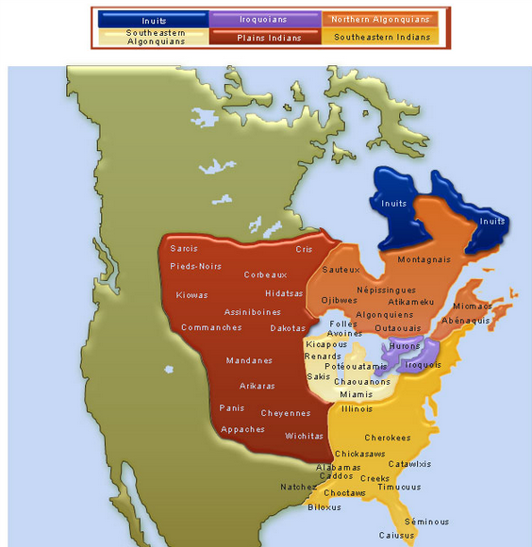

European Influence and the Aboriginals
Early aboriginal societies were affected in many ways by the arrival of Europeans and it effectively changed their way of life.
For instance, trade between the aboriginals and the Europeans was to some extent respectful and potentially beneficial. However, it also led to the rapid expansion of the fur trade and increased conflict and war between the different aboriginal and European groups, as it bred fearless competition to acquire more goods. The Europeans also brought many diseases to Canada such as the measles, typhoid, diphtheria and small pox. As a result, many tribes were seriously afflicted.

Alcohol made its way to North America during this early period of contact between the Europeans and the natives. European traders would give alcohol to the natives in exchange for fur. Unaccustomed to its effects, the results for the native population were often devastating, leading in many cases to problems such as alcoholism and domestic violence. In fact, the long-term effects of these early influences can still be seen today.
In addition, as the number of European explorers expanded, they eventually needed more land for settlement. Through various treaties, natives were forced to move into small reserves or to other regions, which dramatically affected their populations.
In reserves, they had to depend on the European population for food. Native culture was seriously affected in the process. This continues to be a major point of contention today. However, some progress in dealing with such historical concerns does seem evident.
Also important to note is that during this early period in colonial history, Europeans also sent missionaries to convert native populations to Christianity. Furthermore, residential schools were set up to “civilize” native populations. This further destroyed many aboriginal traditions and beliefs. Many natives, even if they officially became Christian, kept their ancestral beliefs. Still, the consequences have had long-term political implications, which recent governments have begun to settle.
Of course, not all of the experiences between the early European settlers and the aboriginals resulted in negative outcomes. For example, the aboriginals shared much of their knowledge about both the land and survival with the Europeans.
They taught the Europeans how to build canoes, use snowshoes and toboggans. They showed them the best routes for furs, and how to navigate the land. And they also helped keep the Europeans warm by sewing their mittens and leggings.
In return, the Europeans brought medicine, alternative food sources and new technologies. In other words, the contact between the two groups had both positive and negative consequences.
While it is fair to say that relations between aboriginals and the rest of Canada have not always been ideal, the federal government has made several attempts to try and remedy the situation. Not all of these attempts have been successful and much work has yet to be done.
Still, there are reasons to suppose that this will remain a prominent issue in Canadian politics and that the future may be more hopeful than the past, and that the aboriginals are likely to remain a major component of Canadian politics for some time to come.

The Exploration of New France
The French were among the first Europeans to set foot in Canada. They established their first settlements at Port Royal, Acadia in 1605 and in Quebec in 1608.
Initially, at least, these new territories were exploited primarily for their riches, making the main goal of the few who sought to discover the new land purely economic. Men would journey to this new world for its furs and fish and to participate in the fur trade.
Only later did the French become more serious about colonizing New France, hoping that this would guarantee their sovereignty over the land and ensure their possession of the natural resources.
The establishment of New France in the early 17th century was slow and painful for various reasons. France did not invest heavily in this process, as it was preoccupied with its own turmoil and needs at home. This made matters difficult because settlers in New France were dependent on France for survival as agriculture was underdeveloped.
Also, few in France had a vested interest in the New World. Fishing and fur trading did not entice many people and this too slowed settlement and population growth. Eventually, however, as interest in the fur trade and other profitable endeavors in New France grew, the French sought to increase the population by giving chartered companies permission to exploit the land in return for the promise of increased settlement.
The coureurs des bois, or “runners of the forests,” were among the first to come to the New World. The coureurs des bois were settlers who had been brought over to New France by chartered companies in order to populate the land, many of whom chose to become fur traders, hunters and fishermen as opposed to farmers.
They associated with the natives. They were very similar to the natives in dress and in the way they fought. And like the natives, they too traveled by canoe and snowshoes. The coureurs des bois were vital to the colony. They explored unknown land. They extended New France’s boundaries. And they charted down their routes, which resulted in the mapping of North America. They also became wealthier through the fur trade.
As time progressed, however, this type of early exploratory activity was increasingly frowned upon as it did not help to develop a strong foundation for sustained community life.
n 1663, the French King at the time, Louis XIV, re-established direct control of New France. He placed his minister, Jean-Baptiste Colbert, in charge of developing the colony. Colbert, together with Jean Talon, who was to be the first intendant of New France, envisioned developing a colony that would be self-reliant and capable of fostering agriculture and industries in the St. Lawrence Seaway. New France was to become the source of many resources that France needed in order to become self-sufficient and independent of other nations.
In order to build a self-sufficient colony, however, it was clear that the Iroquois had to be controlled. Their raids and constant attacks hindered any hopes of establishing permanent and strong French settlements. Troops were better subsidized and dispatched to New France in order to protect and take possession of the land.
War between the French soldiers and the natives was unforgiving and many lost their lives due to the bloodshed. Eventually, the French were finally able to negotiate and secure peace with the natives. French soldiers were not only successful at protecting their settlements and the fur trade, but they also contributed to the growth of the colony as most stayed and settled the land.
For Colbert and Talon, increasing the population of New France was also a very important priority. Marriage became a matter of duty and because initially there were few women in the colony, the King of France eventually sent potential brides for the veteran soldiers and other bachelors in the colony.
The women were known as les filles du roi. Their purpose was eventually to engage in courtship and seal partnerships. In addition, financial incentives were given to young men and women who married and had large families. By the end of the 17th century, the population of New France had begun to increase and the tradition of marriage and large families had been established.
The preliminary governing body that had been put in place in New France was small. It consisted of an elite group which included a governor, a bishop and an intendant.
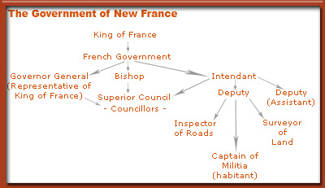
New France’s economy could be described as quasi-feudal, based on agriculture and the fur trade. With time, however, the economy was diversified and new industries, such as ship-building were launched. In the colony, bartering was the main mode of exchange

The Way of Life in New France
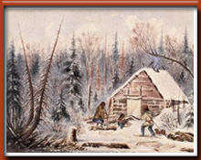
Settlers and the first cabins in New France
Life was not easy in New France. The colony faced hard times when drought, insect invasions and hard rain ravaged their crops and destabilized their operations. The winters were also harsh and long. The New World was being built from scratch, which demanded considerable labour and teamwork. These settlers needed all the assistance they could get from the government as private initiative was not sufficient.
Religious persons such as clergymen and nuns were among the first to make the voyage to New France in order to respond to the spiritual needs of the newly arriving settlers. These missionaries were also motivated by the drive to work with the natives.
Catholicism was the most prominent religion in the region. Protestants and Jews were not welcome and thus few settled in New France. Even the slightest doubt about an immigrant’s religious affiliation necessitated the reiteration of their baptismal and communion vows at a confirmation ceremony conducted by the Bishop.

Settlement in the English Colonies
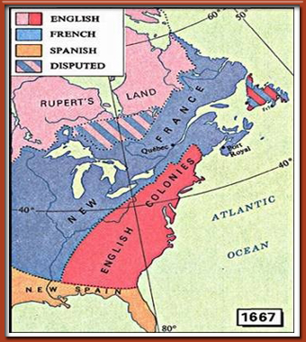
English Colonies in North America in 1667 (in pink)(Original map data provided by the Atlas of Canada.http://atlas.gc.ca/ © 2007. Produced under license from Her Majesty the Queen in Right of Canada, with permission of Natural Resources Canada.)

While the first British exploration of the New World had taken place in the late 15th century, the first English settlers in North America began to arrive during the early 1600s. Many settled in the eastern colonies, which would later become the United States and the Atlantic provinces of Canada
The first settlers came from Great Britain. They were followed eventually by the Scottish and the Irish. The new settlers sought to escape the poor economic conditions in Great Britain as well as acquire greater religious freedom in a more liberal environment. For example, during the 1630s, in their quest to escape religious persecution, the Puritans, a religious group borne from the Protestant religion, founded much of Massachusetts Bay. The role of the colonies was to complement Britain’s economy (as opposed to competing with it) and to offer a favourable balance of trade.
The colonies of the North, Newfoundland and Rupert’s Land concentrated on fishing and fur trading as their prime economic activities. The Hudson’s Bay Company was established in 1670 by the English to amass furs. This chartered company had a monopoly on the fur trade in Rupert’s Land around Hudson Bay.
Similar to settlers in New France, people in the English colonies worked hard for a living. Also, while many settlers had fled religious persecution in the Old World, religion still played a key role in the lives of most of the British colonial settlers on the East Coast. The Protestant religion was ingrained in the various settlements in the British colonies. But this was not always the case. For example, the Irish Potato Famine ushered thousands of new immigrants into the British North American colonies in the mid-1800s.

Irish Immigration
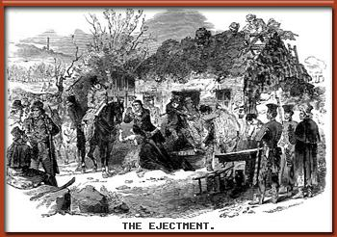
The Irish were forced to leave their homes due to poverty and starvation during the Potato Famine

The Potato Famine was caused by a fungus that attacked and ravaged the potato crops. This event led to poverty and starvation for the vast majority of the population of Ireland, as potatoes were a main source of food. It is estimated that millions of Irish either died or emigrated during the famine.

The journey itself often proved deadly. An estimated 130,000 out of 200,000 Irish immigrants who attempted to flee perished while crossing the Atlantic or within the first year of their arrival. This massive wave of immigration also weighed heavily on the underdeveloped infrastructure of the colonies, as the Irish immigrants had to be quarantined. Caring for the sick and weak and the large number of orphans and widows that the famine and voyage had produced led to the implementation of head taxes—10 to 20 shillings per person—to help cover the cost of caring for them upon their arrival.

The new immigrants did not mirror the social, cultural or religious values of the majority. Many Irish settlers chose to settle in urban centres over rural communities and practiced Catholicism. Their arrival in large numbers not only increased Canada’s population, but effectively added to the already diverse socio-cultural mix of the country.

Required Reading
Stephen Brooks, Canadian Democracy: An Introduction, 7th ed. Toronto: Oxford University Press, 2012, Chapter 16.
- Some of the early history that connects aboriginal, French and English Canadians?
- How Canada’s cultural diversity has developed over time?
- The early history of the first peoples of Canada?
- The effects the arrival of the explorers had on the aboriginals?
- The history and development of New France?
- The history and development of English Canada?
- The historical background of the Irish immigration to Canada?

The prospects for the Canadian political community were doomed from the start.

Lesson 4: The Road to Confederation

Introduction
The last lesson introduced you to the three primary groups of people initially founded and settled in Canada - the aboriginals, the French and the English. These groups had many diverse characteristics and they shared various historical experiences.
In this lesson, you will see that throughout the 17th, 18th and 19th centuries, these three groups of people became engaged in several conflicts and that other diverse groups of people eventually entered into the mix.
It is important to have at least some sense of the most significant of these early experiences and their consequences as they have had substantial and long-lasting effects on the formation of Canada, its people and their relations with one another. In fact, the effects of early experiences and their consequences still resonate in contemporary Canadian politics.

The Indian Wars of the Early 17th Century.
The Indian Wars, which took place during the early 17th century, illustrate the uneasy relationship that once existed between the Europeans and the aboriginals. At the same time, they also show how both the English and the French attempted to defend, protect and advance their interests by becoming allies with certain aboriginal tribes. Both imperialist powers intended to colonize the land because they wanted to prosper from its immense natural wealth and settlement opportunities.
While both the French and the English traded with some aboriginal tribes, they went to war with others. Initially, at least, both the French and English colonies were small, thus limiting their ability to battle. Consequently, during times of war, both colonies enlisted help from the aboriginals to fend off attacks and expand their territory.
Certain French settlements, for example, were under steady attack from the Iroquois. The French eventually joined forces with the Huron and various Algonquin tribes in order to counter the Iroquois. A long series of wars followed, giving the English an opportunity to unite with the Iroquois in the hopes of eliminating the French and taking control of more land.
After many years of fighting, the French managed to convince many of the aboriginal tribes to side with them against the English. This resulted in “the Great Peace of Montreal” which was a treaty signed between several native tribes and the French in 1701. Forty native tribes, including the Iroquois, assembled in Montreal to declare peace not only with the French but also with rival tribes. More than a thousand representations from different tribes were present at the signing of this treaty. The treaty gave the French access to the interior of the continent and native allies in the event of a war against the English.
The Great Peace of Montreal effectively neutralized the Iroquois. By this time, however, the English colonists had grown sufficiently in population and no longer needed the help of the Iroquois to fight the French. It is not difficult to understand how such early experiences between the founding peoples of Canada may have had lasting impressions. Moreover, experiences of this type extended beyond the Indian wars of the early 17th century.

The War of the Spanish Succession

Another potentially influential point in English and French relations was the War of the Spanish Succession. Though this war was originally waged in Europe, it eventually spilled over to the French and English colonies.
War began when Charles II of Spain died, naming his nephew Philip, grandson of Louis XIV of France, heir to the Spanish throne and empire. Philip’s succession was contested by Leopold I, the Emperor of Austria, whose second son, Charles, also had a claim to the throne.
Leopold I and Louis XIV, two of the most powerful leaders in Europe, began fighting on behalf of their heirs and war materialized between Austria and France.
Due to previous agreements, many European states had a vested interest in the outcome of the war. England, Prussia and Holland sided with Austria, while Bavaria and Spain sided with the French. By 1701, the battle had spread to the New World and the French and the English colonies were at war.
A t first, the French colonists and their aboriginal allies successfully raided various English settlements in the thirteen colonies and took control of Newfoundland. The tide soon turned, however, and the English overwhelmingly defeated the French. As a result, in 1710, after four failed attempts, the English took control of Port Royal, located in present day Nova Scotia.
The War of Spanish Succession ended in 1713 and the Treaty of Utrecht was signed. This resulted in France giving up the rights to much of its land in North America. More specifically, the Hudson Bay area, Newfoundland and Acadia—present day Nova Scotia—were ceded to England.
In North America, the Treaty of Utrecht caused many problems for the French. They had now lost two of their most eastern colonies, Newfoundland and Acadia, and their power in the Maritimes was greatly depreciated. To counter this loss, they erected the Fortress of Louisburg in Cape Breton, which was to serve as a protective stronghold.

The Acadian Deportation
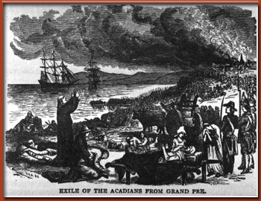
Acadians Awaiting Deportation

The Treaty of Utrecht not only had devastating implications for the French, but it also produced problems for the English as newly acquired Acadia was predominately French.
The Acadians, French colonists who lived in the region and now found themselves under British control, agreed to remain neutral in the event of any future French/English conflicts. They lived in peace under British rule for over forty years.
During this time, the English used Acadia mostly as a landing site for military deployment of new Protestant settlers.
The Acadians, who had experienced both French and English rule, developed their own distinct culture and a strong sense of independence.
This peaceful arrangement came to an end in the mid-1750s when the English and French became ingrained in the Seven Years’ War. This heightened British distrust of the Acadians or “French Neutrals.” Authorities in the colony demanded that Acadians take an oath of allegiance to the British Crown or face deportation.
This resulted in the rounding up and deportation of Acadians to the thirteen colonies, France and England. Many Acadians also fled to the neighbouring French colonies. Most lost their land, which was subsequently redistributed to new English settlers.
This marked a dark time for French and English relations, which added further to the strained relationship and distrust that had been developing between the two groups.

The Seven Years’ War (1756-1763)
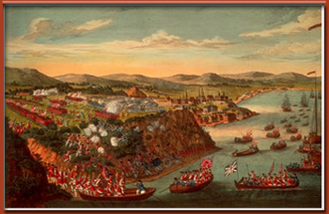
Battle of the Plains of Abraham
The Seven Years’ War had a global impact as both the British and the French sent massive forces in support of their colonies around the world.
Britain, however, sent far more troops to its North American colonies than France.
This war, as the name suggests, lasted seven long years and caused much destruction and grief to the parties involved. The war finally ended in 1762 and a peace treaty was signed in 1763 (the Treaty of Paris).
The most definitive battle (the Conquest) between the French and English colonies during this time took place in 1759 on the Plains of Abraham in Quebec City. It was during this battle that British General Wolfe defeated French commander Montcalm. The Battle of Montreal was another decisive victory for the English in September 1760.
After this war, the British took hold of all of the colonies in North America except for two small islands on the east coast, Miquelon and St. Pierre.

The Conquest
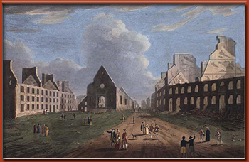
Quebec, destroyed after the war.
At the centre is the Church of Notre-Dame-des-Victoires.

The Conquest marks a critical point in time when the French lost their power and authority in North America. The settlers of former New France were now almost entirely governed by those who did not share their language, religion, culture or traditions. The French who stayed in the British North American colonies turned inward as a people, and in an attempt to protect themselves, formed close-knit communities that were weary of the English.
These distinct settlers were eventually called Canadians (or Canadiens in French), which stems from the Iroquois word Canada, meaning “village.” This was the first time that this term was used to describe a group of people.

The Royal Proclamation (1763)

In the Royal Proclamation of 1763, land was reorganized to appease the different groups that could potentially cause future problems for Britain.
For example, large territories were legally transferred to the natives in an effort to ensure that no native revolt would take place. Moreover, the Proclamation also defined the settled portion of New France as the province of Quebec.
Counter to the spirit of the preceding gestures, however, the Royal Proclamation also determined that in order to hold any administrative office, the Canadians—the French settlers who were now under British rule—had to take an oath of loyalty to the British Crown and abandon their Catholic religion.
The British had now gained possession of most of North America and although they had been somewhat strategic with the Royal Proclamation, many of the settlers in the thirteen colonies were beginning to feel neglected by Britain.
The redistribution of land in the Royal Proclamation was upsetting because the aboriginals had been given more land than they previously owned, but no additional land had been given to the thirteen colonies. The thirteen colonies had sacrificed a great deal in the Seven Years’ War and were angered at the ingratitude shown by the Crown.

The Quebec Act (1774)

The anger in the thirteen colonies intensified and by the 1770s the Crown feared revolt. If this were to happen, the British Crown wanted to ensure that colonies in the North would not join the thirteen colonies in their attempt to break from British rule.
It was particularly important that the Canadians not revolt. Thus, in an attempt to appease the Canadians, the British government introduced the Quebec Act in 1774. This Act attempted to demonstrate that the British respected the Canadians by meeting a few of their demands. It stated that they would protect the Canadians’ religion, culture, law, territory and language.
The Quebec Act also proposed that the Province of Quebec be expanded, which would mean better economic opportunities
As a former French colony, Quebec had been governed by a few traditional elites who were upset when they lost part of their governing power to the British. In order to appease these important figures, the British allowed them to keep their status if they pledged an oath to British loyalty.
As a result of the passing and acceptance of the Quebec Act by the British Parliament, the Canadian population had much less reason to join the thirteen colonies in what would come to be known as the American Revolution. The Act, however, managed to further anger the settlers in the thirteen colonies who were upset that the French were given more land. This fuelled the increasing resentment toward England and was another basis for what was to come.

The American Revolution and the Loyalists
The influence of the American Revolution on Canadian politics is undeniable as it redefined the role of the British Crown in North America. It also affected the relationship between the English and French. It played a role in the eventual formation of a Canadian Confederation, and it redefined the borders and population distribution of North America.
The revolution pushed thousands of refugees from the thirteen colonies to the northern colonies. This migration was instrumental in reshaping the way of life for many. In order to better understand the role the revolution played in the formation of Canada and the impact of the Loyalists who fled north, you must first understand the revolution itself.
As mentioned earlier, during the late 18th century, much of the population in the thirteen colonies grew increasingly aggravated by the way they were being treated by England. There was growing unrest over the Crown’s demands on the colonists and its response to the newly acquired colonies in the north.
People in the thirteen colonies felt as though the Crown had failed to acknowledge their participation in the war. Unlike the aboriginals or the Canadians, they had received no new land. Furthermore, the Crown imposed taxes on the colonies. The colonists protested against the notion of being taxed without being given representation in the British Parliament. Eventually, this resulted in the War of Independence.
The thirteen colonies, led by George Washington, organized and fought the British who had sent troops in an attempt to crush the revolution.
Initially, the thirteen colonies attempted to seize Quebec and make it the fourteenth colony. However, the invasion failed and the Canadians remained neutral in the conflict. France, however, did inevitably send troops to help the thirteen colonies combat the British.
In 1776, the thirteen colonies declared independence from the Crown and after a prolonged battle, these colonies were to become the United States of America.
Not all of the colonists who lived in the thirteen colonies supported the revolution. Some remained loyal to the British Crown. After the revolution, several of these loyal colonists fled to the remaining British colonies.
As a result, in the late 1700s the northern colonies experienced a major increase in immigration. Many English-speaking Protestant refugees found new homes in the Maritimes, Quebec and Ontario. An estimated 80,000 Loyalists fled America during and after the revolution

Many Loyalists valued social order and authority, and as such, they preferred imperial rule to revolution. Others had escaped slavery during the revolutionary war in hopes of attaining a better life. Others still had imperial economic ties, which they depended on and needed to maintain.
The arrival of the Loyalists in British North America stimulated various changes within the colonies. For example, Loyalists who had migrated to Quebec helped to introduce the notion of political representation in lawmaking assemblies—a concept that had been foreign to French-speaking inhabitants.
Likewise, the influx of Loyalists to the northern colonies helped spark the creation of the colonies of New Brunswick and Cape Breton in 1784. The arrival and settlement of Loyalists in present day Ontario helped to establish a new society and influenced the eventual creation of Upper and Lower Canada in 1791.

The Constitutional Act (1791)
In 1791, the Constitutional Act divided the province of Quebec into Upper and Lower Canada.
The northern part of the Great Lakes, which was mostly populated by the English and Loyalists became known as the colony of Upper Canada. The predominantly French areas were to become the colony of Lower Canada. Though both had elected legislative assemblies, most of the decision-making powers lay in the hands of the British Crown’s representative and his legal and executive advisors.
The experience gained from the American Revolution influenced the distribution of power in Upper and Lower Canada. The British had learned that in order to have better control over the population it was necessary to restrain their political power.

The 1837 and 1838 Rebellions
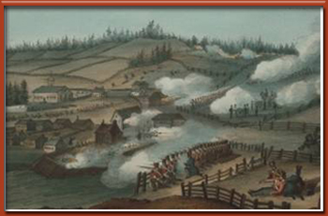
Rebellions in Rural Areas of Lower Canada (Source: McCord Museum)
Rebellions broke out in both Upper and Lower Canada in the late 1830s. The uprising resulted from the Constitutional Act of 1791, which failed to give the elected assemblies in both colonies the ability to control their appointed councils that had decision-making power. Because the British government had failed to acknowledge the demands and grievances expressed by colonists, the populations in both Upper and Lower Canada eventually reverted to violence.
In Lower Canada, ethnic divides and poor treatment of the French majority by the English caused conflict and resentment. Similarly, tensions in Upper Canada were aggravated by the domination of a ruling oligarchy (the Family Compact).

he 1837 and 1838 Rebellions: Lower Canada
In Lower Canada, dissatisfaction towards English governing elite, the Château Clique, was instrumental in creating political pressure and new political parties. Also, in the 1830s an economic crisis plunged many Canadians in Lower Canada to the edge of starvation, and this was another key factor that fueled the desire for change.
In addition, there was a dramatic increase in the number of immigrants from the British Isles, which brought with it disease that affected the local population. All of this increased the uneasiness and discontent felt by the French toward the ruling English elite.
. The Parti Patriote, a radical party borne out of the Parti Canadien, was founded in Lower Canada in 1826. The Parti Patriote represented the demands of the French people and advocated for various changes. For example, the Parti Patriote wanted greater power for the elected assembly. It wanted the elected assembly to decide how revenues raised would be distributed and to be able to effectively challenge the authority of the appointed Legislative Council.
The British minority had appealed to the governor to resist such demands. This neglect caused a rise in extremist politics on both sides and eventually led to violence.
In 1837, the British government effectively rejected all of the Patriotes’ various demands and granted more power to the governor. In response, the Patriotes organized a boycott of British goods, held mass rallies across the colony and began to prepare for an armed insurrection which was to be known as the Rebellion of 1837.
The Rebellion was led by Louis-Joseph Papineau, a nationalist who had been elected as the Speaker of the Assembly and was leader of the Parti Canadien, which later became known as the Parti Patriote.
The first battle between the British forces and the rebels was fought at St. Denis, where the Patriotes defeated the government troops. The Patriotes were then defeated by British troops at St. Charles and St. Eustache.
The Patriotes were outnumbered. They had failed to take into account that the British government had dispatched troops all over Lower Canada and that the English militants in the colony had also taken up arms.
Many insurgents were captured and exiled, while others fled to the United States. The rebellion wounded and killed hundreds.
In 1838, with the help of American sympathizers, the Patriotes prepared for a second rebellion. Once more the Patriotes plotted to spark an uprising, but the uprising was weak and they failed to execute it with success. Within a week, the second rebellion was crushed by the stronger British forces. Many were imprisoned and ninety-nine received the death sentence, of which twelve were executed and the rest deported. These two rebellions were devastating for the Patriotes and their supporters.

The 1837 and 1838 Rebellions: Upper Canada
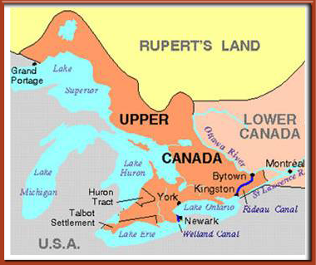
Upper Canada (Source: Canadian Encyclopedia)
A rebellion also began in Upper Canada under William Lyon MacKenzie. Reformers, who attempted to counter the corrupt Family Compact, demanded change in political patronage, education, economic policies and land grants. Furthermore, the reformers demanded an end to the government favouritism of the Anglican Church and its supporters. This discontent was felt by American-born immigrants, particularly the so-called Late Loyalists, who had republican leanings.
Mackenzie and his supporters issued a draft constitution for Upper Canada, which resembled that of the United States. He also attempted to take control of the government in December of 1837. This rebellion lasted only a short amount of time and was not successful.

Lord Durham's Report
Following the rebellions, the Earl of Durham was appointed as Governor General of the British North American colonies and asked to investigate the causes of the rebellions of 1837 in Upper and Lower Canada and to report his findings to the Crown. Lord Durham’s analysis and subsequent report had an immense impact on Canadian political history and French-English relations.

In his report, Lord Durham recommended the implementation of responsible government, the formation of a united Province of Canada that would bring together Upper and Lower Canada and the assimilation of French Canadians. The report sought to make the political executive responsible to the elected assembly as a possible solution to the corrupt and incompetent governing elite in Upper Canada. Moreover, the proposed union of Lower and Upper Canada would attempt to ease ethnic tensions in Lower Canada by gradually assimilating the French.
Both the Family Compact and the Chateau Clique had monopolized power, established elitist views of society and governed as a oligarchies. Both groups of elites had limited success with respect to economic and social development. Through their controlling ways of governing, they enriched themselves and alienated the population in the process. Lord Durham’s recommendations were an attempt to change this ruling system.
The report also sought to ensure harmony between the two nations through the dominance of the English in a united governing body. Most of Lord Durham’s recommendations were accepted and the Act of Union was implemented in 1841. Legislatures in both Lower and Upper Canada were abolished and the Province of Canada was established in their place.
The Act of Union established a single Parliament with equal representation from each colony. Debt was consolidated and English was the official language in government.
This report was controversial and contested by both the French Canadians and the Family Compact. The Act of Union meant that Upper Canada’s culture and political life would be protected by sacrificing the traditions of Lower Canada.
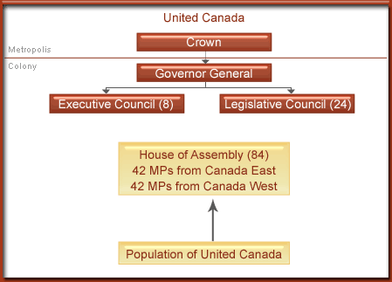
The report had different implications and interpretations for both colonies. The Act of Union effectively made the English the majority in government. English also became the official language of the Parliament of a United Canada.
Lower Canada, which was predominately French-speaking and had a larger population, was allocated the same number of seats as its Upper Canada counterparts. In time it was expected that French Canadians’ ability to defend their rights would be limited. With inadequate representation in Parliament, their demands would be overshadowed and overpowered by the English majority.
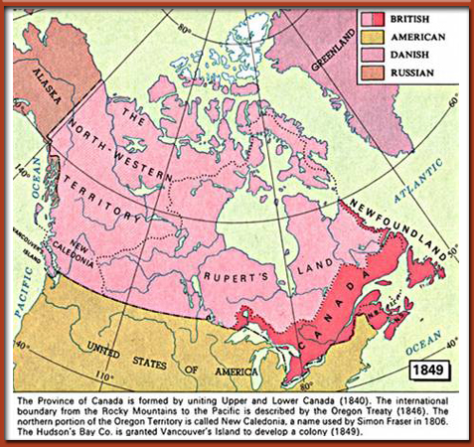
The Durham Report permanently changed the face of Canada and French-English relations.
The Act of Union and the ways in which it was presented and implemented created a deep wound among the French population—one that is still present in today’s political discourse. However, the Act also enabled the formation of a new class of politicians who believed in cooperation between English and French Canadians.
This new group, the Moderate Reformers, led by Baldwin and Lafontaine, wanted to improve political institutions for both nations based on the notion that “opinion” should be what mattered and not “origins.” Moderate Reformers believed that public administrations and institutions should be free of competing cultures in order to give way to social peace and prosperity.
This period, which established responsible government, saw great changes in the colony's political and social spheres. Leaders were able to adopt important reforms and add substantially to the legal and municipal systems of the Province of Canada. In 1848, responsible government was granted by Britain to the North American colonies, which meant that government ministers would now have to command the support of the assemblies.

Readings
There are no assigned readings for this lesson.
- The struggles that emerged among the French, the English and the aboriginals as they vied for control of the land and its resources?
- The conflicts between the British and the French that continued throughout the18th and 19th centuries?
- Important events and legislation that occurred which highlighted the British and French conflicts?

Lesson 5: Confederation and the Founding of Canada

Introduction
The last lesson covered some of Canada’s early history. It highlighted the often conflictual and violent context. It depicted the relevance of the American Revolution, the Loyalists and the early development of quasi-democracy in the British North American colonies. It showed how the early colonial experience soured French-English relations.  In this lesson, you will learn about the motivations for Confederation and develop a better sense of the ways in which the country was built. | 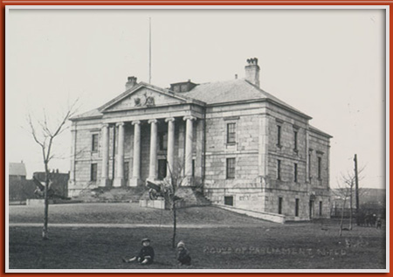

Motivations for Confederation
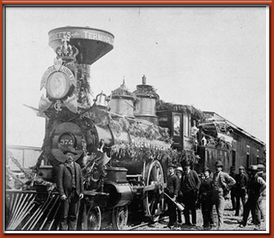
Building the National Railways Â© Canadiana.org
Confederation in the British North American colonies was pitched as a practical solution. It was very much a product of timing, and it was about what was in the best interests of the colonies in terms of future prosperity. The idea came about as an attempt to resolve certain problems that became more evident during the mid-1800s.
For example, the need to improve economic relations became an important driving force. As it stood, the British North American colonies shared limited ties. Economic relations were conducted primarily with neighbours to the south.
It was when the United States withdrew from a trading treaty with Britain that the call for inter-colonial trade between the British North American colonies became more relevant. England supported greater cooperation between its North American colonies, as it would lessen the financial burden of waging a war to defend its territories if they were attacked by the United States.
Political problems also pressed the need for Confederation. Constant deadlocks and the inability to have a clear majority government in the Province of Canada were problematic for good governing. As a result, the coalition government consisting of Macdonald's Conservatives and Brown's Liberals in the Province of Canada decided to try an alternative and seek a union with the Maritime provinces. They envisioned a federal format in which all matters which concerned the union would be dealt with by a federal government and those that were solely of provincial concern would be dealt with by the provinces.
The American Civil War was also highly influential in pushing the Maritimes and the Province of Canada to unite. There was a growing perception that the United States would try to annex the northern colonies. In addition, the Americans had often hinted that the British North American colonies should be part of the United States. In fact, an annexation bill was even passed in the United States House of Representatives in 1866, indicating that the United States was to acquire all of what is present-day Canada.

Confederation
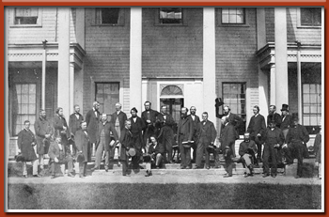
The Charlottetown Conference in 1864 (Source: Canadian Archives)
The thought of possibly uniting with the Province of Canada had not yet been considered in the Maritimes. However, the Maritime colonies had decided to have a conference to discuss the matter of forming a Maritime union more formally. Leaders of the Province of Canada asked if they could attend the conference and proposed the idea of forming a larger union. The Maritime colonies agreed. In the end, one conference expanded into three, and each was very important in the planning and implementation of Canadian Confederation
Charlottetown Conference | September 1864
Quebec Conference | October 1864
London Conference | December 1866 - March 1867

The Charlottetown Conference had been organized by the Maritime colonies (Prince Edward Island, Nova Scotia and New Brunswick) mostly to deal with the possibility of forming a Maritime union.
The discussion, however, was immediately sidetracked by the delegation from the Province of Canada, which wanted to form a larger union, inclusive of all the British North American colonies. The conference considered possible financial arrangements and prospective forms of government.
the new union would preserve ties with Great Britain, give residual jurisdiction to a central authority, and incorporate a bicameral system of government, which meant having both Lower and Upper legislative chambers.
Members of the Lower House would be allocated based on representation by population, and members of the Upper House would be allocated regionally as opposed to provincially. Both the federal and provincial levels of government would operate on the basis of responsible government and appoint a representative of the British monarch.
The Charlottetown Conference set the stage for the eventual drafting of the British North America Act. The Second Conference—the Quebec Conference—further advanced discussion and formal planning. From the Quebec Conference came 72 resolutions, which were to serve as the basis for the final London Conference which began in December 1866.
From the London Conference emerged a draft for a proposed bill, which would create the Dominion of Canada. Not all involved were content with the proposed union. Nevertheless, the bill was eventually completed and tabled in the British House of Lords in February 1867. On March 29, 1867, the British North America Act received Royal Assent. Once this was done, the delegates returned home and prepared for the union.
The new Dominion of Canada included the provinces of Ontario and Quebec, which were previously known as Upper and Lower Canada, as well as New Brunswick and Nova Scotia

The British North America (BNA) Act (1867)
The BNA Act put to rest many issues that the Fathers of Confederation had debated. It was the final agreement in the establishment of the Dominion of Canada. The BNA Act did many things. For example, it outlined the powers of the federal and provincial governments and the various roles that they would take on within the federation.
The choice of a federation of provinces as opposed to a unitary state meant that the provinces retained a degree of self-government within the larger union
The BNA Act established the new Dominion's first legal traditions, which coincided with those of Britain's political and constitutional principles. For example, the BNA Act had parliamentary supremacy at its core. This meant that:
- The legislative branch made the laws subject to the oversight of the Crown.
- The judiciary was limited in its power and had to accept the legislation that emerged from the legislative branch of government.
- Parliament retained the full authority to amend or revoke law under the BNA Act of 1867. Under the BNA Act, the legislative branch of government was also the sole guardian of the rights and freedoms of its citizens.
That being said, the Canadian Constitution has certain aspects to it that are distinct. For example, Canada's Constitution is mostly based on written laws and less on conventions, which characterize Britain's Constitution. Moreover, Britain has a unitary system of government whereas in Canada power is divided between the federal and provincial governments.
Although the BNA Act set the groundwork for a federal governing system, many elements in the BNA Act were quasi-federal. This made provincial governments subordinate to the federal government and weakened the autonomy of the provinces, even in their own areas of jurisdiction.

The Founding of other Canadian Provinces and Territories
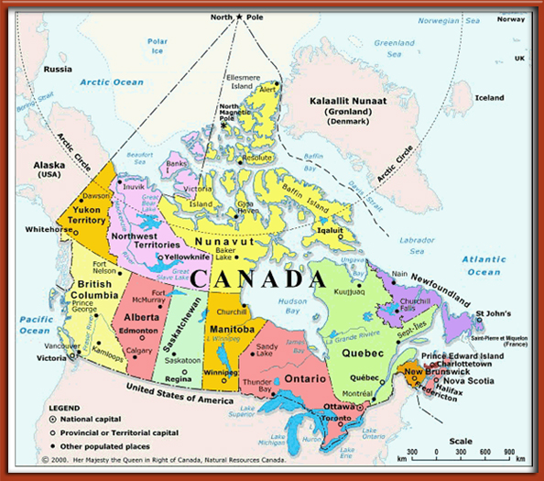
© Listings Canada
Gradually, over the 19th and 20th centuries, several provinces and territories joined the Dominion of Canada. (The material summarized in this section is largely drawn fromCanadian Confederation).
- Northwest Territories, 1870
- Manitoba, 1870
- British Columbia, 1871
- Prince Edward Island, 1873
- Yukon, 1898
- Alberta and Saskatchewan, 1905
- Newfoundland, 1949
- Nunavut, 1999

Northwest Territories (NWT), 1870
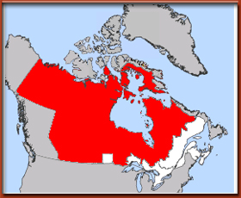  This map shows that the NWT (coloured in red) spanned much of today's Canada. The NWT in the 1800s was vast and populated mostly by aboriginals and fur traders. (Source: answers.com) | 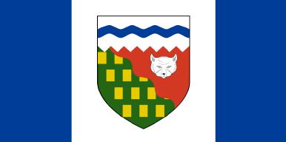  The NWT Flag (Source: Wikimedia.org)
The Northwest Territories (NWT) was initially populated by the aboriginal people and a few British and French settlers. The Hudson's Bay Company transferred this land to the Canadian government in 1870 and it was at this point that it became the first territory in the Canadian Confederation. It is important to understand that the size of the NWT at this time was much larger than today and included areas that are now part of Alberta, Saskatchewan, Manitoba, the Yukon, Ontario and Quebec. It was not until 1886 that an elected assembly was established.

After the arrival of the Europeans, trading posts were gradually established in the NWT and the fur trade became the dominant economic activity. By the late 1800s and early 1900s, however, the focus of the economy shifted to mining, although fur trading remained important. Also during this early period, both Catholic and Protestant missionaries migrated to the NWT to educate the aboriginal population.

Manitoba, 1870
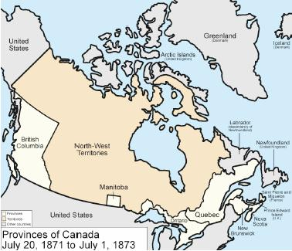
(Source: wikimedia.org)
Prior to 1870, Manitoba was part of the NWT. The economy centered on the fur trade, and the French (from Quebec), the English (from Ontario), the aboriginals, and the Métis coexisted side by side. In addition, located in the southern part of today's Manitoba, close to the Red River, was the settlement of Selkirk, which contained settlers originating from Scotland. As the population close to the Red River colony began to grow, it came to be known as the Red River Colony.
After Confederation, the government of Canada decided to buy up the land in this area and notified the Red River Settlers and the MÃ©tis of its intentions. The idea was to prevent the United States from moving into the territory and to expand and develop the country.
The purchase of the land by the Hudson's Bay Company alarmed and displeased the Métis, largely because the government in Ottawa had not consulted them. Under Louis Riel, the MÃ©tis formed a Committee to help protect their rights and stop the annexation of their territory.
The tension that developed between the MÃ©tis and the Canadian government and the events that marked this period will be covered in greater detail in Lesson 7.
For now, it is important to note that the Métis demanded that their way of life and institutions be protected. The Métis also wanted Manitoba to be admitted into the Confederation as a province as opposed to a territory. They insisted that the Crown's representative to the new province be bilingual.
In late April of 1870, both the Métis and Canadian government officials came to an agreement that respected the MÃ©tis demands overall. Manitoba was to become part of the Canadian Confederation as a province with bilingual institutions, denominational schools, and property rights guaranteed for aboriginal lands.
Manitoba became the fifth Canadian province under the Manitoba Act, which received Royal Assent in July 1870. The province, however, was not as vast as it is today. At the time of Confederation, the province of Manitoba measured about 160 square kilometres. The Canadian government returned control over the remaining area of the Northwest Territories and its resources.

British Columbia (BC), 1871
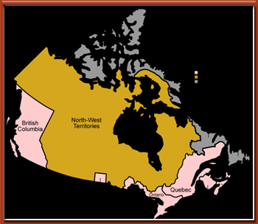
Canada after the entry of British Columbia. In orange, the Northwest Territories. In grey, other territories. (Source: Wikipedia.org)
The first Europeans to settle in British Columbia date back to the late 1800s and early 1900s. Prior to that, most of the population living in this area was aboriginal. The British Crown formally established its first settlement on the Island of Vancouver in 1849.
Most settlers lived in Fort Victoria and they worked for the Hudson's Bay Company. By the mid-1850s, the Gold Rush ushered many people of different ethnic backgrounds to this area in search of wealth. Almost a decade after the establishment of the colony of Vancouver Island, the Crown established the mainland colony of British Columbia.
The two settlements remained very British in their ways, despite the influx of many Chinese, Hispanics and Americans. Also, the two colonies enjoyed close ties with the United States, and like the rest of the country, the fur trade was the main economic activity until the Gold Rush made mining the dominant industry.
The economic boom resulting from the Gold Rush, however, did not last long. The economy slowed down during by the 1860s, thereby sending British Columbia into a recession.
In 1866, the two colonies of British Columbia and Victoria decided to unite, and the government was eventually located in Victoria.
Unlike its counterparts in the East, the newly united colony in the West was to be governed by unelected officials. This was highly contested by some who demanded responsible government for the colony.
Also, it was hoped that the union might alleviate some of the new colony's expenses. This, however, was not to be the case. High infrastructure costs and the increasing fear of annexation by the Americans inevitably pushed BC toward Confederation.
Several great debates over the possibility of joining the union took place and in the end the colony's governor, Sir Anthony Musgrave, was able to subdue opposition against Confederation by promising concerned appointed officials pensions or new positions within the new union.

Negotiations between British Columbia and Canada were held in Ottawa in June 1870. The issue of responsible government proved to be one of the more difficult issues to resolve, as Canadians would only agree to Confederation with British Columbia if it had responsible institutions.
Provisions for responsible government were eventually made and the colony's debt was absorbed.
Royal Assent was granted on May 16, 1871 and British Columbia became the sixth province of Canada on July 20, 1871. After Confederation, some of the terms that had been agreed upon during the negotiation period began to cause major problems. For example, the promise to build a pan-Canadian railway system was slow to start.
Threats of annexation to the United States were voiced in the House of Commons by one of British Columbia's members. This resulted in the creation of the Canadian Pacific Railway Company and more than fourteen years after British Columbia had joined Confederation, the pan-Canadian railway was complete.

Prince Edward Island (PEI), 1873
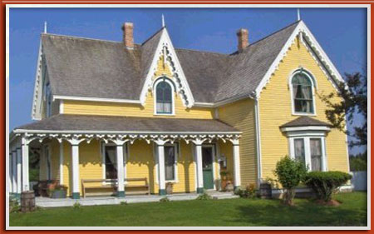
Bideford Parsonage is representative of the typical architecture in PEI. It was also home to author Lucy Maud Montgomery, creator of Anne of Green Gables, during the time she taught in Bideford. Courtesy of Bideford Parsonage Museum.
On the other side of the continent, Prince Edward Island (PEI) also flirted with the idea of Confederation, but this was short-lived as Canada had to work hard to convince the Islanders to join. PEI was home to many Irish, Scottish, English and Acadian settlers. The colony had a budding economy based on agriculture, lumber, shipbuilding and shipping. It also had strong links with the United States.

PEI had established responsible government in 1851 and the franchise extended to most men. Politics within the colony revolved around two divergent groups: the Conservatives, who preferred the status quo, and the Reformers, who sought change.
In September 1864, the colony welcomed Maritime and Canadian delegates who came together at the Charlottetown Conference to discuss a possible union. At this time, PEI delegates had been opposed to a union with other colonies, as they did not see any benefits to a Confederation. They also feared that Confederation would lead to a loss of control over their affairs.
During the Charlottetown Conference, however, some delegates began to see the potential benefits of joining the greater union. This was especially true for those who sought to find a possible solution to the problem of absentee landlords who refused to sell their land. Under the framework of the proposed union, the federal government would purchase large land holdings, and make it less challenging for Islanders to acquire land.
Then came the Quebec Conference in October 1864, where the optimism among the PEI delegates began to sink. A key declining factor was that the proposed union's federal government would no longer be obliged to purchase land from absentee landlords.
Once the delegates from the Quebec Conference returned to the island, Confederation became a hot topic of debate. Some claimed that a union would increase taxes that would not serve Islanders directly. Others argued that a union would increase the threat of conscription during times of conflict, and still others worried that this could result in the possible loss of this legislature. Consequently, in 1866 PEI rejected the Quebec Conference resolutions and Confederation.
Gradually, however, in the years that followed, the perspectives of Islanders on the issue of Confederation began to shift once again. Economic difficulties had surmounted due to an expensive railway project started in 1871 and the loss of a major exporting partner.
Eventually, the colony's government decided to turn to the Canadians for help and began to negotiate a possible union. The Canadians proved receptive and were willing to discuss possible terms. By 1873, government officials went to Ottawa to iron out the terms and secure a deal. PEI became a partner in the Canadian Confederation on July 1, 1873.

Yukon, 1898
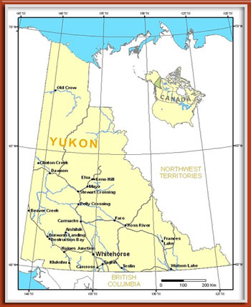
The Yukon joined Confederation in 1898 (Source: Indian & Northern Affairs Canada)
Yukon was the home of various aboriginal tribes and like many territories and provinces, European arrival to this area was driven by exploration and the fur trade. Also, the Hudson's Bay Company and the North West Company eventually sent surveyors to the area and trading posts were set up throughout the 17th and 18th centuries.
Scientific surveyors also ventured to the area to examine the environment, and missionaries, both Anglican and Catholic, traveled to the area with the aim of converting the aboriginals.

nterest in the north and its prospective resources was fairly widespread. The Americans and the Russians were also exploring and trading in the area. In fact, their exploration of the land led to the their purchasing of Alaska in 1867.

The discovery of gold also incited significant interest in the Yukon. Many Americans headed north during the Klondike Gold Rush. This ushered in the need for more police in the area as the Canadian government had to establish better control over the land and its growing population.
Between 1895 and 1898 a fort was established and the North West Mounted Police (NWMP) established a sizeable presence in the area. At the height of the Gold Rush, this force was also reinforced with additional soldiers from the Canadian Army. Furthermore, it is important to note that the NWMP were more than simple law enforcement officials. They also acted as government officials and wore several hats.
Eventually, demands for actual governmental representation increased. As a result, the Yukon Act was passed in 1898. The Yukon was now a separate territory within the Canadian family and it was to be governed by a territorial commissioner. The commissioner was to govern the territory with the assistance of a council consisting of four appointed government officials.

Saskatchewan and Alberta, 1905
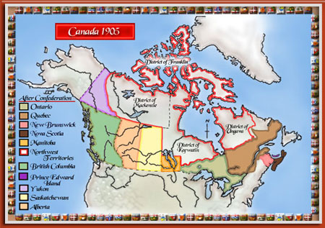
Alberta and Saskatchewan joined Confederation in 1905 (Source: National Library of Canada)
Initially, the West had been settled mostly by the British, but at the turn of the 20th century others also inhabited the area. The region included a French and Métis population as well as smaller German, Russian, French, Austro-Hungarian and Scandinavian populations. Most were of Protestant backgrounds, but there were also Catholics, Doukhobors and other religious denominations.

The Canadian government sought to increase the population of the area through an immigration campaign in 1896. This created a great influx of immigrants to the West but it also created the need for significant investment.
The territorial government in charge at the time was responsible for creating new schools, public works and providing other services; however, it lacked the financial capacity to act.
Prime minister Wilfrid Laurier and delegates from the NWT met to discuss the matter, but the dissolving of the federal government and a subsequent election put these preliminary negotiations on ice. In 1905, however, the negotiations resumed as Laurier had won the election and he had kept his promise to revisit the NWT issue.
The region was to be turned into two provinces as one would have been difficult to administer. Moreover, the arrangement was different from the typical arrangements that the Canadian government had made with the other eastern provinces. In this instance, the federal government would retain the rights to the area's natural resources. However, the two new provinces would receive more funding from the federal government.

In September 1, 1905, the Saskatchewan Act and the Alberta Act made Saskatchewan and Alberta the two newest provinces to join Canada.

Newfoundland, 1949
Initially, the colony of Newfoundland served as a seasonal fishing base for European explorers. As time went on, however, the population of Newfoundland grew and this necessitated the appointment of a full-time governor. In 1855, after much agitation, responsible government was established in the colony.
Representatives from Newfoundland did not attend the Charlottetown Conference. However, delegates from the colony did attend the Quebec Conference, but only as observers. Though the Quebec resolutions were favourable to Newfoundland, anti-Confederation sentiment in the colony was strong and the discussion on Confederation was eventually put on the shelf.
Pressure to join Canada increased in 1895 as the colony faced financial difficulties after a bank crash. This time, however, the terms put forward by the Canadian government were not in the best interest of Newfoundland and negotiations failed.
The First World War proved very profitable for the colony, however massive government spending on infrastructure led to the accumulation of a large debt. By the 1930s, the colony was in terrible financial shape and the advent of the Great Depression only intensified the need for a solution. In an attempt to remedy the situation, Newfoundland turned to Britain for help.
Britain responded in 1934 by suspending responsible government and establishing a Commission of Government that would administer the colony. The British Parliament was to have decision-making authority until the colony was once again in a position to be self-sufficient.
Newfoundland's economy benefited from the Second World War and talk of re-establishing responsible government re-emerged, as did discussions about the prospects of joining Confederation. Some even debated the possibility of joining the United States, while others wanted to maintain the status quo.
Following the war, the British government held a Convention in Newfoundland. The objective was to decide Newfoundland's future. Delegates to this convention were sent from all over Newfoundland and Labrador.
The Convention decided to send a delegation to London to assess what kind of financial support it might provide and gauge how the British government felt about Newfoundland regaining control of its own decision making.
The Convention also proposed to send a delegation to Ottawa in order to meet with Canadian officials and assess the possibility of joining Confederation. The best offer in the end came from the Canadians and this set the ball rolling for a series of referendums that would determine the status of Newfoundland.
The first referendum, held in June 1948, determined that responsible government and Confederation were the top options for Newfoundland.
In the second referendum, held in July 1948, the majority of Newfoundlanders voted for Confederation with Canada.
Following these referendums, Newfoundland and Canada returned to the table to negotiate the terms of Confederation.
Newfoundland officially became the tenth Canadian province on March 31, 1949. In 2001, the province's name was officially changed from Newfoundland to Newfoundland and Labrador.

Nunavut, 1999
The commercial trading network established by the Hudson's Bay Company in the Arctic altered the way of life of the Inuit significantly.
This trading relationship continued until the slowdown in the fur trade in the 1930s. This was detrimental to the Inuit because they had become dependent on it as their means of survival.
During the 1940s and 1950s, the Canadian government—in response to international criticism—took matters into its own hands. The government relocated many Inuit to centralized communities where they might enjoy greater prosperity.
At the same time, however, the Arctic also became a prime location for the exploration of natural resources. This exploration was conducted without consulting with the Inuit. Explorers and developers simply did as they pleased without proper consideration of the environmental consequences.
In 1967, a territorial government was established in Yellowknife.
This may have brought the government and the people closer together physically as the previous government was based in Ottawa. However, this new government failed to consider the needs and circumstances of the region.
During the 1970s, the Inuit presented their first claims to the federal government. These included requests for land, the creation of a new territory, a new governing infrastructure and the establishment of a new official language, Inuktitut.
The first proposal was eventually withdrawn because it was considered too complex and lacking in input from the community involved.
The negotiation process with the federal government was lengthy. However, in 1991, the Nunavut Land Claims Agreement (NLCA) was finally concluded, and signed in 1992. The agreement was snidely supported and ratified in 1993. From there, the Nunavut Land Claims Agreement Act was passed and ratified. Later, the Nunavut Act was passed which created Nunavut as a new territory in 1993.
The implementation of the agreement, however, was scheduled for April 1, 1999, in order for all parties to have time to make arrangements.
Elections for the new legislative assembly of nineteen members were held on February 15, 1999, and the Territory of Nunavut was created and officially became part of the Confederation on April 1, 1999.

Readings
 | Additional Materials  - Library and Archives Canada is very helpful as a search engine for topics discussed in this lesson, especially Confederation.

•
The three successive conferences at which the Founding Fathers of Confederation negotiated the formation of the Dominion of Canada?
• The first four provinces to join Canada?
• The significance of the BNA Act?
• The order in which the remaining provinces and territories joined Canada?

How has the road to Confederation affected the Canadian political community?

Lesson 6: How the West Evolved

Introduction
The previous lesson described the events that took place during the lead-up to Canadian Confederation. It also outlined the chronology of the country’s expansion into 10 provinces and three territories.
In this lesson, you will learn about some of the immediate challenges that Canada faced during the post-Confederation period. More specifically, this lesson outlines some of the thinking behind the first prime minister's National Policy. It explains the perceived relevance of the Trans Canada railway for economic development, and it describes the country’s early immigration policy, which was intended to help populate the West.
Gaining perspective on such key historical developments will help you to better understand the early post-Confederation context and the mindset in which the underlying cleavage structure of contemporary Canadian politics developed and took shape.

Post-Confederation
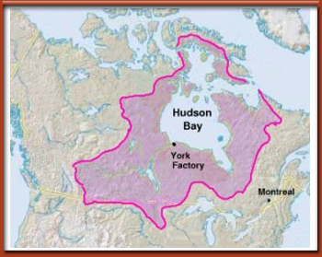
Rupert's Land (Source: Answers.com)
Prior to Confederation, primarily aboriginals and fur traders populated the West. At that time, the area was under the control of the Hudson’s Bay Company.
Shortly after Confederation, however, the Canadian government began to think more seriously about Western expansion. Such a move was considered crucial for growth and economic prosperity. Moreover, the Canadian government did not want to risk losing this land to the Americans.

In an effort to secure this land for further expansion, the Canadian government bought Rupert’s Land from the Hudson’s Bay Company in 1870. Two years later, the government passed the Dominion Lands Act, which was one of the first policies designed to lure immigrants to the West. Under this Act, the government offered 160 acres of land to settlers in return for a commitment to develop the land for a minimum of three years and a registration fee of ten dollars.
Although very little of the land in the West was settled at the time, the Red River district contained a significant number of settlers, most of whom were Métis, whose population alone numbered about 10,000.
The Métis in this region were people of mixed European and aboriginal blood who had been uniting ever since the earliest French arrivals exploring the West in search of furs.
Many Scottish immigrants had also settled in present-day Manitoba. The Earl of Selkirk bought into the Hudson’s Bay Company in 1811 in his quest to establish a settlement for these poor people. Although this settlement flourished, it also experienced conflict with the Métis at times.
Eventually, various other communities also began to settle in the West. Among them were Mennonites, Russian Doukhobors, Ukrainians and Icelanders.

The National Policy
The first Prime Minister of Canada, Sir John A. Macdonald, not only played an important role in Confederation but he was also a major influence during post-Confederation. One of his major goals was to create a strong nation spanning from east to west.
In the 1873 elections, his party lost due to a political scandal, but he returned to power in 1878 by promoting the idea of a National Policy. The National Policy’s aim was essentially to develop a strong country largely by jump-starting the economy. The National Policy sought to:
- develop manufacturing in Quebec and Ontario, and streamline trade between the east and west.
- increase settlement in the West.
- build a railroad that would link the east and West
Macdonald felt that populating the west was crucial and that establishing a means of transportation that extended from east to west was also necessary. Macdonald envisioned the west to be the new market for products produced in central Canada. The railway would provide a more efficient means by which to deliver these goods across the country.

The Railway System
The proposed railway was to be facilitator for economic development as well as a catalyst for further Western expansion. That being said, however, it was an extremely expensive venture and was a process that was not entirely problem free.
The earliest railway in Canada was built in the 1830s in Quebec. Others were built in the Maritimes in the late 1850s. Early projects such as these made transportation more efficient between shorter distances.
In 1867, the BNA Act specified the need to complete a railway system that would unite the colonies. It was not until 1876 that this Intercolonial Railway was finally finished.
Furthermore, the addition of British Columbia to Confederation in 1871 made it imperative to build a railway line that would connect the east to the west. Consequently, the federal government under Macdonald’s Conservatives began planning for this very ambitious and costly project.
However, before long, the government was confronted by a major scandal. Despite the fact that there were competing bids for the contract, this project was secretly awarded to Sir Hugh Allan in return for his financial support to the Conservative Party. When this news went public it became known as the Pacific Scandal and it resulted in the collapse of the Conservative government.
In 1867, the BNA Act specified the need to complete a railway system that would unite the colonies. It was not until 1876 that this Intercolonial Railway was finally finished.
Furthermore, the addition of British Columbia to Confederation in 1871 made it imperative to build a railway line that would connect the east to the west. Consequently, the federal government under Macdonald’s Conservatives began planning for this very ambitious and costly project.
However, before long, the government was confronted by a major scandal. Despite the fact that there were competing bids for the contract, this project was secretly awarded to Sir Hugh Allan in return for his financial support to the Conservative Party. When this news went public it became known as the Pacific Scandal and it resulted in the collapse of the Conservative government.
The Macdonald government returned to power in 1878 with the promise of completing the railway. The Canadian Pacific Railway (CPR) was established in 1881 and it created considerable support for the federal government.
There were many debates about the importance of this railway and the wisdom of Western expansion more generally. The Macdonald government, however, remained committed to the view that building a railway to the West was crucial in order to counter the threat of American expansion and to develop the national economy.
The railway would provide benefits for business and boost employment.
For example, several maintenance centres and railway shops were needed to service the system. The railway system also facilitated the development of the agricultural, mining and forestry sectors of the economy and improved the flow of human capital.
The railway played an integral role in industrialization as it opened up new markets. Furthermore, the building of the railway stimulated entrepreneurship and the development of engineering skills. For example, multiple bridges and tunnels had to be built and often new technologies had to be invented in response to problems experienced.
Of course, the construction of the railway was not easy. The land was difficult to clear and the demand for capable human capital was high.
Particularly in British Columbia it is estimated that 9,000 Chinese workers helped build the railroad between Yale and Kamloops. They were brought in to help complete the railroad.
It was not until 1885 that the last spike was finally hammered into the ground at Craigellachie in Eagle Pass, British Columbia.
Once the building of the railroad was complete, the CPR and the Canadian government tried to stimulate business through the promotion of trade in the Pacific. For example, the CPR:
- became an active importer of goods from Japan.
- carried mail from Britain from the East.
- invested in mining and metallurgy in the West.
- expanded into the tourist industry, establishing hotels, steamships, and eventually an airline.

Who Else Came to the West? (Cont'd)

From 1891 to 1931, more than 5 million immigrants settled in Canada. Indeed, during certain periods, hundreds of thousands of people entered the country annually. The chart below highlights the pattern of immigration in Canada during the first third of the twentieth century.
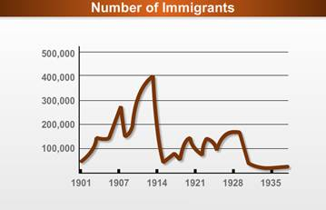
Source: Citizenship and Immigration Canada

During the early 20th century, most new immigrants to the country were from the United Kingdom, followed by the US. Over time, however, the trajectory of this pattern of immigration has shifted. This is a subject that we will revisit in Lesson 10.
Before Confederation, most of the Canadian population lived in Ontario and Quebec. By 1911, however, a much greater proportion of Canadians lived west of the Ontario border. The massive influx of immigrants to Western Canada began to change the socio-cultural and demographic fabric of the nation.
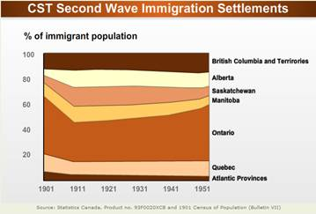
The industrialization of Europe had resulted in a population increase. This reduced the availability of land for farming and created the emergence of a new class of landless peasants. Many of these people sought to escape poverty and immigrated to Canada.
In addition, Canada during this time was more actively appealing to adventurous immigrants who sought to be bold and self-sufficient.
Gradually, Canada’s immigration policy became more controlled and selective. The focus shifted to luring in the right immigrants from the United States, Britain and Western Europe.
Immigrants who did not come from these sources were labeled as foreigners and were viewed as less desirable. That said, however, the government was not entirely averse to bringing in immigrants from elsewhere in order to fill jobs that were low paying or unattractive to Canadians. Still, certain groups of less desirable immigrants were preferred.

Lesson 6: How the West Evolved

Readings
There are no assigned readings for this lesson.
- The people who chose to settle in the West before the Dominion of Canada decided to increase its control over the area?
- The importance of Canada’s first National Policy and the reasons why such a policy was needed?
- The different tools that the government used to develop the country and curb American domination?
- The historical development of the Canadian railway system?
- The government’s immigration policy, which was developed and implemented during this time period?

In what ways do you think that Macdonald's National Policy contributed to the development of Canada's political community?

Lesson 7: The French-English Divide

Introduction
- Like many modern states, Canada’s population is not homogeneous. Rather, it is composed of many different people who have different value systems and political cultures.
- In this lesson, you will see more clearly how Canadians have been shaped by their particular histories.
- More specifically, this lesson explores the main differences between the French and the English and discusses the factors that have fuelled this divide.

Political Culture and Canadian Politics
- As you saw in the previous lessons, Canadian Confederation was established on a foundation of considerable diversity.
- In other words, the population was anything but homogenous.
- It consisted of many different types of people, cultural backgrounds and value systems which have contributed to the development of varying political cultures.
- These variations in political culture play a key role in Canadian politics.
- As such, it is important to understand what political culture means and how it affects Canadian politics.
- This lesson begins by briefly introducing you to the concept of political culture and some of the theories associated with it.
- Political culture is defined as:

The politically relevant values, attitudes, beliefs, and symbols that exert an unseen but crucial influence on the political life of a society. Political culture helps shape the outlooks...of both ordinary citizens and political leaders. It affects the way they react and talk to one another, the problems they consider politically significant, the kinds of solutions and government policies deemed legitimate (Bell 19).
- Political scientists have advanced different theories in their attempts to explain how variations in Canadian political culture have emerged.
- Hartz’s fragment theory, for example, suggests that the political cultures in the New World have resulted from differing patterns of European settlement.
- As such, fragment theory argues that Canada’s political culture has been shaped by variations in cultural background and value systems which were formed in European societies.
- However, those who chose to immigrate to the New World did not fully reflect all aspects of European society. For instance, some were fleeing religious persecution and others were searching for greater prosperity. Consequently, only certain aspects of Europe’s socio-economic and cultural diversity are reflected in Canadian society (Brooks 36).
- Fragment theory is helpful for understanding the political differences between the French and the English. It also helps to account for variations in regional political cultures.
(Source: David V.J. Bell. The Roots of Disunity: A Study of Canadian Political Culture. Revised edition. Toronto: Oxford University Press, 1992, p. 19.)
•
Another prominent theory relies on historical events to help explain variations in Canada’s political culture.
• Lipset’s theory proposes that political culture is shaped by shared historical events, or marked by certain important events that have influenced the development of a society, its institutions and political ideas (Archer 36; Brooks 36).

• For example, for English Canadians, a major formative event that significantly influenced the development of their political culture and institutions was the American Revolution (Brooks 39).
• For French Canadians, a key formative event would be the Conquest of 1759.
• Elements of this theory, however, have been criticized.
• Critics point out that the assumption that formative events impact all individuals in a society in the same way is false (Archer 37).
• Real life suggests that subcultures vary in their perceptions of formative events (Archer 37).

Understanding the Meaning of Cleavages in Political Science
- Variations in political culture are relevant because they can lead to the formation of various cleavages within a society.
- Cleavages are defined as "a politically significant distinction among identifiable groups in a given population" (Archer 58).
- Cleavages become politically significant when they affect political support and political behaviour.
- For example, cleavages play a key role in the formation of political parties and elections as decisions made by the electorate are often determined or at the least influenced by cleavage patterns within the electorate (Archer 411).
- Theories related to cleavages have changed over time and today cleavage structures are viewed as more dynamic.•
- This simply means that cleavages are not frozen in time, for new cleavages continue to form and old ones can lose their importance.
- Since cleavages necessitate clearly defined organizational structures, new political structures giving a voice to new cleavages might be necessary.
- As you will see in this course, there are various old and new cleavages that play an imortant role in Canadian politics.

Language
- Language is an important cleavage in Canadian society.
- The English-French divide has persisted over time as a result of events and decisions by governing bodies that have continued to fuel the divide.
- The language divide has played a key part in intergovernmental politics between the federal government and the provinces and is therefore important to understand.
- As we saw in Lesson 4, the English often attempted to assimilate the French.
- Rarely do we find incidents where the English sought to protect or accommodate the French language.
- In the past, in instances where the English did attempt to respect the French language, it was under circumstances where they had no choice and was therefore in self-interest only.
- We also saw that one such instance was during the American Revolution.
- In the quest to appease the French and to avoid having them side with the Americans, the British proposed to protect their language in 1774.
- This way of addressing the language issue continued throughout history as the divide intensified in the late 1800s and early 1900s.
- As such, the French lived in constant fear of losing their language (Archer 41).
- As time went on, this cleavage became more pronounced. It has been at the root of numerous conflicts and divisions in Canada throughout the 21st century.
- Both the English and the French have used the state apparatus to protect and/or appease language issues.
- Governing bodies and institutions have had to find ways to deal with the English-French divide.

- Bernard Landry, former Premier of Quebec (2001 - 2003) and leader of the Parti Québécois (2001 - 2005), offers his opinion on this topic.

Religion
- As we saw in Lesson 3, the French and the English brought with them different religious beliefs which were influential in their respective ways of life.
- Many English settlers were Protestants.
- Many of these English immigrants came to the British colonies in order to escape religious persecution.
- The French were predominantly Roman Catholic and did not settle in New France for religious freedom but because they had been obliged to do so for financial reasons.
- They came over with fur companies and for better farming conditions.
- Religion remained highly ingrained in both New France and in the British colonies.
- Religion greatly influenced French and English interactions.
- As a result, the English and the French often found themselves at odds because of their religious affiliations and the influence these religions had on their ways of life.
- This created an air of competition between the two groups.
- For example, the two clergies competed for the conversion of natives, and later competed for religious influence within the different governing bodies.
- Moreover, early attempts to convert the French Catholics to Protestantism by the English also fuelled resentment and fear among the French.
- As such, the French turned inward in order to survive under the British Crown.
- Although the English attempted to appease the French fear of assimilation through the enactment of the Quebec Act, the different experiences that the respective groups have had throughout history have helped to reinforce the French-English divide.

Ideology
- French settlers brought with them a more collective and “state-oriented” outlook to politics in which they were more respectful of their political leaders and more cautious and averse to risk (Archer 35).
- English Canadians, on the other hand, were more liberal in their political views.
- These English colonists brought with them more individualistic views which centred around individual rights and freedoms and they were less tolerant of state intervention (Archer 35).
- Also, the rejection of the values and institutions proposed in the American Revolution and the subsequent migration north of those who refused to participate in the uprising against the British Crown contributed to the ideological conservatism and elite values found in English Canada (Brooks 39; Archer 36).

Codes of Law
- The French and English also had different codes of law.

The Civil Code of Quebec
- The Civil Code of Quebec was created in 1663 by a royal amendment known as the Custom of Paris.
- After the Conquest, the Quebec Act guaranteed that the Civil Code would remain the law of the land in Quebec.
- The Civil Code contains all of the laws pertaining to relations between the state and the individual, administrative matters and constitutional division.
- Instead of being evaluated by a judge, the laws in a civil code system are reviewed by the government on a periodic basis (roughly every ten years).
- A judge’s role is simply to apply the law to particular cases.
- The Civil Code is based on proof by preponderance (the more likely scenario).
- This means that rather than having a system where the accused is innocent until proven guilty, both sides state their case and present their proof and then the judge decides in favour of the more likely story (according to his/her judgment).
- The Civil Code can only be found in Quebec. The rest of Canada adheres to the common law tradition.

Common Law
- The common law tradition in Canada is inherited from its British ancestry.
- The code of law is based on a tradition of rulings by judges.
- This means, therefore, that judges' decisions become the force of law.
- This system of law presumes that an individual is innocent until proven guilty.
- Another important characteristic of the common law tradition is that laws are never reviewed by a governing body.
- This means that legal codes are quite dense and contain all judges’ decisions from the inception of the Civil Code.
- Even if there are wide differences between the two systems, Canada manages to accommodate both traditions within its legal framework.
- All criminal matters are based on the common law tradition, and Quebec civil law is based on the Civil Code tradition.
- These differences in legal traditions have also contributed to the development of different political cultures and helped to reinforce the French-English divide.
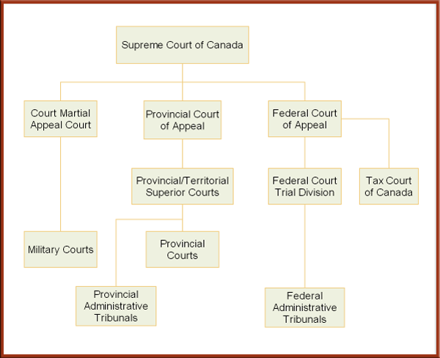

Political Events and Issues Fuelling the French-English Divide
- As we have seen, the French and the English had various cultural differences which helped to contribute to the development of different political cultures and the formation of the French-English divide.
- Both groups have had strong attachments to their respective political communities.
- And various historical experiences, in addition to those already covered in earlier lessons, have helped to deepen this divide.
- We now turn to highlight some of these events.

Two Visions of Canada: Compact Theory vs. Contract Theory
- The BNA Act of 1867 established the union of the first four founding colonies as well as the role that the new provinces would have within the Dominion of Canada.
- This Constitution resulted from a series of compromises between the different colonies.
- At the time, most politicians in Upper Canada as well as certain Anglophone politicians in Lower Canada wanted a unitary state.
- The proponents of the unitary state form of government wanted the decision-making power to reside in a national government. A strong national government was essential in order to promote investments as well as a strong economy.
- In Lower Canada (present-day Quebec) and the Maritime colonies, many politicians were opposed to this.
- The French Canadians in Lower Canada opted instead for a federal state.
- The proponents of a federal state wanted the decision-making power to be distributed among a national government and the provinces.
- These people preferred that some issues be dealt with on the national level, but they also wanted provincial decision-making powers for more local affairs.

Source: Stephen Brooks. Canadian Democracy: An Introduction. 4th ed. Toronto: Oxford University Press, 2004, p. 187.
- More precisely, French Canadians wanted the Constitution to include the protection of their cultural rights and their way of life.
- They believed a federal state and the outlining of the specific jurisdictions of the national and provincial governments would allow for this.
- The Maritimes were also supporters of a federal state, as they too sought to protect their strong local identities.
- Furthermore, many opposed a unitary state as they felt that this type of government arrangement would dilute the powers of the colonies’ politicians.
- Moreover, the need for political stability within the new nation demanded the division of legislative powers.
- A confederation under a federal system would mean that local matters would be under the jurisdiction of the provincial governments, and matters that concerned all the provinces would be under the jurisdiction of the national government.
- Consequently, a federal state was what the Fathers of Confederation eventually decided upon.
- once the Fathers of Confederation agreed on a federal system, many different interpretations emerged as to what this meant.
- Some politicians understood Confederation to be more central and thus saw the provinces as subordinate to the federal governing entities.
- Others believed that the provinces had rights and were not under the domination of the federal government.
- These kinds of competing views on how power should be distributed between the federal and provincial governments have haunted both French-English relations and Canadian politics since Confederation.
- The French and the English view Confederation in entirely different ways.
- The French, for instance, conceive of Canadian federalism as representing a compact between French and English Canada.
- The English, on the other hand, view Canadian federalism as a contract between the provinces and the federal government.

Compact Theory
- Compact theorists argue that Quebec has the power to veto any constitutional changes that are made: to the federal distribution of powers, to the relative weight of Quebec in Parliament and to the number of justices on the Supreme Court.
- Proponents of this theory believe that the Constitution represents a deal made between the two founding nations (the English and the French) and as such, any changes require the approval of both groups.
- Quebec is understood by compact theorists to be representative of French Canadians, as Quebec is the province with the biggest Francophone population and a Francophone majority.
- As such, Quebec is not a province like the others and necessitates special status and powers to protect it as a founding nation.
- The BNA Act, however, makes no mention of the Francophone community’s special status.
- This theory therefore has no legal weight, but carries a great deal of political significance in Canada.

Contract Theory
- Contrary to compact theorists, contract theorists argue that each province has the right to veto constitutional changes if they affect provincial power or national representation.
- This is because the Constitution contains no reference to indicate the different statuses of the provinces. All provinces are considered equal.
- There are, however, different variants of contract theory:
- Some suggest that the restriction of veto rights should apply only to the founding provinces (Nova Scotia, Ontario, New Brunswick, Quebec).
- Others argue that the right of veto should apply to all of the provinces.

Tensions in the West
- Certain events that occurred during the expansion of the West have also helped to fuel the French-English divide.
- The Prairies and northern Canada were initially the property of the Hudson’s Bay Company, which used to employ the Métis in the fur trade.
- After Confederation, the newly formed Dominion of Canada wanted to buy this land from the Hudson’s Bay Company.
- In 1869, Canada’s negotiators successfully bought Rupert’s Land (Canada’s west and north) from the Hudson’s Bay Company.
- The Métis, children of fur traders who married native women, and the natives were concerned about the loss of their land and their rights. They also feared that, similar to the United States, new settlers would wipe out the buffalo population.
- Consequently, in 1869, the Métis, headed by Louis Riel, occupied Fort Gary, the main post of the Hudson’s Bay Company.
- They decided to occupy the Fort until their rights and access to land were guaranteed by the Dominion of Canada.
- Colonists from Ontario decided nevertheless to go to the region in an attempt to civilize and diffuse the situation.
- To maintain stability, the Métis established a provisional government headed by Louis Riel.
- Most Ontarian colonists challenged the provisional government and caused turmoil around the Red River Colony
- One of the Ontarian colonists, Thomas Scott, was a member of the Canadian party which struggled to gain control of the Red River Colony. He believed that the colony should be annexed to Canada.
- Defending their territory, the Métis captured Thomas Scott and the rest of the Canadians and incarcerated them in Fort Gary.
- Scott and some of the others escaped. They plotted to free the remaining captives. They also planned to capture Louis Riel in an attempt to protest against the provisional government established by the Métis.
- Scott, however, was recaptured, but proved to be a difficult prisoner. Consequently, he was charged with insubordination and later convicted of this charge, which was punishable by death.
- The news spread quickly and angered many English Canadians. They felt that Riel’s government was illegitimate and had no power to do such a thing.
- In 1870, after much negotiating between the Canadian government and the Métis, the government of Canada created the new province of Manitoba which was essentially the Red River Colony.
- The Métis were guaranteed property and language rights.
- The English, however, wanted to punish Riel for the execution of Thomas Scott. As a result, Riel went into exile in the United States.
- In Quebec, the creation of a new province where French rights were guaranteed was welcomed.
- In Ontario, the creation of a province for the rebellious Métis, who had executed a good Protestant English Canadian, was criticized.
- There is no doubt that the execution of Thomas Scott and the formation of a new province for those who executed him heightened the tensions between the French and the English.
- By the 1880s, the Métis’ existence was once more threatened as immigration from Ontario to the west displaced the Métis and other natives.
- In order to secure their livelihoods and homes, the colony rebelled and enlisted the help of Louis Riel to defend them.
- In 1884, Louis Riel came back to lead the Métis in their second revolt. They were also aided by other native tribes.
- The Canadian government countered with the North West Mounted Police (which had been formed in 1873) and swiftly crushed the revolt.
- Riel was captured and tried for the murder of Thomas Scott and sentenced to hang alongside other native chiefs for their role in the rebellion.
- This further deepened the French-English divide. French Canadians asked that Louis Riel be spared. English Canadians wanted him dead in order to avenge Thomas Scott’s death.
- Prime Minister Macdonald decided that Riel must be hanged despite strong opposition from French Canadians.
- In his words, “Riel shall hang though every dog in Quebec barks in his favour.”

The Manitoba School Question
- Tensions in the West between the French and the English also reached a boiling point over the Manitoba School Question.
- In 1870, the Manitoba Act established a bilingual school system with both an English Protestant schooling system and a French Catholic schooling system.
- A great influx of English immigrants from Ontario to the West during a 20-year period changed the population mix of the region.
- By 1890, the government of Manitoba decided to stop the funding of religious-based schools and fund only an English public system of schooling.
- This meant the end of the French Catholic school system in Manitoba.
- The decision angered French Canadians as well as some English Canadians who supported the religious schooling system. It also aggravated the rift between the English and the French.
- The French were appalled at the federal government’s lack of intervention in the matter and its failure to protect the French minority.
- Although there were many outcries by the French requesting that the federal government intervene, the Conservative government chose to remain inactive on the question for many years.
- Thus, the federal government stood by as the rights of Catholic and French-speaking Canadians were buried under provincial legislation (Bickerton 247).
- Following a change in government in Ottawa, the new Liberal government, led by Laurier, entered into negotiations with the Manitoba government and reached a compromise which resulted in the protection of some religious rights within the schooling system.
- Nevertheless, it would take almost 100 years for French Catholic rights in Manitoba to be guaranteed.
- In Quebec’s eyes, the Manitoba School Question was the most significant loss of rights for French Canadians outside of Quebec.
- Moreover, this event had a great impact on how French Canadians viewed their position and place in Canada (Bickerton 248).
- They understood that the survival of their religious and linguistic rights would only be ensured in the province of Quebec (Bickerton 248).
- This greatly affected French Canadian political culture and it served as a catalyst for demanding greater power for the provincial government of Quebec.

Diverging Views on War between the French and the English
- War has been a constant influence on French-English relations.
- The French and the English have had very different positions in times of war.
- This first became apparent in the Boer War.

The Boer War
- In 1899, Great Britain and two small republics in South Africa went to war.
- Canadians, who were supportive of the British Empire, felt that Canada should participate in the war and send troops to support England.
- This issue divided Canadians. English-speaking Canadians thought it was imperative to help the British.
- French Canadians, however, did not share this vision. They did not think that Canadian soldiers should be dying for the British Crown.
- Moreover, recent immigrants also wondered why they should participate in the war.
- This was a hotly debated topic in both Parliament and on the streets.
- As a compromise, Wilfred Laurier accepted to send a battalion of volunteers, funded by the British Crown, to South Africa. As a result, 7,000 Canadian volunteers went to South Africa.
- This debate on the role of Canadians in times of war began with the Boer War and was reignited during the First World War.

World War I and the Conscription Crisis of 1917
- As a great ally to Britain, Canada was drawn into the First World War and Canada’s Prime Minister declared, “When Great Britain is at war, Canada is at war and there is no difference at all.”
- Many English-speaking Canadians shared the view that Canada had a duty to England. It was their motherland and many had family in England.
- French-speaking Canadians, on the other hand, had no interest and saw no need to fight for the British Crown.
- French Canadians would not take part in such a war and strongly believed that Canada should not participate.
- This caused great tensions between the French and the English.
- The French-Canadian stance was interpreted by English Canadians as cowardly and unpatriotic.
- The Prime Minister at the time was convinced that it was Canada’s role to participate in the war. It would help demonstrate that Canada was an equal to Britain and not a mere colony.
- By 1917, troops were becoming harder to recruit. Consequently, Prime Minister Robert Borden established a conscription system in order increase the number of troops under the Military Service Act.
- Although there were some English Canadians who opposed the Act, they could not mobilize themselves to be heard.
- French Canadians, on the other hand, were united in their opposition and found in Henri Bourassa a leader to voice their dissent.
- The conscription issue heated up and even exploded into violence in the streets of Quebec City.
- Indeed, the tension was so high that the first bill proposing the separation of Quebec from Canada was created following the conscription crisis.

World War II and Conscription
- During World War II, tensions between the English and the French rose once again as the question of war and conscription reemerged.
- In order to avoid turmoil, Prime Minister Mackenzie King opted to have a plebiscite on the issue of conscription for overseas services in 1942.
- The results showed that 64% of Canadians were in favour of conscription.
- That said, however, 73% of French Canadians voted against conscription.
- This plebiscite illustrated the great disapproval among French Canadians of entering the war. It also suggested that the English were still loyal to the Crown and had a role to play in its defence.
- This issue further fuelled the French-English divide, as French Canadians felt once again that they were being ignored.

La Grande Noirceur
- Over time, Quebecers have developed a strong attachment to their political community.
- After the Conquest, the French started to become a closed community in order to protect themselves. They were especially weary of the English.
- From this they developed a strong political culture which reflected their values and religion.
- Prior the 20th century, it was primarily the elites and the Church who were in charge. They legitimized their power through the idea of la survivance, or the necessity of keeping a French enclave in North America.
- Survival against being assimilated by the English and maintaining their distinct culture became a unifying doctrine for the people of Quebec.
- La survivance was the notion that fuelled traditional Quebec nationalism.
- This way of thinking was supported and dispersed among the Quebecois until the 1950s.
- The traditional nationalism that emerged in Quebec was passed on to future generations.
- Traditional nationalists felt that it was important that the state and the Church operate together and not be secularized.
- Traditional nationalists also saw the province of Quebec as a refuge for all French Canadians. It is important to understand, however, that this nationalism was defined by social and cultural factors and not by the borders of the province.
- The survival of the French nation at this time did not depend on the activities of the Quebec state but on the institutions that transferred the French language and religion: family, parish and schools.
- The elites at this time also understood that the survival of the Quebec people and culture was directly related to their ability to reproduce. As such, women were expected to generate very large families, and they did.
- This was labelled by the Anglophone population as la revanche des berceaux, which translates into “the revenge of the cradle.”
- Quebecers were very conservative. They were deeply influenced by the doctrines of the Catholic Church and they had an agrarian lifestyle. For the most part, they lacked the desire and the knowledge to participate in the commercial capitalism practiced by the English-speaking Protestants who were building up the province’s economy (Archer 47).
- The push toward the cities in the quest for work was encountered by much deception and frustration.
- As a result of their limited skills and education, the French were stratified into certain positions.
- Moreover, the jobs they held were predominately manufacturing jobs, where unionization was low
- These frustrations were further aggravated by the fact that most industries in which the French worked were controlled and managed by the English.
- The use of English in the workplace was a norm and thus threatened the survival of the French language in Quebec (Archer 48).
- This was surprising, given that the Quebecois significantly outnumbered the English in the province.
- In the early 1900s, four-fifths of the whole population of Quebec was Quebecois and by the 1930s, the English minority numbered only 300,000.
- This status quo was maintained not only by the Church and the business elite, but also by government elites who blocked any change in Quebec politics up until the late 1950s.
- Maurice Duplessis’ government, the Union Nationale, which ruled for 20 years in Quebec, was known to be scrupulous and often resorted to electoral fraud, patronage and corruption in order to retain power.
- Many critics of Duplessis voiced that his policies held back unionization and the modernization of the Quebec state.
- His high reliance on tradition was seen as the core of his political program and this limited the Quebecois’ ability to progress.
- This time in Quebec history is characterized by many as la grande noirceur

The Quiet Revolution

Quebecers’ frustrations toward government inaction and its passive stance with respect to the economy and the social sphere, their mounting frustrations toward the Church and its grip on their morals, and their disenchantment with the English-French dynamic began to mount.
- In the summer of 1948, the Church and the government were criticized publicly in a powerful manifesto that was released by a number of young Quebec artists and intellectuals known as “the Automatists.”
- In their work, titled “Refus global” (or "Global Refusal“), they called for the rejection of the psychological and social norms of Quebecois society, which included the rejection of the existence of God.
- The manifesto was extremely controversial, as it went against all of the doctrines that the Church and government had for so long fought to ingrain in Quebecers.
- This manifesto sparked further intellectual debates and pushed the Quebecois to reassess the role of the state, the dominance of the Church and their place in society.
- Bernard Landry, former Premier of Quebec (2001 - 2003) and leader of the Parti Québécois (2001 - 2005), offers his opinion on this topic.
- he manifesto also served as a catalyst for other important texts questioning the status quo, the dominance of the Church and the role of the Quebecois in society.
- In Cité Libre, thinkers such as Pierre Elliot Trudeau proposed the modernization of the Quebec state and criticized the backwardness of nationalism.
- In one important book, White Niggers of America, Pierre Vallières described Quebecers as a slave race that needed to break free from their chains and challenge the English rulers.
- While the intellectuals and artists increasingly questioned the status quo, the masses also began to express their discontent.
- Two events that illustrate this shift in Quebecers' outlooks were the Asbestos Strike of 1949 and the Forum Riot of 1955.
- The Asbestos Strike reflected the disenchantment of the Francophone workers. They were upset by the fact that mines were owned by American or English Canadians and the workers were predominately Francophones.
- The workers united and demanded better working conditions and wages, which were refused by management.
- This led to a massive legal strike initiative that included the National Federation of Mining Industries and the Canadian and Catholic Federation of Labour members.
- This event was very divisive and further fuelled the French-English divide. Violence exploded as the government sent in the police to secure the mines.
- The companies and the government sent in replacement workers to ensure the continuity of the production and the workers retaliated by vandalizing company property and went so far as to abduct and beat up a company official.
- The government finally passed the Riot Act, which allowed for the arrests of a massive number of strikers, who were subsequently beaten and battered.
- When the strike was over, the companies and the strikers negotiated new terms, which resulted in only a few gains for the strikers, who ultimately returned to their jobs.
- In the long run, however, the strike established a precedent in the province and led to better working conditions and wages for workers.
- The second event that demonstrated the rising frustrations of French Canadians with regard to the status quo was the Forum Riot of 1955.
- Hockey had been a sacred sport for the French Canadians and the suspension of one of their favourite players, Maurice Richard, for assaulting another player during a game sparked a major riot in the streets of Montreal.
- The suspension was viewed by many Montrealers as unjust and severe.
- Many fans decided to use the radio in an attempt the make the League revise its decision. The Canadiens were battling for first place with Detroit and Maurice Richard was leading the League in goals prior to his suspension.
- The NHL's president, who had made the decision to suspend Maurice Richard, was despised by Canadiens fans.
- At a Red Wings game in Montreal, Canadiens fans pelted him with eggs, vegetables and other debris.
- This resulted in the release of tear gas at the game, which meant that the arena (known as the Forum) had to be evacuated. The game was ruled to have been won by Detroit, which meant that the Red Wings would enjoy the "home" advantage in the playoffs.
- This led to the riot that would take over Ste. Catherine Street and cause hundreds of thousands of dollars in damage.
- This riot, according to some observers, reflected French Quebecers rising up to protect Quebec culture.
- Another important event that influenced French-English relations was the Radio-Canada strike.
- On December 29, 1958, Radio-Canada producers went on strike.
- Among other things, the producers demanded unionization.
- One of the most popular journalists at Radio-Canada, René Lévesque, fully supported the strike.
- The English producers, however, did not join in the strike.
- This caused a rift between the French and the English journalists.
- In the words of Lévesque: "They hadn’t really noticed it in Ottawa. It was just the French network of the CBC which was shut down. So we came back with nothing. And we kept telling ourselves 'If the English network in Toronto shut down, it would take less than 24 hours before all of Parliament would be mobilized, the government would step in, use the army if needed, to set things right.'"
- The strike continued into the early months of 1960 and even though the producers won, the damage was already done.
- One of the future heads of the Quebec nationalist movement, René Lévesque, was now convinced that cooperation with English Canada was impossible.
- He decide to enter politics, joining the Quebec Liberal Party.
- By the 1960s, Quebec was to embark on the road to revolution where secularization was implemented, economic reforms were undertaken and nationalism was to take root among the Quebec people.
- This led to the emergence of a more pragmatic role for the government in the economy and society as opposed to the passive role it had been playing for years in order to protect Quebec's people and culture (Archer 47-48).
- Jean Lesage was at the head of the Liberal Party and was Premier of Quebec from 1960 to 1966.
- His government significantly influenced the emergence of Quebec nationalism and Lesage became a central figure of hope and change for the Quebec people in their quest for self-assertion.
- Lesage rose to power under the idea of a Quebec state. His government promised economic growth, social progress, and prosperity for French-Canadian culture.
- After analyzing the weaknesses in Quebec’s economy, the Lesage government made changes to the educational system, agriculture, employment and communication, and put Quebec on track to expand.
- The Quebec government also sought to improve benefits in social security and health care insurance.
- It sought to attract new industries to Quebec.
- And it sought the nationalization of hydroelectricity in order to lower the prices of electricity and to increase industrial expansion in Quebec.
- As a consequence, the Quebec state apparatus rapidly modernized and increased in size.
- Politicians and intellectuals more frequently spoke out and demanded prosperity in Quebec, by Quebecers and for Quebecers and their children.
- This period is commonly referred to as the beginning of the Quiet Revolution.
- Political figures such as Pierre Elliot Trudeau, Pierre Vallières and René Lévesque continued to work toward the nationalizing of certain industries, thinking this would build a strong economy with opportunities for Quebecers to hold important positions.
- Neo-nationalism was seen by many Quebecers as the only way to survive and prosper.
- Moreover, during this period the French began preparing to be maîtres chez nous, meaning “masters of our own house.”
- They understood that it was necessary to stop hiding and start building their own world, particularly if French-Canadian culture was to survive.
- The goal was to become as autonomous as possible and possibly even independent.

The Rise of Contemporary Nationalism in Quebec
- As we have seen, la survivance was the notion that fuelled traditional Quebec nationalism.
- The Quiet Revolution gave rise to a new type of nationalism in Quebec which had a different vision of the state and its ability, through its institutions, to help the French survive.
- The new nationalists viewed the state as something that had been shaped and dominated by the economic and political power of English Canadians.
- This altered the role of the province of Quebec with respect to the rest of Canada.
- The Quebec state was necessary in order to end English domination.
- The view had taken hold in the fabric of Quebec society—it was to be found in the province's universities, labour unions, and in extra-parliamentary wings of the Parti Québécois (one of the first nationalist parties in Quebec).
- The use of provincial institutions was to become an instrument for the socio-economic advancement of Francophones
- . It is important to note that more contemporary Quebec nationalists vary. Not all nationalists have the same demands.
- For example, "soft" nationalists believe that Quebec can prosper and develop within Canada under certain conditions.
- What is required is greater autonomy from the federal government.
- As such, soft nationalists demand a rebalancing of the federal system.
- Moreover, soft nationalists call for the constitutional recognition of Quebec as a “distinct society.”
- Hardcore nationalists believe that Quebec cannot survive within Canada. They call for Quebec to be a sovereign state.
- They support Quebec independence and its separation from Canada.
- Regardless of whether they are soft or hardcore nationalists, most nationalists support compact theory and view themselves as one of the founding nations of Canada.
- They believe that Quebec is the homeland of the French in North America and they believe that this merits special status within Confederation.
- Quebec nationalists began to mobilize in the 1960s.
- Some more hardcore nationalists chose to form radical groups and used violence as a tool to get their message heard.
- This was the case for the Front de libération du Québec.
- Others formed political parties in order to have their views heard and to promote the French nation.
- Though violent tactics received little support from the Quebec population, such attempts to direct public attention toward the Quebec nationalist cause left a mark on Canadian and Quebec political history.
- In the same vein, the Parti Québécois, the first important nationalist political party for Quebec sovereignty, has had an important influence on French-English relations and has no doubt exacerbated this divide.
- This party still plays a role in Quebec politics.

The Front de libération du Québec (FLQ)
- The FLQ was a small group of Québécois radical nationalists who sought recognition from Ottawa.
- They were formally the same group that had been known as L’Armée de libération du Québec. Under that banner, the group had targeted federal symbols as well as the Anglophone community in order to express their dissent.
- This group was responsible for the spree of mailbox bombs and Molotov cocktails that went off in Anglophone parts of Montreal in 1963.
- The group reemerged under the FLQ banner and was composed of several separate cells.
- Although the FLQ was small in number, it reflected the dissent felt by many French Canadians toward the federal government and Anglophones in Quebec.
- Through its acts and rhetoric, the group questioned the authority of the federal government and Anglophone domination in Quebec.
- As such, this group was able to harness Quebecers’ sympathy for their cause.
- Yet sympathizers began to shift as the group resorted to greater acts of violence in order to be heard.
- In October of 1970, the FLQ undertook its most controversial move.
- An FLQ cell kidnapped James Cross, a British trade commissioner, and Pierre Laporte, the Quebec Minister of Labour.
- They then had Radio-Canada read their manifesto, which stated their demands.
- They demanded the liberation of the province of Quebec from the grips of the Anglo-centric federal government. They also demanded that the federal government pay attention to their province’s needs and concerns.
- The FLQ also wanted French workers to be protected.
- The federal government viewed the FLQ as a terrorist group that was attempting to defy the elected regime.
- Prime Minister Pierre Elliot Trudeau, at the request of Jean Drapeau, the Mayor of Montreal, and Robert Bourassa, Premier of Quebec, enacted the War Measures Act and sent the army out into the streets.
- By reverting to the War Measures Act, the government suspended civil liberties.
- This gave the police the power to arrest and hold suspects as they saw fit.
- After a Quebec-wide search, one hostage, James Cross, was released, and the other, Pierre Laporte, was killed.
- This series of events came to be known as the October Crisis and marks one of the few violent periods in Canadian history.
- This period also left a significant mark on French-English relations.

The Parti Québécois: Representing Québécois Interests
- In provincial politics, while the Liberal Party of Quebec in the 1960s did a great deal to strengthen the position of the French and their culture, the party was content to have the Quebec nation thrive in Canada.
- As the years went on, however, many came to believe that this would be impossible.
- As such, many party members decided to leave the Liberal Party of Quebec to form their own party which would fight for an independent Quebec: the Parti Québécois.
- Among these defectors was René Lévesque, a former minister under Jean Lesage, who was to become the first leader of the Parti Québécois.
- Quebec nationalism could become more and more powerful now that the nationalists had a political party with which they could mobilize their ideas and goals for Quebec.
- The French-English divide was further aggravated when the Quebec government decided to use its institutions to implement legislation to ensure the survival of the French language in Quebec.
- This caused a great deal of controversy in English Canada.
- In an attempt to counter such nationalist language tactics and appease the French, the federal government also used its institutions to enact legislation related to language.
- There is no doubt that the French-English divide has been fuelled by these issues.
- The Quebec government implemented legislation with the aim of increasing the use of the French language in the economic sphere of Quebec society. It also wanted to counter the loss of the French language that was attributable to population growth.
- The Parti Québécois government introduced la Charte de la langue française, also known as Bill 101, whose principle tenet was to establish the French language as the sole official language in Quebec.
- Bill 101 and other subsequent bills were used strategically to make the French language more prominent in business practices and to enable new French intellects to acquire positions of power within and outside the government.
- Until then, the English language had dominated the business sphere and French Canadians were underrepresented in positions of power.
- The following are five components of Bill 101 which proved controversial:
1 | The establishment of the Office québécois de la langue française | - This entity had the mandate of implementing and monitoring the government’s language laws and protecting the French language.
2 | The implementation of French as the sole official language in Quebec | - This meant that all public and administrative services were to be provided in French.
3 | The limiting of access to English schools (Bill 22) | - The objective of this legislation was to stem the growing tendency of new immigrants in Quebec to choose to send their children to English schools as opposed to French schools.
4 | The implementation of francisation certificates for businesses of 50 or more employees | - This meant that businesses with more than 50 employees were going to have to adjust and use French as their language of business.  - Although similar linguistic quotas were not implemented for corporations, negotiation of the conditions of certification had to be undertaken between individual corporations and the Office de la langue française.
5 | The language law on business signs | - This proved to be the most controversial law.  - This law necessitated the use of French only on business signs.
- Most of these laws have been challenged in the courts and have since been diluted and altered from their original form in order to satisfy court orders.
- Nevertheless, the founding principles of this legislation have remained unchanged..
- The federal government attempted to counter the Quebec government’s actions with respect to the language issue.
- One of its major moves was to establish a bilingual system in Canada.
- The federal government, under the leadership of Lester Pearson and later under Pierre Elliot Trudeau, instigated a series of steps in order to understand the issue and change the status quo.
- First, the federal government established a Royal Commission on Bilingualism and Biculturalism (RCBB).
- The federal government was guiding Canada toward official bilingualism in order to counter the nationalist sentiment in Quebec.
- Moreover, this was a way to compete with Quebec’s public service and for the federal government to provide jobs for French Canadians within federal public administration.
- This bilingual policy was also intended to protect the rights of individuals and to guarantee the use of either French or English.
- The federal government passed the Official Languages Act in 1969.
- It provided Canada with a commissioner who has the mandate of ensuring that the public be served by federal public institutions in the language of their choice, either English or French.
- In implementing bilingualism, the intention was to change the way that Francophones viewed the federal government as an Anglophone institution.
- And although the policies implemented have often been criticized for lack of credibility, the federal government was able to fulfill its goal of luring a good number of Francophones to the federal public service...
- The ongoing debate as to whether Quebec should continue to exist within Canada or not has taken centre stage in Quebec politics for over 40 years, although support for Quebec sovereignty has varied during this period. The Parti Québécois has played a significant role.
- This too has influenced French-English relations.
- At the core of the separatist debate is the issue of what kind of sovereignty Quebecers envision for the new state of Quebec.
- Opinion polls have put public opinion on Quebec sovereignty at different levels.
- At its lowest point, support for sovereignty hovered around the 20-percent mark. At its peak, support for sovereignty reached nearly 60%.
- In the 1980 referendum, support for sovereignty was at 40.4 percent.
- In the 1995 referendum, support was even higher at nearly 50%.
- This meant that close to half of those Quebecers who voted in 1995 were willing to embark on some kind of agreement for an independent Quebec.
- The quest for Quebec nationalism has significantly influenced the relationship between the Quebec government and the federal government in Ottawa.
- Many of the ideas and terms that have emerged as a result of this relationship, such as “sovereignty-association”, “opt-out clauses” and “asymmetrical governing”, play an important role in contemporary politics.
- Moreover, Quebec has been a leader in fighting for provincial rights and other provinces have followed suit
- . On the federal side, Ottawa has tried to appease the sovereignists as well as avoid the threat of political upheavals by accommodating Quebec's demands.
- As we will see in the next lesson, this has caused a great deal of turmoil between the provinces and Quebec and has also caused problems between the other provinces and Ottawa.
- The themes that have emerged from the French-English divide have been influential in paving the way for other provincial and regional demands.

Required Readings

Stephen Brooks, Canadian Democracy: An Introduction, 7th ed. Toronto: Oxford University Press, 2012, Chapter 13.
- What cleavages are?
- How Canadian political culture has developed?
- The differences between Canada's two founding nations: the French and the English?
- The tensions that exist between the French and English?

Lesson 7: The French-English Divide

Discussion Question

Please comment on the following:

How should future generations contend with the French-English divide?

Lesson 8: Regionalism

Introduction
- As we learned in previous lessons, different regions of Canada differ in many ways due to their location, resources, wealth, population and other important characteristics.
- Consequently, different regions have different needs and demands vis-à-vis the federal government.
- As a result, tensions between the different regions and between the regions and the federal government have emerged.
- In this lesson, you will learn about regionalism and the tense relations that have developed between various regions and between the regions and Ottawa.

Defining Regionalism
- Sociologist Harry Hiller suggests that regional sentiments are social constructions, invented and reinvented by the actions of the people who inhabit certain geographic areas.
- Such social constructions may be partly cultural, economic, institutional, historical and even geographical (Brooks 19).
- Such factors and their interaction can breed a particular perspective and way of life that is distinct to individuals in a certain area.
- Regionalism, therefore, is a “product of social interaction in a geographic locale” where the social interaction brings about a local culture which then foments a collective outlook for that region (Brooks 19; Young & Archer 7).
- Regionalism includes a certain level of attachment to a particular region.
- Moreover, regionalism is dynamic; it may be shaped and encouraged by institutions, decision makers and powerful provincial elites (Bickerton & Gagnon 210).
- Regional tensions and cleavages can emerge across different regions due to variations in political culture, past experiences and differences in power (Archer & Young ix).
- Regionalism has played a significant role in Canadian politics. It has helped to build strong communities and unite citizens. It has also fuelled negative outlooks toward the central government and sometimes other regions (Archer et al. 60; Archer & Young ix).

Defining Regions
- Most analyses of Canadian regionalism separate Canada into four main regions:
  - The West, which includes the province of British Columbia and the Prairies
  - Quebec
  - Ontario
  - The Atlantic provinces, which include Nova Scotia, Prince Edward Island, New Brunswick, Newfoundland and Labrador

Regionalism in Canada

The Historical Economic Development Perspective
- There are several theoretical perspectives outlining how regional sentiments may have developed in Canada.
- For example, Harold Innis argues that regional inequality in Canada is linked to the ability to market and trade natural resources (Bickerton & Gagnon 211).
- In particular, regional economic inequality emerges because regions dependent on resource-based industries are at the mercy of the availability of resources, their marketability and their value on the market, which is usually dictated by more industrialized regions.
- Moreover, resource-intensive industries typically located in resource-based regions to extract profits and reinvestment in such regions is usually insufficient. As a consequence, underdevelopment becomes a reality.
- This relationship has limited the ability of the hinterland to develop its economy in a natural and progressive way which would enable its population to establish a healthy, subsistent, autonomous economy and industrial society (Bickerton & Gagnon 211).
- This dynamic has created inequality and variation among regions and has contributed to regionalism and much tension in Canada (Bickerton & Gagnon 211).

The Institutionalist Perspective
- Neo-institutionalists claim that political institutions can also contribute to regionalism and inequality between regions (Bickerton & Gagnon 213).
- In Canada, institutions such as the electoral system and the Senate are often criticized for malfunctioning and breeding discontent as they fail in their ability to integrate different regions, and their people’s interests and needs into national institutions (Bickerton 213).
- This sometimes leads to increased support for regional parties and greater demands for institutional reform (Bickerton & Gagnon 213).
- Likewise, Mallory contends that the federal government uses its federal powers to favour and protect the capitalist class which is concentrated in the central regions of Canada as opposed to the periphery (Bickerton & Gagnon 212).
- Consequently, federalism also plays a role in breeding regionalism and in shaping regional politics.
- Others argue that the increasingly decentralized and conflicting tone of intergovernmental relations between the provincial and federal levels of governments has also played a role in regionalism and in fuelling tensions between the regions and the federal government (Archer et al. 95).

The Regional Political Culture Perspective
- The regional political culture perspective suggests that regionalism is partly explained by variations in political values, attitudes and beliefs.
- Simeon and Elkins, for instance, found that citizens in different regions of Canada had different orientations when it came to political efficacy, trust and involvement (Brooks 102).
- Moreover, other evidence suggests that French Canadians are more supportive of extending equal rights to disadvantaged groups than English Canadians.
- French Canadians also place more importance on civil liberties and are therefore more adamant about restricting police power and guaranteeing the legal rights of vulnerable groups than are English Canadians (Brooks 103).
- All of this suggests that the region of Quebec may be more collectively oriented than other English-speaking regions.
- And lastly, there are variations in how different provincial populations feel toward the federal government and the way it redistributes wealth. This too may contribute to the development of regionalism

Regionalism and the West
- Most discussions on regionalism in Canada gravitate almost instantly to the West.
- Western expansion contributed enormously to the development of regionalism in the West.
- Certain policies established by the federal government, and a perceived lack of adequate representation in federal political institutions has often caused tensions between the West and Ottawa as well as between the West and other regions.
- Although we will often refer to the West as one region, it is important to bear in mind that Western regionalism and the sentiment of Western alienation has varied in strength among the Western provinces and has changed over time in response to events and new policies (Brooks).

The National Policy and the West
- The National Policy era laid the groundwork for understanding the rise of regionalism in the West.
- Recall from Lesson 6 that the National Policy’s main goal was to develop a strong country and economy through Western expansion.
- The settlement and development of the West was intended at least in part to create a market for goods and products produced in Central Canada.
- In this respect, the National Policy often favoured and protected Canadian industries.
- The policies and tools used to create and sustain the new economy (tariffs, railways and freight rates) often benefitted Central Canada, but not necessarily the hinterland. This eventually heightened regional grievances.
- For example, high freight rates established by the federal government under the National Policy had a negative effect on the West (Brooks 102).
- The result of these rates was to discourage manufacturing investment and development in the West. It was cheaper to transport unprocessed raw material than processed or finished goods from the West (Brooks 102).
- Moreover, high tariffs raised the cost of agricultural production and thus detracted from the profits of Western farmers (Brooks 102).
- And federal control of the railways, banks, and grain companies often left Western farmers at the mercy of the federal government's demands and regulations, with little control over their own work and future.
- Tensions between the West and the central powers mounted. The West felt discriminated against and cheated. Their resource-based economy depended on rail transportation.
- Still, the National Policy continued to receive strong support from the Central provinces.
- Since the bulk of seats needed to win power in Parliament were primarily from Ontario and Quebec, many policies coming from the federal government remained in the interests of Ontario and Quebec.
- Thus, the demands and needs that were particularly relevant to Westerners, such as farming, high tariffs, railroads and natural resources were often ignored or overlooked by the national decision-making bodies (Brooks 22).
- The National Policy enabled the Central provinces to gain enormously through their exploitation of the West.
- The National Policy allowed the provinces of Ontario and Quebec to emerge as economic powerhouses. The West, on the other hand, was to play a supporting role in developing the centre through its agricultural and natural resources.
- Various institutional factors made it difficult for Westerners to react.
- For instance, the electoral system inhibited the emergence of new parties from entering electoral competition without a significant basis of regional support (Bickerton & Gagnon 221).
- The federal government's control of an appointed Senate also limited the ability of regional resistance (Bickerton & Gagnon 221).
- And the powers outlined in the Constitution gave the federal government dominance over key economic tools that enabled it to control the economic development of Canada (Bickerton & Gagnon 221).
- As such, the national government in this era was able to dominate the West (Bickerton & Gagnon 221).
- The West’s discontent with the way the federal government was responding to the demands of the Central provinces as opposed to the Western provinces grew and this contributed to regional sentiments and increased feelings of alienation.
- As a result, demands from the Western provinces for fairer treatment and better representation of the region in national political institutions increased (Brooks 19).
- Also, a series of protest movements and parties emerged.
- Moreover, with these movements and parties came the emergence of a more populist style of politics.
- And provincial politicians became major representatives for regional interests.

The Rise of Western Populism
- The populist style of politics is said to have originated in the 1800s in the American Midwest and the West (Brooks 113).
- As more people came to understand that various political and business decisions were often made to reflect elite interests, various populist voices arose demanding more direct democracy and greater decision-making power for the people (Brooks 113).
- This subculture continues to persist even today, as many Western populists remain strong believers in direct democracy and the power of the people. They are also more likely to have a preference for strong provincial government.
- And they are likely to support the notion that all provincial governments are equal. That is, they refute special status claims by any province (Archer et al. 31).

The Rise of Protest Movements in the West
- Protest movements and parties, which were mostly based on populist ideologies, became important avenues through which Western populists and alienated Westerners could voice their views.
- These movements and parties also helped to foster a greater sense of Western regionalism.
- The first of these protest movements began in the 1920s.
- The Progressive Party was made up of populists. It was able to mobilize support by campaigning on issues that affected Westerners and appealed to populist ideals.
- As such, the Progressives campaigned against the National Policy and more specifically against the high freight rates and tariffs.
- They also demanded institutional reforms that would increase accountability and control over representatives in Parliament (Brooks 274).
- In the 1921 federal elections, the Progressives elected 65 candidates to Parliament, which was 18 more than the Conservatives had at the time (Archer et al. 365).
- Most of their seats were won in the Prairies and almost one-third of their seats came from Ontario (Archer et al. 365).
- Their success was short-lived, however, as many party members' populist views clashed with the existing parliamentary system.
- The populists were unable to comply with the dictates of party discipline. They protested its stifling effects on Members of Parliament and the subsequent power this placed in the hands of the party leaders (Archer et al. 365).
- This caused the Progressives to lose much of their support.
- The Social Credit and the Co-operative Commonwealth Federation (CCF) followed in the footsteps of the Progressives.
- Social Credit was a protest party that made great strides in Alberta. From 1935 to 1957, it captured almost all of the seats from this province.
- Like the Progressives, the Social Credit Party voiced its desire for more power to be redirected to the people and far more accountability in Canadian politics (Brooks 274).
- Social Credit faded away when its supporters defected to the Conservative Party in 1958.
- The CCF was a party made up of former members of the Progressives and other Labour MPs who were known in Parliament as the "Ginger Group" for the added spice they provided in parliamentary debates (Archer et al. 365).
- The Ginger Group and a university-based socialist group—the League of Social Reconstruction (LSR)—joined forces and united at the Western Labour Conference of 1932 to create the CCF (Archer et al. 365).
- They were to be the socialist alternative and the voice for many farmers, the working class and socialist intellectuals (Archer et al. 365).
- The CCF was mobilized around the desire to improve economic circumstances and hardships faced by the people during the Great Depression through economic reform and the creation of a welfare state.
- The CCF, like the Progressives and Social Credit, lost much support when a major party managed to lure away its Members of Parliament and voter support (Archer et al. 365).
- More precisely, the CCF lost much ground to the Liberals who were able to win over its electoral base by proposing policies that catered to their supporters' needs and demands.
- By the 1960s, the CCF transformed itself into the New Democratic Party (NDP) and gained the support of the Canadian Labour Congress.
- The most recent example of a populist-based protest party in the West was the Reform Party of Canada, which became known as the Canadian Alliance (Archer et al. 31).
- Similar to its predecessors, the Reform Party also campaigned on a platform of Western grievances, under the slogan of “The West Wants In."
- It called for more power to the people and showed great support for direct democracy in the development of party policies.
- The party also promoted referendums and recall campaigns against MPs in order to increase accountability (Archer & Young 135; Brooks 113).
- The Reform Party sought the sort of institutional reforms that would enable provincial governments to have greater fiscal and legislative autonomy from the federal government (Archer et al. 87).
- The party also tried to appeal to voters concerned about the federal debt and deficit by emphasizing policies that would promote smaller and more fiscally responsible government.
- And the Reform Party also advocated the constitutional equality of the provinces and Senate reform (Archer & Young 131).
- The Triple-E Senate reform proposal advanced by the Reform Party called for an elected, equal and effective Senate (Archer et al. 219).
- The Triple-E Senate would also permit the same number of elected senators from each region of the country, thus enabling the ‘hinterland’ to counterbalance the centre’s domination in the House of Commons (Archer et al. 219).
- The Reform Party also felt that an effective Senate would give the West a voice in Ottawa (Archer et al. 219).
- During the mid-1990s, the Reform Party was the second largest party in Canada.
- The Reform Party eventually transformed itself into the Canadian Alliance Party of Canada in order to appeal to voters in the East.
- In other words, this regional party attempted to become a national party in order to develop a broader base of electoral support.
- In 2003, the Canadian Alliance Party finally merged with the Progressive-Conservatives to form the Conservative Party.
- All of these Western-based protest parties were able to acquire seats and certain amounts of political power on the basis of a populist ideology and their appeal to the West's sense of economic and political alienation.
- Moreover, many in the West still believe that the Central provinces continue to maintain an unfair share of power and make decisions in their own favour.
- Many also continue to believe that the West does not have its fair say in Canadian politics and decision making.
- The continued presence and emergence of protest movements and protest parties over time has helped to perpetuate the existence of regionalism in the West.
- Moreover, various other developments have also contributed to Western regionalism.

1. Quebec Nationalism and the Threat of Quebec Separation
- Quebec nationalism and the threat of Quebec separation have fuelled tensions between Ottawa and the West as well as between the West and Quebec.
- The West has often voiced resentment regarding Ottawa's constant need to appease Quebec through the allocation of resources and through the provision of favourable policies.
- The West has often felt that this has been to its own detriment and this has caused further resentment (Archer et al. 2002, 87).
- Part of this tension is fuelled by Western sentiment toward provincial status and power. Westerners adhere to the "contract" theory of Confederation.
- As such, the West has long refused to recognize Quebec as a distinct society.
- The rise of Quebec nationalism and the threat of Quebec independence have therefore played an important part in reinforcing Western alienation and discontent.

2. The National Energy Program and the CF-18 Bid
- Alberta’s natural resources have also played an important part in perpetuating the West's dissatisfaction with the federal system.
- Alberta is one of the few provinces that has benefited from significant oil deposits.
- Particularly during the 1970s and 1980s, Alberta profited from large oil revenues as the cost of oil skyrocketed.
- Although this was a fortunate economic period for the West, it proved costly for industries in Quebec and Ontario.
- Thus, in the 1970s, the economic interests of Alberta oil producers clashed head-on with the interests of industrial powers in the Central provinces (Archer et al. 87).
- The high costs of oil increased their costs of production and diminished their profit margins. As such, economic development in Quebec and Ontario stagnated (Archer et al. 87).
- In the quest to appease the financial burdens that oil prices caused for central Canadian industries, as well as to increase the federal government’s piece of the pie, the Liberal government created the National Energy Program (NEP) in 1980 (Kanji & Cooper).
- The NEP sought to control oil prices, thereby making it more affordable for Canadian industries. It also provided tax revenues to the federal government. And it nationalized the oil industry and shifted exploration from provincial lands to "Canadian lands" in the North and offshore (Archer et al. 87)
- . The results were dramatic. Alberta's ability to profit from oil was made more difficult as prices for Canadians were fixed to prices that were often below the world prices. And the ability of oil producers to export their oil at higher world prices was monitored and controlled by the National Energy Board (Brooks 102).
- The development of the NEP and the transferring of wealth from Alberta to the rest of Canada was seen as a disguised subsidy that served the interests of the Central provinces at the West’s expense (Brooks 102).
- The NEP highlighted the discrepancies that existed between the way the federal government handled the Western provinces and the way it favoured Ontario and Quebec (Brooks 96).
- The federal policies developed for the natural resources in the West were much less favourable than those developed for the natural resources of Ontario and Quebec (Brooks 96).
- The NEP exposed the persistent flaw in the structure of parliamentary institutions that favoured the interests of the centre (87).
- This added to resentment in the West and placed Alberta at odds with the federal government.
- Another incident that created much suspicion and resentment in the West toward Ottawa was the controversy surrounding a CF-18 maintenance contract awarded in the 1980s (Brooks 273).
- The federal government awarded a multi-million dollar contract to a company based in Quebec as opposed to one based in Manitoba (Brooks 273).
- The decision was contentious because Ottawa decided to award the contract to the Quebec-based company, even though it was said to be technologically inferior and more costly than the Western-based company (Brooks 273).
- This was seen in the West as another example of favouritism towards the centre (Brooks 273).
- Westerners felt even more certain that Ottawa was biased against the West and that the political system bred this type of injustice (Brooks 273).

The NEP and the CF-18 bid have revived regionalism in the West and have become despised symbols of regional discrimination (Bickerton & Gagnon 229).

3. Federal Institutions
- Another constant contributing agent to Western regionalism is the current institutional structure of the Canadian political system.
- Currently, the manner in which the seats in the House of Commons are allocated means that any party that seeks to form a majority must cater to the needs of the centre, as it accounts for over half of the seats in Parliament (Archer et al. 86).
- Because the Western provinces account for less than one-third of the seats in Parliament, a government can be formed without requiring the West’s support (Archer & Young 136).
- Many believe that this has played a key role in the centre's ability to ignore or overlook the West (Archer & Young 136).
- Moreover, the Canadian parliamentary system adheres strongly to the practices of party discipline and Cabinet solidarity (Archer et al. 86).
- Party discipline reduces the ability of the Members of Parliament to speak up and vote in the interest of regional issues. Thus, Western Members of Parliament are not only outnumbered but often also precluded from expressing and acting on the views of their constituents.
- Many Western populists, therefore, believe that federal institutions enable Quebec and Ontario to dominate national politics while discriminating against the West.

Regionalism in Atlantic Canada
- The roots of regional conflict between the Atlantic region and Ottawa can also be traced back to Confederation.
- These regional tensions were eventually addressed by Ottawa through a series of concessions.
- Many concerns were simply accommodated at the constituency level (Bickerton & Gagnon 219).
- Nevertheless, additional tensions have continued to develop between Ottawa and the Atlantic regions and have often played an important role in Canadian politics.

The National Policy and Atlantic Canada
- The federal government’s post-Confederation National Policy had an important impact on the development of regionalism in the Atlantic provinces.
- As we have already seen, the National Policy tended to favour the Central provinces—Quebec and Ontario.
- Thus, wealth that the national economy bred was not equally distributed throughout Canada.
- This was especially true for the Atlantic region, but for somewhat different reasons than those leading to economic inequality in the West.
- Initially, at least, the National Policy helped the Atlantic region to prosper as the Atlantic provinces had special arrangements with respect to the use of the railway system (Bickerton & Gagnon 220).
- Regional control of the Intercontinental Railway, which linked the Atlantic region to Montreal, greatly favoured industrial growth and enabled the region to prosper (Bickerton & Gagnon 220).
- Freight rates were subsidized and this reduced the high costs of transporting goods for sale in the expanding domestic markets of the centre and the West (Bickerton & Gagnon 220).
- Such policies, however, caused much tension in the West.
- This era of industrial prosperity came to a halt when the Atlantic region lost control over the railway system and the federal government changed its regional transportation policy during World War I (Bickerton & Gagnon 220).
- This period was marked by the de-industrialization of the Atlantic region and the marginalization of its economy in relation to the central economy (Bickerton & Gagnon 220).
- The constitutional powers of the federal government had enabled it to make such decisions.
- Moreover, because most federal power was held by decision makers from the Central provinces, the changes made benefited the centre at the expense of the periphery.
- As a consequence, the Atlantic region developed a resource-based economy that served mostly the interests of the centre.
- Moreover, the Atlantic region became plagued by underdevelopment, which has contributed to the development of regionalism.
- The Atlantic region saw much protest and upheaval during the 1920s.
- Many attempted to mobilize their grievances under the Maritimes Rights Movement, but the movement failed to alter the marginalization that their industries had suffered (Bickerton & Gagnon 220).
- The protest was eventually silenced and concerns were redirected through traditional democratic avenues (Bickerton & Gagnon 220).

World War II and Atlantic Canada
- The Atlantic region prospered once again during the Second World War as the federal government's defence spending increased, which benefited the region's wartime economy.
- However, when the war came to an end, so did the region's economic boom.
- As a result, the region’s provincial governments became increasingly active in their quest for a more long-term solution to their economic woes (Bickerton & Gagnon 225).
- In 1954, the Atlantic Provinces Economic Council (APEC) was formed and helped to secure a number of policy breakthroughs for the region.
- Read this article on regionalism in the Atlantic provinces.
- Incentives for industries were established, improvements to the region's infrastructure were made, and new development and planning agencies were introduced.
- Despite these changes, however, the Atlantic region continued to suffer with a weak, sluggish, and underdeveloped economy, and this continued to influence regional sentiments (Bickerton & Gagnon 225).

The Welfare State and Atlantic Canada
- Following World War II, trade between Canada and the United States increased.
- The federal government turned to the welfare state to temper regional divisions and to protect and strengthen domestic markets (Bickerton & Gagnon 223).
- This was also done with the aim of satisfying the demands from the peripheral regions that were voiced as a result of the National Policy.
- Such policies had a great effect on the Atlantic provinces, as the primary function of the welfare state was to establish a greater distribution of wealth.
- The federal government established a policy that would include equalization payments to the poorer provinces.
- This meant that an inter-regional system of transfer payments would be used to allow all regions to participate in national social programs and sustain an adequate level of services (Bickerton & Gagnon 223).
- There is little doubt that without this equalization program the Atlantic provinces could not have been able to afford the same number and quality of social programs as other wealthier provinces.
- As a result, the transfer payments received by the Atlantic provinces are said to have become an essential part of the Atlantic region’s finances (Bickerton & Gagnon 223).
- Despite the fact that this allowed the Atlantic provinces to sustain social programs and services at the same level as other provinces, such transfer payments have not proven effective in alleviating regional unemployment and economic malaise.
- The post-war era was therefore also difficult for the Atlantic region as federal policies failed to cure its economic woes. Indeed, some even argue that welfare state policies have in fact helped to stagnate the region's economy.
- Among other regions, there is the sense that transfer payments may have caused the Atlantic region to become more dependent and less inclined to look for innovative ways to emerge from its economic rut (Young & Archer 97).
- Indeed, some politicians have even gone as far as labelling the Atlantic provinces dependent "charity cases" (Archer & Young 97).
- Although this is an extreme example of the way that some in the West and other regions may view the Atlantic region’s economic situation, it highlights the tensions that have also developed between the Atlantic provinces and other regions.
- This has also contributed to the sense of regionalism that has developed in the Atlantic region.

Fuelling Regionalism in Atlantic Canada
- From the 1970s onward, various other factors have contributed to regionalism in Atlantic Canada. The following slides will explore four in particular:
- The National Energy Program (NEP)
- Mega-project Strategies
- Federal Cutbacks
- Fishing Quotas

The NEP and Atlantic Canada
- The National Energy Program (NEP), which proved to be a core cause of regional tensions between the West and Ottawa, also proved to be a sore spot for some Atlantic provinces.
- In particular, the NEP caused much tension between Newfoundland and Labrador and Ottawa. It even caused some tensions between Newfoundland and Labrador and the other Atlantic provinces.

- Newfoundland and Labrador contested the federal government’s claim over offshore oil.
- Nova Scotia and New Brunswick, however, did not see eye to eye with the government in Newfoundland and Labrador and supported the NEP (Bickerton & Gagnon 231).
- Newfoundland and Labrador protested the federal government's policy and fought for the rights to the offshore resources in an attempt to stop outside exploitation of its natural resources and to ensure its economic future (Bickerton & Gagnon 231).
- The dispute was eventually brought to the highest court, which ruled in favour of the federal government.
- This was a major setback for Newfoundland and Labrador. Although the court ruled in favour of the federal government, the debate carried on between Ottawa and government officials from Newfoundland and Labrador.
- Much of the protest in Newfoundland and Labrador concerned the impact that revenue generated from the natural resources would have on equalization payments.
- As noted earlier, the equalization program was set up initially to provide all provinces with equal access to the same social programs and opportunities (O'Keefe).
- It comes as no surprise, therefore, that as Atlantic Canada discovered the increasing potential for offshore revenues, it also recognized the possibility that their equalization payments would be reduced if their natural resource revenues were to be included in the equalization formula.
- Newfoundland and Labrador opposed the inclusion of offshore revenues in the equalization program and demanded that their revenues be excluded from the formula.
- This was because revenues obtained from alternative sources of revenue such as property, sales and income taxes are more reliable in the long run than revenues form natural resources such as oil, natural gas and minerals.
- As natural resources are depleted, so too are the revenues that they produce.
- Regional tensions between Newfoundland and Labrador and Ottawa's Conservative government were finally appeased to some extent in 1985 when the Atlantic Accord was signed (Bickerton & Gagnon 231).
- The 1985 Atlantic Accord allowed for the facilitation of oil and gas reserve development off the coast of Newfoundland and Labrador. The federal government injected a significant amount of public funds into the venture in order to lure investors.
- More importantly to Newfoundland and Labrador, the Atlantic Accord permitted the provincial government to benefit from the taxing of these resources as though they owned them.
- The Accord also enabled protection against the reduction of equalization payments by increasing the province’s oil royalty payments (O’Keefe).
- Other Atlantic provinces soon followed suit. Nova Scotia signed a similar agreement with Ottawa during the following year (O'Keefe).
- Overall, the NEP was beneficial to the Atlantic region as it resulted in large amounts of public funds and private investment for offshore exploration.
- The question of offshore resource revenues and their management has nonetheless caused much tension between Newfoundland and Labrador and the federal government and continues to do so even today.
- This policy has deepened the financial ties that continue to make the Atlantic provinces dependent on Ottawa's funds, solidified federal power over natural resources in the region, and held up the dominance of the federal government over the region through its economic power (Bickerton & Gagnon 231).

Mega-Project Strategies
- The NEP was followed by other federal mega-project strategies that were intended to affect regional and industrial development (Bickerton & Gagnon 231).
- For example, in the 1980s the federal government established the Department of Regional Economic Expansion (DREE) which had the mandate of stimulating regional economies.
- This department, however, proved to be centrist and technocratic. Moreover its approach to solving the problem of underdevelopment in the Atlantic provinces was inadequate in terms of the region’s needs.
- Moreover, the development plans for the regions were often based on information and theories that were merely at the infancy stage. In other words, they were untested and would not necessarily work.
- The department's decision makers based their policy incentives and regional plans on poorly developed theories which in turn resulted in programs that were continuously reworked or discarded, only to have new strategies introduced that were equally dubious. This eventually resulted in the discrediting of the government’s regional development incentives and it contributed to regional attitudes toward the federal government.
- The policies established under the DREE often failed to create long-term employment and economic prosperity.
- They did, however, create expectations and ultimately disillusionment in the federal government (Bickerton & Gagnon 227).
- As a result, this only contributed to the tension between federal and provincial authorities in Atlantic Canada (Bickerton & Gagnon 226).
- Furthermore, the federal government’s mega-project strategies for the development of the Atlantic sea-coast created a patron-client relationship between the federal government and local politicians (Bickerton & Gagnon 232).
- Multi-national capital, which was invested in the Atlantic region, became the dominant and controlling force and local capital and labour became secondary (Bickerton & Gagnon 232).
- This resulted in greater dependence not only on the federal government, but also on outside capital (Bickerton & Gagnon 232).

Federal Cutbacks)
- Citizens in the Atlantic region have traditionally voted for one of the two major parties (the Liberals or the Conservatives) in lieu of supporting third parties.
- More recent election results suggest, however, that this trend may be changing, as the late 1990s saw an increase in Atlantic support for the NDP (Archer & Young).
- This may, in part, be a reflection of past frustrations. It may also be a reaction to more recent events.
- During the 1990s, the federal Liberals cut spending and altered many programs, some of which had been important to the Atlantic region because of its high unemployment rates.
- Because the Atlantic region’s economy is based largely on seasonal work the region’s workers are more dependent on employment insurance than workers in other regions.

- As such, the liberal government's reforms and massive cuts to employment insurance (EI) benefits and programs fuelled much resentment.
- The federal government's cuts to social programs called into question the long-held assumption that the major parties would be the most efficient means of voicing regional demands (Archer & Young 180).
- Still, despite a rise in support for the NDP, the overall proportion of Atlantic Canadians identifying with one of the two major parties has remained relatively stable (Archer & Young 179).

Fishing Quotas

- In the 1990s, due to the decreasing numbers of codfish, the federal government imposed a fishing ban which also had a terrible impact, particularly on tens of thousands of fishermen in the Atlantic region.
- This inflamed tensions considerably as the Atlantic fishermen resented the federal government for being unable to protect and properly manage the resource.
- Following the ban, the government further aggravated tensions by closing the remaining cod fisheries in the Atlantic region, thus putting the remaining cod fishermen out of work.
- This was a dramatic change as cod fishing had been the economic engine for Newfoundland and Labrador for some time.
- More recently, quotas have been assigned to the number of snow crabs that fishermen are permitted to catch in the southern St. Lawrence Seaway.

- This has affected the fishing community of New Brunswick in particular as crab fishermen argue that the quotas have prevented them from selling their crab to the highest bidder. It also gives a great deal of power to processing plants approximated to the fisheries.
- Furthermore, these quotas are estimated to cost the fishermen roughly one-fifth of their average incomes.
- In the quest to alleviate such conditions, the federal Department of Fisheries and Oceans has been experimenting with aquaculture or fish farming in the Atlantic region.
- Some have welcomed this initiative, viewing it as the solution to the failing east coast fishing industry.
- Others, however, have argued that this program, like many in the past, is not sustainable and will fall short of its social and economic objectives.
- Thus, another federal program that aims to bring sustainable development to the Atlantic region remains a focus of debate.

The Atlantic Accord Revisited
- There is still much tension between the federal government and the Atlantic region over the issue of natural resource revenues.
- As a result, the provinces continued to lobby against the government and fight for the revenues to be excluded from the programs.
- Provincial leaders have continued to make the case that natural resource revenues should be kept separate from equalization payments. This was requested for the Atlantic region to fully emerge from economic malaise.
- In 2005, the 1985 Atlantic Accord was revisited and amended, providing 100 percent protection from equalization payment reductions for a limited time in order for the provinces to address the particular financial challenges they faced.
- As a result, any offshore revenues that would cause a loss in amounts received from equalization payments would be returned to the region in the form of an offset payment
- . In 2007, Stephen Harper’s new Conservative government decided to propose a new formula for calculating equalization payments (O’Keefe).
- This new formula appeared to protect the previous accord as it permitted the provinces to either include 50 percent of resource revenues in calculating their equalization benefits or exclude all resource revenues (O’Keefe).
- This allowed for two things:
  - It would permit the provinces with resource revenues to exclude them if this could help them to obtain higher equalization payments (O’Keefe).

  - It would permit provinces without resource revenues to include them in order to inflate the national average on which the payments were based (O’Keefe).
- The new formula, however, also included a cap on payments (O’Keefe).
- This meant that a province could not receive an equalization payment that would increase its fiscal capacity to more than that of the province with the lowest fiscal capacity not receiving equalization, or the poorest “have” province, in this case Ontario (O’Keefe).
- This posed a problem for the Atlantic region as this cap would apply to all revenues including all resource revenues and Atlantic Accord offset payments (O’Keefe).
- This further inflamed regional tensions in both Atlantic Canada and Western Canada (O’Keefe).
- As a result of the new formula and cap, Newfoundland and Labrador would face a $300 million cut to their equalization benefits (O’Keefe).
- For Nova Scotia, this new formula would prove beneficial in the short term as it would obtain an additional $95 million (O’Keefe).
- In the long term, however, even Nova Scotia could end up in the same position as Newfoundland and Labrador (O’Keefe).
- This new formula also caused much debate in Saskatchewan as it reduced its equalization benefits by $878 million, which it would have received if the cap had not been introduced (O’Keefe).

Regionalism in Ontario?
- Ontario has often been considered the heartland of Canada.
- Unlike other provinces, Ontario’s demands have rarely come off as regional demands as the province’s interests have often been understood as the country’s interests (Bickerton & Gagnon 233).
- This is evident when we look at policies such as the National Policy and the National Energy Program.
- Times, however, are changing and globalization has enhanced competition and shifted decision-making powers away from national governments.

- Ontario must now contend with its new southern economic partners.
- The North America Free Trade Agreement means that Ontario must now focus on the economic opportunities in the North American economic zone instead of focusing solely on the federation and its needs.
- Thus, it is conceivable that regionalism in Ontario could emerge out of the new power struggles that develop between regions in this new economic environment.
- The Ontario government has already begun to take a more aggressive stance on issues that were often left to the other regions.
- For example, calls for better representation in the House of Commons for Ontarians have received greater priority on the current provincial government’s agenda.
- Moreover, Ontario’s Premier McGuinty has led a “fairness campaign” aimed at ending the alleged unfair treatment of Ontario resulting from federal policies that shortchange Ontarians.

Lesson 8: Regionalism

Readings

Required Readings

Stephen Brooks, Canadian Democracy: An Introduction, 7th ed. Toronto: Oxford University Press, 2012, Chapter 4.
- Canada's four main regions?
- The relations that have developed between these regions and between the regions and Ottawa?
- The historical development of Canada's Western protest movements?
- What fueled Western alienation?
- Atlantic regionalism?
- The significance of the Atlantic Accord?
- Regionalism in Ontario?

Discussion Question
- Does regionalism have a positive or negative effect on Canadian politics?
  - regionalism is good
  - because in my opinion furthers more the cultural similarities in the 4 big chunks in the division of canada.
  - it is good to know that the proviciences in each region support each ther is a sign of solidarity inside the country . even thought there are differenes is good to see that the region solidarity ideal remains strong and suportive of those proviecs that are close.
  - Like for example Immigration policies in quebec differ from man other places. Language is necesary. French english is not enough.

Lesson 9: Other Old Divides

Introduction
- The first part of this lesson will look at the class cleavage in Canada.
- The purpose is to explain what class politics is and to outline why it is less pronounced in Canada than in other countries.
- We will also consider why class politics might become more important in Canadian politics.
- The second part of this lesson concentrates on the urban-rural divide.
- We will see that these different regions have different needs and how this may impose different pressures on the state.
- We will conclude this lesson by speculating on the future of this divide.

Class Cleavages
- Within Canada, there are various groups that are distinguishable along social class or socioeconomic lines.
- Differences in class can also influence politics and play an important role in voter choice.
- Unlike other industrial countries where class has played an important role in politics, in Canada class politics has taken a backseat to regional and ethno-cultural cleavages.
- More recently, however, we have seen Canadian class politics increase in importance as globalization has pushed this issue to the fore.
- This is because globalization, some argue, has widened the gap between the rich and the poor.
- Inequality can breed tension between groups.
- Thus, the expanding gap between the rich and the poor might make class politics a more relevant cleavage in the future.

Studying Class
- The study of social class has been approached in many ways.
- Karl Marx purported that social classes exist in all capitalist societies.
- The Marxist approach determines an individual’s class by his or her relationship to the means of production.
- If an individual owns the means of production, is self-employed and does not employ others, he or she is said to be part of the petite bourgeoisie class.
- If an individual does not own the means of production and must sell his or her labour in exchange for wages, he or she is said to be part of the proletariat or working class (Curtis).
- If an individual owns the means of production, employs others and makes a living off of his or her employees’ labour, he or she is said to be part of the bourgeoisie or capitalist class.
- Marxists explain that these divisions in society lead to constant struggle between the classes.
- This is because tensions between the groups emerge as those who hold the wealth and the means of production—the capitalists—in their quest to amass more riches, profit from keeping wages low and productivity high.
- Workers, on the other hand, attempt to increase their share of wealth by demanding higher wages and improved working conditions.
- Capitalists generally hold more power as they control the means of production and because the working class is not always fully organized. Consequently, it is the capitalists who most often determine the distribution of wealth in societies.
- There is no doubt that the division between the owners of capital and workers still exists (Brooks 20).
- However, today class is often defined in relation to an individual’s income, educational attainment, power or occupational prestige.
- In other words, individuals are now identified as belonging to a certain class based on their income, occupational prestige, power and education.
- At the top of this hierarchy there are the very rich, followed by the middle class and then the poor.

Accounting for the Weakness of Class Cleavages in Canada
- Class divisions have played a key role in many societies.
- Class cleavages have been said to affect voting behaviour, behaviour toward political institutions, and the formation of political parties.
- This is because many parties form around class cleavages.
- In Canada, however, it would appear that class politics and the class cleavage are much less significant (Brooks 22)
- . In trying to explain the weak presence of class-based identity in Canada, Brodie and Jenson (1998) argue that Canada lacks established class-based organizations to mobilize the notion of class within the country (Bickerton & Gagnon 52).
- Brodie and Jenson (1998) purport that although class divisions exist in Canadian society, class has not been sufficiently mobilized to serve as a collective identity.
- The definitions of politics and societal relations in Canada have been established predominantly on non-class terms.
- Political parties, Brodie and Jenson argue, have played an important role in keeping class politics weak by using their ability to shape and define people’s interests around non class-based issues (Brodie and Jenson 1998; Bickerton and Gagnon 333).
- Thus, in order for class to become of particular interest to Canadians, political parties need to play an active role in defining it as a matter of political interest (Bickerton & Gagnon 53).
- Political parties and trade unions, usually prominent players in the mobilization of class-based identity, have not been as active in Canada (Bickerton & Gagnon 52).

Canadian Society
- John Porter was one of the first to study the socio-economic hierarchy and elite power in Canada.
- In his 1965 book, Vertical Mosaic: An Analysis of Social Class and Power in Canada, Porter challenges the notion that Canada is a classless society.
- Porter’s main aim was to assess the equality of opportunity in relation to education, employment and decision making.
- What Porter and subsequent researchers have found is that Canada is not as open a society as was once believed.
- Social stratification in Canada remains high and real opportunities to climb the socio-economic ladder are reserved for a few and not accessible to all (Brooks 77).
- Porter’s findings as well as more recent studies suggest that socio-economic mobility is limited by factors such as gender, family background, ethnicity and race (Porter 1965).
- Women, for example, are less likely to be found in the highest levels of the social hierarchy.
- Women are more likely than men to be poor.
- They make up close to 60 percent of the people who live under the poverty line in Canada.
- Furthermore, the average income for a full-time female worker is not even three-quarters of what a full-time male worker earns.
- This difference can be explained by the fact that women are more likely than men to have low-paying occupations. They are also more likely than men to have part-time jobs, and men are more likely than women to occupy more senior-level positions.
- As such, women are more likely to be in the lower and middle classes.
- Nevertheless, women in Canada, as in other advanced industrial states, have progressed and are slowly making their way into higher positions as a result of higher education and changing views on women’s roles in society.
- Socio-economic background has also been shown to affect social mobility.
- Studies have often suggested that parents' educational backgrounds are highly correlated with their children’s levels of educational attainment.
- Findings suggest that the children of parents with higher levels of education and higher socio-economic standing are more likely to obtain higher levels of education and in turn higher levels of income (Brooks 77).
- Moreover, higher levels of education and higher incomes are often associated with higher-paying professions and prestigious jobs (Brooks 77).
- Porter, as well as others who have studied racial and ethnic inequality, have shed much light on the socio-economic status of Canadians by looking at the relationship between ethnic origins and occupational status.
- Porter has long argued that ethnic, linguistic, regional and religious groups are unequal with regard to the distribution of wealth, status and power in Canada and has attributed some of the inequality among certain groups to specific government-created discriminatory policies (Porter 1965).
- Systemic discrimination as well as stratification of certain ethnic and racial groups has caused the funnelling of certain people into poorer classes within Canadian society.
- Porter’s work as well as subsequent works by other authors have suggested that Canadians are divided along ethnic lines as some ethnic groups, such as those of British and Jewish decent, enjoyed better incomes, education and health than other groups, such as Southern and Eastern Europeans.
- These more prosperous groups have often been at the helm of political, economic and bureaucratic power in Canada and have therefore controlled both decision making and policy making (Porter 1965).
- Various regulatory policies as well as systematic discrimination have resulted in certain groups being unable to ascend to higher levels on the socio-economic ladder while others remain at the top.
- Early regulatory policies such as head taxes and other discriminatory immigration policies are said to have affected immigrants’ chances of ascending to higher socio-economic levels.

In earlier lessons we saw how Canada created a role for immigrants when it suited the country’s needs.
- The government sought to fill worker shortages in areas that offered low-paying jobs that were unattractive to Canadians through immigration.
- Even today, professionally trained immigrants have difficulties getting their credentials recognized in Canada.
- Moreover, their lack of experience in the Canadian workplace suggests that the likelihood of finding satisfying jobs in their field of expertise is more limited. Consequently, some immigrants must undertake jobs in other fields which are often lower paying (Statistics Canada).
- The construction of the Canadian Pacific Railway and the growth of mining companies and lumber camps are examples of the government teaming up with business to acquire cheap labour through immigration.

- Immigrants were expected to take lower-paying jobs and were selected precisely because they were cheap, docile and ignorant. This maximized reliability and profitability for business.
- These early policies hindered immigrants’ social mobility by stratifying them into certain occupations and categories (Porter 1965).

Elite Politics
- Canadian political and corporate elites have played an important role in the country’s policy making and decision making.
- But are these elites representative of the average Canadian? Are they from the same background?
- Studies have found that elites are a self-perpetuating group. Through the creation of social networks, they solidify and reinforce their positions (Porter; Clement).
- Such social networks are developed through elite schools and private clubs. Such ties are also maintained in the world of business.
- Furthermore, other studies have found that corporate elites are predominately male. Many have attended private schools and come from upper-class backgrounds.
- Individuals from non-Anglo Saxon backgrounds and women are highly unrepresented among Canadian elites whereas Anglo-Saxon men are overrepresented.
- Nonetheless, elite positions in politics seem to be more accessible than they were in the past.
- Women and minority groups are making their way up the ladder of political power.

Canada in the Future
- Recently, Canada, like other advanced industrial countries, has seen an increase in poverty and an increase in the concentration of wealth in the hands of a few powerful elites.
- In other words, the gap between the rich and the poor is increasing.
- Although collective identity based on class was weak in the past, some suggest that a collective identity based on class differences may yet emerge.
- Consequently, it is possible that class conflict may eventually enter Canadians’ consciousness and affect their political behaviour and place increased pressure on the political system.
- There has been increased protest and activism against free trade and social spending cutbacks.
- At this point, however, class consciousness has not yet entered into the domain of electoral politics and has yet to become a prominent determinant of political behaviour.

The Urban-Rural Divide

- Today, Canada is largely an urban society, but as you may recall, it was once primarily rural.
- Canada shifted from a rural society to an urban society after the Second World War as economic prosperity lured people into the cities (Porter 1965).
- Prior to this, half of Canada’s labour force was involved in some kind of farming and four-fifths of the population lived in rural areas (Porter 1965).
- Rural areas in Canada attracted mostly immigrants, although some immigrants did opt to move to urban centres.
- With the exception of the Great Depression during the 1930s, the period between 1871 and the mid-1950s saw a continual increase in the numbers of people leaving rural areas to find better jobs in urban centres (Porter 1965).
- Many young farmers turned to urban centres to seek out better opportunities.
- The adjustment, however, was not always easy.
- Many lacked the skills needed to prosper in a modern industrial society and as such had to take on unskilled lower-level jobs (Porter 1965). T
- he 1960s saw changes as the Canadian government increased its efforts to facilitate the transition from rural to urban life.
- The federal government worked on improving educational facilities as well as vocational and technical training in both rural and urban areas.
- These changes made it easier for rural farmers to adapt and succeed in the city.
- The government also played a key role in encouraging rural industry.
- Development and use of marginal and sub-marginal farmland also helped to alleviate the hardships of farming and rural life.
- Such efforts, however, did not stop the migration of people from rural areas to urban centres. Indeed, the Canadian government is still trying to resolve this problem today (Porter 1965).
- Today, close to 78% of Canadians live in urban areas.
- And although rural and urban areas have changed over time, at least one thing remains the same: urban and rural lifestyles differ greatly and therefore have unique demands and preferences when it comes to politics (Pong & Pitblado 2003).

Characteristics of Rural and Urban Canada
- Rural Canada refers to regions where the population density is low.
- Rural areas, however, consist of more than just farmland.
- Rural Canada also includes small towns and some suburban regions.
- Conversely, urban centres are regions with high population densities, typically a population of at least 1,000 persons and no fewer than 400 persons per square kilometre (Statistics Canada).

Economies
- Rural and urban areas have different economic realities and different industries.
- Rural economies are based largely on the primary sector and dependent on resource and construction sectors.
- Urban areas tend to have non-resource-based economies, also referred to as service or knowledge-based industries. Urban employment is dependent on business and professional services as well as finance, real estate and non-resource-based manufacturing sectors (Chalifoux et al.).
- Rural regions require less skilled and seasonal workers to fulfill the needs of the primary industry.
- Urban centres, on the other hand, require higher-skilled workers to fulfill the needs of their service and knowledge-based economies.
- Recent studies confirm that rural areas continue to have higher levels of unskilled occupations than their urban counterparts.
- Although employment growth has been observed in rural regions, growth has been attributed to low-skilled jobs (Wojan 2000).
- This may be because rural industries tend to be less innovative than industries found in urban centres (Chalifoux et al.).
- Rural areas also tend to have higher levels of seasonal employment due to their primary-based economy. This means that workers in the rural economy are more affected by seasonal variation than their urban counterparts.
- Seasonal employment causes many problems for those who are employed in this type of economy.
- It results in lower productivity, reduces wages and presents particular challenges to economic well-being and revitalization (Rothwell 2002).
- In other words, seasonal variation imposes limits on the local economy.
- Canadian urban areas are often identified as engines of national prosperity.
- The seven largest metropolitan areas in Canada generate almost 45% of the country’s GDP (Bradford 2002).
- An increasing proportion of the economy in urban centres is based on the service sector, which is the fastest-growing industry (Bradford 2002; Chalifoux et al.).
- This new industry creates many secure and high-paying jobs.
- But it also creates part-time, short-term and non-unionized jobs which are low-paying and offer few benefits (Filion & Rutherford 2000; Bradford 2002).
- For lower-paid workers this type of economy produces a poverty trap where even employed people cannot make enough money to make ends meet.
- This creates a great deal of tension in urban centres and governments have to develop new policies in attempts to remedy this (Maxwell).
- Urban regions are also faced with high levels of child poverty, homelessness, and greater numbers of people who tend to be marginalized (such as the mentally ill, transients, unemployed youth, people on fixed incomes, the elderly, refugees and single mothers and their children) (Bourne; Bradford 2002).
- This trend does not seem to be slowing down (Maxwell).
- Moreover, poverty in urban centres is also unevenly distributed among different socio-cultural groups (Bradford 2002).
- Well-being in urban centres, therefore, is becoming more exclusive to certain groups.
- Consequently, many cities are faced with the challenge of contending with increasing poverty and economic restructuring (Bradford 2002)

Education
- Rural Canadians tend to be less educated than their urban counterparts (Chalifoux et al.).
- Rural Canadians tend to have lower rates of literacy (Chalifoux et al.).
- This could be attributable to the fact that the average age in rural Canada tends to be higher than in urban centres.
- However, the education gap between urban and rural dwellers is visible across all age groups (Chalifoux et al.).
- Moreover, rural Canada also has fewer people with post-secondary education (Pong & Pitblado 2003).
- This education gap may pose a serious challenge for rural Canadians as the economy becomes increasingly knowledge-based, and as higher education and greater skills become more important.

Outlooks
- Traditionally, rural dwellers have been characterized as being more right wing than their urban counterparts.
- This means that they are less tolerant of government intervention in the economy. In other words, they prefer a smaller government and value equality of opportunity as opposed to equality of outcome (Thomas 2001; Cutler & Jenkins 2000).
- Urban dwellers, on the other hand, are more likely to support economic intervention by the state, larger government, equality of outcome and innovation.
- Differences such as these have important implications for party choice.
- In the 2006 election, for example, the Conservative Party won seats in rural Canada but did not win seats in the three largest urban centres, where parties on the left of centre were more successful (Wasko & O’Neill 2006).
- Urban and rural dwellers also differ with respect to their social outlooks.
- Studies have found attitudinal differences between urban and rural regions on issues such as homosexuality, feminism, abortion rights, gun control, immigration policies, public health care and poverty.
- Rural Canadians are less supportive of these issues than their urban counterparts (Thomas 2001; Blais et al. 2002; Cutler & Jenkins 2000).
- Some argue that rural Canadians are more morally traditional and that this is reflected in their more reserved views toward homosexuality and feminism (Cutler & Jenkins 2000).
- Studies have also found differences between rural and urban Canadians in relation to their attitudes toward Quebec, particularly when it comes to the issue of recognition of Quebec as a distinct society.
- Rural Canadians are more likely to be reserved on this issue than their urban counterparts.
- What this finding suggests is that there is a difference in opinion among rural and urban dwellers in relation to "tolerance of diversity". In other words, rural folks may be slightly less tolerant of diversity than their urban counterparts.
- Such cultural differences have been found to be a constant cleavage between rural and urban Canada (Cutler & Jenkins 2000).

Geographical Location
- But what accounts for these differences in outlooks between rural and urban Canadians?
- Some contend that where citizens live can affect their outlooks and may explain the observed geographical variation in political attitudes and behaviour (Cutler 2000).
- Compositional theories suggest that this may have to do with the people who live in certain geographic locations.
- Theories of social interaction suggest that it may also be the result of the interaction that takes place between people in a given region.
- As Cutler & Jenkins (2000) point out:
Different places have different types of people reflecting differences in economic, demographic, religious, and other social characteristics. Cleavages then, could be understood to be the product of the distribution of where people with differentcharacteristics reside or the patterns of their migration.

Economic Development
- Others suggest that the variations in the economic development of rural and urban regions has produced particular needs and therefore influenced people's views in different ways.
- For example, unlike rural regions, urban residents had no close-knit network to fall back on during harsh economic times.
- As such, workers in cities turned to the state to provide some kind of social insurance (Rodden 2005).
- Consequently, the economic realities of urban regions and the need for more governmental intervention through social programs and policies helped city dwellers to survive and may explain their more leftist stance (Rodden 2005).
- In turn, the economic realities of rural regions, which favoured greater self-reliance and interdependence may explain the more right-wing attitudes of rural populations (Wasko & O’Neill 2007).
- Furthermore, Forrest and his colleagues argue that a primary economy breeds a more traditional and less industrialized region that is more reluctant to embrace social and economic change.
- Forrest et al. (2001) suggest that this may explain why rural dwellers maintain their traditions and their "country mindedness".
- Moreover, this "country mindedness" may explain higher levels of conservatism in rural areas.
- Conversely, Forrest et al. (2001) contend that a secondary economy creates regions that are more modern, urban, industrialized and open to social and economic change, thus breeding more liberal views.

Socio-Demography
- Still others have tried to explain the divergence in attitudes between rural and urban residents using various socio-demographic factors that help to shape opinion, such as education, age, religion and immigration status (Cutler & Jenkins 2000; Rodden 2005; Thomas 2001).
- For example, various studies have found that controlling for an individual’s education minimizes urban-rural differences.
- Controlling for education reduces differences in attitudes toward homosexuality, gender, immigration, racial minorities, and attitudes toward Quebec and national unity (Cutler & Jenkins 2000).
- This may be because education acts as a "mechanism of socialization to the dominant, mainstream values of a society" (Cutler & Jenkins 2000, 18).
- Consequently, variations in education may be a leading explanatory factor for the urban-rural divide.
- Generational differences may also account for some of the variations in rural and urban outlooks.
- The more liberal outlooks found in urban regions may be explained by the higher percentage of post-generation Xers. Similarly, the more conservative outlooks found in rural regions may be due to the higher proportion of baby boomers (Wasko & O’Neill 2007).
- Religion may also account for some of the variation in rural and urban viewpoints.
- That is, rural residents may vary in their outlooks from urban dwellers as a result of their more traditional and stronger religious orientations.
- That said, however, Wasko & O'Neill (2007) have found that religion may only play a small role in influencing more conservative rural outlooks. Their study suggests that rural residents hold only slightly more religious views than their urban counterparts and that the differences between the two regions are statistically insignificant.
- Differences in immigration patterns may also be partly responsible for explaining variation in rural and urban outlooks.
- Most recent immigrants to Canada have preferred to settle in urban areas.
- This means that their influence has not been as strong in rural areas.
- Some suggest that this has made urban and metropolitan areas more accommodating to racial minorities and immigrants (Cutler and Jenkins 2000, 16).
- However, Cutler & Jenkins have found that among non-immigrant and non-visible minorities, there is a only small urban-rural cleavage in relation to attitudes toward immigration.
- Thus, what some political scientists have found is that although differences in attitudes toward immigration and racial minorities do exist between rural and urban communities, such differences are minimal.

Changing Political Attitudes in Rural Canadians
- Rural youth are different from their parents’ and grandparents’ generations and are becoming more similar to their urban counterparts when it comes to social issues.
- Their views tend to be more liberal and cosmopolitan.
- For example, rural youth are more embracing of multiculturalism and more tolerant of homosexuals.
- Studies have also found them to be highly tolerant of the conservative and traditional environment in which they live, even though they themselves are not traditional or conservative.
- They are also more tolerant than urbanites of other religious groups.
- Furthermore, young farmers today seem to share many views with small factory operators in cities, including views on taxes, trade, red tape, and the provision of cheap and reliable labour (Globeandmail.com).
- As a result, this may have long-term consequences for the continued relevance of the urban-rural divide.

Lesson 9: Other Old Divides

Readings

Additional Materials

..... some articles Canada’s Immigration Policy, 1962-1974 etc
- What class politics are and why they are less pronounced in Canada than in other countries?
- Why class politics are important in Canadian politics?
- The urban-rural divide that exists in Canada?

Lesson 9: Other Old Divides

Discussion Question
Please comment on the following:

How relevant do you think the class and urban-rural divides will be in the future?

Lesson 10: New Cleavages

Introduction

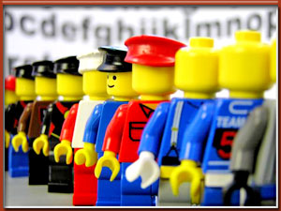
Workforce

Please note that the following lesson is based on an article written by your professor.
- Canada is a diverse society with several historic divides (such as the ethno-religious, regional and class divides) which makes democratic governance especially challenging. The situation is not likely to get any easier. There are reasons to suppose that governing in Canada may be becoming even more complex and this could have important implications for political support. Moreover, the Canadian case may reflect some of the same challenges that might also be faced by other advanced industrial democracies.
- Several structural and lifestyle changes have been altering the socio-cultural mix of Canadian society, possibly contributing to the expansion of various new value divides. Shifting immigration patterns and increasing ethnic diversity, for example, may be fuelling a growing value divide between immigrants and native-born Canadians. Different formative experiences and changing socialization patterns may be expanding the value divide between younger and older generations. And growing numbers of women acquiring higher levels of education and entering the paid workforce may be widening the value divide between sexes.
- Values play a prominent role in shaping people’s policy demands and political preferences.¹ It is entirely plausible, therefore, that increased value diversity resulting from the expansion of various new value divides could elevate the degree of intra-societal stress on Canada’s political system by making it increasingly complicated for governments to consider and respond to citizen demands.² Were this to result in a sustained increase in output failure on the part of governments, it could inevitably threaten the legitimacy of the democratic political system, its institutions, and perhaps even the governing principles and political communities which it serves. At the very least, we would expect that disgruntled citizens may be more inclined to direct their displeasure at people in government, as initially they are the most likely to be blamed.³ Indeed, there are already signs suggesting that dissatisfaction with politicians in Canada may be on the rise.⁴ Moreover, there are also indications that Canadians have become increasingly disgruntled with the responsiveness of their government and politicians.⁵
- In this lesson, we have two main objectives. The first is to employ data from the Canadian World Values Surveys to explore the possibility that value diversity across various new value divides may be on the rise. The second is to test whether the degree of value diversity between different social groups poses negative implications for political support, specifically support for people in government.

Study Materials

The Changing Socio-cultural Mix of Canadian Society
- Conventional wisdom suggests that the underlying cleavage structure that takes root within a society is the product of various historic formative events.⁶ In Canada, for instance, much has been documented about the historical development and continuing relevance of the traditional French-English, Catholic-Protestant, regional and class divides.⁷ Cleavage structures, however, may be more dynamic than originally conceived.⁸ Various structural and lifestyle changes resulting from the transition from industrialism⁹ to late industrialism have been transforming the socio-cultural mix of Canadian society. This process may be contributing to the expansion of several new value divides, and it could potentially reshape the traditional cleavage structure of Canadian society.
- Consider, for example, the changing nature of Canada’s immigrant population. The proportion of foreign-born residents in Canada has increased steadily over the last 70 years.¹⁰ Immigration has become increasingly vital for both population growth¹¹ and the expansion of the labour force.¹² And most importantly, immigration has made Canada a more multicultural society. That is, the ethnic composition of Canada’s immigrants has diversified considerably over time.
- Prior to the 1960s, most immigrants to Canada came primarily from Europe and the United States, which usually meant that culturally they were not very different from native-born Canadians. Today, the majority of immigrants arriving to Canada come from such non-traditional sources as Asia, the Middle East, the Caribbean, Central and South America and Africa.¹³ Because more recent immigrants have been socialized in societies that are more culturally distinct, there are reasons to suspect that with continued immigration the values of Canada’s immigrant population may slowly start to diverge more noticeably from those of their native-born counterparts.¹⁴ Because values play a commanding role in determining people’s issue preferences and policy demands, it is plausible that shifting immigration patterns and a possible divergence in values between immigrants and native-born Canadians may eventually contribute to the formation of a new political cleavage in Canadian society. Furthermore, because the case of immigration in Canada is not unlike changing immigration patterns detected in other advanced industrial states, it is highly probably that what transpires in Canada may also take place in other postindustrial states.
- Increased multiculturalism, however, is not the only concern. There are also reasons to suspect that the values of younger generations may be gradually diverging from those of their older counterparts. Evidence shows that increased economic development in advanced industrial states contributes to an intergenerational shift in the value priorities of mass publics,¹⁵ and Canada is certainly no exception to this trend.¹⁶
- Because younger generations have been socialized during a period of relative affluence, they are likely to espouse value priorities that are distinct from older generations who were raised during periods of greater economic scarcity. Greater economic security, it seems, has enabled younger generations to expand the scope of their value priorities beyond the realm of satisfying their most basic needs.¹⁷ It is not surprising, therefore, that in contrast to older generations, who place a greater priority on making ends meet and striving to attain more materialist goals, younger generations seem increasingly preoccupied with issues such as environmental protection and the quality of life. It is changes such as these that lead us to expect that the generational value divide in Canada may also be expanding. This in turn may contribute to the deepening of another political cleavage that could become increasingly salient over time. Moreover, if this is plausible in the Canadian case, then it is certainly also possible in other advanced industrial states.
- Lastly, research indicates that modernization and development in postindustrial states¹⁸ has resulted in a rising tide of gender equality.¹⁹ "Throughout history, women in virtually all societies have had their life options restricted to the roles of wife and mother. Increasingly today, in postindustrial societies, almost any career and almost any lifestyle is opening up to them."²⁰ Women in advanced industrial states are now more educated and engaged in the paid workforce than they were in the past. It is plausible, therefore, that factors such as greater financial independence and increased enlightenment through higher education could spark a shift in the value systems of working women. This, in turn, could potentially contribute to expanding the value divide between men and women more generally.
- Since Canadian women have experienced the same sorts of structural and lifestyle transformations as women in other advanced industrial states, there are few reasons to suppose that the proposed trajectory of the modern gender value divide would be any different in the Canadian case. Census data indicate that the proportion of Canadian women enrolled in post-secondary educational institutions now outnumbers men.²¹ There is also evidence to show that an increasing proportion of women in Canada are working outside the home. In fact, women in Canada currently make up nearly half of the paid workforce and they contributed to two-thirds of the growth in the labour force during the ‘90s. Furthermore, women "accounted for more than one-half of the growth during the decade in those occupations which normally require a university education."²² All of this is to suggest that a new gender divide may also be developing within Canadian society, just as it may be developing in other advanced industrial states.

Value Diversity and Support for Political Authorities

- Forty years ago, Easton (1965) claimed that political systems are affected by their intra- and extra-societal environments.²³ Changes in either of these contexts, he argued, can place a considerable amount of stress on political life. Output failure on the part of democratic governments can occur if the number of competing demands on the political system increases to the point of creating a demand overload or if too many demands remain unfulfilled.²⁴ In either case, the end result may be a decline in political support.
- In a similar vein, it is plausible that changes in the socio-cultural mix of a democracy could increase the level of intra-societal stress on the political system, by further complicating the governing process. The potential for increased value diversity between different social groups brings with it the inherent possibility of further differentiation in viewpoints and the potential for newly emerging fault lines. This in turn may feed predispositions toward social and political tensions and make democratic governance more difficult. The net result may be an eventual increase in unpopular government decisions (or lack thereof) and declining levels of political support.
- There are multiple ways in which this might occur. One consequence of an expansion in new value divides is the possible injection of new issues and policy debates onto the political agenda. Growing concerns about environmental degradation, for instance, constitute a primary example of a relatively contemporary policy debate that may be fuelled in part by an expanding generational value divide. Likewise, the recent debate over the reasonable accommodation of different ethnic groups (particularly in the province of Quebec) may be at least partly reflective of shifting immigration patterns and an expanding immigration value divide.²⁵ One possibility, therefore, is that an amalgamation of new policy concerns and traditional policy debates might make it increasingly difficult for democratic governments to reconcile the issue preferences of different groups and satisfy a broad coalition of citizens.²⁶
- There is already evidence in Canada which suggests that the consistency between public opinion and policy decisions has begun to decline.²⁷ This is hardly surprising given that governments typically have only a finite amount of time and resources with which to deal with citizens’ wide-ranging demands, in addition to implementing their own political agendas. The concern, however, is that a rise in unpopular government outcomes could eventually deepen citizens’ feelings of political discontent. At first, such negative sentiments may be directed primarily toward people in government as they are the easiest to blame. Eventually, however, it is not difficult to see how a sustained period of unpopular government outcomes could also affect more diffuse levels of support.²⁸
- Another possibility is that increased value diversity between social groups might detract from social cohesion, which may have indirect implications for political support. Recent evidence from both the United States and several other societies suggests that people living in more value diverse communities are less likely to interact and build bridges socially.²⁹ As a result, the prospects of developing dense social networks and sufficient stocks of social capital necessary to lubricate social life and make democracy work may be significantly diminished.³⁰ This in turn could have multiple consequences.
- For instance, in communities with low levels of social capital, citizens may be less inclined to play strictly by the rules because they are not as likely to trust that others will do the same. They may also be less committed to demanding good governance and accountability from their politicians, because they may be less preoccupied with improving the collective good.³¹ The point is that eventually the social infrastructure in such societies may become less compliant with the requirements of a well functioning democratic political system. This, in turn, may contribute to making politicians and government institutions seem less effective and result in lower levels of political support.
- In addition, because dense social networks can serve as important training grounds for developing the practical and civic skills necessary to foster greater democratic participation,³² greater value diversity between social groups might also detract from peoples’ capacity to participate in politics. This is relevant because research suggests that political authorities are more inclined to respond to citizens who voice their opinions the loudest and those who are the most politically active.³³ Consequently, greater value diversity between social groups might indirectly contribute to making it more difficult for citizens to express their concerns and participate in the democratic process. This in turn may make it more difficult for policy makers to consider and respond “equally” to peoples’ respective needs and demands.³⁴ And this too may result in more unpopular government outcomes and eventually, lower levels of political support.
- There are a variety of reasons, therefore, to suggest that changes in the socio-cultural mix of Canadian society may be contributing to greater value pluralization and the growing relevance of various new value divides. There are also reasons to suppose that increased value diversity between social groups and the potential reshaping of the traditional cleavage of Canadian society may have implications for democratic governance and declining levels of political support. To examine these propositions, we turn now to the empirical evidence.

Data
- The data for this analysis come from the Canadian World Values Surveys (WVS). These data are ideal for this investigation for a variety of reasons.
  - First, the WVS contain several indicators tapping different types of political support, including a measure that focuses directly on support for political authorities.
  - Second, the WVS also contain a variety of variables designed specifically to measure attitudes, beliefs and behaviours across a wide range of social, economic and political domains. Data such as these (as we shall explain) make it possible to look empirically at a broad spectrum of value orientations.
  - Third, with the WVS it is possible to both compare value differences between various social groups and to track changes in value divides across time. This analysis, for instance, examines comparable evidence from both 1990 (n = 1,730) and 2000 (n = 1,931).
  - Lastly, the 2000 Canadian WVS include a supplementary survey of recent immigrants – The New Immigrant Survey (NIS) - which is intended specifically to support more detailed investigations of Canada’s immigrant population.³⁵
- Data such as these make it possible to investigate how recent changes in immigration patterns may be affecting the value divide between immigrants and native-born Canadians. The overall effect of the NIS is to add another 563 immigrants to the 665 immigrants already sampled as part of the core WVS conducted in 1990 and 2000. It also boosts the proportion of more recent immigrants who have been in Canada for only a short time and who have come from non-traditional source countries.
- In most every aspect, the basic features of the core WVS and the NIS are the same: both surveys contain the same questions, which are listed in the same order, using exactly the same preamble and response metrics. The only differences are that the NIS respondents were given an additional choice of language of interview – French, English or Cantonese/Mandarin – and they were randomly selected from three major urban centres – Toronto, Vancouver and Montreal.

Identifying Canadians' Values
- The first step in our analysis was to quantify a sample of Canadians’ values. Not a simple task. Because values play a commanding role in structuring people’s “functionally integrated belief systems”, they can be a more “economically analytical tool for describing and explaining similarities and differences between persons, groups, nations, and cultures” than attitudes, beliefs or behaviour.³⁶ But values are difficult to analyze directly because they are embedded in what people say, in what they believe and in how they act.
- Our approach to contending with this issue was to follow the lead of our European counterparts who utilize non-observable latent constructs to identify and measure values.³⁷ This strategy assumes that values are “a simple but general consistency generator”³⁸ and that people’s value orientations serve as an underlying mechanism for structuring their attitudes, beliefs and behaviour. Given these assumptions, it is possible to examine value systems by analyzing the underlying structure of survey responses.
- Step one of our analysis, therefore, was to subject the entire gamut of comparable indicators contained in the 1990 and 2000 Canadian WVS³⁹ to an exploratory factor analysis, which is a data reduction procedure designed to identify groups of indicators that are empirically correlated. Table 1 reports our most consistent and robust findings.⁴⁰
- Note first that Canadians organize their orientations and behaviours in very distinct ways. For example, religious matters cluster separately from outlooks toward the family and moral considerations. And orientations toward work are structured independently from outlooks toward economic and technological progress and postmodern concerns. What these findings suggest is that that there are likely a wide variety of value patterns contained within the Canadian value system and that value orientations vary from one domain to the next.⁴¹
- Note too that value patterns vary even within domains. When it comes to religion, for example, there are at least three different value clusters that emerge. One unites basic outlooks toward religiosity. A second combines more specific views toward the institutional adequacy of church leadership. And a third encompasses spiritual beliefs about life after death, whether people have a soul, and beliefs about heaven and hell. What these findings suggest is that aside from distinguishing their religious values from values in other domains, Canadians also have different values toward different aspects of religion.
- Similarly, Canadians' moral outlooks also cluster in multiple ways. For example, reflections on the appropriateness of behaviours such as abortion, divorce, homosexuality, prostitution, euthanasia and suicide are united by what we refer to as values toward moral permissiveness. And views on more public matters, such as claiming unentitled government benefits, avoiding a fare on public transport, accepting a bribe and cheating on taxes are linked by what we describe as values toward civil permissiveness.
- Because our aim was to probe for changes in the degree of value diversity across various new value divides, we limited our selection of variables for analysis to only those indicators that are comparable and measurable across time.
- By consistent and robust we mean that similar findings reemerge when the data are analyzed in different ways – both for different time points as well as for different demographic groups and sub-communities within Canada.
- Moreover, there are even reasons to suppose that certain values may be more deeply ingrained than others. For example, these preliminary results suggest that religious (average Cronbach’s alpha = .73) and moral (average Cronbach’s alpha = .8) values may be more fundamental than values toward economic and technological progress (average Cronbach’s alpha = .43), values toward work (average Cronbach’s alpha = .40), family values (average Cronbach’s alpha = .40) and postmodern values (average Cronbach’s alpha = .5). Much more research, using alternative indicators from future WVS and other data sources will be required, however, before we are able to further substantiate such claims and better understand the true breadth and diversity of the Canadian value system.
- Orientations toward economic and technological progress comprise a third value domain, also consisting of multiple value patterns. For example, views toward economic competition and privatization combine to reflect values toward the core principles of market economics. Orientations toward income equality and personal responsibility join to represent values toward economic fairness. And orientations toward technology development and scientific advancements come together to reflect values toward technological and scientific progress.
- Because the WVS are particularly rich in indicators measuring orientations toward work, it is not surprising that the statistical scanning of these data reveals a slightly wider array of value patterns. The first cluster of variables represents values toward traditional workplace conditions – factors such as the number of hours involved, the amount of holiday time available, and the levels of pay and stress entailed. A second cluster combines perceptions toward following instructions at work and employee involvement in workplace decision-making to capture values toward workplace participation. The third dimension taps values toward higher level workplace motivations, such as personal initiative, achievement, responsibility and the use of abilities. The fourth cluster measures values toward money and work more generally. And the fifth dimension reflects people’s values toward the traditional work ethic by distinguishing between the importance people place on teaching children about hard work and other priorities such as determination and perseverance.
- When it comes to family values, there are three specific value clusters that emerge. The first combines different orientations toward women working to capture values toward women and work. The second measures values toward a particular style of child-rearing, one that encourages independence over obedience. And the third taps values toward single parenting. Likewise, three separate value structures emerge under the domain of postmodern values. The first captures people’s values toward environmental protection. The second measures the degree to which people value friends and leisure. And the third captures the distinction between materialist and postmaterialist values.

Exploring the Evidence Relating to New Value Divides
- Value orientations in hand, the second step in our analysis was to explore the possibility that structural and lifestyle changes may be contributing to the expansion of several new value divides in Canadian society. In order to investigate the proposition that changing immigration patterns and increasing ethnic diversity may be widening the value divide between immigrants and native-born Canadians, we compared the values of immigrants and native born-Canadians on each of the 19 value clusters identified above (see Table 2). Notice first that there are clear differences in how closely the values of immigrants resemble those of native-born Canadians. Immigrants from non-traditional source countries have more than three times as many value differences (7) with their Canadian-born counterparts as do immigrants from traditional source countries (2).
- Notice too, that the range of value discrepancies between immigrants and native-born Canadians also varies. Immigrants from traditional source countries and native-born Canadians differ mainly on values relating to work. The former are more likely than the latter to emphasize the importance of hard work and to support employee participation in workplace decision-making. Immigrants from non-traditional source countries, on the other hand, differ from native-born Canadians on a much wider array of values, including religious and moral values, values toward scientific and technological progress, values toward work, family values and postmodern values. More specifically, immigrants from non-traditional source countries are more religious and less morally permissive than native-born Canadians. They are also more supportive of technology and scientific advancements and more likely than native-born Canadians to value hard work. In addition, immigrants from non-traditional source countries are not as supportive as native-born Canadians of single parenting and encouraging children to learn about independence as opposed to obedience. And immigrants from non-traditional source countries are less postmaterialistic in their views than their native-born counterparts.

Exploring the Evidence Relating to New Value Divides (Cont'd)
- Furthermore, a comparison of data compiled over the 1990s indicates that the proportion of values on which immigrants from non-traditional source countries and native-born Canadians have shifted further apart (37%) is more than double the proportion of values (16%) on which they have converged. Moreover, the number of values on which immigrants from non-traditional source countries and native-born Canadians differ significantly has increased from 5 (in 1990) to 7 (in 2000). This means that these two groups have even more value differences now than they had in the past. Also, the average magnitude of these value discrepancies has expanded from 12.6% (in 1990) to 14.14% (in 2000) which suggests that the extent of these value discrepancies may be increasingly difficult to reconcile. Furthermore, the vast majority of values (71%) on which immigrants from non-traditional source countries and native-born Canadians have diverged are newly emerging discrepancies which did not exist during the early 1990s. The bulk of the cross-time evidence, therefore, not only points to consistent signs of increased value diversity, but it also suggests that the nature of the value discrepancies between immigrants from non-traditional source countries and native-born Canadians is also changing.
- It is difficult to predict whether the growing value diversity between immigrants from non-traditional source countries and native-born Canadians will begin to fade as immigrants become more acculturated into Canadian society.⁴² At this point, we simply do not have enough longitudinal evidence to know for sure. Based on the evidence that we have, however, it seems more likely that continued immigration from non-traditional source countries may do more to expand the value divide between immigrant and native-born Canadians than the forces of acculturation might do to reverse such a trend.⁴³
- Even the evidence pertaining to immigrants from traditional source countries, who share many more value similarities with native-born Canadians than more recent immigrants, and who have resided in Canada for a much longer period of time than more recent immigrants from non-traditional source countries, indicates more signs of value divergence than convergence.
- For example, data from the 1990s demonstrates that the proportion of values on which immigrants from traditional source countries and native-born Canadians diverged (11%) is more than double the proportion of values on which they converged (5%). Moreover, even the number of values on which immigrants from traditional source countries and native-born Canadians differ significantly has increased (from 1 in 1990, to 2 in 2000) and so too has the average magnitude of those discrepancies (from 9% in 1990 to 10% in 2000). Furthermore, all of the values on which immigrants from traditional source countries and native-born Canadians have diverged represent newly emerging value discrepancies, which were not previously apparent during the early 1990s. Given these preliminary results, therefore, it seems more likely that with the continued influx of immigrants from non-traditional source countries, the immigrant value divide is more likely to continue to expand than contract.
- There is still the possibility that younger immigrants from non-traditional source countries, who have not been socialized for as lengthy a period of time in their countries of origin, may have fewer value differences with their native-born counterparts than older generations. Moreover, because they may be less indoctrinated, it is also possible that they may also be more readily acculturated into Canadian society. These are both very realistic possibilities, and likely to be increasingly salient as Canada’s immigration policy becomes increasingly geared toward attracting younger immigrants.
When we examined these propositions, however, our preliminary findings suggest that young immigrants from non-traditional source countries have even more value differences with their native-born counterparts than similarities. More specifically, they clash on 53% of the values that we examined. Moreover, the average magnitude of these differences (14.3%) is comparable to the average magnitude of the value differences between native-born Canadians and immigrants from non-traditional source countries overall. Also, in not one instance did we find any evidence to suggest that immigrant youth alter their values after having lived in Canada for an extended period of time.
- Shifting immigration patterns aside, however, there is also the possibility that changes in formative experiences and socialization patterns may be contributing to an expanding generational value divide. Table 3 explores this proposition by comparing the value orientations of generations born prior to 1945 with those born after 1960.⁴⁴The results are particularly striking, in that value differences between younger and older generations are even more apparent than the value differences between immigrants from non-traditional source countries and native-born Canadians. On more than a majority (12 out of 19) of the value patterns examined, the findings indicate that the values of younger generations differ significantly from those of older generations. This implies that younger and older generations have even more value differences (63%) than similarities (37%). Moreover, the extent of this value diversity spans across multiple domains.
- For instance, younger generations are both less religious and more permissive than older cohorts, meaning that they are not as likely to value religion and religious institutions, and they are more likely to be morally permissive and accepting of civil misconduct. Younger generations are also more likely than older generations to support a variant of economic fairness that incorporates both greater income equality as well as personal responsibility. And unlike their parents and grandparents, younger generations are more supportive of workers participating in workplace decision-making, but less inclined to emphasize money and work, and less inclined to teach their children about the importance of hard work as opposed to other achievement orientations, such as perseverance and determination. Furthermore, when it comes to family and postmodern values, the evidence suggests that younger generations are more supportive of single parenting, more supportive of women working, more supportive of environmental protection and more postmaterialist in their views than older generations.
- Turning to the cross-time findings, the evidence suggests that during the 1990s, the proportion of values on which younger and older generations shifted further apart (42%) was greater than the proportion of values on which they converged (37%). Moreover, both the total number of significant value differences between young and old and the average magnitude of those discrepancies has increased (the former from 11 in 1990 to 12 in 2000, and the latter from 12.45% in 1990 to 13.5% in 2000). Thus, not only do younger and older generations of Canadians have fewer values in common today then they did in the past, but the extent of those value differences has also expanded. The average magnitude of the value discrepancies between younger and older generations (13.5%) is not as great as the average magnitude of value discrepancies between immigrants from non-traditional source countries and native-born Canadians (14.14%), but is also not insignificant. Moreover, at least half of the values on which younger and older generations have diverged constitute newly emerging value discrepancies which did not exist prior to the turn of the century. The bulk of evidence, therefore, indicates that not only are there profound value differences between younger and older generations in Canada, but that the generational value divide seems to be expanding over time.
- Because many of the forces that are believed to be driving intergenerational value change in advanced industrial states came into effect after WWII and evidence of value change did not actually begin to surface until the 1960s, we use these two markers as our primary cutoff points for examining generational differences in values.

The same may also be true for the gender value divide. Because women are now acquiring higher levels of education and participating in greater numbers in the paid workforce, there is the possibility that such experiences may affect their values and potentially fuel a growing divergence in values between the sexes. Evidence from the 2000 WVS reported in Table 4 suggests that men and women have fewer value discrepancies than younger and older generations, but no fewer value discrepencies than immigrants from non-traditional source countries and native-born Canadians. Based solely on a comparison of numbers of value discrepancies, therefore, it would seem that the gender value divide may be at least as potentially contentious as the value divide between immigrants from non-traditional source countries and native-born Canadians.
On balance, men and women share more value similarities (63%) than differences (37%). Particularly when it comes to family values, the findings suggest that men and women think virtually alike. Where they differ, however, is on religious and moral values, values toward economic and technological progress, values toward work and postmodern values. Women, for instance, are both more religious than men and more supportive of the adequacy of church leadership. Men, on the other hand, are more tolerant of civil misconduct, more supportive of market economics, and more likely to support technology and scientific advancements. Men are also more likely than women to want to encourage their children to learn about the value of hard work. And they are more postmaterialistic in their outlooks than women.
Furthermore, there are indications to suggest that the gender value divide has expanded over time and that it is likely to continue expanding in the future. For example, the cross-time evidence shows that the proportion of value orientations (26%) on which men and women diverged during the 1990s is more than double the percentage of values on which they converged (11%). Also, both the total number of significant value discrepancies between men and women and the average magnitude of these differences have increased (the former from 6 in 1990 to 7 in 2000, and the latter from 7.67% in 1990 to 8.43% in 2000), although the average size of the value differences between men and women is still considerably smaller than the average value discrepancies between immigrants from non-traditional source countries and native-born Canadians and the young and old. Nonetheless, in at least 40% of instances where the values between men and women have diverged, the divergence was attributable to newly emerging value discrepancies, which were not previously apparent in 1990.
Moreover, if we compare males to working females, we find that the proportion of value similarity between sexes declines sharply (from 63% to 47%). That is, men share even fewer value similarities with working women than differences. But does this mean that as more women enter the workforce and occupy higher level positions that the gender value divide will continue to expand? In certain cases, there is evidence to suggest that as the proportion of working women continues to increase, women may actually start to take on values that are more similar to men. For example, working women are no less likely to tolerate civil misconduct than men. They are virtually as supportive of market economics as men. And they are no less postmaterialistic than men. In other respects, the evidence suggests that an increase in working women is likely to reinforce and maintain some of the same value differences noted earlier between men and women more generally. For instance, despite being in the paid workforce, working women remain more religious and supportive of the role of church leadership than men. They also remain less likely to support technology and scientific advancements than men. And they are still less likely to think that it is important to teach children about work.
Most of the evidence, however, indicates that as the proportion of working women continues to increase, the value differences between men and women are likely to increase. For example, unlike women more generally, working women are significantly more morally permissive than men. They are also more likely to value workplace participation, and more inclined to de-emphasize money and work overall. Moreover, working women have entirely different family values from men. For instance, working women are more supportive of single parenting than men. They are more supportive of women working. And they place greater importance on encouraging children to learn about independence.
In addition, when we examine the cross-time results for men and working women, we find even more signs of diverging value gaps (from 26% to 37%) than for men and women more generally. Indeed, during the 1990s, the number of significant value discrepancies between males and working women increased by nearly 70% (from 6 in 1990 to 10 in 2000). And the vast majority of these value discrepancies (86%) were attributable to newly emerging value discrepancies which did not exist in 1990. All of these findings suggest that the gender value divide is more likely to continue expanding as more women enter the paid workforce.
Note, however, that there is also evidence to suggest that the magnitude of the value differences between men and working women may be stabilizing (from 9.67% in 1990 to 8.9% in 2000). During the 1990s the proportion of value convergence that took place between men and working women (21%) was virtually double the proportion of value convergence that occurred between males and females more generally (11%). Thus, in certain respects men may be narrowing the values gap that has developed between them and working women. Still, the majority of evidence indicates that there are significant value differences between men and women and that the number of these discrepancies is increasing at a relatively rapid pace, which suggests that the gender value divide is more than likely to expand over time.
he overall findings summarized in Table 5 lend overwhelming support to the claim that various structural and lifestyle changes may be contributing to the expansion of several new value divides in Canadian society. Certain new value divides, however, may be more contentious than others. Immigrants from traditional source countries, for instance, share many more values in common with native-born Canadians than do immigrants from non-traditional source countries, and the range of their value discrepancies is not very diverse. Likewise, males and females have virtually the same proportion and variety of value differences as immigrants from non-traditional source countries. Moreover, the evidence relating to the males/working females value divide suggests that as more women enter the paid workforce, the gender value divide could become even more contentious. And according to our analysis, it is the generational value divide that is potentially the most contentious. Pre-1945 and post-1960s generations share the least proportion of values in common and the range of these value discrepancies spans across multiple domains and several value dimensions.
Furthermore, data from the 1990s consistently point to more signs of divergence than convergence. The number of significant value discrepancies across each new value divide has increased. And, in 80% of these cases, the average magnitude of these value gaps has also increased. In addition, the evidence in a majority of instances confirms that a significant proportion of the diverging value gaps that we detect are attributable to newly emerging value discrepancies which were not already in existence in the past. Thus, not only do new value divides appear to be expanding, but the nature of the value discrepancies across new value divides also appears to be becoming more diverse.
Based on this evidence, therefore, it is certainly plausible that the increased value diversity introduced by new value divides, when combined with the value diversity caused by old divisions (such as the ethno-religious, regional and class divides) may make it even more difficult for future governments to consider and respond to citizen demands.⁴⁵ Moreover, because “the increasing dimensionality and complexity of policy space create the potential for more citizens to feel that government is not sufficiently addressing their concerns”,⁴⁶ it is also conceivable that greater value diversity may lead to higher levels of public disillusionment with political authorities. But is that the case? What does the evidence suggest?

Value Diversity and Specific Political Support
The final step in our analysis was to investigate whether the degree of value diversity between different social groups poses implications for political support, specifically support for people in government. Figure 1 aims to test this proposition. The x-axis measures the average degree of value diversity attributable to various new and old cleavages. The y-axis reports the average percentage of satisfaction with the way the people now in the federal government are handling the country’s affairs. While the association is far from perfect,⁴⁷ the general pattern is strikingly clear: the greater the degree of value diversity within a particular value community,⁴⁸ the less likely citizens are to be satisfied with the way the people now in the federal government are handling the country’s affairs.
But exactly how significant is this association? The first important point to note is that value diversity accounts for a sizeable proportion (nearly 40%) of the variation in a community’s satisfaction with people in government. Moreover, based on the findings reported in Figure 1, there is reason to suppose that a further increase in value diversity equivalent to the shift that occurred during the 1990s could result, on average, in an additional 7% decline in support for people in government. This means, therefore, that if future shifts in value diversity were to continue to increase at a pace that is consistent with the 1990s, public satisfaction for the work done by political authorities, particularly among especially disgruntled value communities such as Francophones in Quebec could be profoundly eroded in a matter of just one to two short decades.
47The West, for example, would appear to be an outlying case in that support for people in government is lower than support for political authorities in other groups or communities with similar degrees of value diversity. Conversely, support for people in government in Ontario is slightly higher than in other communities with similar levels of value diversity. In both cases, however, these findings are to be expected given that Ontarians voted in greater numbers for the government in power at the time and Westerners were among the least supportive of the government at the time.
48Ideally, we would have liked to test this association across Canada’ more than 300 electoral districts. Sample sizes within these constituencies, however, were not sufficiently large enough to permit such an analysis. As an alternative, we opted instead to aggregate the data that were available and to examine this association across 38 different value communities. For more precise details on the composition of these value communities, see the descriptive note under Figure 1.

Of course, fluctuations in political support are likely affected by a variety of factors. Supporters of a governing party, for instance, may be predisposed to evaluating political authorities more positively than those who support alternative parties. Furthermore, there is also evidence to suggest that Canadians, similar to citizens in other advanced industrial states, have become less respecting of traditional forms of hierarchical authority.⁴⁹ It is plausible, therefore, that variations in support for political authorities may also be linked to a more general decline of deference.⁵⁰

Lastly, there is the additional possibility that variations in political support may be partly tied to media effects. One fairly prominent variant of this line of argument suggests that it is an increasingly interpretive and critical media that feeds public dissatisfaction with political authorities.⁵¹ Another contends that the information explosion and increased exposure to news about politics improves public understanding of the political process and makes citizens more critical of political affairs.⁵² Either way, there is reason to suppose that variations in exposure to the news media may also be linked to variations in people’s assessments of political authorities.

Table 6 reports the results of a multivariate analysis examining the effects of value diversity and each of the three preceding competing arguments on support for people in government. Note first that communities which are more supportive of the governing party are more likely to express a higher degree of satisfaction with political authorities than those who are less supportive. Notice also that the association between citizens’ orientations toward authority and support for people in government does not appear to be significant – at least not at the community level. Likewise, exposure to politics on the news also appears to have no significant impact on public support for people in government at the aggregate level.

What is remarkable about these findings, however, is that even after taking into account various competing arguments, the value diversity explanation not only remains a significant predictor of political support for political authorities, but it turns out to be the most powerful explanation overall. Moreover, when we look independently at the effects of value diversity that are attributable to both old and new divides, the evidence clearly indicates that both are equally relevant. This evidence, therefore, provides more compelling reasons to suppose that the degree of value diversity within a community, regardless of whether it is attributable to new or old cleavages, poses significant implications for political support. Furthermore, these findings lend support to the proposition that the expansion of various new value divides may be making it more difficult for political authorities to maintain political support.

Lesson 10: New Cleavages

Readings

Required Readings

Stephen Brooks, Canadian Democracy: An Introduction, 7th ed. Toronto: Oxford University Press, 2012, Chapter 2, 14 and 15.

Lessons Learned
See what you recall - are you familiar with:
- Governing a democratic society such as Canada is no simple task. It requires making complicated legislative and policy decisions while attempting to consider and accommodate a diverse array of competing needs and preferences. Traditional cleavages such as the ethno-religious, regional and class divides are typically implicated as the primary divisions within Canada’s cleavage structure. In this lesson, however, we argue that societal cleavage structures may be more dynamic than originally conceived. Various structural and lifestyle changes, such as shifting immigration patterns and increasing ethnic diversity, differing formative experiences and changing socialization patterns, and increasing levels of education along with greater participation in the paid workforce, particularly on the part of women, have been transforming the socio-cultural mix of Canadian society. This process, we suggest, may be contributing to the expansion of several new value divides, which in turn could reshape the traditional cleavage structure of Canadian society.
- The results of this analysis demonstrate that there are a wide variety of value patterns contained within the Canadian value system and that value orientations vary from one domain to the next, as well as within domains. Our analysis considers 19 different value dimensions, including religious and moral values, values toward economic and technological progress, values toward work, family values and postmodern values. The findings suggest that the degree of value diversity across various new divides may be shifting. More specifically, evidence compiled during the 1990s indicates that the degree of value diversity between immigrants and native-born Canadians, younger and older generations and men and women has increased.
- Certain value divides exhibit a more diverse and extensive range of value discrepancies than others, which suggests that they may be more potentially contentious than others. However, the cross-time data for all three divides consistently indicate more signs of value divergence than convergence. Moreover, the evidence shows that the number of significant value discrepancies across all three new divides has increased. And in most cases, the average magnitude of the value discrepancies across all three new divides has also increased. Furthermore, there are consistent indications of newly emerging value discrepancies across all three divides. Thus, not only does the bulk of the cross-time evidence suggest that new value divides are expanding, but it also indicates that the nature of the value discrepancies across new value divides appear to be becoming more diverse.
- The increased value diversity introduced by new value divides, when combined with the value diversity that is already attributable to old divides within Canada’s traditional cleavage structure, could make democratic governance more complicated and possibly detract from political support. The results of this analysis lend some preliminary support to this proposition by demonstrating that citizens in more diverse value communities are less likely to be supportive of people in government. Indeed, even after we control for factors such as variations in support for the governing party, variations in respect for authority and variations in exposure to news media, the influence of value diversity on support for political authorities not only remains significant, but turns out to be the most powerful predictor overall. Moreover, when we look independently at the effects of value diversity that is attributable to both old and new divides, the findings clearly indicate that both are equally relevant. The evidence from this analysis, therefore, provides more compelling reasons to suppose that the degree of value diversity within a community poses significant implications for political support and that the value diversity attributable to various new value divides plays an independent role in making it more difficult for political authorities to maintain political support.
- The results of this analysis imply that the context for public policy-making and legislative decision-making in Canada may become increasingly contentious and difficult for making collective choices that respond to differing needs and appeal to mass publics. Political authorities in the future may not only have to contend with the differing preferences and demands that stem from traditional divides, but they may also have to deal increasingly with the stresses posed by various new divides. Moreover, these new divides reflect more than just the challenges posed by increased multiculturalism. They also highlight the potential relevance of the generational and gender divides.
- There are various ways in which new value divides and greater value diversity might make democratic governance more difficult. It could, for instance, breed increasingly varied political demands and issue concerns, which may make it more difficult for governments to bring together competing interests and present platforms that appeal to a mass of voters. It could also have implications for social cohesion and detract from the development of social capital, which may make the workings of democracy more difficult. And it could also make it more difficult for governments to consider people’s demands and preferences. Because dense social networks serve as important training grounds for developing the practical and civic skills necessary to foster greater democratic participation, the deterioration of social networks may detract from people’s capacity to participate in politics. In either of these instances, the more government decision-making continues to become less efficient and less effective, the greater the possibility that this could have even graver consequences for more diffuse forms of political support, such as support for political institutions, overall satisfaction with democracy, support for fundamental regime principles and perhaps even support for the political community.
- The results of this research, therefore, are just the start. There is much more work that has yet to be done. And there are obvious limitations on how far we can speculate based strictly on the results of this analysis. The data that we have examined travel only as far back as 1990. This means that there is no way of telling what levels of value diversity were like prior to that time. Building further support for this line of analysis will require more cross-time data. Also, there are several important questions that have yet to be examined. For example, are some new value divides more relevant than others? How specifically does value diversity affect democratic governance and detract from political support? And do the effects of value diversity transcend beyond support for political authorities and influence more diffuse types of political support? Moreover, because the same structural and lifestyle changes that have taken place in Canada have also occurred in other advanced industrial states, another future objective will be to test the value diversity argument cross-nationally, to see if the findings apply more broadly. The results of this preliminary investigation lead us to believe that there are good reasons to expand the scope of this analysis and to continue pursuing this line of research.

Discussion Question
Please comment on the following:

The new cleavages of today are not going to be as relevant in Canadian politics as the old cleavages of the past.

Lesson 11: The Role of Politics

Introduction
Canadian Flag (Source: Wikipedia.org)
- This lesson provides a general overview of politics.
- It introduces you to different political systems.
- It provides a brief description of constitutions and the different branches of government.
- And it outlines the importance of electoral systems, parties and interest groups.

What is Politics?
Broadly speaking, politics is about societal decision-making and the authoritative allocation of societal values. Cleavages within a society, both new and old, can result in differences in political preferences and demands. Politicians contend with such competing claims and make difficult choices for society as a whole.
More specifically, politics is concerned primarily with "who gets what, when, where and how,"¹ and because the pool of collective resources in a society is often limited or scarce, such decision-making can often be highly contentious and become exceedingly complicated.

What is the Role of the State?
When people talk about “the state”, they are generally referring to the political institutions in a particular country - its legislature, executive, civil service, courts, armed forces, police, and so on.
A state has many responsibilities, including "creating and maintaining internal order" within its borders, "protecting its own territorial integrity in the international system" and making and implementing binding collective decisions for its citizens (Cairns 1986).
Note too, that because of the differences in political systems, economies and military capabilities, states can vary in their degree of authority, both domestically and internationally.

Power, Influence and Compliance
Politics, therefore, can also be understood as the exercise of power, influence and compliance. The state has the power to influence people's lives and there are various reasons why people might comply.
Compliance may result from:
Coercion | emerges as a result of the threat or use of force.
Influence | emerges as a result of one party being able to convince another party that a particular action is reasonable or in their best interest.
Respect for authority | stems from the "recognition on the part of the compliant party that the person or the organization issuing the command has the right to do so and should be obeyed" (Brooks 2007).

Coercion in Canada
In Canada, as in other democratic states, the use of coercion is generally not preferred. Bodies such as the police will sometimes use coercion or force, but it must be justified as being necessary to protect and maintain the rule of law.

What is State Legitimacy?
Legitimacy gives the state the moral authority to pursue its goals and obligations.
When citizens express a broad base of support of their political system and their political authorities, they provide the state with the legitimacy it needs to exercise its powers and fulfill its responsibilities.
Instrumental to this notion of state legitimacy is the existence of a shared political community.
It is important that the state respect this moral legitimacy. Failure to respect the rules of the political system or the misuse of authority may in fact damage the state’s legitimacy.

Political Systems

What are political systems?
There are various types of political systems. Aristotle, for example, claimed that a political system with one ruler constitutes a tyranny. A particular system with a few rulers is an oligarchy. A political system with many rulers is a democracy. Because Canada is a democracy, we will be focusing mainly on this type of political system.
A democracy is a political system that is premised on the formal equality of all citizens. In a democracy, there is a realistic possibility that voters can replace the government or become part of the government. Also, in a democracy, the basic rights and freedoms of citizens are generally protected (Brooks 2007).

The Democratic Model
There are at least two variants of the democratic model. The majoritarian model and the consensual model. Each has a different way of engaging the public.
Majoritarian Model | Consensual Model
Claims that the majority of citizens within a democracy should be responsible for governing. | Claims that a democracy must involve as many of its citizens as possible.
In Canada, one can find examples of both types of political decision-making.
State powers within political systems may also be centralized or decentralized.
Unitary States | vs. | Federation
- States that have power concentrated in the centre or in one central government are referred to as unitary states.  - In unitary states, political power may be transferred or delegated to sub-national units, but the central government has the authority to reclaim that power and to create or abolish sub-national governments.  - England is a unitary state. |  | - A union of a number of partially self-governing states or regions under a central government is called a federation.  - A federation divides political power between two or more levels of government in which each has its own specific jurisdictions of responsibility.  - Canada is a federation.

Constitutions
Constitutions play a key role in ensuring that both the powers of a state and the rights of its citizens are protected. In this regard, Canada’s constitution is considered the fundamental law of the land.
For example, the Canadian constitution outlines the division of power between the federal and provincial governments. It also outlines the rights of all Canadian citizens in the Charter of Rights and Freedoms.

Legislatures
Constitutions also outline the different branches of government and their functions. The legislative branch of government, for example, is responsible for making and amending laws.
There are a variety of different legislative processes around the world.
At the federal level, Canada has a bicameral legislature. This means that bills must pass through two legislative chambers - the Senate and the House of Commons - in order to become laws.

The Executive
The executive branch of government is responsible for implementing laws and the day-to-day management of the state.
The executive in Canada consists of three separate bodies:

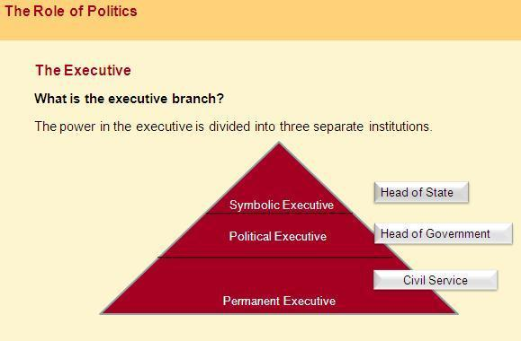
The powers of the head of state in Canada, the Governor General, are limited to a symbolic role. The real power rests with the head of government and the political executive, namely the Prime Minister and the Cabinet.
The executive also includes the permanent executive - the civil service - which plays an important role in implementing and administering policies that have been passed by the legislature and approved by the political executive.

The Judiciary
The judiciary - the third branch of government - enforces and interprets the laws. The judicial system allows for the peaceful resolution of disputes between citizens, between citizens and the state, and between different levels of government.
There are several tribunals within this branch of the government and power is divided hierarchically.
For example, the Supreme Court of Canada is the highest court of appeal and has the ultimate authority on constitutional issues.

Electoral Systems
In democracies such as Canada, certain members of the legislature and political executive are elected and the rules and regulations that govern that process are known as the electoral system.
There are many types of electoral systems. Canada, for example, has a single member plurality (or first-past-the-post) electoral system.
Voting in Canada is open to all eligible voters within the citizenry, but not all eligible voters always vote.
Electoral systems are incredibly important in that they can influence electoral outcomes. In Canada, for instance, it is frequently argued that the electoral system favours large national and regional parties.

Political Parties
Political parties serve as a major link between citizens and their political systems.
One of the main functions of political parties is to transmit public opinion to their political representatives. They also encourage political participation and structure political debates.
Political parties are voluntary and private citizens’ organizations, but because political parties perform functions that are crucial for the health of the political system they are considered to be political institutions.

Interest Groups
Parties, however, are not the only organizations that aggregate and represent citizens’ interests to the state.
Interest groups are another type of private association that also attempt to promote causes and influence the political system. Interest groups, however, do not seek to nominate representatives for election. They are not interested in forming government either.

Readings

Required Readings

Stephen Brooks, Canadian Democracy: An Introduction, 7th ed. Toronto: Oxford University Press, 2012, Chapter 1, 12 and 17.

Lessons Learned

See what you recall - are you familiar with:
- The definitions of politics and state?
- The major institutions that make up political systems?
- The distinct role that major institutions in political systems fulfill?
- How the major institutions that make up political systems link to society and state?

Discussion Question
Please comment on the following:

Is there an ideal type of political system?

Lesson 12: The Canadian Constitution

Introduction
This lesson outlines the purpose of Canada’s Constitution and describes some of its core principles. It also covers the different elements that make up the Constitution, including the new amending formula. In addition, it provides some brief but relevant insights about Canada’s relatively recent struggle for constitutional reform.

What is the purpose of Canada's Constitution?
The Canadian Constitution has many functions. Recall from the previous lesson that the Canadian Constitution is considered the fundamental law of the land. It enshrines fundamental political principles. It outlines the basic structure of Canada's political system and it divides certain powers and responsibilities.

What is the purpose of Canada's Constitution? (Cont'd)
The Constitution legitimates the state's authority. It also provides protection for Canadians by placing certain restrictions on what the state can do. In this respect, the Constitution plays a key role in establishing citizens' rights within the Canadian state.

What is the purpose of Canada's Constitution? (Cont'd)
The Canadian Constitution also plays an important role in helping to define a national identity. It unites citizens under one set of rules and in doing so helps to develop a sense of community. Sometimes, however, the Constitution had the opposite effect by creating negative feelings among the members of the Canadian political community (Brooks 2004). This was the case, for instance, when former Prime Minister Trudeau was attempting to repatriate the Constitution from Britain and certain provinces were not immediately on board.

Core Principles Contained within the Constitution
In 1998, the Supreme Court of Canada re-established that the core principles contained in the 'internal architecture' of the Constitution that governs Canadians are:
- Federalism
- Constitutionalism
- Rule of law
- Democracy
- The protection of minorities

The principle of federalism in the Canadian case means that the power to govern is divided between the federal and provincial governments. Provincial governments in Canada, similar to the federal government, have decision-making authority within their respective areas of jurisdiction. The Constitution outlines this separation of powers in sections 91, 92 and 93.
This division of powers will be covered in greater detail in Lesson 17.

Constitutionalism refers to the authoritative standing of the Constitution. Prior to 1982, the final authority of the Constitution was not spelled out. When the Canadian Charter of Rights and Freedoms was added to the Constitution in 1982, however, the principle of constitutionalism was more clearly outlined in section 52 (1) of the Constitution.
Section 52 (1) states that the Constitution is the final authority. All other legislation and public policy making must conform to the Constitution. This principle effectively places certain rights and freedoms beyond the reach of the government. It also shifts decision-making powers related to rights and freedoms in part to the judiciary. Judges, in addition to Parliament, are now charged with the responsibility of making sure that government legislation and public policy making are not unconstitutional.

The rule of law refers to due process, which is an attempt to limit the potential for arbitrary authority. It means that governments and legislatures must state their laws clearly and precisely. It ensures laws are interpreted and reviewed by an independent body—the judiciary—other than those who make and implement the laws. It also means that no Canadian, regardless of their position or status, is above the law. Everyone must abide by the law.
Democracy refers to a form of government that has a variety of characteristics and differing degrees of authenticity. A central feature of Canadian democracy is that citizens can take part, and have a say, in the governing process. Canada has an indirect democracy, which means that citizens elect representatives at different levels of government to make societal choices. Citizens in Canadian democracy also have basic freedoms and rights so that they can more freely engage in politics and societal affairs without feeling unfairly and discriminated against by the state and other members of society. Of course, the overall fairness of Canadian democracy and its implications for political and societal equality are debatable.
The principle of constitutionalism also helps to ensure the protection of minorities. The next lesson will shed greater light on the specifics of this principle. For now it is important to note that even when the majority of citizens support a particular legislative act or decision, if this decision unreasonably conflicts with protected rights and freedoms that are enshrined, judges can declare the law or policy as being unconstitutional. In this way the Constitution shields certain minorities from the free will and domination of the majority.
The protection of group rights in Canada dates back to the Royal Proclamation of 1763.

The Makeup of the Constitution
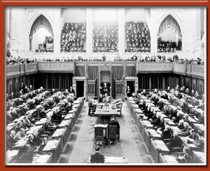
House of Commons in session (© CGMPB / Library and Archives Canada / C-024358)
The Canadian Constitution consists of both written and unwritten elements.
The written documents include both entrenched and non-entrenched laws. Entrenched laws refer to constitutional documents as well as formal amendments to the constitutional documents such as the Constitution Acts of 1867 and 1982.

Non-entrenched laws are basic federal laws, which are also found in the Constitution. These documents, however, are not as difficult for governments to change as entrenched laws. Because non-entrenched laws are made by parliaments, they may also be changed through a simple majority vote by parliament. The procedures for altering entrenched written laws are much more difficult because there is now a separate amending formula that governs this process. We will examine this formula in the latter part of this lesson. Examples include the Elections Act and the Constitutional Veto of 1996 (Archer et al. 2002).
The Elections Act outlines the rules and regulations pertaining to elections.
The Constitutional Veto of 1996 limits the federal government's power to ratify any future constitutional amendments without the consent of the 'five regions' of Canada: British Columbia, the Prairies, Ontario, Quebec, and the Atlantic Region.
Case law is the final type of codified or written document found in the Canadian Constitution. This includes judicial interpretations of the Constitution conducted by the Judicial Committee of the Privy Council (JCPC) (before 1949), as well as the judicial interpretations of the Supreme Court of Canada (from 1875 to the present).
Before 1949, Canada's highest court of appeal was the JCPC. The JCPC was composed of British legal authorities who had the power to strike down a law that conflicted with British law. This practice ended in 1949 when the Supreme Court took over this function.
Judicial interpretations are key in keeping the Constitution current and relevant. Through the process of judicial review, judges interpret the vague and general language of the Constitution in light of the contemporary context. Also, judicial review enables the Supreme Court to indentify and knead out laws that do not conform to the Constitution and the Charter of Rights and Freedoms.

Unwritten Elements
The unwritten elements of the Constitution are referred to as conventions. These are the "unwritten principles of political practice, which gradually acquire binding force over time" (Archer et al. 2002). They are rooted in customs and precedent.
For example, executive power is outlined in the Constitution as being vested in the Governor General, but in practice this power has come to reside with the Prime Minister and the Cabinet. The convention, therefore, has become that the Governor General simply defers his or her powers to the political executive.
Because they are not written, however, conventions are not enforceable by the courts. Still, from time to time judges may be asked to determine if a particular convention exists. Also, just because they are not written does not mean that they are not as relevant as the codified elements of the Constitution. Conventions play a significant role in the functioning of the Canadian political system.

Conventions keep the Constitution consistent with the changing times. They fill the holes that may emerge between written laws and changes in political culture. Moreover, they do not require changing the Constitution.

Amending the Constitution
Before 1982, any request to change the Canadian Constitution would have to be sent to the British Parliament for review, as the Constitution of Canada was still a British law.
The 1982 Constitution Act introduced formal procedures for amending the Constitution. These rules were put in place partly to fill a void and partly to ensure that constitutional supremacy could not be easily tampered with using basic legislation.
There are five different amending procedures, depending on the type of constitutional change that is being sought. For instance, to change the composition of the Supreme Court or the amending formula, or to abolish the Monarchy, would require majority support in the House of Commons, the Senate and in the legislatures of all provinces. This is known as the Unanimity Procedure.
To create new provinces or to change the proportionate representation of the provinces in the House of Commons or the Senate would require majority support in the House of Commons, the Senate and at least seven provinces representing 50% of the population of the country. This is known as the General Formula or the "7/50" procedure.
Amendments that would affect some but not all provinces, such as the adjustment of boundaries between different provinces, would require majority support in the House of Commons, the Senate and the legislatures of those provinces involved.
Lastly, amendments that affect only the federal government require majority support in the House of Commons and the Senate, whereas amendments that affect only one province require majority support in that provincial legislature.
What is evident is that changing the Canadian Constitution in any major way is no easy task, as has been demonstrated previously in Canadian history by attempts to settle the Meech Lake and Charlottetown Accords. Moreover, were there to be any desire on the part of citizens and other interest or advocacy groups to want to be involved in the process, this too would likely contribute to the difficulty of the process and make any major consensus even harder to achieve.
It is important to note, however, that in certain instances, if a provincial government does not agree with a proposed amendment that it feels may transfer powers from the province to the federal government, it can simply "opt out" of that process. Furthermore, the federal government must provide compensation to any provincial government that decides to take such a route. This "opt out" option applies mainly to powers over education and cultural matters.

Constitutional Baggage
Some other important points to keep in mind are as follows:
The Constitution Act of 1867 did not entrench many rules and regulations governing the relationship between citizens and the state. The framers of this document intended for this relationship to be determined by the federal and provincial governments. As such, the Constitution Act of 1867 invested a significant amount of power in legislatures and they were seen as being supreme—more so than the Constitution or the courts.
The introduction of the Constitution Act of 1982 and the Charter of Rights and Freedoms tilted this balance of powers in favour of the Constitution and the courts. The principle of parliamentary supremacy in Canada had shifted to constitutional supremacy.
The 1982 Constitution increased the power of the judiciary as courts are now able to review executive and legislative decisions and identify those cases that do not conform to the Charter of Rights and Freedoms. It is important to note as well that governments do have section 33 of the Charter at their disposal. This section, known as the notwithstanding clause, allows them to retain laws even if they are seen by the courts as being unconstitutional. In the past, however, this power has not often been used.
The next lesson will cover the Charter of Rights and Freedoms in more detail.

The background behind this transition is also useful to note. Recall from preceding lessons that the early 1960s marked the beginnings of the Quiet Revolution in Quebec. During this time, many Quebec nationalists started to mobilize, as they became increasingly displeased with their cultural and political status quo and the fact that other parts of Canada did not seem to respect or equally value the distinct status for Quebec as a founding nation.
Also, Quebec felt increasingly frustrated with the federal government and its meddling abuse of its spending powers.
Around the same time, Western Canadians began to grow increasingly impatient with the Canadian political system, which limited their ability to be heard in Parliament. In addition, other minority groups (such as women and aboriginals) also began to make demands for a greater voice and change. All of this placed increased pressure on the federal government to seek a solution and change the rules of the game, which were based in the Constitution.
Furthermore, the Canadian Constitution at the time did not have an amending formula. Any changes in the Constitution would have to go through the British Parliament. This was another issue that also needed to be addressed.
It was former Prime Minister Pierre Trudeau who felt that implementing a Charter of Rights and Freedoms would be a way to unite Canadians in every province and disgruntled minority groups under one set of values and beliefs. As part of this process, the government would also develop an amending formula and repatriate the Canadian Constitution from Britain. After several failed attempts at forming a country-wide consensus, Trudeau proceeded to repatriate the Constitution unilaterally without the consent of the provinces.
Provinces such as Manitoba, Newfoundland and Quebec brought this issue to their provincial supreme courts in order to determine whether Trudeau's decision was unconstitutional. Their key concerns related to whether Ottawa's proposed amendments to the Canadian Constitution affected provincial powers and whether provincial approval was required in order to make such changes. In addition, Quebec also asked whether the province had a special veto over any constitutional amendments.
These respective provincial court decisions were eventually appealed to the Supreme Court of Canada, which ruled that some level of provincial approval was needed for changes that affected provincial powers. However, this was deemed to be a constitutional convention and as such could not be enforced by the courts. With respect to the level of provincial approval that was needed, the court was unclear. While the majority of the provinces should agree, unanimous consent, the court argued, was not necessary.
In response to Quebec's question about veto power, the Supreme Court of Canada determined that in constitutional law, veto power did not exist. In effect, the Supreme Court ruled that the federal government was entitled by law to unilaterally proceed in its efforts to change the Constitution in areas that concerned the provinces, but the act would be considered unconstitutional if the federal government did so without the consent of the majority of the provinces.

Consequently, the Constitution Act of 1982 repatriated the Canadian Constitution from Britain. The Act also put in place procedures for amending the Constitution and entrenched the Charter of Rights and Freedoms.
The Constitution Act of 1982 did not, however, resolve core grievances voiced by some provinces, particularly Quebec. As a result, the government of former Prime Minister Brian Mulroney attempted to get Quebec back into the fold by instigating multiple rounds of constitutional negotiations between 1984 and 1993. The first such attempt at amending the Constitution Act of 1982 under the new amending formula was the Meech Lake Accord. These talks were started in 1987. The second was the Charlottetown Accord in 1991-1992.
After three years of negotiations, Meech Lake came to a halt as the time limit to reach an agreement expired. The Meech Lake negotiations reinvigorated the anti-French backlash in Western Canada and increased separatist nationalism in Quebec. It also helped fuel tensions between the public and the governing elites as the former felt that they did not have the opportunity to participate in the negotiation process.
The Charlottetown Accord appeared to be a continuation of Meech Lake, as many of the same issues were readdressed. This round of debates, however, was doomed because there were too many competing demands, thus rendering the process unworkable (Gibbins 1999). Also, it became clear that amending the Constitution was no longer the exclusive domain of governments, politicians, lawyers and academics. In an attempt to satisfy the public's demands for greater democratic involvement in the process, the government called a national referendum on the Charlottetown Accord, but it was defeated.
Since this point in Canadian history, there has been very little determination for once again attempting to significantly change the Constitution. This does not mean, however, that in the future major constitutional reforms would not be possible—just difficult without a great deal of will, an extremely important cause and very compelling logic.

Readings

Required Readings

Stephen Brooks, Canadian Democracy: An Introduction, 7th ed. Toronto: Oxford University Press, 2012, Chapter 5.

Lessons Learned
After having gone through this lesson, you should be able to say something about:
- The purpose behind Canada’s Constitution.
- Its core principles, including its makeup and its amending formula.
- Canada’s relatively recent struggle for constitutional reform.
- Has the process of constitutional reform had positive or negative effects on the Canadian political community?

- This discussion question will help you focus your thoughts around the bigger themes in this lesson and help you prepare for the final exam. You may also choose to provide a response to this question in the form of a discussion paper. More information on what is expected for the discussion paper can be found in the course outline, and more specific guidelines will be posted in the "Announcements" section of the course, one week before the papers are due.

Lesson 13: The Charter of Rights and Freedoms

Introduction
This lesson explores how Canadian citizens’ rights and freedoms were governed before the arrival of the Constitution Act of 1982 and the entrenchment of the Charter of Rights and Freedoms. It also examines how the Charter changed the relationship between citizens, Parliament and the judiciary. In addition, this lesson covers some of the key provisions contained in the Charter.

Lesson 13: The Charter of Rights and Freedoms

Study Materials

Before the Charter
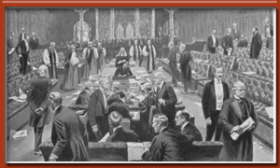
Parliamentary supremacy: passing of the Parliament Bill, 1911, in the United Kingdom (from "The Rise of the Democracy" by Joseph Clayton, Project Gutenberg eText 19609)
As mentioned in the previous lesson, Canada's Constitution of 1867 was founded on the principle of parliamentary supremacy. What this meant essentially was that only Parliament had the power to make, amend or revoke a law and judges were restricted primarily to legal interpretation. In fact, courts were rarely critical of laws, unless the federal parliament had interfered in matters that were under provincial jurisdiction or provincial legislatures had interfered in matters that were to be dealt with by the federal government.
During this early period, there were no entrenched guarantees existed for the protection of minority or individual rights and freedoms. Parliament basically had the power to govern as it pleased. For example, some Canadians were barred from voting and others were arrested and detained on the basis of race alone.
The same was true even at the provincial level. For example, the Alberta legislature had hundreds of mentally ill individuals sterilized.
After the creation of the UN Charter, calls for greater protection of rights and freedoms increased and demands were made to have them put in writing. Canada was no exception to this developing trend. There was now increased pressure from Canadian lawyers, academics and interest groups to move forward on this issue.

The United Nations and the Universal Declaration of Human Rights
The United Nations established the Universal Declaration of Human Rights in 1948, which adopted a number of rights and freedoms that were to be respected by member states. These included political rights, fundamental freedoms, democratic rights, legal rights, economic rights and equality rights.

After the creation of the UN Charter, calls for greater protection of rights and freedoms increased and demands were made to have them put in writing. Canada was no exception to this developing trend. There was now increased pressure from Canadian lawyers, academics and interest groups to move forward on this issue.
In an attempt to appease this growing demand for for the protection of human rights, the federal government decided to put forward a Bill of Rights in 1960, which was not entrenched into the Constitution. It was an ordinary statute that did not override other federal laws and it did not apply to provincial areas of jurisdiction. At the time, there were concerns about entrenching a Bill of Rights in the BNA Act as many feared that this would alter the significance of parliamentary supremacy.
Although this was a positive step toward protecting of the rights and freedoms of Canadians, this Bill of Rights ultimately had little impact. Judges referred to it as an interpretive tool. This statute did not permit the judiciary to do much else. The Bill of Rights did, however, cause many to question the significance of an unentrenched Bill of Rights and demands for entrenched protection began to mount.

The Charter

As was mentioned in Lesson 12, former Prime Minister Pierre Trudeau's vision of constitutional reform included the idea of formally entrenching a Charter of Rights and Freedoms. Trudeau saw this as a means by which to:
- Strengthen Canadian identity.
- Temper regionalism and percolate sentiments of Quebec nationalism.
- Give primacy to protecting all Canadians' rights and freedoms as opposed to catering only to particular groups and values.

The process that was implemented was quite extensive. A special committee was established in order to solicit public opinion on the proposed federal package. There were several rounds of discussion and numerous changes made to Trudeau's original proposal. For instance, various sections pertaining to the rights of women, aboriginals and people with disabilities were modified based on citizens demanding stronger entrenched protection for individual and groups rights.
Many provincial premiers were initially opposed to the Charter because it could potentially undermine provincial legislative powers. The provincial premiers demanded that a clause be added to allow the legislative branch to override court decisions based on the Charter if necessary. In other words, they wanted to put in place a formal mechanism which they cold use to maintain certain parliamentary decisions even if judges felt that they restricted people's rights and therefore were unconstitutional.
In an effort to convince the premiers of various provinces to accept the Charter, a variety of overtures were made. For example, the 'reasonable limitation' clause in section 1 of the Charter was modified to be a broader limitation clause.
The result is that rights and freedoms are not absolutely guaranteed. Legislatures can and may restrict rights and freedoms if it is "demonstrably justified to protect a free and democratic society" (Canadian Charter of Rights and Freedoms 1982).
For instance, freedom of speech does not imply absolute freedom to say anything and everything. The use of this freedom in a manner that may cause danger to others may not be tolerated.
Rights and freedoms may also be restricted by practicality and feasibility. For example, although the Constitution guarantees the right of official-language minorities to acquire a public education in their mother tongue, this does not necessarily mean that this is an absolute right in all of Canada. In communities where only a few families demand such a right, it may not be reasonable to build a new school. Common sense would suggest that this would not be practical. Moreover, even in those instances where it may be more practical, such as in Quebec for example, where there is a significant English-speaking minority, it may not always be politically feasible.
In addition, section 33, also known as the "notwithstanding clause", was established to allow both the federal and provincial governments to preserve laws even though they may be deemed by judges to violate certain rights and freedoms, specifically those listed in section 2 or sections 7-15 of the Charter (fundamental freedoms, legal rights and equality rights). (More details on each of these sections will be provided toward the end of this lesson.)
This was a crucial overture. Without it, many believe that the federal-provincial deal which established the Charter would have been called off.
What is ironic, however, is that although section 33 clearly gives legislatures the power to retain laws that may violate certain sections of the Charter and to side-step or reverse a court order that finds a law unconstitutional, in reality the clause is rarely used.
Also, it is important to note that restrictions of rights and freedoms under section 33 cannot be implemented for an indefinite period. Such decisions must be revisited and reviewed after every five years.
To this point, the notwithstanding clause has been used most extensively in Quebec but mostly for symbolic reasons. For instance, the Quebec government repeatedly used this clause between 1982 and 1985 to demonstrate its dissatisfaction with the constitutional reforms of 1982.
The Quebec government has also used section 33 to enforce a modified version of Bill 101, which restricts the use of languages other than French in the province.
The province of Saskatchewan also used the notwithstanding clause in 1986 to uphold a law that obliged public servants who went on strike to return to work. This was a pre-emptive move as the government suspected that the Supreme Court would strike down such a law on the grounds that it infringed on freedom of association, which is protected in the Charter.

The Post-Charter Era
In the past, judicial review was limited mainly to legislation that affected the division of powers between different levels of government. With the introduction of the Charter and the Constitution Act of 1982, however, the role of the judiciary has been expanded.
In the post-Charter era, judges also help to protect the rights and freedoms set out in the Charter by pointing out unconstitutional laws and asking governments to make them Charter compliant.
As alluded to in the previous lesson, the Constitution Act of 1982 established new powers for resolving violations of guaranteed rights and freedoms.
The entrenchment of the Charter of Rights and Freedoms and Section 24(1) makes it possible for any individual group whose Charter rights have been violated to turn to the courts for a just remedy. Section 52 and the principle of constitutionalism gives the judiciary the legitimacy to strike down any federal or provincial law that conflicts with the Charter, particularly if governments are not willing to revise those laws and to make them Charter compliant.
The Charter opens up the possibility for more dialogue between the courts and the legislators.
For example, the courts may suspend an offensive law for a specific period of time in order to give legislatures the opportunity to amend the legislation rather than simply striking it down.
The Supreme Court may also provide guidelines for legislatures on how to amend and re-enact a law that conflicts with the Charter.
Before the Charter came into existence, the role of the courts was primarily to "apply the existing law to the facts of each individual case, without indulging in sweeping statements about the broader implications of their ruling" (Archer et al. 2002). Now, the bigger the case, the greater the chances that the role of the court may shift from one of adjudication to attempting to indirectly reshape policy.
As a consequence, at the Supreme Court level broader questions of law and policy have become more significant.
Thus, not only do higher courts give disgruntled litigants the right to contest a decision made by a lower court. They also help to unify the application of any re-shaped legislation. Once the Supreme Court decides on a matter, it would be difficult for a lower court not to follow such decisions because any rulings to the contrary would easily be overturned through the appeals process by the highest court in the land.

Key Provisions of the Charter
The Canadian Charter of Rights and Freedoms is organized into several sections.

Section 1: Limitation Clause
As mentioned earlier, the limitation clause located in section 1 of the Charter limits the application of rights and freedoms in order to protect societal interests. This means that rights and freedoms are not guaranteed unconditionally.

Section 2: Fundamental Freedoms
Section 2 of the Charter covers fundamental freedoms. It provides protection for basic freedoms, such as the freedom of conscience and religion, freedom of thought and expression, freedom of the press and freedom of peaceful assembly and association.
The combination of this section and section 1 means that the protection of such freedoms is not absolute. For example, the courts may determine that certain types of expression are more important to protect than others. Political voice and artistic expression, for instance, may be considered more relevant than hate propaganda or child pornography.
Likewise, the freedom to associate does not include the right to strike. This freedom does not extend to the economic domain and it guarantees the state certain protection for collective bargaining. Similarly, the Supreme Court has also ruled that forcing an individual to participate in a given organization violates his or her freedom not to associate.

Sections 3-5: Democratic Rights
Sections 3 to 5 of the Charter cover democratic rights. For example, every Canadian citizen has the right to vote, and run as an elected official as long as they are 18 years of age or older. This section also protects citizens from governments ruling for extended periods of time. The exception to this rule might be during a war or invasion of some kind. But even then, more than a majority of the legislature must agree to such an extension. Lastly, this section also makes certain that legislatures meet at least once every 12 months.

Section 6: Mobility Rights
This section guarantees Canadian citizens the right to enter, remain in and leave Canada as they please. This section also makes it possible for Canadians to move from one province to another and to make a living with only a few conditions.

Sections 7-14: Legal Rights
Sections 7-14 of the Charter refer to life, liberty and security of the person—which are not to be restricted unless it is for reasons having to do with the principles and implementation of fundamental justice.
These sections also protect Canadians from unreasonable search or seizure, and detainment or imprisonment. They protect Canadians' rights in the event that they are arrested or charged with an offence.
They protect citizens from cruel and unusual punishment as well as provide them with certain witness protections.

Section 15(1): Equality Rights
The purpose of this section is to provide citizens with the reassurance that they are equal before the law and that they have an equal right to the law's protection and benefits without discrimination. For instance, this section protects citizens from being discriminated against based on race, national and ethnic orientation, religion, sex, age, or mental or physical ability.
Section 15(2) makes clear that the protection of these rights does not apply against affirmative action programs.

Additional Protections
Sections 16-22 of the Charter protect the equality of status and use of both official languages- English and French- in all the institutions of Parliament and government of Canada. These sections of the Charter also indicate that provincial services in Manitoba, Quebec and New Brunswick are to be provided in both official languages.
Section 23 of the Charter protects the rights of official language minority populations within a province to have their children receive primary and secondary school instruction in that language, provided that it is practical.
Lastly, section 25 of the Charter makes clear that any of the protections guaranteed shall not detract from the rights and freedoms that pertain to the aboriginal peoples of Canada. This includes treaty rights, any rights and freedoms recognized in the past and any rights and freedoms that may exist as a result of land claims agreements.

Readings

Required Readings

Stephen Brooks, Canadian Democracy: An Introduction, 7th ed. Toronto: Oxford University Press, 2012, Chapter 6.

Lessons Learned
After having gone through this lesson, you should be able to say something about:
- How citizens’ rights and freedoms were governed by the legislature before the introduction of the Canadian Charter of Rights and Freedoms.
- How a change in one institution, the Constitution, had tremendous effects on other institutions such as the legislature and the judiciary.
- The key Charter provisions that affect citizens’ lives and the Canadian political system.

Discussion Question
Please comment on the following:

Should governments use the notwithstanding clause more often?

This discussion question will help you focus your thoughts around the bigger

